

Aging Process
  - INSTRUCTOR GUIDE
December 2025

Contents
Module 0. Manual Guide 2
0.1. Acknowledgements and Partners 2
0.2. Course Summary 2
0.3. Target Audience 2
0.4. Course Requirements 2
0.5. Goal 3
0.6. Learning Objectives 3
0.7. Course Length 3
0.8. Trainer Preparation 3
Module 1. Welcome and Overview 4
1.1. Introductions 7
Module 2. Aging, Ageism, and Bias 8
2.1. Activity 1: Ageism and Bias: Video and Discussion 11
Module 3. Physical Changes 17
3.1. Activity 1: Biological Changes 19
3.2. Activity 2: Common Medical Conditions 27
Module 4. Cognitive, Psychological, and Sociological Changes 33
4.1. Activity 1: Cognitive Changes 35
4.2. Activity 2: Psychological Changes 37
4.3. Activity 3: Sociological Changes 39
Module 5. Considerations for Service Planning 43
5.1. Activity 1: Strength-Based Service Planning with Older Adults 44
5.2. Activity 2: Case Scenario Activity 47
Module 6. Wrap-Up 51
6.1. Activity 1: P-I-E Wrap-Up 52
Appendix A: Medical Conditions Activity 54
Appendix B: Case Scenario Activity (Trainer Copy) 55
Appendix C: Case Scenario Activity (Participant Copy) 61
References 64

Manual Guide

Acknowledgements and Partners
The curriculum was originally created by NAPSA in collaboration with the Academy for Professional Excellence. It was then used as a foundation for training content and materials developed by NAPSA under the grant for the National APS Training Center.
The creation of this curriculum was the result of a collaborative effort between Adult Protective Services professionals, professional educators, and NAPSA members. NAPSA would like to thank the following:
Committees
NAPSA Education Committee
NAPSA Curriculum Development Committee
NAPSA Curriculum Review Committee
Curriculum Developer
Katie Wilson, MS

Course Summary
In this interactive and engaging introductory training, participants will gain a basic understanding of the aging process, including the physical, cognitive, psychological, and sociological changes that occur as we age. This understanding will enhance their ability to conduct investigations and develop effective strength-based service plans when working with older adults.

Target Audience
The course is intended for new APS professionals but is also applicable to allied disciplines and partners that work with older adults (law enforcement, conservatorship investigators, workers in aging networks). This training is also appropriate for tenured staff who require knowledge or skill review.

Course Requirements
There are no course requirements. It may be helpful for participants to have some experience of working with older adults and service planning.

Goal
The purpose of this training is to enable APS professionals to have a better understanding of the various aspects involved in the aging process in an effort to minimize ageist beliefs and improve service planning that leverages older adults’ strengths.

Learning Objectives
After completing this course, participants will be able to:
- Identify typical changes that affect most older adults
- Describe common biases and stigmas about the aging process that affect older adults
- Identify how typical changes that affect the aging process can either reduce or cause risk for an older adult
- Recognize how chronic medical conditions can cause risk for an older adult
- Identify how psychological changes affecting the aging process can reduce or cause risk for an older adult
- Create service plans that leverage an adult’s strengths.

Course Length
This curriculum was developed as a 4-hour training. It is recommended that time be permitted for two 15-minute breaks, determined by the trainer’s discretion.

Trainer Preparation
This instructor-led curriculum is designed for both classroom delivery and virtual delivery.
The optimal size for this training is 20-25 participants.

Welcome and Overview
Time: 20 minutes
Associated Objective: NA
Purpose: Welcome and introduction of the course. This section includes the introduction of the trainer, participants and the purpose and background of the course.
Facilitation Instructions: Follow the talking points and associated prompts.
Tools: PowerPoint Presentation
Slide 1: Welcome
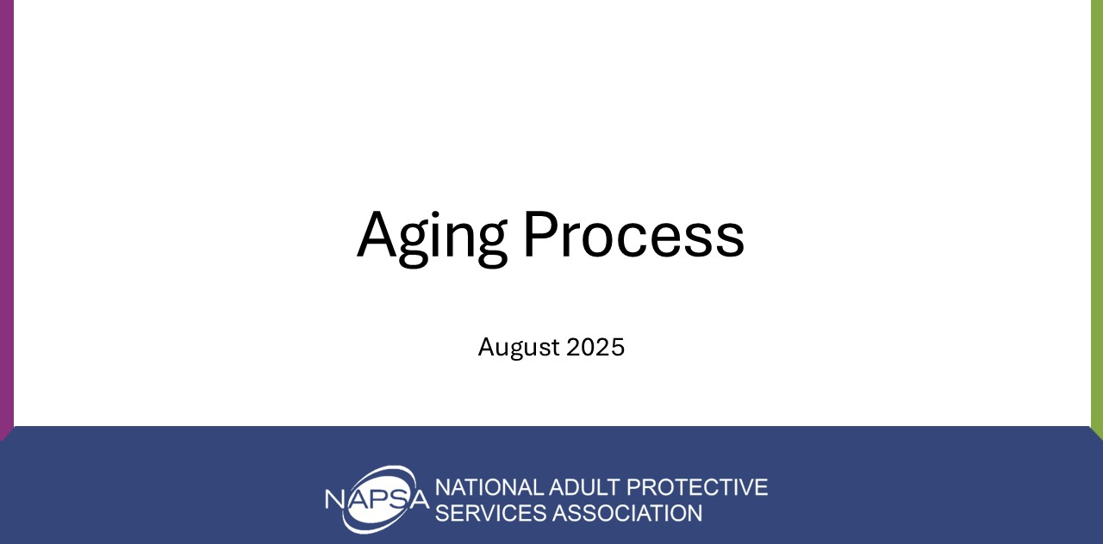
Do: Welcome participants to the course and introduce yourself by name, job title, organization, experience, and qualifications as the trainer.
Review the following housekeeping items:
- Respect everyone’s opinions, each other’s time, and speakers.
- Timeliness- be on time for breaks.
- Confidentiality- at any point when we discuss real cases, do not share names or identifying information.
- Sensitive Content Warning - Content and discussion today may activate feelings based on personal or professional experiences. Please do what you need to do to safely engage in the training today.

Virtual Additions
- Always keep your audio on mute, unless instructed otherwise.
- Use the raise hand option to ask questions.
- Use reaction tabs to interact in class.
- Post any questions in the chat box that need additional clarification or information.
- Explain breakout rooms (if used in the course)
Slide 2: Learning Objectives
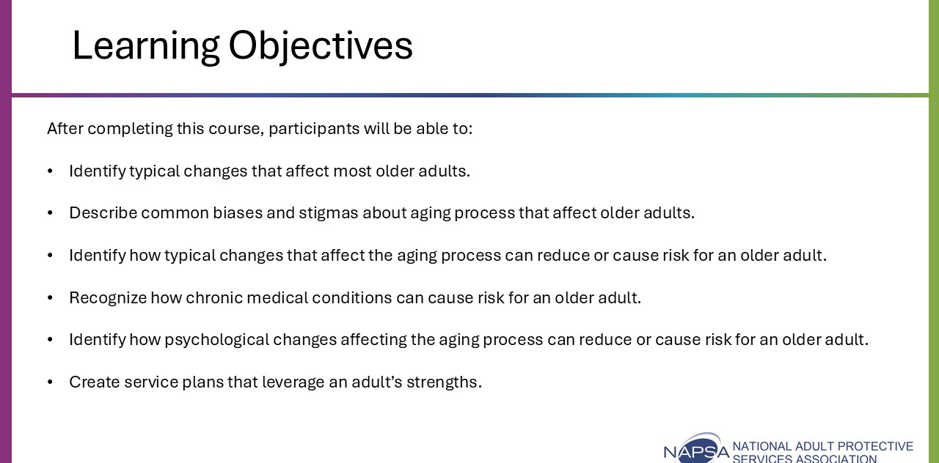
Discuss the learning objectives:
After completing this course, participants will be able to:
- Identify typical changes that affect most older adults
- Describe common biases and stigmas about the aging process that affect older adults
- Identify how typical changes that affect the aging process can reduce or cause risk for an older adult
- Recognize how chronic medical conditions can cause risk for an older adult
- Identify how psychological changes affecting the aging process can reduce or cause risk for an older adult
- Create service plans that leverage an adult’s strengths.
Explain class expectations – what they will learn, upcoming activities, length of class, number of breaks, etc.

Introductions
Time: 10 minutes
Method: Will vary depending on selected activity
Slide 3: Introductions

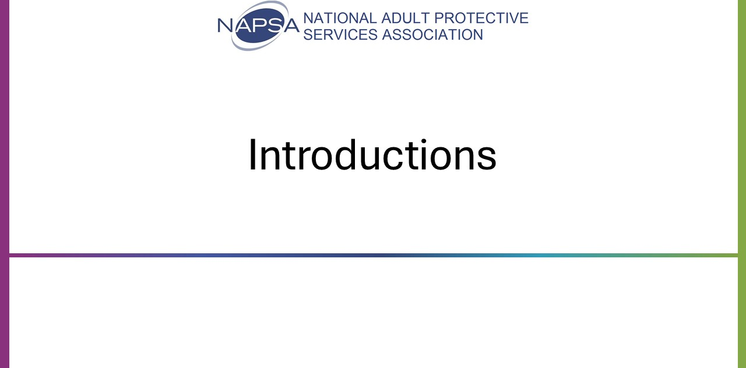
Do: Facilitate an icebreaker that will allow participants to become comfortable with interacting in class. There is flexibility with this activity as adjustments must be made depending on class size and participant familiarity with each other. The trainer may use an icebreaker of their choice, but it should tie to the class content to some degree.

Aging, Ageism, and Bias
Time: 30 minutes
Associated Objectives:
- Identify typical changes that affect most older adults
- Describe common biases and stigmas about the aging process that affect older adults.
Facilitation Instructions: Follow the talking points and associated prompts. Prepare the video.
Tools: PowerPoint Presentation, participant guide, video

Slide 4: More Than a Number
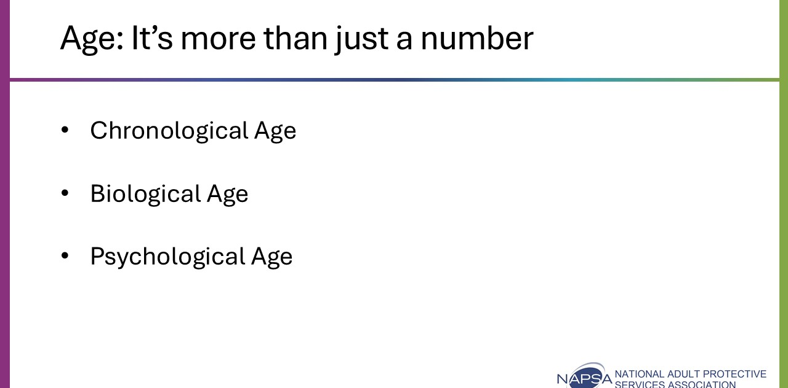
Say: Aging is not simply a numerical age. Most APS laws set an age at which someone becomes an older adult, usually at age 60 or 65. These ages are based on policy and not necessarily on the study of aging.
In other words, not every older adult on an APS caseload is aging in the same way or at the same rate as someone else the same age.
Let’s review the differences between each form of aging:
- Chronological: This perspective on age is based simply on the amount of time someone has lived, usually measured in years. This age tells us very little about where someone is in the aging process, other than whether they meet our statutory definition for an older adult.

- Biological: This age refers to when someone experiences the changes in the body that commonly occur as people age. Every older adult is different. These changes will occur sooner for some people than they will for others.
  - Example: one person will experience significant changes to their hearing at 65 years of age while another person who is the same age may still have hearing more similar to that of the average 50-year-old person.

- Psychological: A client's psychological age is significant for APS professionals to consider as it's based on how people act and feel and not simply their chronological age or biological conditions. In other words, it is based on their outlook, which is important for APS professionals to consider when working with people.
  - Example: For example, an 80-year-old may have congestive heart failure and vision challenges, but they volunteer five days per week, are looking forward to a cruise that they have planned, and stay active in all neighborhood activities. They may have a younger psychological age than their chronological age or biological age.

Older adults vary significantly depending on many factors such as demographics, health status, and cultural and life experiences. Despite the stereotype that all older adults are the same – in actuality, after a lifetime of development, the older we grow, the more unique we become.

Activity 1: Ageism and Bias: Video and Discussion
Time: 20 minutes
Method: Group discussion/Chat feature, “Frame of Mind” Video
Slide 5: What stereotypes have you heard about aging?
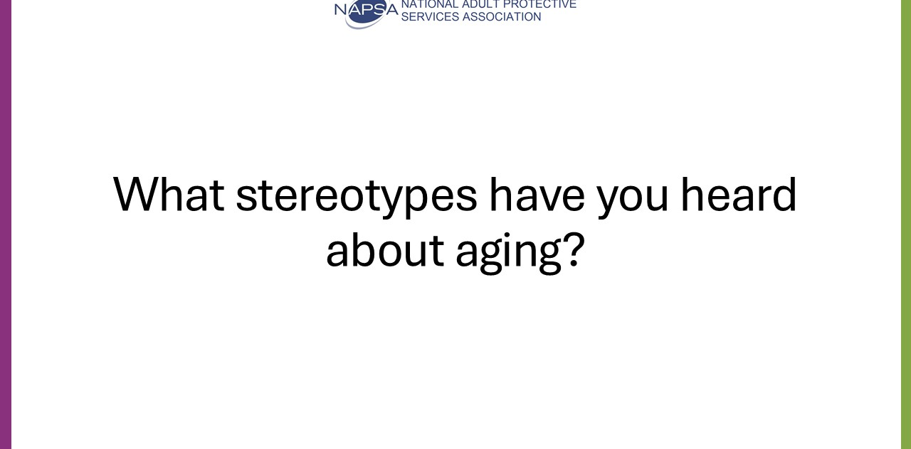

Say: Each of us receives messages about aging throughout our lifetime. Some of these messages have been positive, but more often they are not and are based on ageist views.
Ask: What stereotypes have you heard about aging?
Direct participants to use the chat feature or share their responses. Use the responses to generate a group discussion.
Possible answers: Older adults are set in their ways, Older adults are not capable of learning new information, Intelligence declines in old age, Most people end up in a nursing home, Older adults all act alike, Older adults grow increasingly irritable and angry as they age, Older adults are not tech-savvy, Older adults are not sexually active.
Say: These statements are inaccurate and examples of ageism against older adults.

Slide 6: Frame of Mind Video, Part 1

Say: Ageism is the stereotyping and discrimination against individuals or groups based on their age. We will now watch a video that will talk a bit more about ageism.
Play Video: Watch the video titled “Frame of Mind: Confronting Our Implicit Bias About Ageism” (National Center to Reframe Aging) and pause at 1:06 to review some of the points made in the video.
Video link provided in PowerPoint or can be accessed with this link: Frame of Mind: Confronting Our Implicit Bias About Ageism
Discuss the definition of implicit bias. Thoughts and feelings are “implicit” if we are unaware of them or are mistaken about their nature. We have a bias when, rather than being neutral, we have a preference for (or aversion to) a person or group of people. Thus, we use the term “implicit bias” to describe when we have attitudes towards people or associate stereotypes with them without our conscious knowledge. Most of our actions occur without our conscious thoughts. This means, however, that our implicit biases often predict how we will behave more accurately than our conscious values.

Slide 7: Ageism in APS
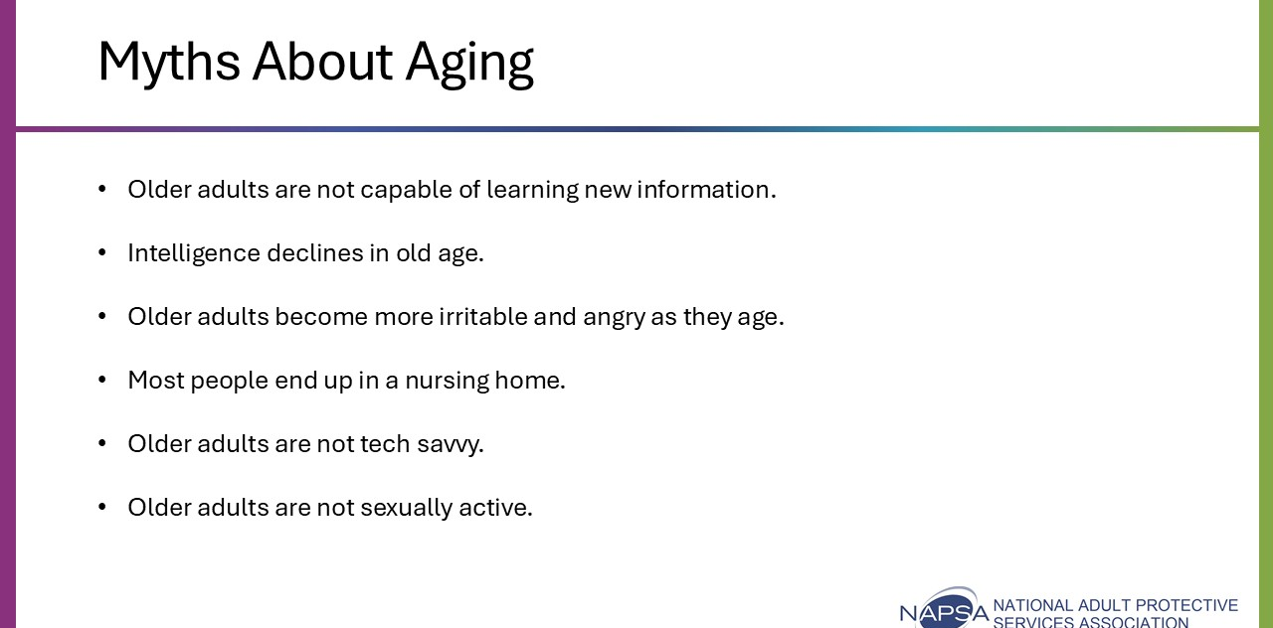
Say: Implicit bias/ageism can affect our work at APS. Let’s revisit some of those stereotypes discussed earlier, as these are examples of implicit bias. Consider how these inaccurate beliefs may influence investigation and service planning.
Allow for group discussion on how stereotypes about aging can negatively impact APS casework. Some examples are provided below:
- Older adults are not capable of learning new information: May be less likely to share new information that is necessary for the older adult to provide informed consent.
- Intelligence declines in old age: May use over-simplified language that talks down to the older adult and keeps rapport from being built.
- Older adults become more irritable and angry as they age: May be quick to judge the older adult’s reluctance to cooperate with the investigation as resistance and anger when there are many reasons that could cause that response, such as the effects of trauma.
- Most people end up in a nursing home: Might be too quick to recommend placement and not fully explore the least restrictive options for the older adult.
- Older adults are not tech savvy: Might fail to consider and investigate the use of a computer to make Bitcoin purchases by the older adult during an exploitation investigation.
- Older adults are not sexually active: May assume the diagnosis of a sexually transmitted disease is a result of sexual abuse rather than exploring with the older adult their consensual sexual activity.

Slide 8: Impacts of Ageism
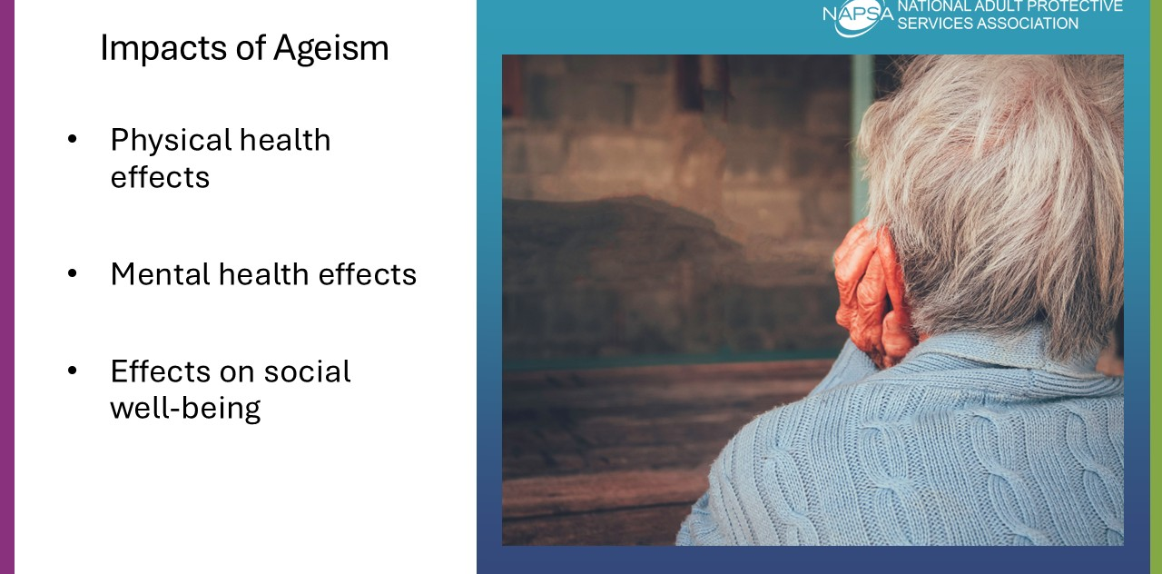
Say: Implicit bias can have significant and often detrimental effects. Ageism has been shown to have negative effects across several domains, including physical health, mental health, and social well-being (Levy, 2022; World Health Organization, 2021).
- Physical Health Effects: Linked to poorer health outcomes, higher risk of chronic illness, reduced longevity, and delayed recovery from disability.
- Mental Health Effects: Contributes to stress, anxiety, and depression. Lowers self-esteem, which may lead to older adults internalizing negative beliefs about aging.
- Effects on Social Well-Being: Leads to social isolation and reduced participation in meaningful activities, which can weaken social support networks and overall diminish a person’s quality of life.
With all of this in mind, what are some ways we can eliminate or at least reduce the effects of ageism in APS? Let’s return to the video for some ideas.

Slide 9: Challenging Ageism in APS
Finish Video: Resuming at 1:06, watch the second portion of the video “Frame of Mind: Confronting Our Implicit Bias About Aging” (National Center to Reframe Aging).
Video link for Part 2 (resuming at 1:06) provided in PowerPoint or can be accessed with this link: Frame of Mind” Confronting Our Implicit Bias About Aging Part 2.
Discuss some of the points made in the video.

Slide 10: Challenging Ageism in APS
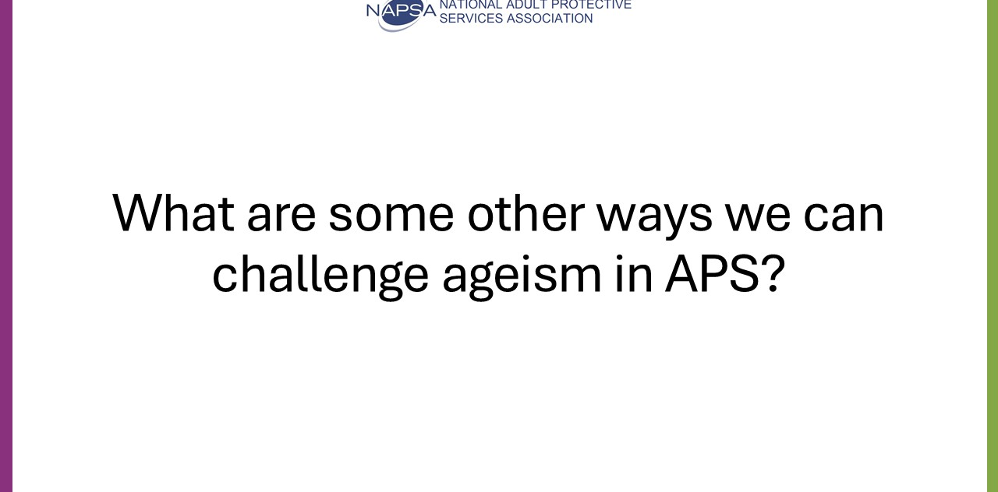
Ask: What are some other ways we can challenge ageism in APS?
Allow for group discussion, but offer the following additional points:
- Challenge stereotypes in conversation (directly but respectfully)
- Model inclusive terminology
- Adopting a strength-based perspective
- Educate and advocate
Say: By having a better understanding of the aging process, you’ll be better equipped to spot misinformation on aging and provide clarification as inaccurate statements are made.

Physical Changes
Time: 80 minutes
Associated Objective:
- Identify how typical changes that affect the aging process can reduce or cause risk for an older adult.
- Recognize how chronic medical conditions can cause risk for an older adult.
Facilitation Instructions: Follow the talking points and associated prompts. Prepare for breakout room activity (determine groups and case scenarios).
Tools: PowerPoint Presentation, participant guide, breakout groups, case scenario

Slide 11: Introduce Physical Changes in Aging
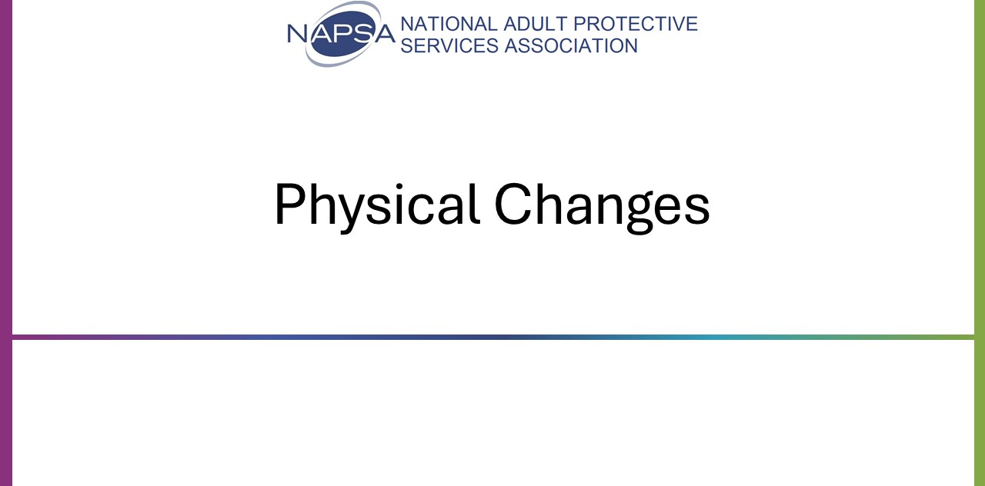
Say: It’s a fact that our bodies do change as we age. Many of these changes are determined by genetics, lifestyle, and disease, so the aging process will vary significantly from one person to the next.
However, a number of physical changes and health issues will become more common as people age, so some key generalizations can be made about the aging body.

Activity 1: Biological Changes
Time: 30 minutes
Method: Group discussion
Slide 12: Biological Changes
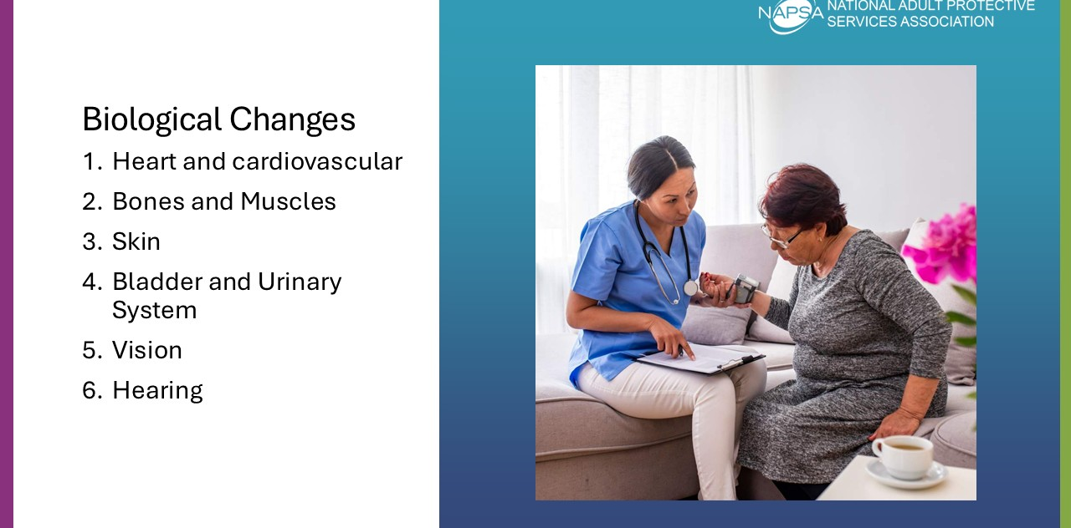
Trainer Note: During lecture portion of the curriculum, it is advised that you ask questions or use virtual learning platform features such as raise hand or chat feature to encourage participation throughout to generate class discussion.
Say: Let’s review some of the more common systems that will change as the body ages and how these changes may impact an APS case.
- Heart and Cardiovascular
- Bones and Muscles
- Skin
- Bladder and Urinary System
- Vision
- Hearing

Slide 13: Heart and Cardiovascular
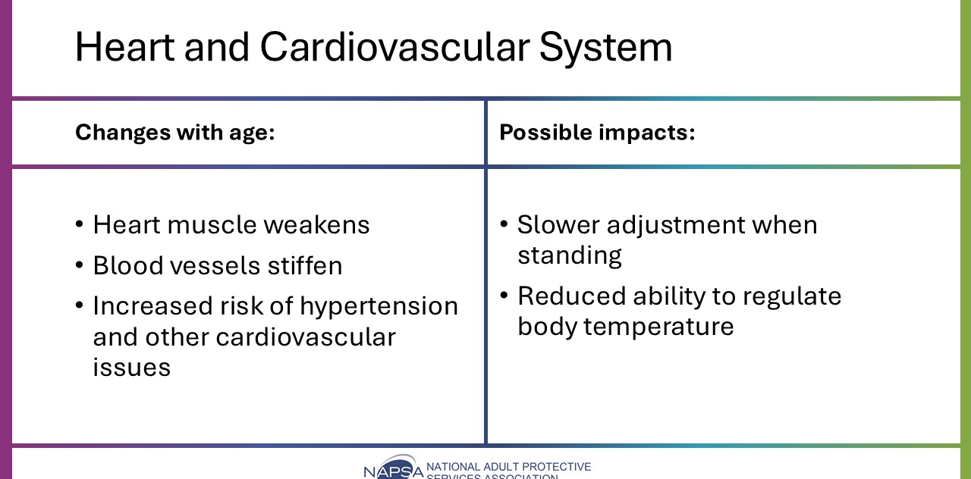
Say: As we age, our heart and cardiovascular system are affected. Changes with age include:
- Heart muscle weakens – pumps less effectively
- Blood vessels stiffen – heart works harder
- Increased risk of hypertension and other cardiovascular issues
Some impacts on functioning include:
- Slower adjustment when standing – dizziness, confusion, stumbling, or falls
  - When investigating a case involving falls, ask about cardiovascular health and the circumstances of the fall.
- Reduced ability to regulate body temperature – higher risk of hypothermia/hyperthermia
  - Be alert to extreme weather conditions, as older adults may face life-threatening risks due to temperature regulation problems.

Slide 14: Bones and Muscles
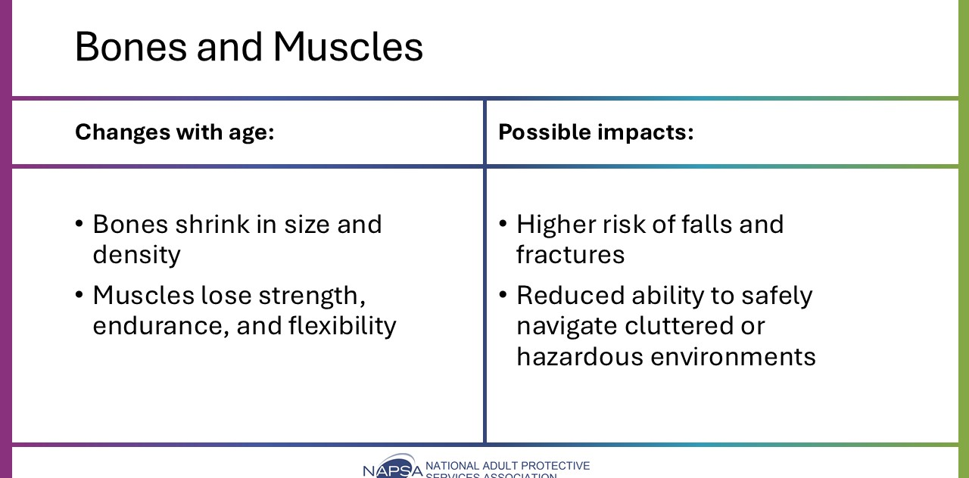
Say: Bones and muscles are affected during the aging process. Changes with age include:
- Bones shrink in size and density - weaker, more prone to fractures (especially hips).
- Muscles lose strength, endurance, and flexibility - impacts coordination, stability, and balance.
Some impacts on functioning include:
- Higher risk of falls and fractures.
- Reduced ability to safely navigate cluttered or hazardous environments.
For APS, consider how weakened muscles and limited pathways may increase fall risks. Assess bone health when evaluating the severity of potential injuries, as hip fractures can be fatal.
Having knowledge of these changes can guide urgency, safety planning, and interventions.

Slide 15: Skin
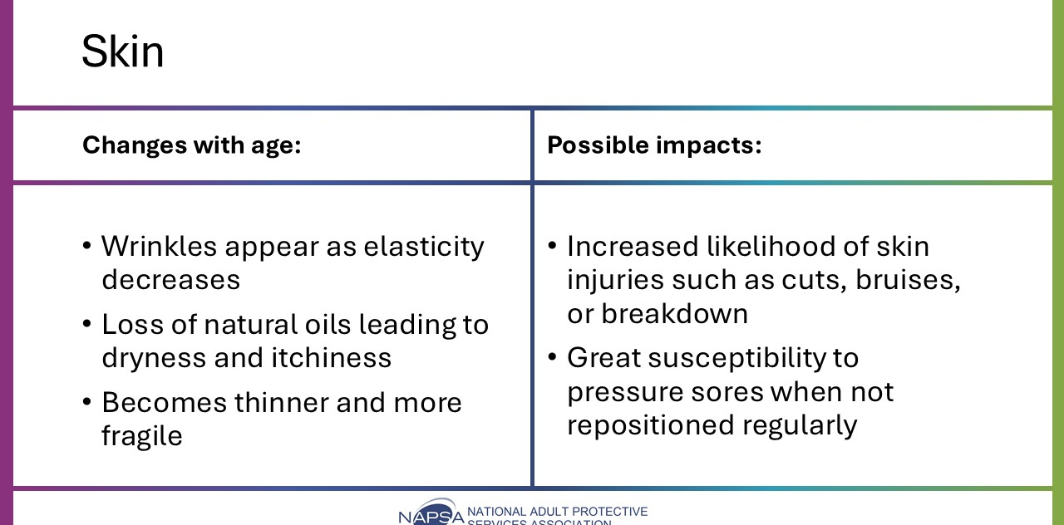
Say: The skin is often one of the most noticeable forms of aging. Changes with age include:
- Wrinkles appear as elasticity decreases
- Loss of natural oils leading to dryness and itchiness
- Skin becomes thinner and more fragile, increasing the risk of cuts, bruises, and breakdown
Some impacts on functioning include:
- Increased likelihood of skin injuries
- Great susceptibility to pressure sores when not repositioned regularly
Consider that pressure sores are common in APS. Their presence does not automatically indicate neglect, but it does signal insufficient repositioning. Knowing that the aging process makes people more susceptible to developing pressure sores without proper repositioning will affect our investigations and service planning, particularly in caregiver neglect and self-neglect cases.

Slide 16: Bladder and Urinary System
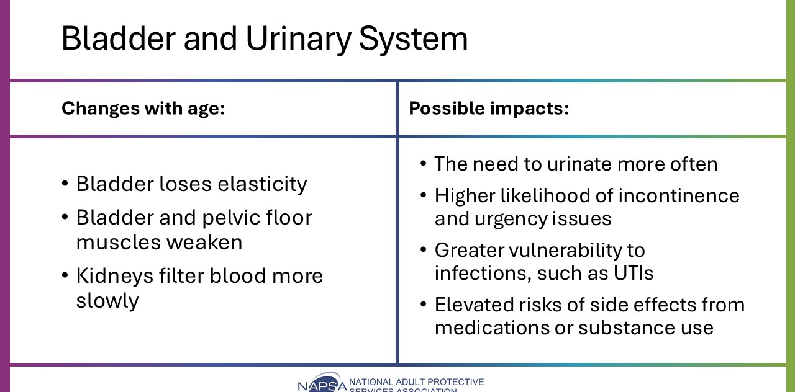
Say: The bladder and urinary systems also change with age and can include the following:
- Bladder loses elasticity, resulting in the need to urinate more often.
- Bladder and pelvic floor muscles weaken, leading to incomplete emptying, incontinence, or urgency
- Increased risk of urinary tract infections (UTIs).
- Kidneys filter blood more slowly, meaning medications and substances remain longer in the body.
Some impacts on functioning include:
- Higher likelihood of incontinence and urgency issues.
- Elevated risks of side effects from medications or substance use.
- Greater vulnerability to infections, such as urinary tract infections (UTIs)
UTI’s, like all infections, can become serious. UTIs can spread from the bladder to the kidneys and bloodstream and if left untreated can result in a life-threatening infection, sepsis. The single best sign of a UTI in an older person is often a sudden behavioral change. UTI’s are a common cause of sudden confusion (delirium), which can worsen existing neurocognitive disorders/dementia.

Slide 17: Vision
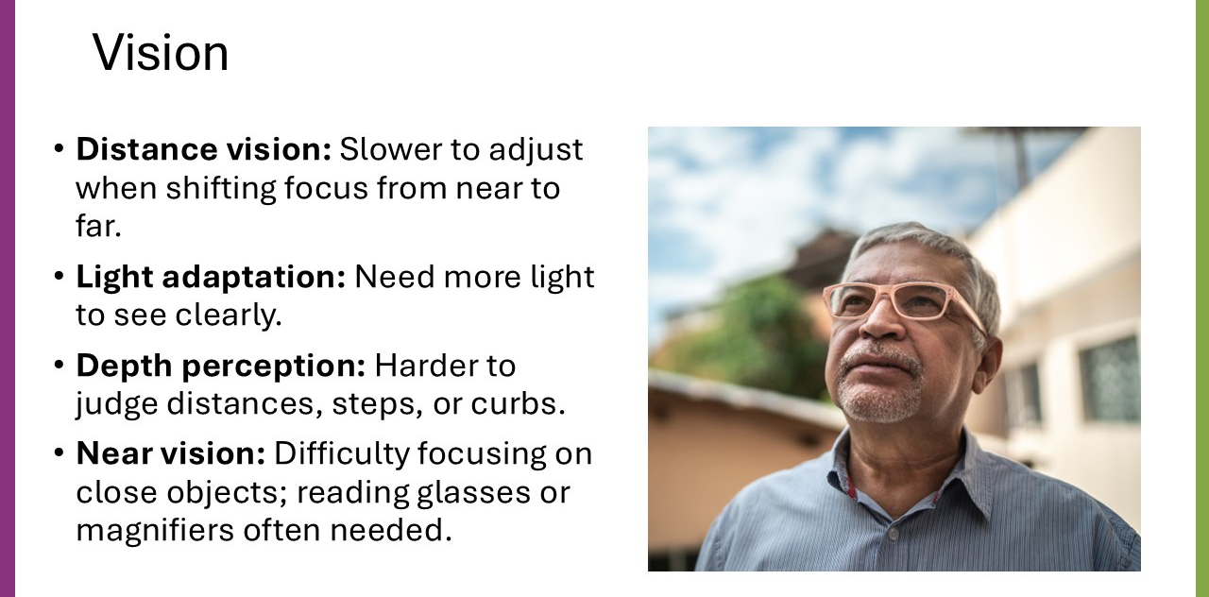
Say: Vision is affected by aging, usually starting in about the fourth decade of life. Some of the more common effects include:
- Distance vision: Lens loses flexibility resulting in the eyes being slower to adjust when shifting focus from near to far.
- Light adaptation: Pupils respond more slowly, leading to difficulties seeing in dim light, slower adjustment to darkness, and increased glare sensitivity. Older adults need more light to see clearly.
- Depth perception: Fewer nerve cells will make it harder to judge distances, steps, or curbs.
- Near vision: Lens stiffens, which results in difficulty focusing on close objects; reading glasses or magnifiers are often needed.
Some impacts on functioning include difficulty recognizing people or objects at varying distances, increased fall risk due to misjudging steps or uneven surfaces, and challenges with reading small print.
Slide 18: Hearing
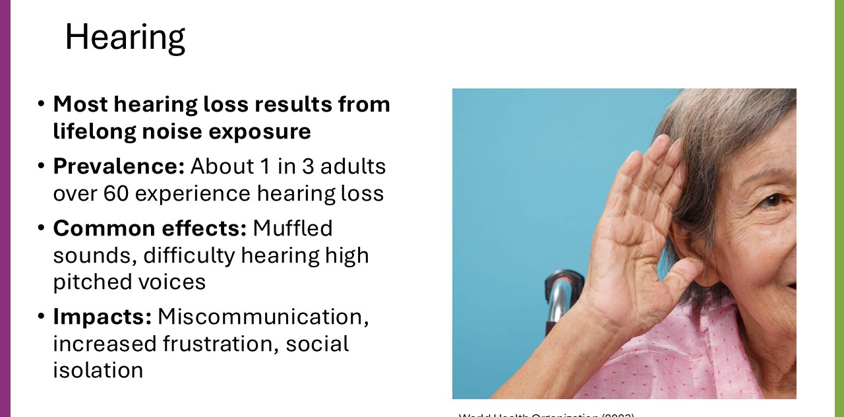
Say: Hearing is also affected by the aging process. About one third of people who are 60 years of age or older experience hearing loss (World Health Organization, 2023).
The loss of hearing can have a significant effect on daily functioning for older adults. Sounds become muffled, and high-pitched sounds and voices become harder to understand.
Some impacts include miscommunication, increased frustration, and social isolation.
Slide 19: Communication and Hearing Loss
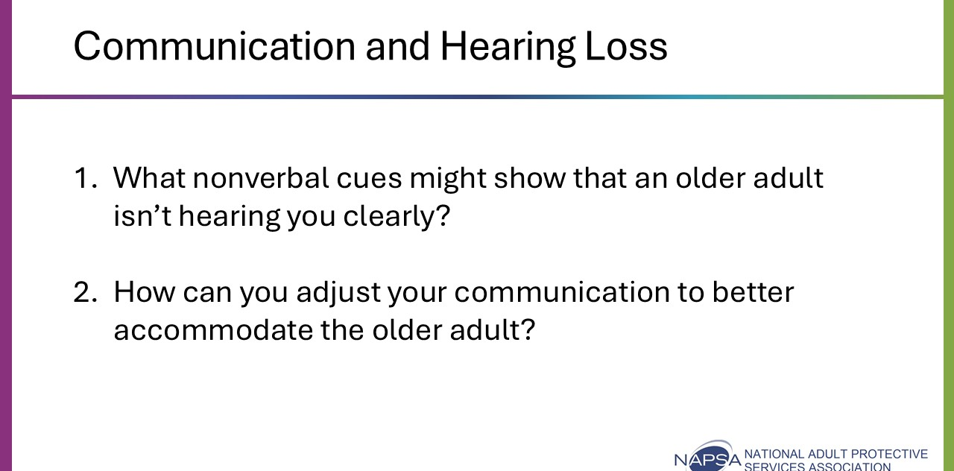
Say: For APS professionals, we should keep hearing changes in mind when communicating with older adults. When they can’t hear us clearly, people with hearing loss may insert information based on what they think we said and not what we said.
We should be mindful of nonverbal cues that they are having difficulty hearing or following the conversation.
Ask: What nonverbal cues might show that an older adult isn’t hearing you clearly?
Possible answers: Cues may include a confused look, leaning in closer, head tilted, holding their hand up beside their ear as if to focus on the sound.
Ask: How can you adjust your communication to better accommodate the older adult?
Possible answers: We should keep hearing changes in mind when communicating with older adults. We should face the person and minimize the use of our hands so as not to distract their focus from what we are saying. Minimize or limit distractions.
Say: If we are unsure that a person is hearing us, we should ask. We should avoid making the person frustrated or getting frustrated ourselves with communication, even when it is difficult due to hearing issues.

Activity 2: Common Medical Conditions
Time: 45 minutes
Method: Breakout groups, case scenario
Slide 20: Common Medical Conditions
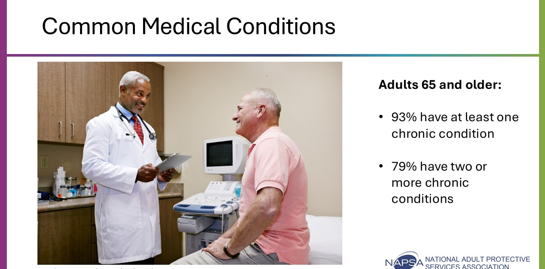
Say: Among adults 65 years of age or older, 93% have at least one chronic condition, and 79% have two or more chronic conditions (National Council on Aging, 2025). Because of this prevalence, it is important for APS workers to have a basic understanding of the common types of chronic medical conditions for older adults.
There are hundreds of medical conditions we may encounter in APS, and we may not always be familiar with them. While generally APS workers are not medical professionals, it is important that we know how to use our resources to understand key characteristics of the medical condition, as they may impact our investigation and service planning.
We will practice doing just this with the next activity.

Slide 21: Activity: Medical Conditions (Breakout Groups)
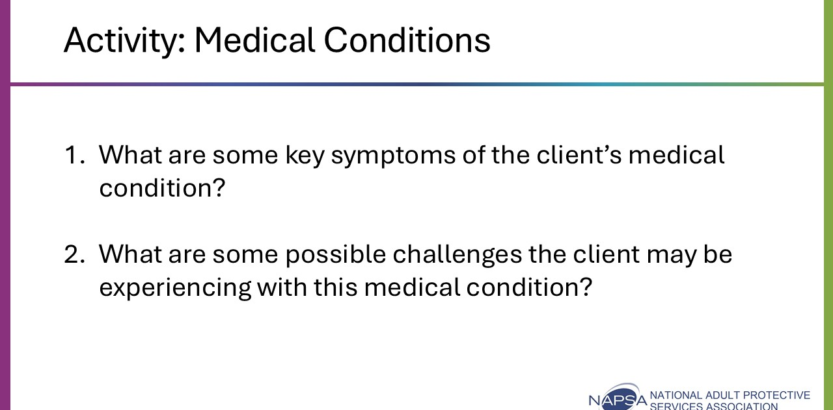
Say: For this activity, you will be assigned to a breakout group. Each group will be assigned one of the three case scenarios (Marty, Gloria, or Lee). Each case scenario features an APS client with a particular medical condition. As a group, you will review the case scenario and discuss the two questions provided on the PowerPoint slide.
- What are some of the key symptoms of the client’s medical condition?
- What are some possible challenges the client may be experiencing with this medical condition?
You will be given 10 minutes to read the scenario and discuss the questions. The focus here is on the medical condition. Use reliable and relevant resources to find information on the medical condition (some good examples include Mayo Clinic and MedlinePlus). We will be returning to these groups/case scenarios to discuss service planning later in the training. Be sure to designate a spokesperson because when we come back, each group will be asked to summarize their discussions.
Do: After 10 minutes, close out the breakout groups. Allow each spokesperson to share some highlights from their discussion (about 5-10 minutes per case scenario). Each case scenario has a designated slide with additional information on each featured medical condition.

Slide 22: Case Scenario 1: Marty
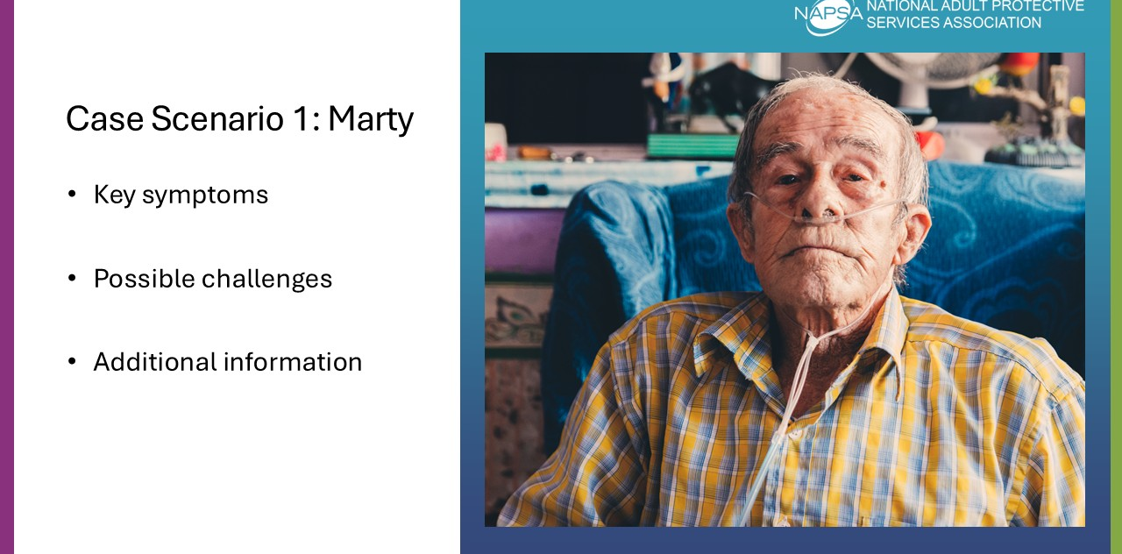
Do: Review case scenario 1 as a group (case scenarios located in Appendix A). Be sure to provide additional information on each medical condition that wasn’t otherwise covered by the group (information provided).
Chronic Obstructive Pulmonary Disorder (COPD)
- Key Symptoms: Symptoms include shortness of breath, coughing, wheezing, mucous production, and chest tightness. People with COPD may experience exacerbations, which are episodes of their symptoms becoming worse than the usual day-to-day experience.
- Possible Challenges: Shortness of breath, fatigue, low energy, and mobility limitations could make routine activities and ADLs difficult to accomplish. Medication management could include keeping track of inhalers, oxygen therapy, and multiple prescriptions.
- Additional Information: COPD occurs in eleven percent of older adults. Two conditions are the primary forms of COPD, emphysema and chronic bronchitis. COPD makes it difficult to breathe. People with COPD are at increased risk of developing heart disease, lung cancer, and several other conditions.
Slide 23: Case Scenario 2: Gloria
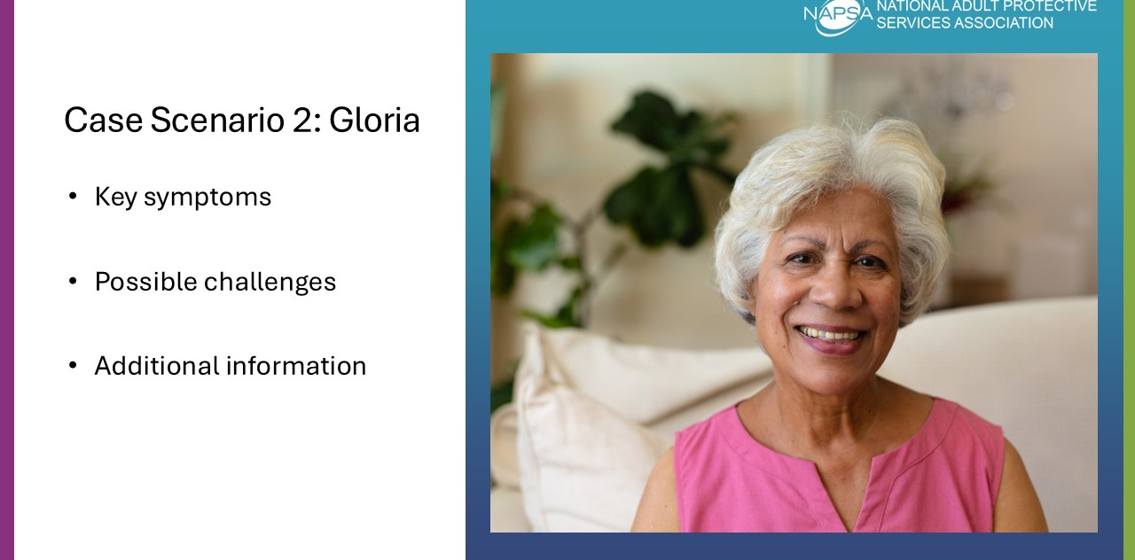
Do: Review case scenario 2 as a group. Be sure to provide additional information on each medical condition that wasn’t otherwise covered by the group (information provided).
Diabetes -Type 2
- Key Symptoms: Increased thirst, frequent urination, extreme hunger, unexplained weight loss, fatigue, irritability, blurred vision, slow-healing sores, and frequent infections.
- Possible Challenges: Careful dietary management is required (will need to limit certain foods, keep blood sugar balanced). Medication management (remembering to take oral medications or insulin at the right time/doses) and monitoring blood sugar can be difficult (in particular, with vision changes). Because of increased infection and slow-healing sores, minor cuts and illnesses can become more serious. May experience fatigue, dizziness, or weakness that can interfere with their ability to complete ADLs.
- Additional Information: Diabetes is a group of diseases marked by high levels of blood glucose resulting from defects in insulin production, insulin action, or both. A little over one out of every four people 65 years of age and older has a diagnosis of diabetes.
- Diabetes is often categorized as Type 1 (genetic) or Type 2 (resulting from lifestyle changes). Diabetes occurs when the body is resistant to, or doesn’t produce enough, insulin. Insulin is what the body uses to get energy from food and distribute it to the cells. When this doesn’t occur, a person will get high blood sugar, which can lead to significant complications like kidney disease, heart disease, or blindness.
Slide 24: Case Scenario 3: Lee
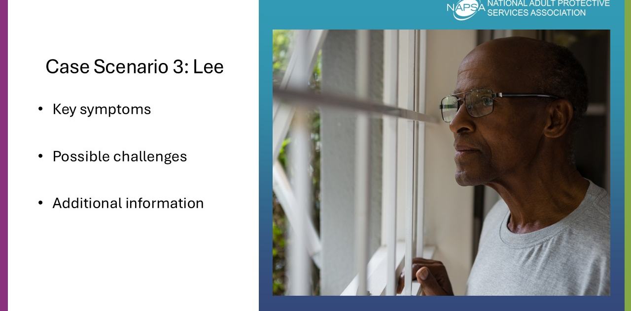
Do: Review case scenario 3 as a group. Be sure to provide additional information on each medical condition that wasn’t otherwise covered by the group (information provided).
Group 3 (Lee): Arthritis
- Key Symptoms: Symptoms include pain, stiffness, swelling, redness, and decreased range of motion.
- Possible Challenges: Severe arthritis, particularly if it affects the hands or arms, can make it difficult for the older adult to do necessary daily tasks such as cooking, cleaning, or even getting dressed. When arthritis affects weight-bearing joints like the knees, the older adult may find difficulty with walking comfortably.
- Additional information: Almost half of adults 65 or older have some form of arthritis, according to the CDC. Arthritis is more common in people with other chronic conditions, such as obesity, diabetes, and heart disease.
- Arthritis is not a single disease (there are more than 100 different types).
  - Osteoarthritis is the most common type, and the risk increases as we age. It is a degenerative joint disease marked by the breakdown of the joint’s cartilage and happens most frequently in the hands, hips, and knees.
  - Rheumatoid arthritis, gout, and fibromyalgia are other common forms of arthritis.

Slide 25: Medical Conditions and APS
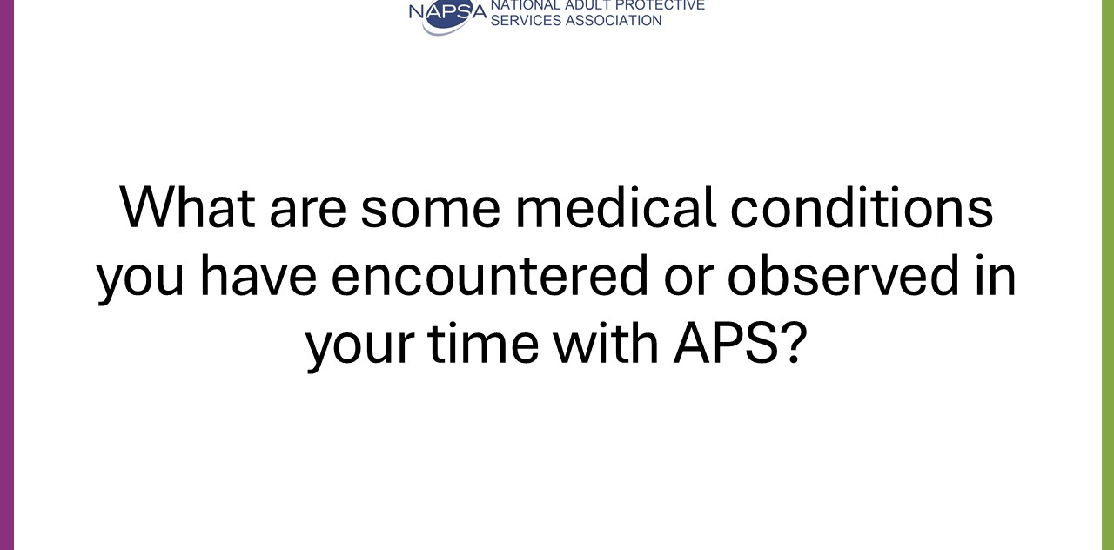
Say: These case scenarios only cover a few medical conditions you may encounter in APS.
Ask: What are some medical conditions you have encountered or observed in your time with APS?
Engage in a brief group discussion on common medical conditions the participants may have encountered in APS. Follow up with questions about how the medical condition may have impacted the investigation or service planning.
Say: Chances are, you will encounter one you may have no familiarity with. When that happens, it can be helpful to do some quick research using reliable sources to get a general understanding of the medical condition. Again, we are not medical professionals and should not be providing medical advice. However, having a general familiarity may help you with setting expectations and possible service planning considerations. Depending on the situation, you may consider consulting with the client’s medical provider, especially if there are concerns that could impact safety or care.

Cognitive, Psychological, and Sociological Changes
Time: 30 minutes
Associated Objective:
- Identify how typical changes that affect the aging process can reduce or cause risk for an older adult.
Facilitation Instructions: Follow the talking points and associated prompts.
Tools: PowerPoint Presentation, participant guide, group discussion

Slide 26: Introduce Cognitive, Psychological, and Sociological Changes in Aging
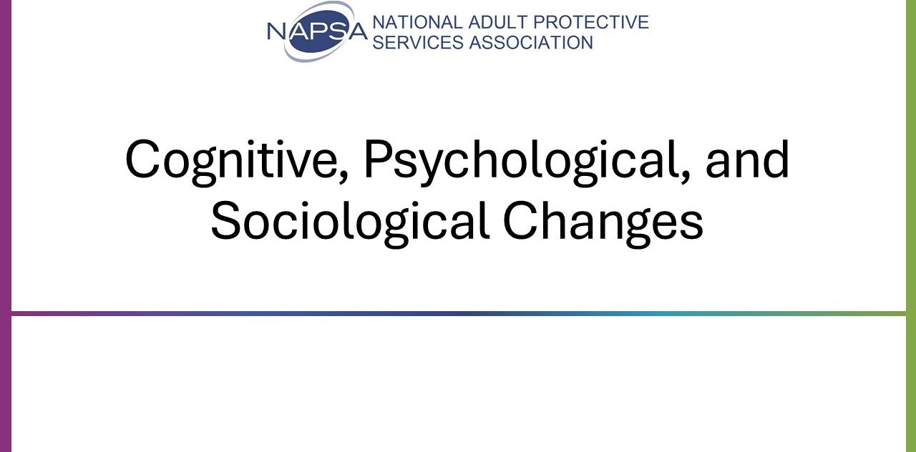
Say: Now that we have a better understanding of some of the physical changes that happen as we age, let’s discuss some of the other changes. We will take a look at cognitive changes, psychological changes, and finally, sociological changes.

Activity 1: Cognitive Changes
Time: 10 minutes
Method: Group discussion
Slide 27: Cognitive Changes
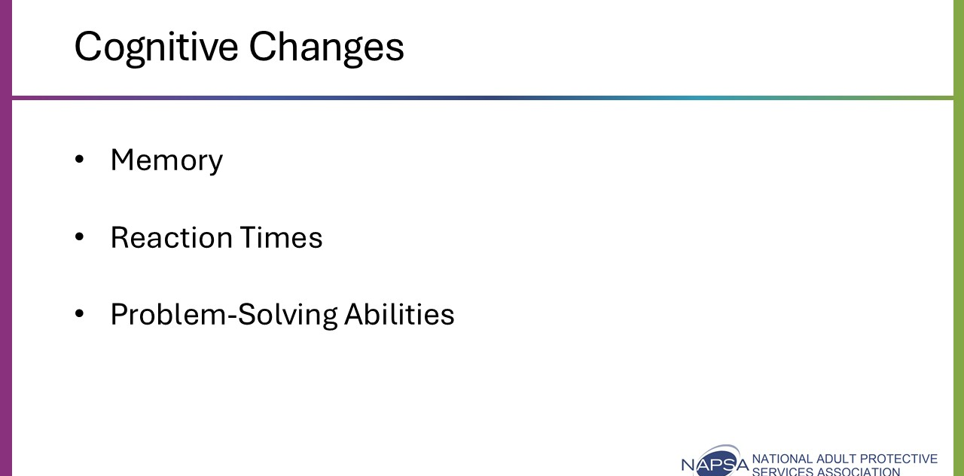
Say: For most older adults, cognitive changes are mild and do not have much of an impact on their daily lives. Unless there is an underlying medical condition, our cognition stays relatively stable throughout our lifespan.
- Memory: As people age, short-term memory does decrease, but long-term memory can improve. This is why some older adults may have a much easier time remembering something that happened decades prior than events that occurred during the last week. Though most people experience a decrease in their thinking and cognitive processing abilities as they age, these changes are generally mild and don't significantly affect their daily lives. Older adults are capable of learning new skills, even at the very late stages of life.
- Reaction Times and Problem-Solving Abilities: As we age, the speed at which our brain encodes, stores, and retrieves information slows. This is not to say that older adults are less intelligent. When older adults take intelligence tests that utilize accumulated knowledge and experience, many older adults will do better than younger adults.

Slide 28: Areas that Remain the Same Through Aging
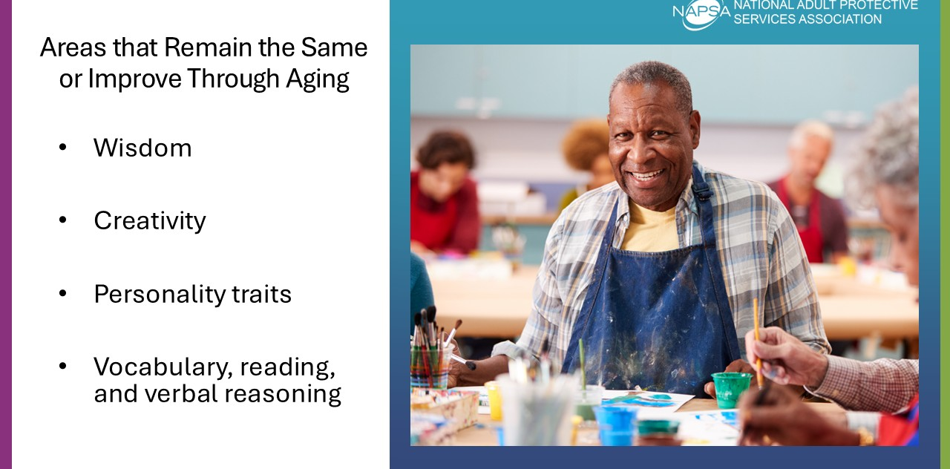
Say: Did you know there are several other areas that remain the same or improve throughout the aging process, including:
- Wisdom
- Creativity
- Personality traits
- Vocabulary, reading, and verbal reasoning
As APS professionals, we should expect an older adult’s cognitive abilities to be similar to what they had earlier in life. If we notice changes that seem unusual or new, the person should be referred to a medical provider for an assessment. These changes could be caused by a temporary issue, like delirium, or a chronic condition, like a neurocognitive disorder.

Activity 2: Psychological Changes
Time: 10 minutes
Method: Group discussion
Slide 29: Psychological Changes
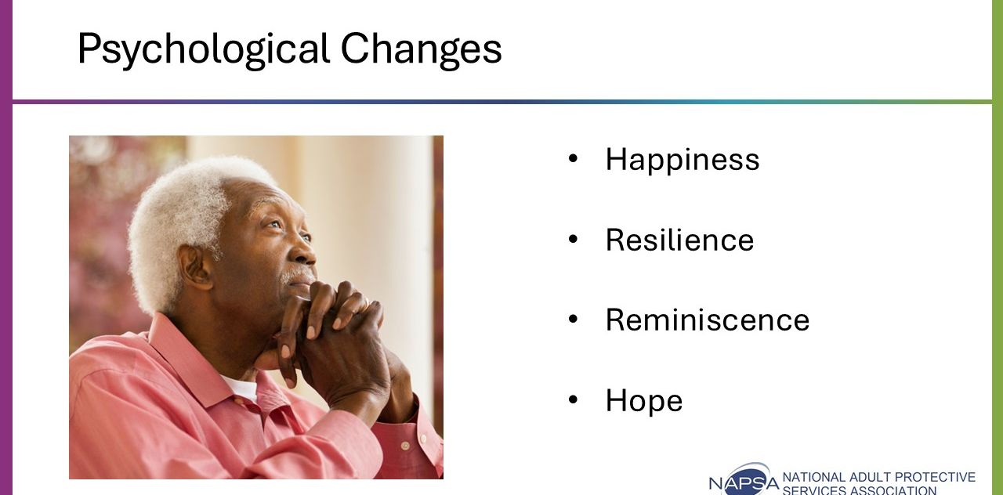
Say: Unless the older adult is experiencing an acute mental health condition, a person's psychological makeup is likely similar to what they've already experienced when they were younger. The older adult's psychological makeup may even help them manage their current circumstances more than when they were younger.
Let’s look at four psychological attributes that are important in aging and our work in APS.
Discuss the four psychological attributes (happiness, resilience, reminiscence, and hope) by asking the following questions:
Ask: How do older adults cope with adverse situations like experiencing abuse, neglect, or exploitation (ANE) and maintain a positive mindset? (Happiness)
Possible answers: Strong social connections with family and friends, or through volunteering and community clubs or events, older adults may look to find positivity in a situation, even when ANE has occurred.
Ask: How can we draw on an older adult’s history of successfully navigating change when service planning? (Resilience)
Possible answers: Stay person-centered and strength-based, ask the person how they overcame obstacles in the past, draw on past events where a similar need to change has occurred, and allow time for decision-making.
Ask: What role does reminiscence play in an older adult’s coping skills? (Reminiscence)
Possible answers: Allows them to seek understanding and validation for past life decisions when sharing, reinforces dignity and worth, allows us to get a better understanding of the person, allows reflection on prior decisions and how these shape current situation.
Ask: What role does hope play in navigating change to improve quality of life? (Hope)
Possible answers: Hope looks toward a positive outcome even in times of uncertainty, reduces depression and anxiety, and older adults tend to focus on the most positive outcome possible despite challenges rather than trying to change external factors.

Activity 3: Sociological Changes
Time: 10 minutes
Method: Group discussion
Slide 30: Sociological Changes
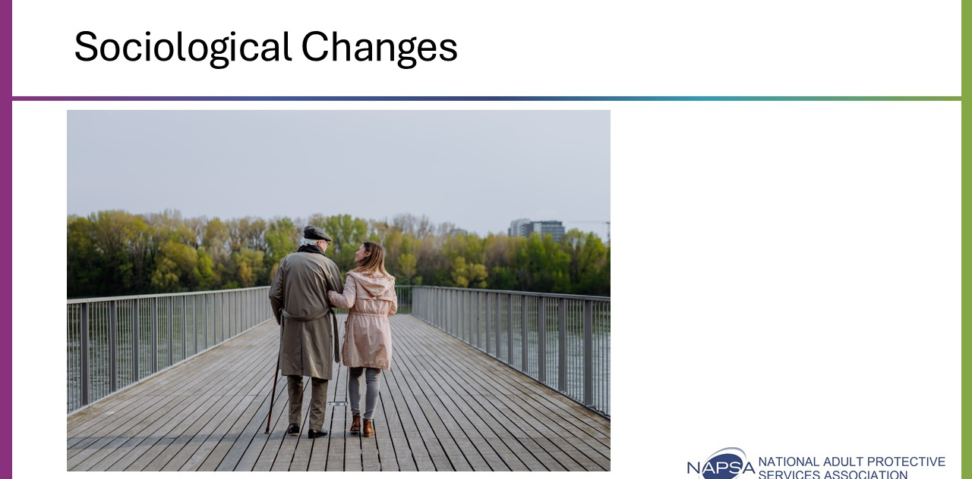
Say: There are sociological changes that occur during aging that affect our work in APS. These changes are not universally true for all older adults. You need to be alert to when they do occur, as they can impact your APS interventions.

Slide 31: Shifting Roles
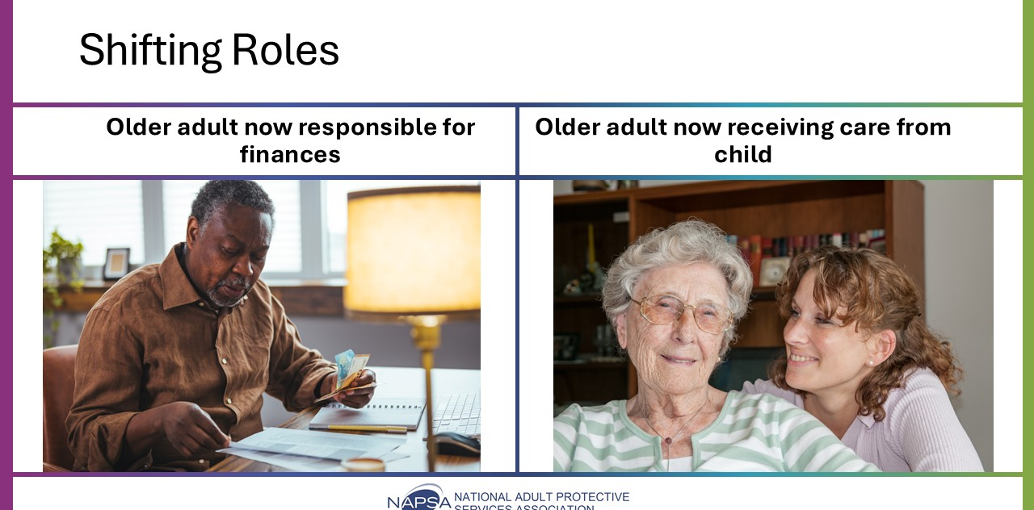
Say: Roles in life can change over time. Some examples of these shifting roles include:
Older Adult Now Responsible for Finances
- Be alert to risks such as scams or financial exploitation
- Approach without judgment and offer education on scams, or consider offering services that support the management of their finances.
Older Adult Now Receiving Care from Child
- Explore how the role change is affecting both the older adult and the caregiver.
- Identify any stress points and explore possible services to connect families with additional support, as needed.
Ask: How can older adults adapt to giving up long-held roles within their family due to the aging process?
Possible answers: Find other avenues to maintain independence, driving assistance or ride share, assistance with chores, connection with other adults, community involvement, finding ways for the older adult to contribute to family to maintain engagement and sense of independence.

Slide 32: Socialization
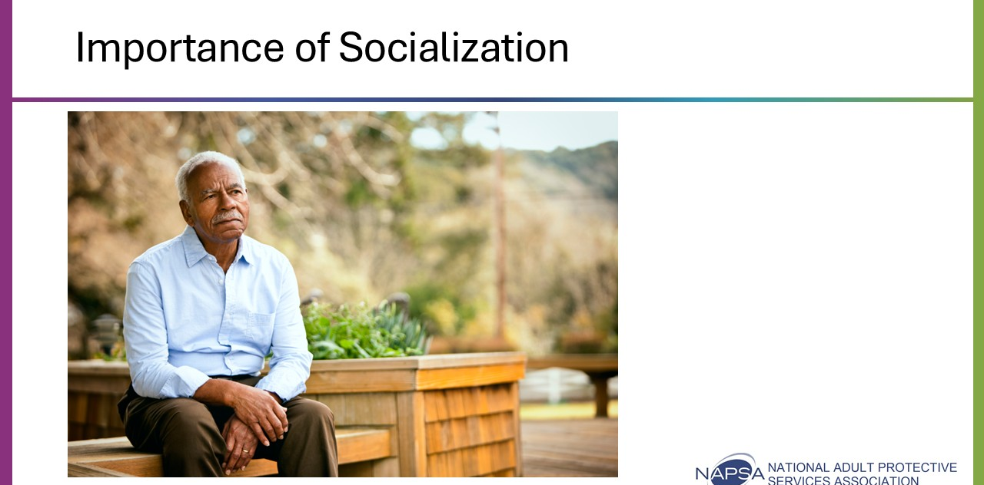
Say: Many older adults maintain active social lives. Others may find that their socialization has diminished or at least changed as they have become older.
Social isolation is a significant issue not only because it increases vulnerability to experiencing abuse, neglect, or exploitation, but also because it impacts several health issues, including:
- Changes in health conditions and changes in living can be missed.
- Limited support for tasks such as medication management, transportation, and meals.
APS considerations should include:
- Always assess an older adult’s social network during investigations.
- Incorporate supportive relationships into person-centered service planning.
- Recognize challenges when:
  - An older adult has long-term voluntary isolation.
  - A perpetrator has isolated the older adult through undue influence.
Utilizing social relationships with people who have the older adult’s best interest in mind is critical to an effective person-centered service plan in APS.
Slide 33: Grief-Related Challenges
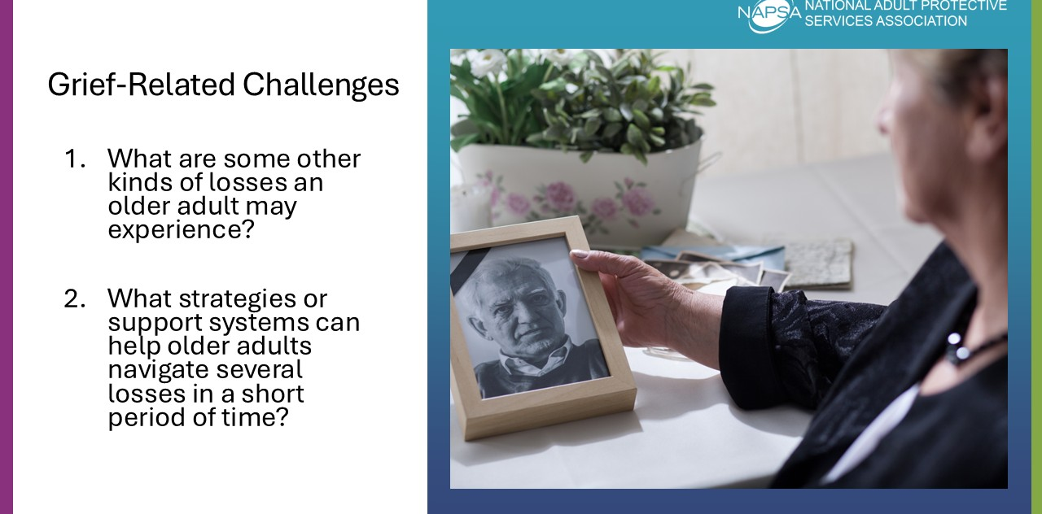
Say: Many older adults experience multiple losses over a short period. Losses come in many forms; not all are readily acknowledged in broader society.
For example, the death of a partner may activate changes that create other losses, such as loss of financial security, loss of shared experiences and friendships, and loss of social contacts.
Age-related changes or stresses can impact older adults and lead to feelings of grief and loss.
Do: In a large group, discuss the grief-related challenges and answer the following questions:
Ask: What are some other kinds of losses an older adult may experience?
Possible answers: Changes in health, pain or disability, loss of driving privileges, retirement, income or housing changes, changes in physical appearance, sensory decline, mobility limitation.
Ask: What strategies or support systems can help older adults navigate several losses in a short period of time?
Possible answers: Relying on existing support systems such as family or friends, seeking out and engaging in new community activities, looking at coping skills used in the past when dealing with loss, etc.
Discuss any local or online resources that staff can share with clients who are experiencing grief.

Considerations for Service Planning
Time: 60 minutes
Associated Objective:
- Create service plans that leverage an adult’s strengths.
Facilitation Instructions: Follow the talking points and associated prompts. Prepare for breakout room activity.
Tools: PowerPoint Presentation, participant guide, breakout groups, case scenarios

Activity 1: Strength-Based Service Planning with Older Adults
Time: 15 minutes
Method: Group discussion, Case Scenario, Handout
Slide 34: Considerations for Service Planning
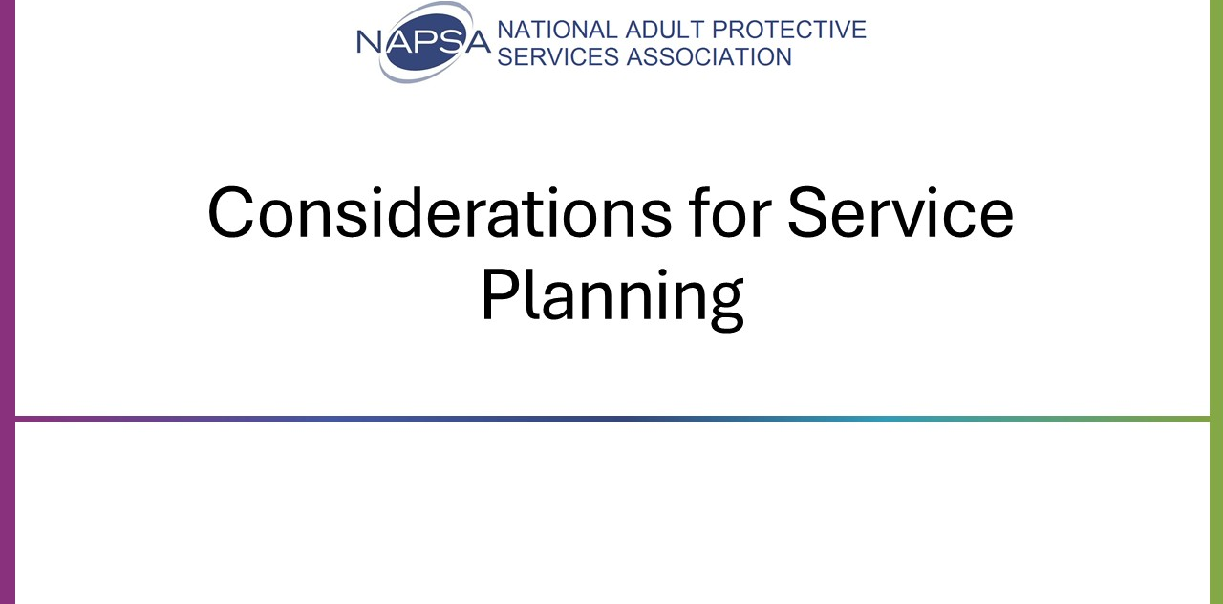
Say: Adopting a strength-based perspective can make all the difference when working with older adults APS. This shifts the focus from what’s ‘wrong’ to what’s ‘strong.’ This is particularly important considering our earlier discussion on ageism.
Despite the adverse situations that older adults working with APS often face, they have gained strengths from the aging process. Considering these strengths can help with building a strength-based service plan.

Slide 35: Identifying Strengths in Aging
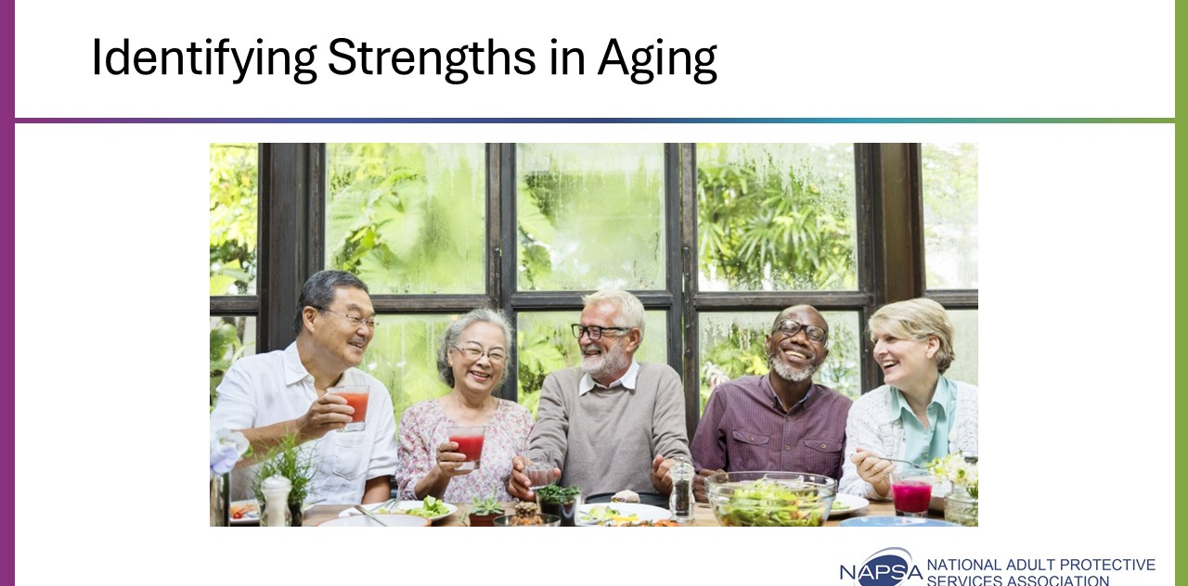
Ask: What are some strengths we often see with older adults?
Possible answers: Resiliency, improved emotional skills and experience, happiness/positivity, high levels of emotional empathy, lower perceived stress and daily well-being, improved reasoning and problem-solving, and satisfaction with social relationships.
Acknowledge that not every older adult has all or any of these strengths because of their aging process. Factors such as a strong social network, financial stability, experiences with trauma, and physical health can affect these outcomes. Each person is unique and has their own strengths to offer.

Slide 36: Strength-Based Service Planning
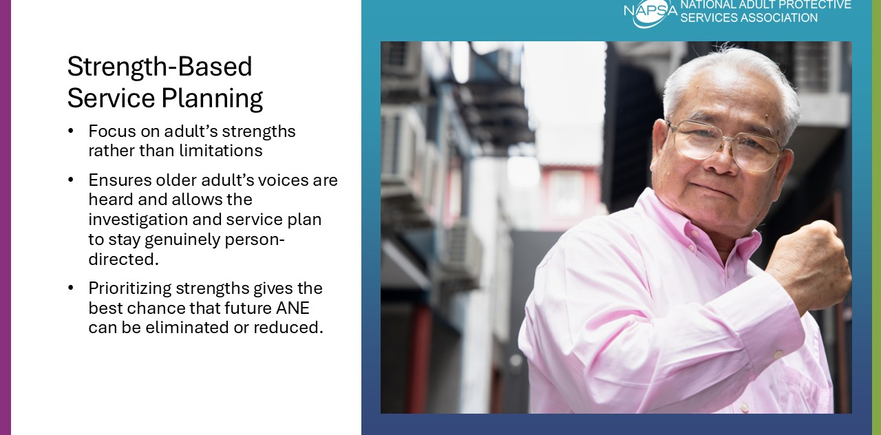
Say: When an APS professional focuses on an older adult’s strengths rather than limitations, we are more likely to ensure that older adults' voices are heard and to allow the investigation and service planning to stay genuinely person-centered.
We do not ignore issues or challenges that result from aging for older adults. Instead, we prioritize their strengths to give the best chance that future abuse, neglect, or exploitation risks can be eliminated or reduced.
In this next activity, we will practice doing just that and pull everything we have learned together.

Activity 2: Case Scenario Activity
Time: 45 minutes
Method: Breakout groups, Case Scenario, Handout
Slide 37: Case Scenario Activity: Service Planning (Breakout Groups)
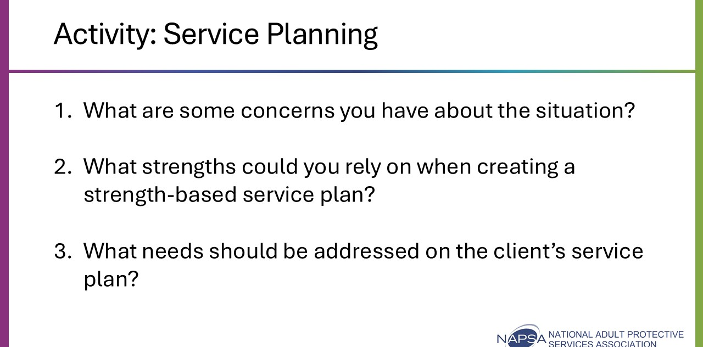
Say: For this activity, you will be returning to your groups to continue discussing your previously assigned case scenario (Marty, Gloria, or Lee). However, this time, you will be provided with additional information and will have a different set of questions to discuss. The questions can be found in your participant guide, along with the full case scenario, and will involve the following topics:
- Concerns
- Strengths
- Service Planning Considerations
You will be given 10 minutes to discuss. Be sure to designate a new spokesperson because when we come back, each group will be asked to summarize their discussions.
Do: After 10 minutes, close out the breakout groups. Allow each spokesperson to share some highlights from their discussion (about 10 minutes per case scenario).
Trainer Note: The trainer's copy of the case scenario handout (Appendix B) includes possible answers to each question, which may help generate discussion if participants are having difficulties with any of the scenarios or questions.

Slide 38: Case Scenario 1: Marty
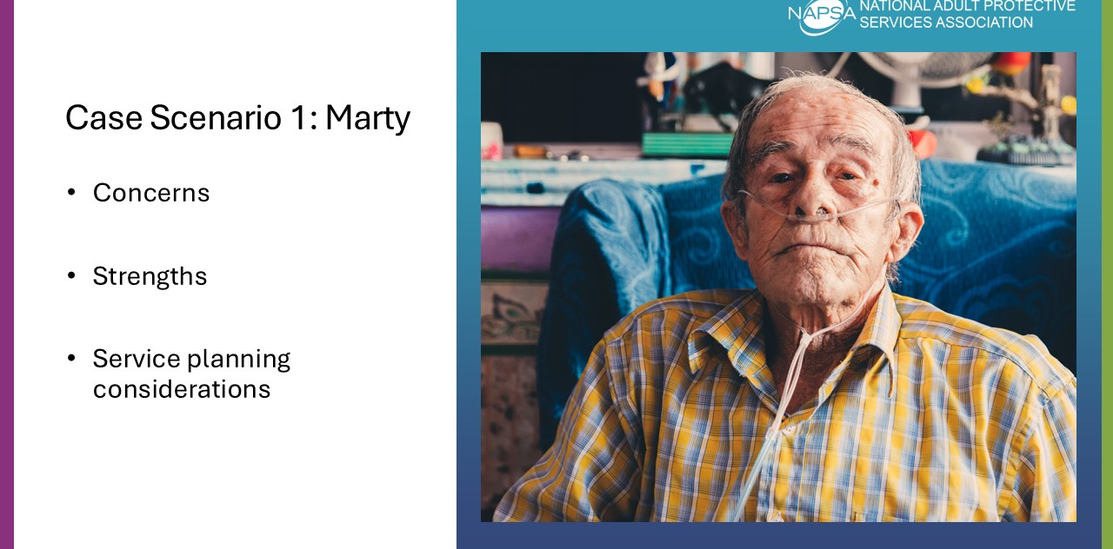
Do: Review each of the three questions for the case scenario as a group. Some suggested answers are provided below for each one:
Question 1 (Concerns): Missing doctor appointments, not refilling medications, and not managing COPD symptoms. Increased shortness of breath, fatigue, and history of falls, which may indicate worsening COPD or other health issues. Possible unresolved grief after his wife’s death, which may contribute to low motivation and depression. Difficulty managing bills and daily routines that were previously handled by his spouse. Hesitancy to ask for help from his children, increasing the risk of further decline and loneliness.
Question 2 (Strengths): He has two children who visit frequently and are willing to help. He recognizes his challenges and is able to communicate about them. Desire to manage on his own can be reframed into collaborative goal-setting. Previously consistent routines, like daily coffee with his friend, indicate potential to rebuild engagement.
Question 3 (Service Planning Considerations):Scheduling appointments with his primary care provider, COPD management education, and ensuring access to medications. Reduce fall risks, organize bills and medication, and possibly provide assistance with household tasks. Grief counseling or support groups to address ongoing loss. Encourage his children to participate in care planning in ways that respect his independence.

Slide 39: Case Scenario 2: Gloria
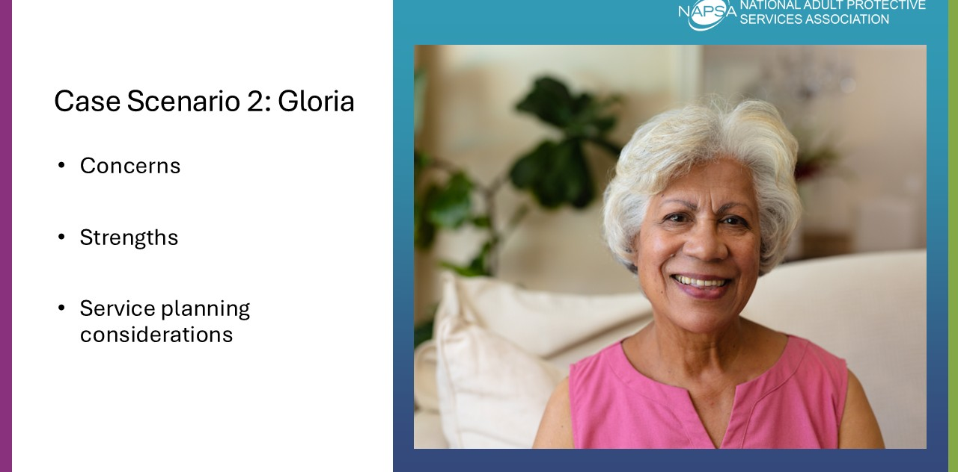
Do: Review each of the three questions for the case scenario as a group. Some suggested answers are provided below for each one:
Question 1 (Concerns): Concerns related to diabetes management including missing blood sugar checks, skipping meals, and not taking medications consistently. Small foot sore (risk for infection or ulceration), poor nutrition, vision difficulties affecting medication management. Living alone with limited support; possible risk for falls or complications from diabetes. Unmet needs despite the presence of a willing caregiver due to Gloria’s hesitancy to accept help. Forgetfulness around medications and meal preparation.
Question 2 (Strengths): Motivation from faith and church community since Gloria has a support network and values social engagement through her church. She is open about her challenges and able to articulate her needs. Gloria has a daughter who is actively trying to provide support. Independence and desire to manage her own life: Can be framed positively in planning support without undermining autonomy.
Question 3 (Service Planning Considerations): Scheduling appointments with her primary care provider and diabetes educator. Assistance with blood sugar monitoring and medication management. Nutrition support that allows Gloria to remain involved in meal planning while reducing fatigue. Foot care and vision support. Education and support for both Gloria and Sandra on navigating changing family roles and accepting help in ways that preserve dignity. Check for fall risks, clutter, or other hazards. Encouraging engagement with church or community programs to build social support.

Slide 40: Case Scenario 3: Lee
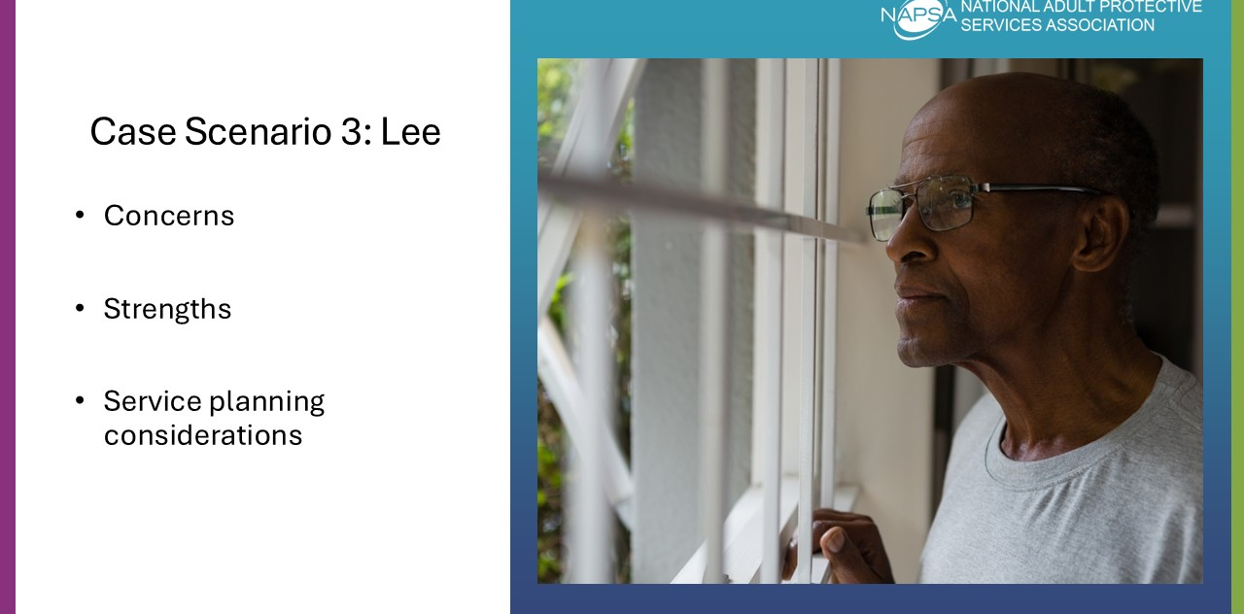
Do: Review each of the three questions for the case scenario as a group. Some suggested answers are provided below for each one:
Question 1 (Concerns): Difficulty cooking, cleaning, and performing personal care due to arthritis. Pain management issues including skipping medications because of side effects, leading to potential worsening of mobility and quality of life. Cluttered home, limited mobility, and risk of falls. Difficulty standing, walking, and using hands for everyday tasks. Reduced social engagement and withdrawal from previously enjoyed activities. Partner’s unrealistic expectations, which may contribute to unmet needs, increased stress, and potential neglect.
Question 2 (Strengths): Enjoys reading and listening to music, which can be used to engage him in programs or therapeutic activities. Presence of a live-in partner, indicating potential support if expectations and understanding can be addressed. Strong motivation to maintain autonomy, which can guide collaborative planning. Recognizes mobility issues and pain, which can help in accepting interventions if framed respectfully.
Question 3 (Service Planning Considerations): Education and support for both Lee and his partner regarding arthritis, functional limitations, and realistic expectations. Reduce fall hazards, consider assistive devices or home modifications. Review medications with his medical provider, explore alternatives for side effects, and provide tools to open pill bottles. Help with cleaning, meal preparation, and laundry, possibly through home health services or community programs. Referral to physical therapy to maintain strength and flexibility, and safe ways to use mobility aids. Encourage participation in senior center or community programs, possibly with transportation support. .

Wrap-Up
Time: 20 minutes
Associated Objectives: N/A
Purpose: Identify how to apply knowledge gained from the training to casework practice.
Facilitation Instructions: Follow the talking points and associated prompts.
Tools: PowerPoint Presentation, participant guide, group discussion
Slide 41: Key Points
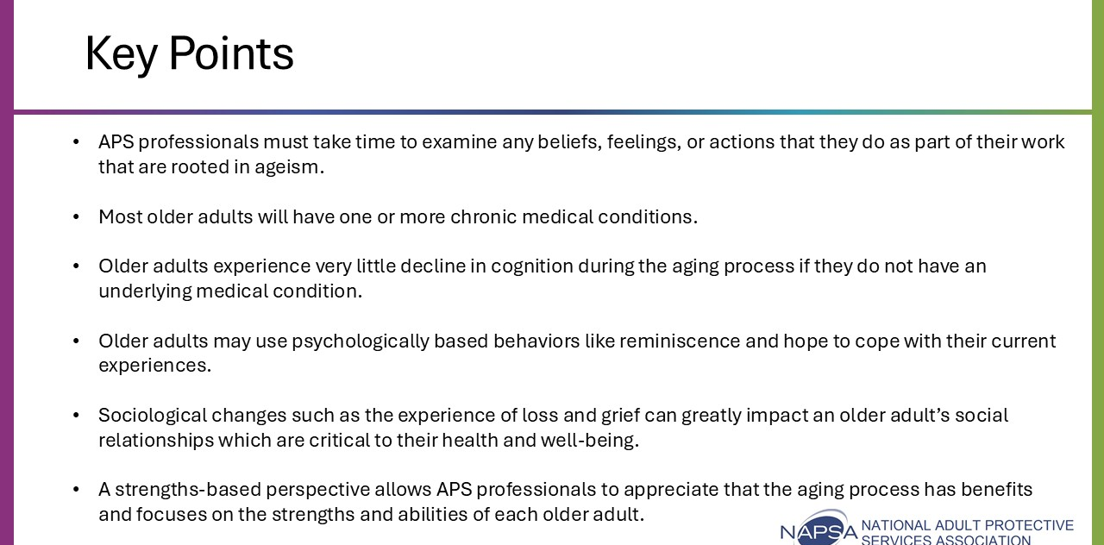
Summarize key points from the training, including:
- APS professionals must take time to examine any beliefs, feelings, or actions that they do as part of their work that are rooted in ageism.
- Most older adults will have one or more chronic medical conditions.
- Older adults experience very little decline in cognition during the aging process if they do not have an underlying medical condition.
- Older adults may use psychologically based behaviors like reminiscence and hope to cope with their current experiences.
- Sociological changes, such as the experience of loss and grief, can greatly impact an older adult’s social relationships, which are critical to their health and well-being.
- A strengths-based perspective allows APS professionals to appreciate that the aging process has benefits and focuses on the strengths and abilities of each older adult.

Activity 1: P-I-E Wrap-Up
Time: 15 minutes
Method: Personal reflection, group discussion
Slide 42: P-I-E Wrap-Up
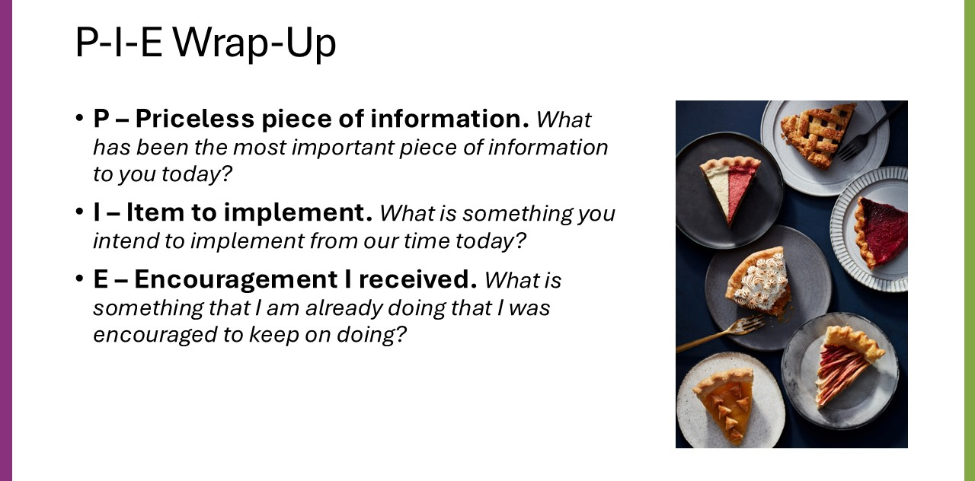
Say: Based on what we have talked about during our time together, I want you to answer a few questions.
- P – Priceless piece of information. What has been the most important piece of information to you today?
- I – Item to implement. What is something you intend to implement from our time today?
- E – Encouragement I received. What is something that I am already doing that I was encouraged to keep on doing?
You have 5 minutes to answer the questions on your own.
Do: Once complete, ask for volunteers to share what they wrote down. Request the participants to use the “Raise Hand” feature to volunteer to speak.
Use the following questions for debrief:
- What were some of the key words that you heard while you shared?
- What were the common themes that kept coming up?

Slide 43: Thank you!
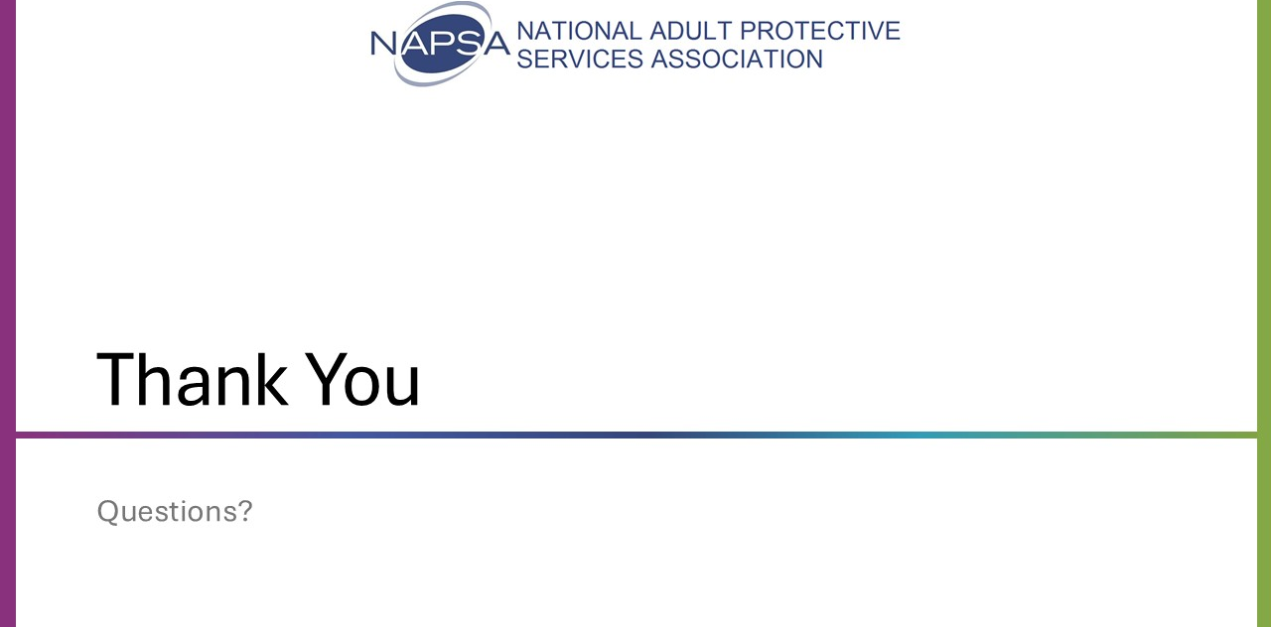
Say: Thank you for your time and participation today with such an important topic.

Appendix A: Medical Conditions Activity

Case Scenario 1: Marty
APS receives a report on a 72-year-old. White man, Marty, with Chronic Obstructive Pulmonary Disorder. Report from his friend, alleges he may be experiencing self- neglect as he believes Marty is not taking care of himself.
Marty’s wife of 48 years passed away six months ago, and his “health has declined” since that time. He has not been going to his doctor’s appointments and has missed coffee (reporting party says they have been having coffee for years, and he has never missed a day until recently). He just “doesn’t seem like himself”. According to the reporting party, Marty has COPD and seems to be having more trouble breathing lately. When the reporting party asked him about his health, he stated he hadn’t “had time” to go to the doctor or refill his medications. Reporting party thinks Marty may be grieving still and lacks desire to take care of himself like he used to now that his wife is gone.

Case Scenario 2: Gloria
APS receives a report on a 69-year-old Hispanic woman, Gloria, who has type 2 diabetes. The report, made by her church friend, worries that Gloria is not managing her diabetes well and seems to be having trouble caring for herself. The friend shared that Gloria has been “forgetting things,” seems more fatigued lately, and has missed several church activities she once attended regularly.
Gloria is divorced and lives with her adult daughter, Sandra, who moved in several months ago. According to the reporting party, Gloria has not been checking her blood sugar regularly and sometimes skips meals. The friend also noted Gloria has mentioned trouble reading the small print on her medication bottles and occasionally forgets whether she has already taken her pills.

Case Scenario 3: Lee
APS receives a report regarding Lee, a 79-year-old Black man, who may be experiencing self-neglect due to difficulties managing his arthritis. The report comes from a neighbor who has noticed that Lee has been moving more slowly, seems to be in pain frequently, and has not been leaving his home as much as he used to. The neighbor also reports that Lee’s mail is piling up and his lawn is overgrown.

Appendix B: Case Scenario Activity (Trainer Copy)
Case Scenario 1: Marty
APS receives a report on a 72-year-old. White man, Marty, with Chronic Obstructive Pulmonary Disorder. Report from his friend, alleges he may be experiencing self- neglect as he believes Marty is not taking care of himself.
Marty’s wife of 48 years passed away six months ago, and his “health has declined” since that time. He has not been going to his doctor’s appointments and has missed coffee (reporting party says they have been having coffee for years, and he has never missed a day until recently). He just “doesn’t seem like himself”. According to the reporting party, Marty has COPD and seems to be having more trouble breathing lately. When the reporting party asked him about his health, he stated he hadn’t “had time” to go to the doctor or refill his medications. Reporting party thinks Marty may be grieving still and lacks desire to take care of himself like he used to now that his wife is gone.
You visit Marty and note the following: His home is cluttered, and he appears disheveled himself. He struggles to breathe when walking around his home and tells you about his COPD. He has old medication bottles on the counter that appear empty, and you note piles of what appear to be bills there as well. When you ask him about his medications, he says he hasn’t had time to go to the doctor lately to get them refilled.
When you point out the bills he tells you his wife handled the finances and he is overwhelmed with the thought of paying bills.
He tells you he has two children who visit him frequently and they have offered to help, but he cannot bear to ask them to do so. He doesn’t want to burden them and feels he can handle things on his own.
Discussion Questions:
- What are some of the concerns you note from the information presented on Marty?
Possible Answers: Missing doctor appointments, not refilling medications, and not managing COPD symptoms. Increased shortness of breath, fatigue, and history of falls, which may indicate worsening COPD or other health issues. Possible unresolved grief after his wife’s death, which may contribute to low motivation and depression. Difficulty managing bills and daily routines that were previously handled by his spouse. Hesitancy to ask for help from his children, increasing the risk of further decline and loneliness.
- What are some strengths that you could rely on when creating a strength-based service plan?
Possible Answers: He has two children who visit frequently and are willing to help. He recognizes his challenges and is able to communicate about them. Desire to manage on his own can be reframed into collaborative goal-setting. Previously consistent routines, like daily coffee with his friend, indicate potential to rebuild engagement.
- What needs to be addressed on Marty’s service plan, assuming he is willing to accept help and referrals?
Possible Answers: Scheduling appointments with his primary care provider, COPD management education, and ensuring access to medications. Reduce fall risks, organize bills and medication, and possibly provide assistance with household tasks. Grief counseling or support groups to address ongoing loss. Encourage his children to participate in care planning in ways that respect his independence.

Case Scenario 2: Gloria
APS receives a report on a 69-year-old Hispanic woman, Gloria, who has type 2 diabetes. The report, made by her church friend, worries that Gloria is not managing her diabetes well and seems to be having trouble caring for herself. The friend shared that Gloria has been “forgetting things,” seems more fatigued lately, and has missed several church activities she once attended regularly.
Gloria is divorced and lives with her adult daughter, Sandra, who moved in several months ago. According to the reporting party, Sandra tries to help, but Gloria has always been in the caregiver role and has a difficult time accepting help from others, even if she is struggling. Additionally, the friend mentioned concerns that Gloria has not been checking her blood sugar regularly and will sometimes skips meals. The friend also noted Gloria has mentioned trouble reading the small print on her medication bottles and occasionally forgets whether she has already taken her pills.
When you visit Gloria, you observe the following: Her kitchen contains mostly processed and packaged foods, with few fresh items. She reports her vision has been getting worse, and she sometimes has trouble seeing her glucose monitor. You also notice she is wearing slippers indoors but has no socks on, despite having a small sore on her foot. When asked about it, she says it doesn’t hurt and “will heal on its own.” Gloria mentions her daughter lives with her, but Gloria doesn’t want to “bother her with problems.” She tells you her faith is very important to her, and her church community is “like family.”
Discussion Questions:
- What are some of the concerns you note from the information presented on Gloria?
Possible answers: Concerns related to diabetes management including missing blood sugar checks, skipping meals, and not taking medications consistently. Small foot sore (risk for infection or ulceration), poor nutrition, vision difficulties affecting medication management. Living alone with limited support; possible risk for falls or complications from diabetes. Unmet needs despite the presence of a willing caregiver due to Gloria’s hesitancy to accept help. Forgetfulness around medications and meal preparation.
- What strengths could you rely on when creating a strength-based service plan?
Possible answers: Motivation from faith and church community since Gloria has a support network and values social engagement through her church. She is open about her challenges and able to articulate her needs. Gloria has a daughter who is actively trying to provide support. Independence and desire to manage her own life: Can be framed positively in planning support without undermining autonomy.

- What needs should be addressed on Gloria’s service plan, assuming she is willing to accept help and referrals?
Possible answers: Scheduling appointments with her primary care provider and diabetes educator. Assistance with blood sugar monitoring and medication management. Nutrition support that allows Gloria to remain involved in meal planning while reducing fatigue. Foot care and vision support. Education and support for both Gloria and Sandra on navigating changing family roles and accepting help in ways that preserve dignity. Check for fall risks, clutter, or other hazards. Encouraging engagement with church or community programs to build social support.

Case Scenario 3: Lee
APS receives a report regarding Lee, a 79-year-old Black man, who may be experiencing self-neglect related to difficulties managing his arthritis. The report comes from a neighbor who has noticed that Lee has been moving more slowly, appears to be in pain frequently, and has not been leaving his home as much as he used to. The neighbor also reports that Lee’s mail is piling up and the lawn is overgrown.
During your visit, you learn that Lee lives with his long-term partner, Sam, who is 68 years old and in generally good health. You observe the home to be cluttered, with laundry and dishes stacked on counters. Lee reports that arthritis in his hands, knees, and hips makes it difficult for him to cook, clean, and complete other daily tasks. Lee struggles to stand from his chair without support and grimaces while walking short distances. Lee states that he avoids using his walker because he feels like it makes him appear frail. Lee will often skip his medications prescribed for pain management because he dislikes the side effects. Lee shares that he enjoys reading and listening to jazz music, which helps him cope with stress, but he has stopped attending activities at the local senior center because the building is difficult to navigate with his limited mobility.
Sam believes Lee should “push through the pain” and continue doing things the way he always has, stating that slowing down or using help will only make Lee “weaker.” Sam appears attentive but repeatedly states that Lee “just needs to try harder” to pull his weight with keeping the house tidy.
Discussion Questions:
- What are some of the concerns you note from the information presented on Lee?
Possible Answers: Difficulty cooking, cleaning, and performing personal care due to arthritis. Pain management issues including skipping medications because of side effects, leading to potential worsening of mobility and quality of life. Cluttered home, limited mobility, and risk of falls. Difficulty standing, walking, and using hands for everyday tasks. Reduced social engagement and withdrawal from previously enjoyed activities. Partner’s unrealistic expectations, which may contribute to unmet needs, increased stress, and potential neglect.
- What strengths could you rely on when creating a strength-based service plan?
Possible Answers: Enjoys reading and listening to music, which can be used to engage him in programs or therapeutic activities. Presence of a live-in partner, indicating potential support if expectations and understanding can be addressed. Strong motivation to maintain autonomy, which can guide collaborative planning. Recognizes mobility issues and pain, which can help in accepting interventions if framed respectfully.
- What needs should be addressed on Lee’s service plan, assuming he is willing to accept help and referrals?
Possible Answers: Education and support for both Lee and his partner regarding arthritis, functional limitations, and realistic expectations. Reduce fall hazards, consider assistive devices or home modifications. Review medications with his medical provider, explore alternatives for side effects, and provide tools to open pill bottles. Help with cleaning, meal preparation, and laundry, possibly through home health services or community programs. Referral to physical therapy to maintain strength and flexibility, and safe ways to use mobility aids. Encourage participation in senior center or community programs, possibly with transportation support.

Appendix C: Case Scenario Activity (Participant Copy)

Case Scenario 1: Marty
APS receives a report on a 72 y.o. White man, Marty, with Chronic Obstructive Pulmonary Disorder. Report from his friend, alleges he may be experiencing self- neglect as he believes Marty is not taking care of himself.
Marty’s wife of 48 years passed away six months ago, and his “health has declined” since that time. He has not been going to his doctor’s appointments and has missed coffee (reporting party says they have been having coffee for years and he has never missed a day until recently). He just “doesn’t seem like himself”. According to the reporting party, Marty has COPD and seems to be having more trouble breathing lately. When the reporting party asked him about his health, he stated he hasn’t “had time” to go to the doctor or refill his medications. Reporting party thinks Marty may be grieving still and lacks desire to take care of himself like he used to now that his wife is gone.
You visit Marty and note the following: His home is cluttered, and he appears disheveled himself. He struggles to breathe when walking around his home and tells you about his COPD. He has old medication bottles on the counter that appear empty, and you note piles of what appear to be bills there as well. When you ask him about his medications, he says he hasn’t had time to go to the doctor lately to get them refilled.
When you point out the bills he tells you his wife handled the finances and he is overwhelmed with the thought of paying bills.
He tells you he has two children that visit him frequently and they have offered to help, but he cannot bear to ask them to do so. He doesn’t want to burden them and feels he can handle things on his own.
Discussion Questions:
- What are some of the concerns you note from the information presented on Marty?

- What are some strengths that you could rely on when creating a strength-based service plan?

- What needs to be addressed on Marty’s service plan assuming he is willing to accept help and referrals?

Case Scenario 2: Gloria
APS receives a report on a 69-year-old Hispanic woman, Gloria, who has type 2 diabetes. The report, made by her church friend, worries that Gloria is not managing her diabetes well and seems to be having trouble caring for herself. The friend shared that Gloria has been “forgetting things,” seems more fatigued lately, and has missed several church activities she once attended regularly.
Gloria is divorced and lives with her adult daughter, Sandra, who moved in several months ago. According to the reporting party, Sandra tries to help, but Gloria has always been in the caregiver role and has a difficult time accepting help from others, even if she is struggling. Additionally, the friend mentioned concerns that Gloria has not been checking her blood sugar regularly and will sometimes skips meals. The friend also noted Gloria has mentioned trouble reading the small print on her medication bottles and occasionally forgets whether she has already taken her pills.
When you visit Gloria, you observe the following: Her kitchen contains mostly processed and packaged foods, with few fresh items. She reports her vision has been getting worse, and she sometimes has trouble seeing her glucose monitor. You also notice she is wearing slippers indoors but has no socks on, despite having a small sore on her foot. When asked about it, she says it doesn’t hurt and “will heal on its own.” Gloria mentions her daughter lives with her, but Gloria doesn’t want to “bother her with problems.” She tells you her faith is very important to her, and her church community is “like family.”
Discussion Questions:
- What are some of the concerns you note from the information presented on Gloria?

- What strengths could you rely on when creating a strength-based service plan?

- What needs should be addressed on Gloria’s service plan, assuming she is willing to accept help and referrals?

Case Scenario 3: Lee
APS receives a report regarding Lee, a 79-year-old Black man, who may be experiencing self-neglect related to difficulties managing his arthritis. The report comes from a neighbor who has noticed that Lee has been moving more slowly, appears to be in pain frequently, and has not been leaving his home as much as he used to. The neighbor also reports that Lee’s mail is piling up and the lawn is overgrown.
During your visit, you learn that Lee lives with his long-term partner, Sam, who is 68 years old and in generally good health. You observe the home to be cluttered, with laundry and dishes stacked on counters. Lee reports that arthritis in his hands, knees, and hips makes it difficult for him to cook, clean, and complete other daily tasks. Lee struggles to stand from his chair without support and grimaces while walking short distances. Lee states that he avoids using his walker because he feels like it makes him appear frail. Lee will often skip his medications prescribed for pain management because he dislikes the side effects. Lee shares that he enjoys reading and listening to jazz music, which helps him cope with stress, but he has stopped attending activities at the local senior center because the building is difficult to navigate with his limited mobility.
Sam believes Lee should “push through the pain” and continue doing things the way he always has, stating that slowing down or using help will only make Lee “weaker.” Sam appears attentive but repeatedly states that Lee “just needs to try harder” to pull his weight with keeping the house tidy.
Discussion Questions:
- What are some of the concerns you note from the information presented on Lee?

- What strengths could you rely on when creating a strength-based service plan?

- What needs should be addressed on Lee’s service plan, assuming he is willing to accept help and referrals?

References
Academy for Professional Excellence. (2024). NATC eLearning Facilitator Guide: Aging Process. Retrieved from: https://theacademy.sdsu.edu/programs/apswi/core-competency-areas/natc-elearning-facilitator-guide-aging-process/
American Psychological Association (APA) (2021). Older Adults: Health and Age-Related Changes. Retrieved from: https://www.apa.org/pi/aging/resources/guides/older
Beadle, J. & De la Vega, C (2019). Impact of Aging on Empathy: Review of Psychological and Neural Mechanisms. Front. Psychiatry 10:331. doi: 10.3389/fpsyt.2019.00331 Retrieved from: https://www.frontiersin.org/journals/psychiatry/articles/10.3389/fpsyt.2019.00331/full
Caskie G, Kirby M, Root E. (2024). Perceiving Greater Ageism in Barriers to Mental Healthcare Relates to Poorer Mental Health for Older Adults. Clin Gerontol. Nov 7:1-14. doi: 10.1080/07317115.2024.2425307. Epub ahead of print. PMID: 39508425. Retrieved from: https://pubmed.ncbi.nlm.nih.gov/39508425/
Harris, F and Muller, T. (2011). Elder Care: A Resource for Interprofessional Providers: Communicating with People who have Hearing Loss. POGOe ‐ Portal of Geriatric Online Education. Retrieved from http://www.pogoe.org/productid/20861 .
Hunt, S. (2004). The Aging Process: Equipping Long-Term Care Ombudsmen for Effective Advocacy: A Basic Curriculum. Retrieved from: https://ltcombudsman.org/uploads/files/support/The-Aging-Process.pdf
Kang H, Kim H. Ageism and Psychological Well-Being Among Older Adults: A Systematic Review. (2022). Gerontol Geriatr Med. 11;8:23337214221087023. doi: 10.1177/23337214221087023. PMID: 35434202; PMCID: PMC9008869. Retrieved from: https://pubmed.ncbi.nlm.nih.gov/35434202/
Levy, B. (2022). Breaking the Age Code: How your age beliefs determine how long and well you live. New York: Harper Collins.
Long K, Kim E, Chen Y, Wilson M, Everett J, VanderWeele T. (2020). The role of Hope in subsequent health and well-being for older adults: An outcome-wide longitudinal approach. 100018. 10.1016/j.gloepi.2020.100018. Retrieved from: https://www.sciencedirect.com/science/article/pii/S259011332030002X?via%3Dihub
Luong G, Charles S, Fingerman K. (2011). Better with Age: Social Relationships Across Adulthood. J Soc Pers Relat. 2011 Feb 1;28(1):9-23. doi: 10.1177/0265407510391362. PMID: 22389547; PMCID: PMC3291125. Retrieved from: https://pmc.ncbi.nlm.nih.gov/articles/PMC3291125/
Mayo Clinic (2020). Aging: What to Expect. Retrieved from: https://www.mayoclinic.org/healthy-lifestyle/healthy-aging/in-depth/aging/art-20046070
Mayo Clinic (2020). COPD – Symptoms and Causes. Retrieved from: https://www.mayoclinic.org/diseases-conditions/copd/symptoms-causes/syc-20353679
National Adult Protective Services Training Center (NATC) (2022). Aging Process. Retrieved from: https://natc.acl.gov/home
National Council on Aging (2025). The Top 10 Most Common Chronic Conditions in Older Adults. Retrieved from: https://www.ncoa.org/article/the-top-10-most-common-chronic-conditions-in-older-adults/
National Institute on Aging. (2022). 10 Myths About Aging. Retrieved from: https://www.nia.nih.gov/health/healthy-aging/10-common-misconceptions-about-aging
National Institute of Arthritis and Musculoskeletal and Skin Diseases. National Institutes of Health, U S Department of Health and Human Services. Handout on Health: Osteoarthritis. Retrieved from: http://www.niams.nih.gov/Health_topics/Osteoarthritis/ .
National Institute of Corrections. (2022). Strength-Based Approach. Retrieved from: https://nicic.gov/
Office of Disease Prevention and Health Promotion. (2021) Neighborhood and Built Environment. Retrieved from: https://health.gov/healthypeople/objectives-and-data/browse-objectives/neighborhood-and-built-environment/evidence-based-resources
Reframing Aging Initiative. (2022). Communication Best Practices, Reframing Aging Initiative guide to Telling a More Complete Story of Aging. Retrieved from: https://www.reframingaging.org/resources
Smith, M., Robinson, L., & Segal, J., (2018). Coping with Grief and Loss: Dealing with the Grieving Process and Learning to Heal. Retrieved from https://www.helpguide.org/articles/grief/coping- with-grief-and-loss.htm .
Sparrow EP, Swirsky LT, Kudus F, Spaniol J. Aging and altruism: A meta-analysis. Psychol Aging. 2021 Feb;36(1):49-56. doi: 10.1037/pag0000447. PMID: 33705185. Retrieved from: https://www.merckmanuals.com/home/older-people-s-health-issues/the-aging-body/indirect-influences-on-health-in-older-adults
Stefanacci, Richard G. (2022). Indirect Influences on Health in Older People. Merck Manual Consumer Version. Retrieved from: https://www.merckmanuals.com/home/older-people-s-health-issues/the-aging-body/indirect-influences-on-health-in-older-adults
Strough J, Bruine de Bruin W and Peters E (2015) New perspectives for motivating better decisions in older adults. Front. Psychol. 6:783. doi: 10.3389/fpsyg.2015.00783 Retrieved from:https://www.frontiersin.org/journals/psychology/articles/10.3389/fpsyg.2015.00783/full
The National Center to Reframe Aging. FrameWorks Institute (2019). Quick Start guide. Retrieved from https://www.reframingaging.org/resources
The National Center to Reframe Aging. (May 2023). Frame of Mind. Confronting our Implicit Bias About Aging. [Video]. YouTube. https://www.youtube.com/watch?v=-v_memk2f3I
Urry H, Gross J. (2010). Emotion Regulation in Older Age. Current Directions in Psychological Science. 2010;19(6):352-357. doi:10.1177/0963721410388395. Retrieved from: https://journals.sagepub.com/doi/10.1177/0963721410388395
Wagner J, Hoppmann C, Ram N, Gerstorf D. (2015). Self-esteem is relatively stable late in life: the role of resources in the health, self-regulation, and social domains. Dev Psychol. 2015 Jan;51(1):136-49. doi: 10.1037/a0038338. PMID: 25546600; PMCID: PMC4397980. Retrieved from: https://www.ncbi.nlm.nih.gov/pmc/articles/PMC4397980/
WebMD. Symptoms of Coronary Artery Disease. Retrieved May 5, 2011 from
https://www.webmd.com/heart-disease/guide/heart-disease-coronary-artery-disease#2-5 .
World Health Organization (WHO), (2021). Ageing: Ageism. Retrieved from: https://www.who.int/news-room/questions-and-answers/item/ageing-ageism

