Supervisor as Trainer
Division of Aging and Adult Services
Adult Protective Services
Facilitator Guide

Course Code 3-B

Supervisor as Trainer
Supervisor Core Competency 3B

This training was developed by the National Adult Protective Services Association with support from the Arizona Department of Economic Security, Division of Aging and Adult Services-Adult Protective Services, and funded, in part, by a grant (No. 90EJSG0035-01-00) from the Administration for Community Living, U.S. Department of Health and Human Services (DHHS). Grantees carrying out projects under government sponsorship are encouraged to express their findings and conclusions. Therefore, points of view or opinions do not necessarily represent the official Administration for Community Living or DHHS policy.

Curriculum Developer:
Becky McGowan and Susan Staples, NAPSA Consultants

Acknowledgements:
This training is the result of a collaboration between Adult Protective Services administrators, supervisors, staff development officers, workers across the state and the nation, and professional educators. We would like to thank the following contributors:

Agencies:
Arizona Adult Protective Services, Division of Aging and Adult Services, Department of Economic Security
National Adult Protective Services Association
Adult Protective Services Workforce Innovations

Committees:
Supervisor Curriculum Advisory Committee (SCAC)
National Adult Protective Services Association Education Review Committee

Supervisor as Trainer
Supervisor Core Competency 3B

Use of Training Materials

This training was developed to provide APS programs across the nation with NAPSA-approved training content and materials that support specific learning objectives and promote APS supervisor core competency.

States and jurisdictions may customize these materials by adding content to meet their needs for state-specific information (regulations, policies, procedures, tools) in the following ways:
- State-specific PowerPoint slides
- State-specific hand-outs
- State-specific examples and experiences shared by the facilitator during trainings

Users agree to refrain from making any changes to the basic approved content.

No commercial reproduction is allowed.

Table of Contents
Icons 3
Virtual Setup 4
Instructor and Particiant Supplies 4
Course/ Lesson Goal 4
Learning Objectives 4
Target Audience 5
Course/ Lesson Length 5
For Facilitators 5
Introduction 6
Section 1- Learning & The Adult Brain 13
Section 2- Training Settings & Techniques 22
Section 3 – Phases of Learning 37
Section 4 - Transfer of Learning 45

Note: Supervisor as Trainer is a training program that is part of the National APS
Supervisor Core Curriculum.
It is one of four training modules focused on supporting core competency
in Teambuilding and Individual Development. These modules include:
- Building and Managing Effective APS Teams (Module 3A)
- Supervisor as Trainer (Module 3B)
- Onboarding New Staff (Module 3C)
- Supervisor as Coach (Module 3D)
While one is not a pre-requisite for another, it is recommended that the
modules be completed in the order listed.

National APS Supervisor Core Curriculum.

Icons
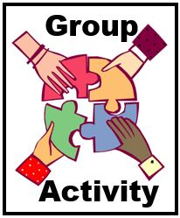
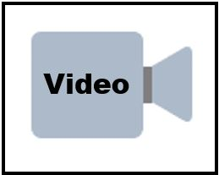
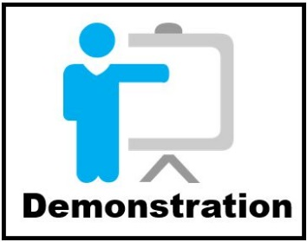

Virtual Setup
- Internet connection/Laptop computer
- Connection to virtual platform (Zoom)

Instructor and participant Supplies
- Supervisor as Trainer Facilitator Guide
- Supervisor as Trainer PowerPoint Slides
- Supervisor as Trainer Participant Guide
  - Links to Articles About Learning and Training
  - Characteristics of Training Techniques
  - Links to National Training Resources
  - Small Group Activity – Developing a Training Activity
  - Sample Transfer of Learning Tool
  - Transfer of Learning Follow-up Assignment

Course/ Lesson Goal
The goal of this course is to provide APS supervisors with an understanding of their role as trainers/facilitators, principles of adult learning, training settings and techniques, and ways to assess transfer of learning.

Learning Objectives
By the end of this course, participants should be able to:
- Describe adult learning principles and how the brain learns.
- Describe strategies for learning retention.
- List six characteristics of adult learners.
- Name the settings and techniques used to train staff.
- List the four phases of learning and describe how to support staff in each phase
- Evaluate the effectiveness of training.

Target Audience
The target audience for this training is APS supervisors.

Course/ Lesson Length
This training is presented in 4 sections of approximately 30 minutes each for a total training time of 2 hours. The course could also be offered in smaller, half-hour segments by presenting each section individually.

For Facilitators
This Facilitator Guide provides the structured content, activities, and PowerPoint slides to present a 2-hour training. Facilitators are encouraged to review the guide and to add any state-specific information and/or examples from their professional experiences as appropriate. The accompanying Participant Guide contains the PowerPoint slides and hand-out materials that will be referenced during the training. Facilitators are encouraged to review these hand-out materials ahead of trainings, to be prepared to screen-share them as directed, and briefly describe content and use.

 | Introduction
Slide 1 | 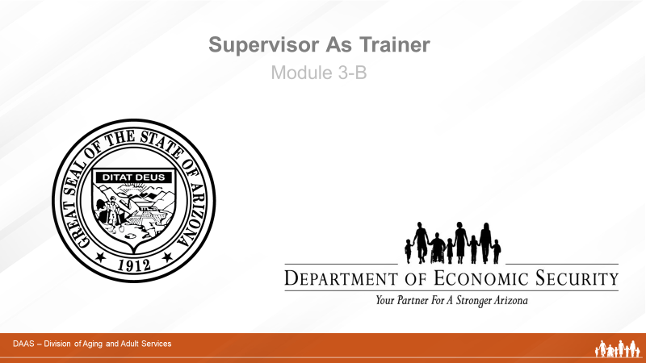
Producer:
Welcome, everyone, to today’s module on Supervisor as Trainer. (Introduces self and role in overseeing technology and managing questions and group activities.)

Slide 2 | 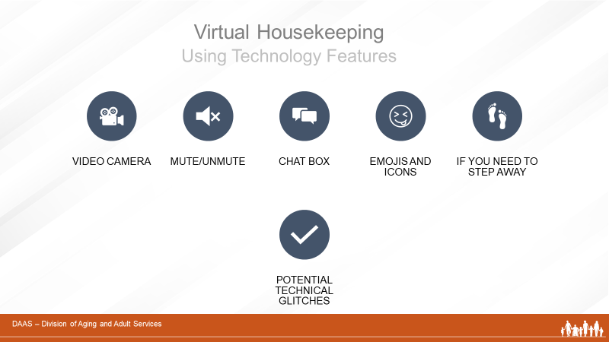
Producer:
Before we get started, let’s review some virtual housekeeping details to be sure we’re familiar with the technology features we’ll be using to communicate with each other.
Some of you may be more familiar than others navigating through a virtual learning course. So we will briefly review the various functions of the virtual environment:
- Video Camera: Find the camera icon; when you do, please turn the camera off and on. During the session, please keep the video camera on since this is an interactive course.
- Mute/Unmute: Now, please locate the microphone. When you do, practice muting and unmuting yourself.
- Chat box: Find the chat icon. We will be using the chat function to communicate throughout the session.
- Emoji and Icons: These differ within the different virtual platforms
There will be a ten-minute break approximately 60 minutes into the training. And while participants are expected to attend the entire training, if you need to step away please let the facilitator know by private chat.
And just a word about technical glitches. They are inevitable - on our end and your end! So please be patient and forgiving as we all navigate this virtual platform together.
Slide 3 | 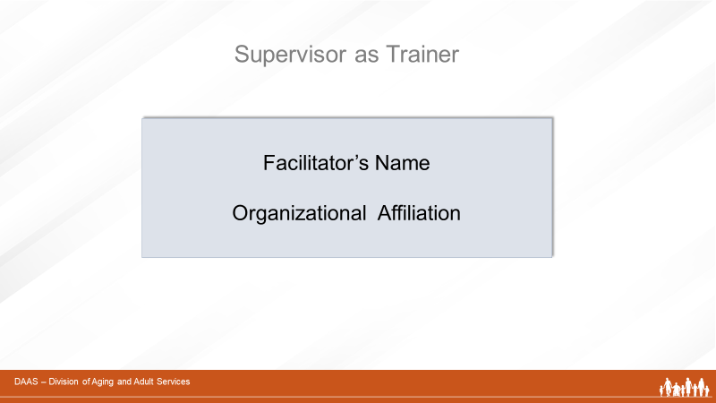
Producer:
Now, let me introduce our facilitator for today’s session. (Introduces with short bio.)
Slide 4

Facilitator:
Thank you! I’m very pleased to join you all to facilitate this module on the role of Supervisor as Trainer. (May want to add a little more about professional background.)
As APS supervisors, you all know the many different responsibilities that are part of your job. So I’d like to take a minute and ask you to use your chat button to share a few of the tasks that you carry out as part of your job.
(Producer monitors responses and reports.)
Slide 5 | 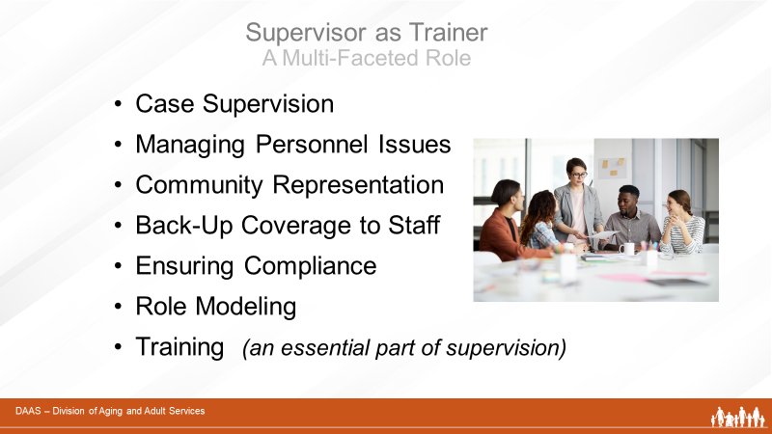
Facilitator:
Great responses! Let’s continue building a list on the screen. Mention each task ending with training as an essential part of the job.)
It looks like the hardest job in the agency!
Given these multiple tasks, we know it can be very challenging to dedicate the time to training new and experienced staff and you may even hold the belief that this is the responsibility of agency trainers.

However, it’s important to recognize that your role as a supervisor and your role as a trainer are interchangeable. You are always training your staff – not only in formal ways - but in the way you model professional behaviors and attitudes.

Your role as trainer may take many forms that we will talk about in this module. For example, you may be the sole trainer for your unit. Or training may look like coaching in individual supervision or in a team meeting. It may take the form of integrating activities after staff attend formal training in order to support the transfer of learning from the classroom into the field.

Whether you are a new or seasoned supervisor, you already have knowledge, experience and skills that will serve you well in training your staff. This session will focus on providing you with additional information and techniques that can enhance your abilities and build your comfort level in carrying out your role as trainer.
Slide 6 | 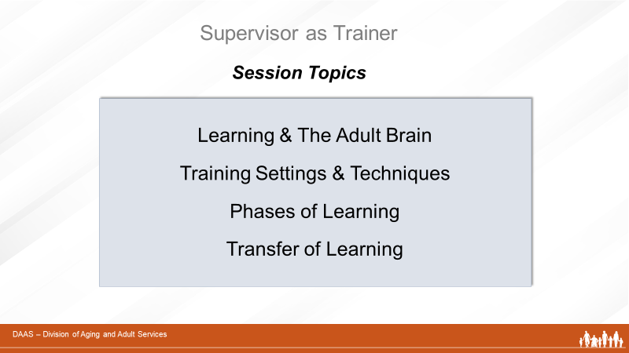
Facilitator:
We will cover:
- How the adult brain learns
- The various settings in which training can take place and different training techniques
- We’ll look at the four phases of learning and their implications for training
- And we’ll finish with evaluating the effectiveness of training – how will you know if it is successful?
We’ll also share some tips for new supervisors. And you will become familiar with additional materials and resources in your Participant Guide. Are there any questions?

 | Section 1- Learning & The Adult Brain
Slide 7 | 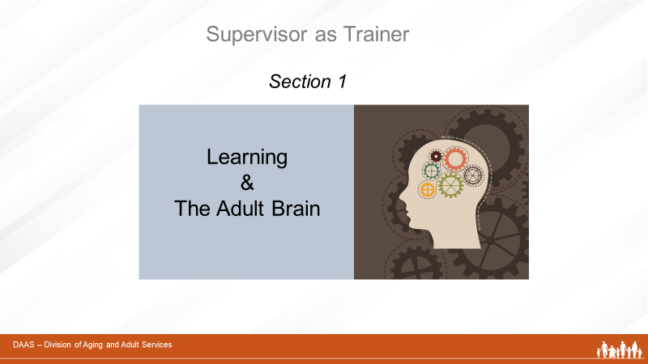
Facilitator:
Let’s start by first talking about how adults learn. While there are numerous theories, most share some common principles.
Slide 8 | 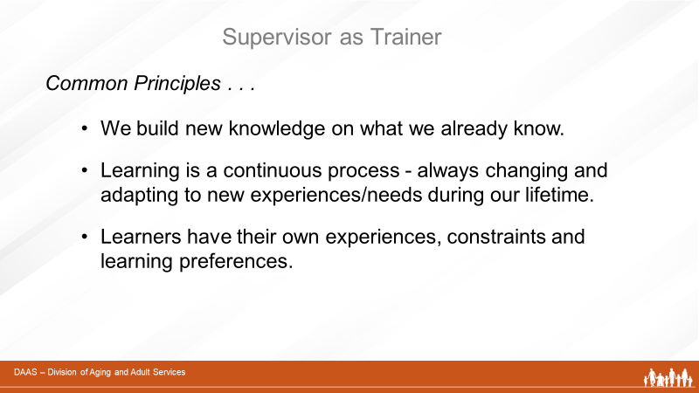
- We build new knowledge on top of what we already know. We are always making connections between new and existing information. Learning is not only about gaining knowledge, but being able to make sense of it and use it.
- Learning is a lifelong process of building knowledge, skills and attitudes. We are continually taking in new information and adapting to changes and needs as they arise during our lives.
Learners have their own experiences, limits, and ways that help them learn. Some learners benefit from having visual information while other might prefer listening and discussing information with others.
Let’s look more closely now at how our brain functions as we are exposed to new experiences and information.
Slide 9 | 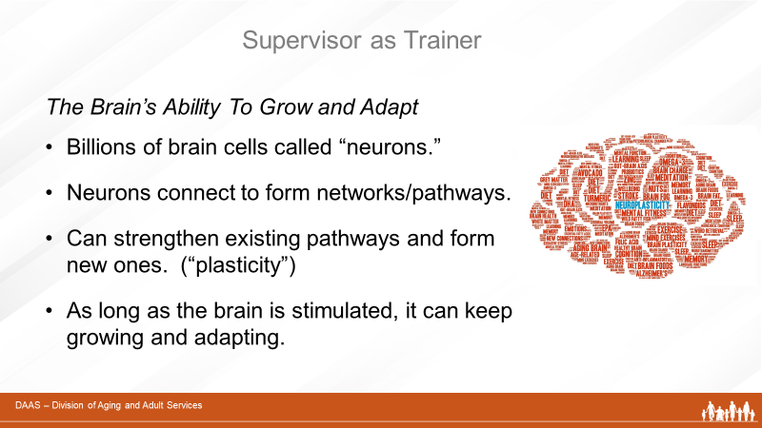
- We have billions of brain cells called “neurons” and our brain forms connections between neurons to form networks or pathways.
- When we are exposed to new information or experiences, the brain’s networks can reorganize and grow. This ability is called “plasticity.” Young brains have the greatest plasticity. As we age, we lose some of this plasticity so making new networks or pathways may not happen as quickly or easily. However, as long as our brains are stimulated, they remain capable of connecting new information to existing neurons – and continue to grow and adapt.

We are all lifelong learners. And as trainers, we can apply what we understand about adult learning and brain function as we support staff at all levels in developing their knowledge, skills and attitudes.

Before we move on, are there any questions or comments?
Slide 10 | 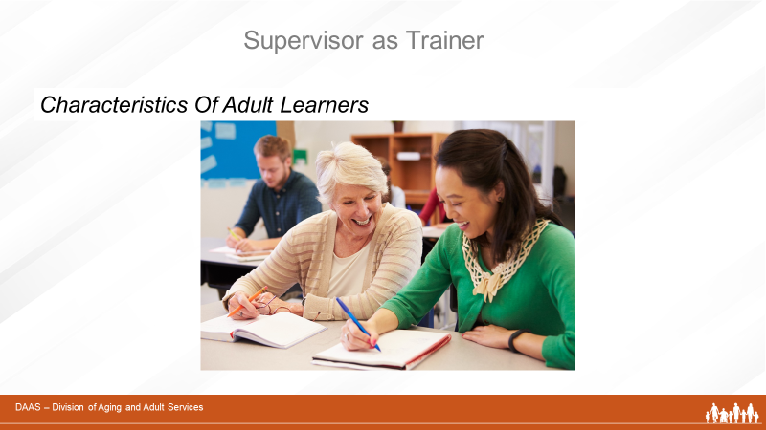
Facilitator:
Although every learner is different, most adults share some common characteristics when it comes to learning. Using your CHAT button, please take a moment to share one or two things that you think adult learners have in common.
(Producer acknowledges responses.) Possible responses: bring own life experience, want to know how training will help them, motivated to apply new information, want opportunities to talk with others

Thank you, everyone! Let’s now watch a brief video on this topic.

Slide 11 | 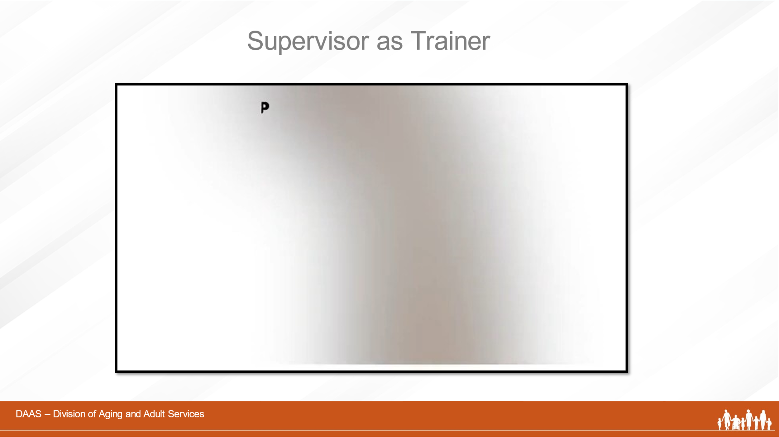
Slide 12 | 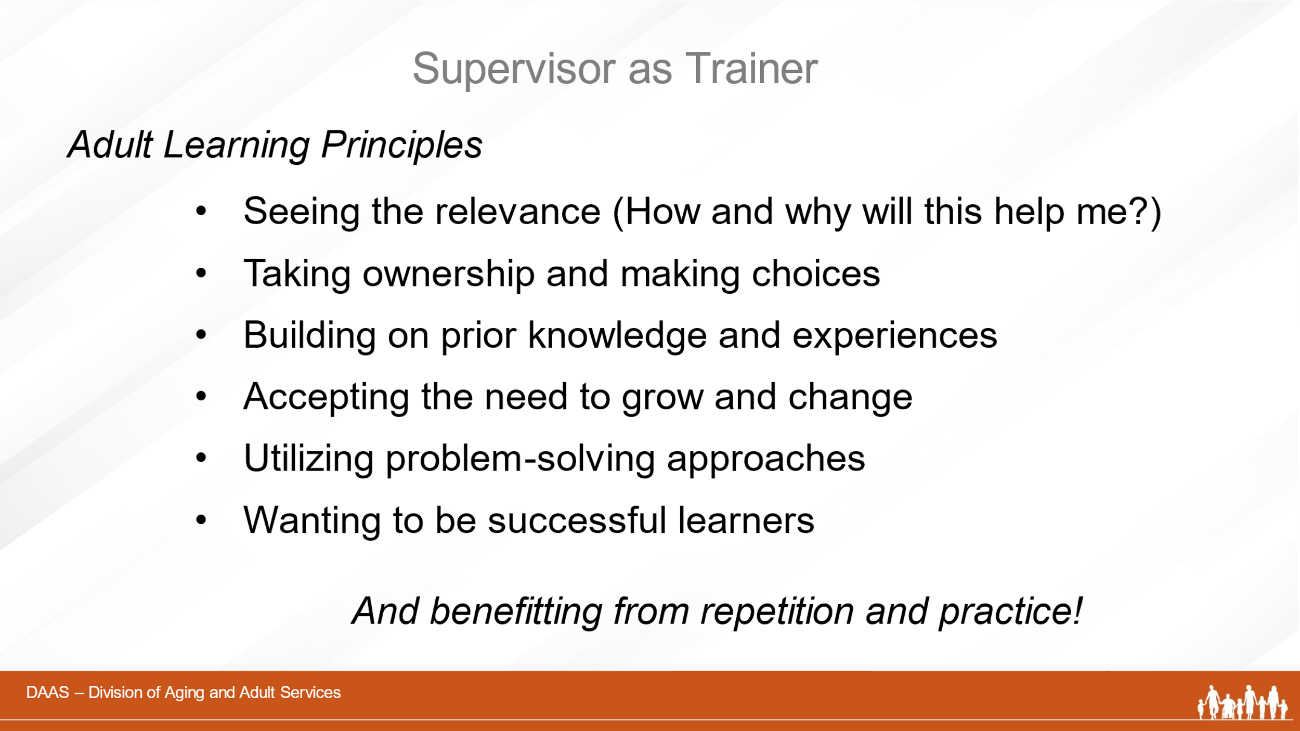
Facilitator says:
So let’s recap for a moment what we just watched about the way adults learn by:
- Understanding the relevance of new learning. (How will it help me?)
- Taking ownership and making choices about how they learn new material.
- Using their prior knowledge and experiences
- Accepting the need to grow and change.
- Preferring problem-solving approaches that can help them with the challenges of their work
- Wanting to succeed and use new learning to solve real-life problems.
And we’ve added one more principle to the list:
- Understanding the benefits of repetition and practice and their direct relationship to training.
Slide 13 | 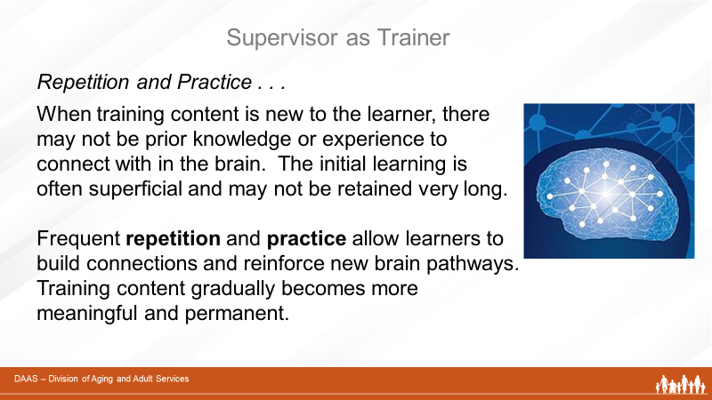
Facilitator:
Adults build new knowledge on what they already know. But what if learners have little prior knowledge of or experience with the new material to be learned? Their ability to fully understand and remember after one training is limited.

Repetition of key concepts – especially as they apply in different areas of practice builds and reinforces connections in the brain and learning becomes more meaningful and permanent. Repetition combined with opportunities to practice help build good work habits as well. We’ll revisit this as we talk about supporting staff in different phases of learning.

We’ve recognized that adults share similarities in how they learn. Now we want to briefly mention a few of the barriers that can impact learning.

Slide 14 | 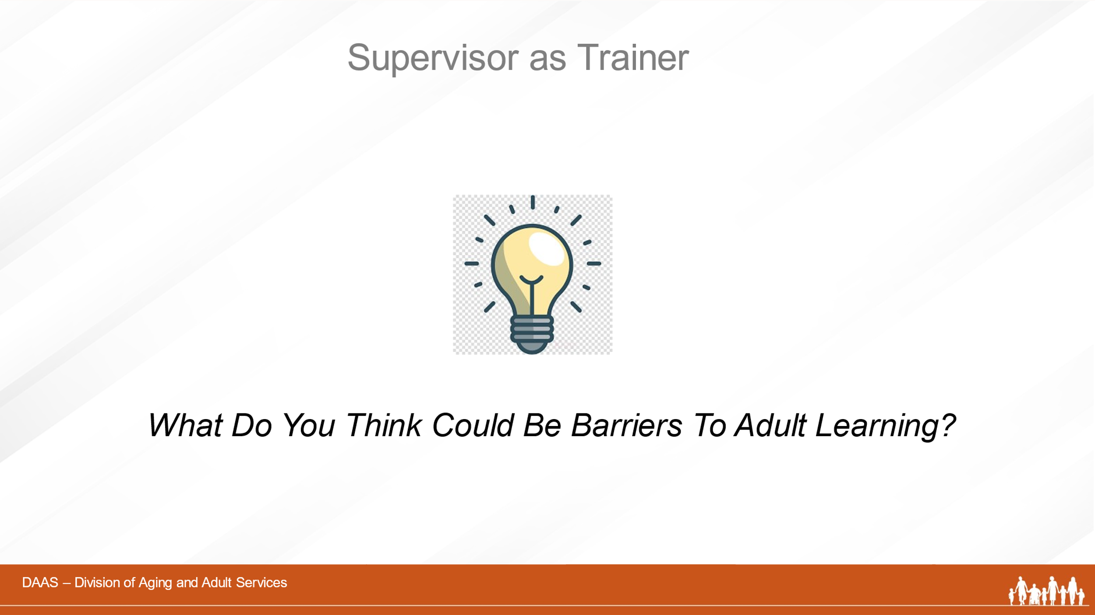
Facilitator:
Let’s start by having you use your CHAT to share your ideas of what you think could be barriers to learning.
(Acknowledges responses.) Thank you, everyone! Good responses. Now let’s compare them to the screen.
Slide 15 | 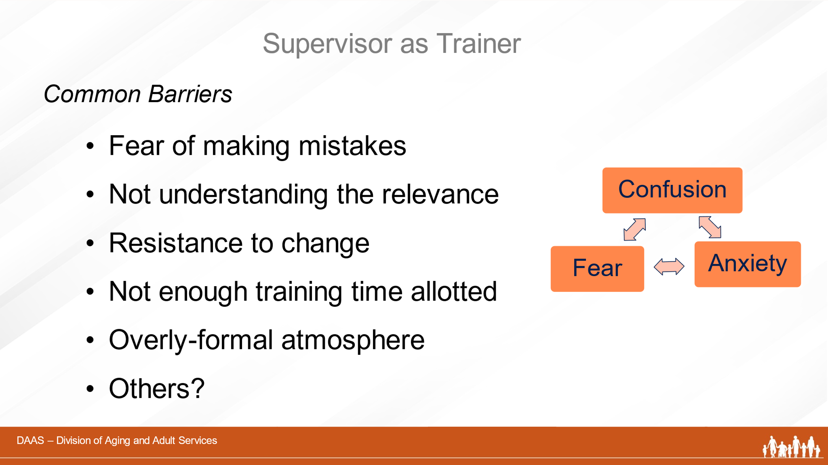
Facilitator:
Learning is a catalyst for change and learners need to be challenged – taken out of their “comfort zones.” But fear, anxiety and confusion can interfere with the learning process and make it more difficult. Being afraid to make a mistake can keep people from participating fully. And, as mentioned earlier, not understanding why or how the training material is beneficial is another obstacle to learning.

We all learn best in an emotionally supportive training environment where expectations, objectives and relevance of the training are clear to the learner and the atmosphere encourages participation. So let’s summarize this section.
Slide 16 | 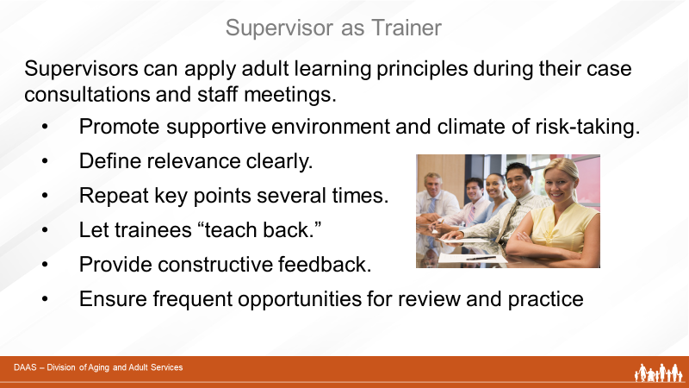
Facilitator:
Gaining new knowledge, skills and attitudes through training present ongoing opportunities and challenges to your staff.

As APS supervisors, you are the best resource for encouraging and guiding your staff through the learning process and ensuring that the skills acquired are applied and practiced.

Be clear about training objectives and how they relate to job perfomance; plan time for review and practice opportunities; and give constructive feeback

Understanding and utilizing key principles of adult learning will help you succeed in your role as a trainer.
Resources for Additional Information:
Links to Articles About Learning and Training. . . . . . Pg. 10

 | Section 2- Training Settings & Techniques
Slide 17 | 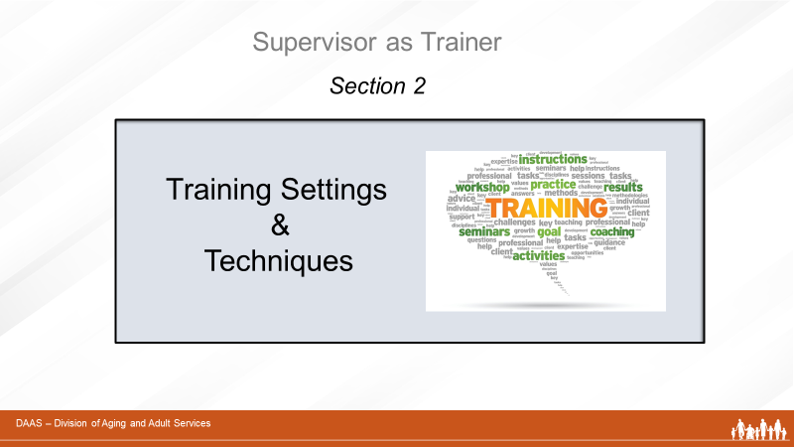
Facilitator:
Now that we have talked about how adults learn; some common and individual characteristics of adult learners; and some of the barriers to learning, let’s look more closely at training itself.
APS staff training happens in a variety of settings. And supervisors have variety of training techniques to use depending on what is to be learned and the skill level of the learner.
Slide 18 | 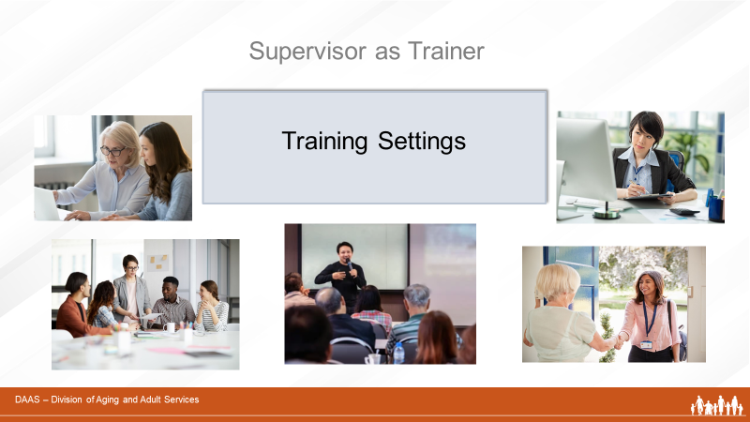
Facilitator:
Let’s start by looking at the settings in which APS training can take place – formal classes, one-on-one supervisory sessions, team meetings, individual assignments, and on-the-job experiences in the field.
Slide 19 | 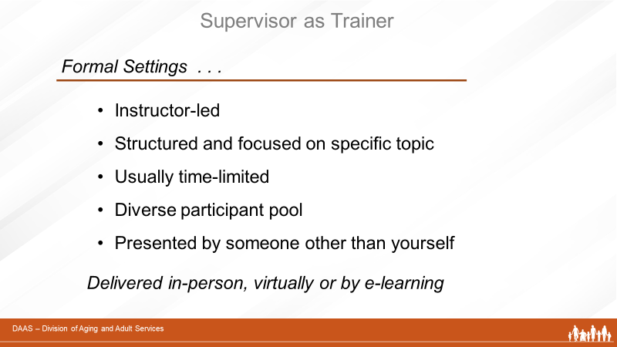
Facilitator:
We’re all familiar with formalized training sessions that are usually led by a professional trainer. Training can be delivered either in-person or virtually to a group of participants - and the content is usually structured and focused on a specific topic.
E-learning is another example of formalized training that is also referred to as “online learning”. Typically, e-learning is conducted on the Internet and lets students access their learning materials online at any place and time.
Slide 20 | 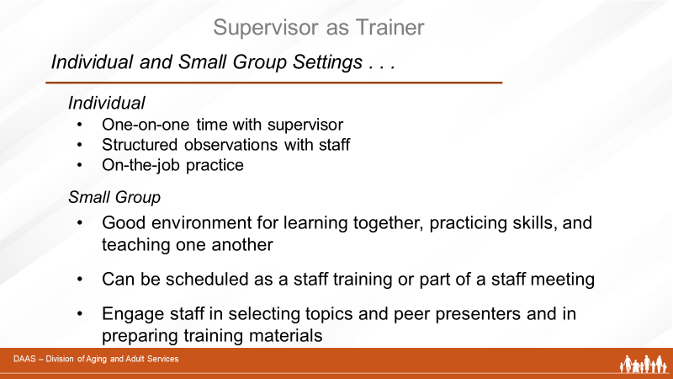
Facilitator:
Examples of less formal training settings include one-on-one supervisory sessions – especially with new staff. You also provide training when you plan structured learning opportunities (shadowing) in the field. New staff learn by accompanying and observing experienced staff members as they carry out APS work - and by gradually putting newly-learned information and skills into practice in “on-the-job” situations.

Team meetings or team trainings are another good setting for learning together, helping each another, and involving staff in helping to prepare and present training topics.
Slide 21 | 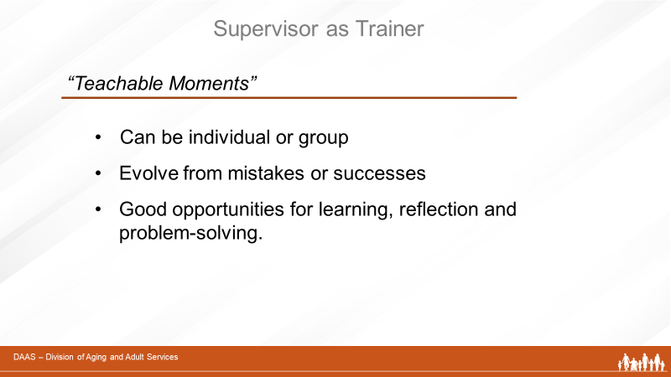
Facilitator:
As supervisors, you are all probably familiar with those unexpected, unscheduled events that provide opportune moments for learning. Teachable moments evolve from not only mistakes or misunderstandings but successful outcomes as well. They are catalysts for meaningful learning, reflection, problem-solving, and improved performance.
Slide 22 | 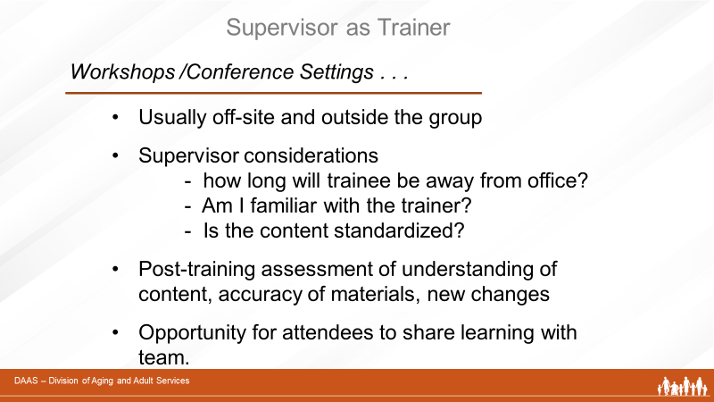
Facilitator:
Conferences and workshops offer off-site training settings that provide attendees training content and materials that can be brought back and shared with the team. They also offer opportunities to network with other professionals in the field.
Slide 23 | 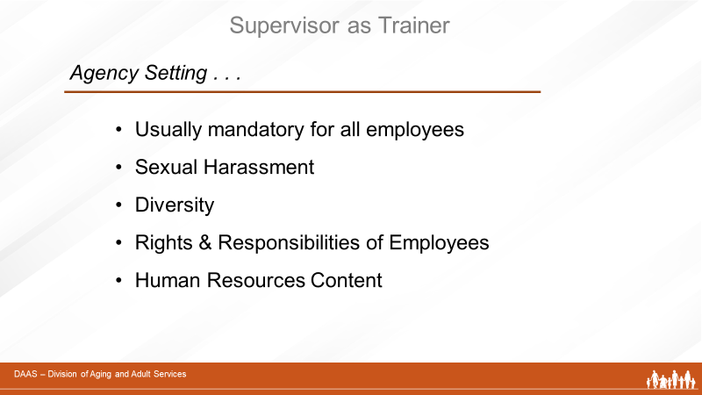
Facilitator:
And finally, APS supervisors need to plan on time for staff to attend mandatory agency trainings. These are usually provided by human resource departments and focus on workplace issues like those listed on the screen.
Any questions or comments you want to share before we move on to talking about training techniques?
Slide 24 | 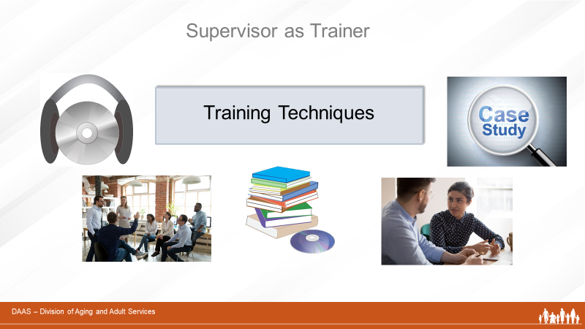
Facilitator:
As we mentioned earlier, there are a variety of training techniques that can be used in training your staff – depending on what is to be learned and the skill level of the learner. So matching the appropriate techniques with the needs of the “trainee” is a key to successful learning. In this segment, we’ll look at some of these training techniques and then use a group activity to further explore them.
Slide 25 | 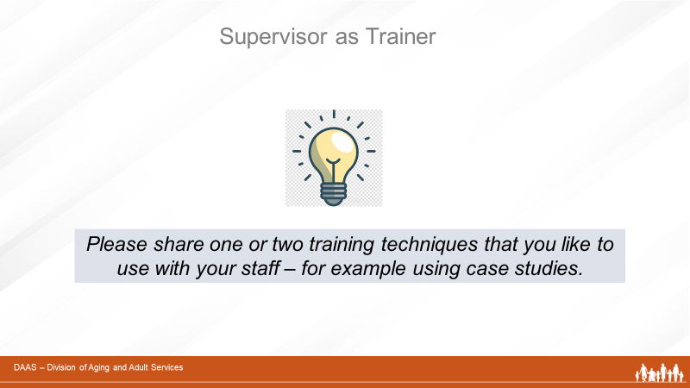
Facilitator:
Let’s start by using your CHAT button to share one or two training techniques that you have used with your staff. I’ll give you an example: reviewing case studies.
Possible answers – videos, shadowing, written materials, etc
Producer acknowledges responses
Thank you for those ideas! Now let’s compare them with this list on the screen.
Slide 26 | 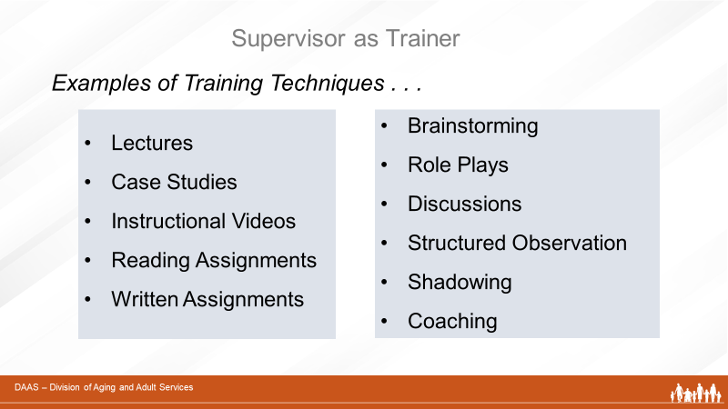
Facilitator:
As we’ve just acknowledged, there are a number of different training techniques that you can use with your staff depending on the training content and the needs of the learner. Each technique has its own charateristics and benefits. For example, using a lecture allows a trainer to present the same content to a number of trainees at one time. Shadowing is an on-the-job technique that allows an individual learner to see and understand the nuances of a particular job as it is performed in the field. Using several techniques in combination during training can be effective since they allow the learner to input new information in a variety of ways.

You might use reading assignments with new staff to help them learn about agency policies and procedures. Then, follow the reading assignments with a one-on-one discussion session that includes questions and answers.

Another example is using an instructional video as a lead-in to a follow-up group discussion in a topic-specific area such as investigating allegations of financial exploitation.

Your Participant Guide has a hand-out listing the characteristics and benefits of each as well as links to two national training resources for supervisors.
Resources for Additional Information:
Characteristics/Benefits of Training Techniques . . . . . . . . . Pg. 16
Links to National Training Resources for APS Supervisors . . Pg. 18
Slide 27 | 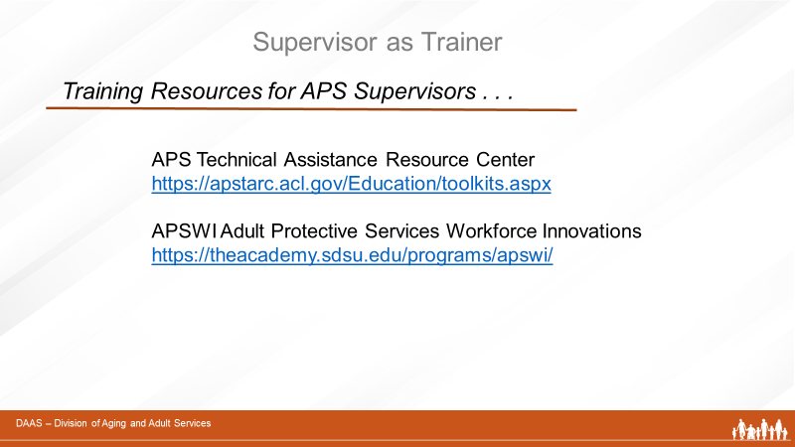
Facilitator:
When planning for the training needs of your staff, APS supervisors have access to a wealth of national training materials – topic-specific content, tools, videos and suggested activities so I would like to talk a little bit more about the two resources displayed on the screen.

- The first link connects to the APS Education and Training Toolkit available at the Training and Resource Center (TARC) on the Administration for Community Living’s website. It is a compendium of APS educational materials, videos, and other resources. The toolkit helps APS administrators and supervisors stay abreast of offerings, supplement trainings made available by their state programs, and promote continuous learning opportunities for APS staff.
- The second link is to Adult Protective Services Workforce Innovations (APSWI). This is a training program of the Academy for Professional Excellence, a project of the San Diego State University School of Social Work. APSWI provides innovative workforce development to APS professionals and their partners. In partnership with state and national organizations, APSWI has developed a nationally recognized Core Competency Training Curriculum for APS professionals.

Visit the site to access the many topic specific trainings and the Field Guide for APS. The Guide is intended to provide an agency or an individual APS supervisor with an organized system to ensure that the new APS worker gains the experiences and training needed to be an effective professional.
Your state may also have prepared a state-specific field guide for your use. (AZ is customizing their own version with AZ-specific information )
Slide 28 | 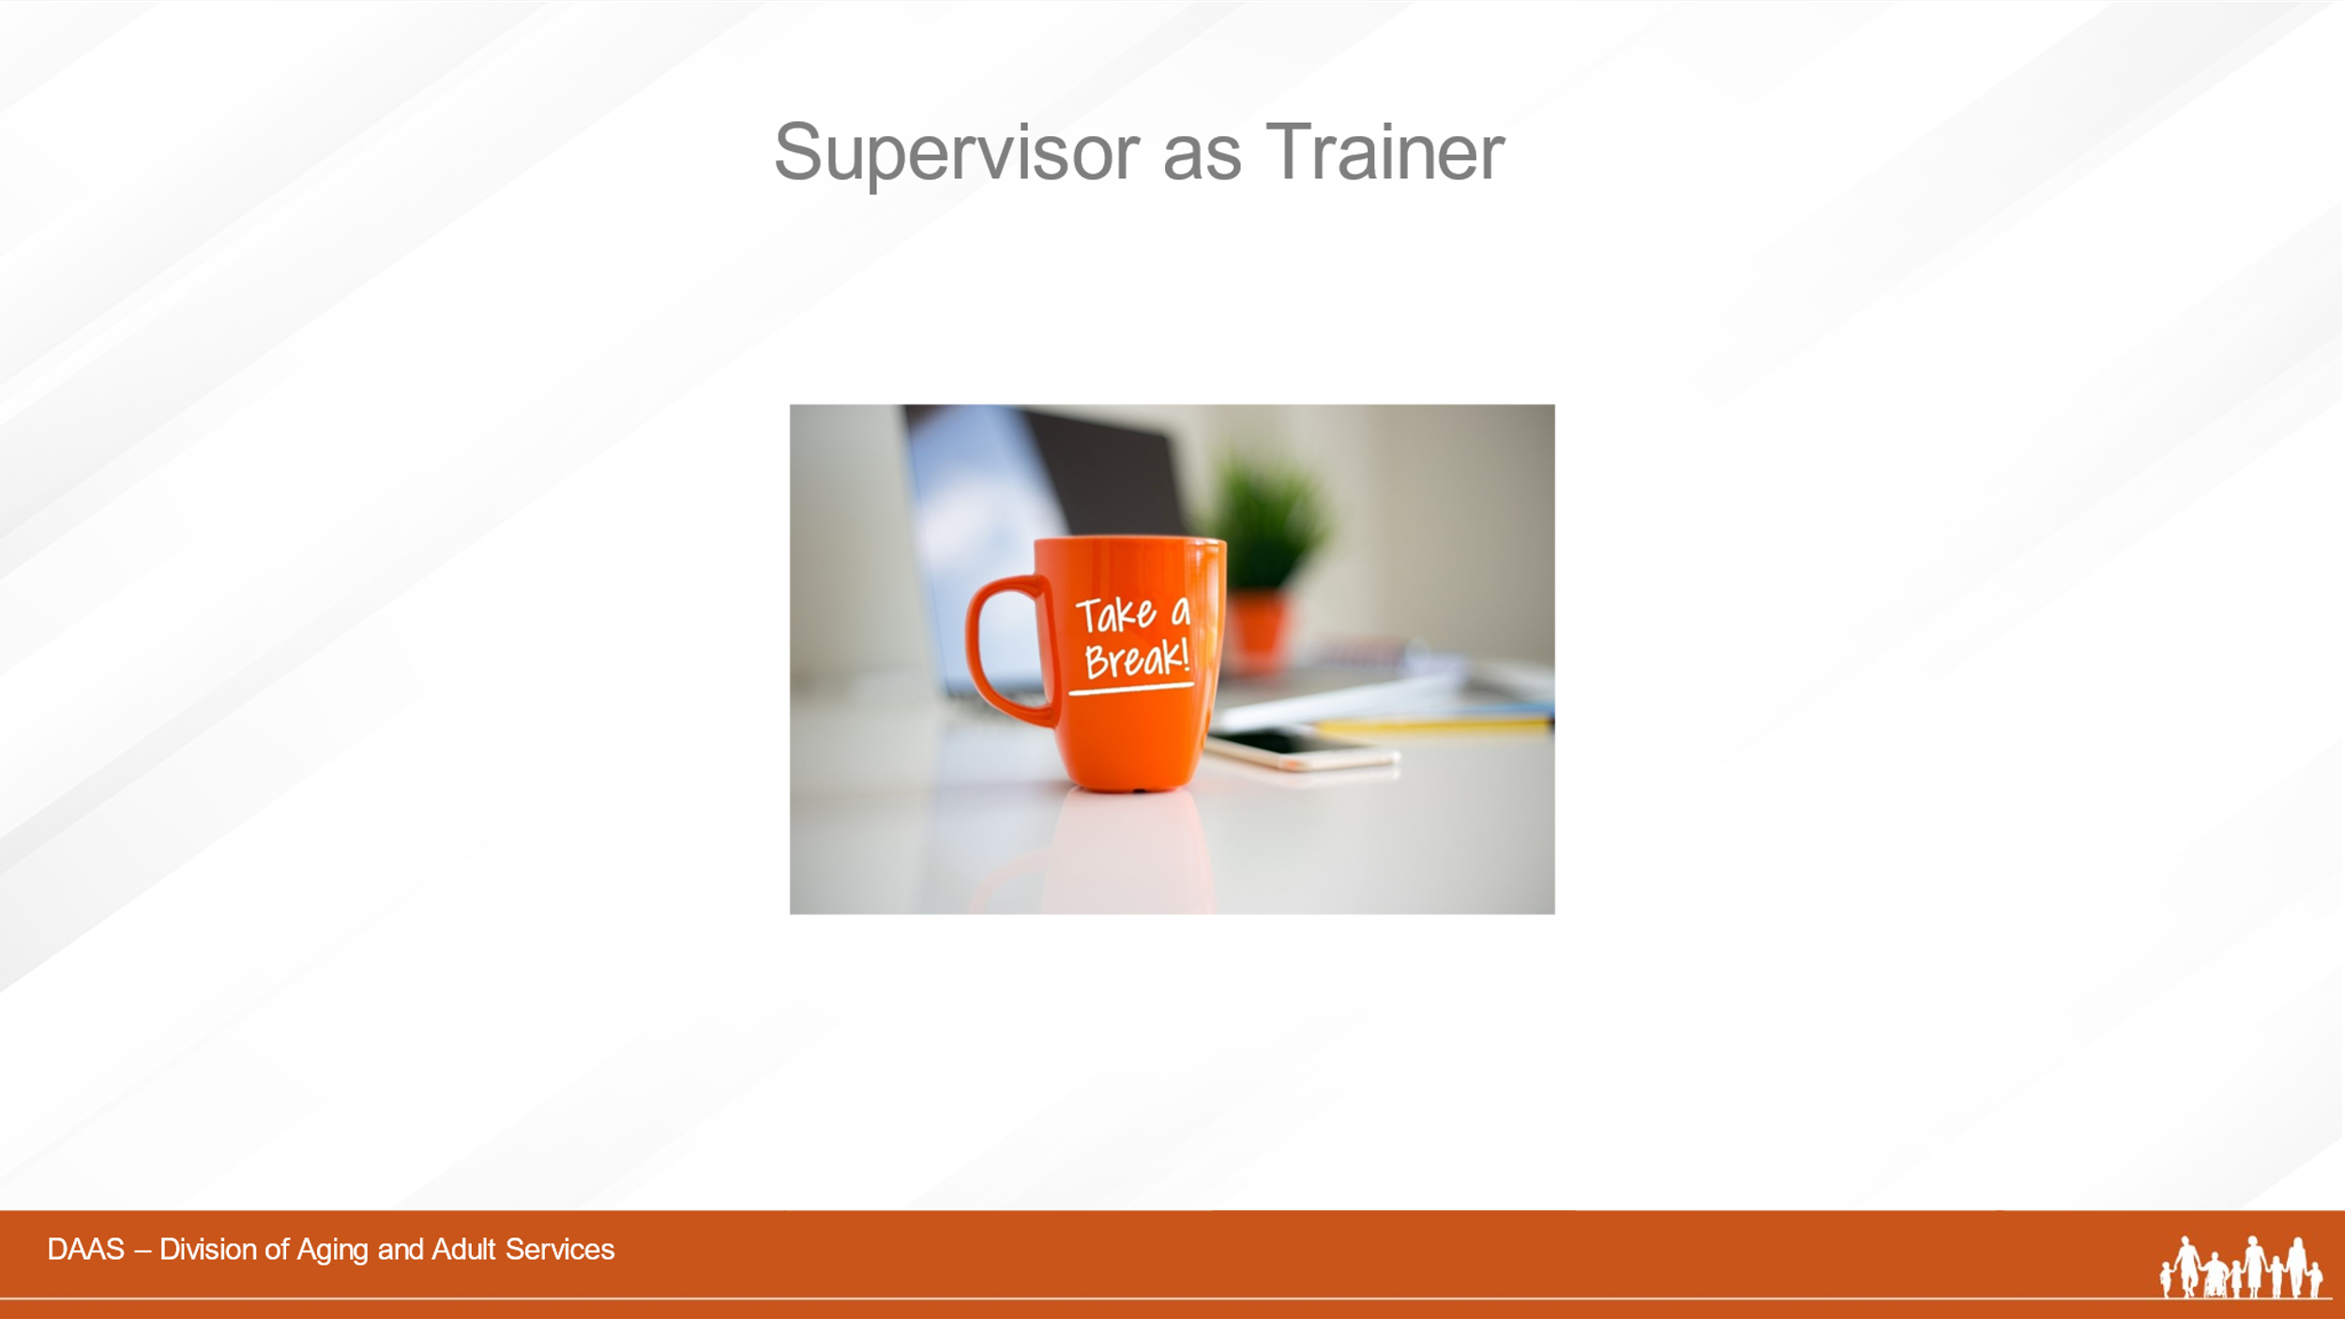  (10 minute break suggested.)
Slide 29 | 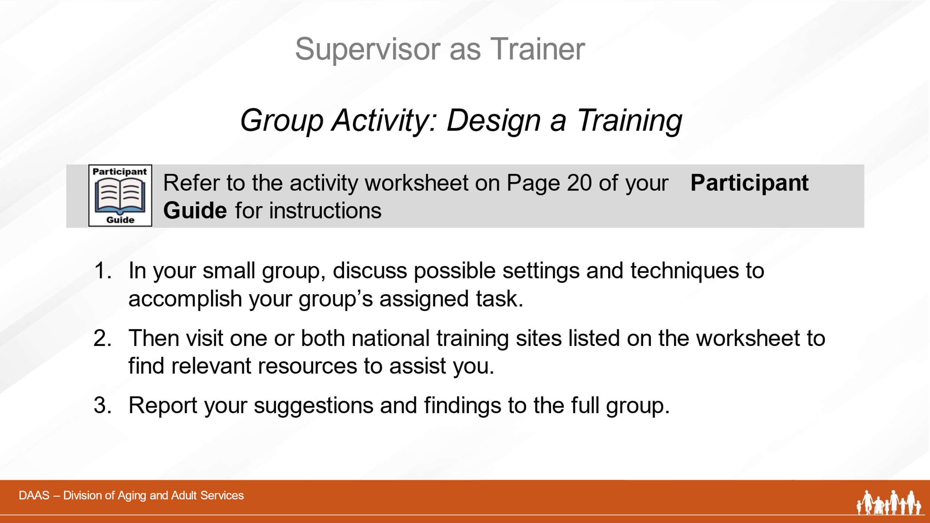
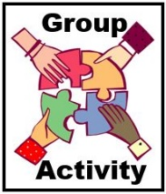 | Facilitator:  Welcome back, everyone! To further explore the use of training settings, techniques and available resources, let’s move now to a group activity.  Note to producer: Assign each break-out group a number and identify which participants are in each group. (See facilitator version with instructions/sample responses on Page 56 of this Guide.)  - First, we’ll divide you into small groups and assign a spokesperson for each one.  - Next, each small group will be given a different training task to work on. In your small group, first discuss the various settings and techniques you might use to accomplish the task.  - Then, visit one or both of the links on the screen,  to locate a few resources you could use to  support and enhance your training. These resources  could be specific content, related activities, videos,  etc. Although you won’t have time to review them  in depth, the purpose of this activity is for you to  locate the kinds of training resources available to  you.  Your small group will have 20 minutes to complete your task. When we reconvene as a full group, each spokesperson will present their task, their recommended training settings and techniques, and related support materials they found on the national sites.
Small Group Activity Worksheet . . . . . . . . . . . . . . . . . Pg. 19
(Use the worksheet to reference your group’s task, the list of training settings and techniques to consider, the links to training resources and to keep notes during your small group discussion.)

Producer: Allow 20 minutes for small group work. Give a 5-minute warning.
Facilitator:
Welcome back! Let’s hear what each small group suggests for their particular training task.
(Have each group spokesperson report on their suggestions and findings and keep a list of their suggested settings and techniques on the whiteboard. As each group reports, check those that are repeated. After each group has reported, comment on the settings and techniques noted – especially those that have been repeated. Acknowledge the training resources they located. Ask if there are other comments or suggestions to add.)

Thank you, everyone, for your contributions to this exercise. As you can see, there are many options for providing training. The key is to choose those that best support the content to be learned and the skill level of the learner.

 | Section 3 – Phases of Learning
Slide 30 | 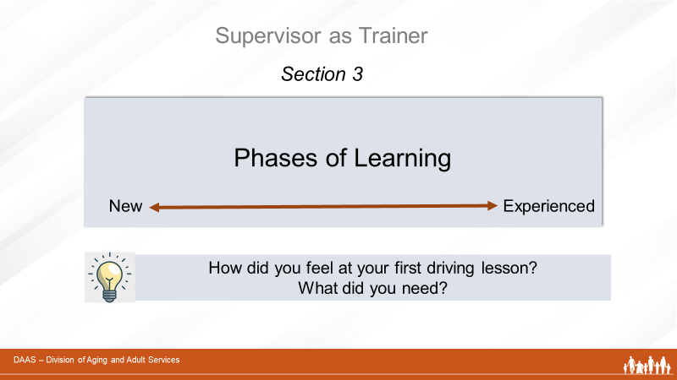
Facilitator:
So how do adult learning principles, training settings and various techniques apply to a team that ranges from brand new staff members to very experienced ones? In this section, we’ll pull that together by looking at training supports during different phases of learning.
We’ll start with a question for you. Think back to learning to drive a car. How did you feel at your first lesson? What did you need? Take a minute and use the CHAT to share your thoughts. (Producer reports responses)

Slide 31 | 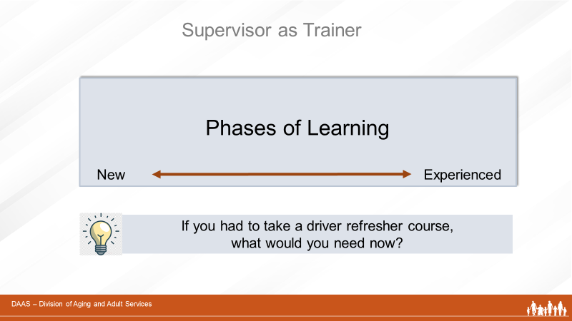
Facilitator:
You all felt a certain amount of anxiety and excitement. Now, if you had to take a driver refresher course next week, what would you need? Please use the CHAT again to send your responses. (Producer reports responses and notes the differences between the experience of learning something brand new compared to refresher learning.)

Learning something for the first time feels is experienced differently than refreshing something you already know. When you first learned to drive, it was all new information; you were unskilled; and you had little experience. You couldn’t be expected to be a competent driver after one lesson. Your brain pathways needed to grow and be reinforced. You needed frequent review and practice.
Compare that now to having years of practice and plenty of driving experience. You are confident. You don’t have to think about every step anymore. And even if you have new information to learn during a refresher course, you have the prior knowledge and experience that make taking in that new information much easier for you.

Building on what you already know, reviewing often, and having plenty of opportunity to practice makes learning at any stage meaningful and permanent.
Slide 32 | 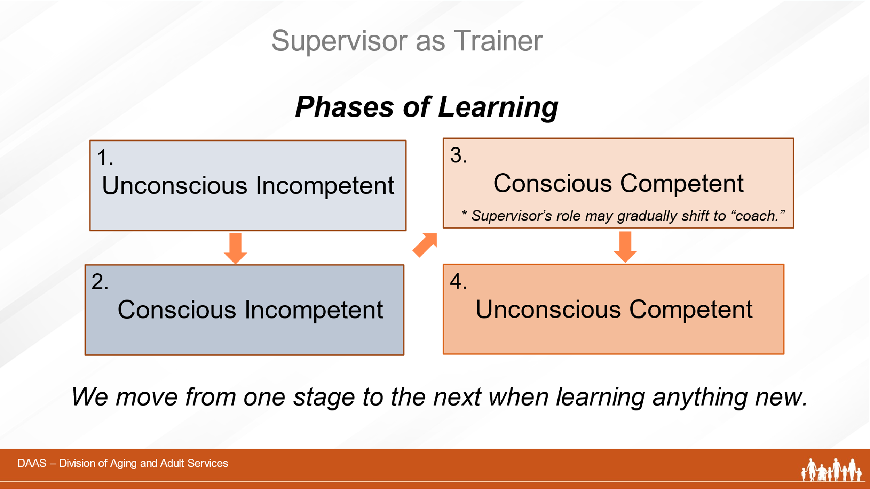
Facilitator:
So let’s look now at different phases of learning and how they apply to the training needs of staff with ever-changing levels of knowledge and experience. As you see on the screen, we all move through different phases of learning anytime we need to learn something new - accomplishing one phase before moving to the next. This graphic represents a theory of adult learning that features 4 different phases of learning.
- The first stage - “unconscious incompetent”- refers to a brand new learner - who doesn’t know what they don’t yet know. Learners in this phase will not readily retain complex information during training because they don’t have the neural pathways to which the can connect the new information. This is often the case with brand new staff.
- The second stage - “conscious incompetent” - refers to learners who have had some training, know what they don’t know and are able to retain and apply new information. They are are in the best mental space to learn new information because they have the brain pathways to build on and understand the relevance of new information to improved job performance.
- The third stage - “conscious competent” – refers to learners who have had ongoing training which they can apply effectively in their field work. These team members are often the best ones to have new staff shadow because they still remember how hard it was to learn how to be competent.
- The fourth and final stage - “unconscious competent”- refers to learners who can carry out complicated tasks with little thought because they have become so adept at performing. APS staff members in this phase can unconsciously pick up on cues from an alleged victim but they have a hard time explaining to new staff just what they are seeing or how they are coming to decisions because these are just coming “naturally” to them.

How long it takes a learner to move from one phase to the next for any given area of learning/competency depends on his/her own learning pace. Some learners may not reach the final stage for a particular task, but still be able to perform it with competence.

So let’s talk a little more about these four stages.
We’ll start the the unconscious incompetent.
Note: It’s important to mention here that while staff at any level of experience will re-visit this stage – even briefly - when learning something new, it often applies to new staff in the first months on the job. In a subsequent module, Onboarding New Staff, we will look in more depth at the specific needs of new staff.
To support any staff in this first phase of learning, supervisors can:
- Assess background and current skills and tie aspects of APS content with things they already know how to do
- Avoid overwhelming with an overload of information at one time.
- Provide smaller amounts of information with frequent opportunities for review and application to on-the-job practices.
- Can benefit from structured observations, shadowing
and case reviews.
Learners in the conscious incompetent phase:
- Are more aware of what they don’t know
- Ask pointed and relevant questions
- May begin to question their own ability to do the job
- May need encouragement from supervisor and review of previous trainings
- Can benefit from team discussions, role plays and review of more complex cases.

Any thoughts or observations about this phase to share?
In the third phase of learning called conscious competent, learners:
- Know what they are doing and why
- Are gaining experience and confidence
- Are often good matches for structured observations and shadowing with new staff.
- Encounter new situations and challenges in their work.
As noted on the slide, your supervisory role with learners at this stage may gradually begin to shift - from one requiring frequent monitoring to one of a “coach” - advising, consulting, assisting with problem-solving, encouraging critical thinking and training for developing new skills. In a subsequent training module called Supervisor as Coach, we will look in more detail at the role of the supervisor as “coach”.

Comments or questions about this phase?
And the fourth and final phase of learning – unconscious competent - applies to learners who have mastered a particular area of practice. These learners:
- Understand all aspects of the job and don’t have to think about each step of the process any longer.
- Are usually assigned the most complex cases.
- Can assist supervisor with group trainings.
- May benefit from advanced training opportunities.
 | Your Participant Guide has a listing of these phases with related learning activities for each one beginning on Page 22.
Slide 33
Facilitator:
The phases of learning can be a helpful guide when planning for the training needs of your team. And it’s important to remember that all staff – new and experienced - move in and out of these phases as they encounter new tasks or content, policy changes, or new procedures.

In your leadership role, you can promote and model a mindset of growth – one of continuous learning – that will help create positive expectations and motivation for your staff.
Any questions or comment about phases of learning before we move on?
 | Section 4 - Transfer of Learning
Slide 34 | 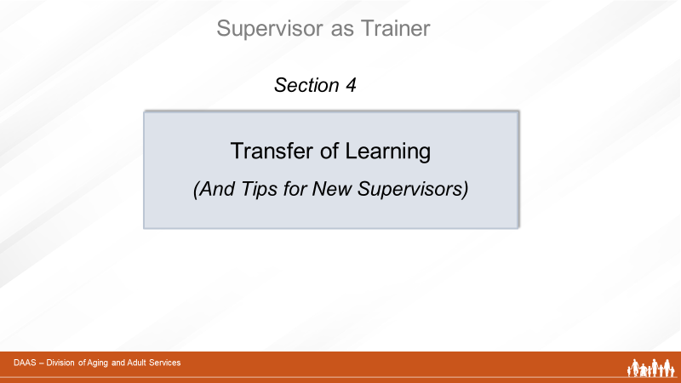
Facilitator:
In this last section, we’ll discuss transfer of learning - or retention and application of learning - and ways to know if training has been effective. And we’ll end the section by offering some tips to those of you who are new to your supervisory/training role.
Slide 35 | 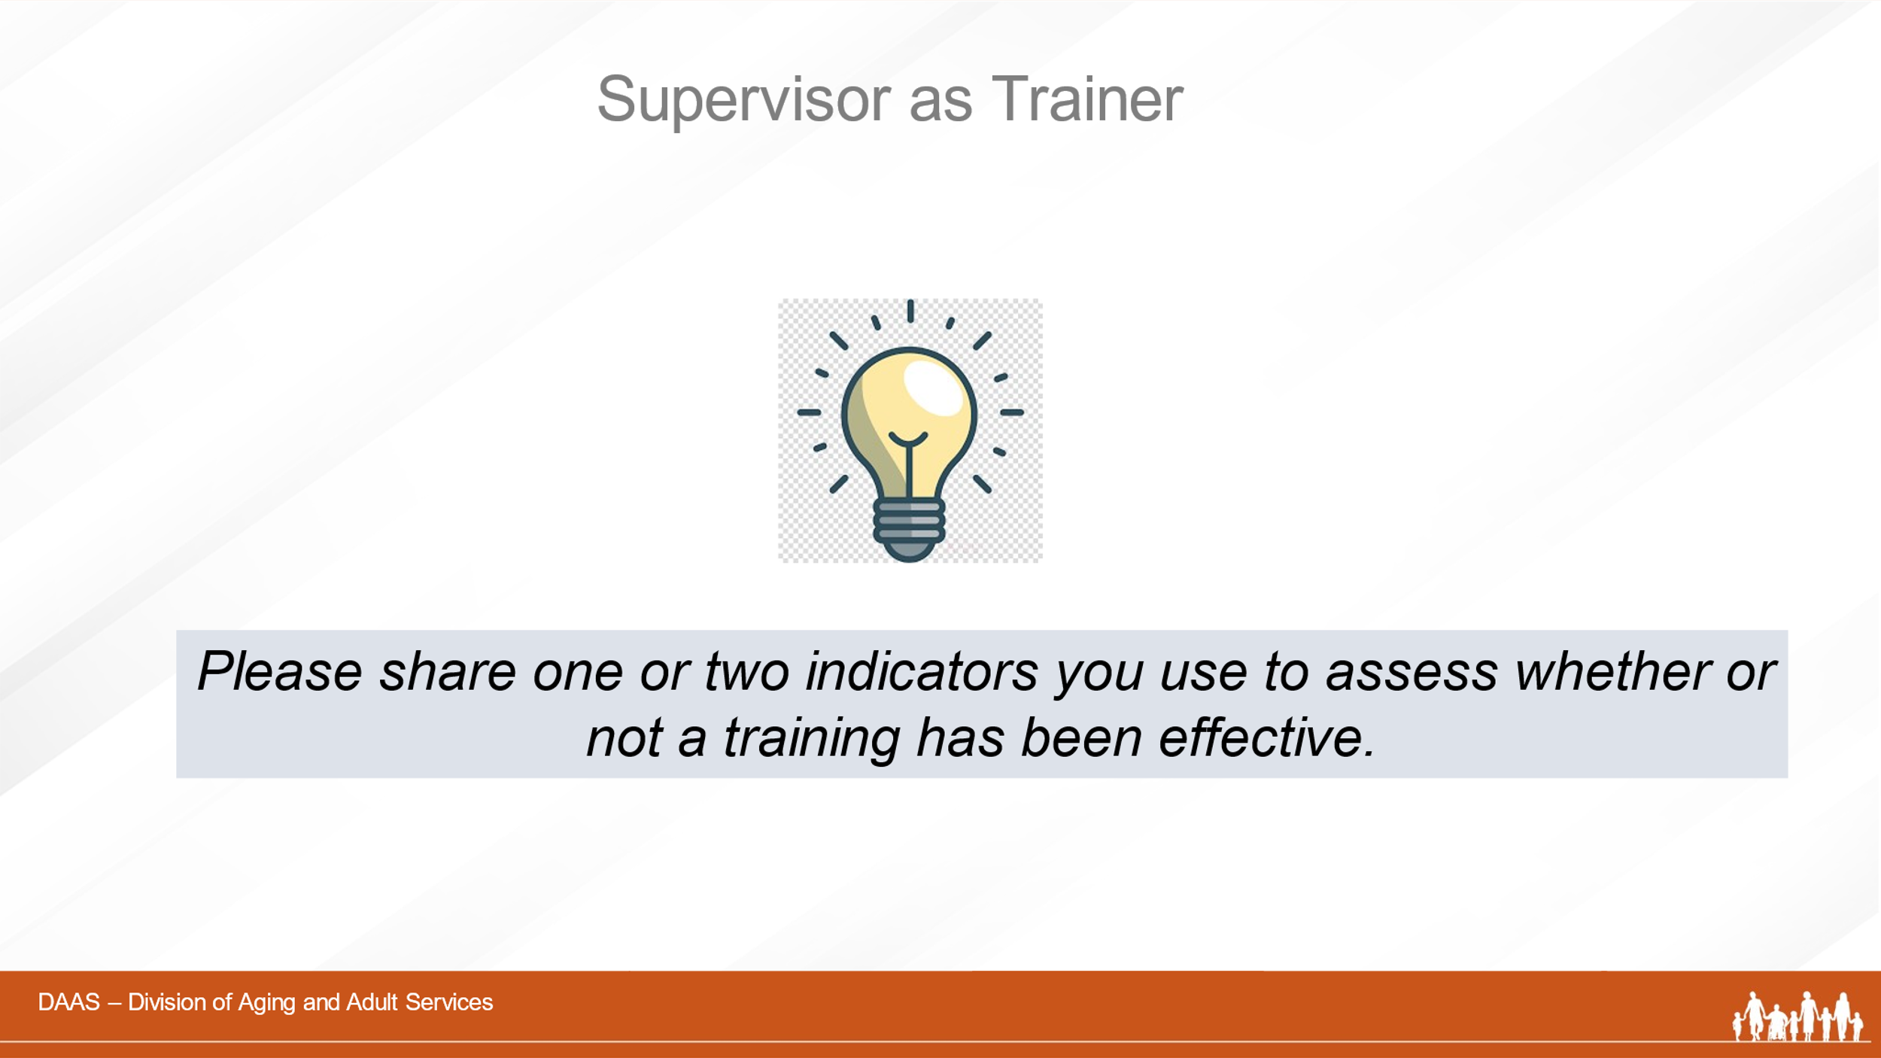
Facilitator:
Let’s start by having you either chat or unmute yourself to share one or two indicators you use to assess training effectivess. (Acknowledge responses.)
Slide 36 | 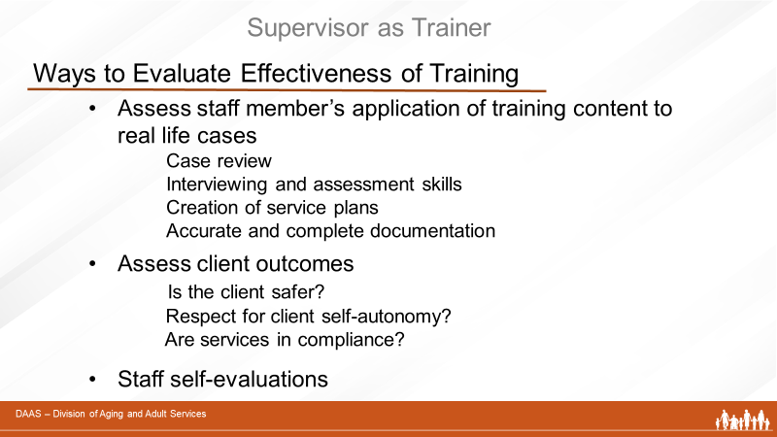

Thank you for your ideas! In summary, let’s also review these measures of training effectiveness:
- Assessing staff members’ application of training content to real life cases
  - Case review
  - Interviewing and assessment skills
  - Creation of service plans
  - Accurate and complete documentation
- Assess client outcomes
  - Client safety (Is the client safer?)
  - Was there respect for client self-automony
  - Are services in compliance with state regulations?
- Have staff do self-assessments
If you identify gaps in understanding or needs for additional training, review the basics of adult learning again to ask:
- Did the learner have any previous knowledge to build on?
- Was there too much content given at one time?
- Did the training settings and techniques match the level of the learner?
What does the learner share about what worked for them and what didn’t?

 | I want to call your attention to a sample transfer of learning tool on Page 26 in your Participant Guide. The tool was developed in California but can be adapted for use in any state.
Slide 37 | 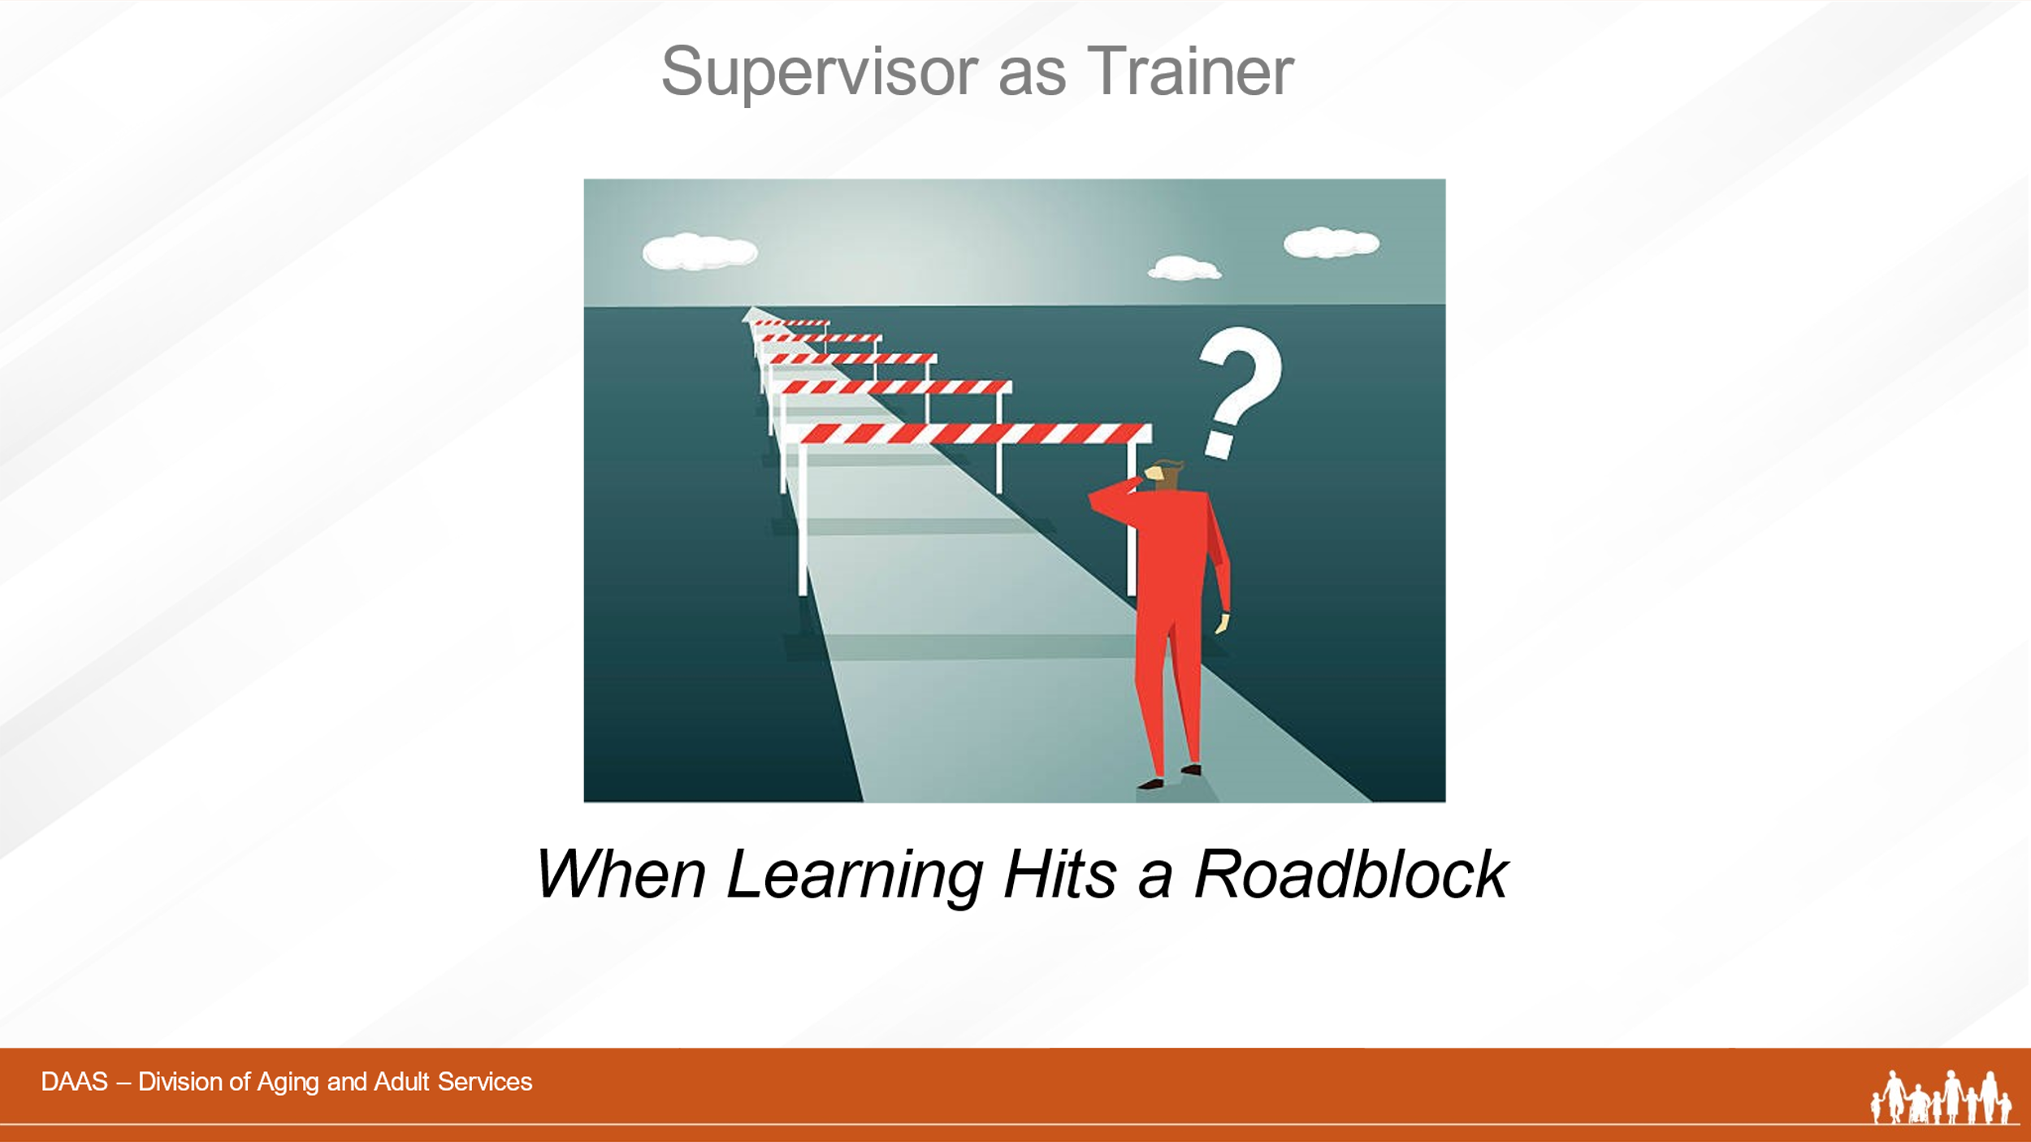
Facilitator:
We’ve all probably experience staff who seem to be progressing well in their learning journey and then seem to become “stuck.”
Slide 38 | 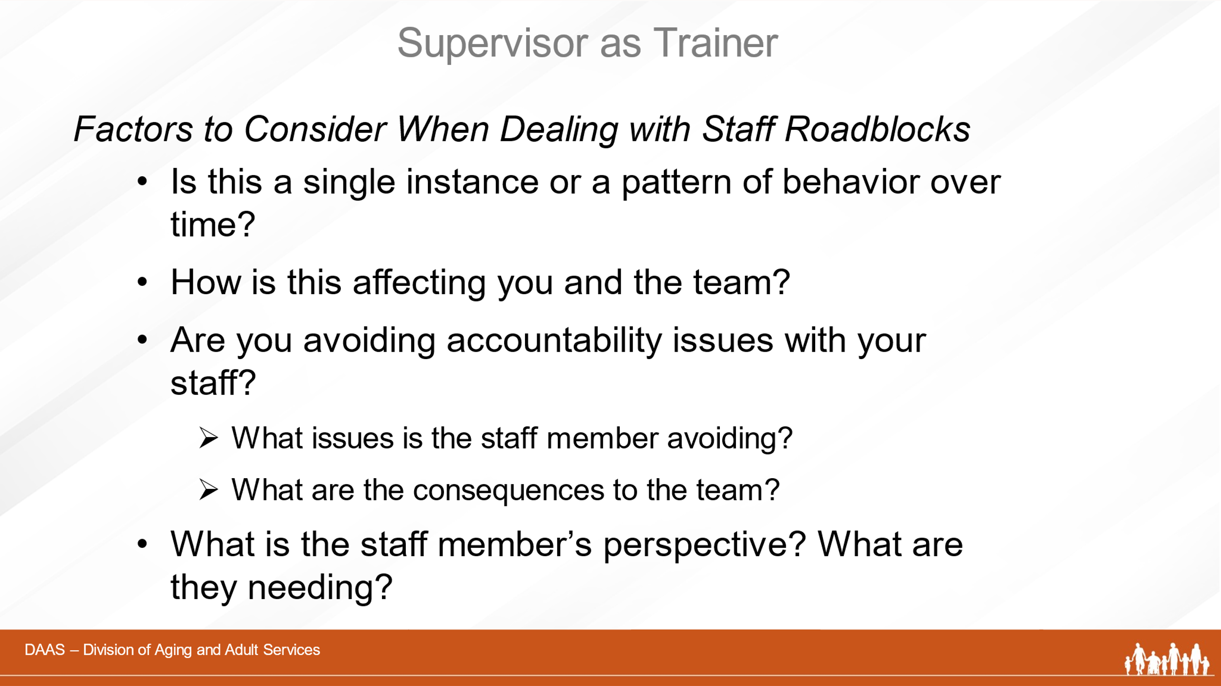
Facilitator:
Here are a few considerations to make as you decide how to respond:
- Is this something new or have you noticed a change over a period of time?
- Have you noticed an effect on the rest of the team?
- Does the staff member seem to be avoiding certain issues and are you clear about what is expected?
- Have you asked the staff member what they are experiencing and what they need?
Slide 39 | 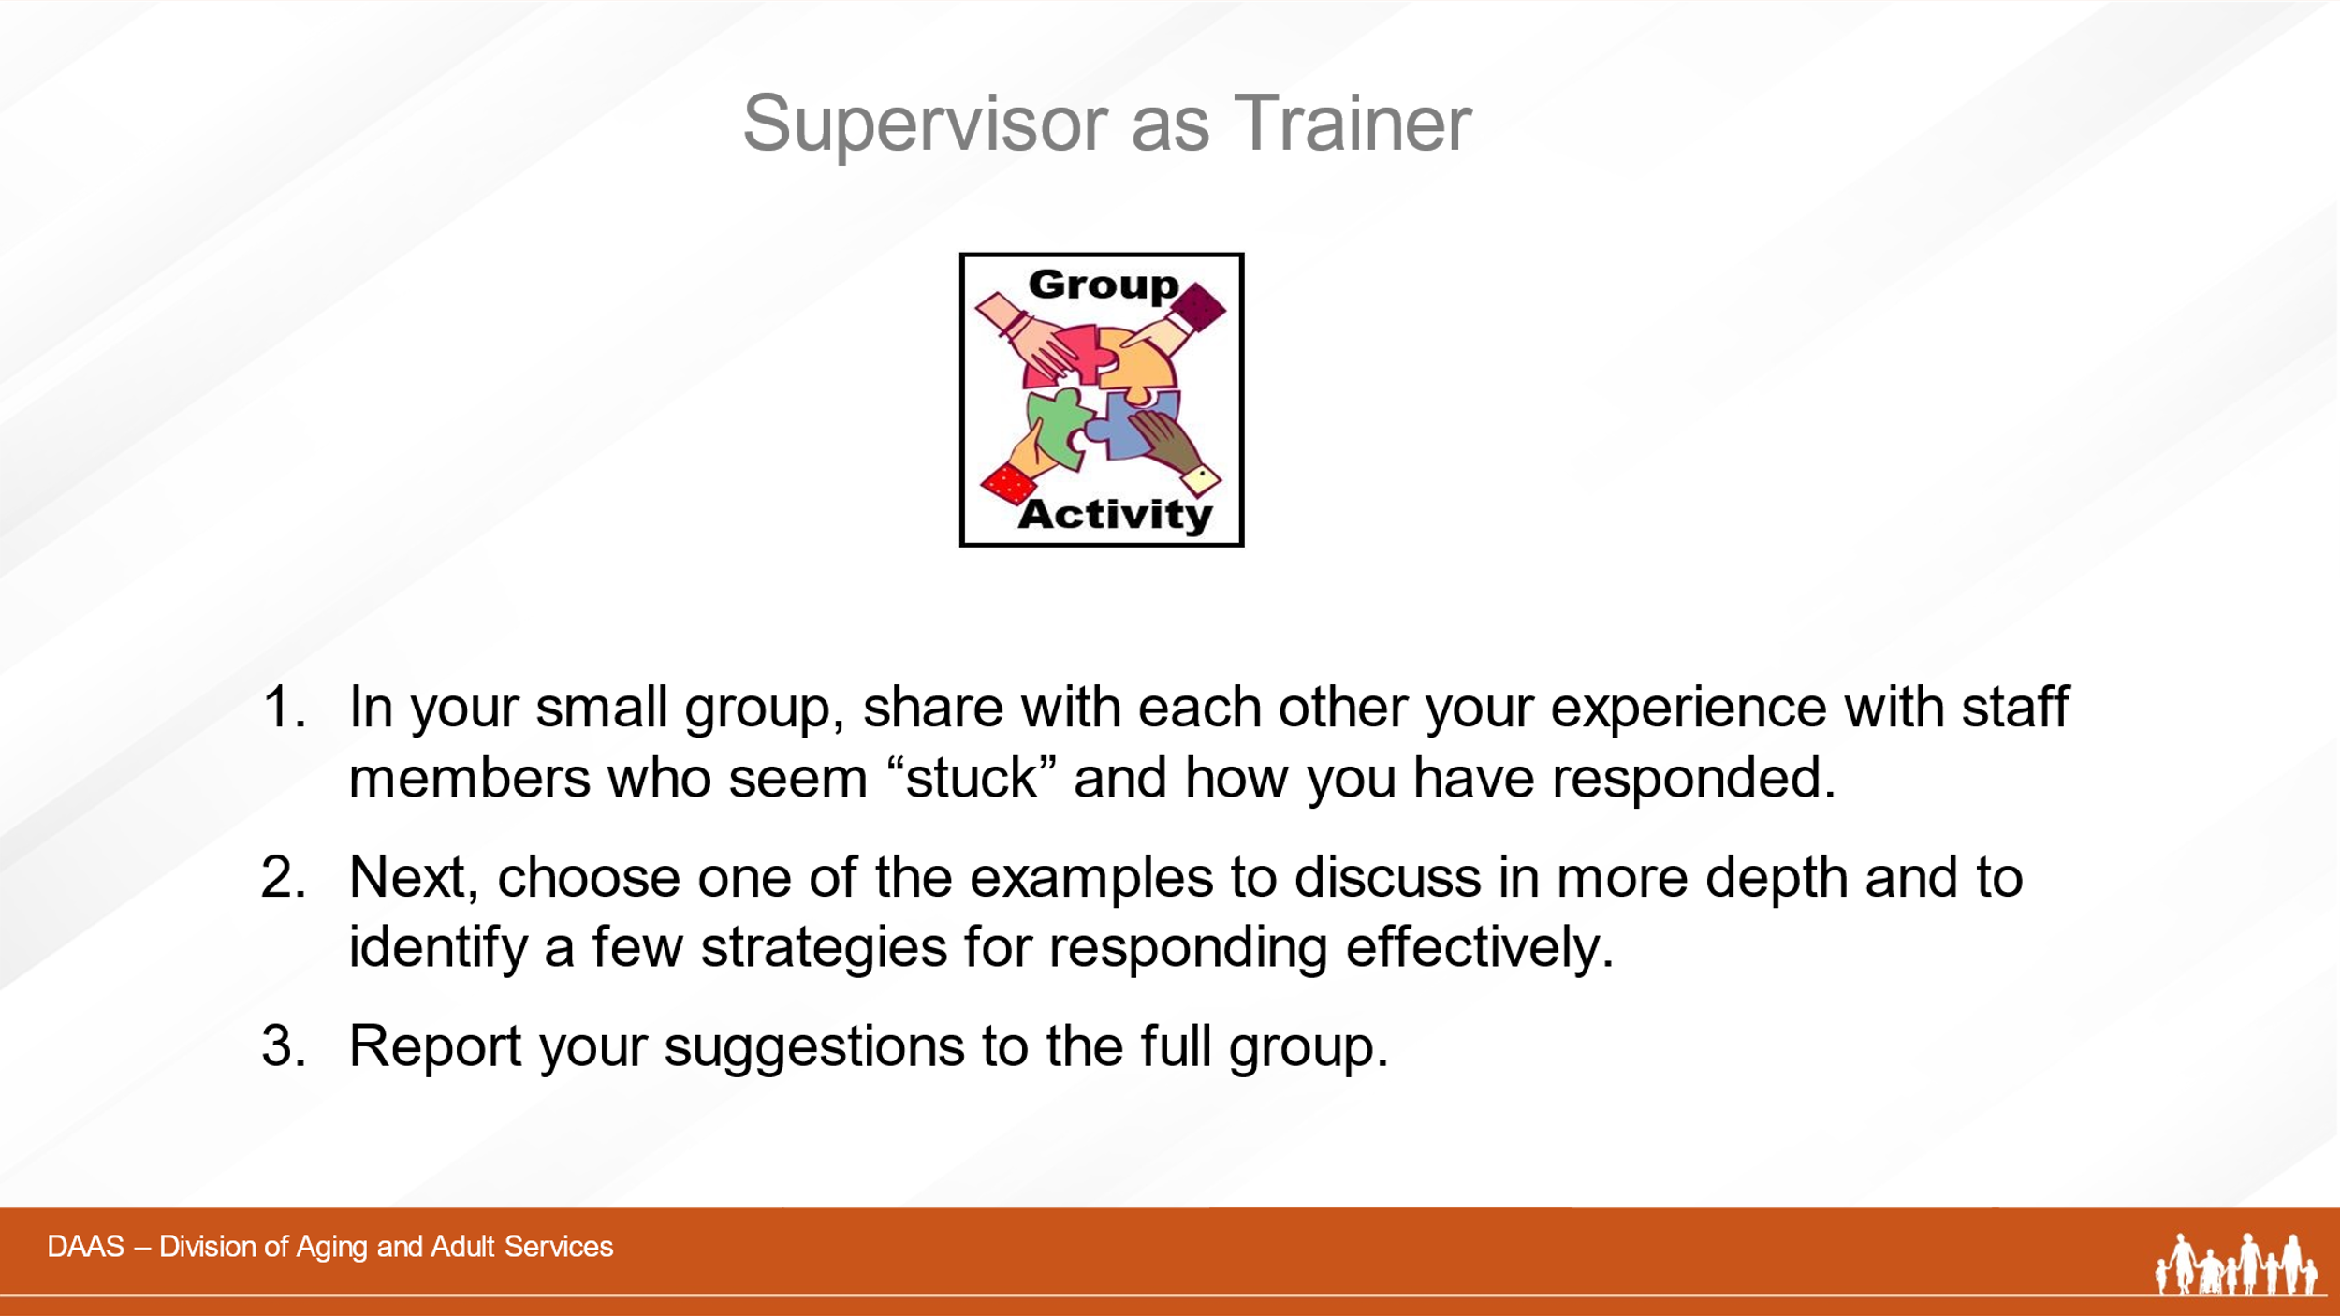
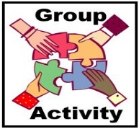 | Facilitator:  So taking these considerations into account, let’s try a group activity. As you see on the screen, you’ll be working in small groups to first share with each other your experiences with staff members who seem to have hit a roadblock. Describe what you observed and what you did that worked – or didn’t.  Then, as a group, choose one example to focus on and come up with a plan for addressing the situation that you will share with the whole group.  You’ll have 20 minutes in your small group and we’ll send you a 5-minute warning.
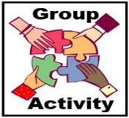 | * Note to Producer:  - Break participants into small groups of 4-5, announce each group’s participants and assign a spokesperson for each group.  - Paste the directions in the CHAT.  - Give a 5-minute warning before bringing groups back together.  *Note to Facilitator:  Possible answers: information overload; no opportunties for practice or shadowing shortly after receiving content; need for more review; personal issues affecting readiness to learn
Facilitator:
Welcome back, groups! Let’s hear from each of you about your chosen “roadblock” and your suggested strategies for responding.
(Groups share their suggestions and facilitator acknowledges the contributions of each. )
You have all shared some very good strategies for helping staff members who hit roadblocks. Thank you!
Slide 40 | 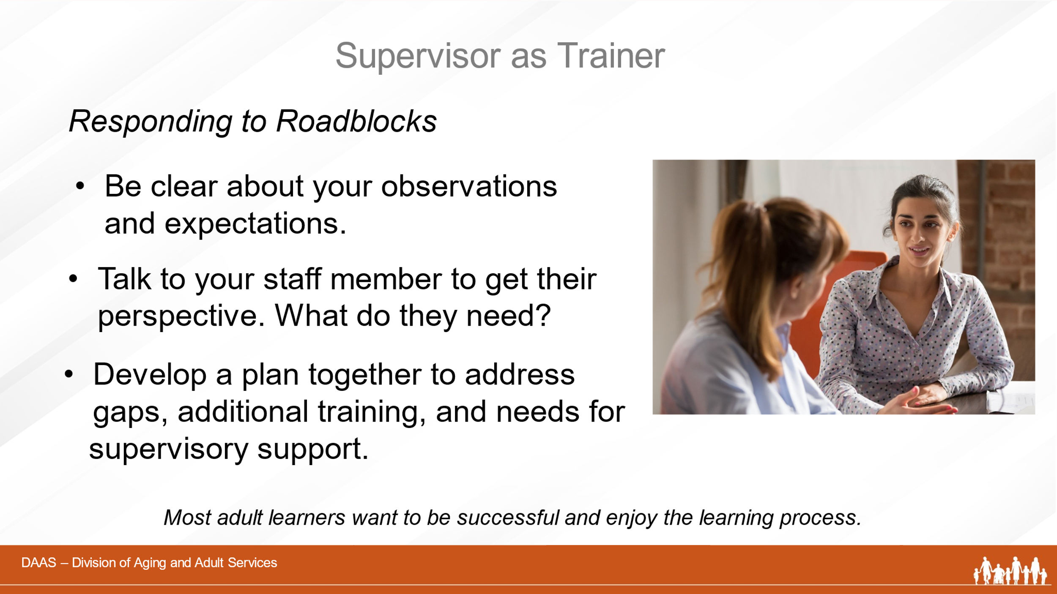
Facilitator:
Let’s summarize now with these thoughts about responding to learning roadblocks.
- Be clear about your observations and expectations with your staff.
- Have conversations with your staff to gain their perspectives.
- Develop plans to address learning gaps, additional training, and needs for supervisory support.
Slide 41 | 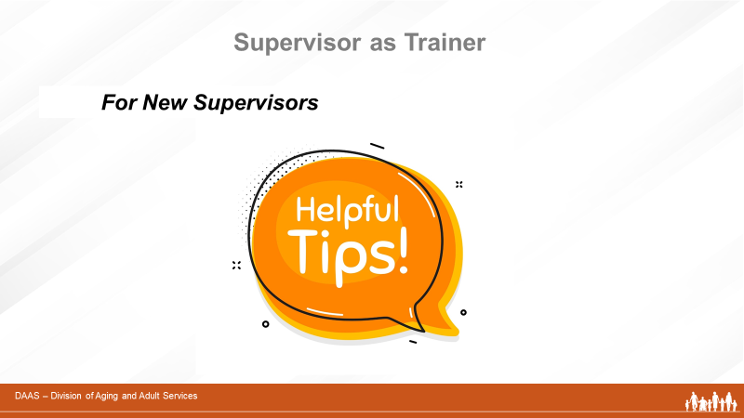
Facilitator:
As we discussed earlier in this module, an APS supervisor has a multi-faceted role keeping many balls in the air at the same time. Those of you who are new APS supervisors might feel like you have jumped on a merry-go-round. You need to keep your balance, change your pace, and learn from your mistakes. Many things are new to you so we want to close this module by sharing some tips to help you navigate your own phases of learning.
Slide 42 | 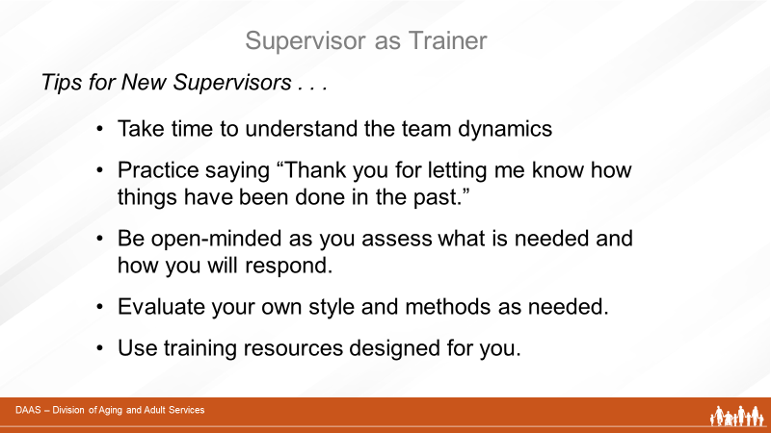
Facilitator:
- Take time to understand the internal dynamics of your team. Things may look different from a supervisory point of view.
- Practice saying “Thank you for letting me know how things have been done in the past.” You may not be ready or want to change the current routine right away.
- Be open-minded as your assess what is needed and how you will respond.
- Evaluate your own style and methods as needed. Do you need to adapt or change your approach?
- Use training resources designed for you.
(Facilitator may want to add own experiences as a new supervisor and invite comments from the group.)
Slide 43 | 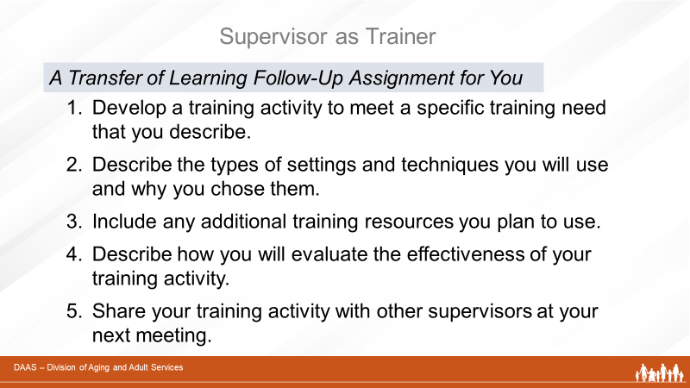
Facilitator:
We want to thank you all for taking the time to participate in this training module! As supervisor/trainer, you have the leadership role in helping your staff continue to develop their knowledge, skills and attitudes as competent professionals and members of a team.
Applying principles and techniques of adult learning provide a solid foundation for your own continued growth and success in your role as a trainer.
In closing, we would like to evaluate whether this training has been effective. To do this, we are leaving you with a follow-up assignment.
Please develop a training activity to address a specific staff training need of your choice. Describe the training need and activity you want to develop. Include the types of setting(s) and techniques you plan to use and why you chose them. List any existing training resources you plan to use and how you will evaluate the transfer of learning for this activity. Finally, be prepared to share your training activity with other supervisors during your next meeting.
 | You will find the Instructions for Transfer of Learning Assignment on Page 32 of your Participant Guide.
Slide 44 | 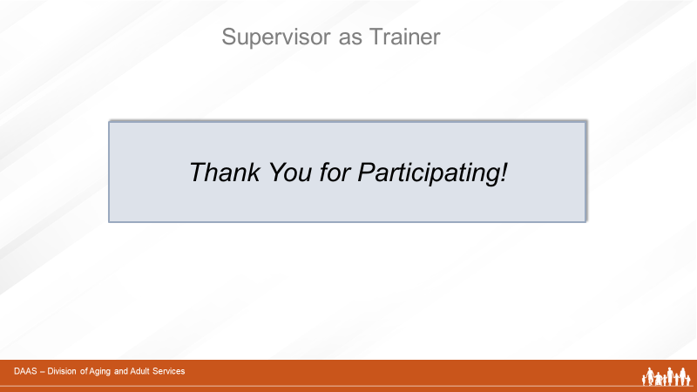
 | Thank you again for being such a great group!!

Training Tasks for Small Group Activity – Developing a Training Activity
(Facilitator’s Version)
Break participants into small groups. Assign a spokesperson for each group. Give each group one of the following training tasks to work on.
Allow 20 minutes to complete small group work. Reconvene and ask each group to report their suggestions. Have producer keep whiteboard list of suggested training settings and techniques to review.
- Identify several training strategies to increase a new staff member’s knowledge of the aging process.
Possible Responses:
Training Settings | Training Techniques | Support Materials
Instructor-led class  One-on-one supervision  On-the -job training  Small group | Lecture  Reading – writing assignments  Structured observations  Role plays | APSWI – e-learning “Aging Process” and Supervisor’s Workbook with Activities

- Identify several training strategies for staff needing to increase knowledge and skills for serving adults living with disability.
Possible Responses:
Training Settings | Training Techniques | Support Materials
Instructor-led class  Small group  On-the-job training | Lecture  Video  Small group discussion  Structured observations | APSWI – e-learning “Physical & Developmental Disablility.”  TARC – “Meet Us Where We Are” (video)

- Identify several training strategies for increasing staff knowledge and skills for investigating reports of alleged financial exploitation.
Possible Responses:
Training Settings | Training Techniques | Support Materials
Instructor-led class  Small group  On-the-job training | Lecture  Reading & Writing Assignments  Video  Small group discussion  Structured observations in field | APSWI – e-learning “Financial Exploitation”  Field Guide Activities – (11.3, 11.4, 11.5)  Field Guide – Abuser Tactics  APSWI Video – “Alleged Perpetrator Interview”

- Identify several training strategies for increasing staff knowledge and skills to complete accurate risk assessments.
Possible Responses:
Training Settings | Training Techniques | Support Materials
On-the-job field visits  One-on-one discussions | Structured observation – Intake  Case reviews  Small group discussion | Field Guide – Knowledge Area 2: Activities 2.2, 2.3, 2.4

- Identify several training strategies to increase staff knowledge and skills for investigating reports of alleged self-neglect.
Possible Responses:
Training Settings | Training Techniques | Support Materials
Individual  Group Setting  On-the-Job Field Visits | Video  Small group discussion  Structured observations | Field Guide – Knowledge Area 9: 9.1, 9.2, 9.4  APSWI: Video “Successful Initial Visit”

