Supervisor as Coach
Division of Aging and Adult Services
Adult Protective Services
Participant Guide

Table of Contents
Introduction……………………………………………………………………………………………………….3
Section 1-Similarities Between Coaching and Mentoring………………………………………………… 5
Hand-Out #1 – Coaching and Mentoring Comparison Chart …………………………………………….8
Section 2-Coaching and Mentoring for Staff Development………………………………………………....9
Small Group Activity – Difficult Conversations …………………………………………………………….13
Section 3 Identification of Coaching Strengths through Self-Assessment……………………………….14 Handout #2 – Coaching Self Assessment Form …………………………………………………………17
Handout #3 – Strengths Action Planner …………………………………………………………………..18
Handout #4 – Example of Strengths Action Planner …………………………………………………… 19
Section 4 Strategies for Development and Improvement………………………………………………….21
Hand-Out #5 - Example of Coaching Conversation for Development …………………………………23
Hand-Out #6 - Example of Coaching Conversation for Performance ………………………………… 24
Hand-Out #7 - Coaching Conversation Planner ………………………………………………………… 25
Transfer of Learning Instructions …………………………………………………………………………….30
References ……………………………………………………………………………………………………..32
Additional Resources …………………………………………………………………………………………..34

Introduction
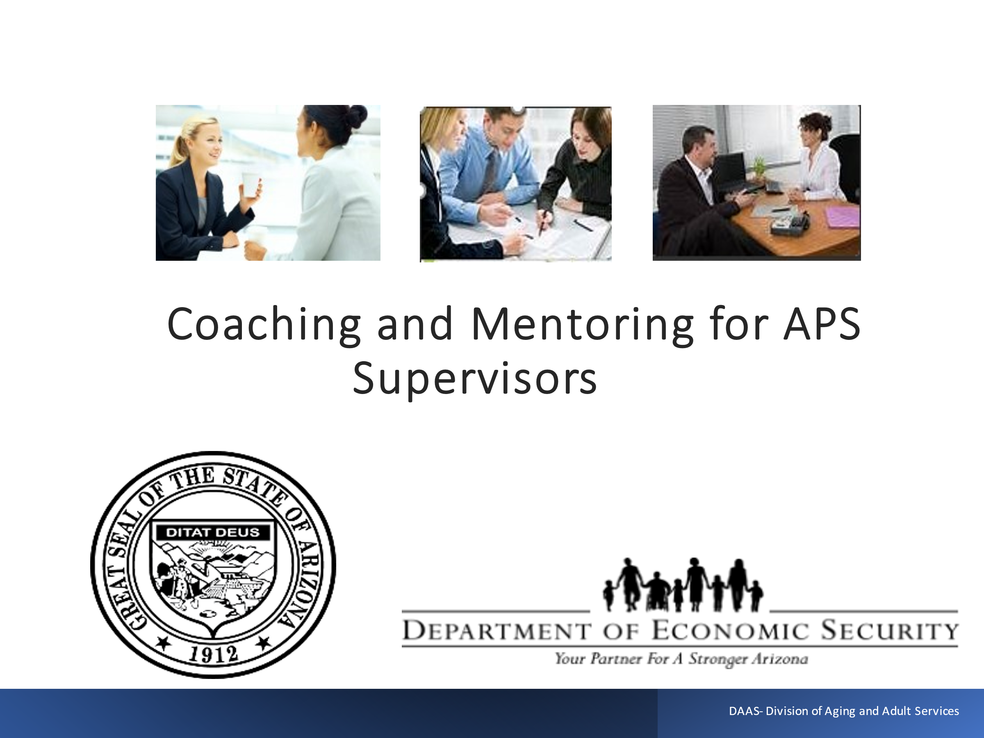

Notes: _____________________________________________
____________________________________________________
____________________________________________________
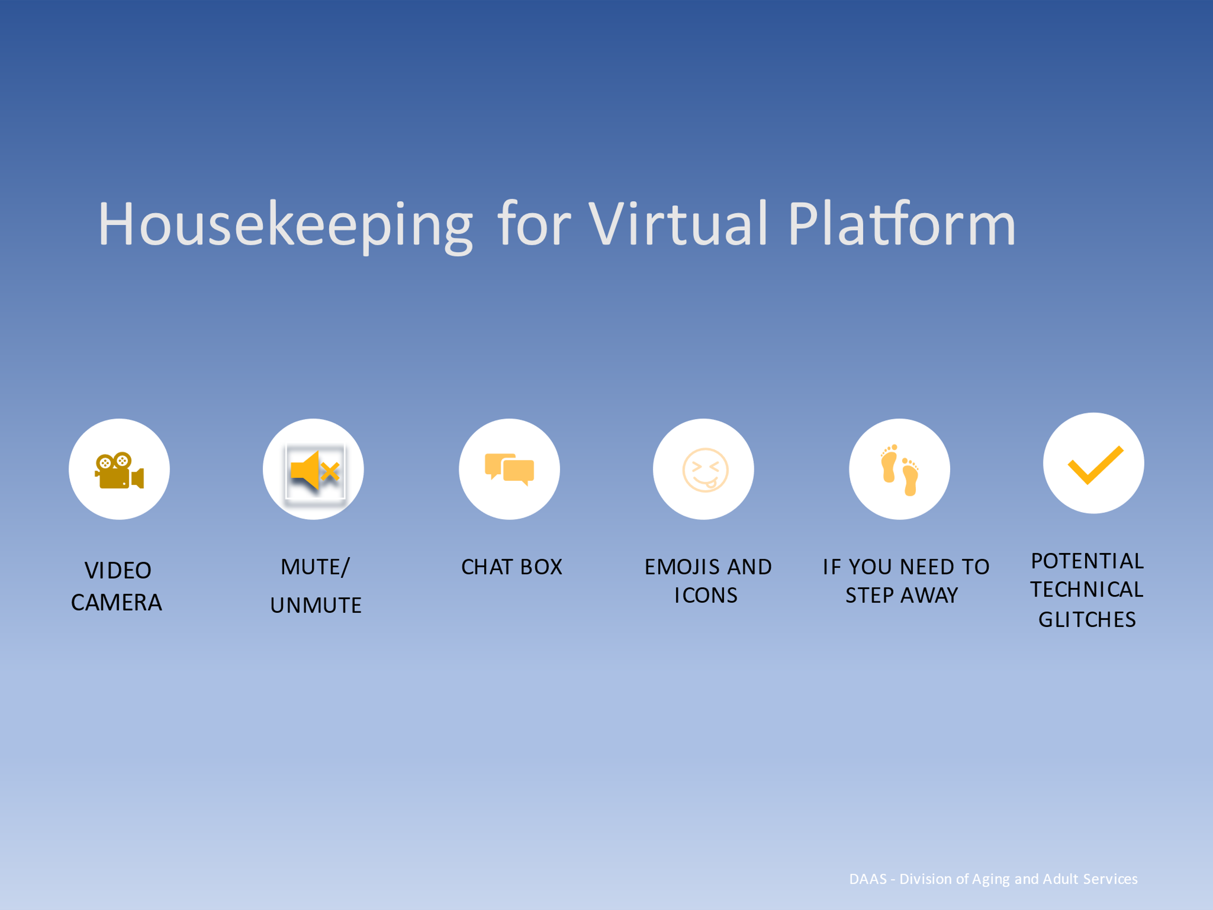
Notes: _____________________________________________
____________________________________________________
____________________________________________________
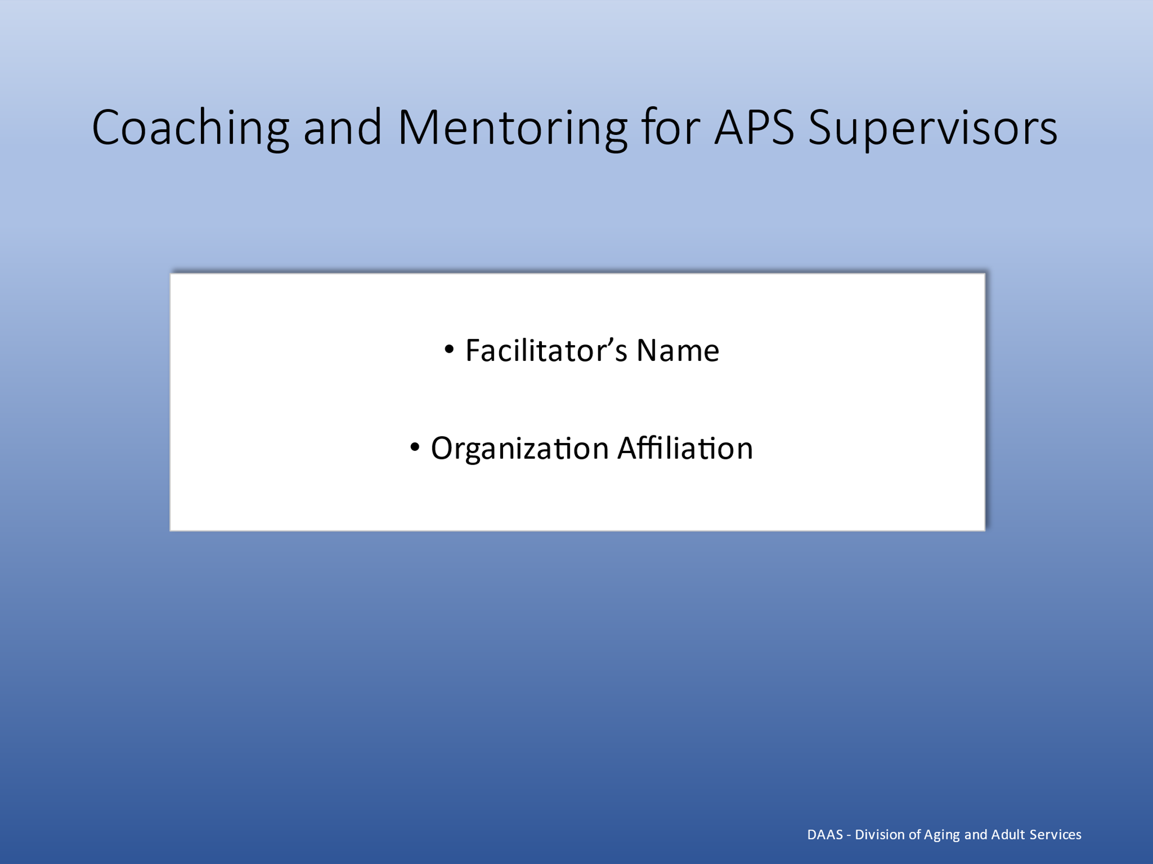
Notes: _____________________________________________
____________________________________________________
____________________________________________________
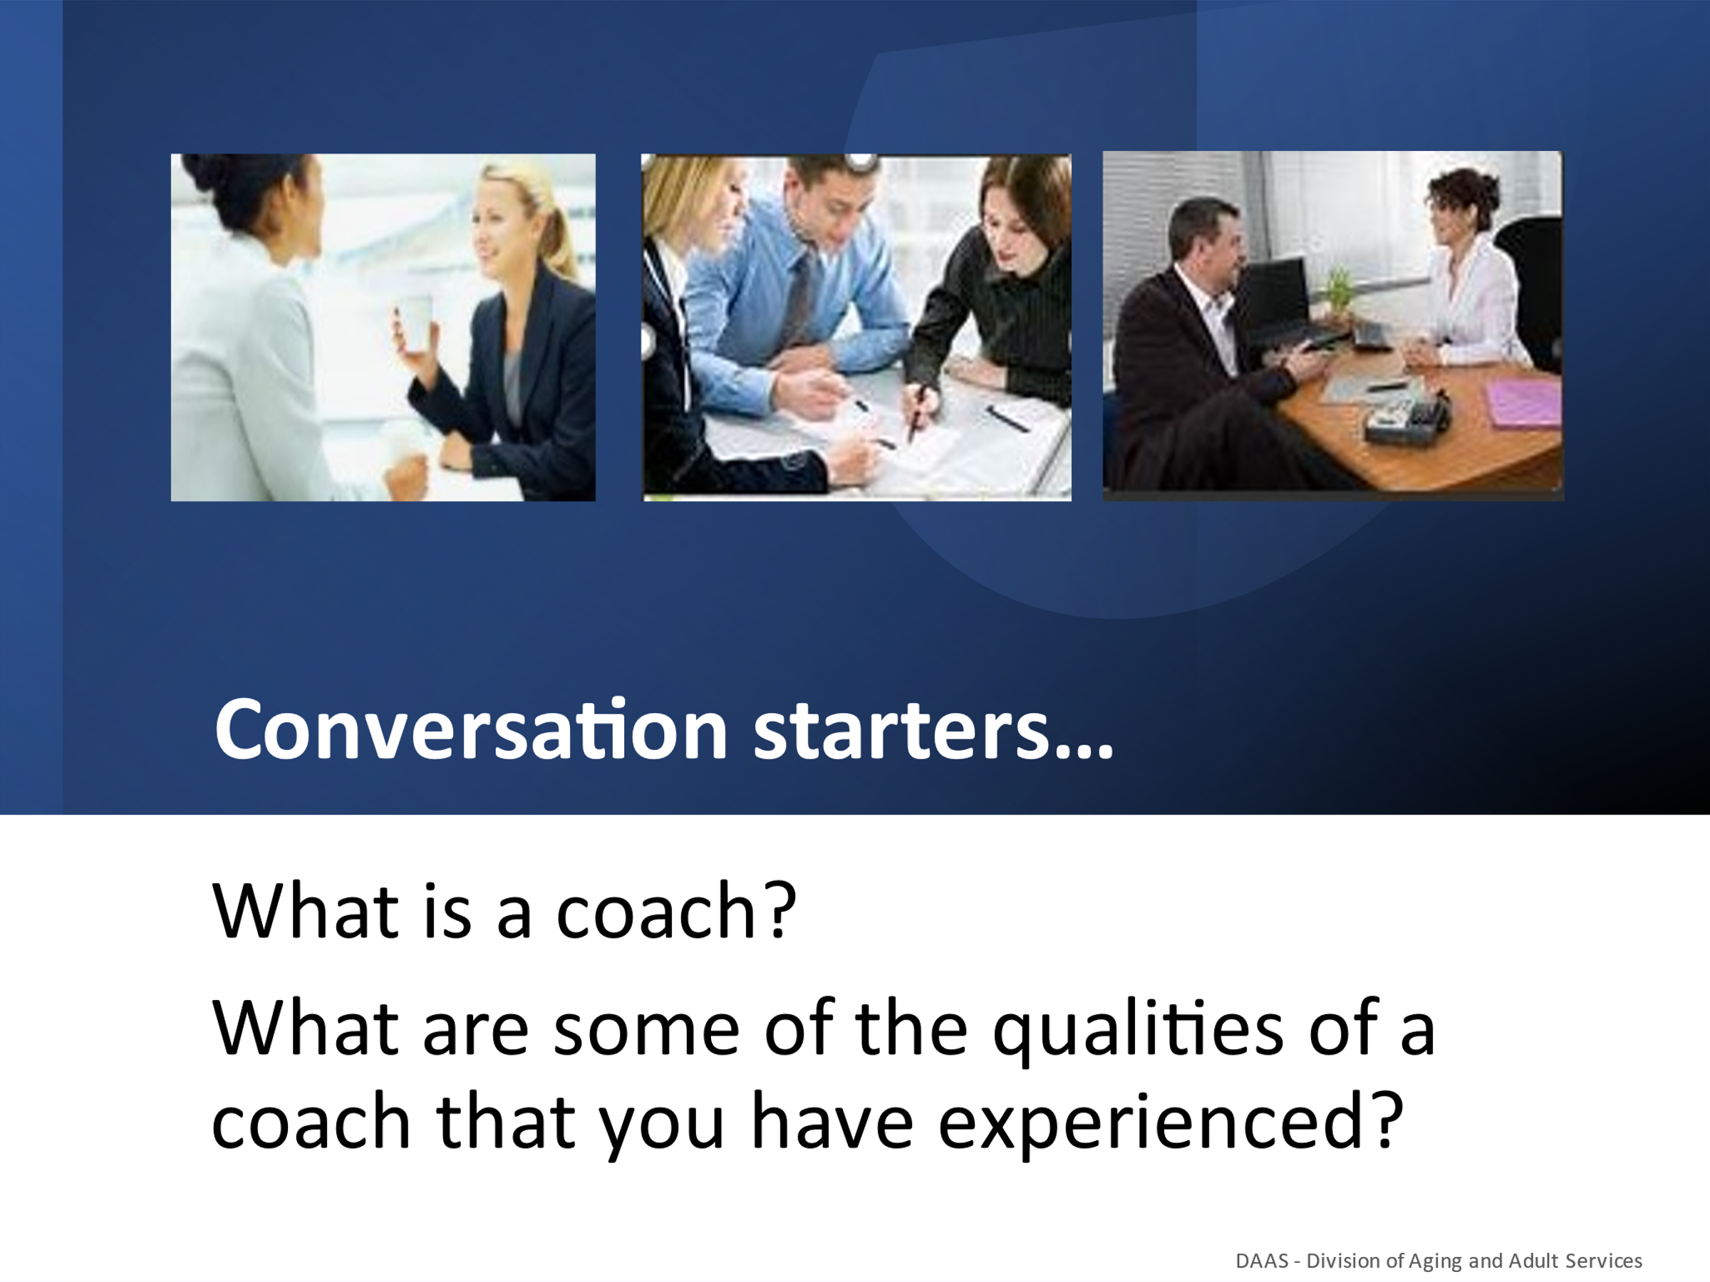
Notes: _____________________________________________
____________________________________________________
____________________________________________________
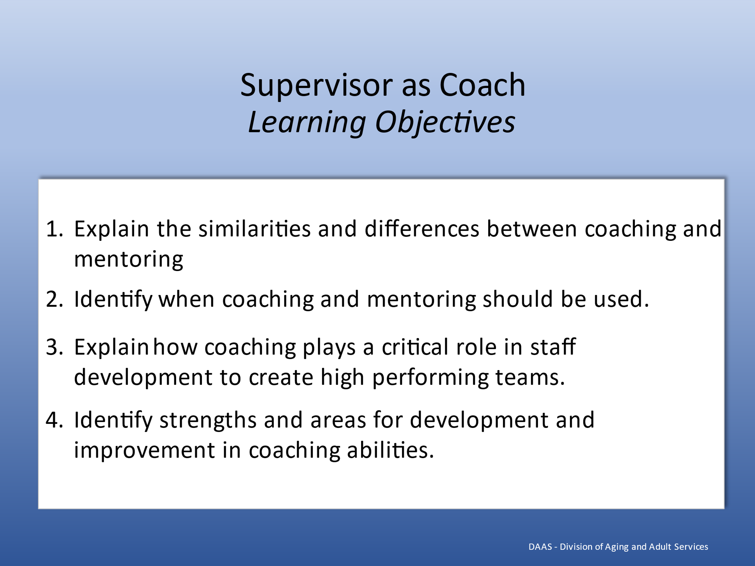
Notes: _____________________________________________
____________________________________________________
____________________________________________________

Section 1 – Similarities & Differences Between Coaching and Mentoring
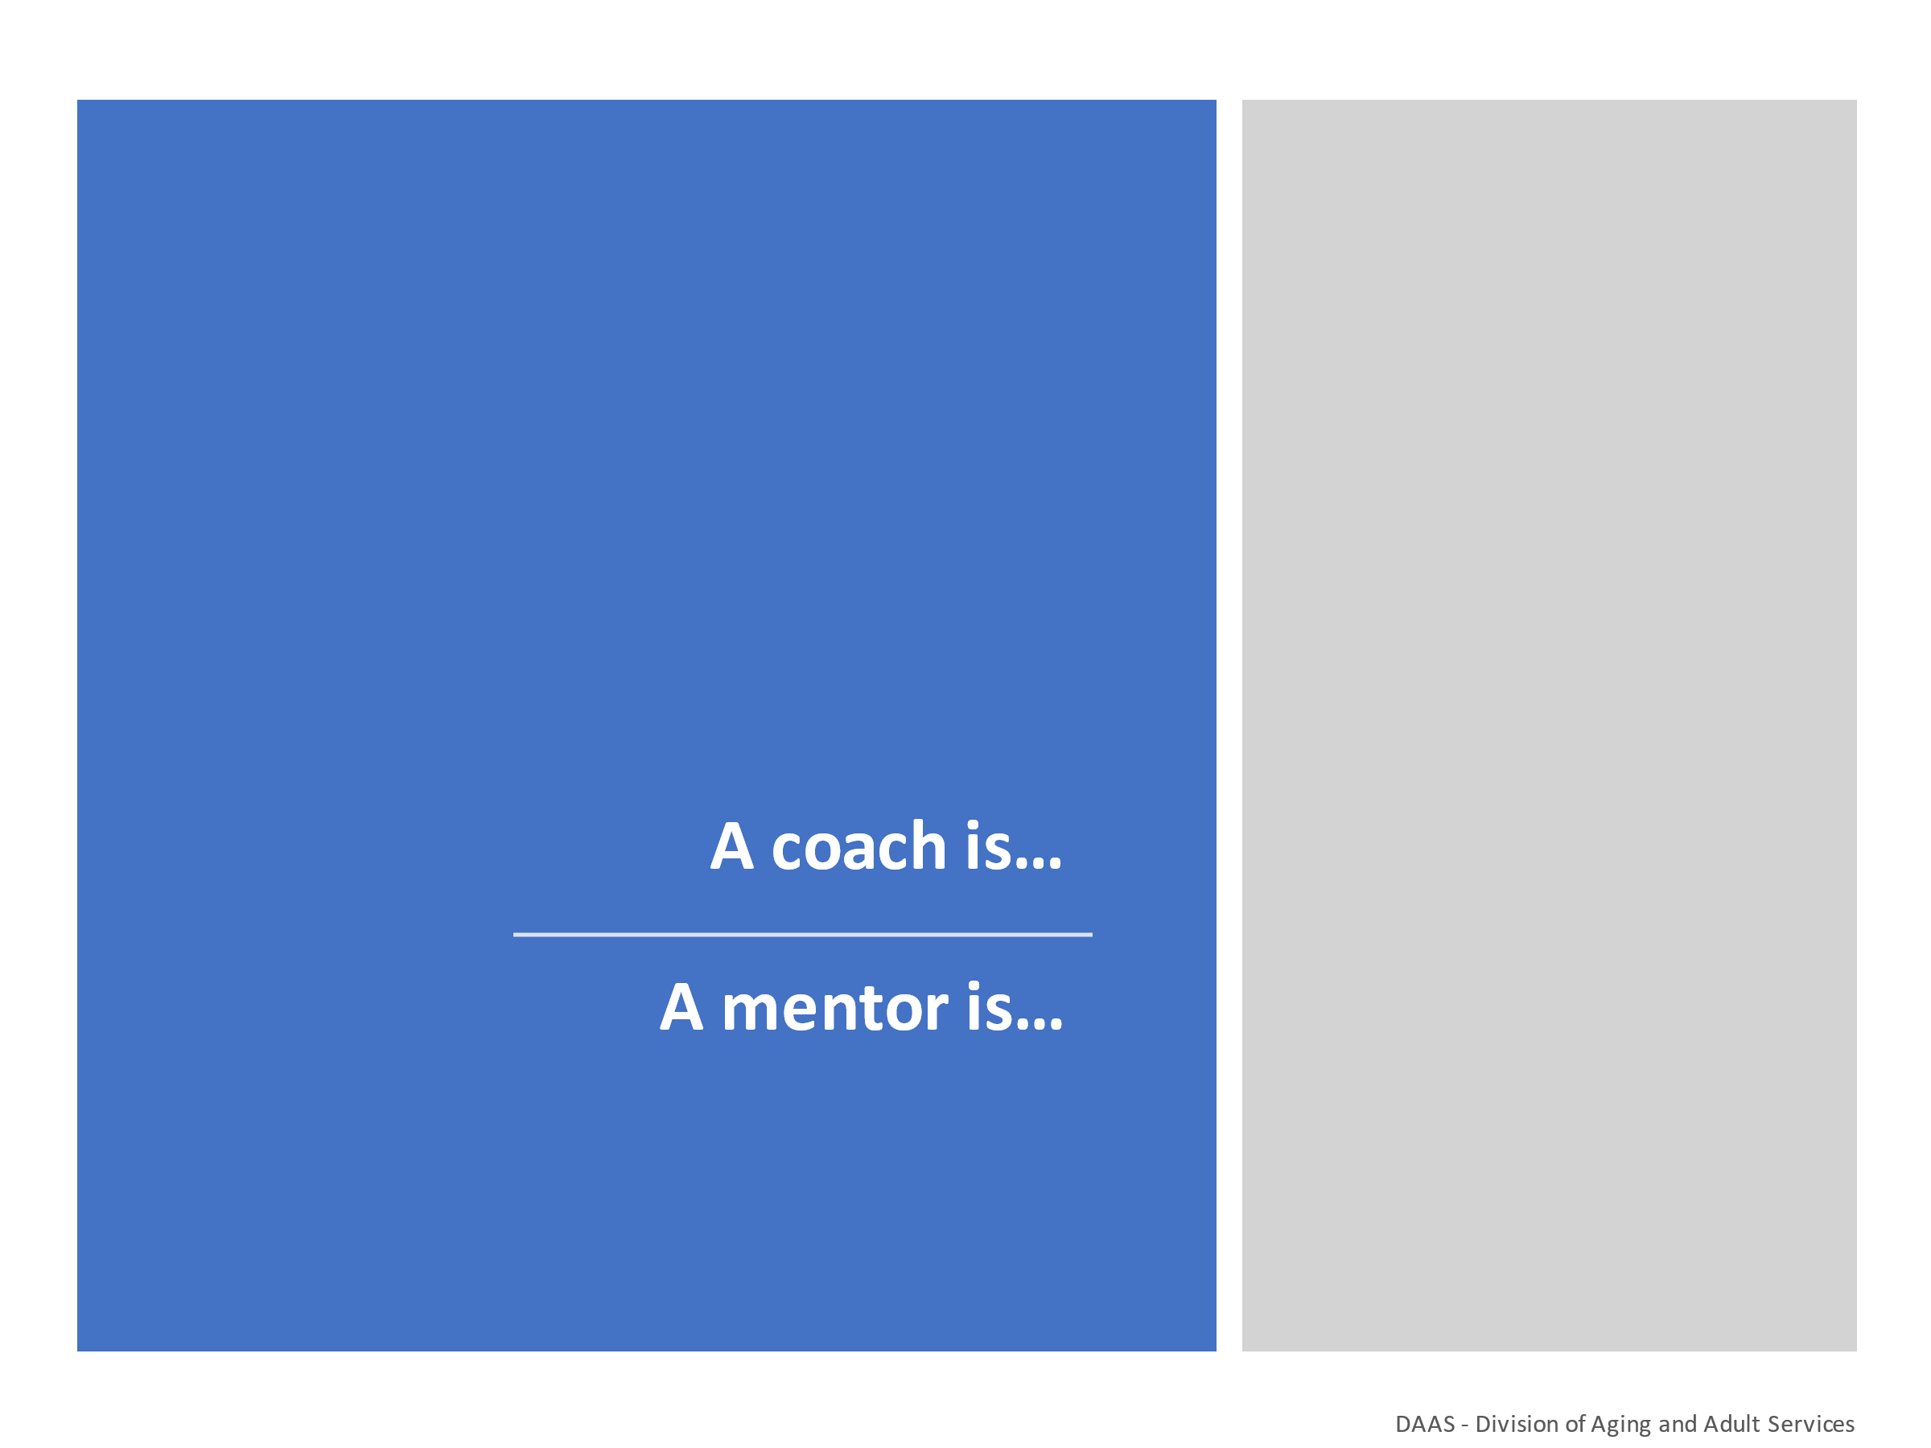

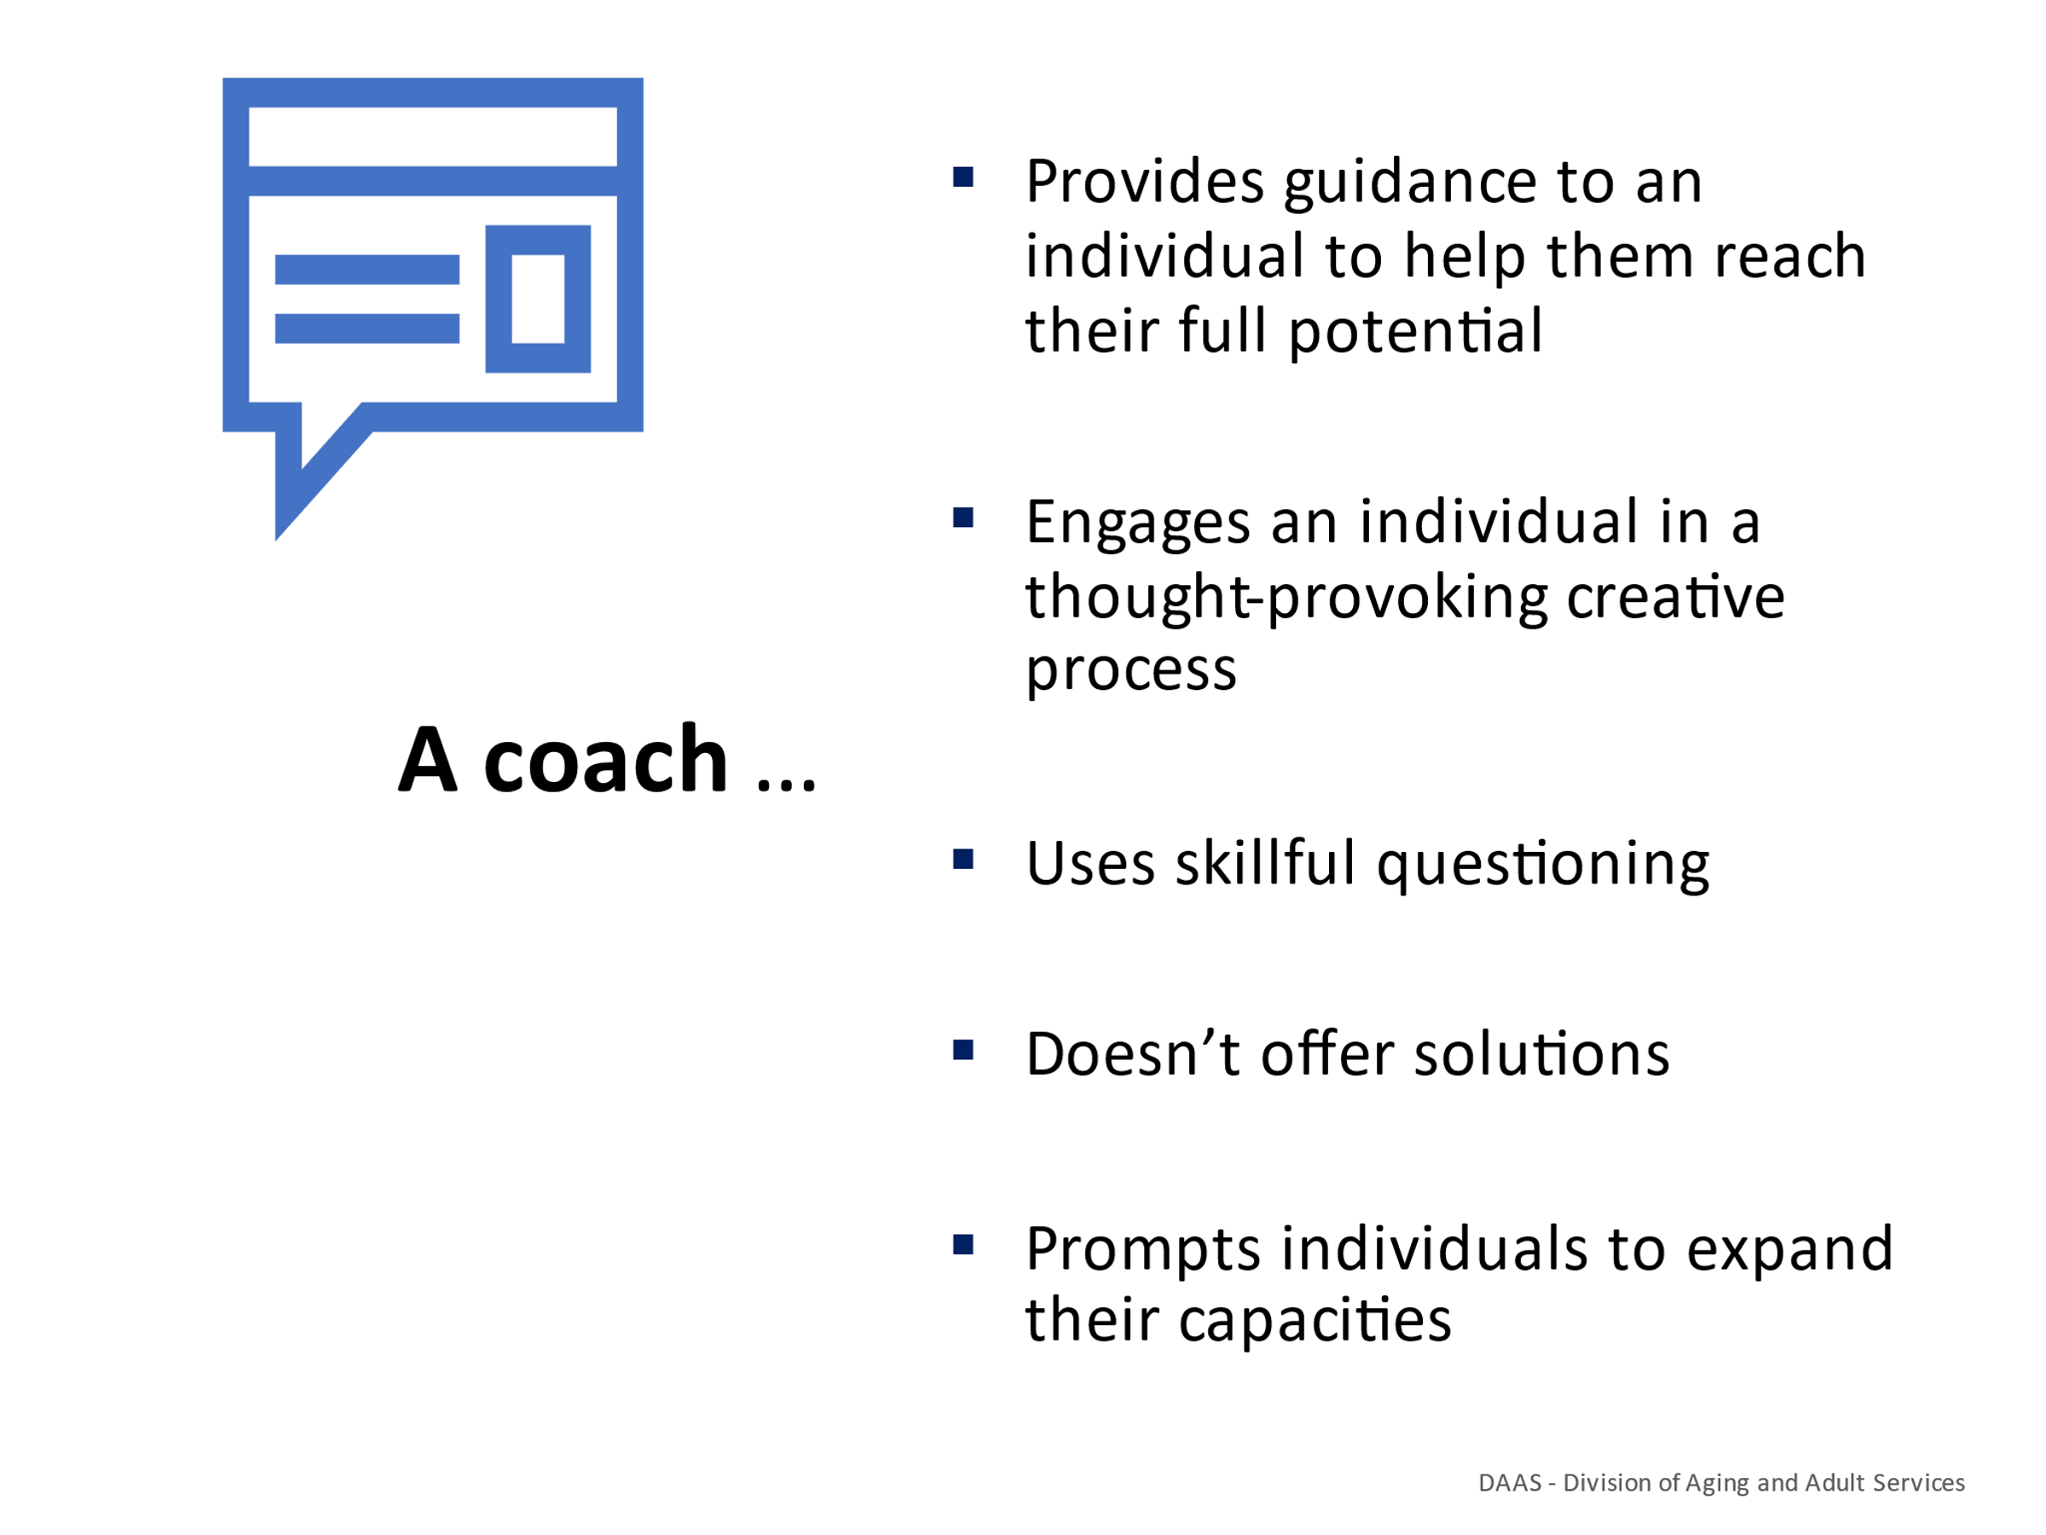
Notes: _____________________________________________
____________________________________________________
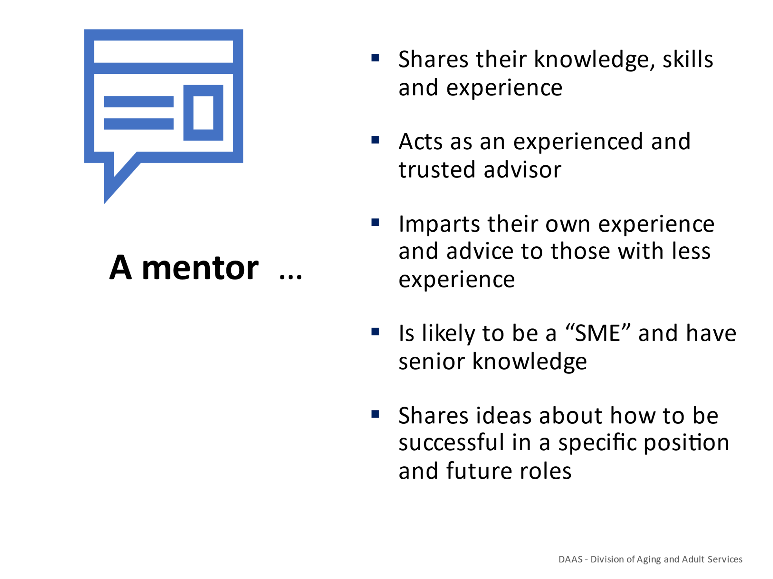
Notes: _____________________________________________
____________________________________________________
____________________________________________________

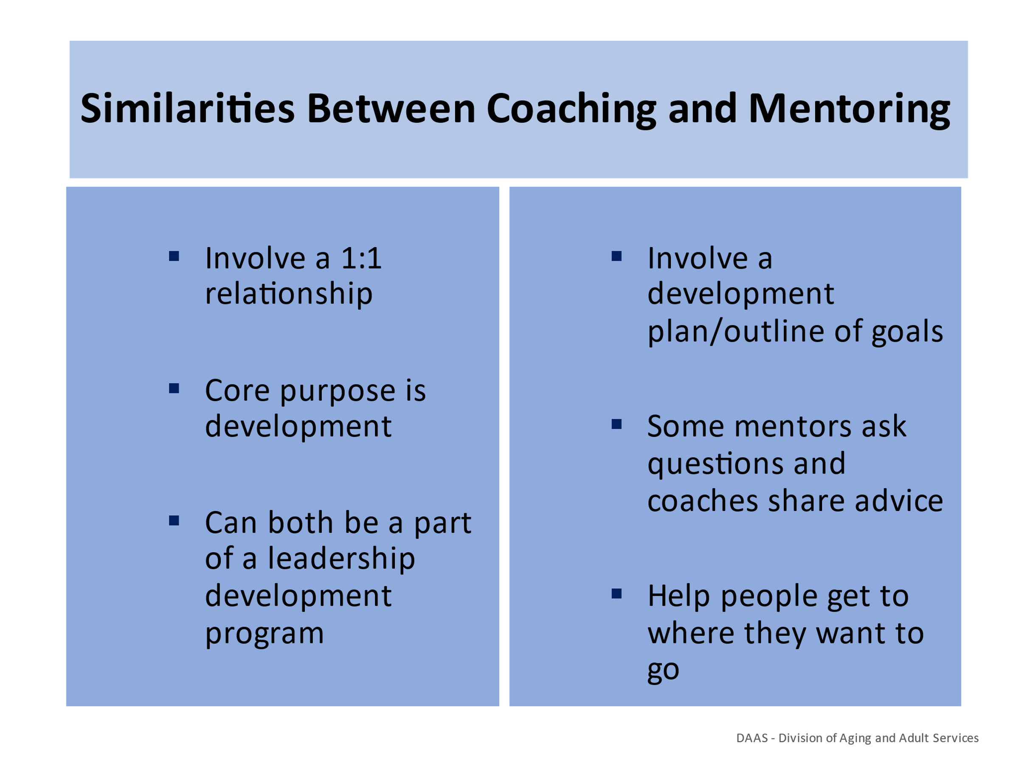
Notes: _____________________________________________
____________________________________________________
____________________________________________________

Handout # 1
Coaching & Mentoring Comparison Chart
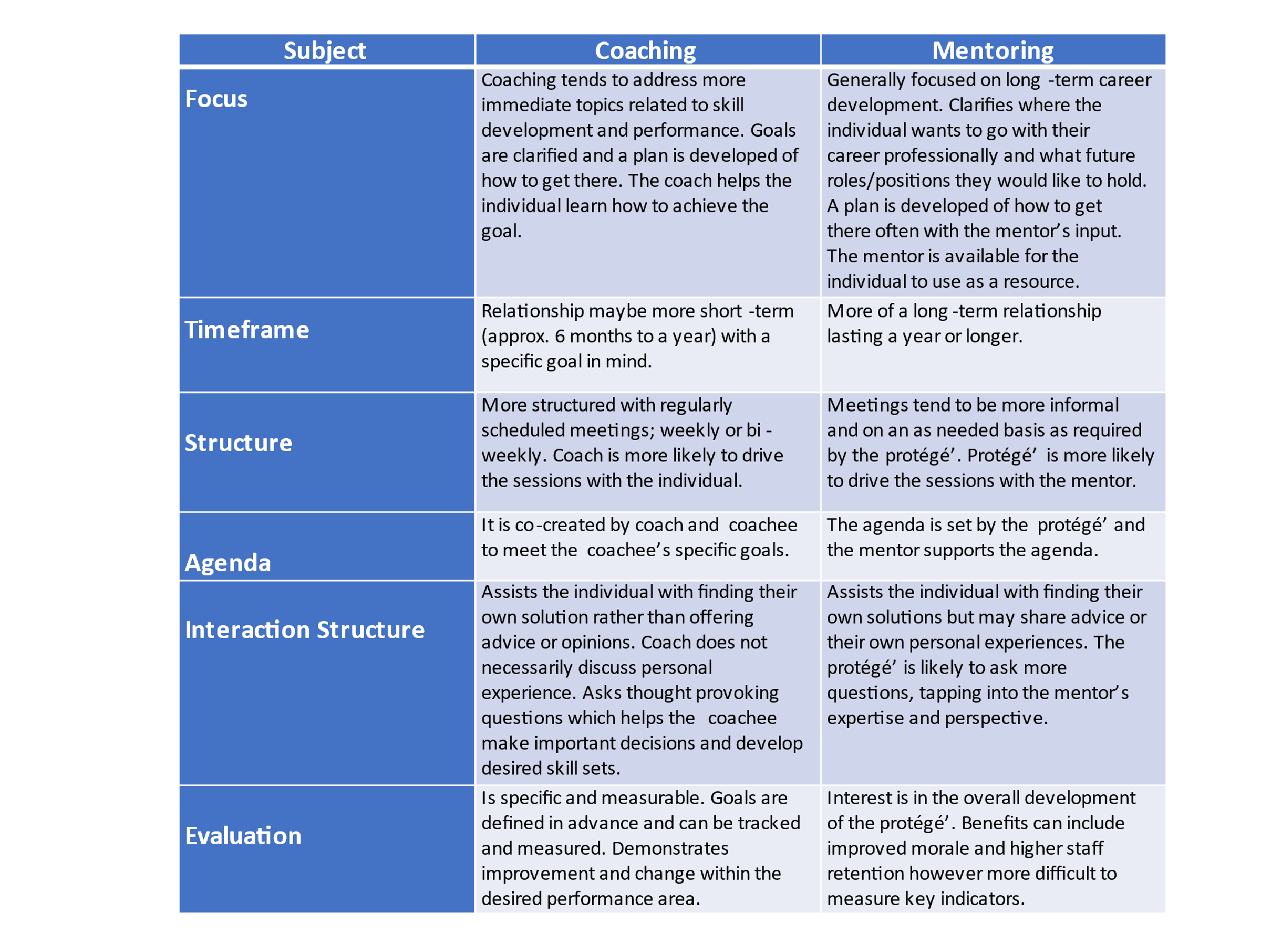

Section 2 – Coaching & Mentoring for Staff Development & Performance
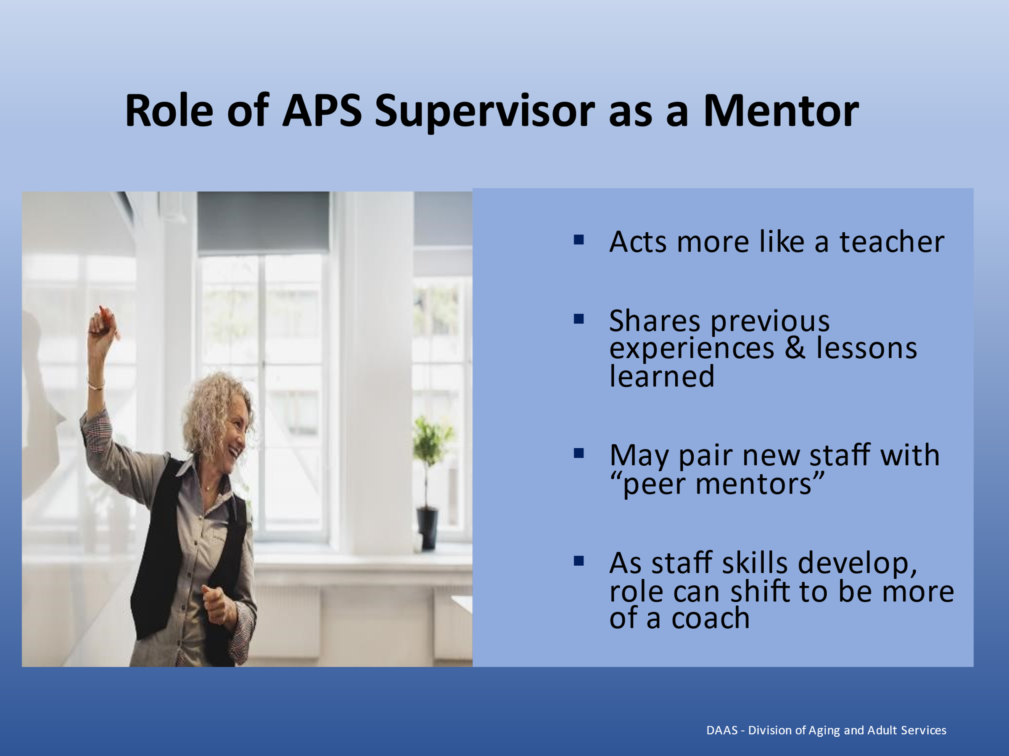
Notes: _____________________________________________
____________________________________________________
____________________________________________________
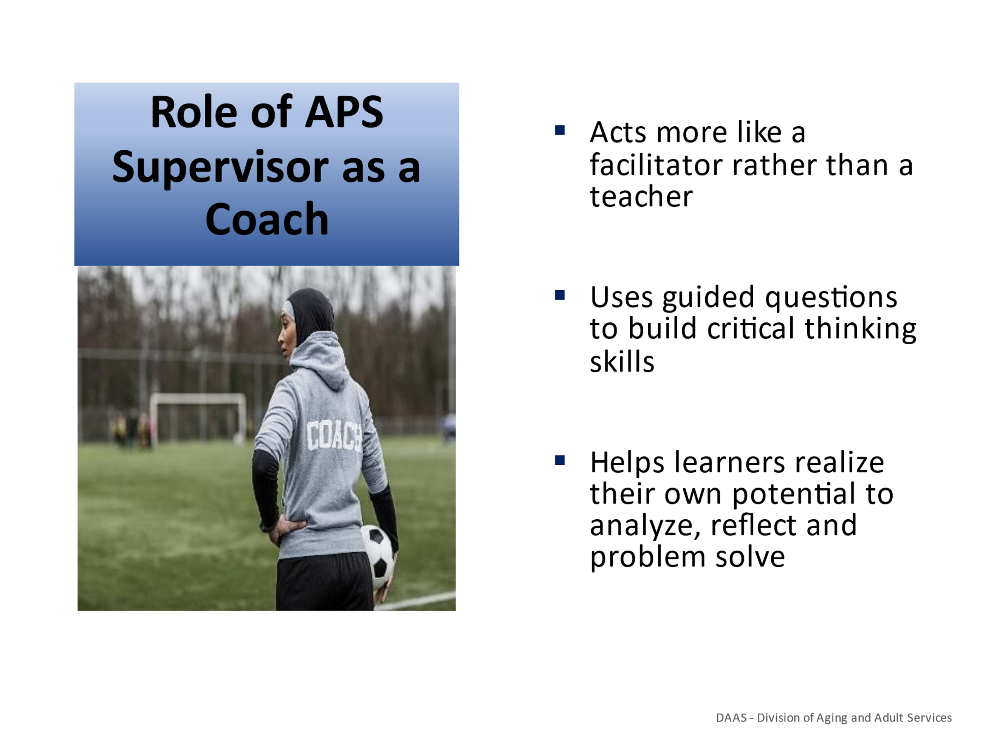
Notes: _____________________________________________
____________________________________________________
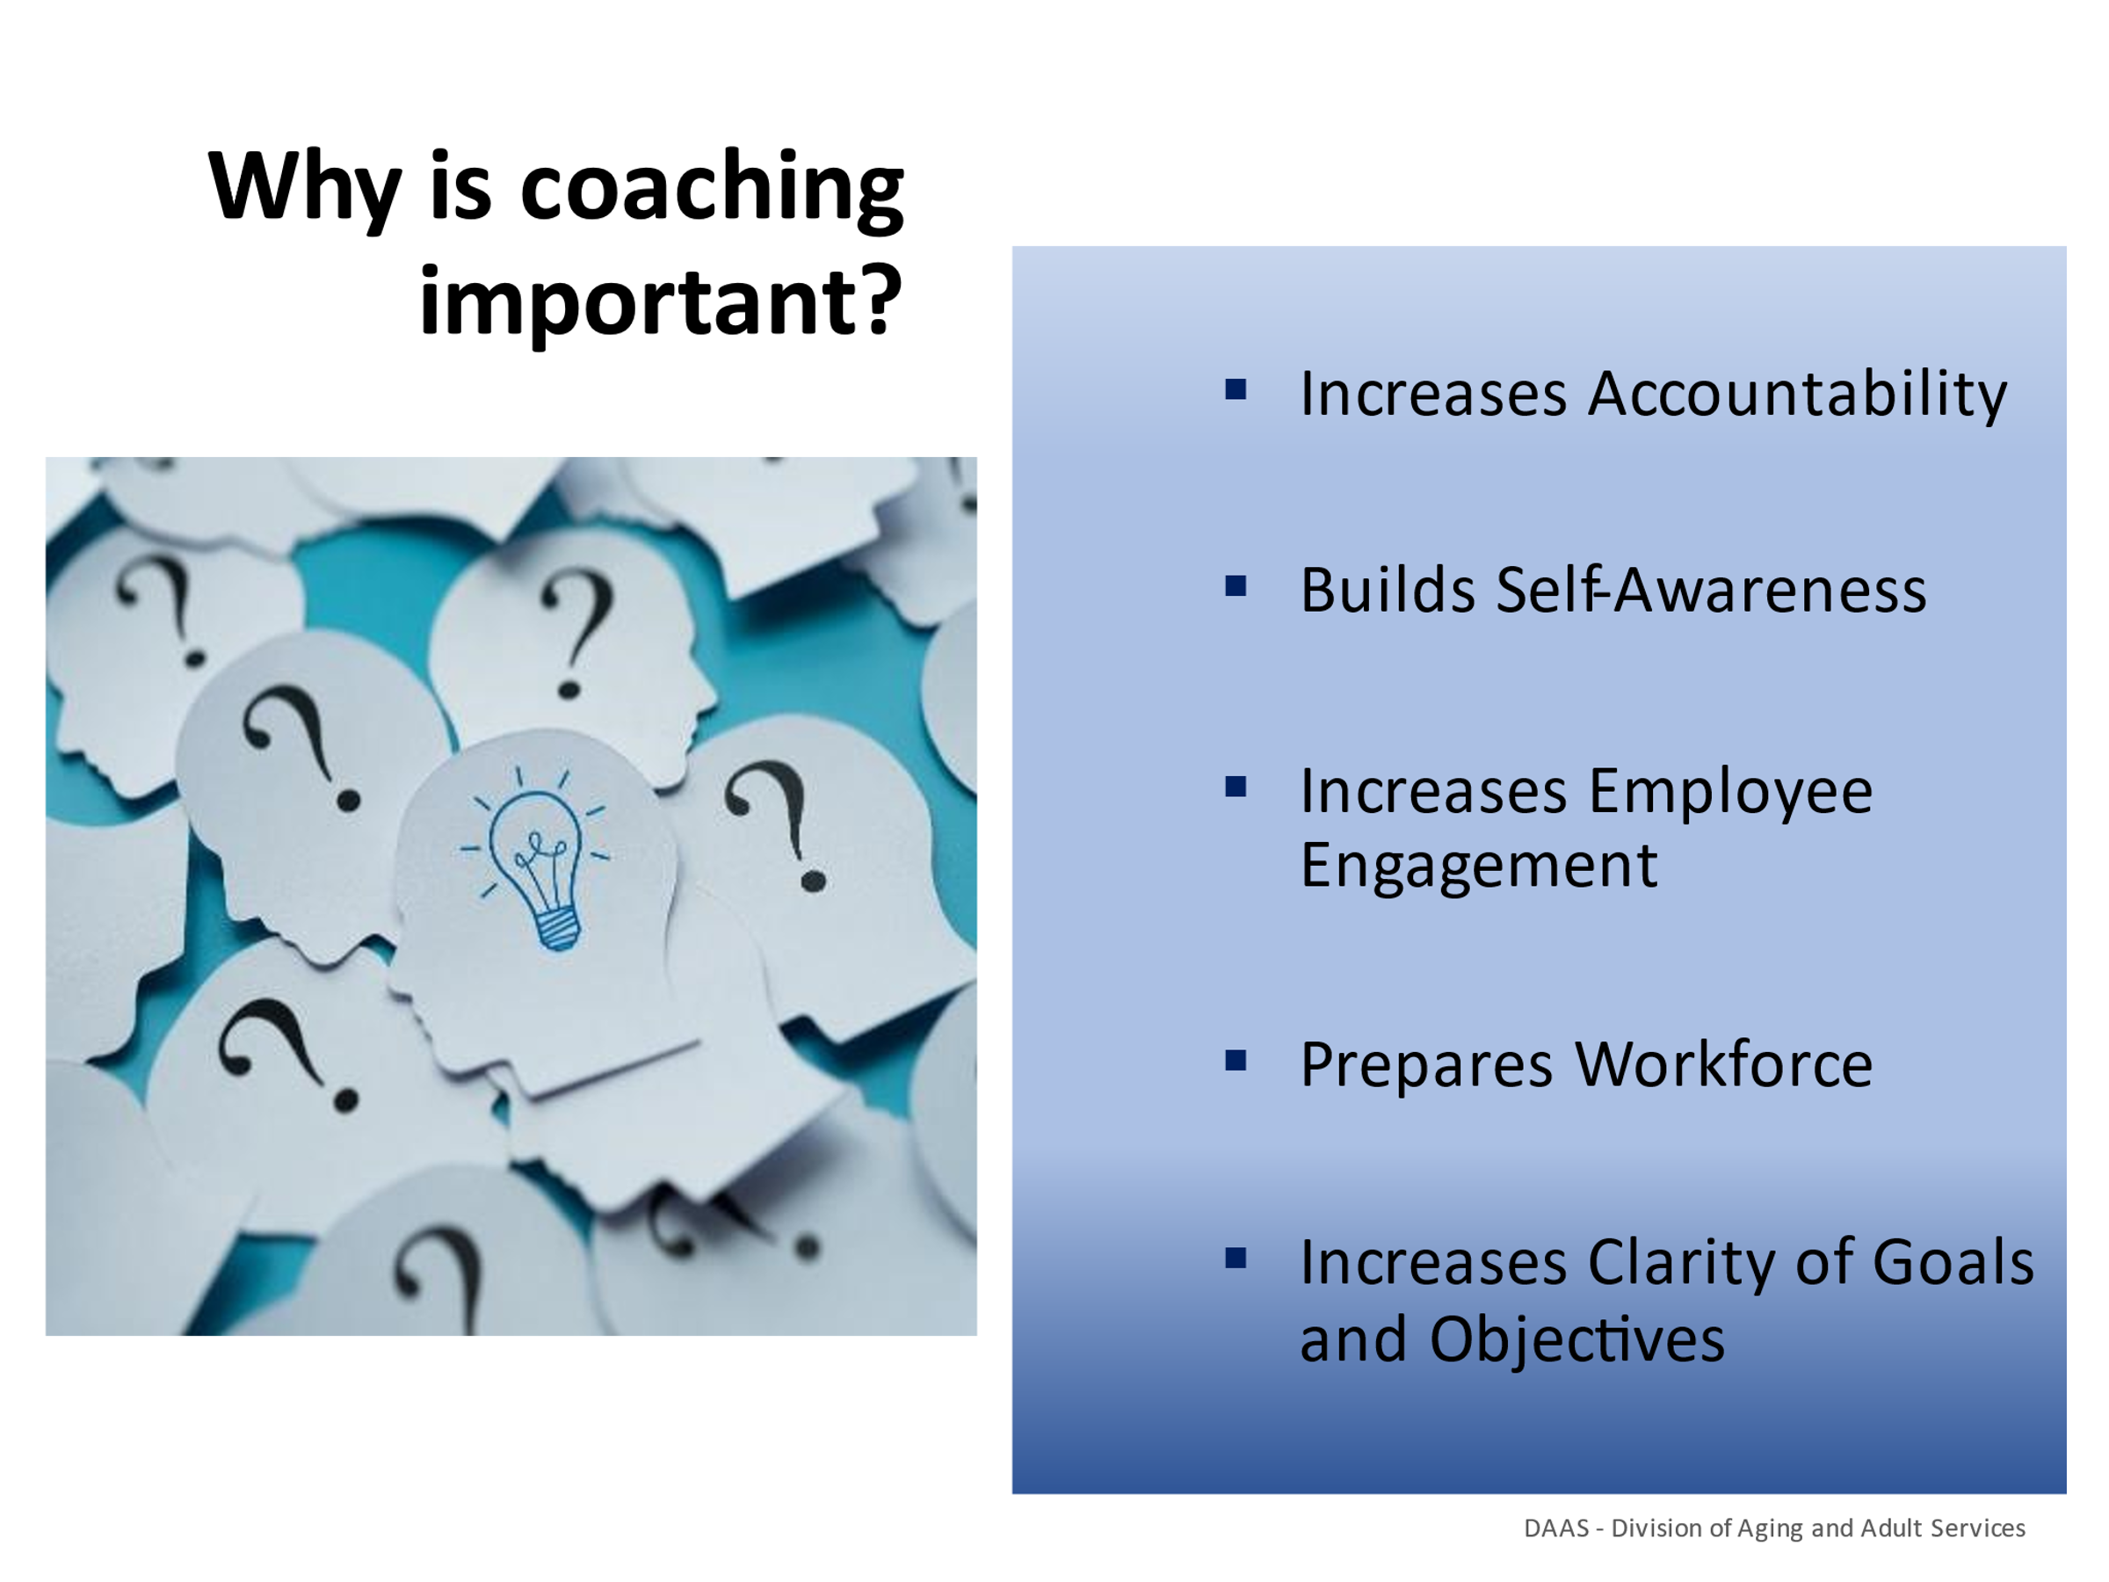
Notes: _____________________________________________
____________________________________________________
____________________________________________________
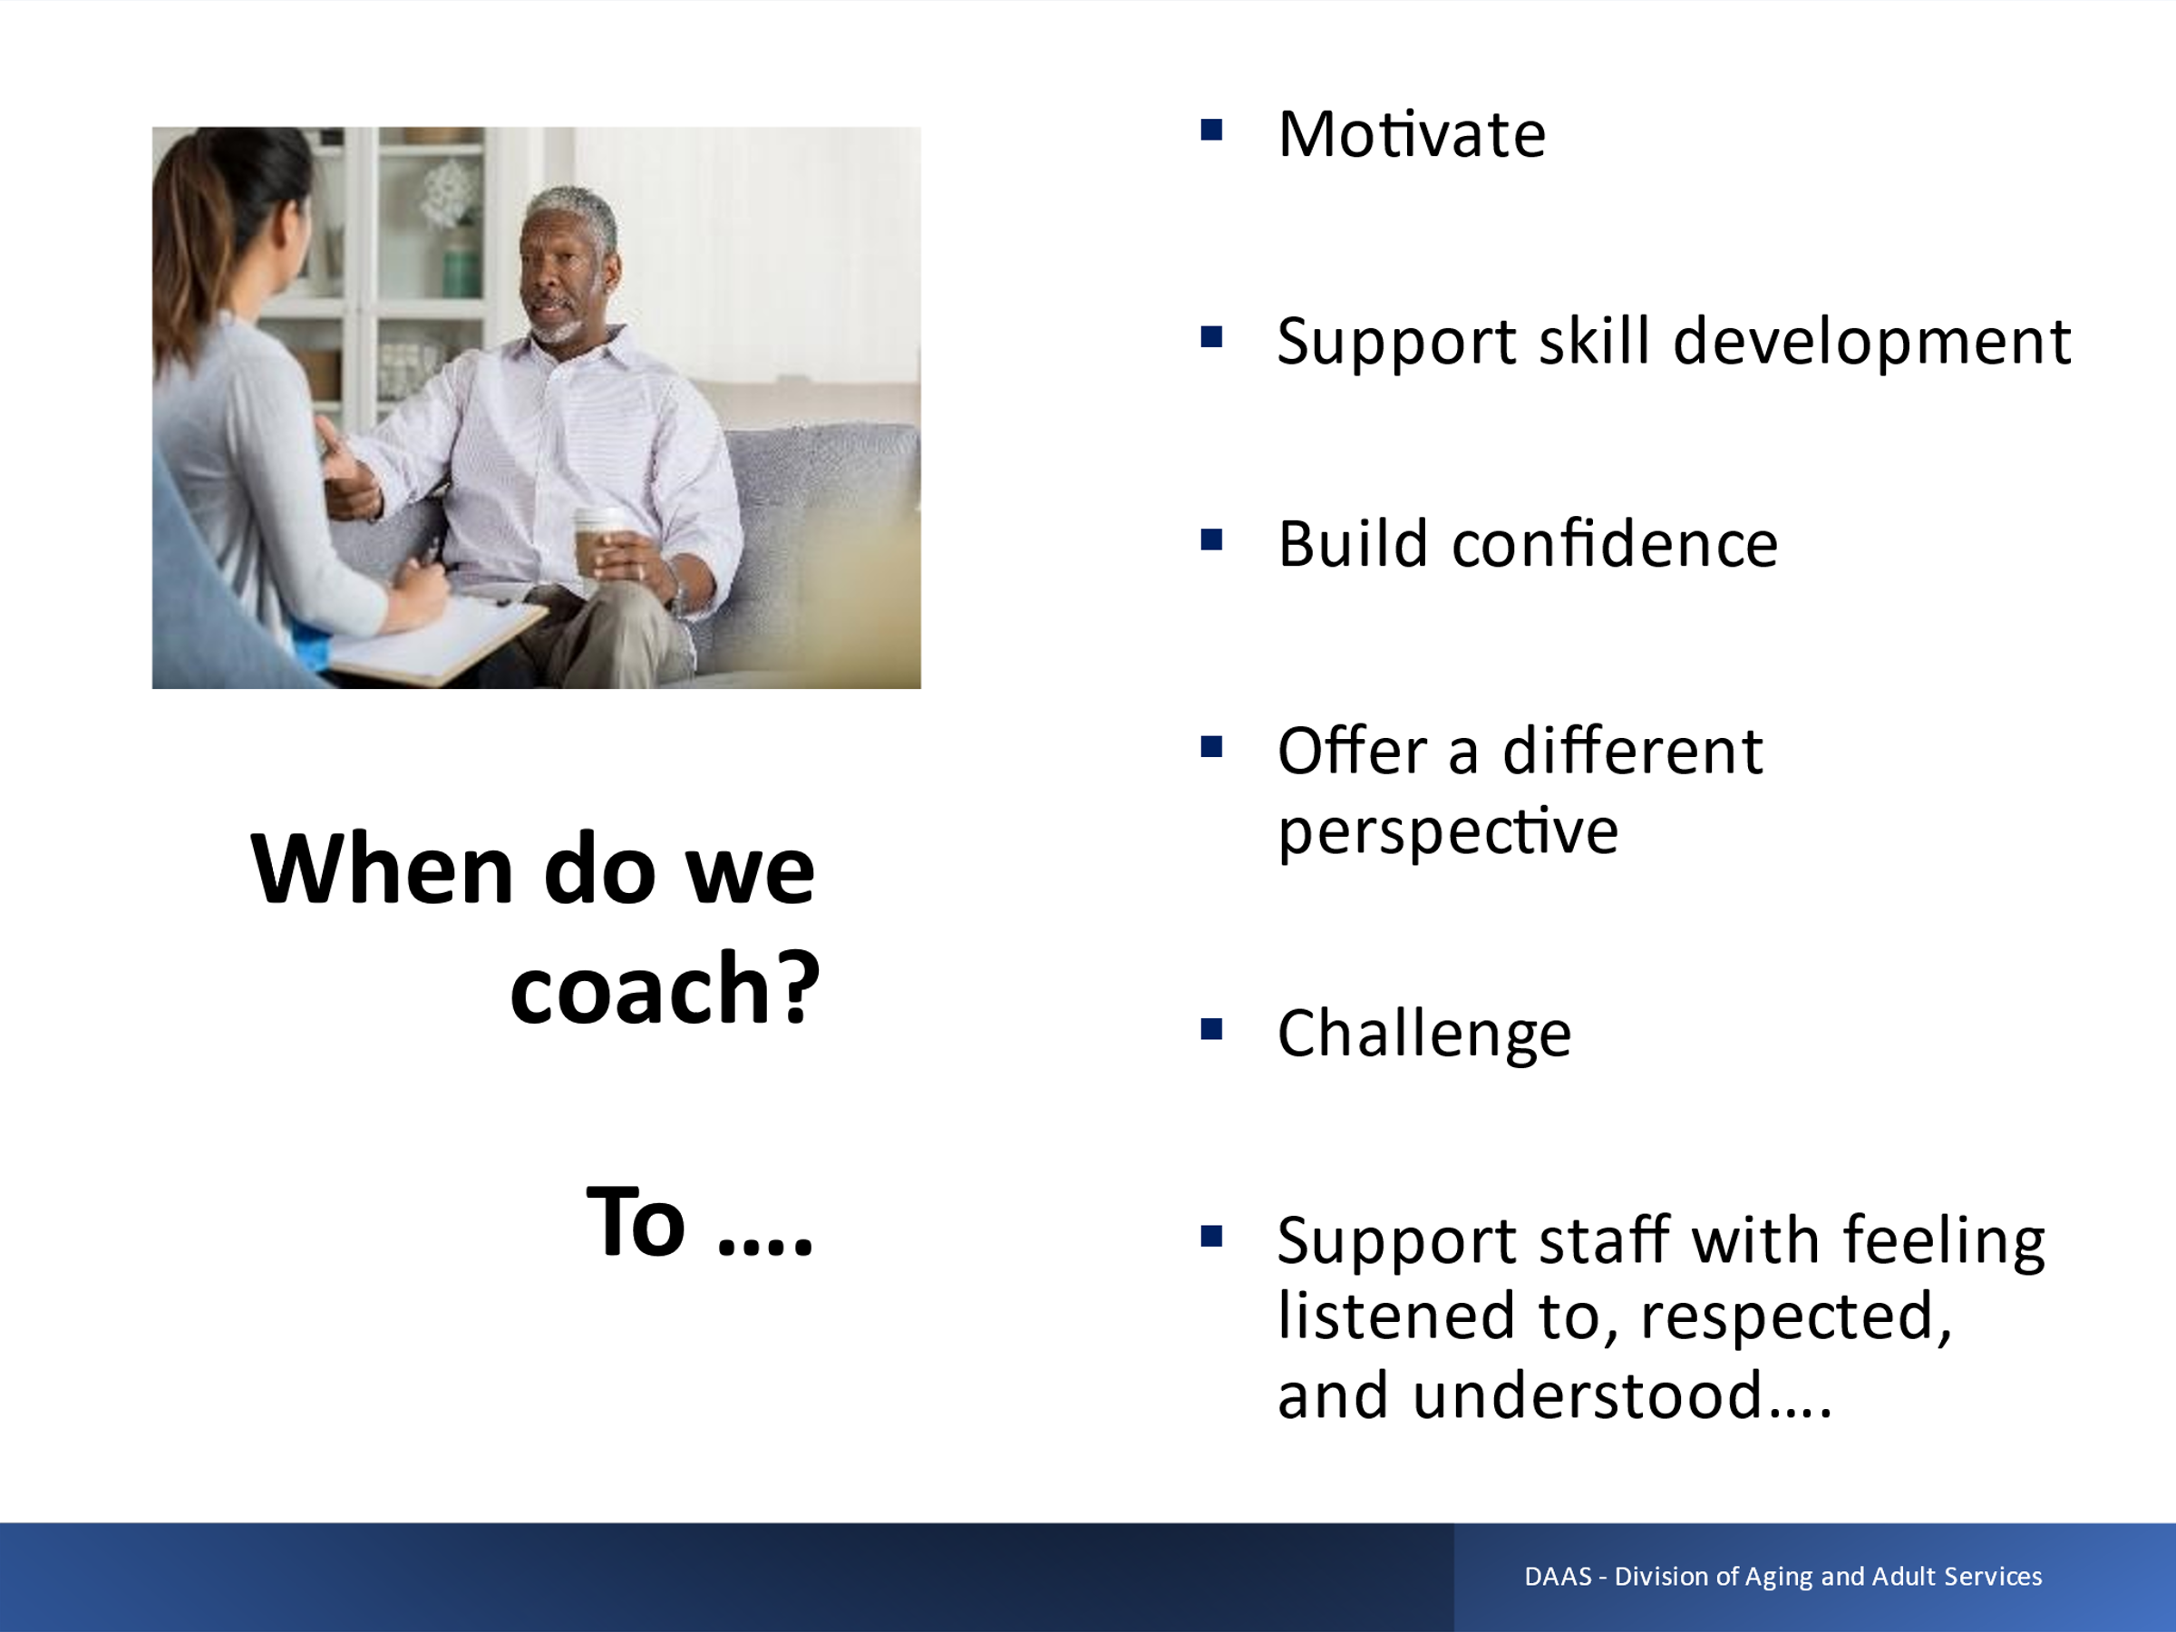
Notes: _____________________________________________
____________________________________________________
____________________________________________________

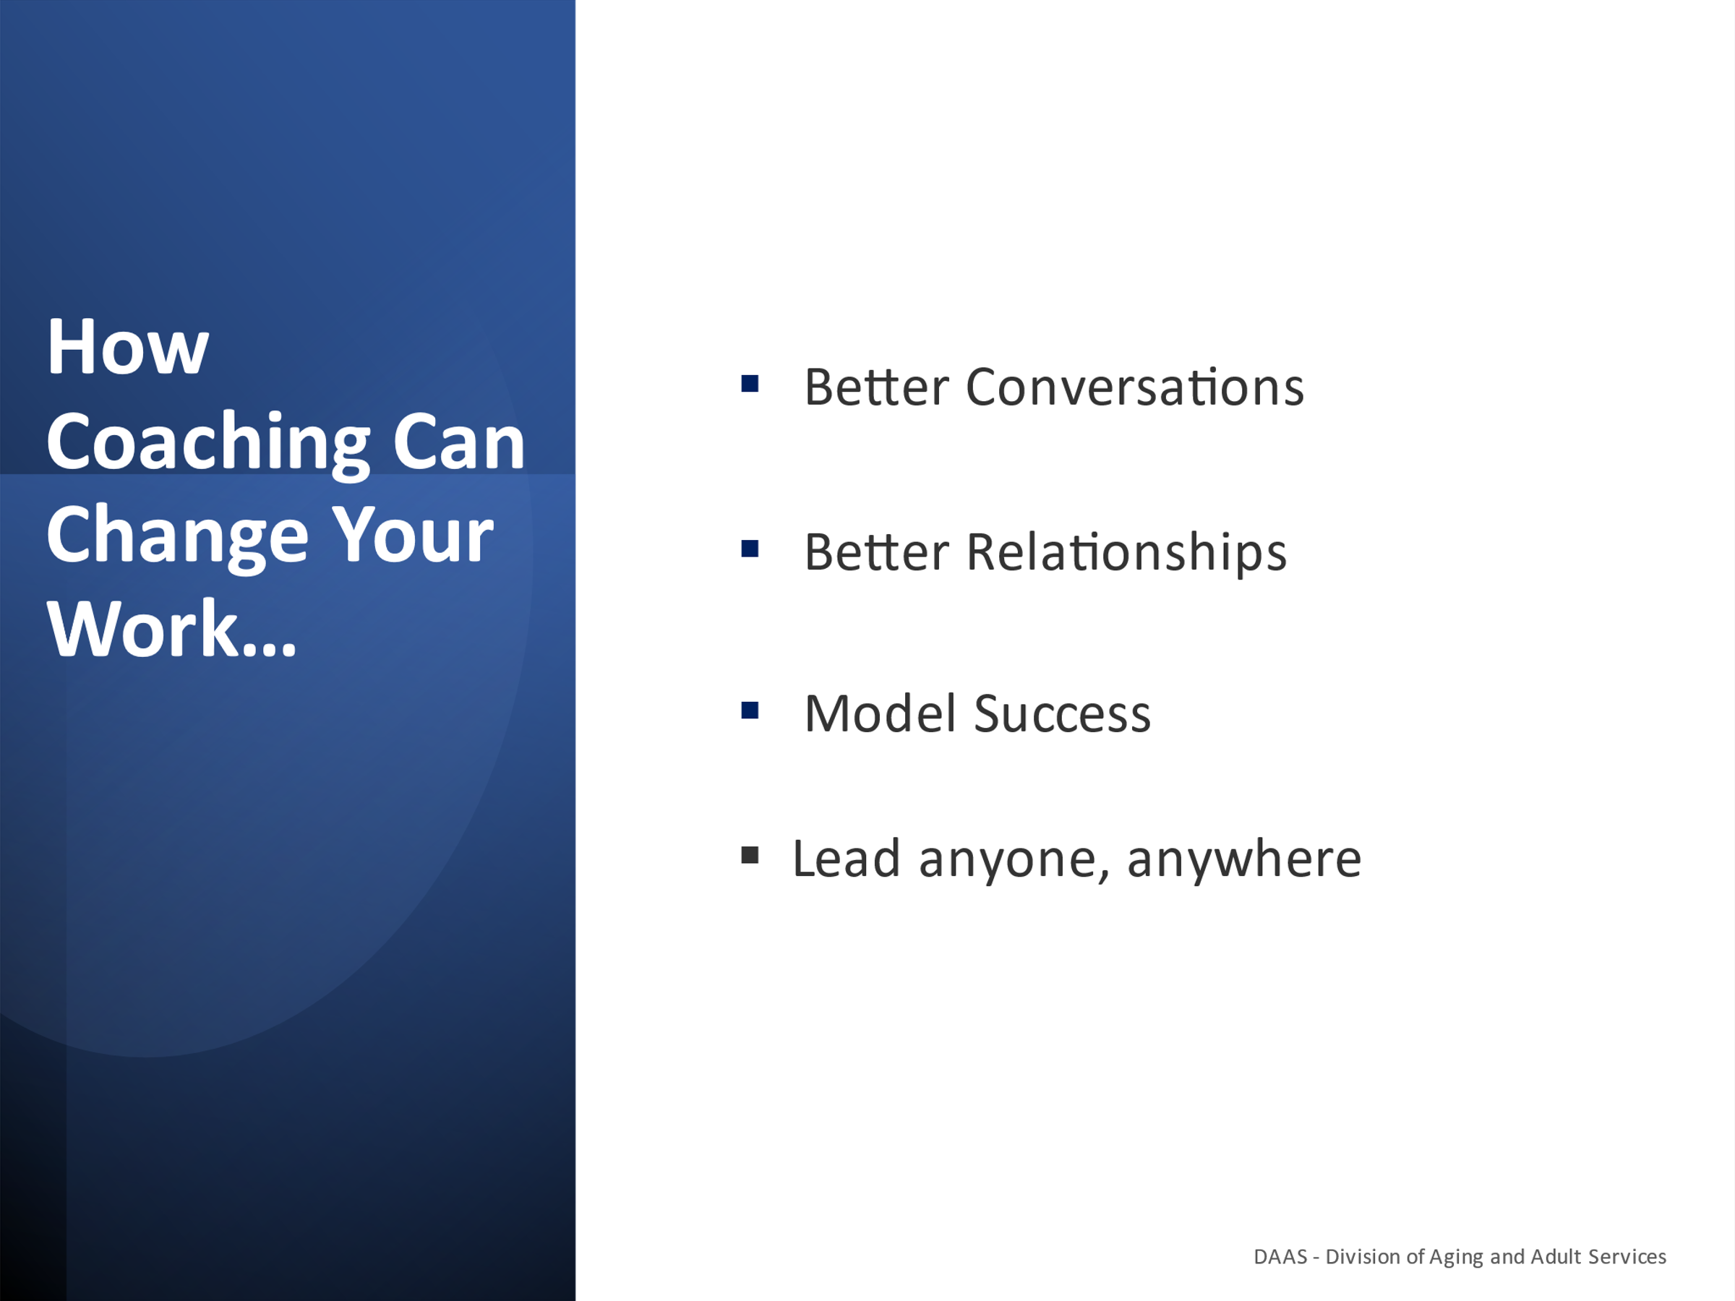

Notes: _____________________________________________
____________________________________________________

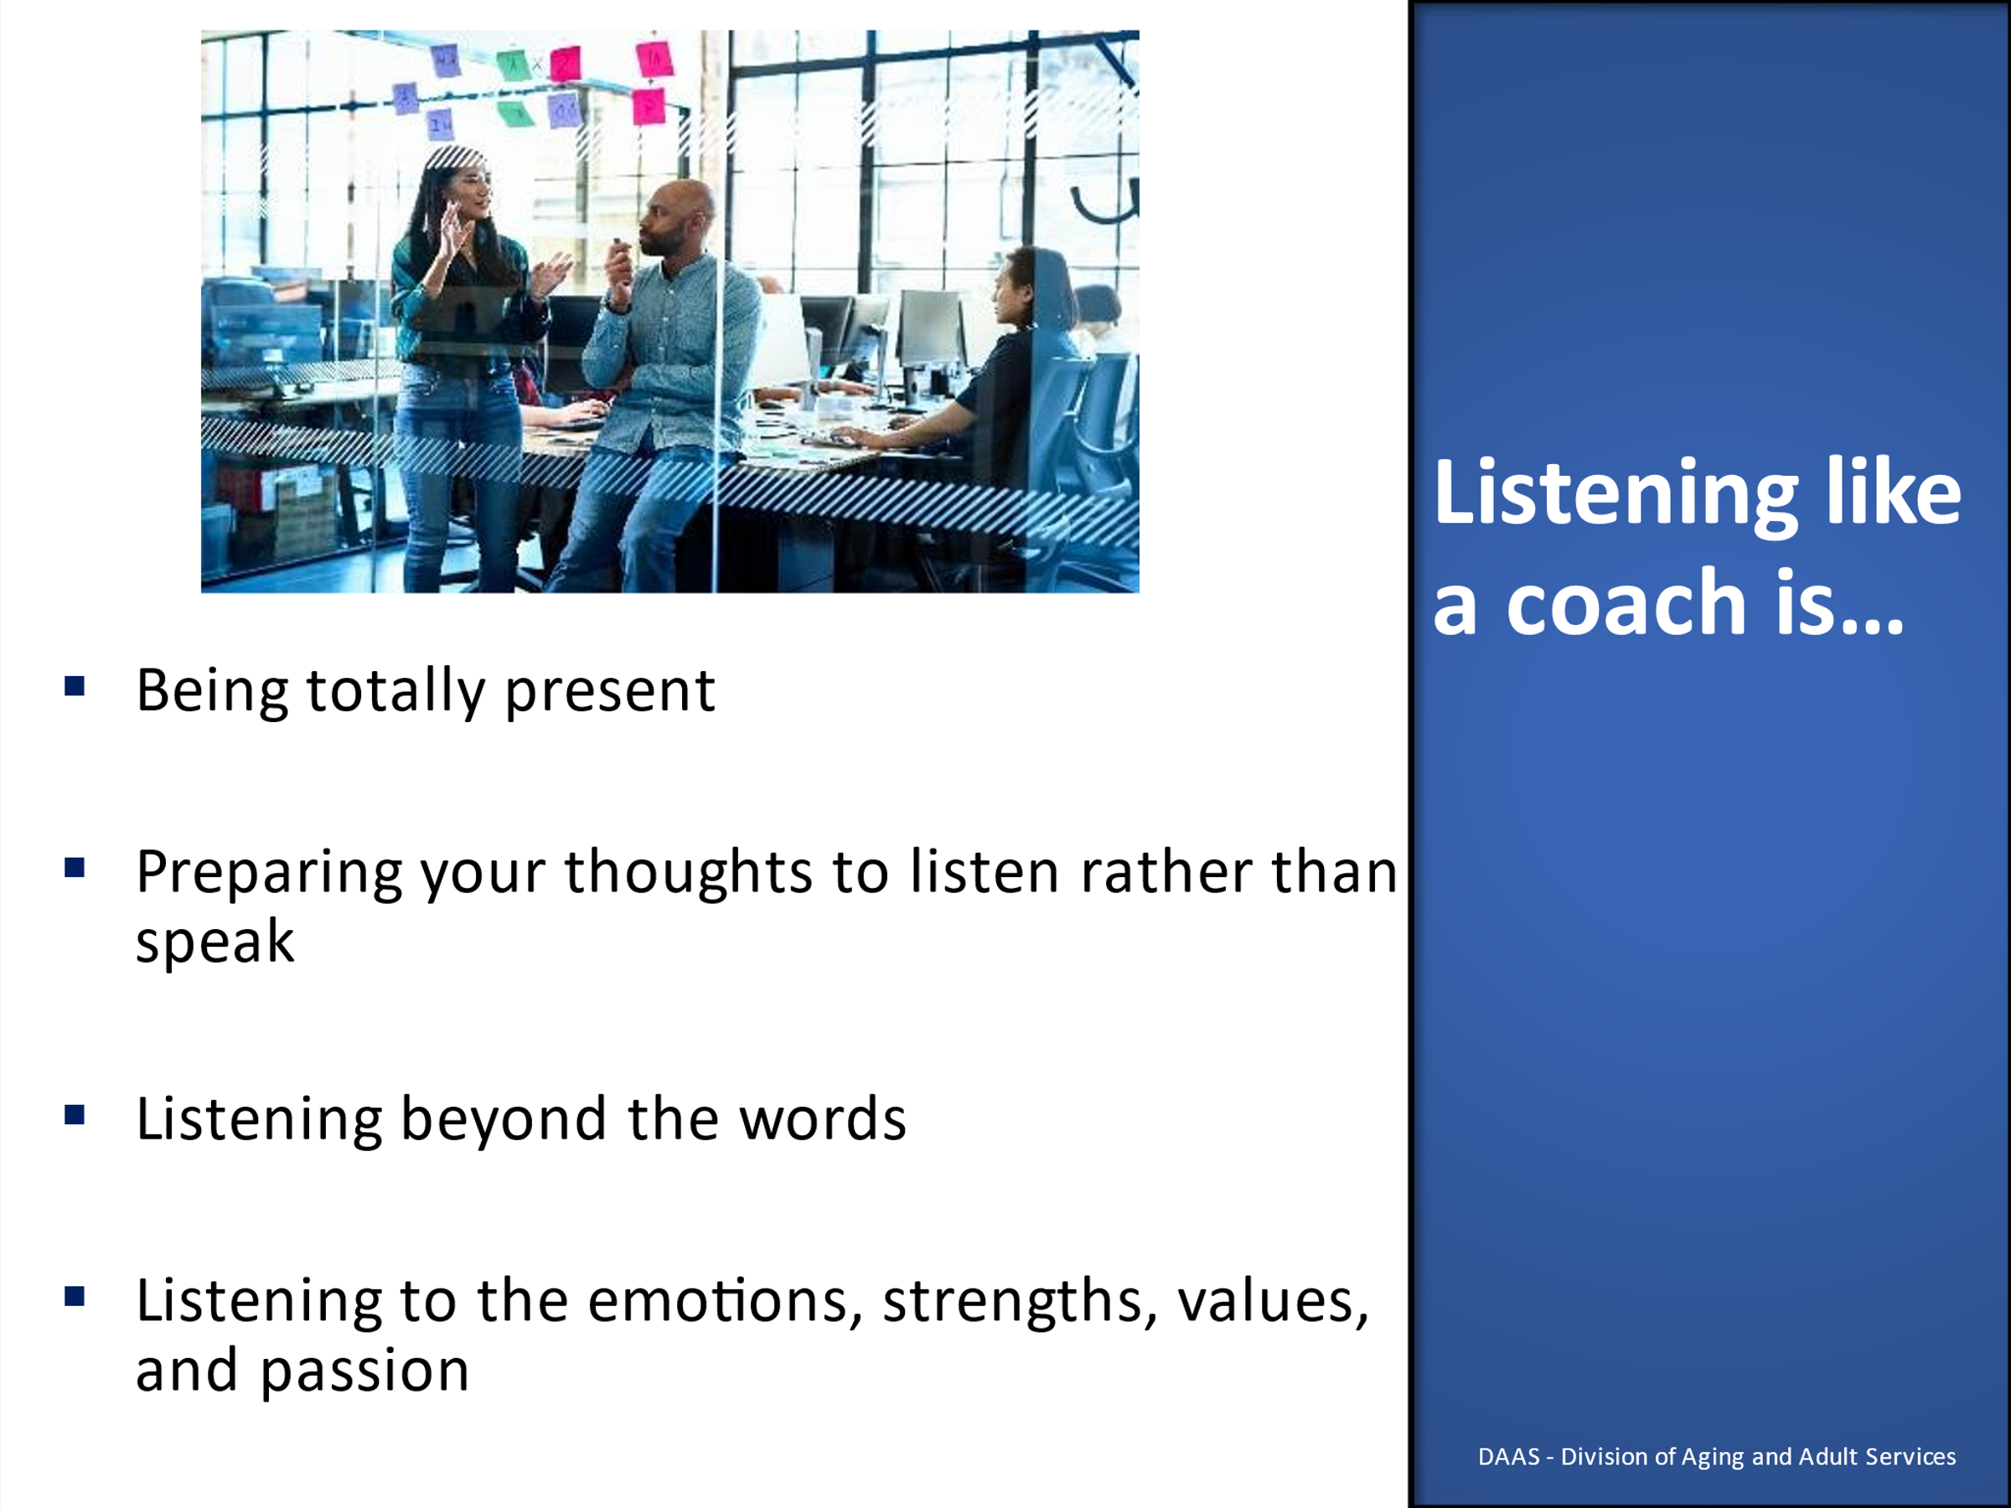

Notes: _____________________________________________
____________________________________________________
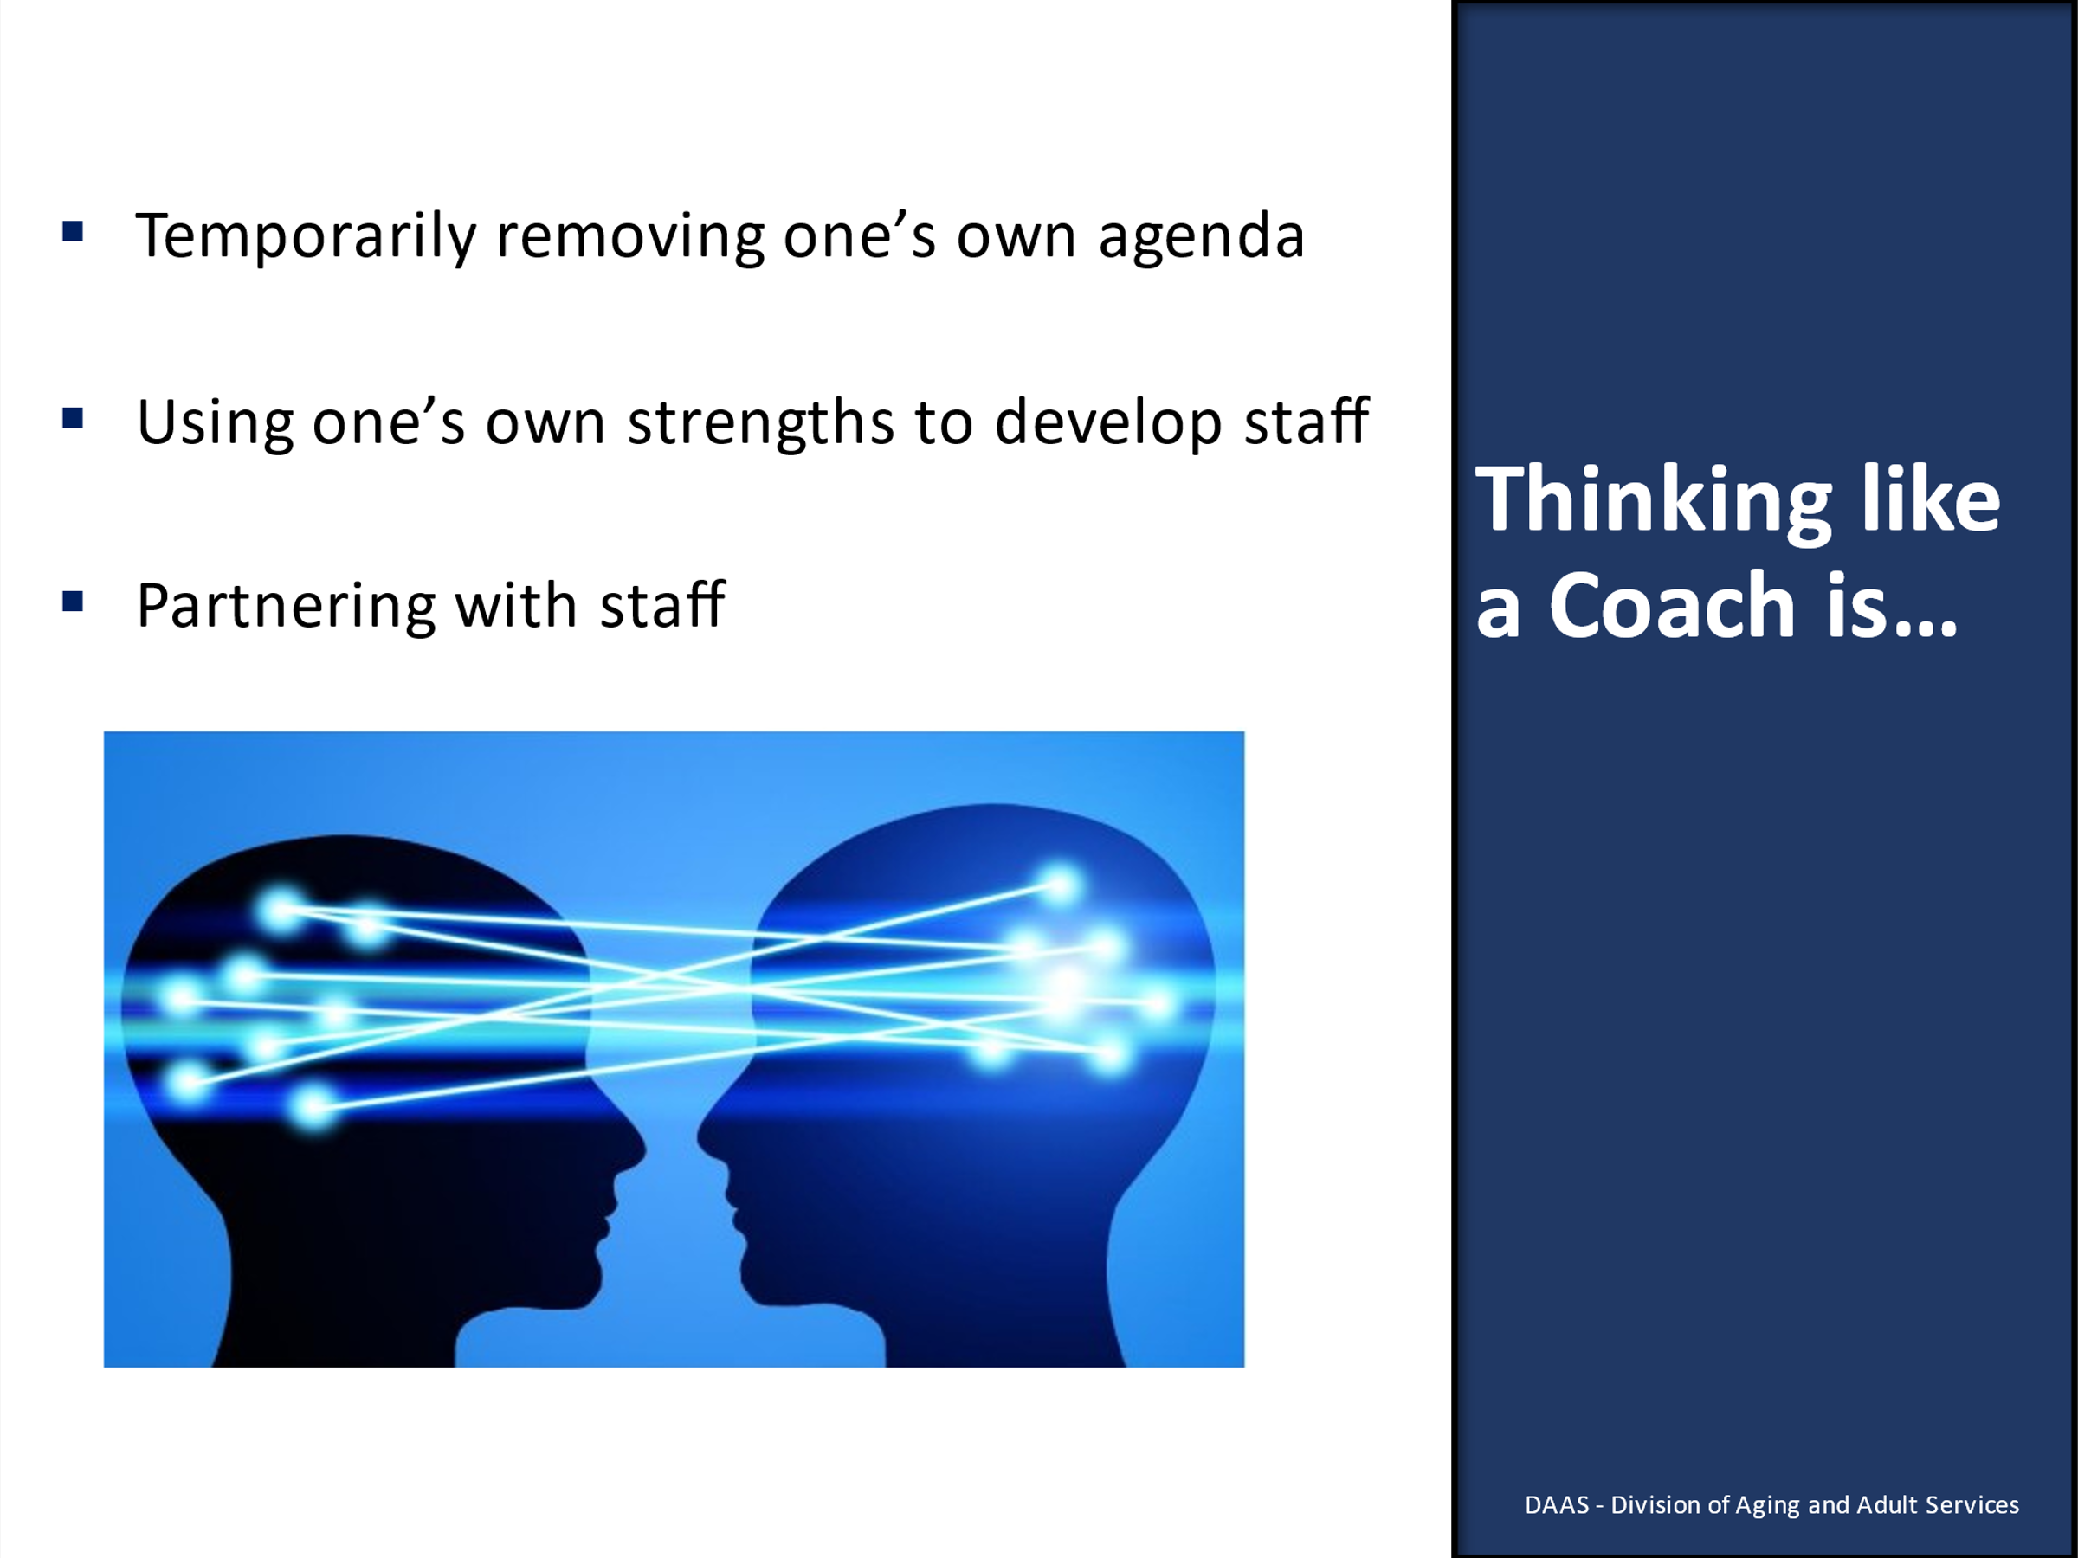
Notes: _____________________________________________
____________________________________________________
____________________________________________________
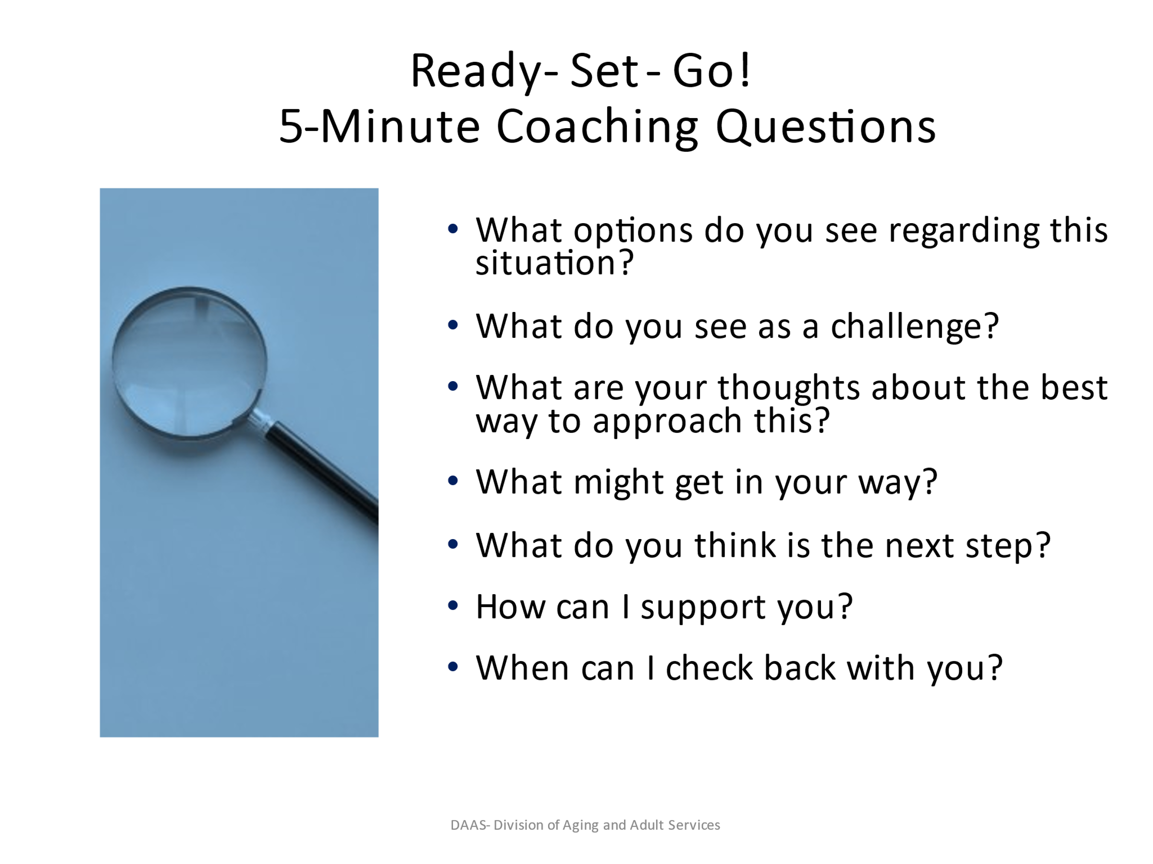
Notes: _____________________________________________
____________________________________________________
____________________________________________________
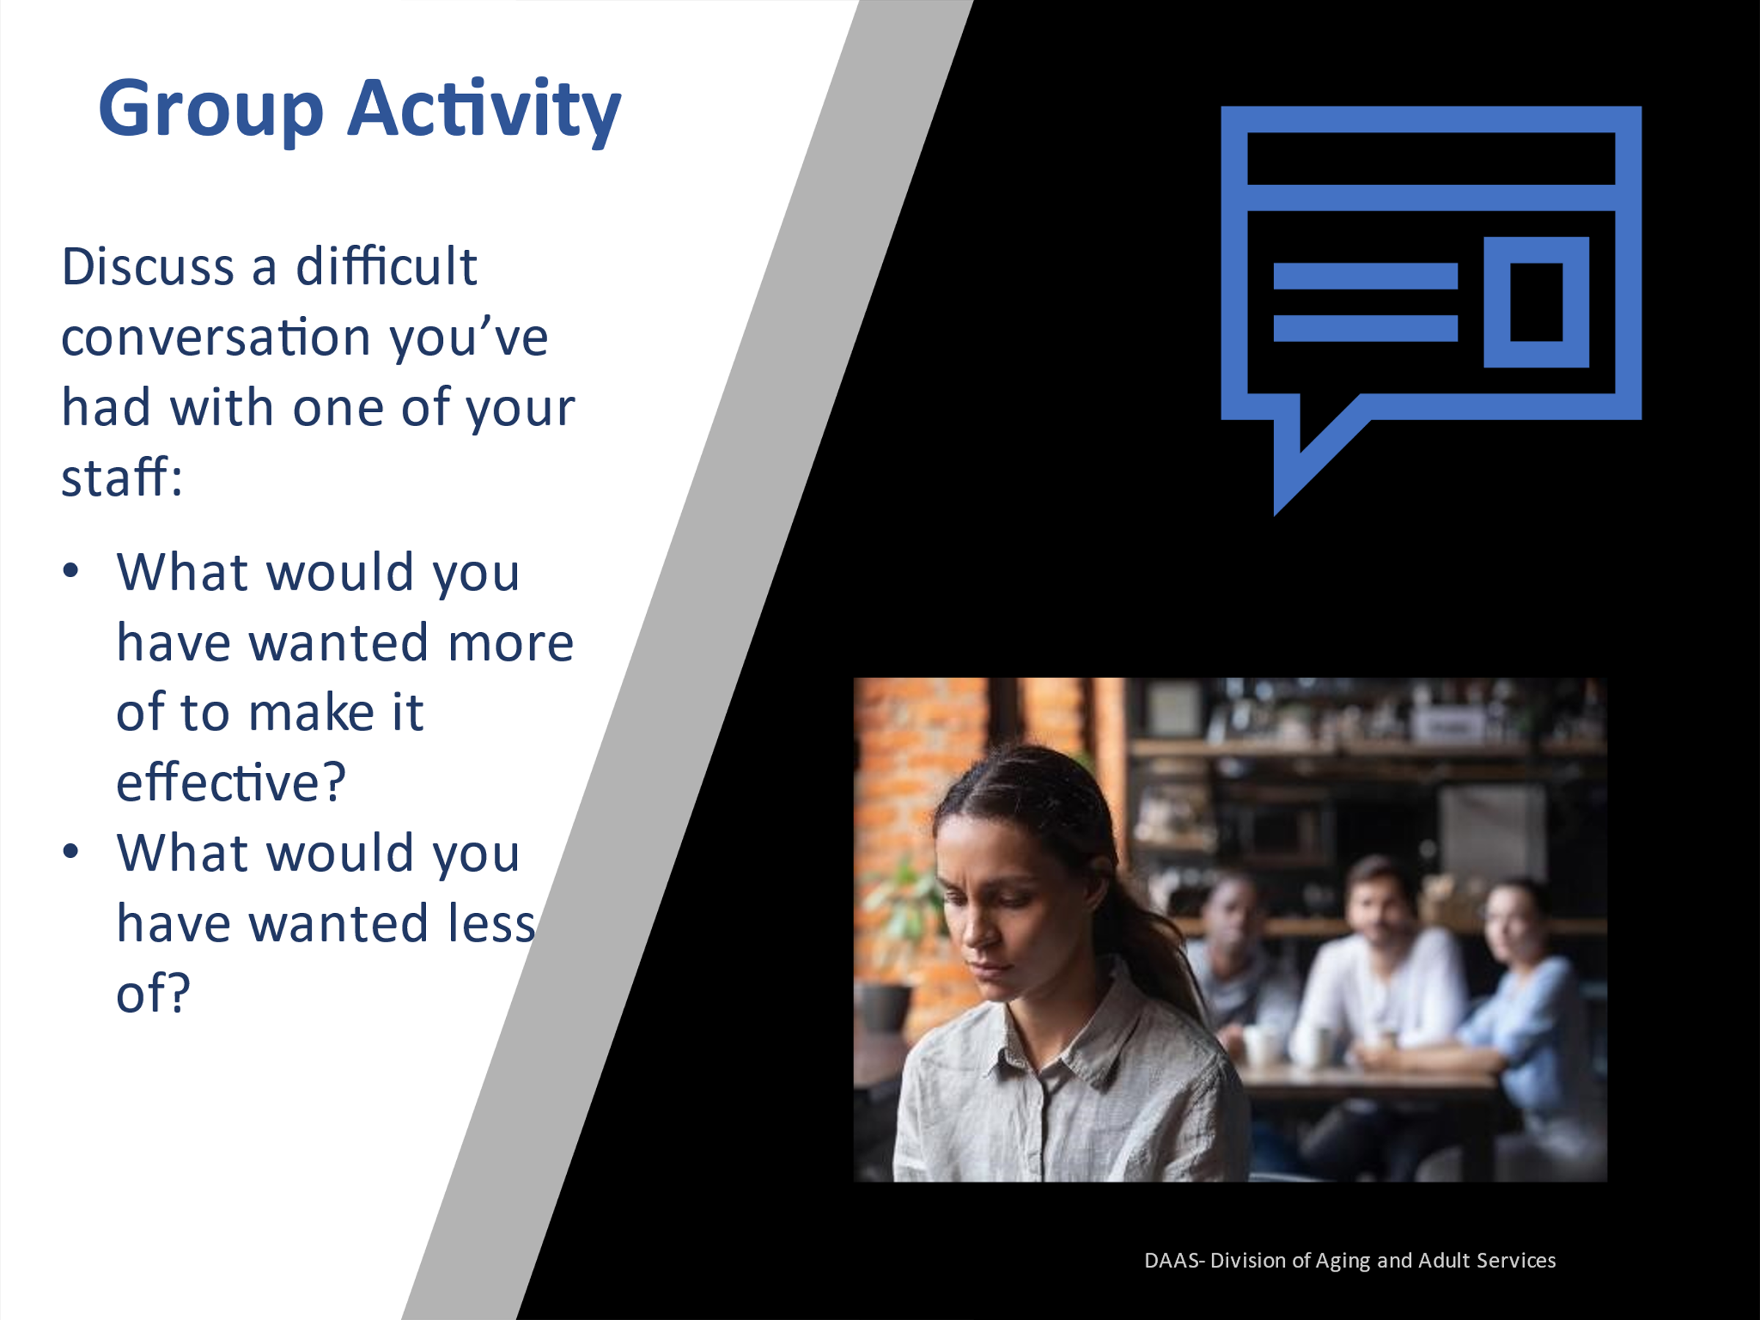
Small Group Activity
- Each participant in small group will take 3 minutes and write a written response to the following question below:
- As a supervisor, discuss a difficult conversation you’ve had with one of your staff. What would you have wanted more of to make it effective?

- What would you have wanted less of?

- Each group will have a spokesperson to lead the discussion, take notes, and report back to the large group if asked to share their responses.

Notes: _____________________________________________
____________________________________________________
____________________________________________________
____________________________________________________
Section 3- Identification of Coaching Strengths Through Self-Assessment
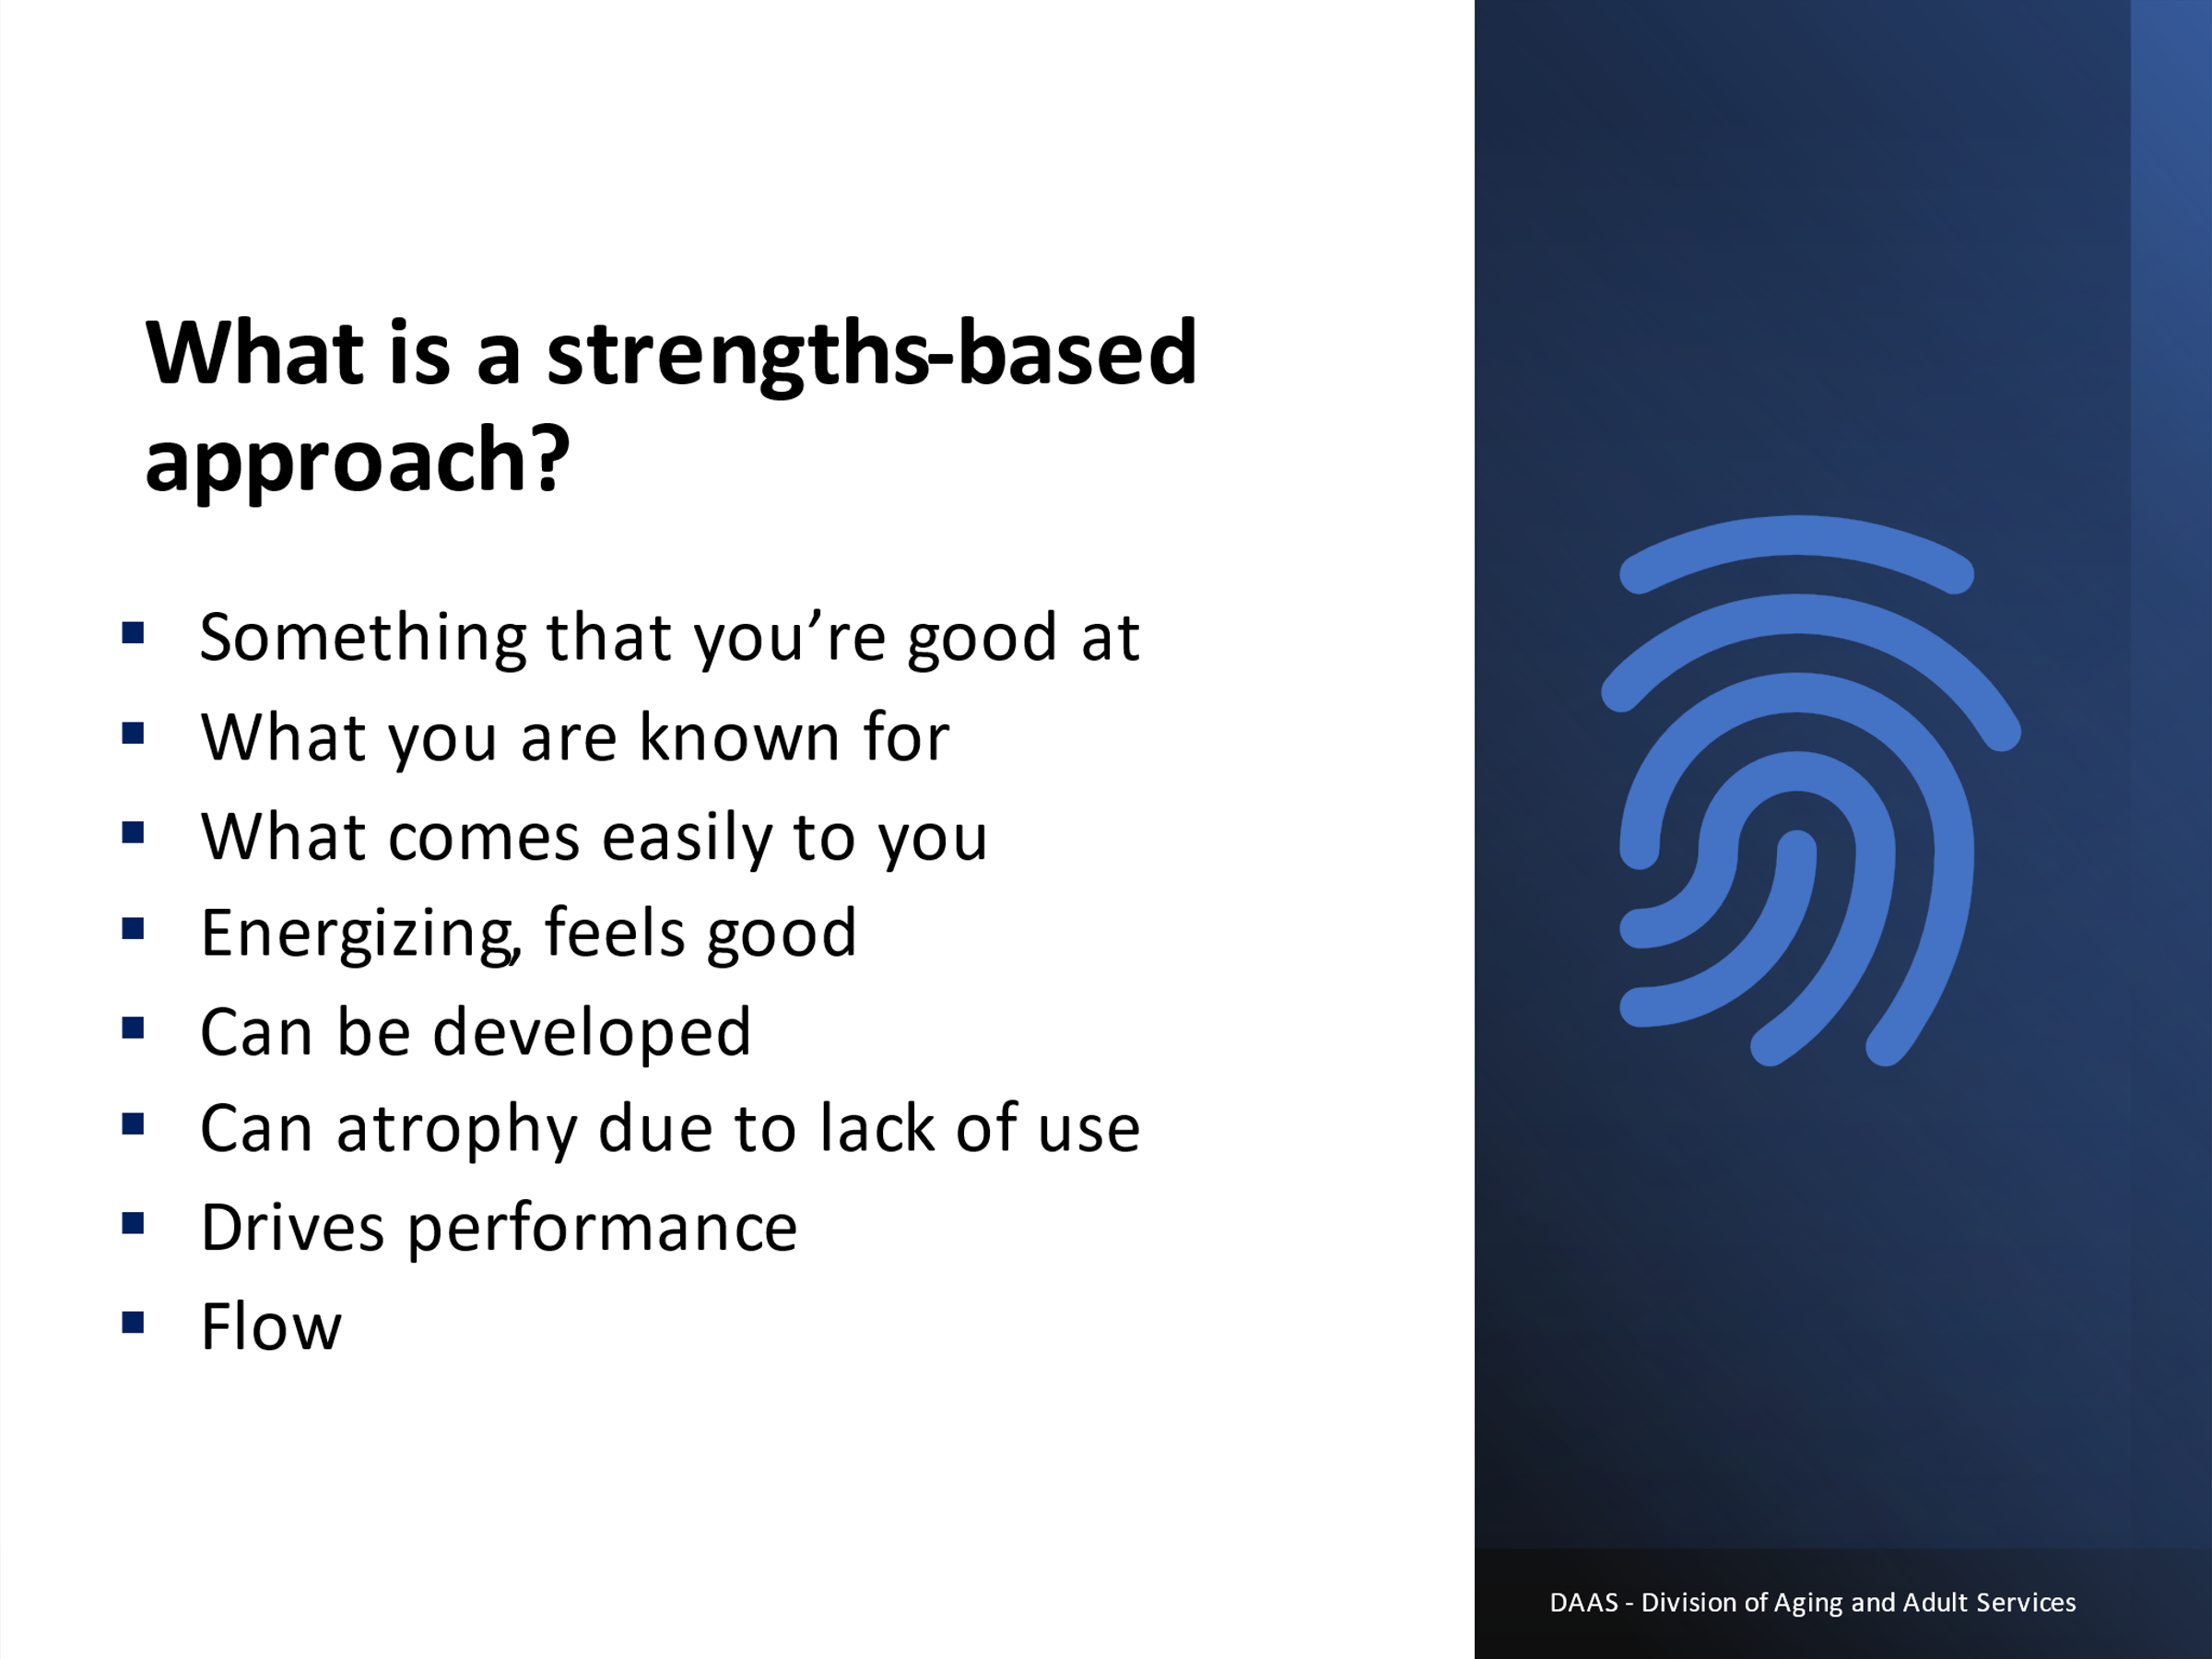
Notes: _____________________________________________
____________________________________________________
____________________________________________________
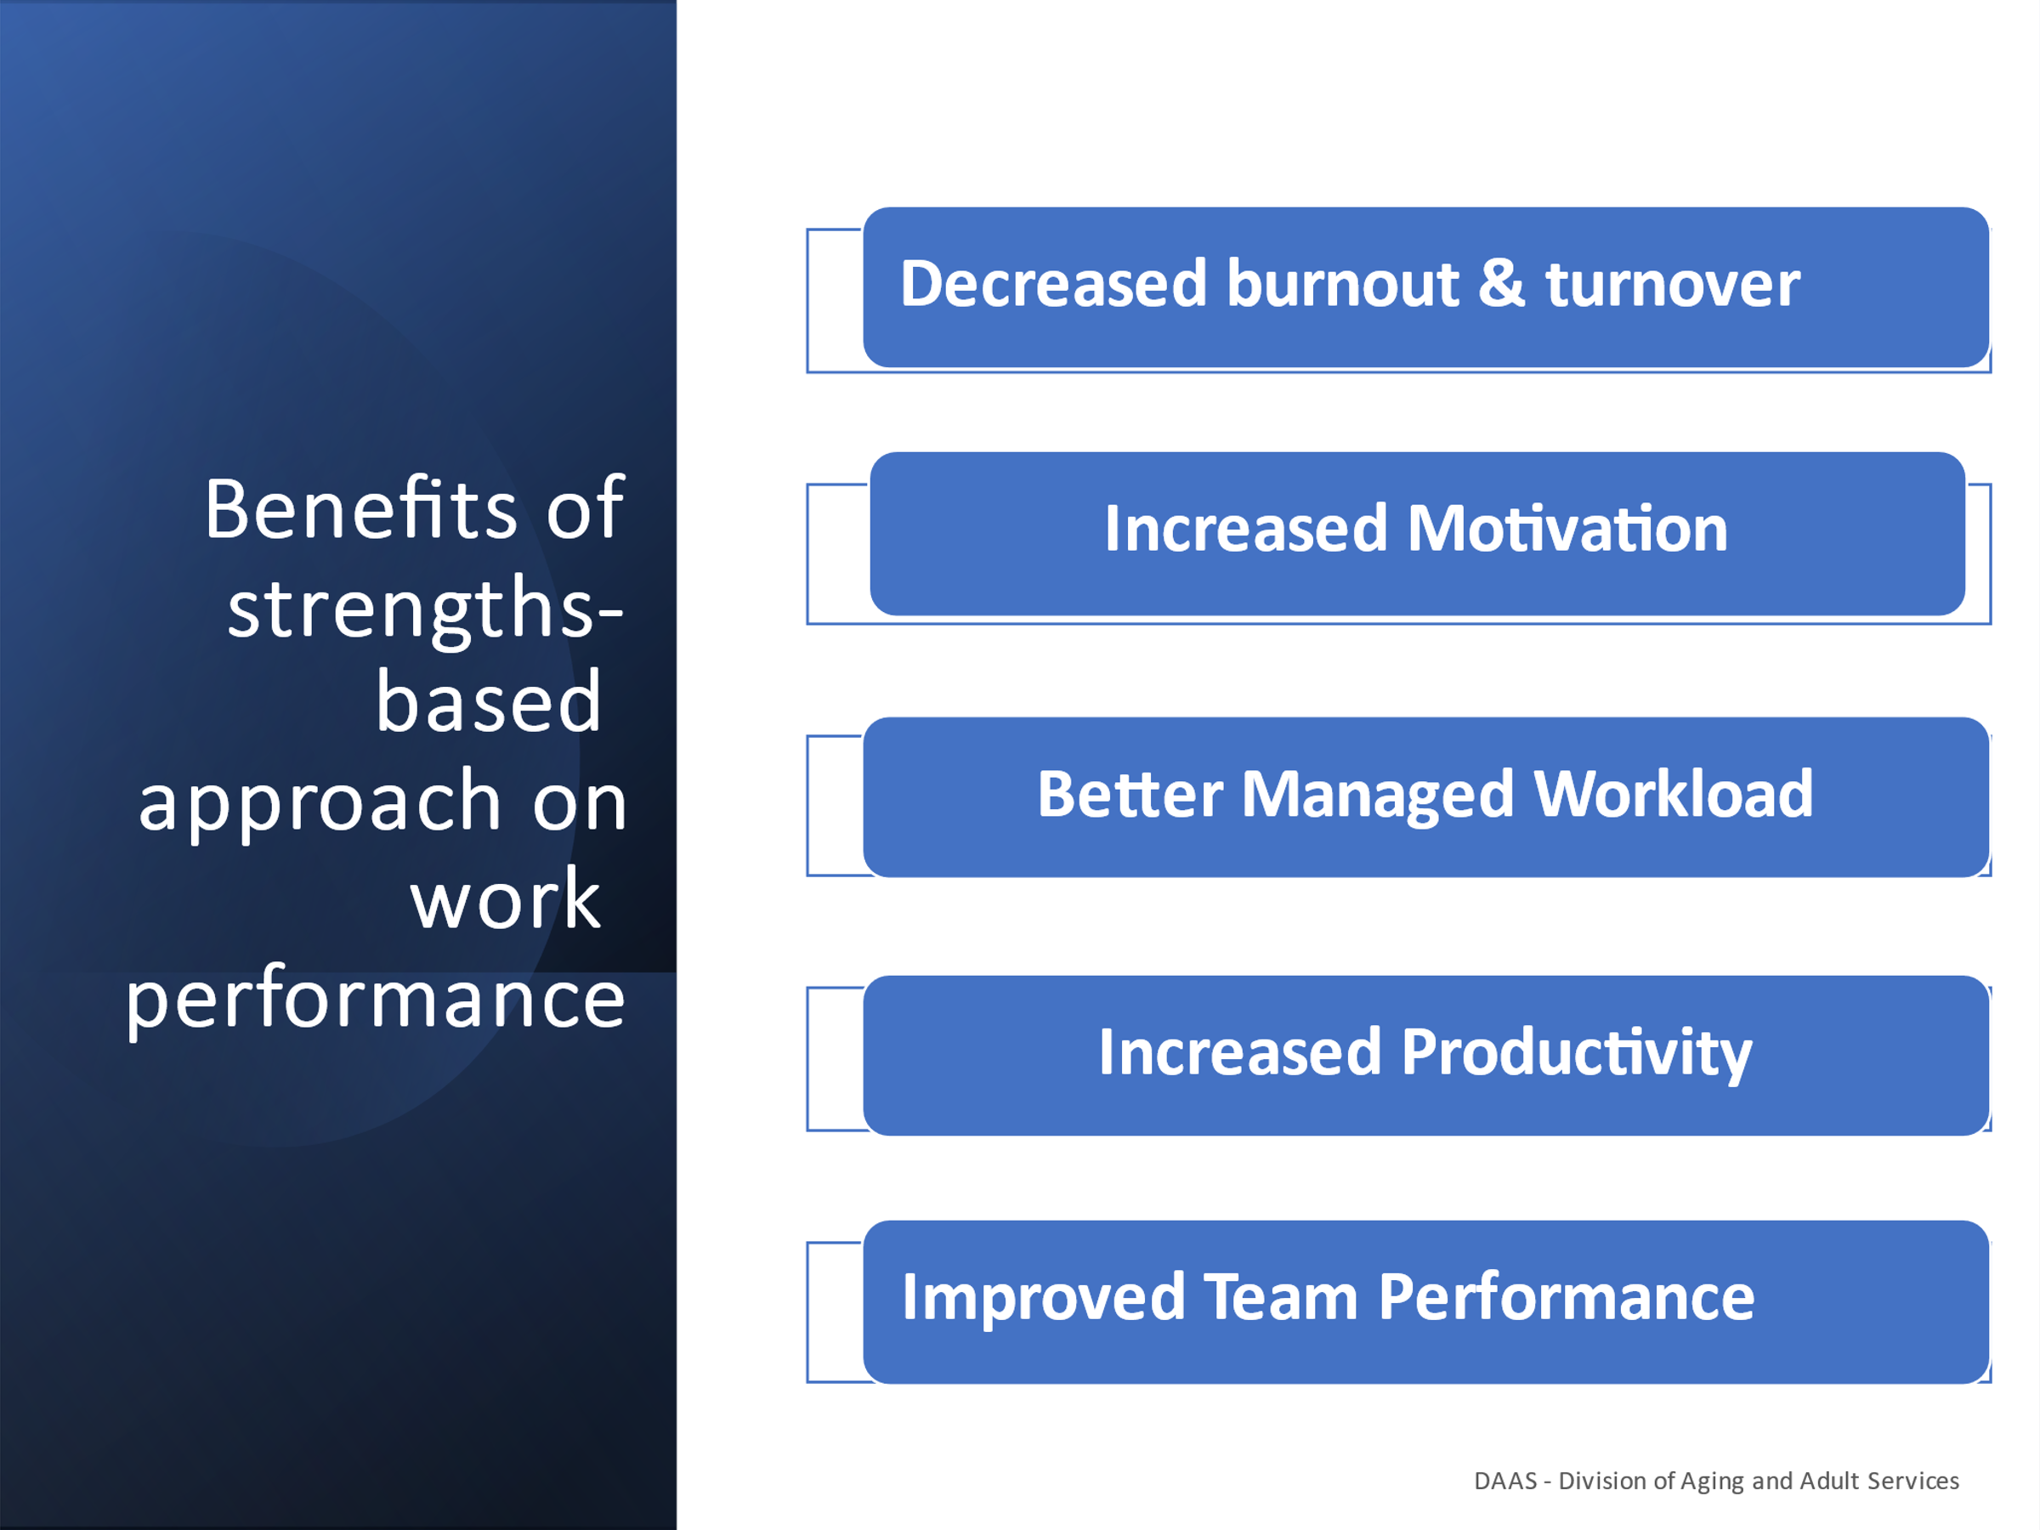
Notes: _____________________________________________
____________________________________________________

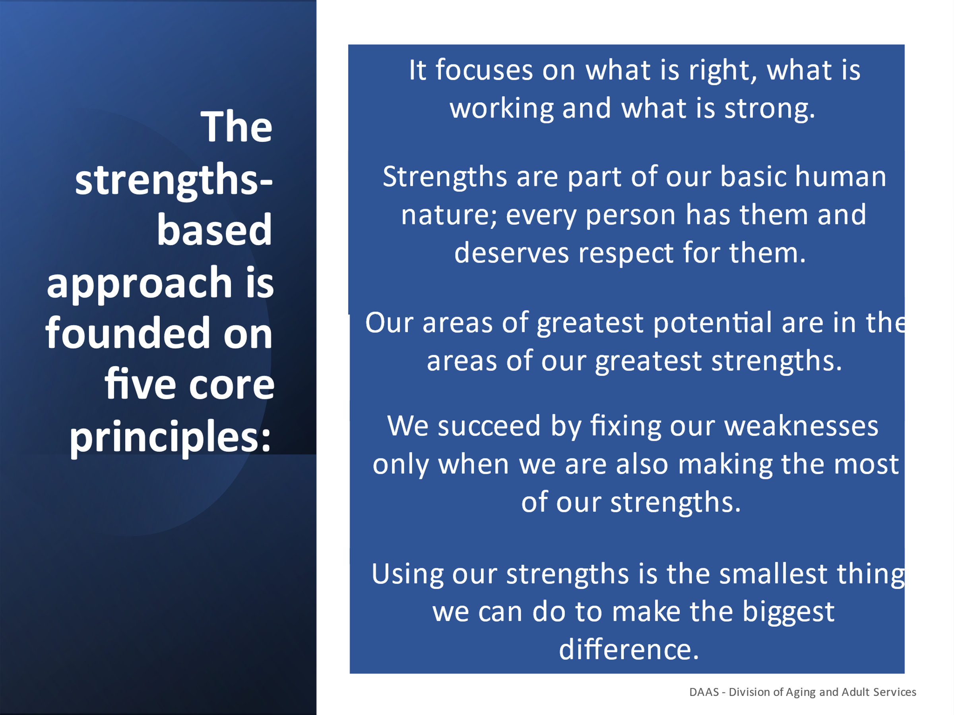
Notes: _____________________________________________
____________________________________________________
____________________________________________________

Assessment Activity: Complete a Coaching
Assessment Planner
- Pull out your Team STEPPS ASTD Coaching Self-Assessment Form, Handout # 2 that you completed as pre-work prior to attending today’s training
- Use Handout # 3, Coaching Assessment Planner
- You will fill out the planner by responding to the 3 questions on the upcoming slide below.
- An example is provided of a strength to upgrade to demonstrate how the form can be completed.
- You will have 10 minutes to write your responses.

Handout # 2
Team STEPPS-Team Strategies and Tools to Enhance Performance and Patient Safety
ASTD-American Society for Training and Development
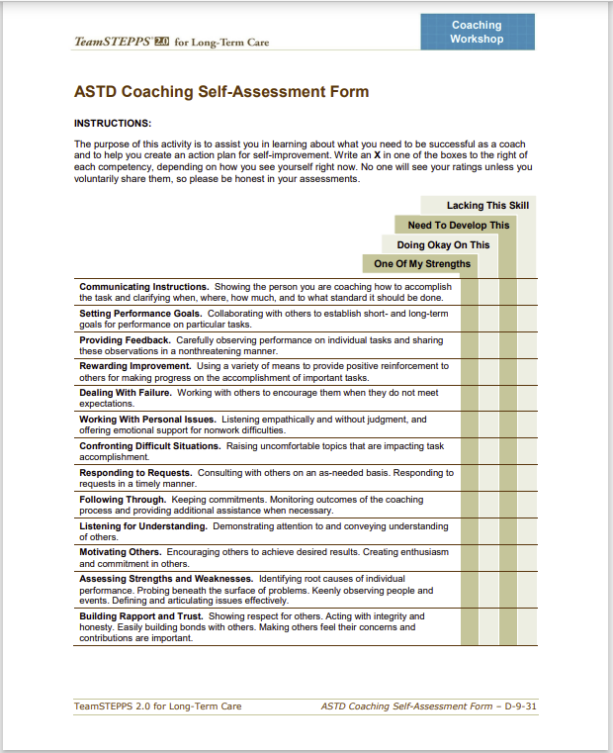

Handout # 3
Strengths Action Planner

Strength to Upgrade | What are your next steps? | What support do you need? | How will you monitor your progress?
1.
2.
3.

Strength | How can you leverage these strengths to coach staff
1.
2.
3.

Handout # 4
Strength to Upgrade | What are your next steps? | What support do you need? | How will you monitor your progress?
1. Providing Feedback | I will use my coaching conversation conference planner to prepare for my next 1:1 conference with staff to provide feedback. | I will reach out with one of my peers and ask them to be my accountability partner. I will also let my supervisor know about the strength I’m working on upgrading. | I will review my conference 1:1 notes every Friday to assess how I’m doing and report my progress every Tuesday to my accountability partner and ask for feedback. I will report my progress to my supervisor and ask for their feedback.
2.

3.

Strengths Action Planner Example

Strength | How can you leverage these strengths to coach staff
- Listening for Understanding | I can use my ability to listen effectively by using active and reflective listening techniques to provide feedback about my observations about areas where the person is doing well and areas they can upgrade.
2. Building Rapport and Trust | I can use my ability to follow through on my commitments and create trusting relationships to be able to provide feedback in a non-threatening manner.
3. Motivating Others | I can leverage my strength of enthusiasm and ability to encourage others to support them in my commitment to improving areas they can upgrade.

Assessment Activity: Complete a Coaching Strengths Planner responding to the following questions. You will have 10 min to complete the Strengths Action Planner.
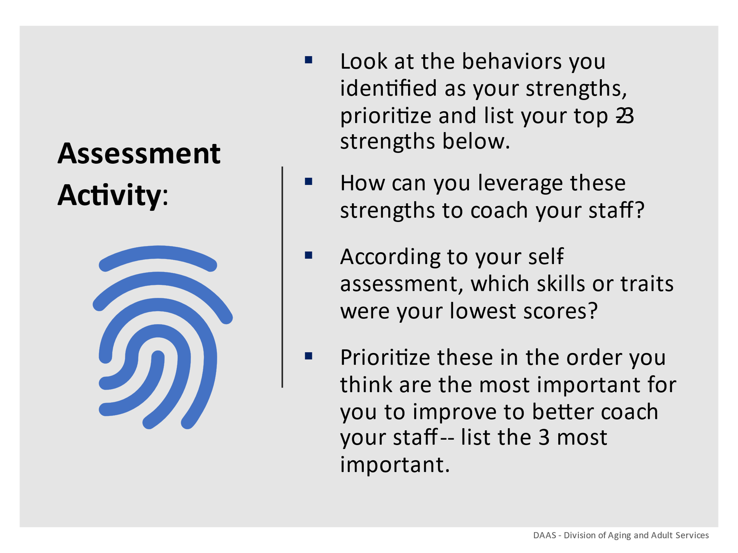

Notes: _____________________________________________
____________________________________________________
____________________________________________________
____________________________________________________

Section 4 – Coaching Strategies for Performance & Development

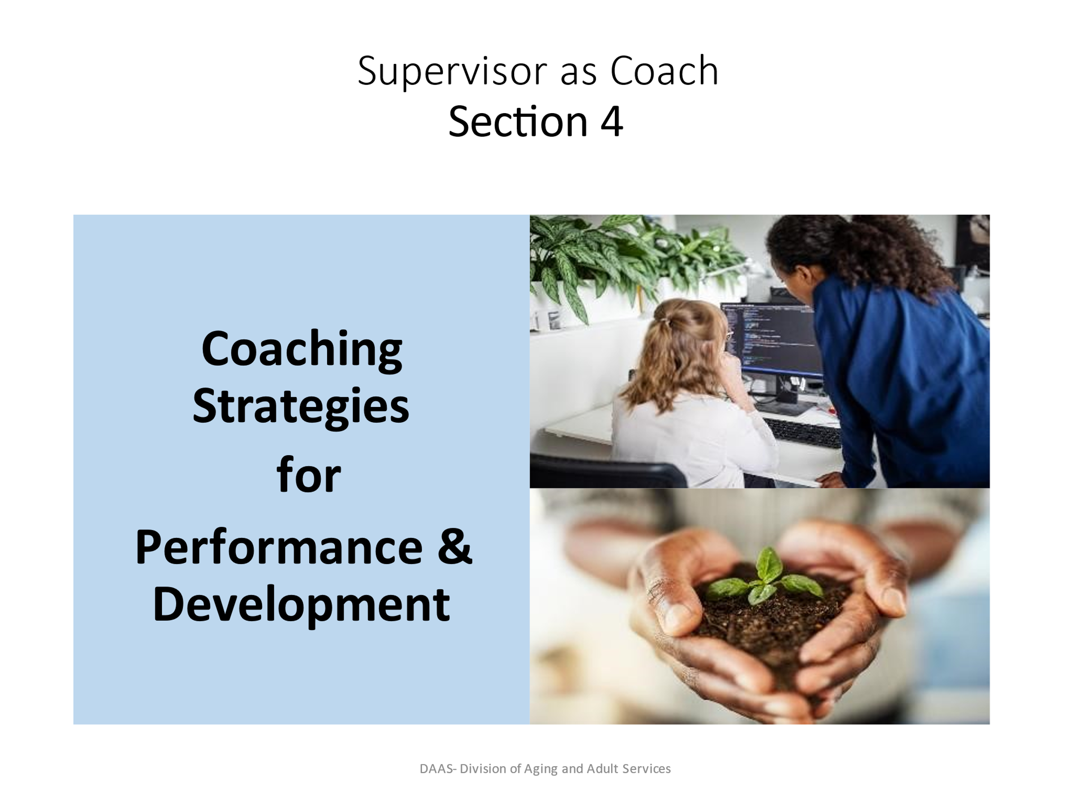
Notes: _____________________________________________
____________________________________________________
____________________________________________________
____________________________________________________
____________________________________________________
____________________________________________________

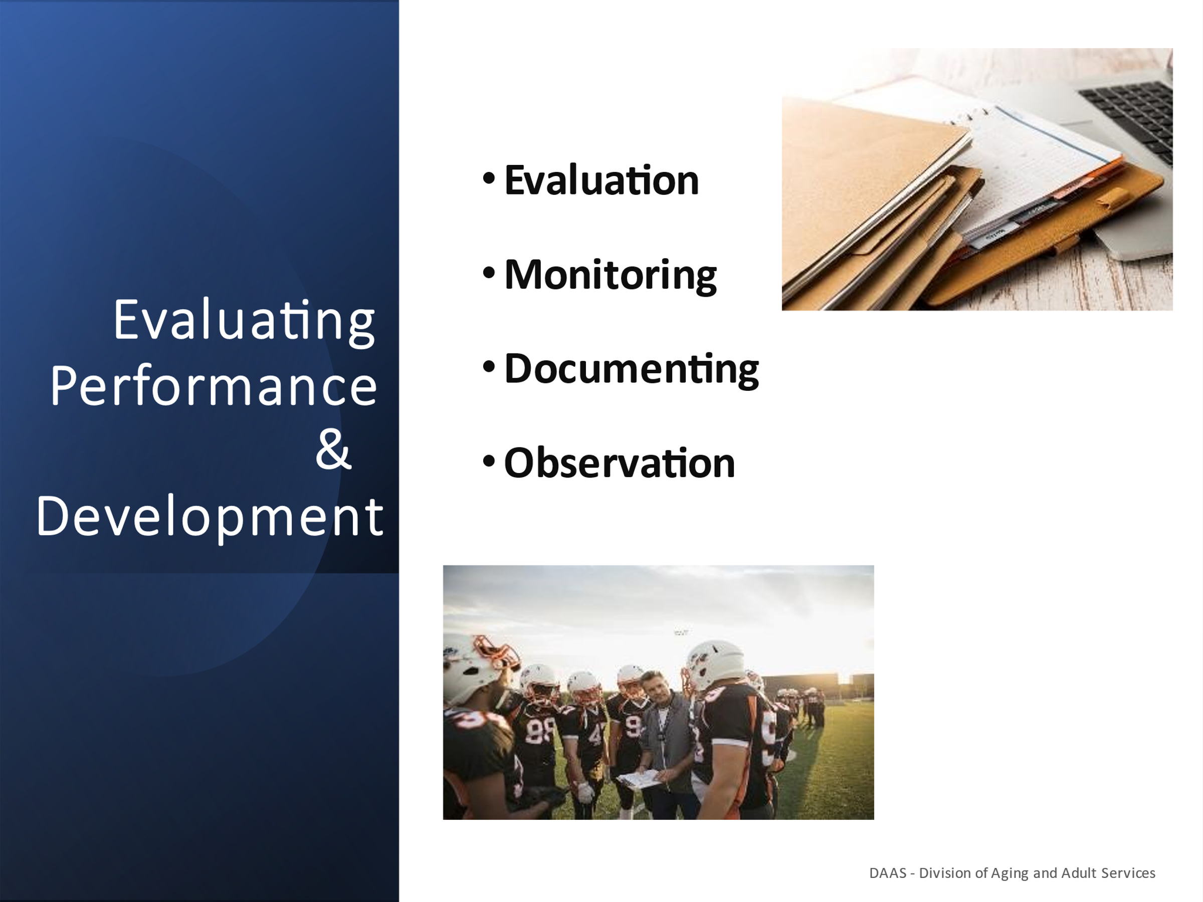
Notes: _____________________________________________
____________________________________________________
____________________________________________________
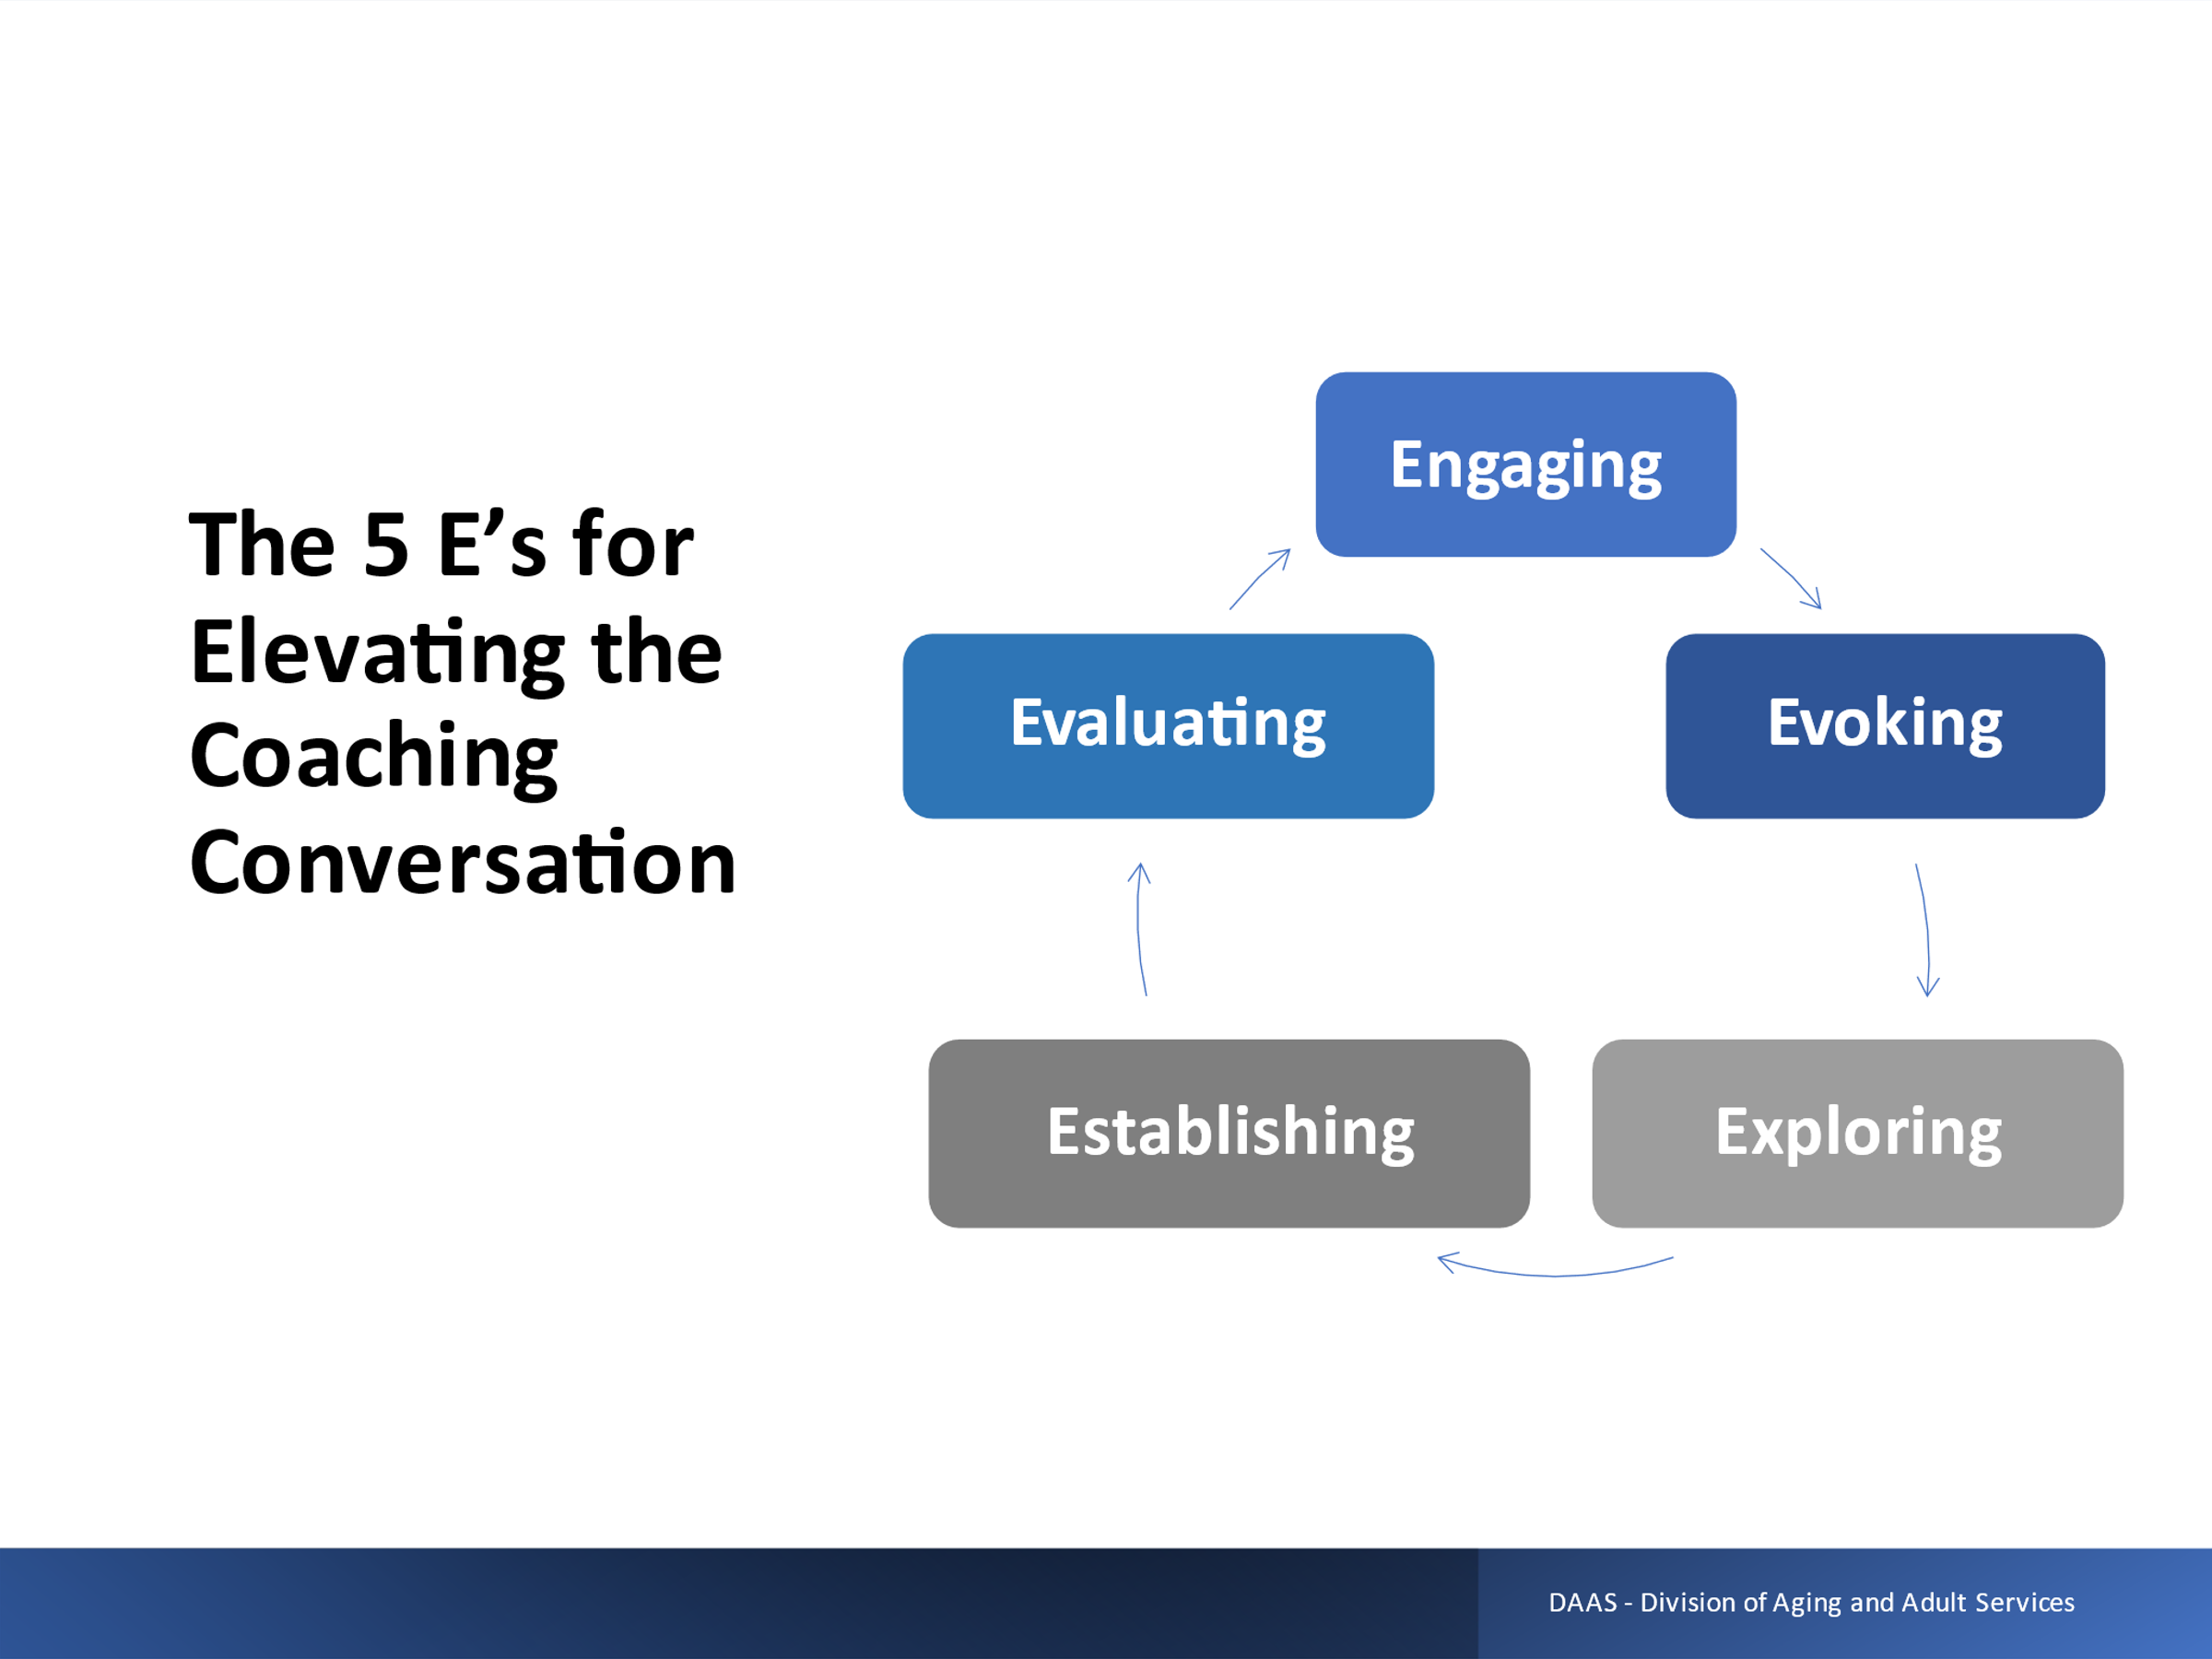
Notes: _____________________________________________
____________________________________________________
____________________________________________________
Handout # 5
Examples of Coaching Conversation for Development
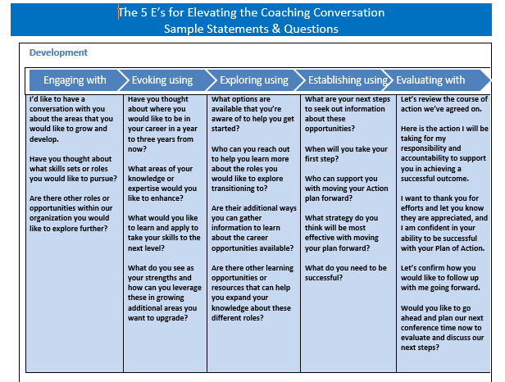

Handout # 6
Example of Coaching Conversation for Performance
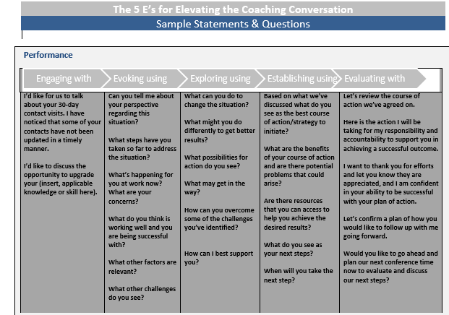

Handout # 7
Coaching Conversation Plan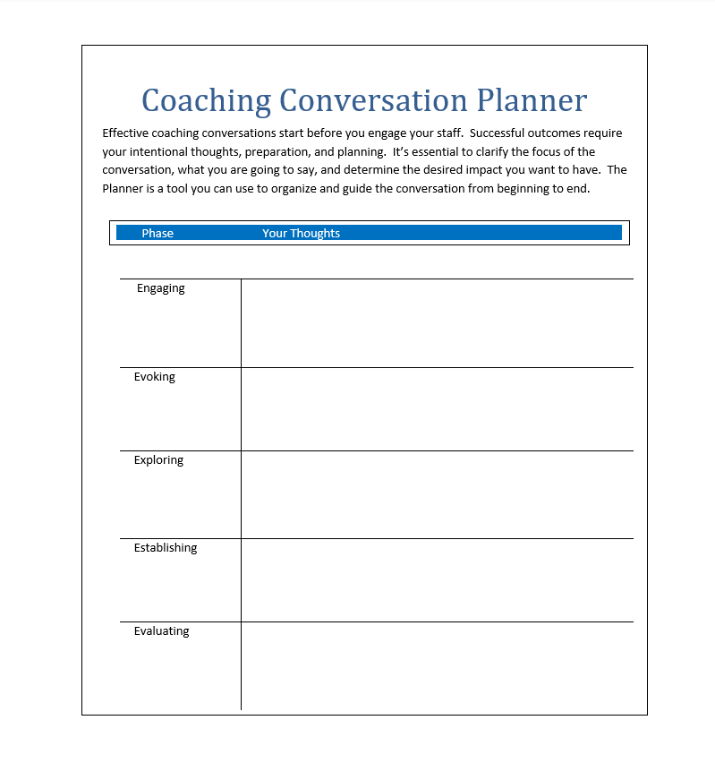Notes: _____________________________________________
____________________________________________________
____________________________________________________
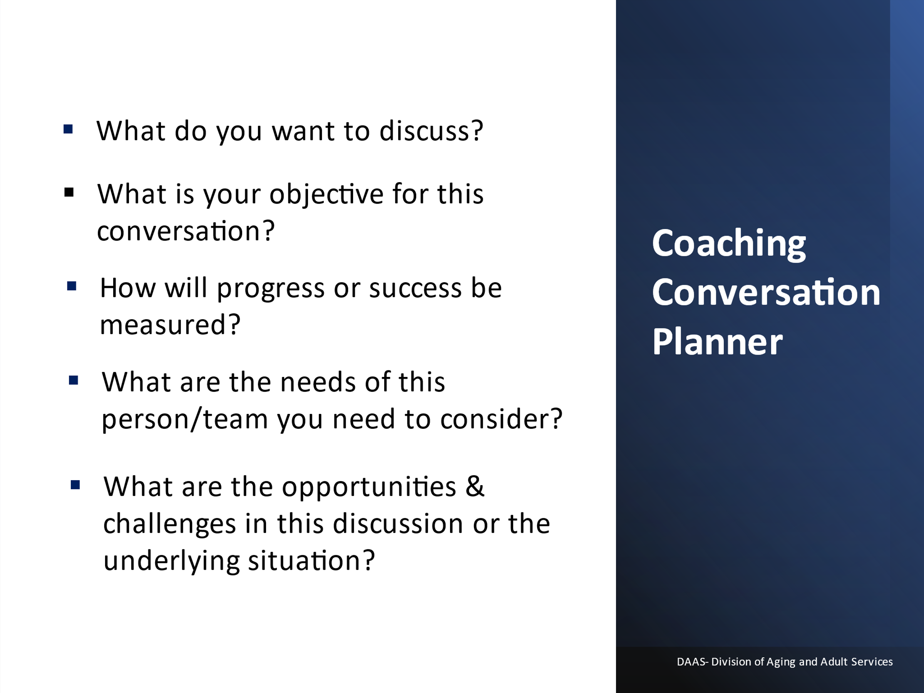
Notes: _____________________________________________
____________________________________________________
____________________________________________________
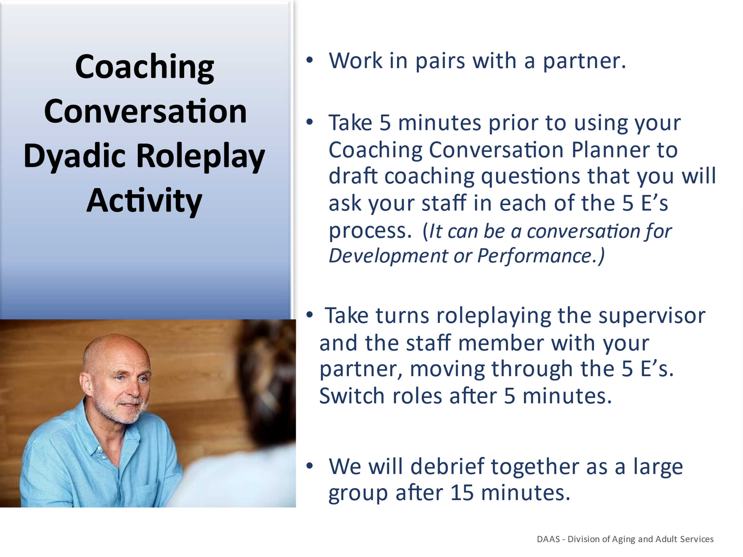

Notes: _____________________________________________
____________________________________________________
____________________________________________________
____________________________________________________
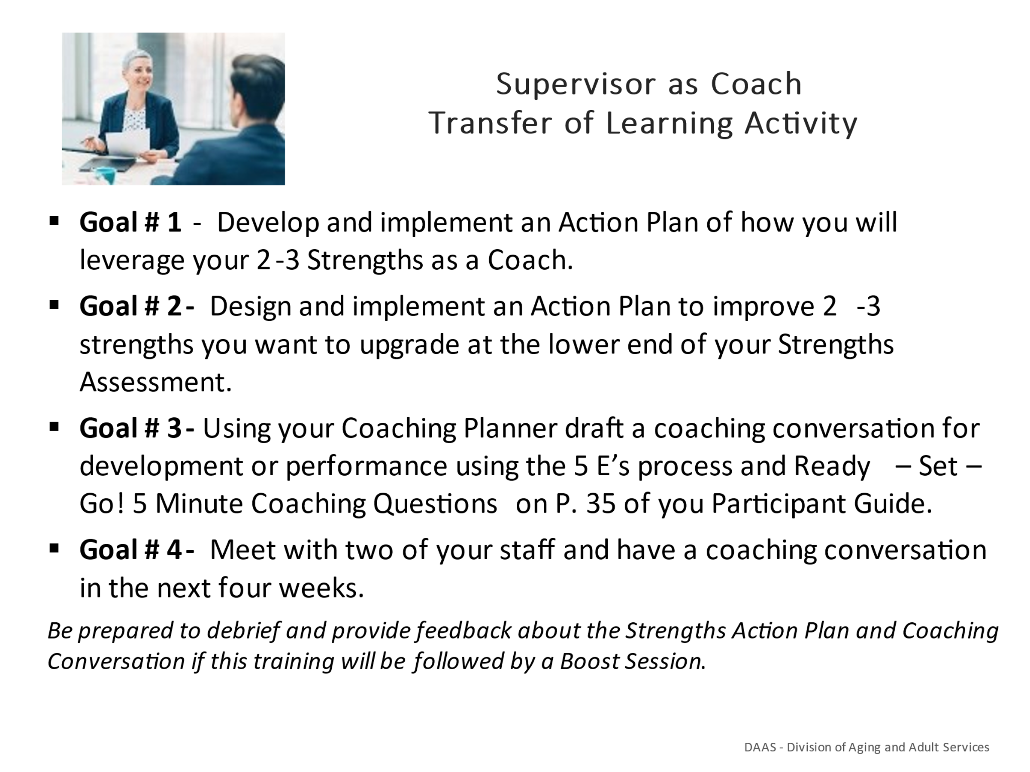
Notes: _____________________________________________
____________________________________________________
____________________________________________________
____________________________________________________
____________________________________________________
____________________________________________________
____________________________________________________

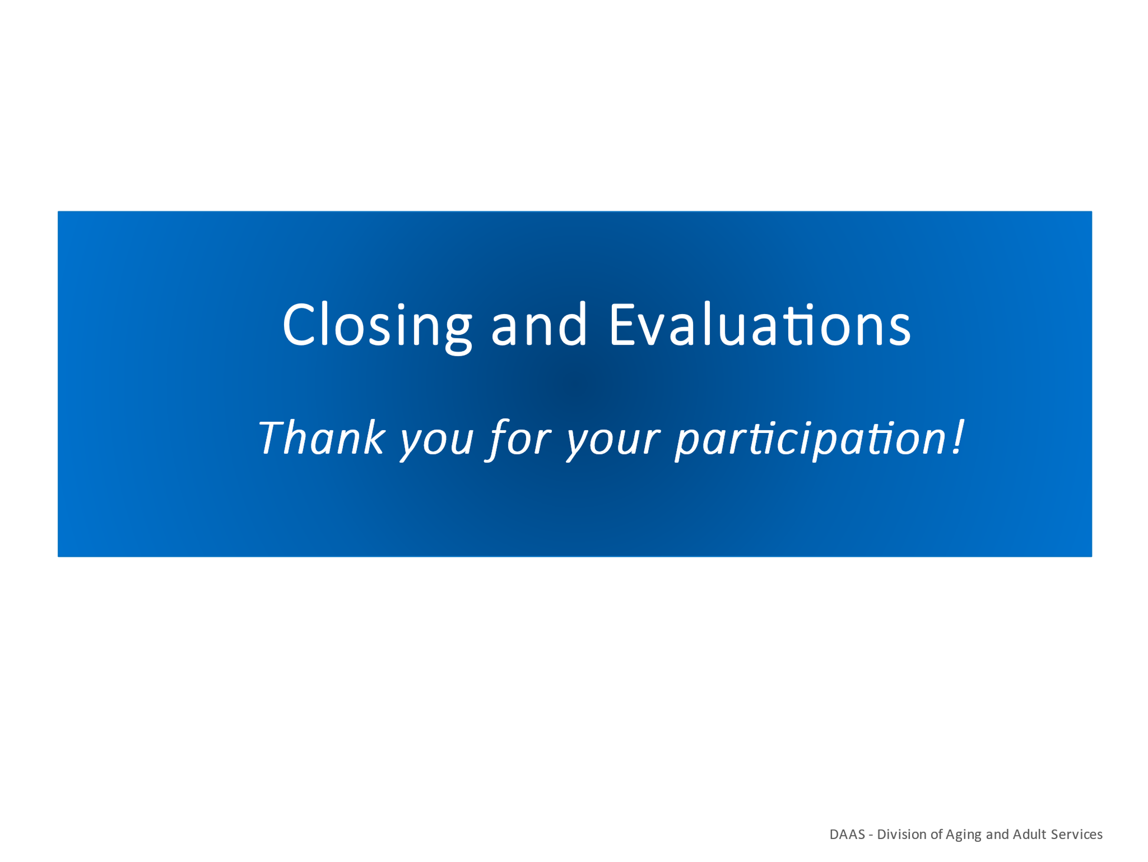
Notes: _____________________________________________
____________________________________________________
____________________________________________________
____________________________________________________
____________________________________________________
____________________________________________________
____________________________________________________

Post-Work Instructions in Preparation for Boost Session
We look forward to seeing you at the next Boost session! Below are instructions for the post-work to complete prior to attending the session. Review the Action Plan you created in today’s training to leverage 2-3 strengths when coaching and a plan to upgrade 2-3 strengths you want to improve. Review and further develop the plan which will take approx. 20 minutes.

- Use your Coaching Conversation Planner and incorporating the 5 E’s Step Process, plan 2 conversations with staff. Conversations can be for development or performance. You can also incorporate the Ready-Set-Go- 5 minute Coaching Questions as questions to ask in your planner that are in your Participant Manual on page 45.

- Meet with your staff in the next two weeks and use your planner for a coaching conversation for development or performance.

- When you return for the Boost training we will debrief and ask for your feedback/experience of these activities. We will be sending you reminder emails to nudge you about the TOLs for you to complete prior to the Boost.
- Be thinking about the following questions to discuss in small groups at the Boost training.
- What is your plan to leverage your top 2-3 strengths to coach staff? What have you incorporated and how has this worked for you?
- What strengths have you identified you want to upgrade and how will you leverage your existing strengths to help you improve in these areas?
- Who can you support you in your development?
- How will you monitor your progress?
- What was your experience of engaging in a coaching conversation for performance? Was it difficult or relatively easy to do? How was the conversation for development?
- Is there anything you might want to incorporate or do differently next time when engaging in a conversation with staff?

References
Ambrose, L. (2008). What Mentors do (and How They Do it). In P. LeForge (Ed.) A Mentor’s Companion (pp. 6-9). Mineola, NY: Dover Publications.

Asplund, J., Harter, J.K., Agrawal, Plowman, S. 2016, July). Strengths Meta-Analysis Report
https://www.gallup.com/cliftonstrengths/en/269615/strengths-meta-analysis-2015.aspx
Bungay Stainer, M. (2016). Question Masterclass Part 4. (pp. 106-107). The Coaching Habit. Say Less, Ask More & Change the Way You Lead Forever. Toronto ON Canada: Box of Crayons Press.

Deweede, C. (2017, February 15). How to Make Your Coaching Truly Strengths Based
How to Make Your Coaching Truly Strengths-Based (gallup.com)

Gilbert, W. (2019, February 27). Identifying and Coaching to Your Strengths
Identifying and Coaching to Your Strengths – Coaches Insider

Richardson, M. (2019) Coaching and Mentoring: Same, Similar or Different?
https://artofmentoring.net/coaching-and-mentoring-same-similar-or-different/

SkillsPacks, (2021, June 15). Coaching vs. Mentoring: Many Similarities, One Critical Difference
https://www.skillpacks.com/coaching-vs-mentoring/

Westfall, C. (2019, July 4). Why Coaching Matters: How Leaders Can Become Better Coaches and Build Stronger Teams. Forbes Why Coaching Matters: How Leaders Can Become Better Coaches And Build Stronger Teams (forbes.com)

Wilson, C. (2021, June 15). The Difference Between Coaching and Mentoring . Culture at Work. https://www.coachingcultureatwork.com/difference-between-coaching-mentoring/
Zust, C. (2017, July 5). Know The Difference Between Coaching and Mentoring. Kent State University. The Center for Corporate and Professional Development.
https://www.kent.edu/yourtrainingpartner/know-difference-between-coaching-and-mentoring

Additional Articles/websites/videoclips/handouts
https://unboxedtechnology.com/the-importance-of-coaching-at-the-workplace/
Why You Should Coach Your Team - businessnewsdaily.com
Coaching and Mentoring - Nigel MacLennan - Google Books
What is the GROW Coaching Model? (incl. Questions + Examples) (positivepsychology.com)
ASTD Coaching Self-Assessment Form,” Source: TeamSTEPPS® 2.0 (Module 9. Coaching Workshop), Self-Assessment Form (ahrq.gov)
Best coaching conversation - YouTube
Up In The Air: Coaching Leadership Style - YouTube
The Coaching Habit: The Kickstart Question - YouTube
Great Questions to Use When Coaching Someone - YouTube
The GROW model in action - YouTube
GROW for coaching and problem solving (live role play) - YouTube
Training Resources for APS Supervisors
Center APS Technical Assistance Resource
https://apstarc.acl.gov/Education/toolkits.aspx

APSWI Adult Protective Services Workforce Innovations
https://theacademy.sdsu.edu/programs/apswi/

Ready – Set – Go! 5 - Minute Coaching Questions

- What options do you see regarding this situation?

- What do you see as a challenge?

- What are your thoughts about the best way to approach this?

- What might get in the way?

- What do you think the next step?

- How can I support you?

- When can I check back with you?

Are You Ready to Give Healthy Feedback?
Brené Brown’s 10-Step Preparation Checklist

1. I’m ready to sit next to you rather than across from you.
2. I’m willing to put the problem in front of us rather than between us (or sliding it toward you).
3. I’m ready to listen, ask questions, and accept that I may not fully understand the issue.
4. I want to acknowledge what you do well instead of picking apart your mistakes.
5. I recognize your strengths and how you can use them to address your challenges.
6. I can hold you accountable without shaming or blaming you.
7. I’m willing to own my part.
8. I can genuinely thank you for your efforts rather than criticize you or your failings.
9. I can talk about how resolving these challenges will lead to your growth and opportunity.
10. I can model the vulnerability and openness that I expect to see from you.

Power Questions…
Listening. “Tell me what’s going on.” “What got you to this point?” “What happened to bring
you two to this place?”
Clarifying purpose. “What’s important about this for you?” “What matters most for you in all of this?”
Equipping. “What strengths, needs, wants are evident in the other’s communication style?”
“Where do your strengths, needs and wants fit in all of this?” “What strengths could you draw from to effectively engage the other?” “How might you approach this difficulty if your communication style was similar to theirs?”

Exploring options. “What have you tried to work this out?” What did you discover in those
efforts?” “What seems to have worked well?” “What else might work?”

Removing obstacles. “What might get in the way?” “What are your foreseeable challenges?”
“How might you overcome these?”

Empowering. “What might you do differently to get a different result?” “What is the outcome you hope to achieve?” “What next steps will assist you in achieving this outcome?” “How might resolving this difficulty contribute to your professional growth and development?”

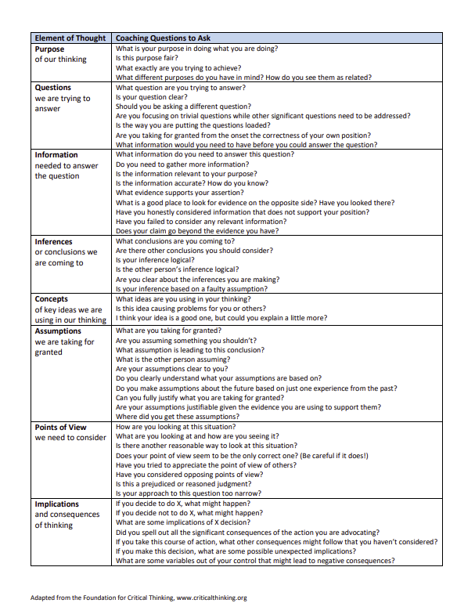

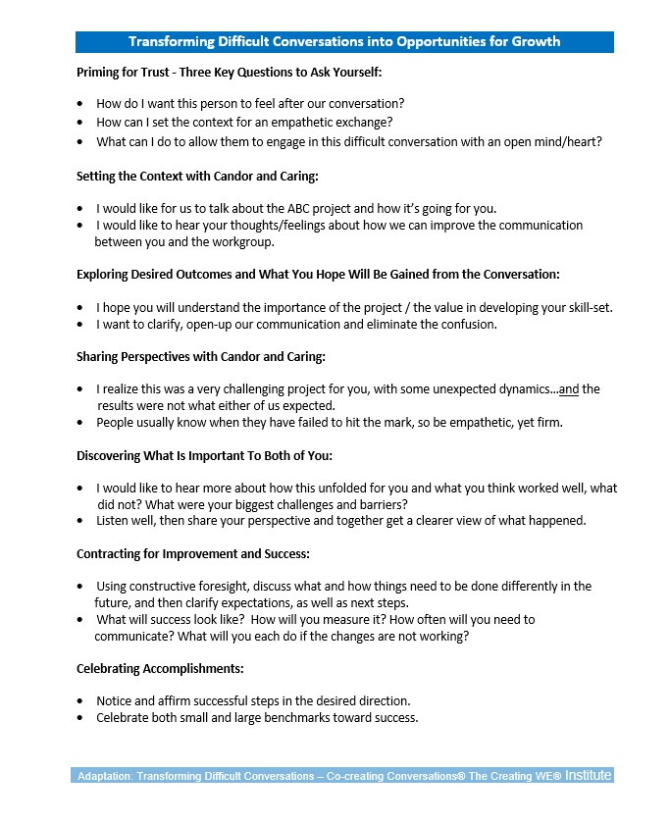

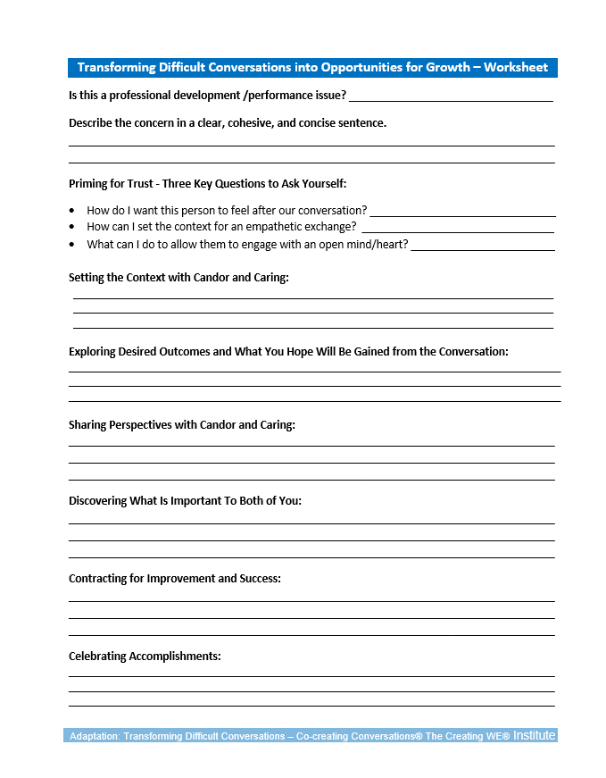

RISK Assessment Tool from APSWI Training Core Competencies- Module 18 Risk Assessment of Victims of Elder Abuse
Risk assessments are a process and help APS professionals assess clients’ vulnerability and needs, develop and monitor care plans, and make decisions about how to use their time and resources.
-NAPSA Core Competency Module 18: Risk Assessment

Directions: Using a current case, complete the risk assessment chart based on your observations and the information gained during your investigation.
For each Risk Factor that you identify:
- List the apparent risk next to the #.
  - Circle or highlight whether you find that risk to be low, medium or high.
  - Work through the 3 S’s by noting how Soon might the client be harmed, how Severe might they be harmed and how Sure are you that the harm will occur (i.e. the likelihood).
    - Make sure to include why you believe that to be true.
- Discuss any risk indicators.
- Provide a global assessment of that particular risk.
- Note any factors that may mitigate that risk.
- Create a service plan for each risk.

RISK ASSESSMENT CHART
RISK FACTORS  (Conditions which put a person at risk of harm) | RISK INDICATORS  (Observable signs that indicate that risk may be present) | GLOBAL ASSESSMENT  (History and context around this particular risk) | FACTORS THAT MITIGATE THE RISK  (Client’s strengths, motivation, support network) | SERVICE PLAN  (Identify services that might be of help and follow up if connections were made.)
#1.

- Soon

- Severe

- Sure

Based on 3 S’s, the level of risk is: Low, Med, High?
#2.

- Soon

- Severe

- Sure

Based on 3 S’s, the level of risk is: Low, Med, High?

#3.

- Soon

- Severe

- Sure

Based on 3 S’s, the level of risk is: Low, Med, High?

#4.

- Soon

- Severe

- Sure

Based on 3 S’s, the level of risk is: Low, Med, High?

#5.

- Soon

- Severe

- Sure

Based on 3 S’s, the level of risk is: Low, Med, High?

