Supervising APS Investigations Involving
Transnational Financial Fraud
Division of Aging and Adult Services
Adult Protective Services
Participant Guide

Table of Contents

Introduction 2
Section 1 – What Is Transnational Financial Fraud 3
Section 2 – Role of the APS Supervisor ………………………………………………………………… 6
Collaboration/Prevention Group Activity ………………………………………………………..7
Section 3 – Addressing Common Roadblocks …………………………………………………………….. 13
Section 4 – Using Guiding Questions and Action Steps…………………………………………………. 14
Section 5 – Case Scenarios Activity – Directions ……………………………………………………. 18
Scenario 1………………………………………………………………………………………. 19
Scenario 2………………………………………………………………………………………. 21
Scenario 3………………………………………………………………………………………. 23
(Sample Responses)……………………………………………..……………………. 25
Summary ………………………………………………………………………………………… . . . . . 33

Introduction
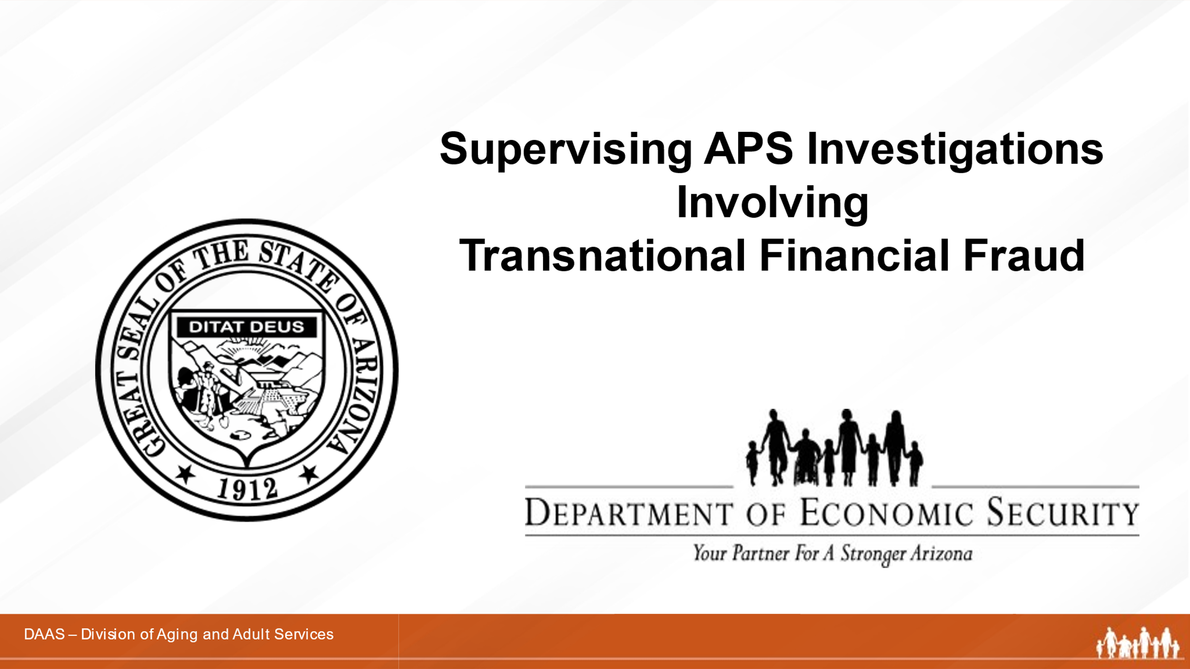

Notes: _____________________________________________
____________________________________________________
____________________________________________________

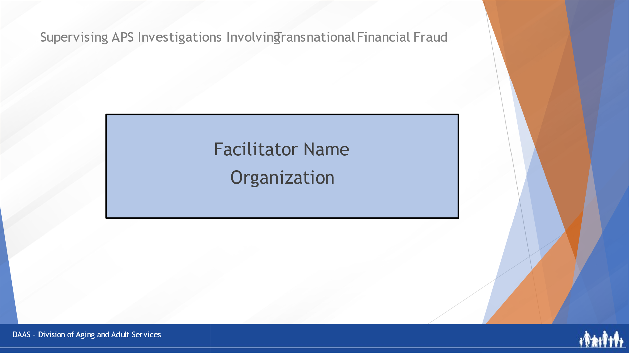
Notes: _____________________________________________
____________________________________________________
____________________________________________________
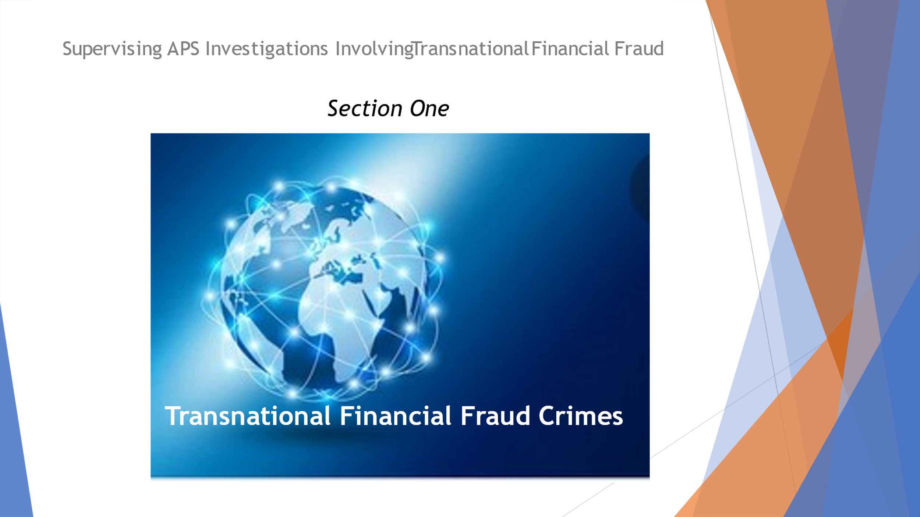
Notes: _____________________________________________
____________________________________________________
____________________________________________________

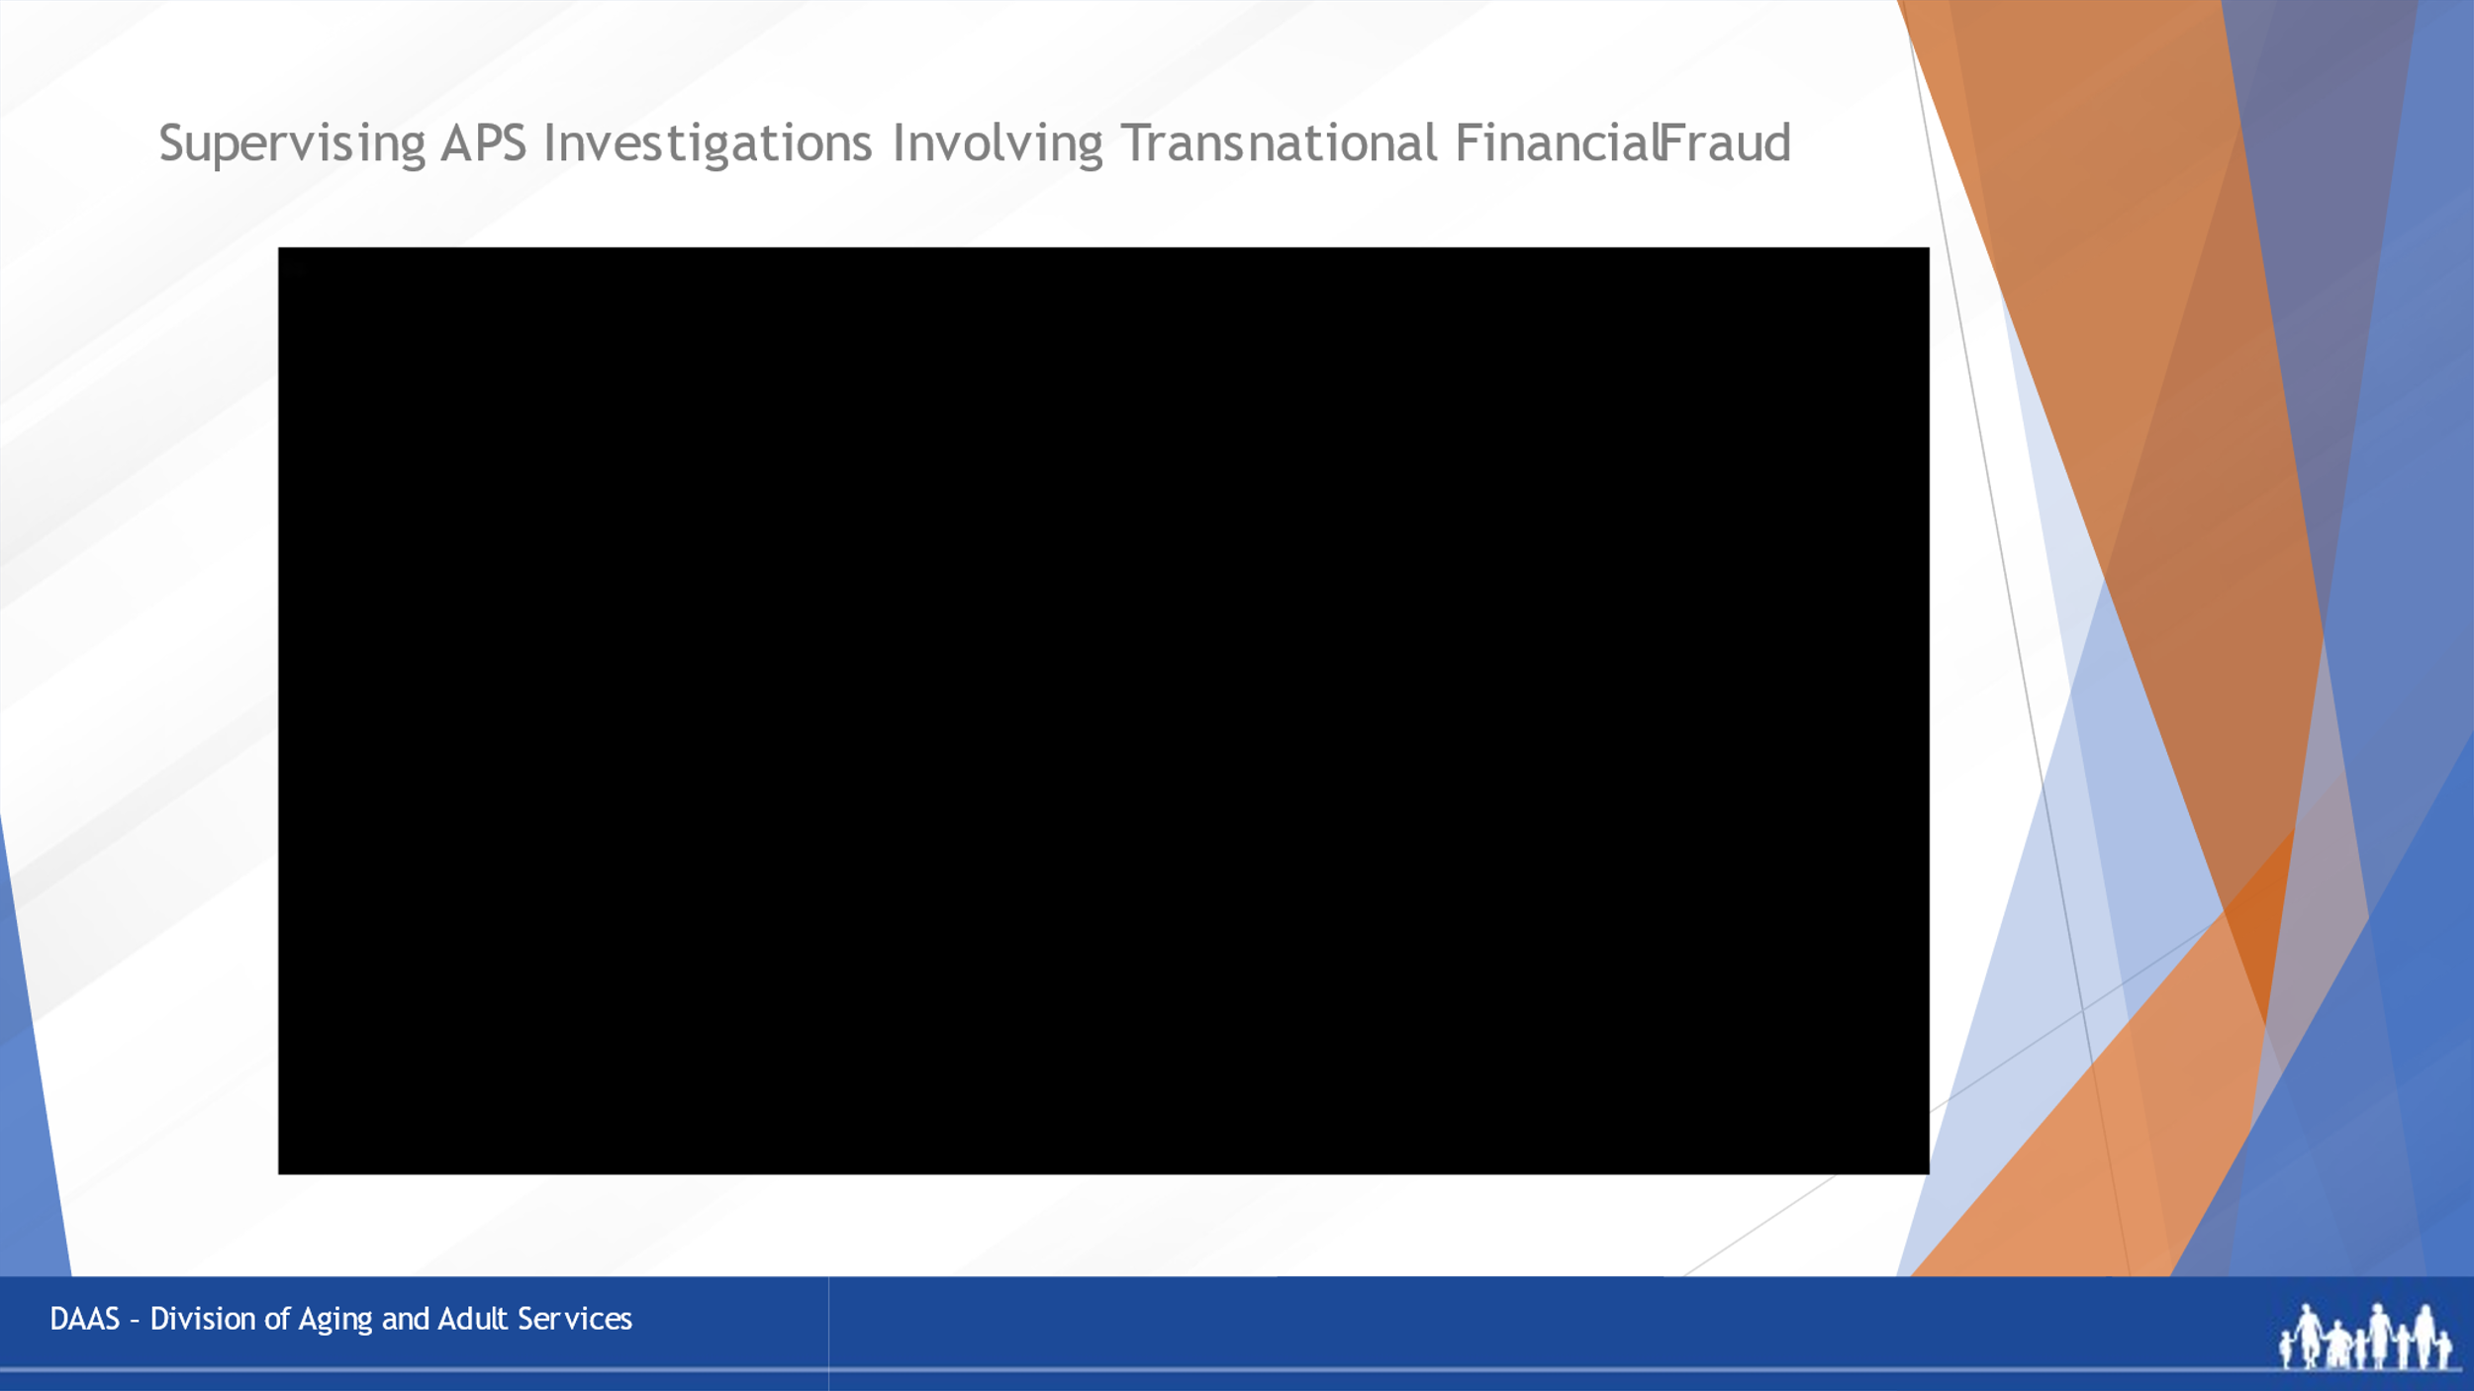
Notes: _____________________________________________
____________________________________________________
____________________________________________________
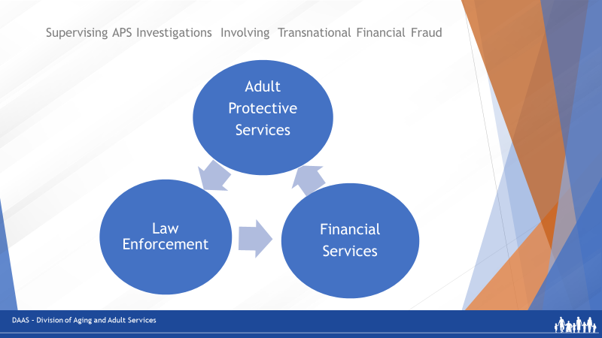
Notes: _____________________________________________
____________________________________________________
____________________________________________________

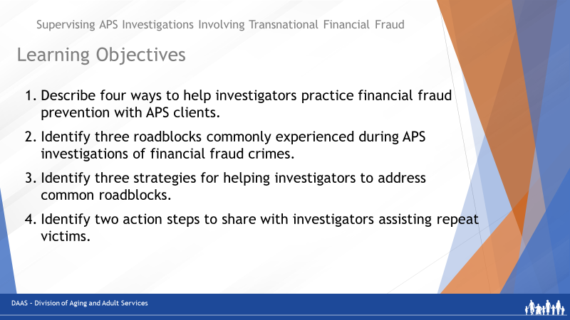
Notes: _____________________________________________
____________________________________________________
____________________________________________________

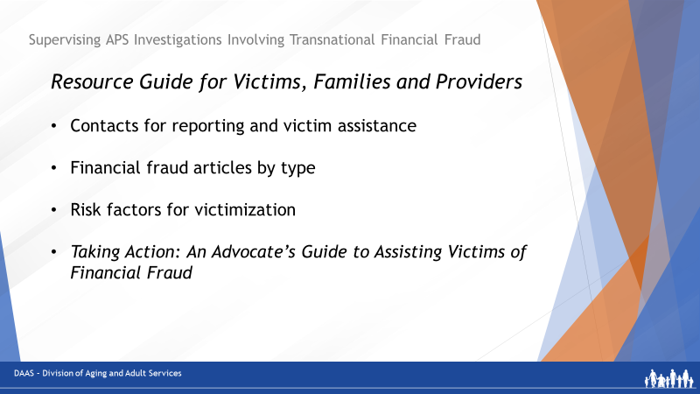

Notes: _____________________________________________
____________________________________________________

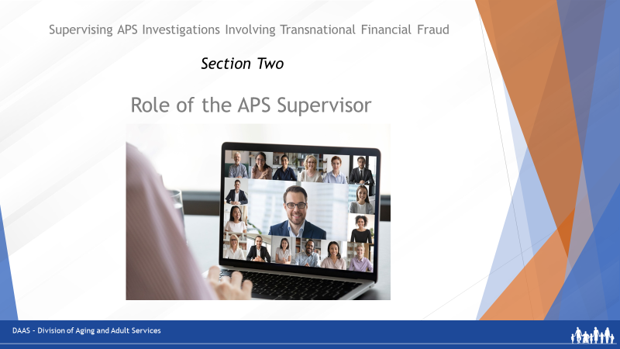
Notes: _____________________________________________
____________________________________________________
____________________________________________________
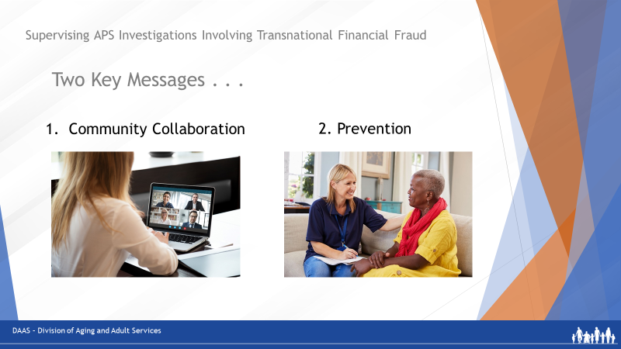
Notes: _____________________________________________
____________________________________________________
____________________________________________________

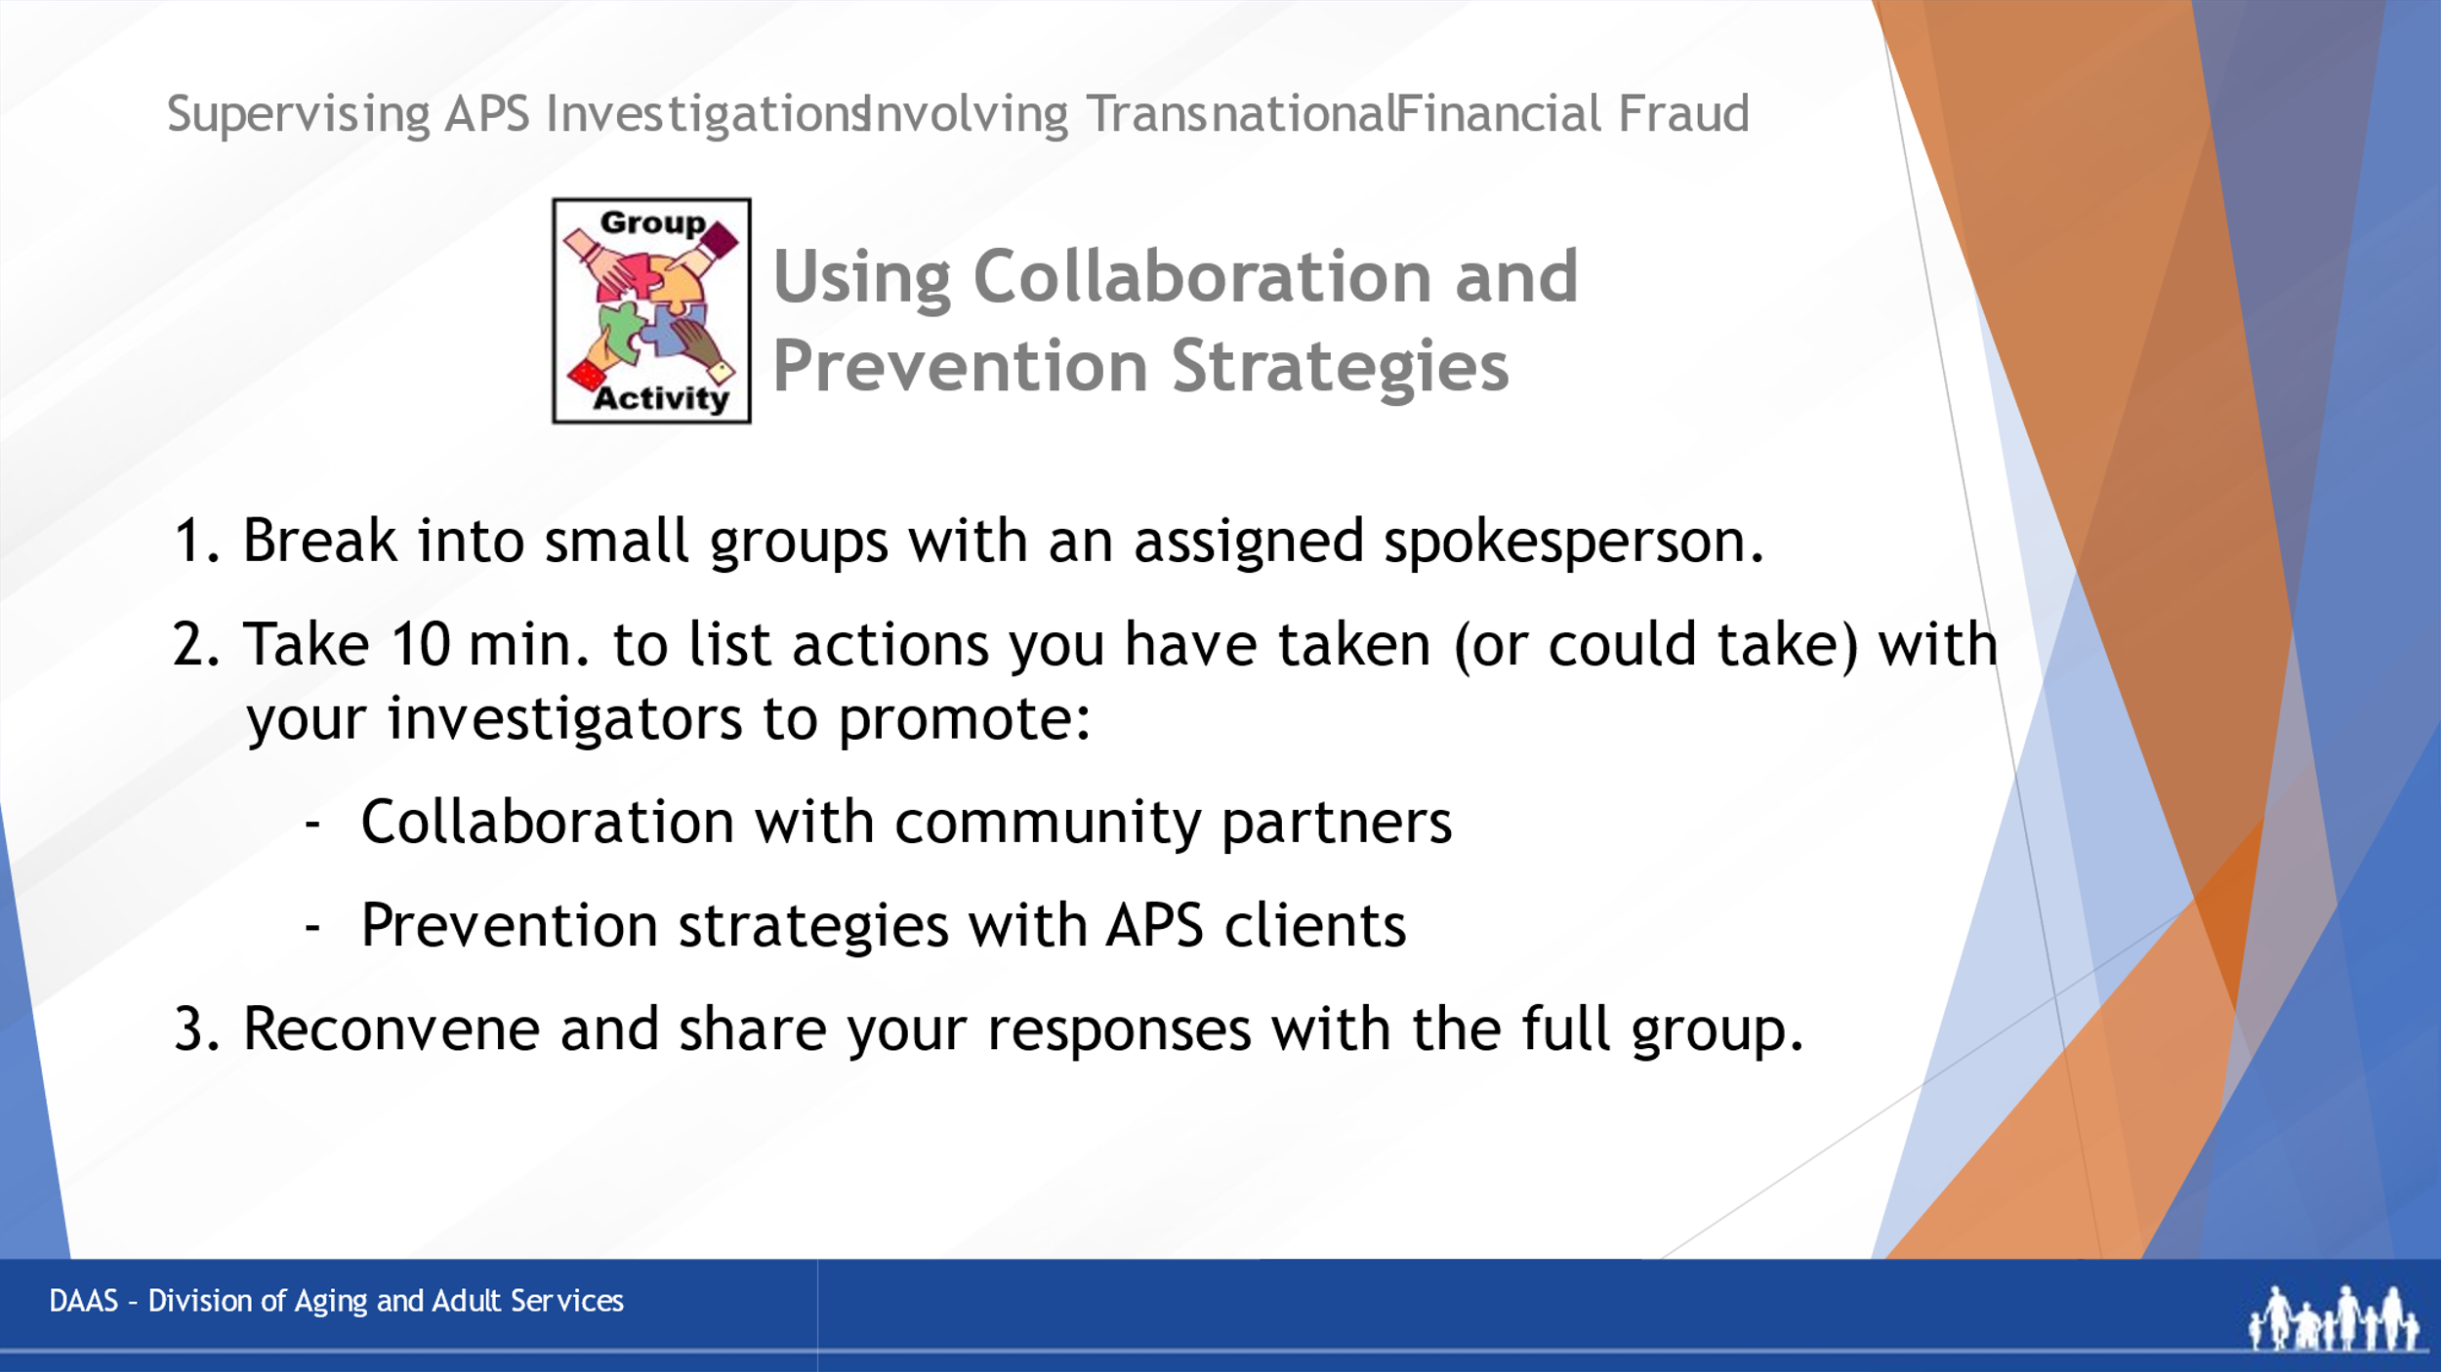
Notes: _____________________________________________
____________________________________________________
____________________________________________________

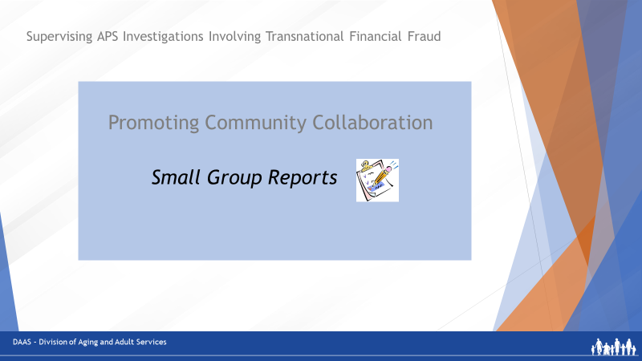
Notes: _____________________________________________
____________________________________________________
____________________________________________________

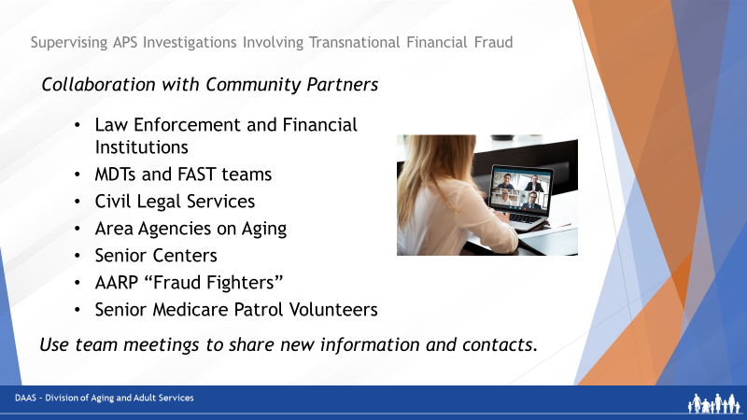
Notes: _____________________________________________
____________________________________________________
____________________________________________________

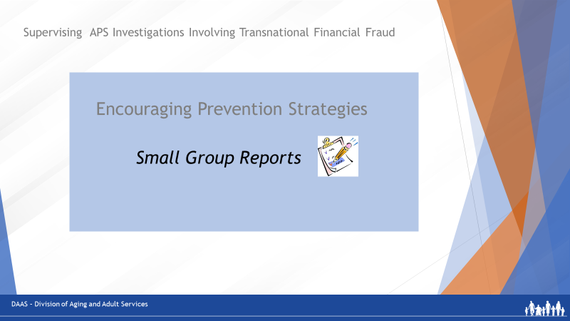

Notes: _____________________________________________
____________________________________________________
____________________________________________________

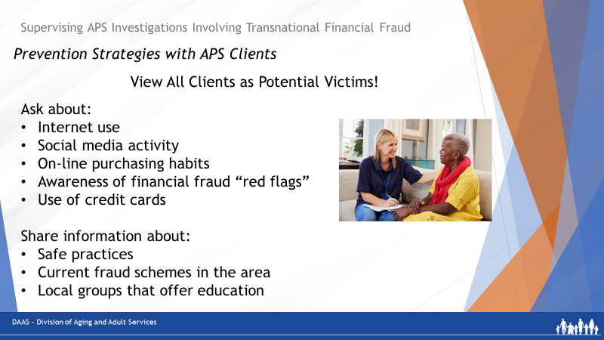
Notes: _____________________________________________
____________________________________________________
____________________________________________________

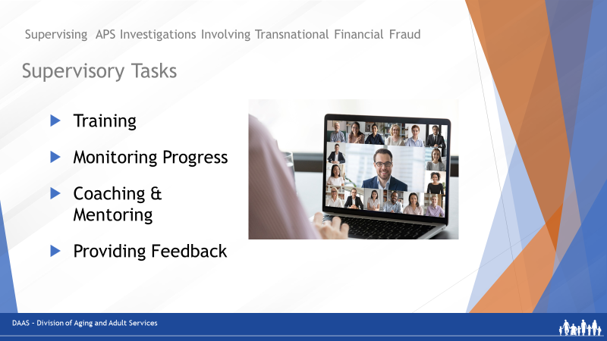
Notes: _____________________________________________
____________________________________________________
____________________________________________________

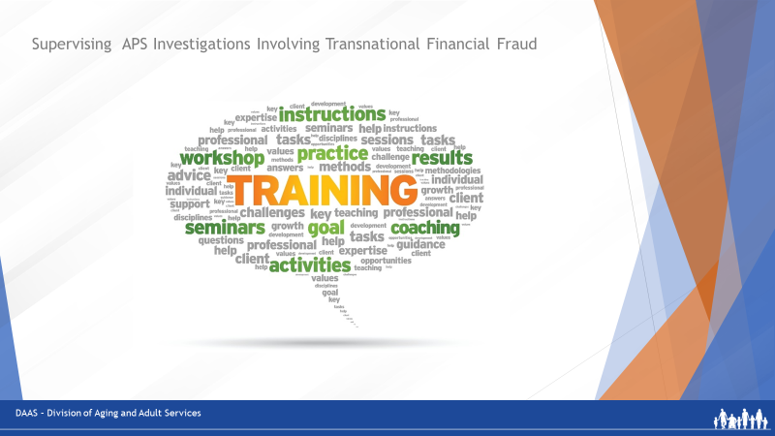
Notes: _____________________________________________
____________________________________________________
____________________________________________________

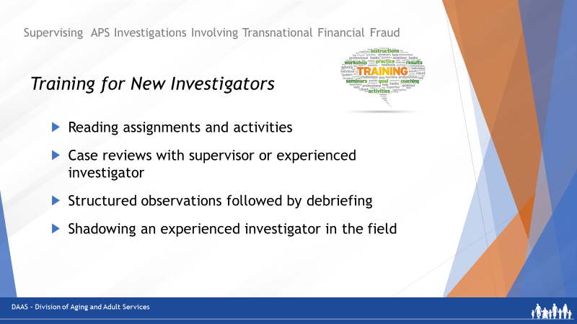
Notes: ____________________________________________________
____________________________________________________

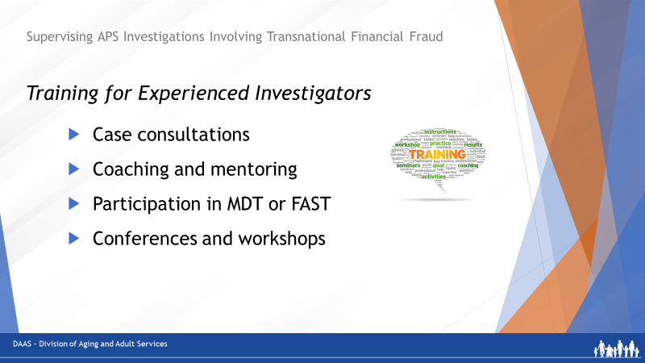
Notes: _____________________________________________
____________________________________________________
_____________________________________________
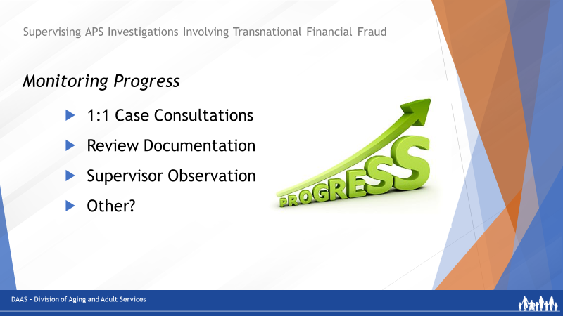
Notes: _____________________________________________
____________________________________________________
_____________________________________________

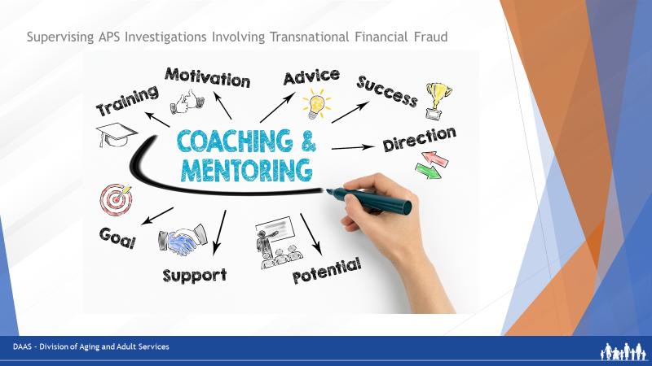
Notes: _____________________________________________
____________________________________________________
___________________________________________________

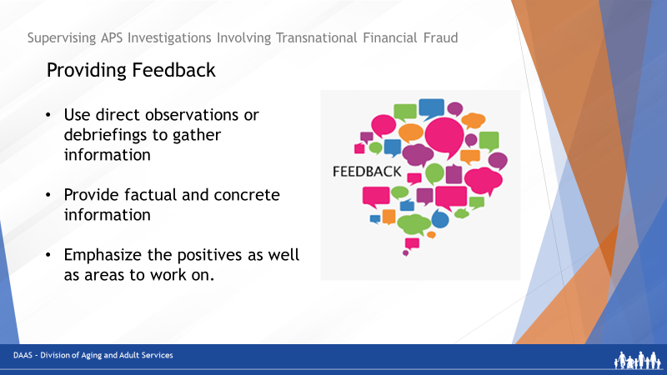
Notes: _____________________________________________
____________________________________________________
___________________________________________________

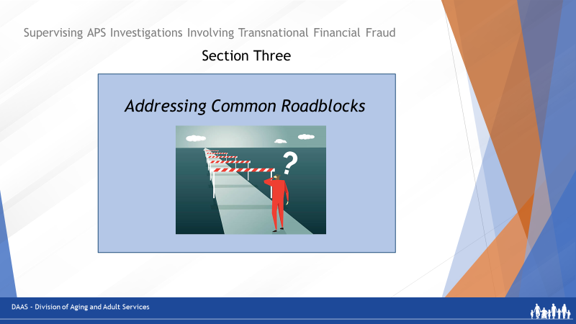
Notes: _____________________________________________
____________________________________________________
____________________________________________________

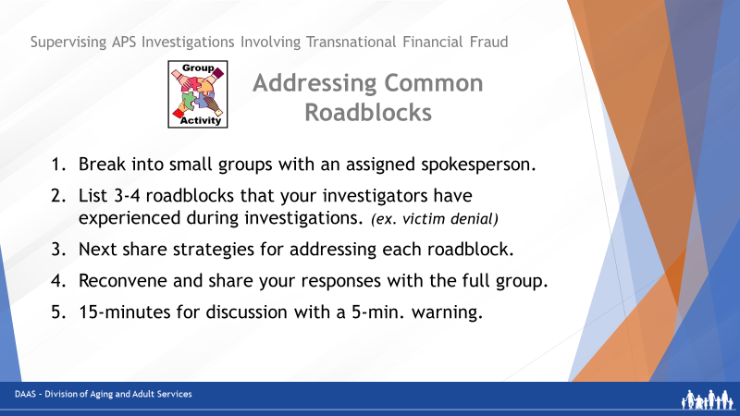

Notes: _____________________________________________
____________________________________________________
____________________________________________________

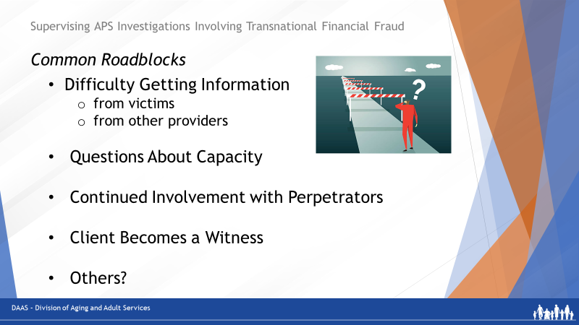

Notes: _____________________________________________
____________________________________________________
____________________________________________________

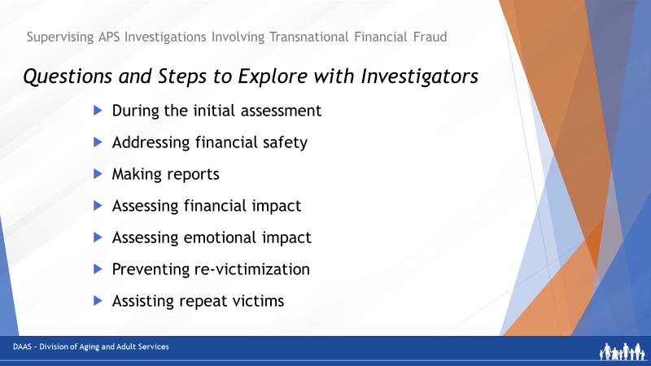
Notes: _____________________________________________
____________________________________________________
____________________________________________________

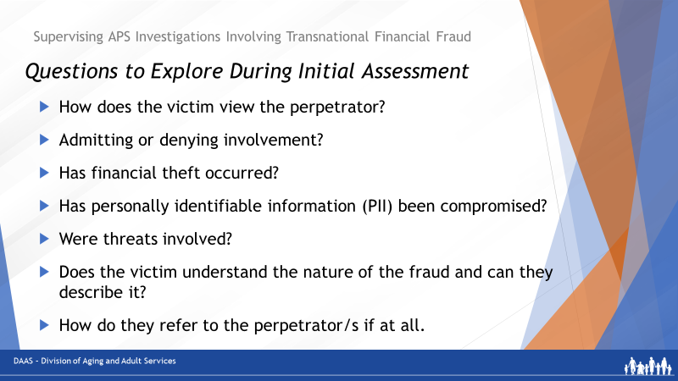

Notes: _____________________________________________
____________________________________________________
____________________________________________________

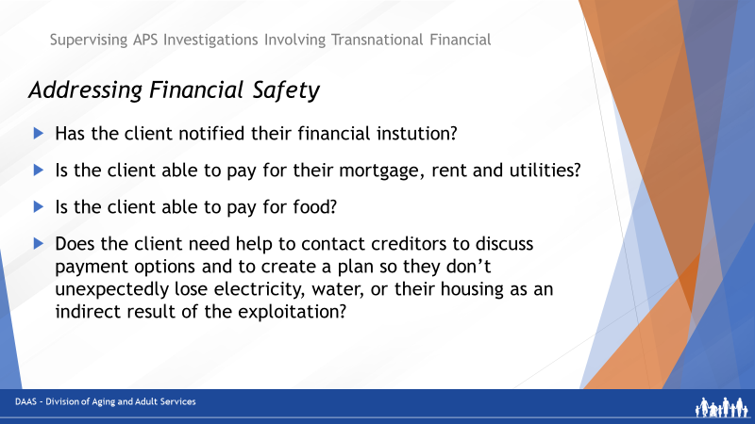
Notes: _____________________________________________
____________________________________________________
____________________________________________________

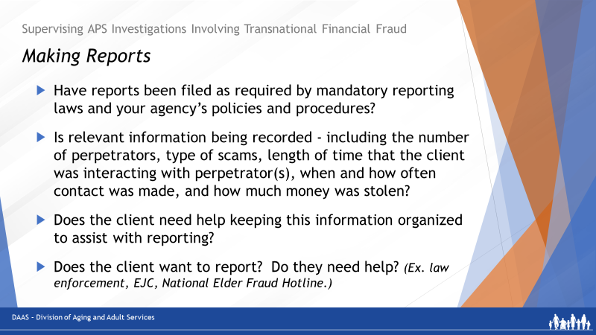

Notes: _____________________________________________
____________________________________________________
____________________________________________________
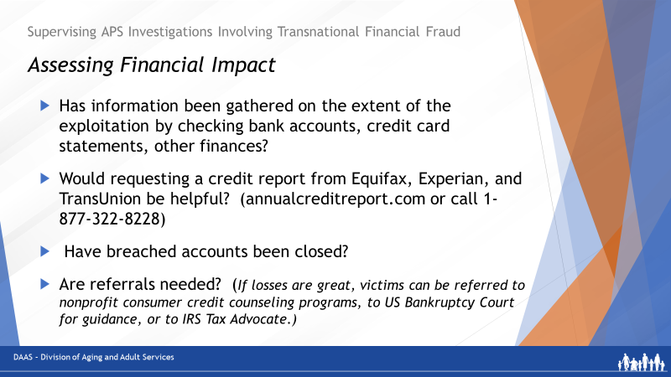
Notes: _____________________________________________
____________________________________________________
____________________________________________________

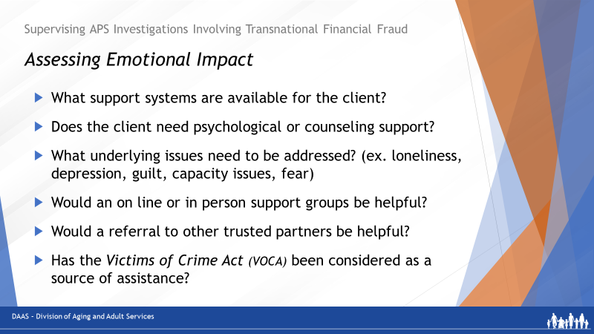
Notes: _____________________________________________
____________________________________________________
____________________________________________________

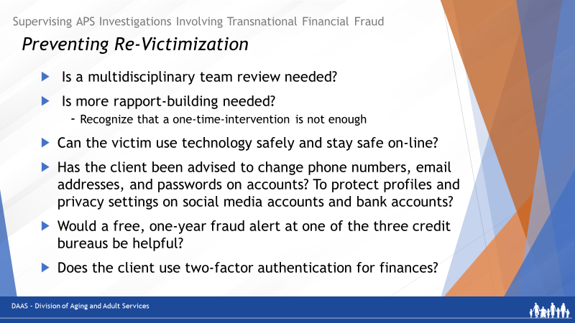

Notes: _____________________________________________
____________________________________________________
____________________________________________________

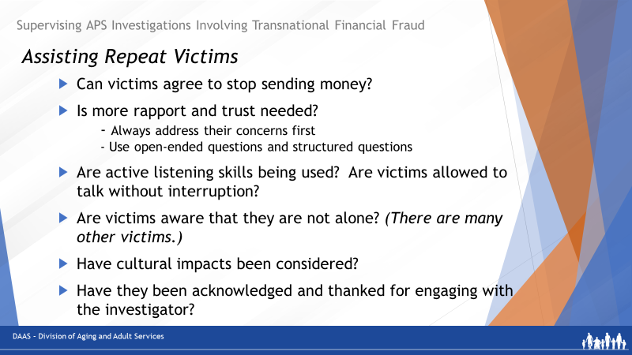
Notes: _____________________________________________
____________________________________________________
____________________________________________________
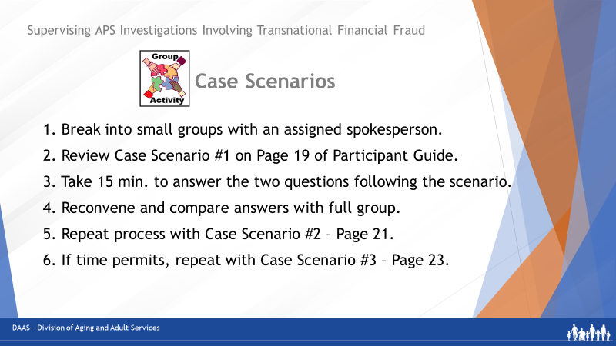
Notes: _____________________________________________
____________________________________________________
____________________________________________________

Case Scenario 1 - Louise
You receive a report from intake about an alleged financial fraud crime against a 75-year-old woman living alone in senior housing and described as confused and despondent.

The reporting source is a neighbor who became concerned when the alleged victim disclosed that she had wired most of her savings ($10,000) to someone who called claiming to be her grandson. The caller said that he was in legal trouble and needed an immediate cash payment to avoid being jailed.

Reporter Statement:
Because of the coronavirus pandemic, Louise hasn’t been able to see her grandchildren in a long time. Last week, she received a call from an unknown number. The caller said that he was her grandson, Robbie, and that he was in trouble. He told Louise he was in South America on vacation and was arrested after going out to a bar. He said that he was facing jail and criminal punishment unless he could come up with the $10,000 fee to be able to return home.
Louise was very anxious about Robbie, but also a bit skeptical. She asked the caller a few questions, and based upon his responses, she believed him. When Louise asked where to send the money, the caller pleaded with her to make a wire transfer, gave an account number, and said that time was running out.
A few hours after Louise wired the money, she got a call from Robbie. She was relieved to know that he was safe and asked him what happened. Robbie told her that he was not the caller and that she had probably been “scammed.” Now, Louise is embarrassed, fearful and very despondent about her loss. She doesn’t know what to do.
Small Group Questions for Case Scenario #1 – Louise

Question #1
What considerations would you make before assigning this case to one of your investigators?

Question #2
What questions could you use to coach or guide the investigator during the investigation?

Case Scenario 2 - Doris
One of your investigators asks for your help with a case of an alleged financial fraud crime against an 84-year-old woman that the investigator is working on. The client has severe arthritis that keeps her housebound. Since the death of her husband, she been anxious about managing by herself in the apartment.

The alleged perpetrator is her nephew, Matthew, who stepped in to manage Doris’ finances. He has convinced her that the tasks of money-management are too much for her to cope with. Doris has given him her checkbook and her credit cards. Recently, Doris received a call from a credit card company to verify some major purchases made from one of her accounts. Then, a check to the home care agency bounced.

The reporting source is a home health agency who employs a health aide assigned to visit Doris. The aide reported to her agency when Doris disclosed that she was worried her nephew was stealing her money and that she was afraid of him. The aide visits several times a week to assist her with personal care, errands and housekeeping. Doris allows the aide to use her debit card to purchase groceries.

The APS investigator is reviewing Doris’ bank and credit card statements but needs assistance in determining what expenses were for the alleged victim’s benefit and which were for the alleged perpetrator’s benefit.

Small Group Questions for Scenario 2 - Doris

Question #1
How would you guide your investigator in determining which expenses were for Doris’ benefit and which were for Matthew’s benefit?

Question #2
How would you help guide the investigator’s next steps based on the information from the review of Doris’ accounts?

Case Scenario 3 – Gary
You receive a report from intake about an alleged financial fraud crime against a 68-year-old man with mild physical and cognitive impairments due to a stroke. He lives in an assisted living facility where the alleged crime is reported to have happened within the last 24 hrs. The reporting source is a staff member at the facility who Gary reached out to about his on-line contact with a stranger who subsequently withdrew $4,000 from his bank account.

Reporter Statement:
Since moving into an assisted living facility, Gary has been using his iPad to communicate with family members, play online games with friends, and to track his finances. He uses online banking because it is easier thatn getting to the bank in person.

Yesterday, while he was online, he received a pop-up message from someone he didn’t know. When he clicked on the link provided in the pop-up, he became connected to a fraudulent scheme. The message claimed there was a virus on his iPad that could be fixed for a fee. When Gary authorized the fee as directed, the fraudster gained remote access to Gary’s bank account. Before Gary could turn off his iPad, he watched as a $4,000 withdrawal from his account was made.

Small Group Questions for Case Scenario #3 - Gary
Question #1
What considerations would you make before assigning this case to one of your investigators?
Question #2
What questions could you use to coach or guide the investigator during the investigation?

Possible Responses for Scenario 1: Louise
For Question #1 – What considerations would you make before assigning this case?
What is the investigator’s level of experience with exploitation cases?
Is this an opportunity to assign the case to an experienced investigator and have a less experienced investigator shadow?
Do you have MDT partners who could provide input into this investigation?
Others?

For Question #2 – What questions could you use to help coach or guide your investigator
Has the investigator:
- Spoken directly with the alleged victim?
- Found out where Louise wired the money from and help her contact the company to let them know that this was a fraudulent transaction? Asked about the possibility of recovering the assets? (If only a short period of time has passed, the company may be able to help.)
- Asked Louise if she provided the caller with any other information? (specifically, any other personal identifying information).
- Helped her record detailed information about the incident, including the account number where she sent the payment.
- Talked with her about the benefits of reporting and offered assistance in reporting if she is willing.
  - Contact the National Elder Fraud Hotline information for victim assistance and support.
  - Report to IC3 and the FTC.
  - Report to local law enforcement, Attorney General consumer protection division, the Better Business Bureau, etc.
- Asked Louise about any supportive relationship(s) with family and friends and encourage her to reach out to them for support? Consider a referral for counseling if needed?
- Asked if she would like any assistance with money management?
- Ensured that the financial loss will not preclude her from paying for rent, utilities, food and, if so, helped her contact creditors to discuss payment options?
- Encouraged her to reach out to you directly if she needs to?
- Has Louise experienced anything like this in the past?
- How will you help prevent her from becoming a repeat victim?
  - Spending more time on the case to build rapport and connections to supports.
  - Exploring coping strategies to deal with loneliness and isolation.
  - Refer for ongoing counseling if she could benefit from talking with someone regularly.
- Are there other community supports that Louise could connect with that might benefit her?
- Others?

Possible Reponses to Scenario 2: Doris
For Question #1- How would you help your investigator determine what expenses were really for Doris or her nephew?
- Review the bank statement for expenses that don’t fit with Doris’ situation and everyday needs. (For example, frequent visits to restaurants, repairs for a car she doesn’t own, veterinary bills for a pet she doesn’t have.)
- Review credit card statements for purchases that also don’t seem to fit. (For example: purchases of cryptocurrencies or large numbers of gift cards)

For Question #2: - What would be the next steps based on a review of Doris’ accounts?
Has the investigator:
- Reviewed this information with Doris?
- Determined the financial impact of the exploitation her?
- Discussed possible reporting options?
- Explored finding a different helper to assist with money management?
- Interviewed the nephew? (Could he be using Doris’s assets because he has become involved in a transnational financial fraud scheme?)
- Made reports as appropriate: to local law enforcement, Attorney General consumer protection division, the Internet Crime Complaint Center (IC3), the Better Business Bureau.
- Talked with Doris about how she’s been coping with anxiety and loneliness.
  - Connect her with therapists, counselors, and/or support groups for victims of romance scams.
  - Identified other organizations that may provide social engagement and support for Doris so that she doesn’t begin speaking to Matthew again

Possible Responses to Scenario 3: Gary
For Question #1: What considerations would you make before assigning this case?
- Which investigator has the experience to take actions quickly?
- Is this an opportunity to having a less experienced investigator shadow the assigned investigator?
- Do you have MDT partners who could provide immediate assistance?
- Others?

For Question #2: What questions could you use to help guide your investigator during this case?
Has the investigator:
- Asked Gary if he has notified the bank to help him make changes to protect his account from further losses?
- Asked Gary what other information he keeps on his iPad and advised him to change any passwords that may have been compromised?
- Asked Gary if he has experienced anything like this in the past? If he is a repeat victim, you may need to spend more time with him and connect him with additional support.
- Provided him with National Elder Fraud Hotline information for victim assistance and support?
- Reported: to local law enforcement, Attorney General consumer protection division, the Internet Crime Complaint Center (IC3), the Better Business Bureau, etc.
- Considered a credit freeze depending on the extent of the breach, particularly if the perpetrator could have found his social security number?

Additional questions for the investigator to consider about preventing re-victimization:

- Does Gary have relationship(s) with family and friends?
- Would he like assistance with money management? It could be helpful to have someone to take him to the bank when needed or to give a trusted individual access to his online banking to flag anything strange on his accounts.
- Does Gary have supportive relationship(s) with family and friends?
- What is Gary’s experience with isolation and coping with loneliness?
- Refer him to therapists or counselors if he feels that he might benefit from talking to someone regularly?
- Refer him to online programs such as cyberseniors.org?
- Give Gary some information on tech safety and common online scams?
- Tell him about two-factor authentication, safe passwords, and reviewing emails and other correspondence to look for red flags (like unknown links)?
- If he is interested, refer him to classes and other online activities?

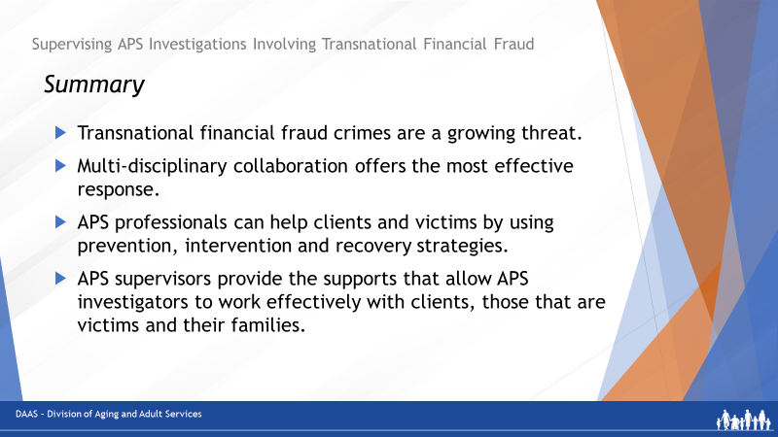
Notes: _____________________________________________
____________________________________________________
____________________________________________________

Notes: _____________________________________________
____________________________________________________
____________________________________________________

