Supervising APS Investigations Involving
Transnational Financial Fraud
Division of Aging and Adult Services
Adult Protective Services
Facilitator Guide

Supervising APS Investigations Involving Transnational Financial Fraud
Supervisor Core Competency 4D

This training was developed by the National Adult Protective Services Association with support from the Arizona Department of Economic Security, Division of Aging and Adult Services-Adult Protective Services, and funded, in part, by a grant (No. 90EJSG0035-01-00) from the Administration for Community Living, U.S. Department of Health and Human Services (DHHS). Grantees carrying out projects under government sponsorship are encouraged to express their findings and conclusions. Therefore, points of view or opinions do not necessarily represent the official Administration for Community Living or DHHS policy.

Curriculum Developers
Laura Cook, National White Collar Crime Center (NW3C)
Debbie Deem, Financial Abuse Specialist Team (FAST) Coordinator, Ventura County
Lori Delagrammtikas, NAPSA Executive Director Emeritus
Susan Staples, NAPSA Training Coordinator

ACKNOWLEDGEMENTS
This training is the result of a collaboration between Adult Protective Services administrators, supervisors, staff development officers, workers across states and the nation, and professional educators. We would like to thank the following contributors:

Agencies:
Arizona Adult Protective Services, Division of Aging and Adult Services, Department of Economic Security
National Adult Protective Services Association
Adult Protective Services Workforce Innovations

Committees:
Supervisor Curriculum Advisory Committee (SCAC)
National Adult Protective Services Association Education Review Committee

Supervising APS Investigations Involving Transnational Financial Fraud
Supervisor Core Competency 4D

Use of Training Materials

This training was developed to provide APS programs across the nation with NAPSA-approved training content and materials that support specific learning objectives and promote APS supervisor core competency.

States and jurisdictions may customize these materials by adding content to meet their needs for state-specific information (regulations, policies, procedures, tools) in the following ways:
- State-specific PowerPoint slides
- State-specific hand-outs
- State-specific examples and experiences shared by the facilitator during trainings

Users agree to refrain from making any changes to the basic approved content.

No commercial reproduction is allowed.

Table of Contents
Icons 3
For Facilitators 4
Virtual Set-Up……………………………………………………………………………………………………. 5
Instructor and Participant Supplies 7
Course/ Lesson Goal 7
Learning Objectives and Target Audience 8
Suggested Timeline 9
Introduction 10
Section 1- What Is Transnational Financial Fraud? 14
Section 2- The Role of the APS Supervisor 20
Section 3 –Addressing Common Roadblocks 34
Section 4 – Using Guiding Questions and Action Steps 39
Section 5 - Case Scenarios .………………………………………………………………………………….53
Summary ……..…………………….………………………………………………………………………….. 67

Equal Opportunity Employer/Program
Equal Opportunity Employer/Program Under Titles VI and VII of the Civil Rights Act of 1964 (Title VI & VII), and the Americans with Disabilities Act of 1990 (ADA), Section 504 of the Rehabilitation Act of 1973, the Age Discrimination Act of 1975, and Title II of the Genetic Information Nondiscrimination Act (GINA) of 2008, the Department prohibits discrimination in admissions, programs, services, activities, or employment based on race, color, religion, sex, national origin, age, disability, genetics and retaliation. The Department must make a reasonable accommodation to allow a person with a disability to take part in a program, service or activity. For example, this means, if necessary, the Department must provide sign language interpreters for people who are deaf, a wheelchair accessible location, or enlarged print materials. It also means that the Department will take any other reasonable action that allows you to take part in and understand a program or activity, including making reasonable changes to an activity. If you believe that you will not be able to understand or take part in a program or activity because of your disability, please let us know of your disability needs in advance if possible. To request this document in alternative format or for further information about this policy, contact: [Insert Division/Administration/Program Name and Number]; TTY/TDD Services: 7-1-1. Free language assistance for DES services is available upon request.

Icons

For Facilitators
This Facilitator Guide provides the structured content, activities, and PowerPoint slides to present a 3-hour training. Facilitators are encouraged to review the guide and to add any state-specific information and/or examples from their professional experiences as appropriate. The accompanying Participant Guide contains the PowerPoint slides and group activity materials that will be referenced during the training. In addition, there is a separate Resource Guide with links to resources - contacts for reporting and assistance for victims and articles related to financial fraud crimes. Facilitators are encouraged to review these reference materials ahead of trainings, to be prepared to screen-share them as directed, and briefly describe content and use.
Here are a few suggestions to help facilitate a successful class:
- Do not stray from the curriculum provided in the online session materials. Even if you may disagree with a policy or procedure, know a “shortcut”, or have worked at an office that did things in a different way than what is stated in the material, do not alter the materials. To keep the training message consistent, please follow any policy and procedures cited as written in this manual. If you do not agree with something, please bring it to the attention of your Training Manager before training.
- Be prepared and ready to welcome your Participants by having the online session materials ready to go at least 30 minutes prior to class start time.
- Always start and resume class on time.
- Dress professionally, even if it’s a “casual day”.
- Know the material and study its origins and applications.

Virtual Set-Up
This guide provides specific instructions for the producer and the facilitator. However, it can be facilitated by one person and both the producer and facilitator should be able to fill both roles should the need arise. To reduce the possibility of any problems arising, both the facilitator and the producer should:
- Ensure the most recent version of ZOOM is installed
- Practice using the needed tools after an update to ensure functionality
- Practice in both roles so as to be prepared for any technical issues
- Ensure you facilitate from a high-speed connection, preferably directly connected to a server instead of just WIFI
Practice utilizing multiple screens. If available, having more than one screen allows for quick access to the PowerPoint, Facilitator’s Guide and ZOOM interactive tools.
Note: ZOOM offers a wide variety of training videos concerning their product. Make sure both the producer and the facilitator are both trained on how to navigate this tool. For more information, go to the ZOOM Website and click the “Resources” Tab at the top of the home page. Even though this particular curriculum was designed with the ZOOM platform in mind, there are numerous platforms available for use (e.g., GoToMeeting, Blue Jeans, Microsoft Teams, Google Meets, etc.). You will need to adapt the curriculum to meet the limitations of the platform you choose to use.

Before the Class
Create Zoom link for the session and send to all participants both as an e-mail and an appointment when possible. Provide a number where you can be reached by text in the event of technical problems. Also include the Participant Guide and the Resource Guide as attachments. Remind them to have a printed copy to use during the session.
Send an e-mail reminder the morning of as well as 1 hour prior to the session. Encourage people to log in 15 minutes early, especially if they are uncomfortable with technology.
3.) Launch ZOOM Meeting and PowerPoint 30 minutes prior to the session. Prepare to welcome guests and troubleshoot technical issues as people arrive.
4.) As people arrive, ensure their name is displayed. You may also choose to have them update their name with their location.

Instructor and participant Supplies
- Supervising APS Investigations Involving Transnational Financial Fraud - Facilitator Guide
- Supervising APS Investigations Involving Transnational Financial Fraud - PowerPoint Slides
Supervising APS Investigations Involving Transnational Financial Fraud - Participant Guide
- Transnational Financial Fraud – Resource Guide

Course/ Lesson Goal
This 3-hour virtual course was developed to provide APS supervisors with a foundation for effective supervision of APS investigations involving transnational financial fraud crimes. It can easily be adapted to a classroom environment. It is designed with the following considerations in mind:
- Facilitated to be interactive.
- Designed for a class size of 20 - 25 staff.

Learning Objectives
At the end of this training, learners will be able to:
- Identify three roadblocks commonly encountered during APS investigations involving financial fraud crimes.
- Identify three strategies for helping investigators address common roadblocks.
- Describe four ways to help investigators practice financial fraud prevention with APS clients.
- Identify two action steps to share with investigators assisting repeat victims.

Target Audience
The target audience for this training is APS supervisors.

.

Timeline
 | Section | Content
5 Minutes | Welcome | Welcome participants, make announcements, review use of virtual platform, introduce facilitator.
10 Minutes | Section 1  Introduction to Transnational Financial Fraud Crimes | Opening video and learning objectives
40 Minutes | Section 2  The Supervisor’s Role | Promoting collaboration and prevention.  Supervisory tasks
 | Suggested 10 Min. Break
30 Minutes | Section 3  Addressing Common Roadblocks | Group Activity – Identifying roadblocks and sharing strategies for addressing them.
30 Minutes | Using Guiding Questions | Questions supervisors can use to help investigators assess financial safety, financial and emotional impacts, reporting steps, repeat victimization, etc.
 | Suggested 10-min. break
60 minutes | Case Scenarios | Working three case scenarios
5 min | Wrap-Up Summary

 | Introduction
Slide 1 | 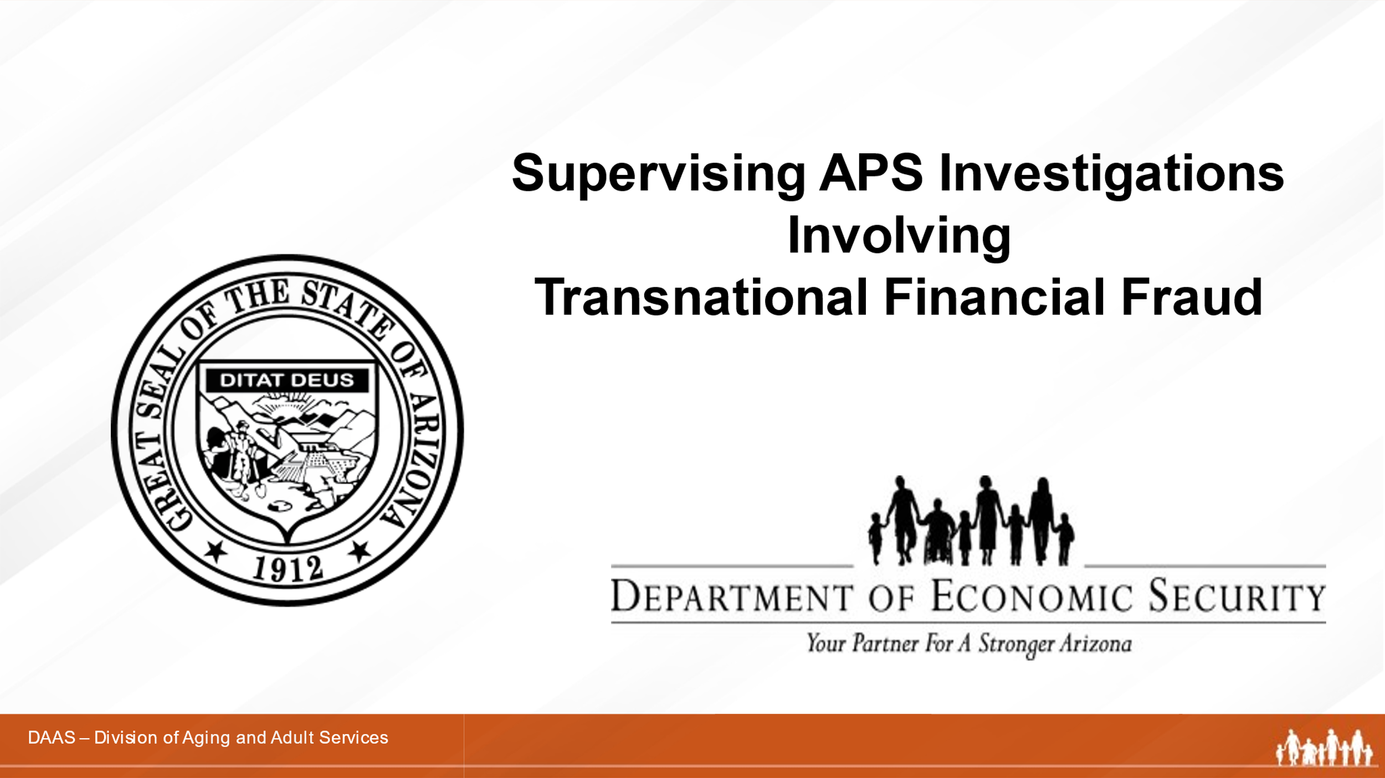
Producer says:
Welcome, everyone, to today’s training on Supervising APS Investigations Involving Transnational Financial Fraud. (Introduces self and role in overseeing technology and managing questions and group activities.)

Slide 2
Producer says:
Before we get started, let’s review some virtual housekeeping details to be sure we’re familiar with the technology features we’ll be using to communicate with each other.
Some of you may be more familiar than others navigating through a virtual learning course. So, we will briefly review the various functions of the virtual environment:
- Video Camera: Find the camera icon; when you do, please turn the camera off and on. During the session, please keep the video camera on since this is an interactive course.
- Mute/Unmute: Now, please locate the microphone. When you do, practice muting and unmuting yourself.
- Chat box: Find the chat icon. We will be using the chat function to communicate throughout the session.
- Emoji and Icons: These differ within the different virtual platforms
There will be a ten-minute break approximately 60 minutes into the training. And while participants are expected to attend the entire training, if you need to step away, please let the facilitator know by private chat.
And just a word about technical glitches. They are inevitable - on our end and your end! So please be patient and forgiving as we all navigate this virtual platform together.
Slide 3 | 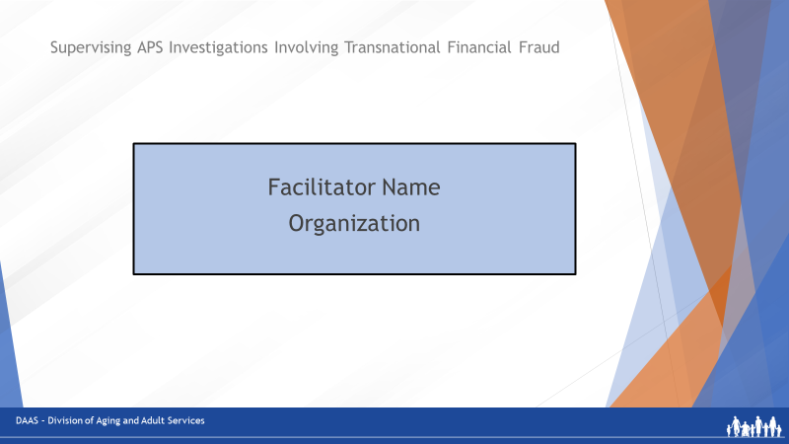
Producer says:
Now, let me introduce our facilitator for today’s session. (Introduces name and affiliation.)
Facilitator says:
Thank you! I’m very pleased to join you all to facilitate this training on Supervising APS Investigations Involving Transnational Financial Fraud. (May want to add a little more about own professional background.)

 | Section One: Introduction to Transnational Financial Fraud Crimes
Slide 4 | 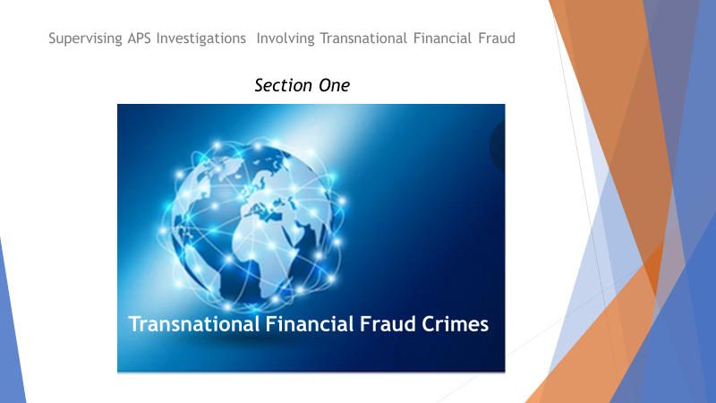
Facilitator asks:
So, let’s start with what we mean by “transnational financial fraud.” The title sounds complex. But what we will be focusing on is a form of criminal financial exploitation you are already familiar with – one that has been more commonly referred to as “scams.”

Why the change in the way we label these crimes?

- One reason is the global nature of the crimes. Criminal perpetrators are continuously finding new, timely and technologically-advanced ways to find and exploit individuals – from anywhere in the world.

- A second reason is that these schemes are serious crimes that are often devastating to victims. Terms like scams, consumer fraud, victim losses, or nonviolent crime are now recognized as minimizing the nature, extent and significance of the damage done.

- A third reason for the change in labeling is to increase the perception of professional responsibility among all service providers to respond to victims with services and help in getting reports filed, investigations done, referrals made, and recovery assistance for victims provided.

Transnational financial fraud crimes are a growing danger to all of us and the clients that APS serves may be especially at risk.

Perhaps the best way to begin our discussion is to watch what happens to Bessie – a woman who responds to a fake e-mail notifying her of a questionable charge by Amazon to her bank account. The e-mail tells her that, if she doesn’t recognize this charge, she is to call the phone number listed in the e-mail for assistance. And when she does, you can probably guess who answers the call. Bessie becomes connected to a call center of criminals in India. Let’s watch how they operate.
Slide 5  Play Video:  (4min. 43sec.)  In PowerPoint, move cursor over the bottom of black rectangle until the “Play” arrow appears. Click play arrow to start.  When video finishes, move to next slide. | 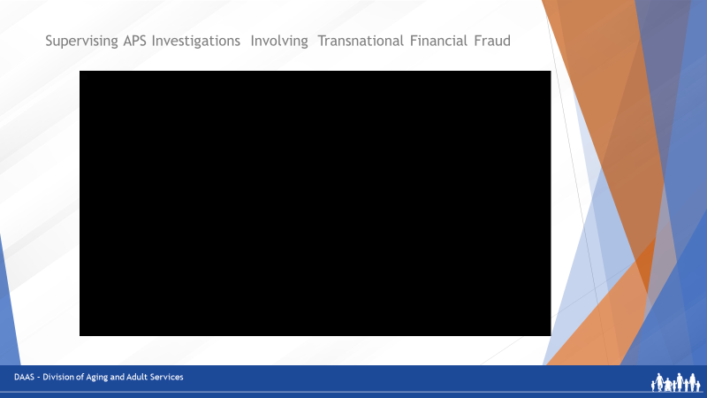
Facilitator asks:
Have any of you had experience with this type of crime? (Invite participant responses to share any experiences.) You can see how quickly a person can be targeted and victimized, how the perpetrators act, and the impact it has on the victim.
Slide 6 | 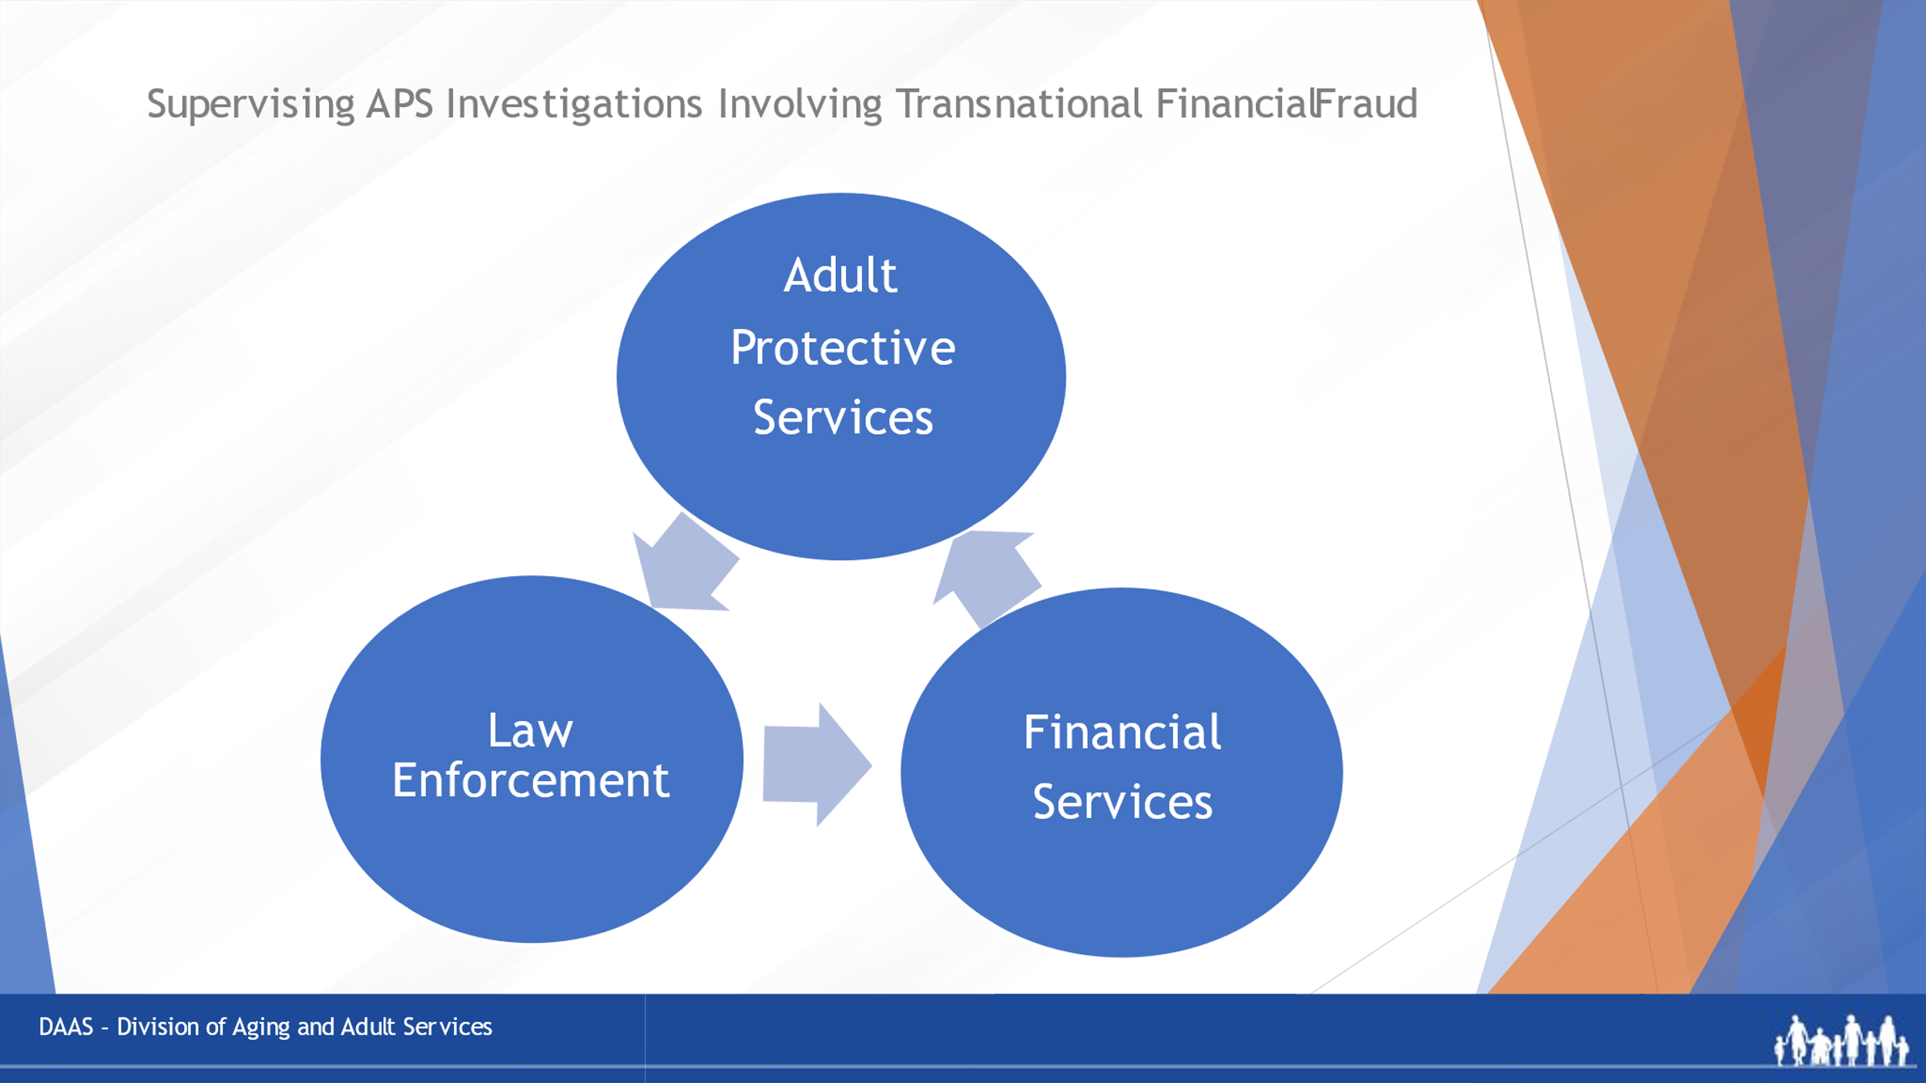
Facilitator says:
What we just saw is only one example of a transnational financial fraud crime using mass marketing techniques like e-mails and robo-calls. And, as cited in the video, millions of potential victims are targeted daily.

APS, law enforcement and financial services are the front-line professionals most often called upon to respond to reports of financial fraud crimes. Using a multi-disciplinary, coordinated approach to investigating, intervening and reporting these crimes is the most effective strategy for helping victims.

APS supervisors play a key role by providing their staff with the knowledge, skills and supervisory guidance to carry out their role as APS investigators of these types of financial fraud.
Slide 7 | 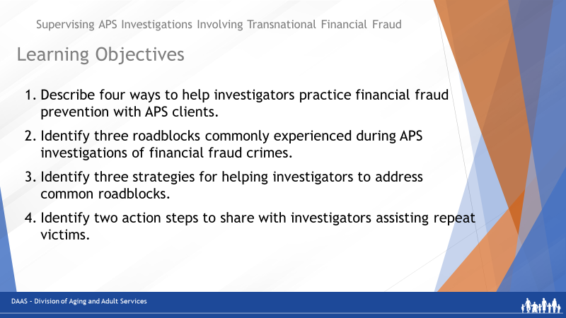
Facilitator says:
So, the learning objectives for this session will focus on being able to:
- Describe four ways to help investigators practice financial fraud prevention with APS clients.
- Identify three roadblocks commonly encountered during APS investigations of financial fraud crimes.
- Identify three strategies for helping investigators address common roadblocks.
- Identify two action steps to share with investigators assisting repeat victims.
Slide 8 | 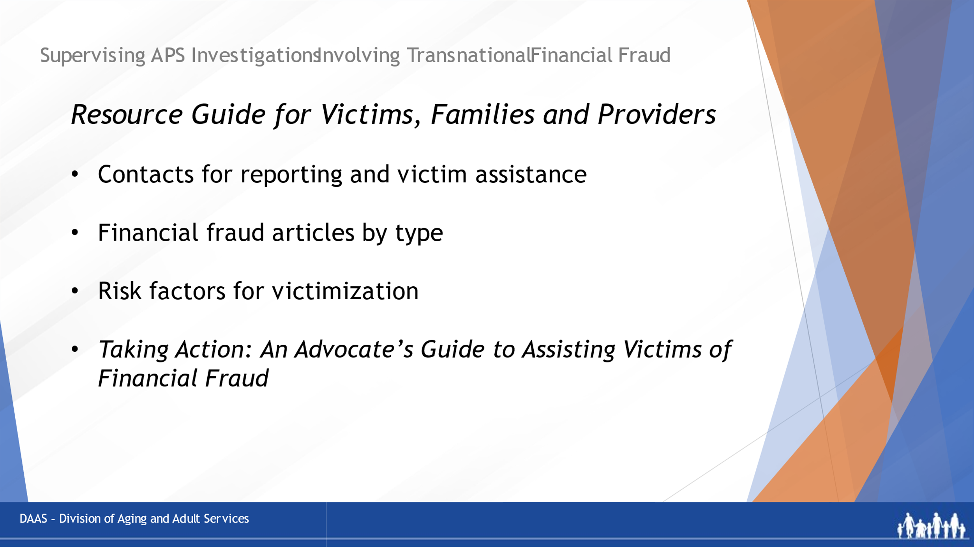
Facilitator says:
In addition to your Participant Guide, you have been provided with a separate Resource Guide that you can share with your investigators. It offers a wide variety of resources for victims, families and professionals including: reporting contacts, services for victims, and informative articles related to transnational financial fraud.

And be sure to check out the link to Taking Action: An Advocate’s Guide to Assisting Victims of Financial Fraud. The booklet outlines the advocate’s role, action steps to take by fraud type, and many preventive strategies.

 | Section Two- Role of the APS Supervisor in Supporting APS Investigators
Slide 9 | 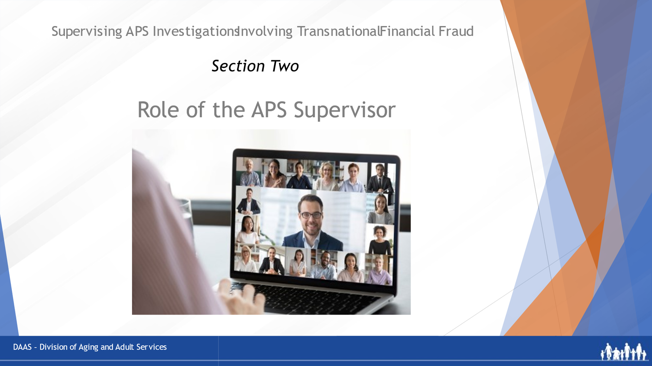
Facilitator says:
This segment of today’s training will focus on the role of the APS supervisor in supporting investigators in their work with clients who have become victims – or who may be at risk for becoming a victim.

Cases of transnational financial fraud crimes can be complex and discouraging for APS investigators. Significant losses may have already occurred before APS becomes involved and the losses may not be recoverable. Victims and their families may be in crisis. Some victims may be in denial, refuse help and continue to be involved with the perpetrator.

While these cases can be difficult, there are ways that APS can help – by offering prevention, intervention and recovery strategies to assist victims and their families.
Slide 10 | 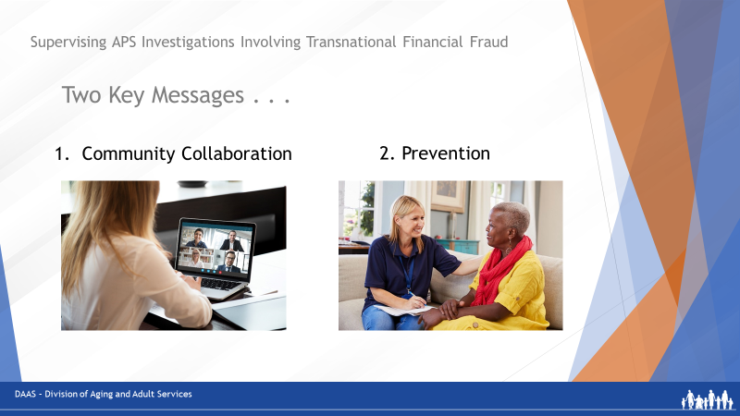
Facilitator says:
As we look more closely at the supervisor’s role, let’s begin with two key messages about cases of financial fraud that supervisors will want to instill early and often with their staff:

- First is the need for community collaboration - Collaboration and coordination with other community providers is essential to effective and timely response. This might be with law enforcement, financial service providers, or other community services.
- And second is the importance of prevention - Preventing APS clients from ever becoming victims is a key goal. Encourage investigators to view all their clients as potential victims of financial fraud.

Slide 11 | 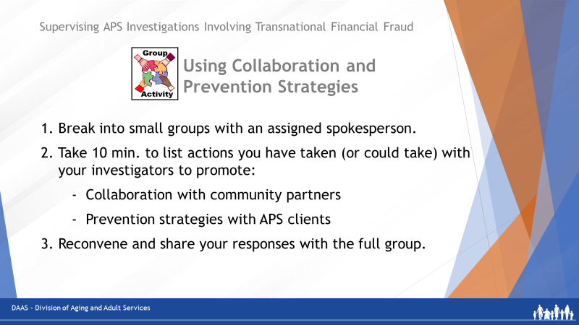
Facilitator says:
To further explore collaboration and prevention strategies, let’s get some of your input and experience.
- First, we’ll break you into small groups with a spokesperson for each.
- Next, we’ll give each small group 10 minutes to list some actions supervisors can take or have taken to promote both collaboration with community partners and prevention strategies with all APS clients.
- Then, as a full group, we’ll discuss your responses.

(You will find these same directions on Page 7 of your Participant Guide.) Any questions before we start?
(Producer breaks participants into small groups and assigns a spokesperson. Sends a 2-minute warning and then reconvenes the large group.)
Facilitator says:
Welcome back! Let’s hear some your ideas starting with the first question on promoting community collaboration. How about starting with Group 3?
Facilitator recaps the group’s contributions and then asks each of the other groups if they have additional ideas to contribute.

Slide 12 | 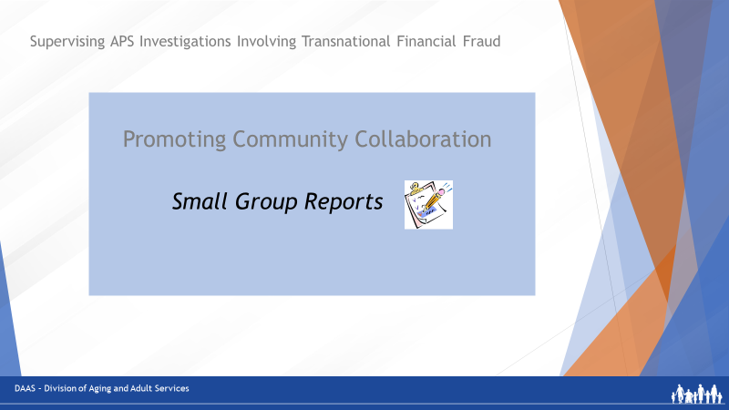
Slide 13 | 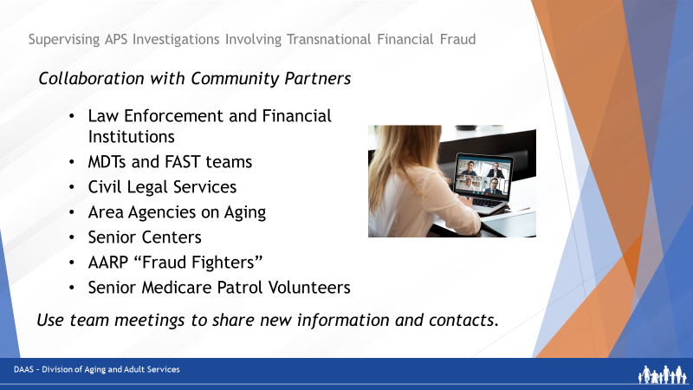
Facilitator says:
Good job! Let’s quickly re-cap various ways to promote collaboration with other community partners.

Along with APS investigations, there may be other on-going investigations in the same case - especially by law enforcement and banks. When front-line responders like APS, law enforcement and banks collaborate, they gain clearer understanding of:
- What each agency can and cannot do
- How to best coordinate efforts and share information with one another.
Some areas have multidisciplinary FAST teams (financial abuse specialist teams) that focus entirely on financial fraud – and case reviews as well as public and professional education.
Encourage your staff to engage with other agencies or groups in their communities that work on preventing or responding to financial fraud crimes. These could include civil legal services, area agencies on aging, senior center directors, senior housing coordinators, AARP and Senior Medicare Patrol volunteers.
Collaboration builds working relationships among professionals who can share expertise and help that is mutually beneficial. Use team meetings as times for investigators to provide updates about new community contacts or resources they have discovered.
Slide 14 | 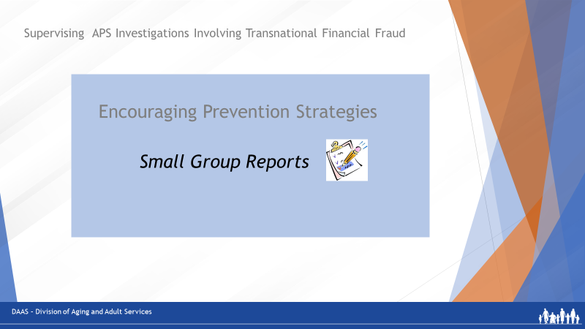
So now, let’s hear about your ideas for encouraging your investigators to use prevention strategies with clients. Would the spokesperson for Group 2 please tell us what suggestions you have?
Facilitator recaps the group’s contributions and then asks each of the other groups if they have additional ideas to contribute until all groups have reported.

Great responses, everyone. Thank you!
Slide 15 | 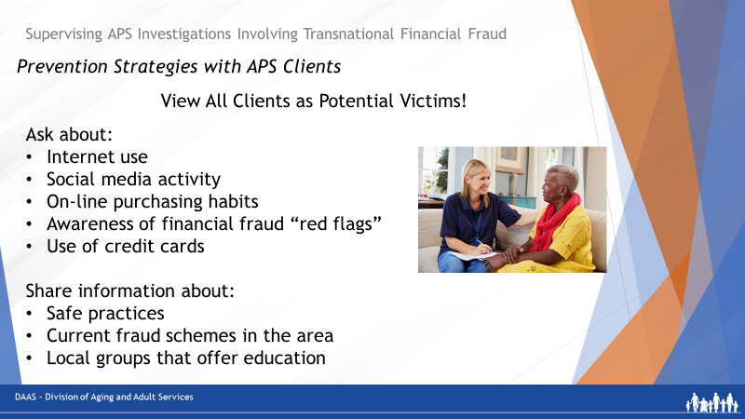
Facilitator says:
Just to recap: Supervisors can promote the use of prevention strategies by encouraging investigators to view all their clients as potential victims.
Here are some specific questions to share with investigators as they do client risk assessments:

- Do they spend a lot of time on the Internet?
- Are they on any social media platforms or dating platforms? Advise them not to accept friend requests from people they don’t know.
- Do they make purchases or bank on-line?
- Do they call a company directly if there is any report of discrepancies in their accounts?
- Are they aware of financial fraud schemes?
- Do they understand how to use technology safely?
- Do they seem able to make financial decisions for themselves?
- How about cell phone usage? Do they have more than one cell phone?
- How about credit card usage? Do they use more than one card? Do they update passwords? Do they use two-step verification?

Providing information about financial fraud crimes to all clients can help raise their general awareness about red flags to watch for. Encourage investigators to stay alert for financial fraud crimes being reported in their area and share that information with clients and their families.

You will find a link in your Resource Guide to free public awareness materials that can be printed and shared with clients.

In addition, community volunteer groups such as AARP Fraud Fighters and Senior Medicare Patrol provide group presentations and materials to educate individuals on how to protect themselves from becoming victims.

Any other ideas or thoughts before we continue?
Slide 16 | 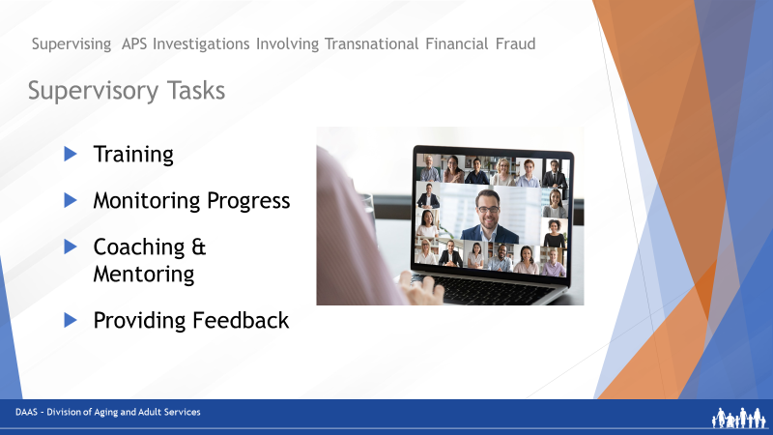
Facilitator says:
So now let’s review other supervisory tasks that are part of the supervisor’s role and include preparing investigators, checking their progress during investigations, using coaching and mentoring techniques as needed and providing effective feedback.
Slide 17 | 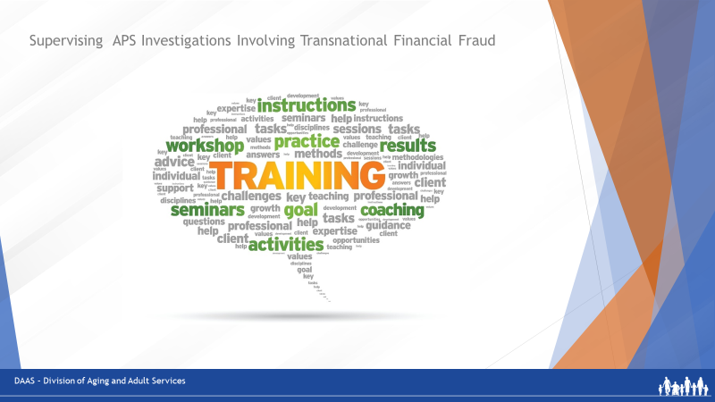
Training is essential to develop the knowledge, skills and confidence to conduct effective investigations of financial fraud crimes. Investigators build on a foundation that includes an understanding of the transnational nature of these crimes; how they operate, how and where to report them, and what resources exist for victims.

To plan training for investigators, supervisors can use topic-specific training materials; invite knowledgeable community partners to share expertise; connect staff with subject matter experts through webinars and workshops and plan field experiences.

Slide 18 | 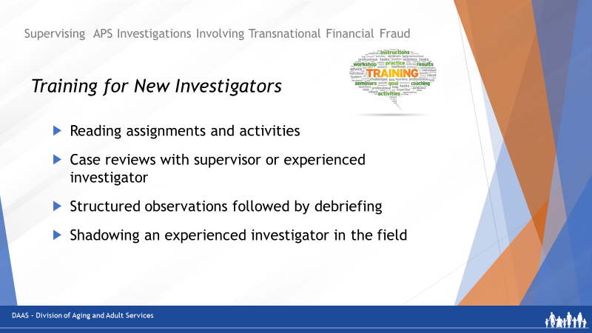
Facilitator says:
New investigators need time to build a base of knowledge, skills and experience before being assigned a financial fraud case. Learning techniques can include:
- Assigning topic-specific reading materials and activities to build knowledge
- Reviewing cases with the supervisor or another more-experienced investigator.
- Using structured observations followed by debriefing
- Shadowing an experienced investigator in field work

Supervisory sessions are a good time to check in with investigators on the learning progress, identify any needs, and provide feedback.

As mentioned earlier in this training, your Resource Guide contains many links to topic-specific reference materials that can be used in training.
Slide 19 | 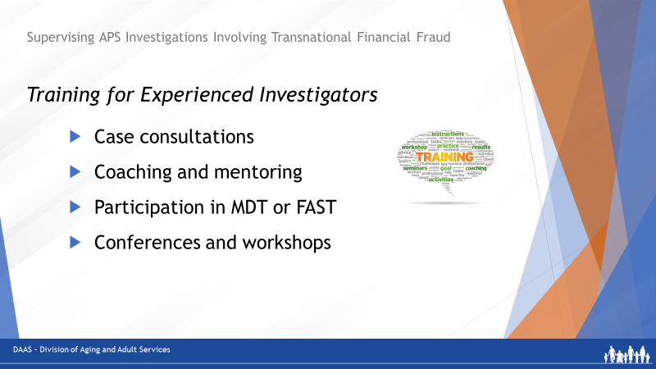
Facilitator says:
More experienced investigators will benefit from coaching and mentoring during case consultations, perhaps serving as APS representatives on an MDT or FAST team and attending financial fraud conferences and webinars to gain additional knowledge that can then be shared with their team.
Slide 20 | 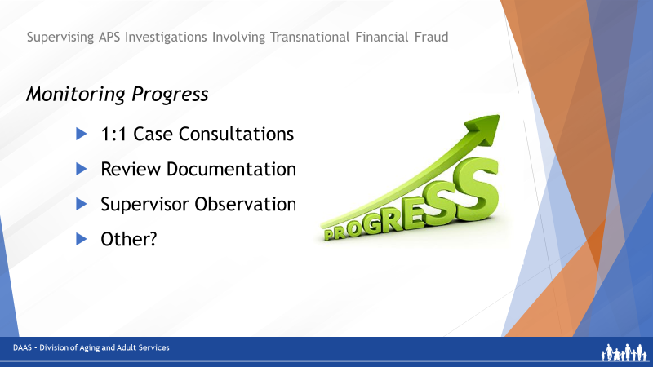
Facilitator says:
Supervisors monitor the progress of investigations through their case consultations with investigators, review of documentation, field observations, and inviting feedback from the investigator about their experiences.
Slide 21 | 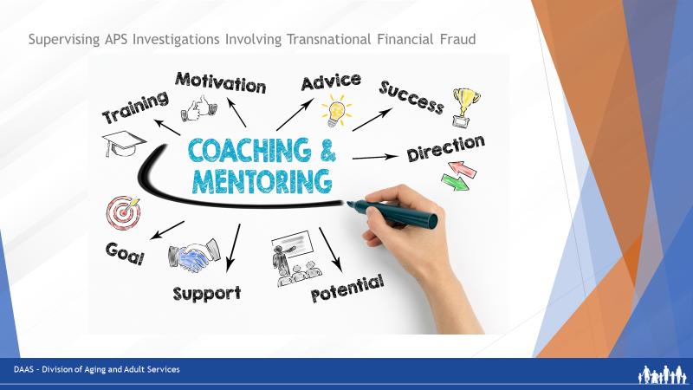

Facilitator says:
Supervisors also use coaching and mentoring techniques as they meet with investigators help them identify risks, do case planning, set goals, and develop solutions. With complex cases like financial fraud, a combination of coaching and mentoring may be needed.
Slide 22 | 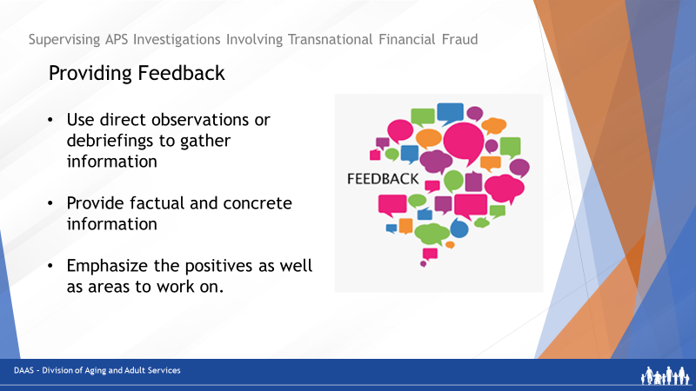
Facilitator says:
And finally, providing regular feedback during financial fraud investigations is a key element of supervision.

Keeping the feedback factual and concrete helps staff understand their areas of strengths and areas that need further development. And providing effective feedback builds confidence and shows concern for an investigator’s wellbeing – especially during difficult cases.
 | 10-minute break
 | Section Three – Addressing Common Roadblocks
Slide 23 | 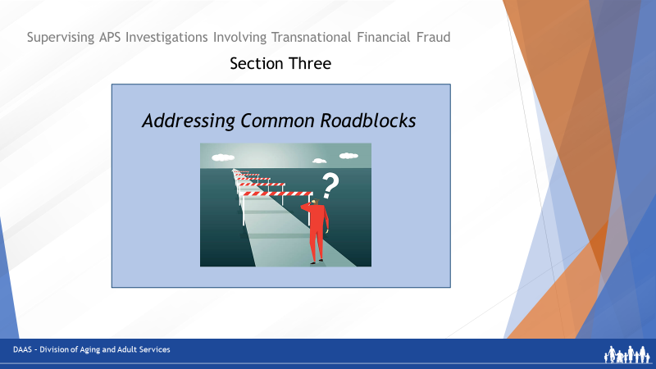
Faciliator says:
Welcome back, everyone! Now that we have discussed the tasks of supervising APS investigations of transnational financial fraud, we’ll explore some of the roadblocks that investigators may encounter and bring to their supervisors for assistance. An example of a roadblock could be an alleged victim refusing provide information.

Slide 24 | 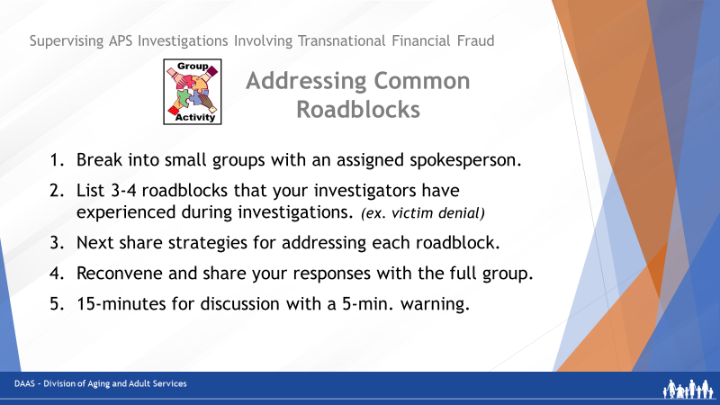
So to start this discussion, we’re going to break you into small groups so you can share some of the roadblocks your investigators have brought to you as well as the strategies you’ve used to assist them.

Small groups will have 15 minutes to first identify several roadblocks their investigators have needed help with and then to share some strategies for addressing them.

Small groups will receive a 5-min. warning and then we’ll reconvene as a large group to debrief each small group’s findings and suggestions.

Facilitator says:
Welcome, back! Let’s start with the spokesperson for Group 4. What kinds of roadblocks and possible solutions did your group identify?
(Facilitator recaps the responses and then asks each of the other small groups to add their findings to the discussion.)
Slide 25 | 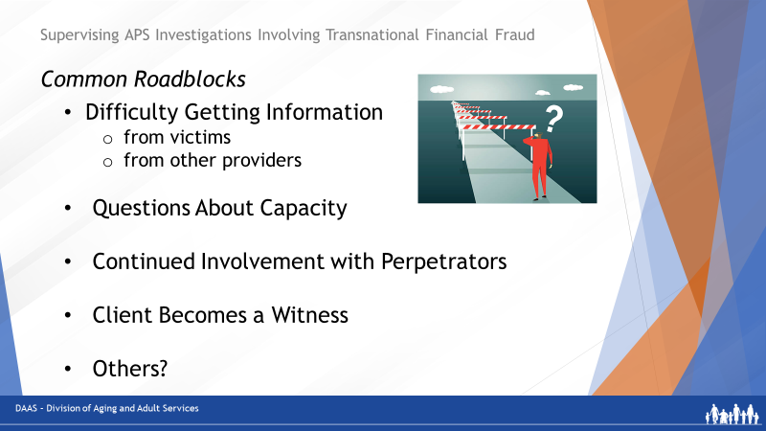
So let’s briefly recap some of the common roadblocks investigators may need supervisory assistance with:
- Difficulty getting information
  - From the victim (shame? denial? memory loss?)
- Try casual conversation
- Understand that the victim has the right to
refuse help.
    - If memory loss is suspected, request and review medical records. If there is no supporting diagnosis, consider an evaluation. If there is a diagnosis, try to get trusted family, friend or public fiduciary involved.
  - From other providers (law enforcement, banks, medical professionals)
- Reach out to providers to ask for information.
Use your state’s statutes regarding sharing
of information with APS.
- Collaborate whenever possible with other
providers and agencies to build professional
relationships.
- Questions about capacity
  - Request client’s medical records to see if there is a diagnosis. If records confirm that the client cannot make medical or financial decisions, continue the investigation to substantiate allegations according to your agency’s policies.
  - Share observations and concerns with client’s PCP
  - If there is no medical diagnosis but client shows signs of being unable to make own decisions, refer for an evaluation and follow-up assistance.
- Victim continues to be involved with the perpetrator due to lonliness.
  - Talk with victim about the risks of being implicated in the fraud.
- Victim has received compensation for their loss from bank and now becomes a witness.
  - Case is closed if there are no further referrals or services needed.

 | Great job, everyone! Roadblocks can occur at any point during a financial fraud investigation and sharing strategies with investigators for overcoming them can help them to move on with their work effectively.

 | Section Four – Using Guiding Questions and Action Steps with Investigators
Slide 26 | 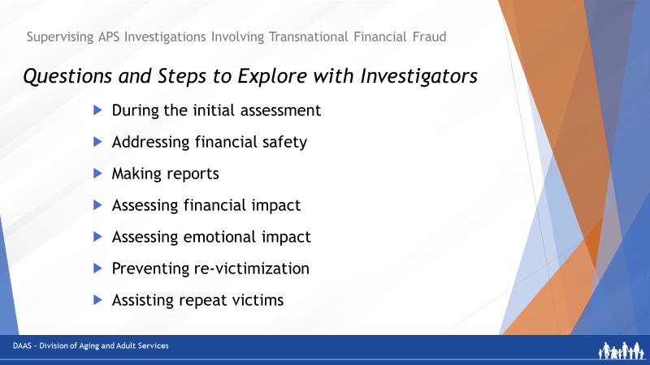  Facilitator says:  Now let’s look at some questions and action steps that supervisors can use to guide investigators during the course of a financial fraud investigation – keeping in mind that victims may refuse to share information, make reports or change their behaviors and, as long as they have capacity to make their own decisions, it is their right not to accept assistance. The questions and steps that we will review cover aspects of a financial fraud investigation from gathering information during the initial assessment to steps for assisting repeat victims. Supervisors can use these questions and steps as a resource for providing training, giving mentoring advice or offering coaching guidance. The slides that we’re about to review are included in your Participant Guide from Page 14 to Page 18 so you’ll have them as a reference if needed.
Slide 27 | 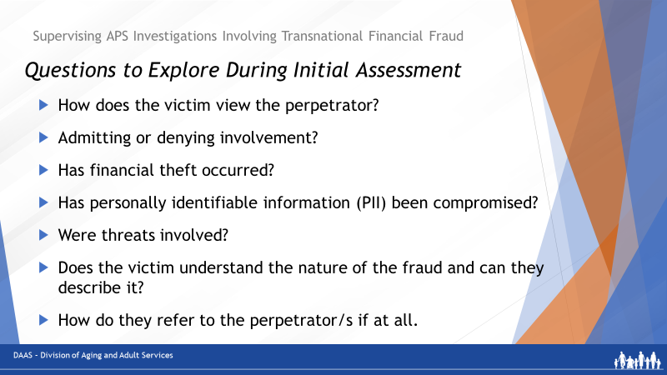
Facilitator says:
Let’s start with the initial assessment. Encourage investigators to begin with crisis intervention & safety planning, while continually assessing critical information about the victim. It is important to address physical safety and any threats that have been made. If possible, victims should discontinue contact with the perpetrator.
Here are some questions to explore with investigators:
- How does this victim view the perpetrator/s?
- Is he/she admitting to being involved with 1 or more perpetrators or denying involvement?
- Has financial theft occurred?
- Has personally identifiable information (PII) been compromised?
- Were threats involved?
- Does the victim understand the nature of and can they describe the fraud or do they appear confused and disconnected in describing it?
- How do they refer to the perpetrator/s if at all?
If the victim has had money stolen or financial information compromised, encourage and help them to call their banks or other account holders so access to the breached accounts can be stopped before more loss occurs.
Slide 28 | 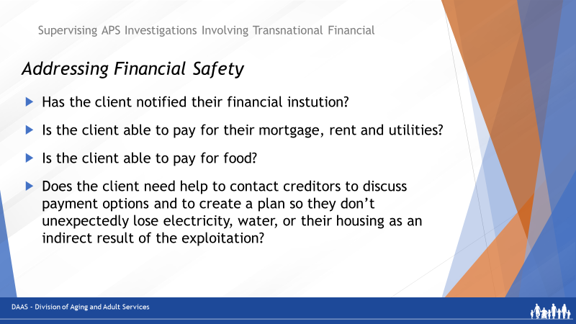
Facilitator says:
Next, financial safety should be addressed. If a victim has had money, assets or personal information stolen, they may not be paying bills and utilities could be shut off. Issues to explore with investigators as needed include:
- Has the client notified the bank?
- Is the client able to pay for their mortgage, rent and utilities?
- Is the client able to pay for food and other personal needs? (clothing, medications, transportation, etc.)
- Does the client need help to contact creditors to discuss payment options and to create a plan so they don’t unexpectedly lose electricity, water, or their housing as an indirect result of the exploitation?
Slide 29 | 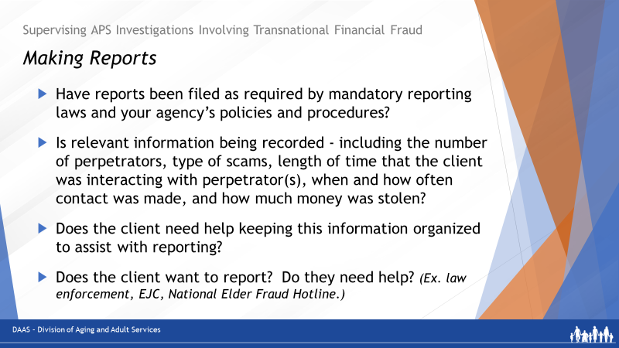
Facilitator says:
Supervisors will want to check with investigators about
r reporting. Are they:
- Filing reports as required by mandatory reporting laws and your agency’s policies and procedures?
- Analyzing the extent of victimization, and recording relevant information including the number of perpetrators, type of fraud scheme, length of time that the client was interacting with perpetrator(s), when and how often contact was made, and how much money was stolen?
- Helping the client keep a record of information about the incident to assist with further reporting?
- Assisting clients with reporting based upon how they would prefer to move forward and address the crime?
  - Local law enforcement
  - The Elder Justice Coordinator
  - The National Elder Fraud Hotline, sponsored by the US Dept. Justice is a great resource that should be provided by APS and other responders such as police to every older victim of a fraud crime. It can assist victims, age 60 and older, with support, information, and even help with filing reports to the Internet Crime Complaint Center at IC3.gov and the Federal Trade Commission at www.Reportfraud.ftc.gov

Slide 30 | 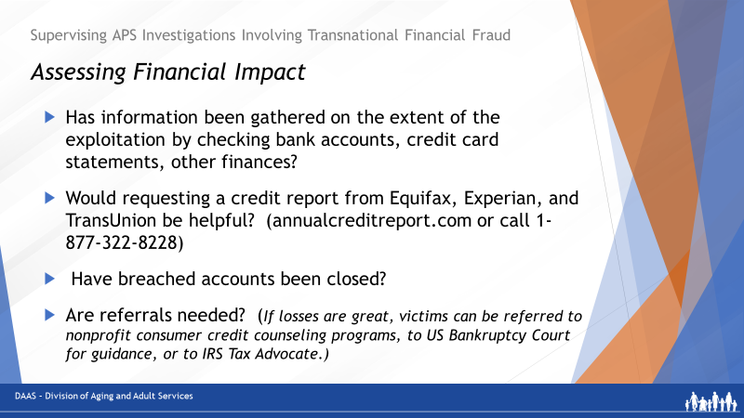
Facilitator says:
To assess the financial impact on the client, it may be helpful to review these steps with investigators as they are working on the case:
- Gather information on the extent of the exploitation by checking bank accounts, credit card statements, and other finances.
- If the client is unable to do so, request a credit report from Equifax, Experian, and TransUnion at annualcreditreport.com or call 1-877-322-8228. This information helps to document the impact of exploitation on the client’s credit and may be needed for referral to a public fiduciary or to law enforcement.
- Consider other interventions like closing breached accounts if they have not already been closed.
- If losses are great, victims should be referred to nonprofit consumer credit counseling programs and may need to consider filing for bankruptcy.
A listing of those can be found on the US Dept. Justice site here. In addition, the US Bankruptcy Court has guidance for those victims who may be considering bankruptcy.
- Still others may need a referral to the IRS Taxpayer Advocate if their ability to pay taxes has been impacted due to the fraud, or their PII was used in a way to compromise their IRS filings.

Remember, information and links to all these resources are listed in your Resource Guide.
Slide 31 | 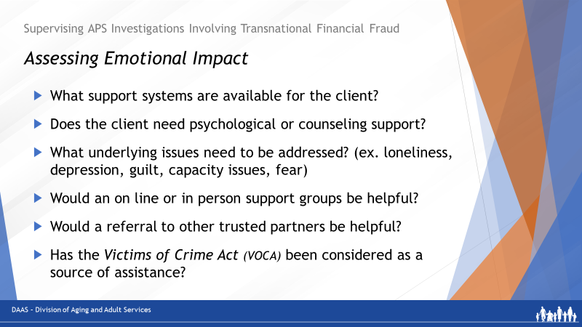
Facilitator says:
Assessing emotional impact is another important step.
Review with investigators these ways to support victims and make possible referrals.
- Clearly explain options to the client – such as legal action, community/familial assistance - and proceed based upon their decisions.
- Discuss contacting family members for support with the client as they may be willing and able to provide assistance. Alternatively, work with a responsible person or agency to assist with managing the client’s assets.
- Determine what support systems are available to the victim and who they may be willing to safely rely upon. Many victims experience shame and guilt and do not want family members contacted.
- Help them explore if they have a nonjudgmental friend or family member, they can contact for support.
- Assess whether the client needs psychological or counseling support (if they are dealing with depression, anxiety, are suicidal, or experiencing other psychological issues).
- Understand and address underlying issues, including loneliness, depression, guilt, capacity issues, and fear.
Therapy may be available in-person, by phone, or online. Sometimes therapists may not be knowledgeable or have experience working with financial crime victims. Forwarding them articles from the FTC or Better Business Bureau’s scam studies may help them to better understand and support this type of client. (www.bbb.org/scamstudies)
- Support groups can also be helpful to address emotional impacts and may also be offered in-person or via online video conference. Since these vary from state to state, APS investigators will need to research what may be available in their area. The Coalition for Elder Justice in California has created a webinar to discuss the value of peer support for victims. There is a link to a recording of this webinar in your Resource Guide.
- Connect clients with other needed resources. Refer them to trusted partners and organizations for counseling, legal aid, and other types of assistance.
- Also consider Victims of Crime Act assistance - some states provide crime victim compensation for financial crimes. Usually, to be eligible, the crime must be reported to law enforcement shortly after it has occurred.

Slide 32 | 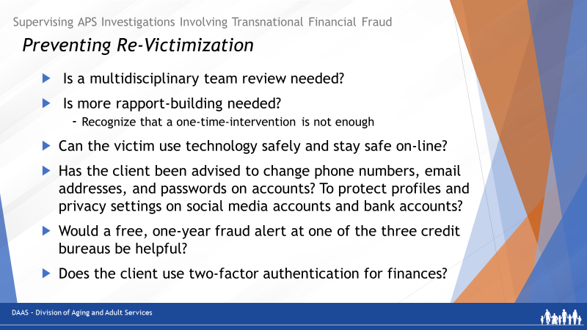

Facilitator says:
Working with repeat victims of financial fraud crimes can be very challenging. As they are working with clients, encourage investigators to be aware of the risks for re-victimization and take steps to help prevent it. Individuals who have been previously victimized are more likely to be victimized again.

Here are some steps you can suggest to your investigators:
- Facilitate multidisciplinary team review to help protect client’s money. Multidisciplinary teams in this field typically involve APS, law enforcement, victim advocates, long-term care ombudsmen, financial industry professionals, and others who work with victims of financial exploitation and they can provide a more holistic and coordinated response.
- If the victim is in denial, try to build rapport by
  - starting where the victim is
  - recognizing that a one-time intervention may not work
  - helping victims/families find new, safer activities/relationships
- Provide victims with information about using technology safely and staying safe on-line.
- Assess clients’ technical abilities: can they save pertinent information (mail, voicemails, emails, other messages, and correspondence) and then block calls, report emails, and unfriend perpetrators? Then assist where they need support. A website called Stay Safe Online has many user-friendly ideas. A link to the site is in your Resource Guide.
- Advise clients to change phone numbers, email addresses, passwords on accounts, protect profiles and privacy settings on social media accounts, and bank accounts where needed.
- Place a free, one-year fraud alert at one of the three credit bureaus. Show clients how to get copies of credit reports.
- Tell them about the use of two-factor authentication, especially for finances.
Slide 33 | 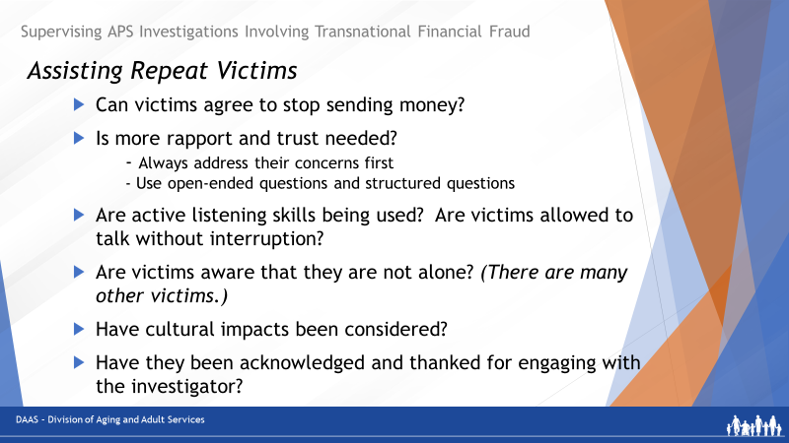
Facilitator says:
Helping clients who are repeat victims can take time.
As mentioned earlier, with repeat and chronic victims, one-time interventions usually will not suffice. Some victims may not believe that they have been victimized by financial fraud or they that they continue to be taken advantage of by a perpetrator.

- Try to get them to agree to stop sending money, at least for a period of time. This may upset perpetrators and cause negative reactions and threats - prepare clients for this and use this to show the perpetrators true intentions.
- Build rapport and trust with the client; this can be done in many ways.
  - Always address their concerns first.
  - When interviewing, use open-ended questions about crime, and structured questions when needed to keep the interview moving.
  - Avoid complex questions. If possible, do not interrupt when they are talking.
- It may be helpful to tell them about others who have had similar experiences to show that they are not alone. Consider their cultural background and impacts it may have on their interactions and experiences.
- After you’ve spoken with them, thank them for their input.
Support is critical for repeat victims, and may include family, friends, and/or support groups. If the client interacts with the perpetrator often, they will need something to replace this interaction. Encourage the investigator to identify other community services/agencies that can provide social engagement, support, and potentially intervention if the client continues to engage with perpetrator(s). Consider multidisciplinary team review, and report everywhere.
 | 10 Minute Break Suggested

 | Section Five – Case Scenarios
Slide 34 | 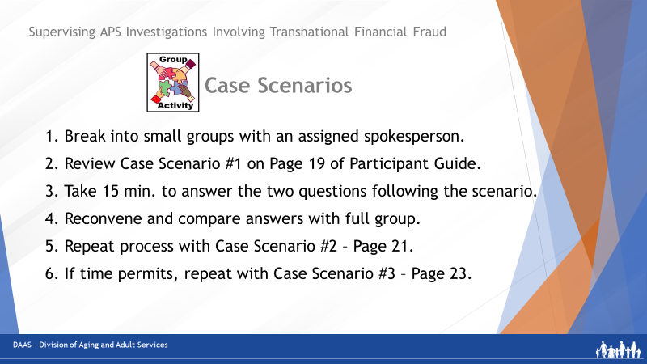
Facilitator says:
Welcome back, everyone! Now, in this final segment, we will put some of this information to work as we have you review a few case scenarios that might come to you either as reports from intake or requests for help from one of your investigators.

First, we will break you into small groups with an assigned spokesperson. The directions you see on the screen also appear on Page 18 of your Participant Guide.

Each small group will review the first case scenario on Page 19 of your Participant Guide. Then, discuss possible answers for the two questions that follow: what you would consider in assigning the case and what questions you could use in coaching and guiding the investigator during your 1:1 consultations as the investigation progresses. You will have 15 minutes and then we will reconvene and compare responses.

Then we’ll repeat this process with the second scenario on Page 21 – allowing 15 minutes of small group activity and then 10 minutes to discuss responses.

Producer Notes:
- Break participants into small groups of 4 or 5.
- After 8 minutes in small groups, give a 2-minute warning.
- Reconvene and ask one group to share their responses. Then ask the others to contribute additional responses from their small group discussion.
- After 10 minutes of sharing, send them back to break-out groups and repeat the process using Scenario 2.

Facilitator Note: There are possible responses to the questions following each scenario. You can add them to what each group reports. These responses are also in the Participant Guide. If time permits, there is a Scenario 3 on Page 23.

Let the participants know that there are sample responses to each of the scenarios beginning on Page 25 of the Participant Guide.

Case Scenario 1 - Louise
You receive a report from intake about an alleged financial fraud crime against a 75-year-old woman living alone in senior housing and described as confused and despondent.

The reporting source is a neighbor who became concerned when the alleged victim disclosed that she had wired most of her savings ($10,000) to someone who called claiming to be her grandson. The caller said that he was in legal trouble and needed an immediate cash payment to avoid being jailed.

Reporter Statement:
Because of the coronavirus pandemic, Louise hasn’t been able to see her grandchildren in a long time. Last week, she received a call from an unknown number. The caller said that he was her grandson, Robbie, and that he was in trouble. He told Louise he was in South America on vacation and was arrested after going out to a bar. He said that he was facing jail and criminal punishment unless he could come up with the $10,000 fee to be able to return home.
Louise was very anxious about Robbie, but also a bit skeptical. She asked the caller a few questions, and based upon his responses, she believed him. When Louise asked where to send the money, the caller pleaded with her to make a wire transfer, gave an account number, and said that time was running out.
A few hours after Louise wired the money, she got a call from Robbie. She was relieved to know that he was safe and asked him what happened. Robbie told her that he was not the caller and that she had probably been “scammed.” Now, Louise is embarrassed, fearful and very despondent about her loss. She doesn’t know what to do.
Small Group Questions for Case Scenario #1 - Louise
Question #1
What considerations would you make before assigning this case to one of your investigators?
Possible Reponses:
- What is the investigator’s level of experience with exploitation cases?
- Is this an opportunity to assign the case to an experienced investigator and have a less experienced investigator shadow?
- Do you have MDT partners who could provide input into this investigation?
- Others?

Question #2
What questions could you use in coaching and guiding the investigator during the investigation?
Possible Responses:
Has the investigator:
- Spoken directly with the alleged victim?
- Found out where Louise wired the money from and help her contact the company to let them know that this was a fraudulent transaction? Asked about the possibility of recovering the assets? (If only a short period of time has passed, the company may be able to help.)
- Asked Louise if she provided the caller with any other information? (Specifically, any other personal identifying information).
- Helped her record detailed information about the incident, including the account number where she sent the payment.
- Talked with her about the benefits of reporting and offered assistance in reporting if she is willing.
  - Contact the National Elder Fraud Hotline information for victim assistance and support.
  - Report to IC3 and the FTC.
  - Report to local law enforcement, Attorney General consumer protection division, the Better Business Bureau, etc.
- Ask Louise about any supportive relationship(s) with family and friends and encourage her to reach out to them for support? Consider a referral for counseling if needed?
- Asked if she would like any assistance with money management?
- Ensured that the financial loss will not preclude her from paying for rent, utilities, food and, if so, helped her contact creditors to discuss payment options?
Encouraged her to reach out to you directly if she needs to?
- Has Louise experienced anything like this in the past?
- How will you help prevent her from becoming a repeat victim?
  - Spending more time on the case to build rapport and connections to supports.
  - Exploring coping strategies to deal with loneliness and isolation.
  - Refer for ongoing counseling if she could benefit from talking with someone regularly.
- Are there other community supports that Louise could connect with that might benefit her?
- Others?

Case Scenario 2 - Doris
One of your investigators asks for your help with a case of an alleged financial fraud crime against an 84-year-old woman that the investigator is working on. The client has severe arthritis that keeps her housebound. Since the death of her husband, she been anxious about managing by herself in the apartment.

The alleged perpetrator is her nephew, Matthew, who stepped in to manage Doris’ finances. He has convinced her that the tasks of money-management are too much for her to cope with. Doris has given him her checkbook and her credit cards. Recently, Doris received a call from a credit card company to verify some major purchases made from one of her accounts. Then, a check to the home care agency bounced.

The reporting source is a home health agency who employs a health aide assigned to visit Doris. The aide reported to her agency when Doris disclosed that she was worried her nephew was stealing her money and that she was afraid of him. The aide visits several times a week to assist her with personal care, errands and housekeeping. Doris allows the aide to use her debit card to purchase groceries.

The APS investigator is reviewing Doris’ bank and credit card statements but needs assistance in determining what expenses were for the alleged victim’s benefit and which were for the alleged perpetrator’s benefit.
Questions for Case Scenario # 2
Question #1
How would you guide your investigator in determining which expenses were for Doris’ benefit and which were for Matthew’s benefit?
Possible Reponses:
- Review the bank statement for expenses that don’t fit with Doris’ situation and everyday needs. (For example, frequent visits to restaurants, repairs for a car she doesn’t own, veterinary bills for a pet she doesn’t have.)
- Review credit card statements for purchases that also don’t seem to fit. (For example: purchases of cryptocurrencies or large numbers of gift cards)
Question #2
How would you help guide the investigator’s next steps based on the information from the review of Doris’ accounts?
Possible Responses:
Has the investigator:
- Reviewed this information with Doris?
- Determined the financial impact of the exploitation her?
- Discussed possible reporting options?
- Explored finding a different helper to assist with money management?
- Interviewed the nephew? (Could he be using Doris’s assets because he has become involved in a transnational financial fraud scheme?)
- Make reports as appropriate: to local law enforcement, Attorney General consumer protection division, the Internet Crime Complaint Center (IC3), the Better Business Bureau.
- Talk with Doris about how she’s been coping with anxiety and loneliness.
  - Connect her with therapists, counselors, and/or support groups for victims of romance scams.
  - Identify other organizations that may provide social engagement and support for Doris so that she doesn’t begin speaking to Matthew again

Case Scenario 3 – Gary
You receive a report from intake about an alleged financial fraud crime against a 68-year-old man with mild physical and cognitive impairments due to a stroke. He lives in an assisted living facility where the alleged crime is reported to have happened within the last 24 hrs. The reporting source is a staff member at the facility who Gary reached out to about his on-line contact with a stranger who subsequently withdrew $4,000 from his bank account.

Reporter Statement:
Since moving into an assisted living facility, Gary has been using his iPad to communicate with family members, play online games with friends, and to track his finances. He uses online banking because it is easier than getting to the bank in person.

Yesterday, while he was online, he received a pop-up message from someone he didn’t know. When he clicked on the link provided in the pop-up, he became connected to a fraudulent scheme. The message claimed there was a virus on his iPad that could be fixed for a fee. When Gary authorized the fee as directed, the fraudster gained remote access to Gary’s bank account. Before Gary could turn off his iPad, he watched as a $4,000 withdrawal from his account was made.

Questions for Case Scenario #3 - Gary
Question #1
What considerations would you make before assigning this case to one of your investigators?
Possible Reponses:
- Which investigator has the experience to take actions quickly?
- Is this an opportunity to having a less experienced investigator shadow the assigned investigator?
- Do you have MDT partners who could provide immediate assistance?
- Others?
Question #2
What questions could you use to coach or guide the investigator during the investigation?

Possible Responses:
Has the investigator:
- Asked Gary if he has notified the bank to help him make changes to protect his account from further losses?
- Asked Gary what other information he keeps on his iPad and advised him to change any passwords that may have been compromised?
- Asked Gary if he has experienced anything like this in the past? If he is a repeat victim, you may need to spend more time with him and connect him with additional support.
- Provided him with National Elder Fraud Hotline information for victim assistance and support?
- Reported: to local law enforcement, Attorney General consumer protection division, the Internet Crime Complaint Center (IC3), the Better Business Bureau, etc.
- Considered a credit freeze depending on the extent of the breach, particularly if the perpetrator could have found his social security number?

Additional questions for the investigator to consider about preventing re-victimization:

- Does Gary have relationship(s) with family and friends?
- Would he like assistance with money management? It could be helpful to have someone to take him to the bank when needed or to give a trusted individual access to his online banking to flag anything strange on his accounts.
- Does Gary have supportive relationship(s) with family and friends?
- What is Gary’s experience with isolation and coping with loneliness?
- Refer him to therapists or counselors if he feels that he might benefit from talking to someone regularly?
- Refer him to online programs such as cyberseniors.org?
- Give Gary some information on tech safety and common online scams?
- Tell him about two-factor authentication, safe passwords, and reviewing emails and other correspondence to look for red flags (like unknown links)?
- If he is interested, refer him to classes and other online activities?

Facilitator says:
Thank you, everyone, for your participation and shared ideas in these scenarios. You’ll find the scenarios and the possible responses in your Participant Guide.
Slide 35 | 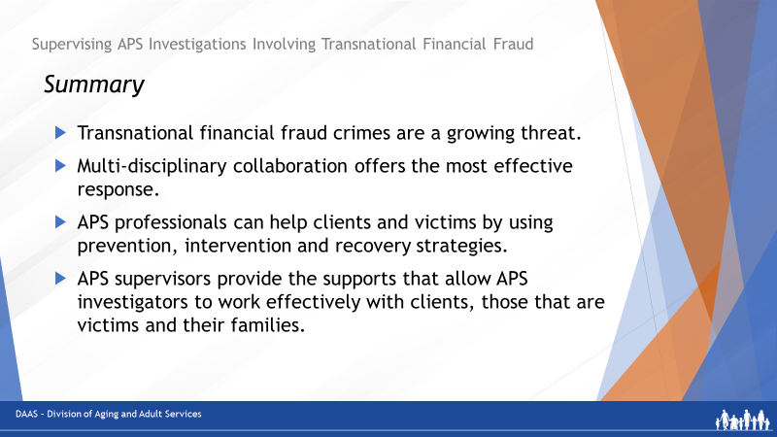
Facilitator says:
So as we wrap-up this session, let’s review some key points to take away:
- Transnational financial fraud crimes are a growing threat to us all.
- Perpetrators of these crimes use mass marketing strategies and a variety of tactics to connect with and defraud potential victims.
- Multi-disciplinary collaboration offers the most effective response.
- APS professionals can help clients and victims with prevention, intervention and recovery strategies.
- APS supervisors provide the supports – training, coaching/mentoring, and feedback - that allow APS investigators to work effectively with victims and their families.

Slide 36
Facilitator says:
Thank you for making the time to attend today’s training. We hope you found this session useful. And we welcome your feedback!!

