Supervising Virtual Investigations

Division of Aging and Adult Services
Adult Protective Services
Participant Guide

Table of Contents

Introduction 2
Section 1 – Impact of Pandemic on APS Practice and Supervisory Role 3
Link to Final Report: Adult Protective Services Study on Impact of Covid-19 6
Section 2 – Benefits and Risks of Using Technology……………………………………………………….. 8
Section 3 – Role of the APS Supervisor 12
Section 4 – Supervisor Tools and Checklists......……………………………………………………… 18
Checklist #1 - Promoting Effective Engagement………………. …………………………….19
Checklist #2 - Promoting Privacy……………………………………………………………….21
Checklist #3 - Promoting Safety………………………………………………………………. 22
Checklist #4 - Documenting Using Technology……………………………………………….24
Group Activity …………………………………………………………………………………….25
Group Activity Worksheet ……………………………………………………………………….26
Tips for Conducting a Virtual Investigation …………………………………………………. 27
Links to Additional Resources ………………………………………………………………….38
Summary ………………………………………………………………………………………………………39

Introduction
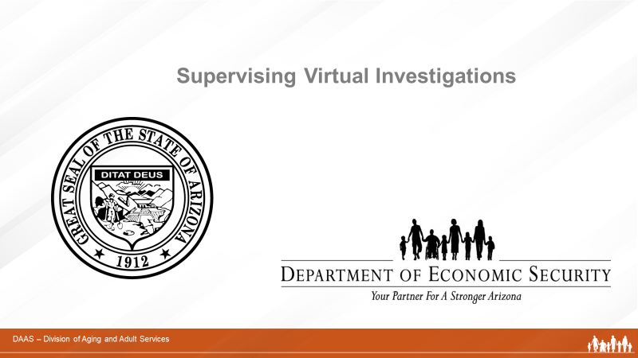

Notes: _____________________________________________
____________________________________________________
____________________________________________________
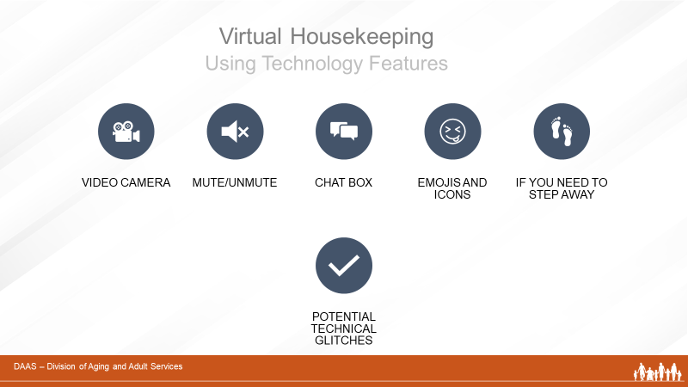
Notes: _____________________________________________
____________________________________________________
____________________________________________________

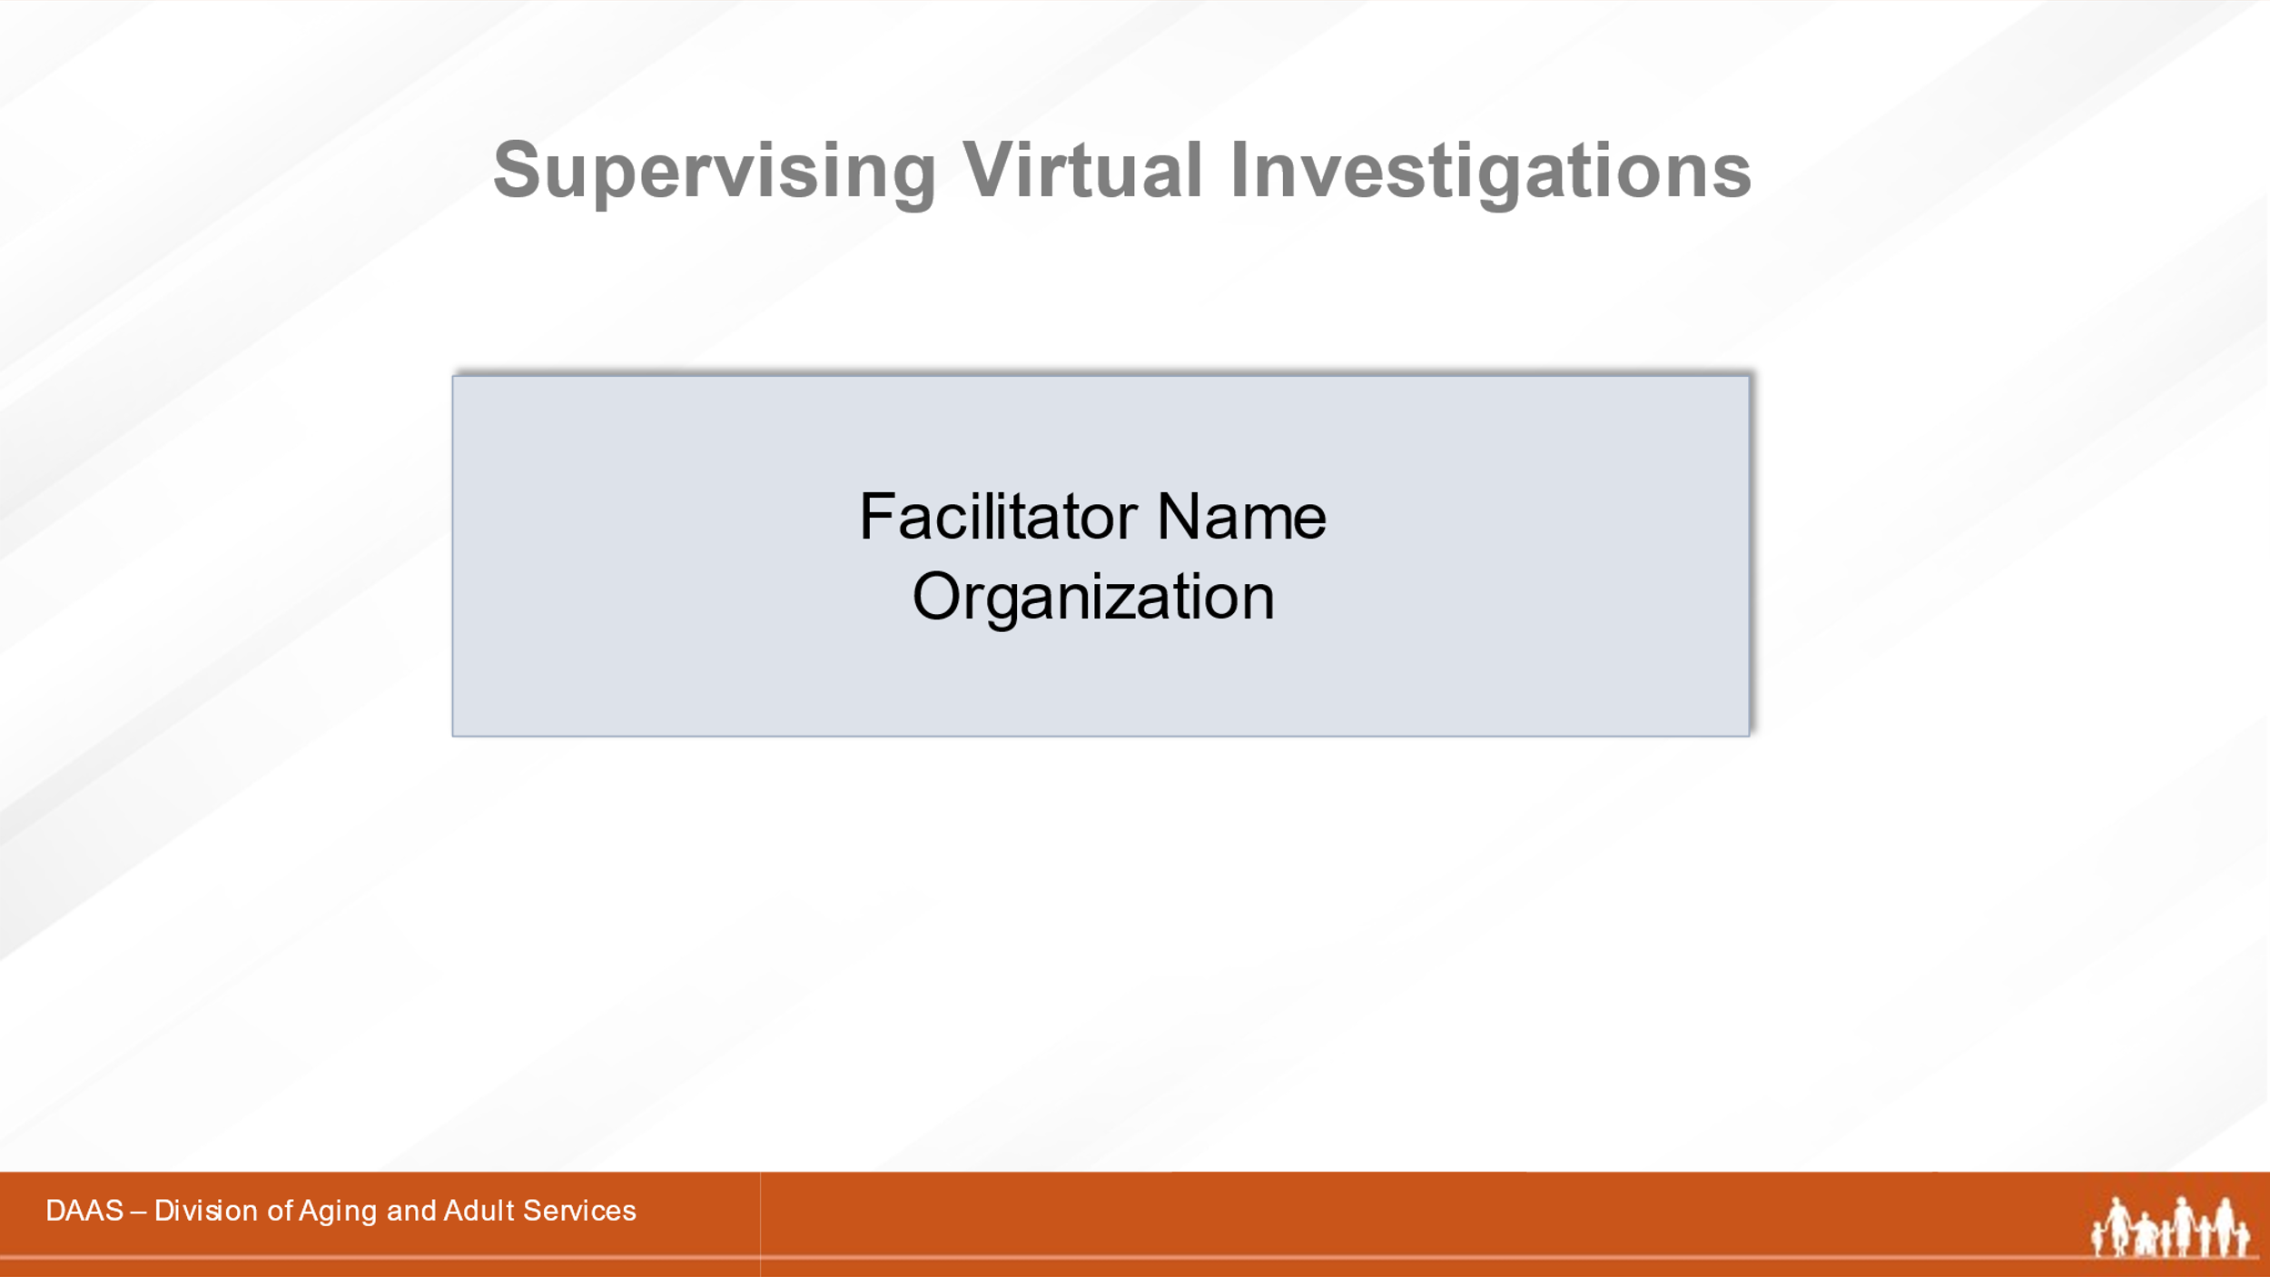
Notes: _____________________________________________
____________________________________________________
____________________________________________________
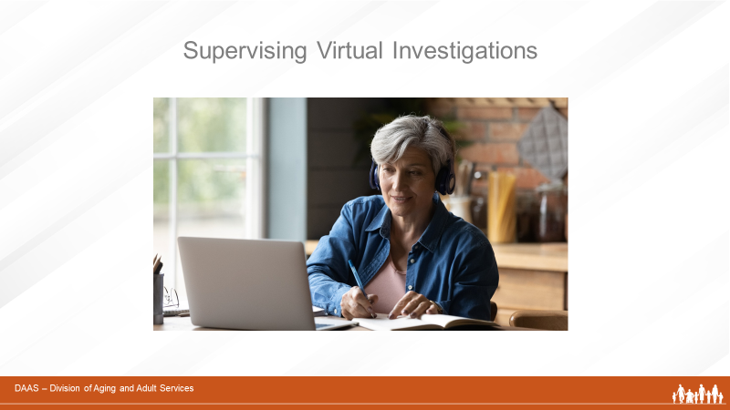
Notes: _____________________________________________
____________________________________________________
____________________________________________________
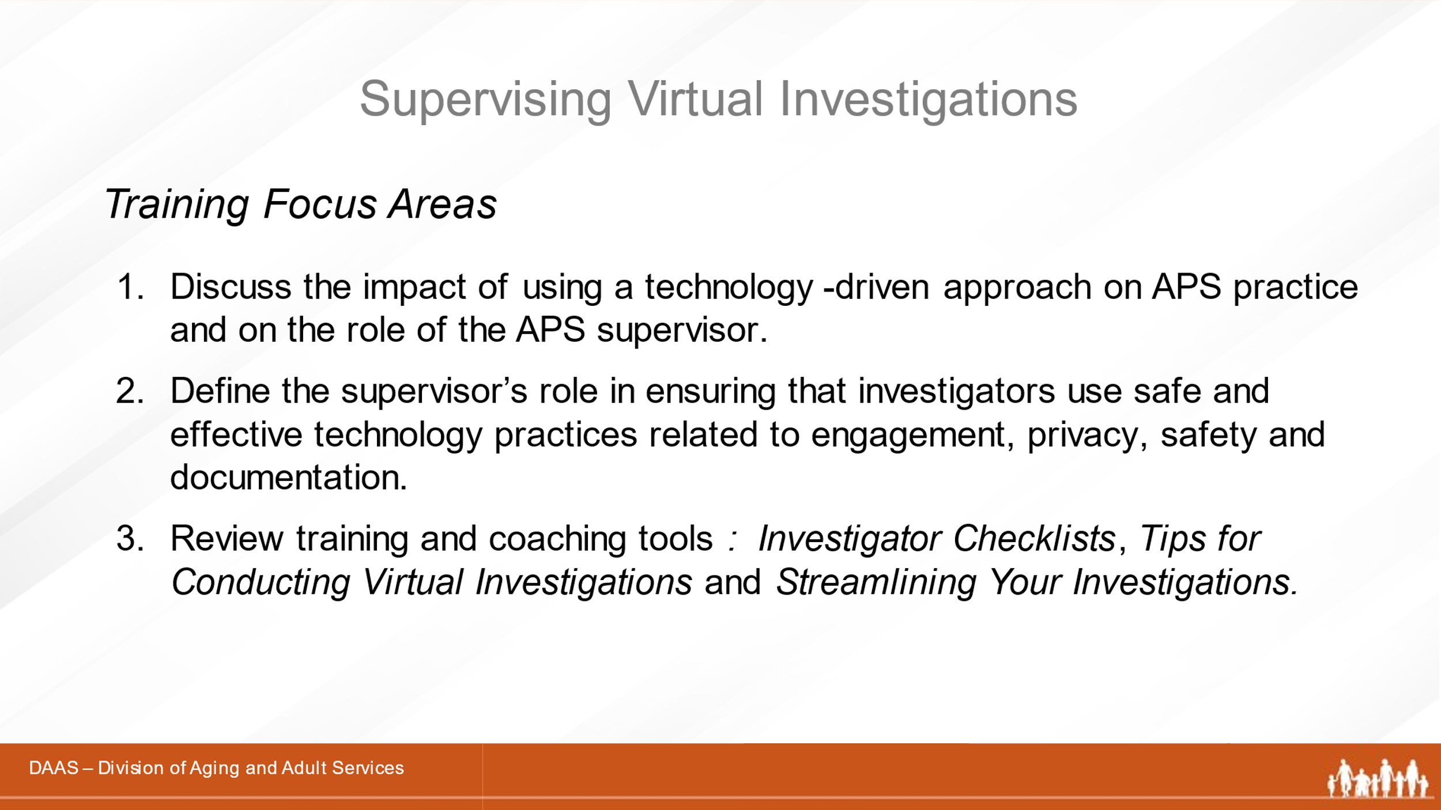
Notes: _____________________________________________
____________________________________________________
____________________________________________________

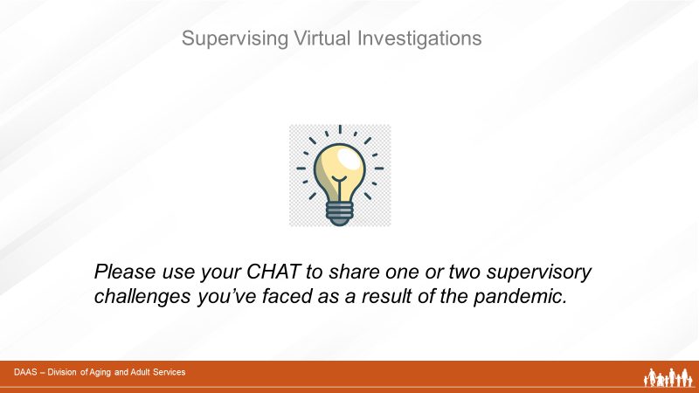
Notes: _____________________________________________
____________________________________________________
____________________________________________________

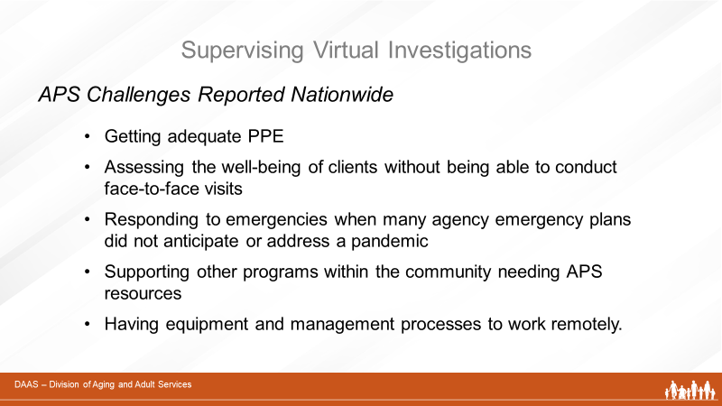
Notes: _____________________________________________
____________________________________________________
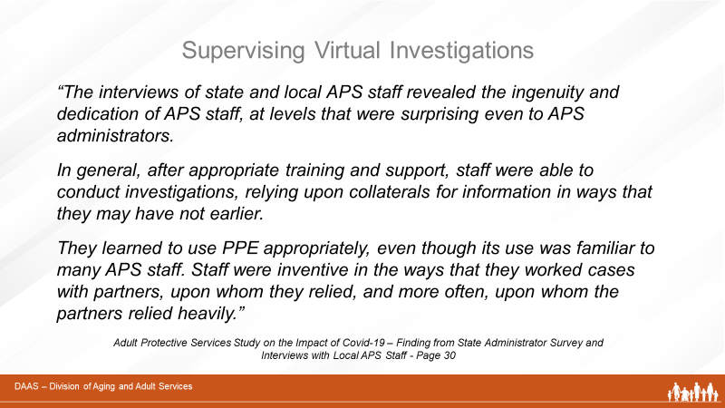
Notes: _____________________________________________
____________________________________________________

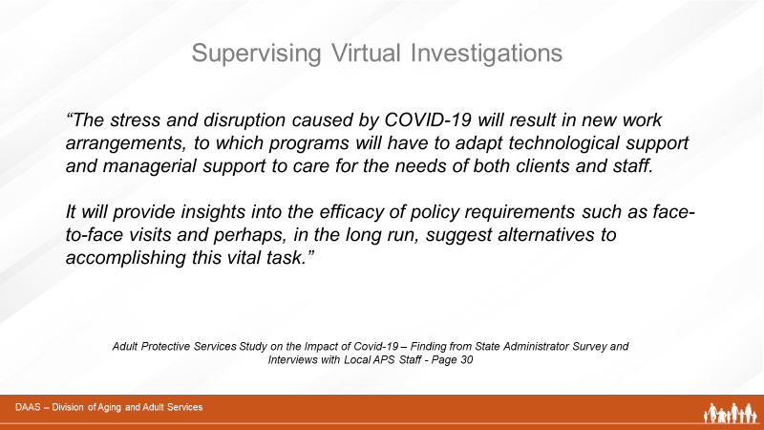
Notes: _____________________________________________
____________________________________________________
____________________________________________________

Link to Final Report: Adult Protective Services Study on the Impact of Covid-19
https://apstarc.acl.gov/getattachment/Information-Research/COVID-19/LRC_COVID_19_Final_Report_508.pdf.aspx?lang=en-US

National Adult Protective Services Technical Assistance Resource Center’s Website

Notes: _____________________________________________
____________________________________________________
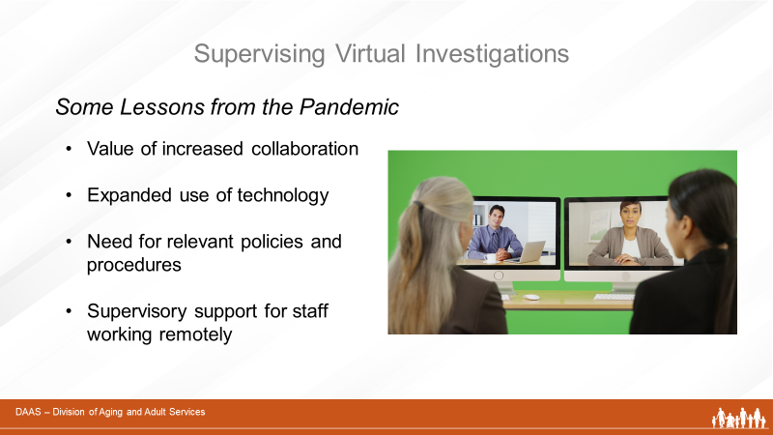
Notes: _____________________________________________
____________________________________________________
____________________________________________________
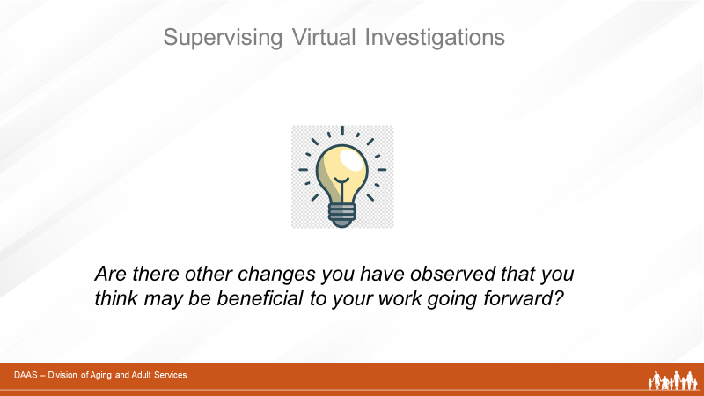
Notes: _____________________________________________
____________________________________________________
____________________________________________________

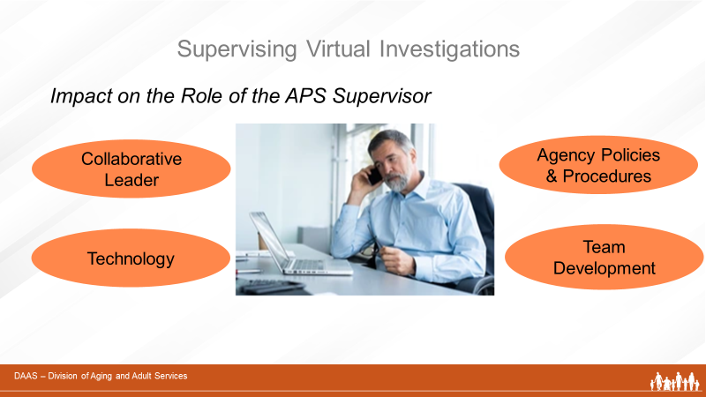
Notes: _____________________________________________
____________________________________________________
____________________________________________________
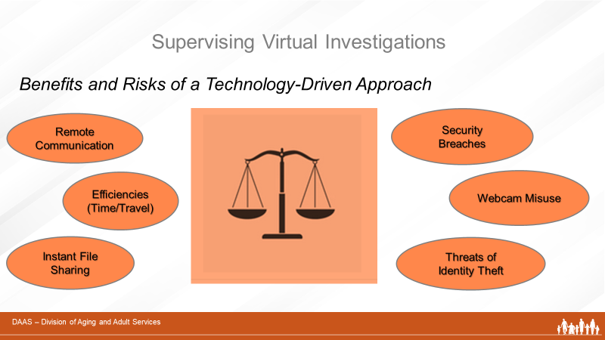

Notes: _____________________________________________
____________________________________________________
____________________________________________________

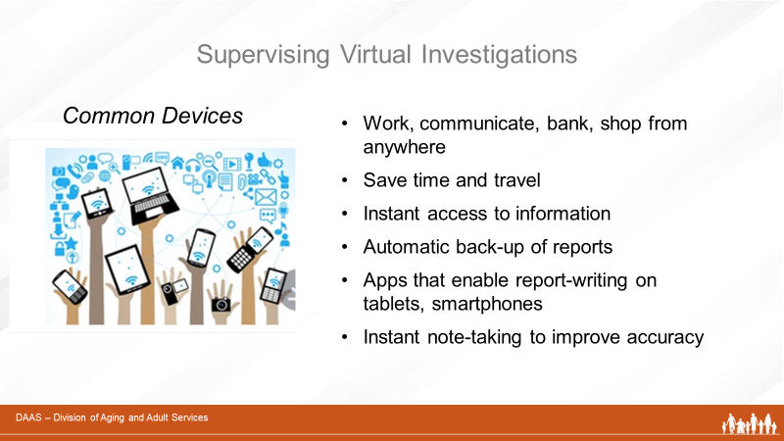

Notes: _____________________________________________
____________________________________________________
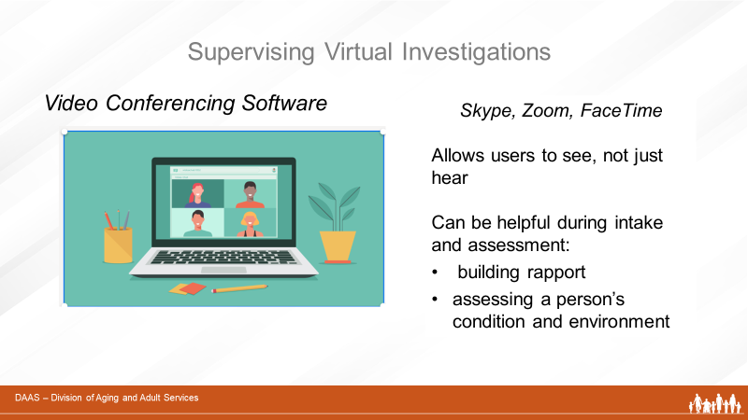
Notes: _____________________________________________
____________________________________________________

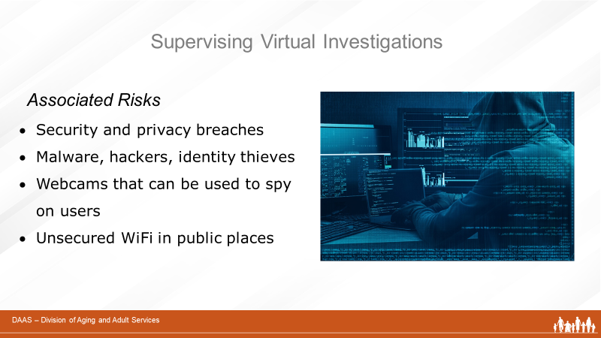
Notes: _____________________________________________
____________________________________________________
____________________________________________________
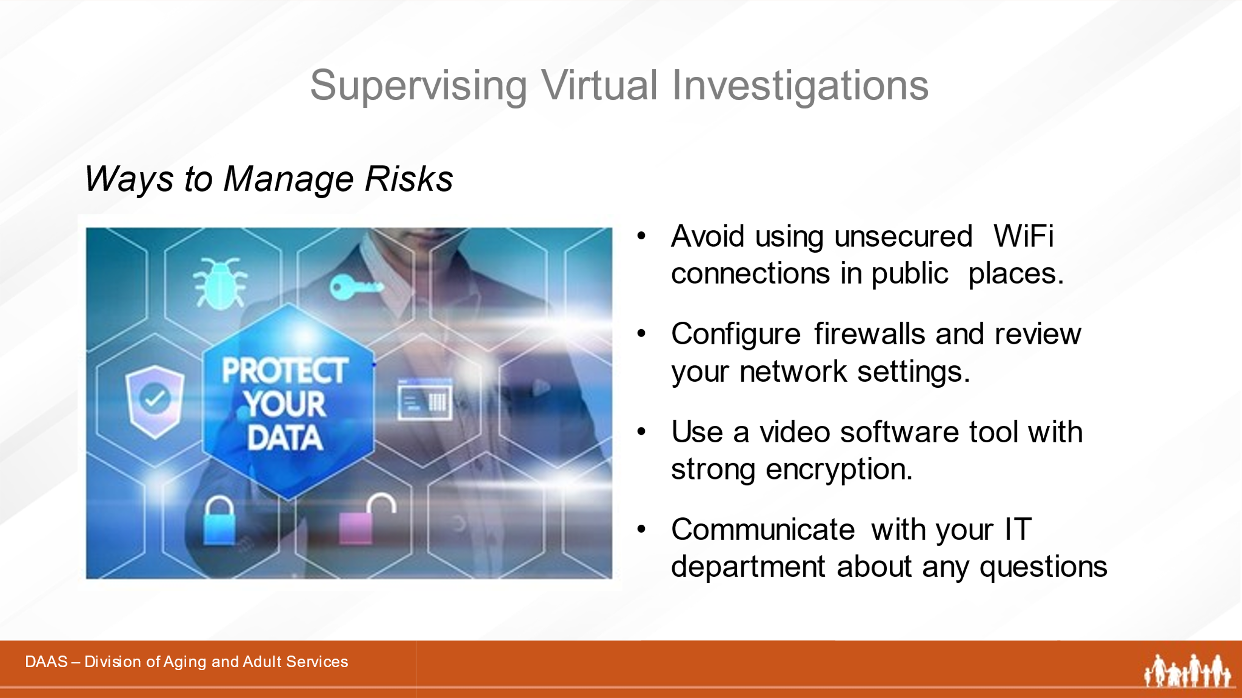

Notes: _____________________________________________
____________________________________________________
____________________________________________________
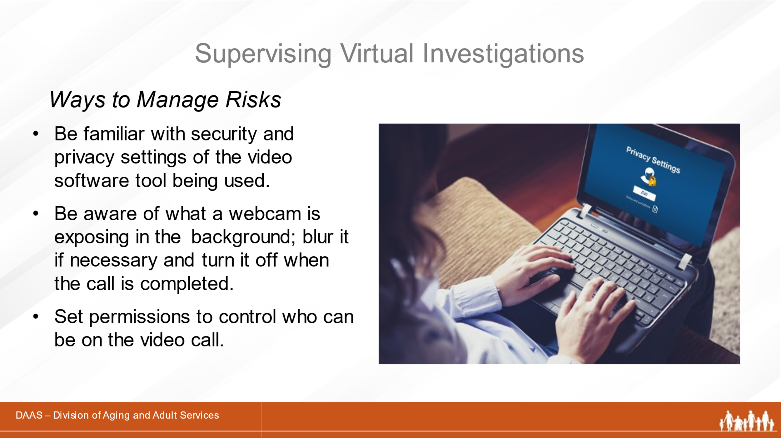
Notes: _____________________________________________
____________________________________________________
____________________________________________________
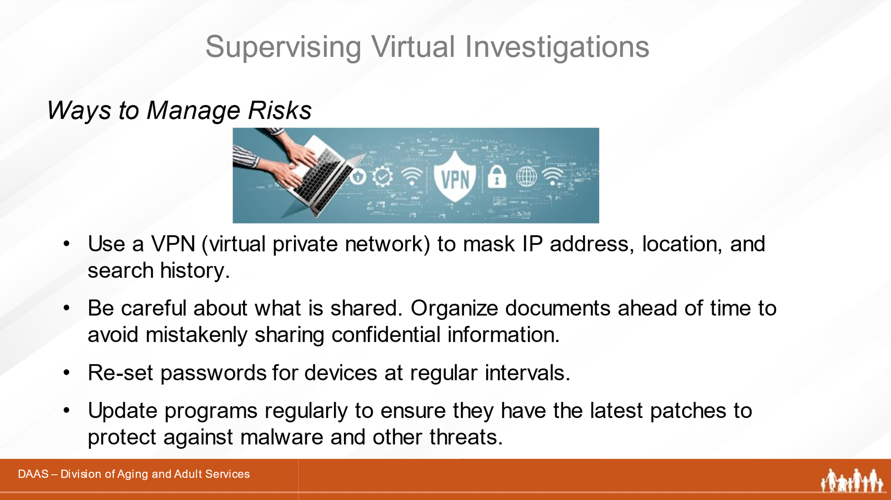
Notes: _____________________________________________
____________________________________________________
____________________________________________________

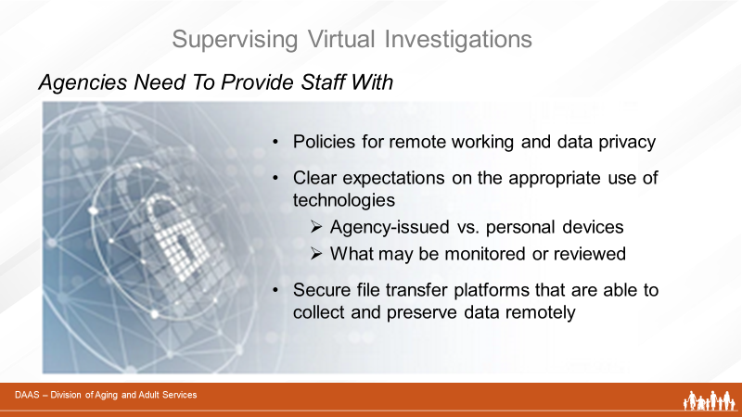
Notes: _____________________________________________
____________________________________________________
____________________________________________________
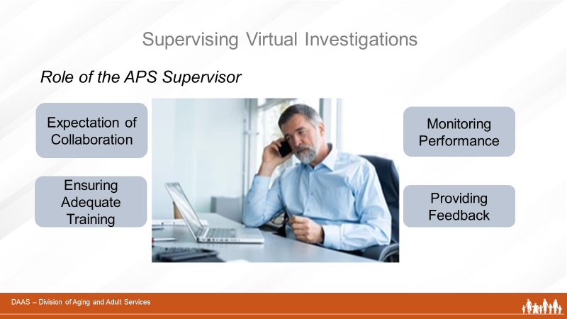

Notes: _____________________________________________
____________________________________________________

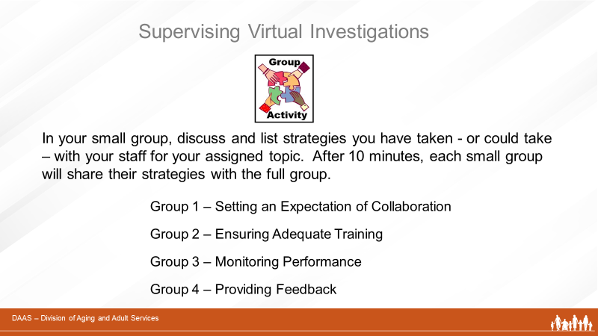

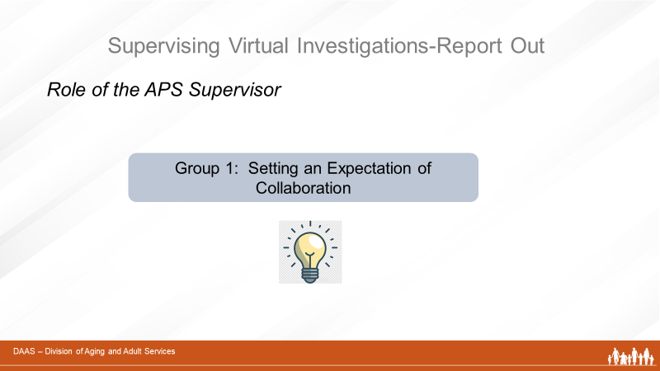
Notes: _____________________________________________
____________________________________________________
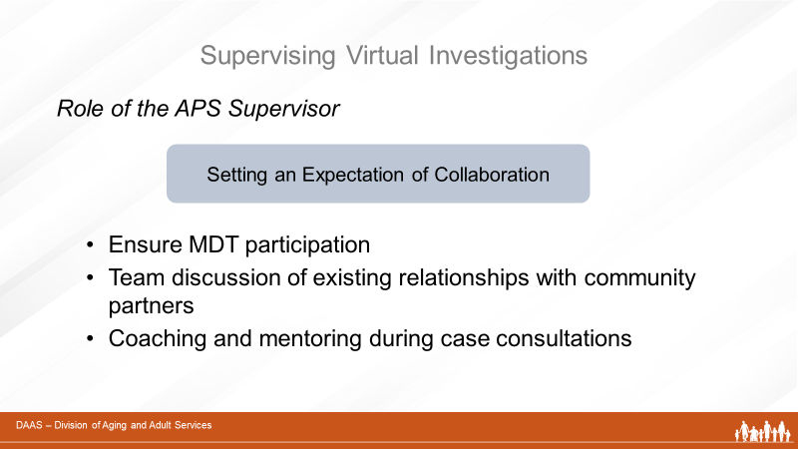
Notes: _____________________________________________
____________________________________________________
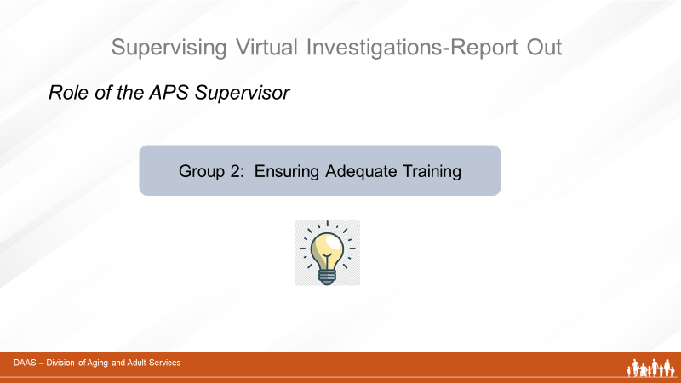
Notes: _____________________________________________
____________________________________________________
____________________________________________________

Notes: _____________________________________________
____________________________________________________
____________________________________________________

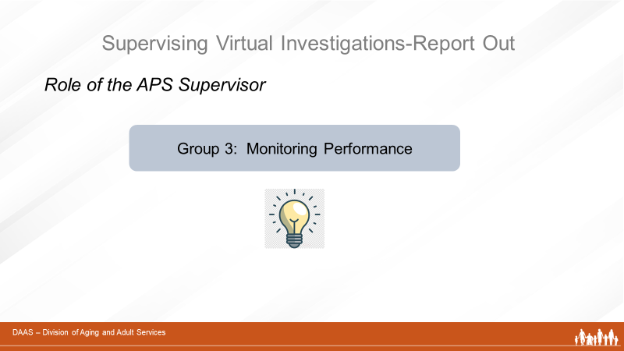

Notes: _____________________________________________
____________________________________________________

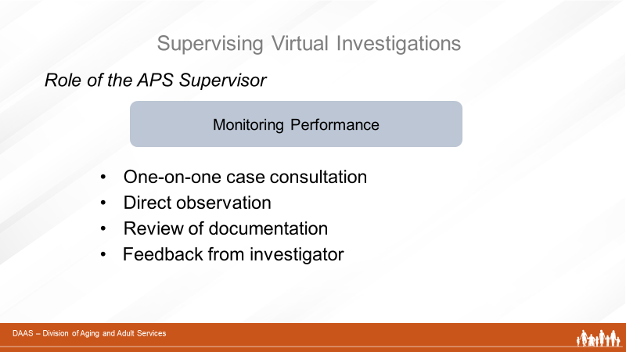

Notes: _____________________________________________
____________________________________________________
____________________________________________________
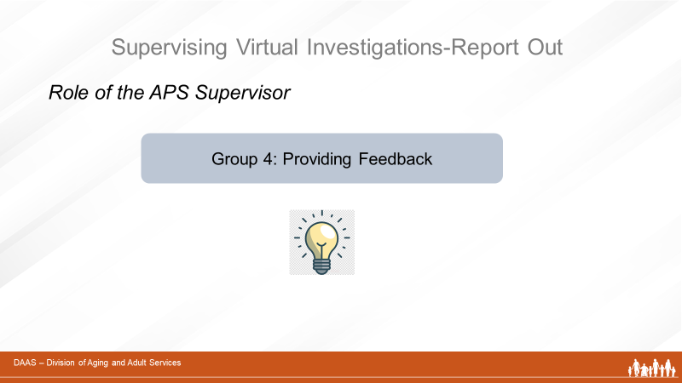
Notes: _____________________________________________
____________________________________________________
____________________________________________________
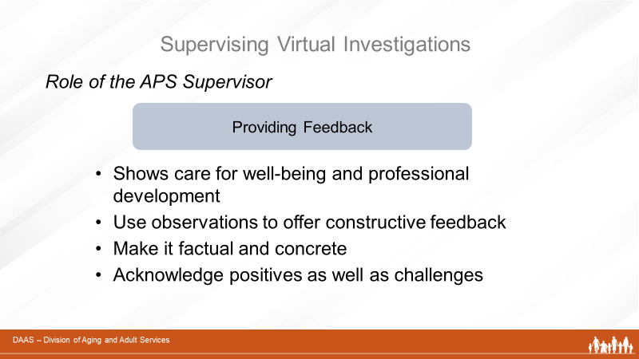
Notes: _____________________________________________
____________________________________________________
____________________________________________________

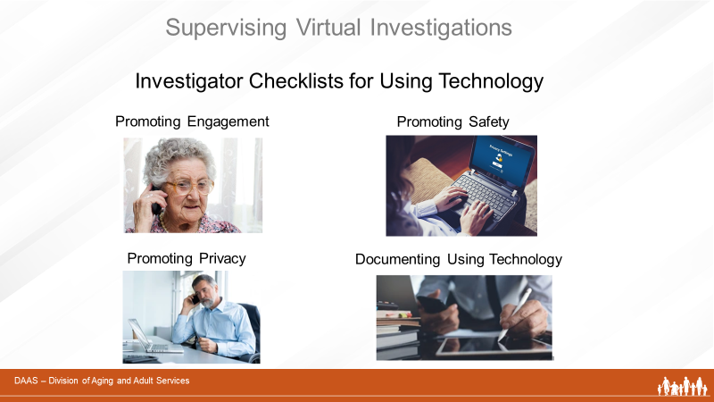
Notes: _____________________________________________
____________________________________________________
____________________________________________________

Engaging with clients virtually may require more time than face-to-face visits. Although most strategies for engagement are the same as face-to-face visits, investigators need to plan more time for building rapport. It may take several calls to develop enough rapport for the person to share information.
The following considerations can be used by investigators to plan virtual engagements with clients and collaterals and by supervisors as training and coaching aids.

Investigator Checklist #1
Promoting Effective Engagement in Virtual Investigations

Engaging with Clients – Initial Questions to Ask
- Does client have access to a computer, tablet or a smartphone?
(Some individuals may not be able to communicate this way –
especially those with significant cognitive deficits.)
- Would client like and feel safe having video chats or conferences?
- Does client use e-mail and would they like and feel safe receiving
updates or corresponding through e-mail?
- Would written communication with the client (letters or emails) be
effective and safe?
- Use telephone contacts with a client’s family, friends, facility staff, or other professionals involved with the case to inquire about the client’s safety.

Engaging with Clients – By Phone or Video Conferencing

- Send directions for using the app ahead of time to help ensure an
on-time, glitch-free start.
- Recognize that the call may be stressful. Using a trauma-informed
approach can affect the client’s feelings of increased control and decreased vulnerability and makes a significant difference in the efficiency and effectiveness of interactions between the client and APS staff.
- Try to accommodate to interviewee’s schedule and needs
(best time of day, etc.)
- Provide reassurance of confidentiality and safety of information.
- Ease into interviews – build rapport by starting with conversational questions like “How are you doing?”
- Allow adequate time so the interviewee doesn’t feel rushed.
- When using video-conferencing, check to see that the interviewee can see and hear you.
- Maintain eye contact to show you are paying attention.
- Maintain an interested and neutral facial expression.
- Watch body language for signs of fatigue and need for a break.

Engaging with Collaterals
- If your agency is part of an MDT, have team discussions about
virtual investigations, when they may be needed, and how
partners can collaborate effectively.
- Have information-sharing agreements (MOUs) in place to
facilitate the transfer of information among partners.

Investigator Checklist # 2
Promoting Privacy During Virtual Investigations

The following considerations address privacy issues when planning calls with alleged victims. Supervisors may also find this information helpful as a training aid.

Privacy of the Investigator and the Client
- The investigator should be alone in a quiet room to ensure confidentiality.

- The investigator should ask the interviewee, “Is anyone in the room with you?”
or “Is anyone able to hear you?” If the client indicates they do not have
privacy, ask if you can reschedule the call.
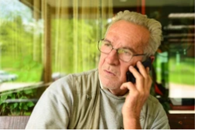

Privacy of the Client’s Information

- Ensure all platforms and systems are secure and can be accessed only by the relevant parties.
- Parties involved in the investigation should have access only to the information specifically relevant to them.
- Organize files and their locations for online correspondence, e-mails, documents, and other evidence.
- Any evidence existing in hard-copy form must be securely stored.

Investigators can use the following safety considerations as a check-list when planning and conducting interviews virtually. Some may overlap with privacy considerations but are also safety issues.
Following these safety steps require pre-planning and preparation on the part of the investigator. Supervisors may find the checklist helpful as a training or coaching aid.
Investigator Checklist #3
Promoting Safety During Virtual Investigations

- Know how your video conferencing platform works.
- Before setting up an interview via video conferencing or phone, ask if there is a safe, private place the interviewee can use.
- Advise the client/ witness upfront that you do not consent to allow the client/witness to record the interview.
- When beginning the interview, determine whether the conversation is private:
  - Ask the interviewee, “Is anyone in the room with you?” or “Is anyone able to hear you?”
  - Listen for background noise and watch for movement behind the client.
  - Ask the client to show the room to the camera if using video software.
  - Ask the interviewee if they are able to use earphones or earbuds to reduce the chance of conversation being overheard from another room.
- Have a backup plan if the client indicates they are not alone.
- When the interview is finished, advise the interviewee to turn off the webcam.
- Technology may not always work as intended, so exchange telephone numbers ahead of time in case the interview needs to be conducted by phone.
- Before starting a videoconference interview, advise the client/witness to clear any sensitive information and to close sensitive applications from their screens.
- Avoid conducting investigative interviews in public areas.
- Do not use a public Wi-Fi system to conduct interviews or otherwise perform other tasks related to the investigation such as sending emails.
- Investigator should always be the “host” so they are in control of the interview.
- Set a unique password to access the meeting and “lock” the meeting after the allowed participants have joined. If using Zoom, for example, review the security settings and be sure to use the most secure methods including password-protecting meetings; enabling the “private meeting” setting, and disabling screen-sharing and private chat for participants.
- For subsequent meetings or interviews, always use a different link, dial-in number, and password to prevent unauthorized others from accessing the meeting.
- Carefully organize any documents you plan to share to avoid any unintended sharing.

While using technology to document may represent a shift in practice for those accustomed to “pen and paper” note taking, it does offer the benefits of speed and accuracy. Supervisors will want to review the benefits and practices below with their staff, monitor their documentation and assist as needed to ensure consistent practice.

Investigator Checklist #4:
Documenting Using Technology

- Follow agency policies and procedures regarding documentation.
- Using technology to document avoids duplication of handwriting and transcribing notes and improves the accuracy of recall.
- Ensure that you have remote connectivity to the agency’s case management system.
- Upload evidence into the case record as soon as it is collected.
- Entering evidence into data systems in real-time significantly improves the integrity and quality of the information obtained and enables supervisors to effectively monitor and support staff.

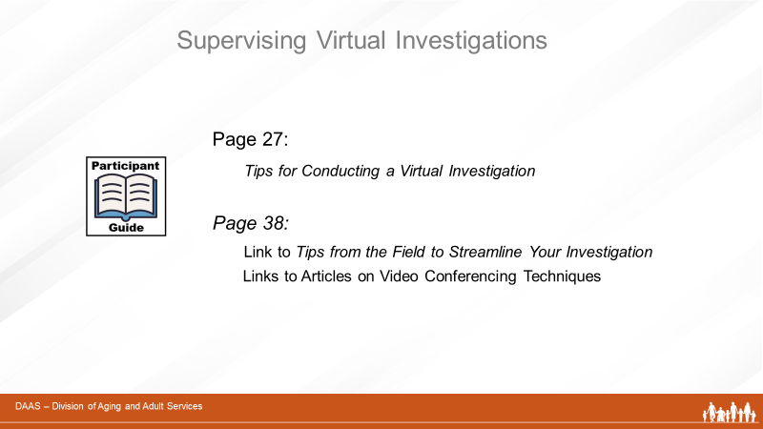
Notes: _____________________________________________
____________________________________________________
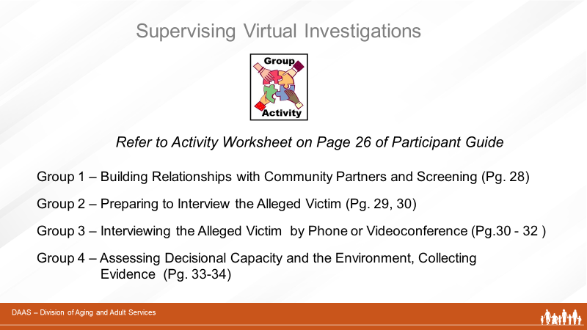

Directions:
Group Activity Worksheet
Tips for Conducting a Virtual Investigation
- Break into small groups with assigned spokesperson.
- Each small group is assigned sections of the tip sheet beginning on Page 27 to review.
- In your group, review assigned sections and discuss how tips could translate into supervisory actions to support staff. (ex. develop a role-playing scenario)
- Report ideas to full group.
- Time: 20 min. in small groups then 20 min for full group reports.

Small group assignments:
Group 1 – Building Relationships with Community Partners and Screening (Pg. 28)
Group 2 – Preparing to Interview the Alleged Victim (Pg. 29, 30)
Group 3 – Interviewing the Alleged Victim by Phone or Videoconference (Pg. 30, 31, 32)
Group 4 – Assessing Decisional Capacity and the Environment, Collecting Evidence (Pg. 33,34)
Notes:

Tips for Conducting a Virtual Investigation
November 2020

Introduction
When investigating allegations of abuse, neglect and exploitation, APS workers are charged with conducting an in-person interview with the alleged victim. An in-person interview allows the APS worker to compare the alleged victim’s statements with their actual situations and abilities. It is always best practice to see the alleged victim in-person and to complete a comprehensive bio-psycho-social assessment.
The current COVID pandemic is a good example of the challenges APS workers face when best practice in-person interviews are not possible. Situations occur where the health of the APS worker, the alleged victim - or both – is put at increased risk by conducting in-person visits. This goal of this tip sheet is to respond to these challenges with some practical tools for doing virtual investigations when in-person visits cannot be carried out. It incorporates suggestions and experiences shared by APS workers from many jurisdictions. We hope that that the information provided will help APS workers to do their best possible job in challenging situations.
Important Consideration: Because each APS program operates under its own set of policies and procedures, some tips may not apply in your jurisdiction. Be sure to check with your administration if any of the suggestions offered seem to conflict with your program’s policies and procedures.

WARNING:
Conducting investigations by phone or video conferencing is not best practice and should only be considered when the risk to the investigator or the alleged victim or both outweighs the benefit of conducting the investigation in-person.

From planning for effective collaboration to screening and interviewing; from making assessments to collecting evidence; we hope the following information will assist you with all elements of a virtual investigation.
Building Relationships with Community Partners
In order to conduct effective virtual investigations, it is vitally important that APS workers build collaborative relationships with community partner agencies. To promote the sharing of information and coordination of services, we recommend that your agency:
- Develop a plan with community partners that limits the number of agencies providing in-person services to the alleged victim. (For example, if a home health service is seeing the alleged victim, ask them to share information with APS.)
- Develop Memoranda of Understanding (MOUs) with each of your community partners regarding confidentiality (when possible, within the context of an MDT) that allow workers from different agencies and departments to share information and ensure the safety of all involved.

Screening
The initial screening of abuse reports becomes even more essential when you are unable to see alleged victims in-person. It is important that screeners gather enough information to separate crisis reports from non-emergency reports.
Crisis reports are those that require someone to physically observe the alleged victim and their condition - even during a pandemic. Consider the following alternatives to sending an APS worker out:
  - Can law enforcement do a welfare check?
  - Can a current service provider observe and report the situation?
  - Should Emergency Medical Services be called?
  - If available and appropriate, can you activate a Mental Health Crisis Unit?
  - Can you establish a video call with the help of a collateral?
  - Are there relatives or neighbors that can check in and report back?
  - Can the Internet be a resource for identifying relatives or neighbors to contact?

Non-emergency reports are those that may be appropriate for a phone investigation. Examples of non-emergency reports include:
  - Reports that indicate the alleged victim only needs a resource referral.
  - Reports of past abuse that have already been remedied.
  - Reports of current abuse that have already been referred to appropriate services.
  - Reports of abuse that are already being investigated by law enforcement.
  - Reports from callers with a history of not being credible.
  - Reports on alleged victims already known to APS due to recent or long history.
  - Reports that indicate that the alleged victim is being seen by multiple collaterals.
  - Scam calls when a mandated reporter indicates that there are no other immediate risks.

Additional Considerations:
In all cases, the information from the report needs to be confirmed by the phone investigation. If new information is uncovered, APS may need to arrange for the alleged victim to be seen in-person (e.g. by law enforcement, by a service provider already in the home or by APS if critical).
During a pandemic like Covid, states may want to consider assigning phone investigations to APS workers whose health is at higher risk due to age or pre-existing conditions. This keeps them working on cases safely.
Preparing to Interview the Alleged Victim
It is always recommended that APS workers develop a plan before interviewing an alleged victim. This is especially important when you are unable to interview the alleged victim in-person. To prepare for a virtual interview, we recommend that APS workers collect more history and more collateral information before the interview than they might normally do. Here are some suggestions to consider:
Obtain as much background information as possible.
  - Review APS records for alleged victim history
  - Collaborate with law enforcement to learn of any history of alleged victim/ alleged perpetrator
  - Check local probate court to learn if the alleged victim is conserved/under guardianship
  - If APS has a mental health crisis management team, check whether the alleged victim is receiving services
  - Talk to MDT members about the alleged victim’s history (especially home health providers)

Interview the reporting party and collaterals before contacting the alleged victim
  - Always follow your agency’s confidentiality policies regarding what you can say to reporters and collateral contacts.
  - Consider saying something like: “I am calling from [Social Services Agency] and I will be contacting [Alleged Victim’s names] to ensure that he/she is managing ok during this crisis. What can you tell me about his/her situation? Do you have concerns about his/her situation? What are they?”
  - If you talk to collateral contacts after interviewing the alleged victim, most agencies will require you to get the victim’s consent, so get as much information on the front end as possible.

Ask the reporting party some initial questions
Ask for as much objective detail as possible about the allegation. You want details that you can
later compare with the alleged victim’s statement of the situation. Suggested questions
include:
  - Who was involved?
  - What happened?
  - Where did it happen?
  - When did it happen? If there are repeated occurrences, try to get dates or identifying details (e.g. “during my brother’s last visit”).
  - Why does the reporting party believe that it happened?
  - If doing a facility investigation, get a staff phone number list to contact employees outside of work to maintain privacy and confidentiality.
  - Ask in-depth questions about the alleged victim’s eligibility for services as this may be more difficult to determine over the phone.

Ask additional questions of both the reporting party and known collaterals
    - When did you last see the alleged victim?
    - How urgent is the situation?
    - Do you have current safety concerns?
    - What other concerns do you have?
    - Does the alleged victim have basic supplies? (food, water, power, medical supplies, etc.)
    - Who else is in the home?
    - If the alleged perpetrator lives with or works for the alleged victim, when are they most likely to be away from the home?
    - Who sees the alleged victim regularly?
    - What do you know about the alleged victim’s family members? What are their relationships?
    - Who does the alleged victim trust?
    - Does the alleged victim have a support system? Who?
    - Who is the alleged victim’s primary health care provider?
    - Do you believe that the alleged victim has decisional capacity?
    - Is the alleged victim able to perform their own Activities of Daily Living (ADLs) and Instrumental Activities of Daily Living (IADLs)?
    - What services is the alleged victim currently receiving?
    - What services do you think the alleged victim needs?
    - Does the alleged victim have a guardian or a POA?
    - Are there animals in the home?
    - Is there anything specific APS can ask the alleged victim that would verify the alleged victim’s identity? (Think about computer password identity questions- “What is the name of your elementary school”, etc.).

Interviewing The Alleged Victim by Phone
Because you cannot use all your senses to do a full bio-psycho-social assessment when you are investigating by phone, you need to flip your information gathering process on its head. Your interview with the alleged victim becomes less about discovering information and more about confirming the information that you have collected from collateral contacts ahead of the victim interview. You will be listening to discover whether details from the reporter’s and/or collateral’s descriptions of the situation match alleged victim’s description. This becomes especially important when there are differences that cannot be explained.
Prepare potential interview questions ahead of time to ensure you have covered what you need but be careful not to use it as a script. Take good notes. Consider the following when carrying out a phone interview:
Using safety questions
  - Is your phone number or IP address blocked? Can you be located by the alleged victim or perpetrator? (When possible, use a government phone.)
  - Is anyone else listening? How do you know?
  - Can you speak privately? Is there anyone in the home with you? Can you call me back when its safe?
  - Can law enforcement do a wellness check if someone in the home (other than the alleged victim) hangs up on you?
  - Is there a need for COVID screening? (Follow your department policy or see questions in Appendix 1)
    - Is it possible to do the interview through a window?

Developing rapport
  - Plan more time for these calls. Take the time to build rapport by asking general questions before getting to other reasons for the call.
  - Begin your call like a welfare check call (as an icebreaker):
    - How are you doing?
    - Do you have your basic needs?
    - Can you get your health care and medications?
    - Is anyone helping you? Family? Neighbors?
    - Do you have special concerns during the pandemic?
- Explain APS and your role clearly. Give the alleged victim options to confirm your identity (such as calling into your hotline number). You may need to send an official letter asking for a wellness check interview. Some departments are reporting good call back results from letters.
- Ask open ended questions such as “Could you help me understand ...” or “please tell me more about that”.
- Just as in face-to face interviews, let the person talk. Resist the urge to interrupt.
- Embrace the silence. You will often find that great information is given when people are trying to fill silence.
- Make multiple calls if needed to develop a relationship where the alleged victim is willing to trust you.

Determining the veracity of the alleged victim’s statements (i.e. are they denying or minimizing their situation):
During a face-to-face interview you can use all your senses to determine whether the alleged victim’s statement match what you see, hear and smell. For example, when an alleged victim says “I’m fine” but winces with pain when walking and smells like he hasn’t bathed in a month, it is clear that he is minimizing his situation. When you can only assess the situation by phone, you must spend more time asking questions. Suggestions include:
- Asking the same question several times during the conversation in a couple of different ways and check whether the answers are the same.
- Listening for hesitation or conflicting responses.
- Confirming responses with others if possible.
- Listening for whether the alleged victim’s description of a situation matched that of collateral contacts. If there are differences, can the alleged victim explain them?
- Drilling down for details if there seem to be discrepancies.
- Being alert when they say “everything is fine” and won’t discuss much more.
- Determining the alleged victim’s ability to perform ADLs by asking questions several times and looking for variations.
- Using collaterals to determine whether meds are being picked up, are they getting to appointments, etc.

Interviewing the Alleged Victim Using Videoconferencing
Both medical and psychological telehealth programs have proven that clinical video teleconferencing platforms can meet the confidentiality/security needs that are required for APS investigations. Using video conference, when possible, can be preferable to phone calls because you can see the alleged victim. You can watch their body language, view their environment, evaluate their abilities, etc. However, many alleged victims are unable to use this technology.
When considering whether or not to interview the alleged victim using videoconferencing, ask if they are familiar with using popular platforms like FaceTime or Zoom. If they have the technology and are familiar with using it, a videoconference may work well. If victims have the technology but need assistance to use it, ask if there is someone they trust – a family member or a collateral - to provide that support if appropriate.
When using videoconferencing, there are some potential issues to be aware of. These include:
- Visual artifacts: Frozen image, “ghost”, images, tracer images, poor resolution (especially with regard to facial features)
- Audio artifacts: Delay, echo, mechanical voices, “Dropped” calls
- Challenges exchanging paperwork
- Heavy Internet traffic on holidays.
Some of the commonly used VCP platforms for telehealth include Doxy.me, Simple Practice, Zoom, VSEE, NousTalk, Ring Central. Skype, and FaceTime. Check with your administration or IT department as to which VCP platforms meet your programs requirements.
Assessing Decisional Capacity
Assessing the alleged victim’s capacity over the phone is challenging but using the following tips can be
helpful.
- Get as much information as possible from the reporter at intake. Explain that current conditions might not allow you to see the alleged victim in person and that you need as much information related to their decisional capacity as possible.
- Identify individuals that can speak to the alleged victim’s decisional capacity.
- Use your phone interview to verify information you’ve received. Document any inconsistencies and follow up as needed.
- If you don’t have much information on the alleged victim, ask him/her questions and corroborate their answers with others later.
- Listen for confusions and ask clarifying questions.
  - Have longer or multiple conversations as you are more likely to see discrepancies. During a long call, the alleged victim may suddenly ask “Who are you?” or set down the phone and not coming back, get off topic, and show other signs of confusion.
  - Listen for repetition.
    - Listen for deflection.
  - Ask the same thing over a couple of calls and see if the answers change or the details are different. Ask about those discrepancies.
  - Ask whether the alleged victim understands the risks of not accepting help. Can they explain the risks?
  - Ask the alleged victim for an explanation of their decisions. Do they make sense even if you don’t agree with them?

Assessing the Environment
Because you cannot see the alleged victim’s environment, you will need to be creative.
- Consider driving by the home to look for conditions of neglect or that are unsafe.
- Take time to listen to the background sounds in the home. Can you hear another person coaching the victim or are other conversations happening?
- Ask the alleged victim about what you hear:
    - Are there other people in your home? Am I hearing your grandkids?
    - Do you have a dog? Do you have cats?
- Ask collaterals about the alleged victim’s environment and compare with statements from the alleged victim.

Collecting Evidence

In community investigations, you can ask the caregiver, doctor, or any other collaterals in contact with the alleged victim to help you get needed documents and/or photographs.
- Allow for the possibility of receiving evidence via text, email, or mail as you deem appropriate. Be cautious about not causing further harm to alleged victim when using alternative methods.
- Some alleged victims may be able to email or text photos but may need help encrypting them.
- Ask collateral contacts for necessary documents if they have them on file.
- To get documents from some collaterals, you may need to have a three-way conference call with the alleged victim.
- Law enforcement or victim advocates may have, or be able to collect, some needed evidence.
- In facilities, you can ask staff to help you with taking pictures or video’s and ask them to send those documents in a secure manner.

Ending The Interview
As you are bringing the interview to a close, consider asking these questions:
- Is there anything else I should know?
- Is there anyone else who might have information that I should talk to?
- Is there any other documentation that I didn’t ask for that has relevant information about this investigation? Document their response.
- Ask if it is ok to call them back if you need to follow up with them. It would be encouraged to get an e-mail if available for a back-up way to communicate should a phone call not be appropriate.
- Make sure you provide them with your name and contact information.

Potential Interview Challenges . . .
If the alleged victim is hearing impaired or non-verbal and your alleged perpetrator is the only support you know of thus far, try the following approach, “We received a report of concern for (name of alleged victim) and given the current conditions, we want to make sure they are okay. Can you help me make contact?” (recommendation from Oregon)
APS workers have reported others pretending to be the alleged victim. We recommend that you verify the alleged victim’s identity by asking a question(s) that only the alleged victim can answer. (The reporting party or collaterals may be able to provide you with that information.)

Conclusion
APS is difficult work in the best of times. In a crisis it becomes even more difficult.
We would like to thank all those APS workers who participated in focus groups to help develop the tips provided in this document. We hope that other APS workers will find the tips helpful in allowing them to rise to the challenge of investigating cases when they cannot see the alleged victim in person.

APPENDIX
Sample from San Diego (used with permission):
INTRODUCTION:
This guide is provided for APS workers during the COVID-19 emergency per the requirement of ACL 20-30 that APS workers contact APS alleged victims who may need additional support and connections to available resources. In addition, this guide can assist workers in conducting and documenting phone investigations/assessments that are taking place of in-person visits in some situations. This guide is a tool and does not prescribe exact practice or flow of phone assessments.

GENERAL INFORMATION:
(Verify and update demographic information.)
Alleged victim Name:
Language Spoken:
Allegation:

SAMPLE INTRODUCTION
If you want to start with COVID-19 first:
“Hello (APS Alleged victim), my name is (APSS’ name), I am with the County of San Diego, Aging & Independence Services. I am calling to make sure you’re doing okay during this time that our community is dealing with the effects of the Coronavirus. We want to make sure your needs are being met. May I take a few minutes of your time to ask you a few questions about any needs that you may have right now?” Then proceed to Section 1, first.

If you want to start with the allegations first:
“Hello (APS Alleged victim), my name is (APSS’ name), I am with [Agency Name]. We contact Seniors throughout the County to make sure they are doing okay. We received a concern about…”

Then proceed to Section 2 first. Once this section is complete...

” We also want make sure you are doing okay during this time that our community is dealing with the effects of Coronavirus.” Then proceed to Section 1, second.

Section 1: COVID-19 SAFETY/ASSESSMENT INFORMATION
1. Coronavirus is a newly identified virus where Seniors age 65+ and people with disabilities are particularly at risk. It causes symptoms that include mild to severe respiratory illness with fever, cough, and difficulty breathing. Are you experiencing any of these symptoms?
Comments/referrals/resources provided:

2. Do you have access to ☐ food, ☐ water, and ☐ basic supplies at home?
Comments/referrals/resources provided:

3. Do you take ☐ medications? Do you have ☐ supply or ☐ ability to obtain more?
Comments/referrals/resources provided:

4. Are you able to ☐ transfer, ☐ ambulate, (walk) ☐ dress, and ☐ use the bathroom on your own?
Comments/referrals/resources provided:

5. Are you able to ☐ make your own meals, ☐ clean, ☐ drive, or ☐ have transportation?
Comments/referrals/resources provided:

6. Do you have Social Support such as ☐ friends, ☐ family, ☐ relatives?
Comments/referrals/resources provided:

7. Do you have services that come to your home, such as ☐ caregivers? ☐ home health? ☐ meal deliveries?
Comments/referrals/resources provided:

8. Do you need any durable medical equipment such as ☐ respirators, ☐ oxygen, ☐ wheelchairs?
Comments/referrals/resources provided:

9. Are you experiencing any ☐ anxiety, ☐ depression or ☐ suicidal ideation? Would you like ☐ mental health resources?
Comments/referrals/resources provided:

Section 2. PROTECTIVE ISSUE INFORMATION
(Discuss/address allegation(s))

OTHER ASSESSMENT QUESTIONS TO CONSIDER
ENVIRONMENT:
CL lives with - ☐ alone ☐ roommate ☐ family ☐ partner
Ability to pay for utilities - ☐ yes ☐ no
Comments/referrals/resources provided:

MEDICAL:
Diagnoses - ☐ yes ☐ no List:
Doctors - ☐ yes ☐ no Name:
Health Insurance - ☐ yes ☐ no List:
Comments/referrals/resources provided:

MENTAL HEALTH:
A&O x 4 ☐ yes ☐ no
Advocate for Self - ☐ yes ☐ no
Memory - ☐ excellent ☐ fair ☐ poor
Mood - ☐ receptive ☐ calm ☐ uncooperative
Comments/referrals/resources provided:

FINANCIAL:
Manage own bills/affairs - ☐ yes ☐ no; If no, who assists?
Income - ☐ SSA ☐ SSI/SSDI ☐ pension ☐ retirement ☐ Other Income amount:
Fiduciary/Payee - ☐ yes ☐ no
Rent/Own - ☐ yes ☐ no
Comments/referrals/resources provided:

LEGAL:
Trust - ☐ yes ☐ no Trustee name: Beneficiary name:
POA financial - ☐ yes ☐ no Name:
POA medical - ☐ yes ☐ no Name:
Will - ☐ yes ☐ no
Comments/referrals/resources provided:

SAFETY PLANNING:
Do you feel safe right now? ☐ yes ☐ no
Preventative measures discussed - ☐ yes ☐ no
Plans/options discussed - ☐ yes ☐ no
Other Parties involved - ☐ yes ☐ no Name:
Offered Resources - ☐ yes ☐ no

Links to Additional Resources

Tips from the Field to Streamline Your Investigation
https://apstarc.acl.gov/getattachment/Education/Briefs/Streamlining-your-Investigation-FORMATTED.pdf.aspx?lang=en-US

8 Tips for Better Video Conference Calls
https://www.pcmag.com/how-to/8-tips-for-better-video-conference-calls

Stay Safe While Video Conferencing
https://www.consumer.ftc.gov/blog/2020/04/stay-safe-while-video-conferencing

Video Conferencing: 10 Privacy Tips
https://www.ftc.gov/news-events/blogs/business-blog/2020/04/video-conferencing-10-privacy-tips-your-business

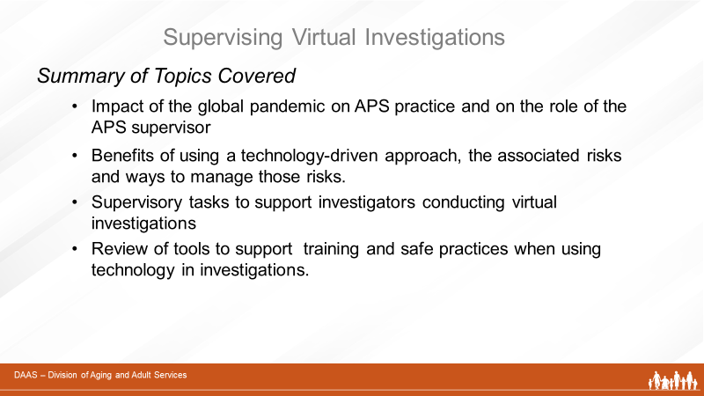
Notes: _____________________________________________
____________________________________________________
____________________________________________________

