Supervising Virtual Investigations

Division of Aging and Adult Services
Adult Protective Services
Facilitator Guide

November 2021

Supervising Virtual Investigations
Supervisor Core Competency 4C

This training was developed by the National Adult Protective Services Association with support from the Arizona Department of Economic Security, Division of Aging and Adult Services-Adult Protective Services, and funded, in part, by a grant (No. 90EJSG0035-01-00) from the Administration for Community Living, U.S. Department of Health and Human Services (DHHS). Grantees carrying out projects under government sponsorship are encouraged to express their findings and conclusions. Therefore, points of view or opinions do not necessarily represent the official Administration for Community Living or DHHS policy.

Curriculum Developers
Lori Delagrammatikas, NAPSA Executive Director Emeritus
Susan Staples, NAPSA Training Coordinator

ACKNOWLEDGEMENTS
This training is the result of a collaboration between Adult Protective Services administrators, supervisors, staff development officers, workers across states and the nation, and professional educators. We would like to thank the following contributors:

Agencies:
Arizona Adult Protective Services, Division of Aging and Adult Services, Department of Economic Security
National Adult Protective Services Association
Adult Protective Services Workforce Innovations

Committees:
Supervisor Curriculum Advisory Committee (SCAC)
National Adult Protective Services Association Education Review Committee

Supervising Virtual Investigations
Supervisor Core Competency 4C

Use of Training Materials

This training was developed to provide APS programs across the nation with NAPSA-approved training content and materials that support specific learning objectives and promote APS supervisor core competency.

States and jurisdictions may customize these materials by adding content to meet their needs for state-specific information (regulations, policies, procedures, tools) in the following ways:
- State-specific PowerPoint slides
- State-specific hand-outs
- State-specific examples and experiences shared by the facilitator during trainings

Users agree to refrain from making any changes to the basic approved content.

No commercial reproduction is allowed.

Table of Contents
Icons 3
Virtual Setup 4
Instructor and Participant Supplies 4
Course Lesson & Goal / Learning Objectives 5
Target Audience 5
For Facilitators …………………………………………………………………………………………………..6
Suggested Timeline 7
Introduction 8
Section 1- Impact of the Pandemic on APS Practice & Supervisor Role 12
Section 2- Benefits and Risks of Using Technology 22
Section 3 –Role of the APS Supervisor & Group Activity 30
Section 4 – Tools for Supervisors and Group Activity 42
Summary …………………………………………………………………………………………………….. 57
Resources ……………………………………………………………………………………………………. 59
This training module is intended as a resource for APS supervisors to promote the safe use of technology by APS investigators. The use of technology in conducting APS investigations has increased in part due to the the recent worldwide pandemic and its impact on APS practices– but also because of the recognized efficiencies that technology can offer long-term.
The key topics presented include:
- Lessons learned from the pandemic
- Benefits and risks of using technology in investigations
- Training and coaching tools that supervisors can use with staff to promote the safe use of technology during investigations with emphasis on engagement, safety, privacy, and documentation.

Equal Opportunity Employer/Program
Equal Opportunity Employer/Program Under Titles VI and VII of the Civil Rights Act of 1964 (Title VI & VII), and the Americans with Disabilities Act of 1990 (ADA), Section 504 of the Rehabilitation Act of 1973, the Age Discrimination Act of 1975, and Title II of the Genetic Information Nondiscrimination Act (GINA) of 2008, the Department prohibits discrimination in admissions, programs, services, activities, or employment based on race, color, religion, sex, national origin, age, disability, genetics and retaliation. The Department must make a reasonable accommodation to allow a person with a disability to take part in a program, service or activity. For example, this means if necessary, the Department must provide sign language interpreters for people who are deaf, a wheelchair accessible location, or enlarged print materials. It also means that the Department will take any other reasonable action that allows you to take part in and understand a program or activity, including making reasonable changes to an activity. If you believe that you will not be able to understand or take part in a program or activity because of your disability, please let us know of your disability needs in advance if possible. To request this document in alternative format or for further information about this policy, contact: [Insert Division/Administration/Program Name and Number]; TTY/TDD Services: 7-1-1. Free language assistance for DES services is available upon request.

Icons
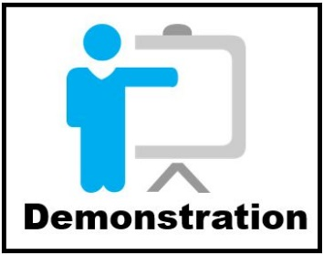

Virtual Set-Up
This guide provides specific instructions for the producer and the facilitator. However, it can be facilitated by one person and both the producer and facilitator should be able to fill both roles should the need arise. To reduce the possibility of any problems arising, both the facilitator and the producer should:
- Ensure the most recent version of video conferencing platform is installed
- Practice using the needed tools after an update to ensure functionality
- Practice in both roles so as to be prepared for any technical issues
- Ensure you facilitate from a high speed connection, preferably directly connected to a server instead of just WIFI
- Practice utilizing multiple screens. If available, having more than one screen allows for quick access to the PowerPoint, Facilitator’s Guide and ZOOM interactive tools

Instructor and participant Supplies
Supervising Virtual Investigations Facilitator Guide
Supervising Virtual Investigations PowerPoint Slides
Supervising Virtual Investigations Participant Guide

Course/ Lesson Goal
This 2-hour virtual course was developed to provide supervisors with basic information to help them guide their staff in conducting virtual investigations. It can easily be adapted to a classroom environment. It is designed with the following considerations in mind:
- Facilitated to be interactive.
- Designed for a class size of 20 - 25 staff.

Learning Objectives
By the end of this course, participants should be able to:
- Describe the impact of virtual investigations on APS practice and on the role of the APS supervisor.
- Describe the supervisor’s role in ensuring that investigators use safe and effective practices related to engagement, privacy, safety and documentation.
- Use tools to support investigator training: Investigator Checklists, Tips for Conducting Virtual Investigations and Streamlining Your Investigations.

Target Audience
The target audience for this training is APS supervisors.

For Facilitators
This Facilitator Guide provides the structured content, activities, and PowerPoint slides to present a 2-hour training session. Facilitators are encouraged to review the guide and to add any state-specific information and/or examples from their professional experiences as appropriate. The accompanying Participant Guide contains the PowerPoint slides and resource materials that will be referenced during the training. Facilitators are encouraged to review these reference materials before the trainings, to be prepared to screen-share them as directed, and briefly describe content and use.
Here are a few suggestions to help facilitate a successful class:
- Do not stray from the curriculum provided in the online session materials. Even if you may disagree with a policy or procedure, know a “shortcut”, or have worked at an office that did things in a different way than what is stated in the material, do not alter the materials. To keep the training message consistent, please follow any policy and procedures cited as written in this manual. If you do not agree with something, please bring it to the attention of your Training Manager before training.
- Be prepared and ready to welcome your Participants by having the online session materials ready to go at least 30 minutes prior to class start time.
- Always start and resume class on time.
- Dress professionally, even if it’s a “casual day”.
- Know the material and study its origins and applications.

Suggested Timeline
 | Section | Content
5 Minutes | Introduction | Introduce facilitator and participants, review Zoom platform
10 Minutes | Section 1  Impact of the pandemic on APS practices and on the role of the APS supervisor | Changes and adaptations to APS practice, what has been learned, implications for the future
10 Minutes | Section 2  Benefits and risks of using technology | Overview of common devices, benefits and associated risks, general guidelines for managing risks.
25 Minutes | Section 3  Role of the Supervisor and Group Activity. | Supervisory tasks related to training, monitoring and providing feedback
10 min. | Suggested Break
55 Minutes | Section 4  Review of Training Resources  Group Activity | Investigator Check-Lists related to Engagement, Privacy, Safety and Documentation  Tips for Conducting a Virtual Investigation
5 min. | Summary and Closing Comments

 | Introduction
Slide 1 | 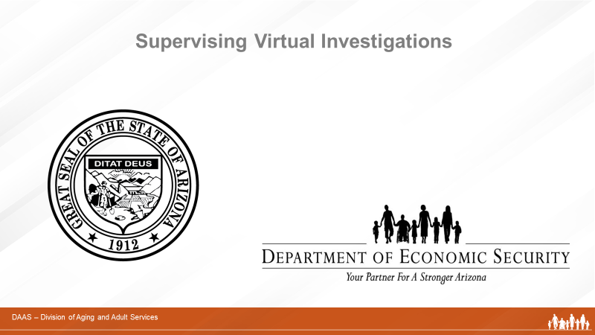
Producer:
Welcome, everyone, to today’s training on Supervising Virtual Investigations. (Introduces self and role in overseeing technology and managing questions and group activities.)

Slide 2 | 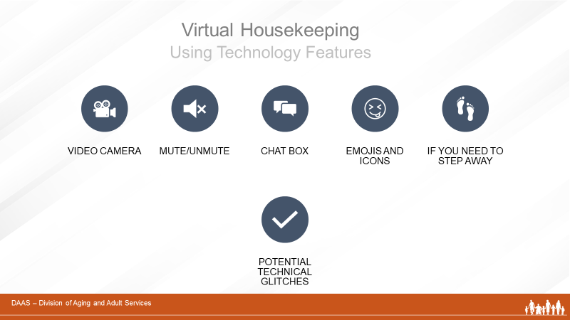
Producer:
Before we get started, let’s review some virtual housekeeping details to be sure we’re familiar with the technology features we’ll be using to communicate with each other.
Some of you may be more familiar than others navigating through a virtual learning course. So we will briefly review the various functions of the virtual environment:
- Video Camera: Find the camera icon; when you do, please turn the camera off and on. During the session, please keep the video camera on since this is an interactive course.
- Mute/Unmute: Now, please locate the microphone. When you do, practice muting and unmuting yourself.
- Chat box: Find the chat icon. We will be using the chat function to communicate throughout the session.
- Emoji and Icons: These differ within the different virtual platforms
There will be a ten-minute break approximately 60 minutes into the training. And while participants are expected to attend the entire training, if you need to step away please let the facilitator know by private chat.
And just a word about technical glitches. They are inevitable - on our end and your end! So please be patient and forgiving as we all navigate this virtual platform together.
Slide 3 | 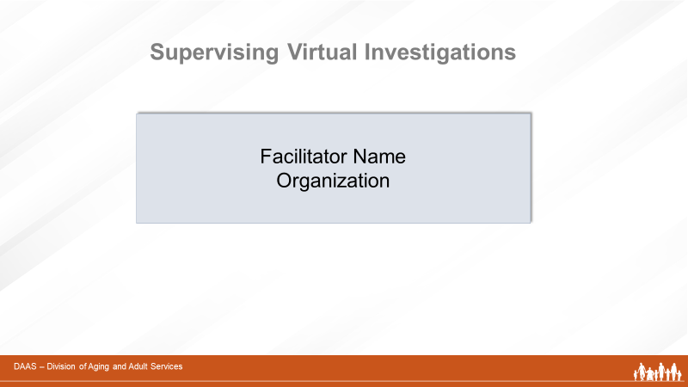
Producer:
Now, let me introduce our facilitator for today’s session. (Introduces name and affiliation.)
Facilitator:
Thank you! I’m very pleased to join you all to facilitate this training on Supervising Virtual Investigations. (May want to add a little more about your professional background.)

 | Section One: The Impact of the Pandemic on APS Practices and on the Role of the APS Supervisor
Slide 4 | 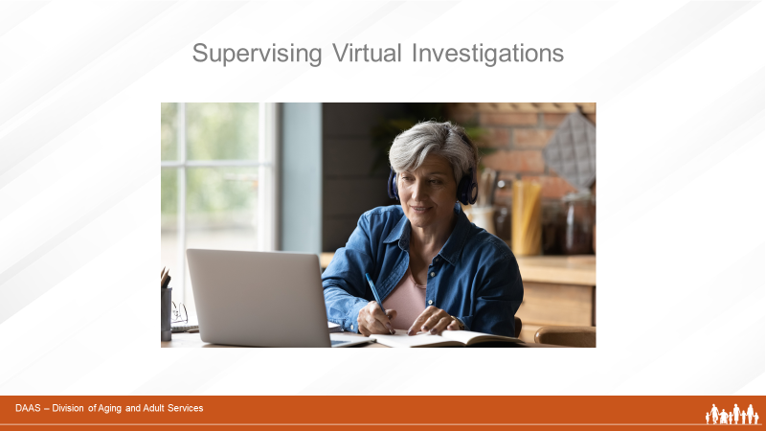
Facilitator:
As you know, most APS programs have policies and procedures in place to deal with emergencies or disasters. However, the Covid-19 crisis presented a different kind of emergency – a global pandemic – that forced us to adapt to new ways of working, communicating, and supporting clients and staff over a long period of time. One of the adaptations to APS practice has been the use of technology to conduct investigations when in-person visits are considered unsafe. Although in-person visits remain best practice in many situations – and often required by agency policy – APS programs have found that some investigations, at least in part, can be carried out effectively using technology.
Slide 5 | 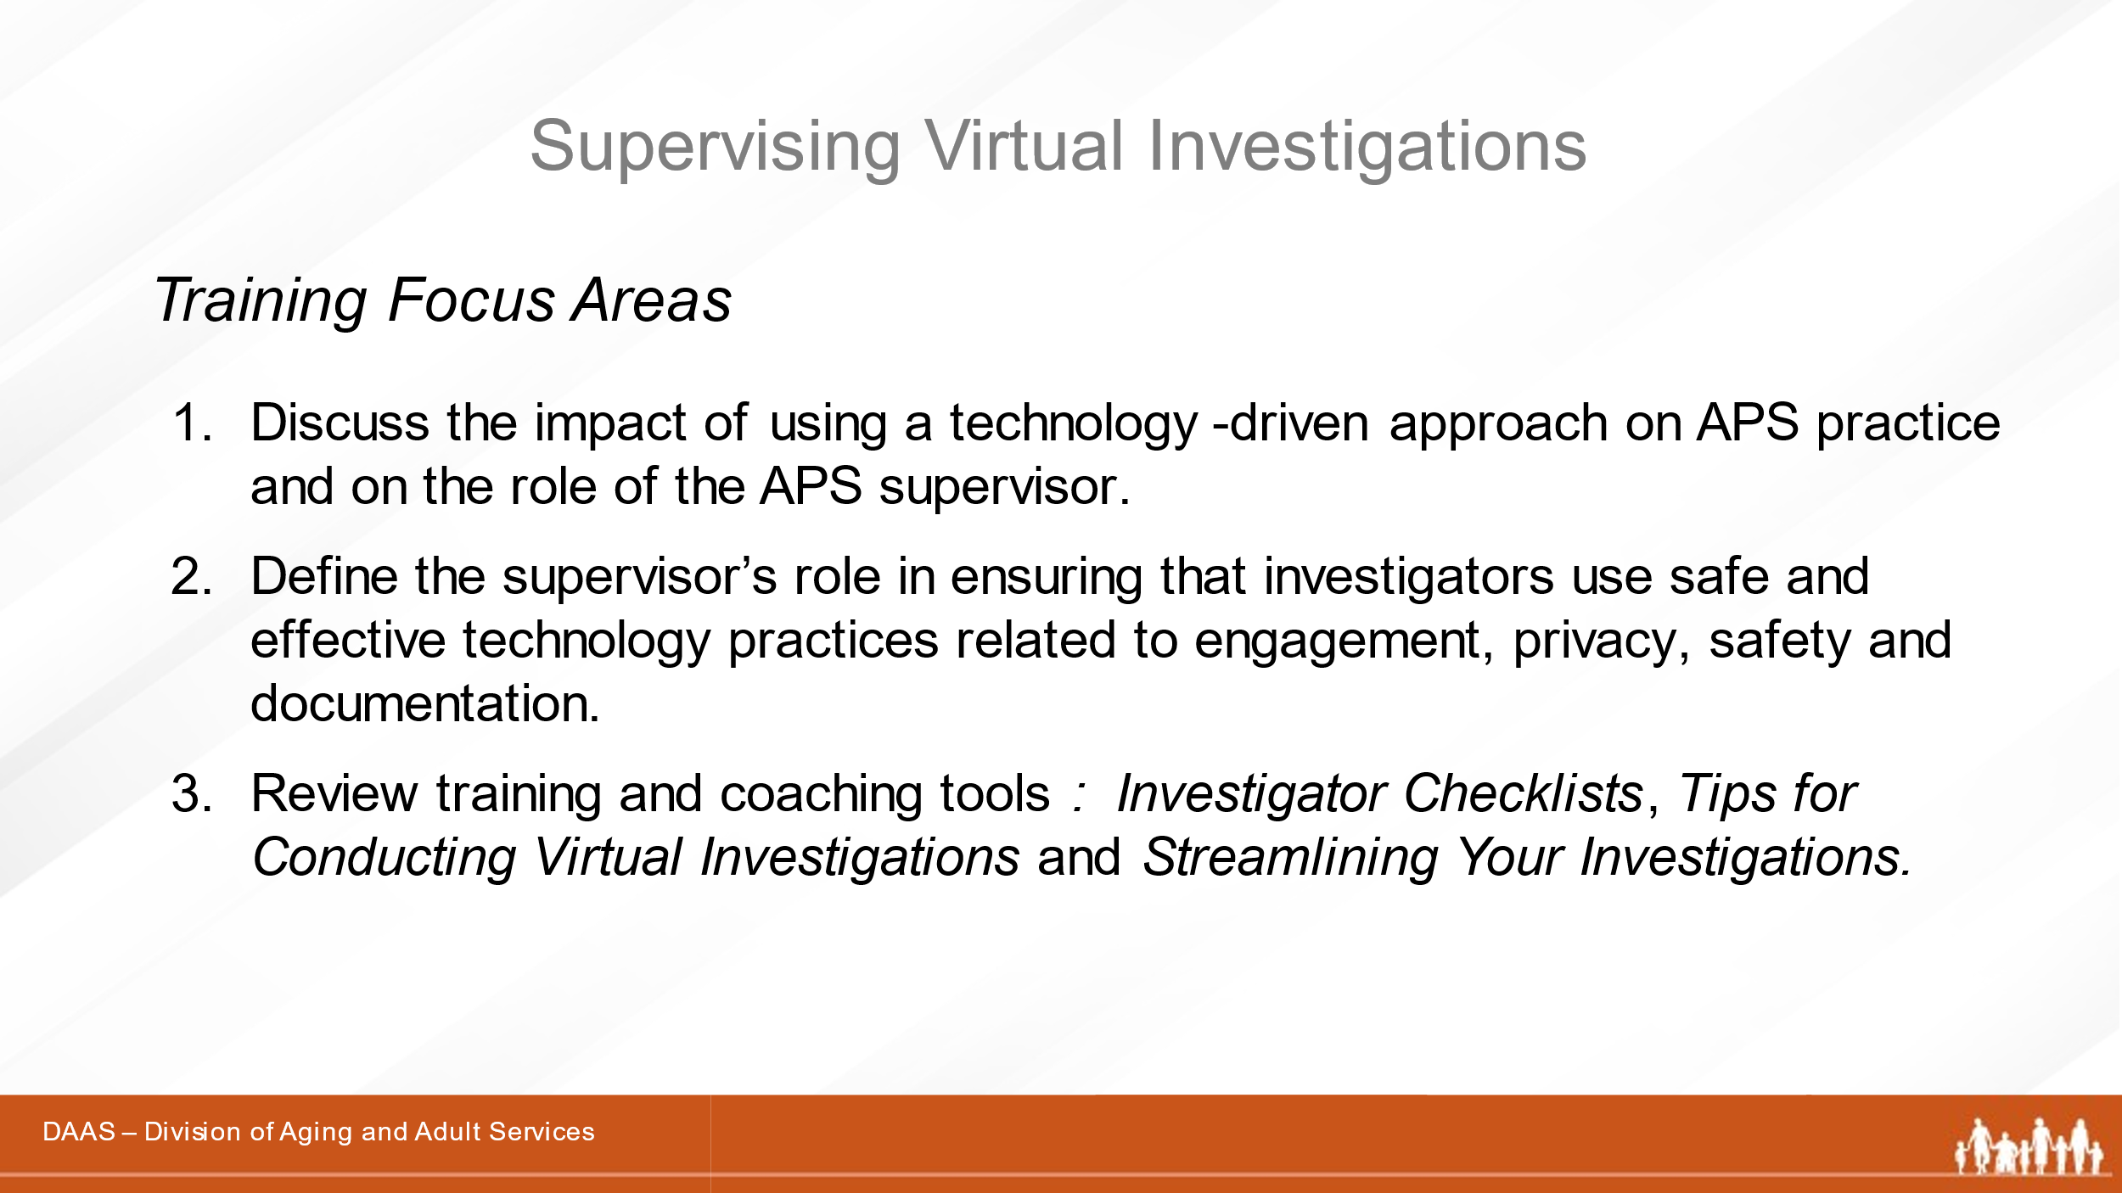
Facilitator:
In this session, we will focus on:
- How the use of technology impacts APS practice and the role of the APS supervisor.
- The supervisor’s role in ensuring that investigators use safe and effective practices related to engagement, privacy, safety and documentation.
- Training and coaching tools and resources supervisors can use to support their investigators.
Slide 6 | 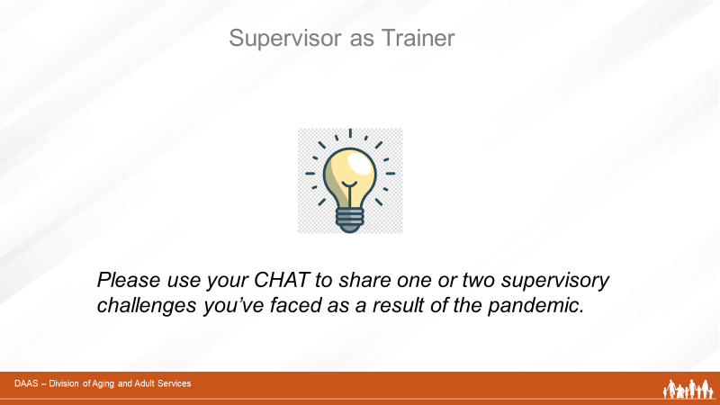
Facilitator:
I want to begin by asking you all to take a moment and, using the CHAT, share one or two of the challenges you faced in your supervisory role during the pandemic.
(Producer monitors responses and reports.)
Thank you for those responses. Lots of impact on a supervisor’s role!
Slide 7 | 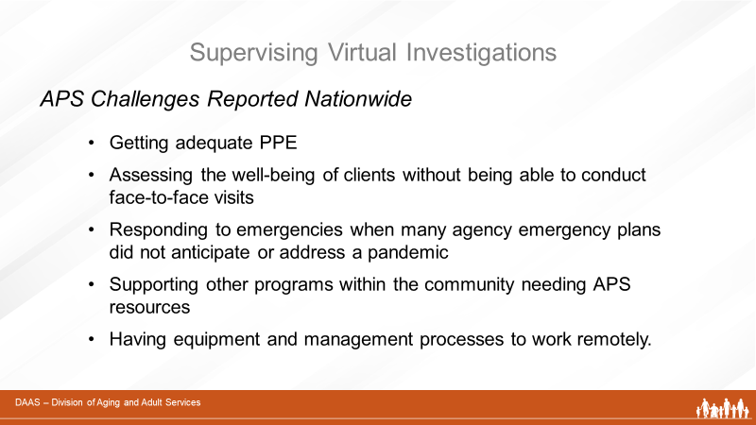
Facilitator:
Now let’s look at what other APS programs across the country reported as challenges in a study called Adult Protective Services Study on the Impact of Covid-19. It was done in 2020 for the Administration for Community Living (ACL).

As cited in the study, APS programs are viewed as “front-line” resources for addressing the needs of vulnerable adults. As such, APS staff faced a number of challenges in carrying out their work – especially at the beginning of the pandemic. Although these varied from state to state, they included:

- Getting adequate PPE
(Often, PPE was reserved for “first-responders.”)
- Observing and assessing the well-being of clients without being able to conduct face-to-face visits
- Responding to an emergency even though many agency emergency plans did not anticipate or address a pandemic
- Supporting other programs within the community needing APS resources
- Having equipment and management processes in place to support working remotely. Relying on technology offers many benefits but it also comes with risks that need to be managed. We will discuss these in the next section.
In its summary of findings, the study reported positive observations about APS staff performance during the pandemic and how new practices forced by the pandemic may affect the way we work going forward. Let’s look at these.

Slide 8 | 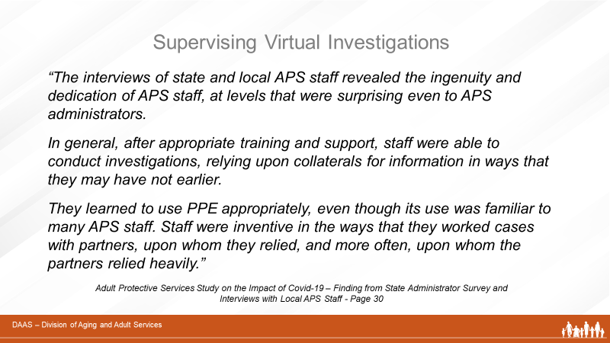
 | Facilitator summarizes the content of this slide for participants.

Slide 9 | 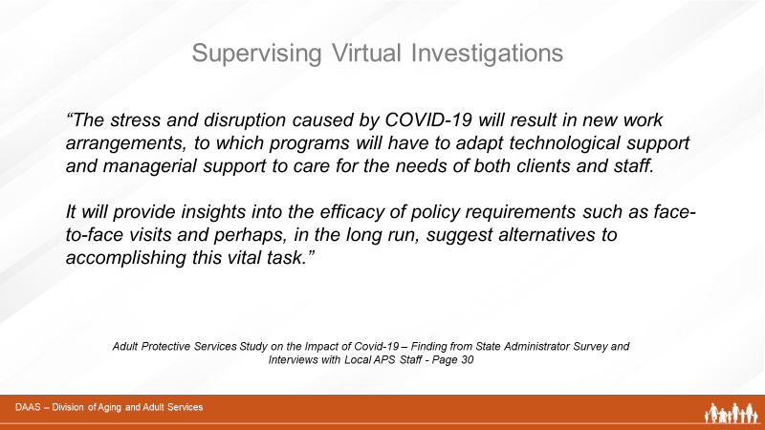
Facilitator summarizes content of slide then continues:
So the impact of the pandemic on APS practices – especially on investigative practices – have caused us to change the way we work and to use more technology. And what we’ve learned is that some of the changes may offer benefits for the long-term.
Slide 10 | 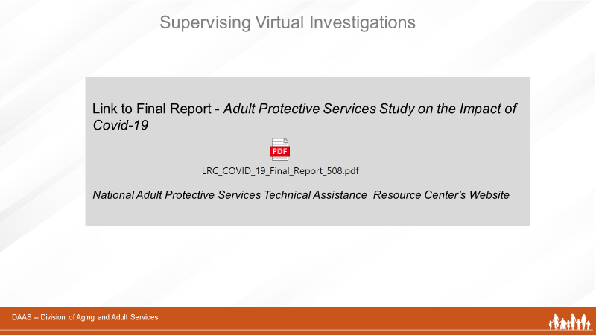
Facilitator:
The link that you see on the screen allows you to access the full report from this study. It is on Page 6 in your Participant Guide.
Slide 11 | 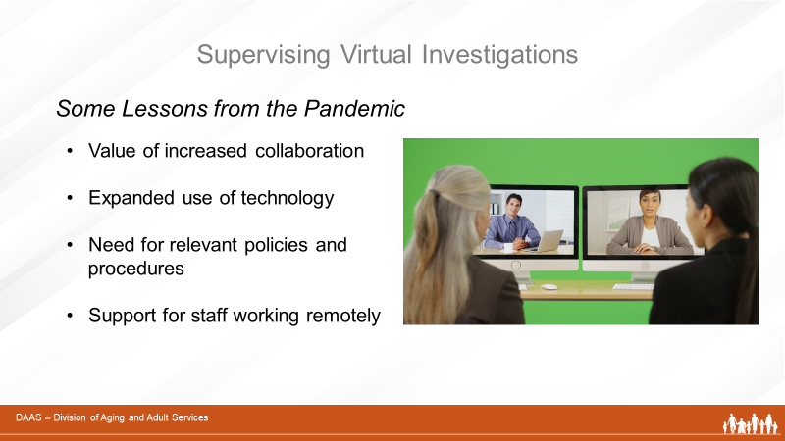
Facilitator:
So now let’s look at what we’ve learned and how that may offer greater efficiencies in APS work for the long-term. These include:
- The value of increased collaboration
- The expanded use of technology (a more technology-driven approach.)
- The need for review/adaptations of policies and procedures (ex. face-to-face visits)
- The importance of supervisory support for staff working remotely

Slide 12 | 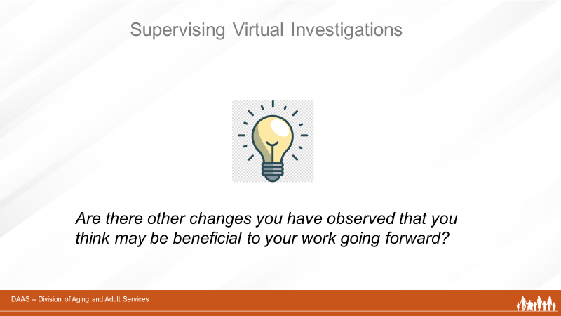  Facilitator:  Let’s get some input from you. Please use your CHAT to share any changes you’ve experienced that you think might be helpful long-term?  Producer reports responses.  Thank you for sharing those observations!
Slide 13 | 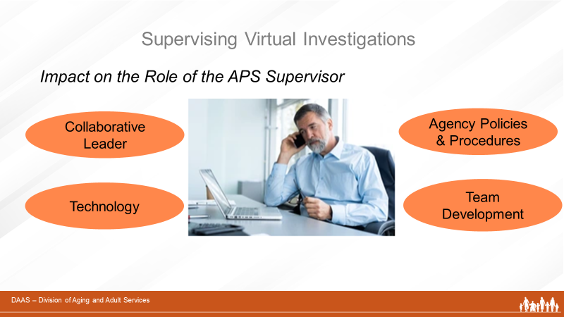
Facilitator:
The lessons we’ve just talked about have an impact on APS practices and also on the role of APS supervisors. Supporting a team that is adapting to working remotely and conducting investigations in a new way requires a supervisor to:
- Provide leadership and guidance to staff in utilizing collaborative approaches with community partners.
- Ensure that all staff understand the benefits, risks and safe practices when using a technology-driven approach.
- Ensure that staff understand and follow agency policies and procedures related to use of technology
- And, above all, be the source of information and support that promotes staff development.
We will discuss these supervisory tasks in more detail in Section Three of this training.
 | Section 2: Benefits and Risks of Using Technology
Slide 14 | 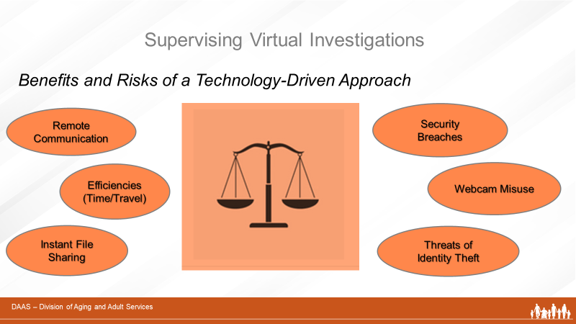
Facilitator:
Before we do, however, we’ll look briefly at the benefits and risks associated with using technology in investigations as well as some ways to manage the risks. This is an important discussion to have with your team since it provides everyone with basic awareness of the risks and associated safe practices when using technology.
Slide 15 | 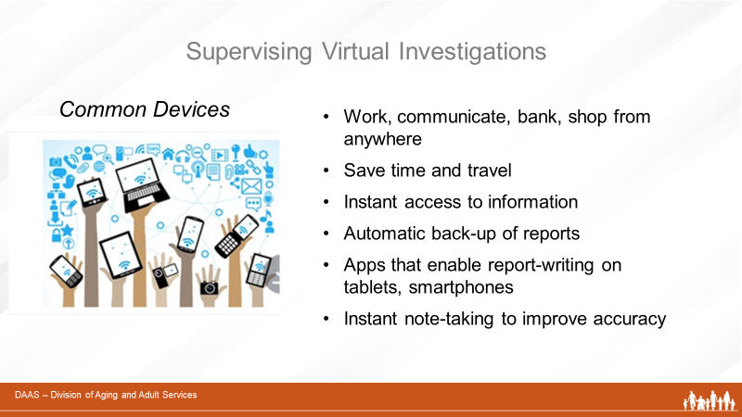
Facilitator:
Let’s start by reviewing the common devices found in offices and many households – laptops and mobile devices like tablets and smartphones. An increased number of older adults are now using these devices and we’re all probably familiar with the benefits they offer:
- Ability to work, communicate, bank, and make purchases from any location.
- Save time and travel
And especially helpful to APS investigations . . .
- Instantly upload reports and other documents
- Automatic back-up of reports
- Apps that enable report-writing on tablets, smartphones
- Instant note-taking to improve accuracy

Slide 16 | 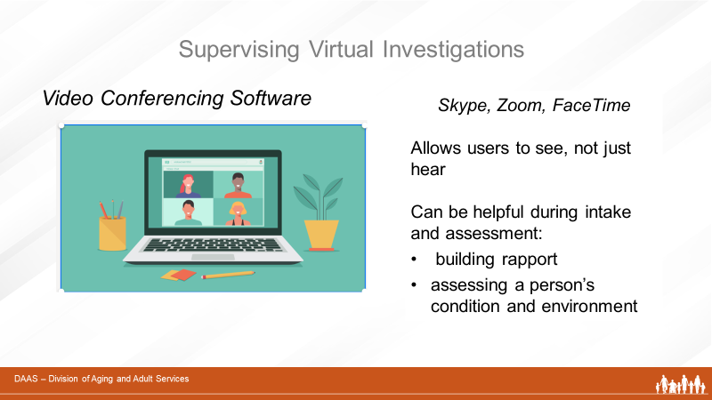
Facilitator:
In addition to devices, video conferencing software like Skype, Zoom, and FaceTime, to name a few, add the benefit of being able to see each other during a conversation rather than just hearing voices over the phone.

Video conferencing can be a very helpful tool to APS investigators during intake and assessment - in building rapport, assessing a person’s general condition and their environment.

Slide 17 | 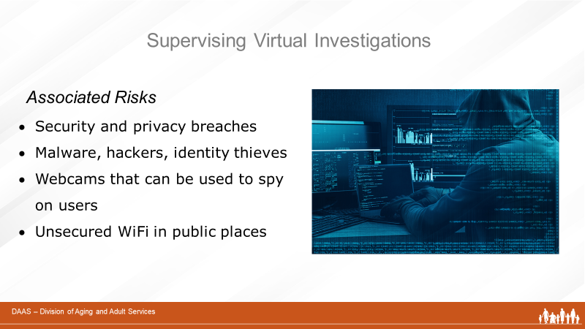
Facilitator:
But along with the benefits of these devices and software programs, come associated risks and vulnerabilities for every user. These include:
- Security and privacy breaches
- Malware, hackers, identity thieves
- Webcams that can be used to spy on users
- Unsecured Wi-Fi in a public place

Slide 18 | 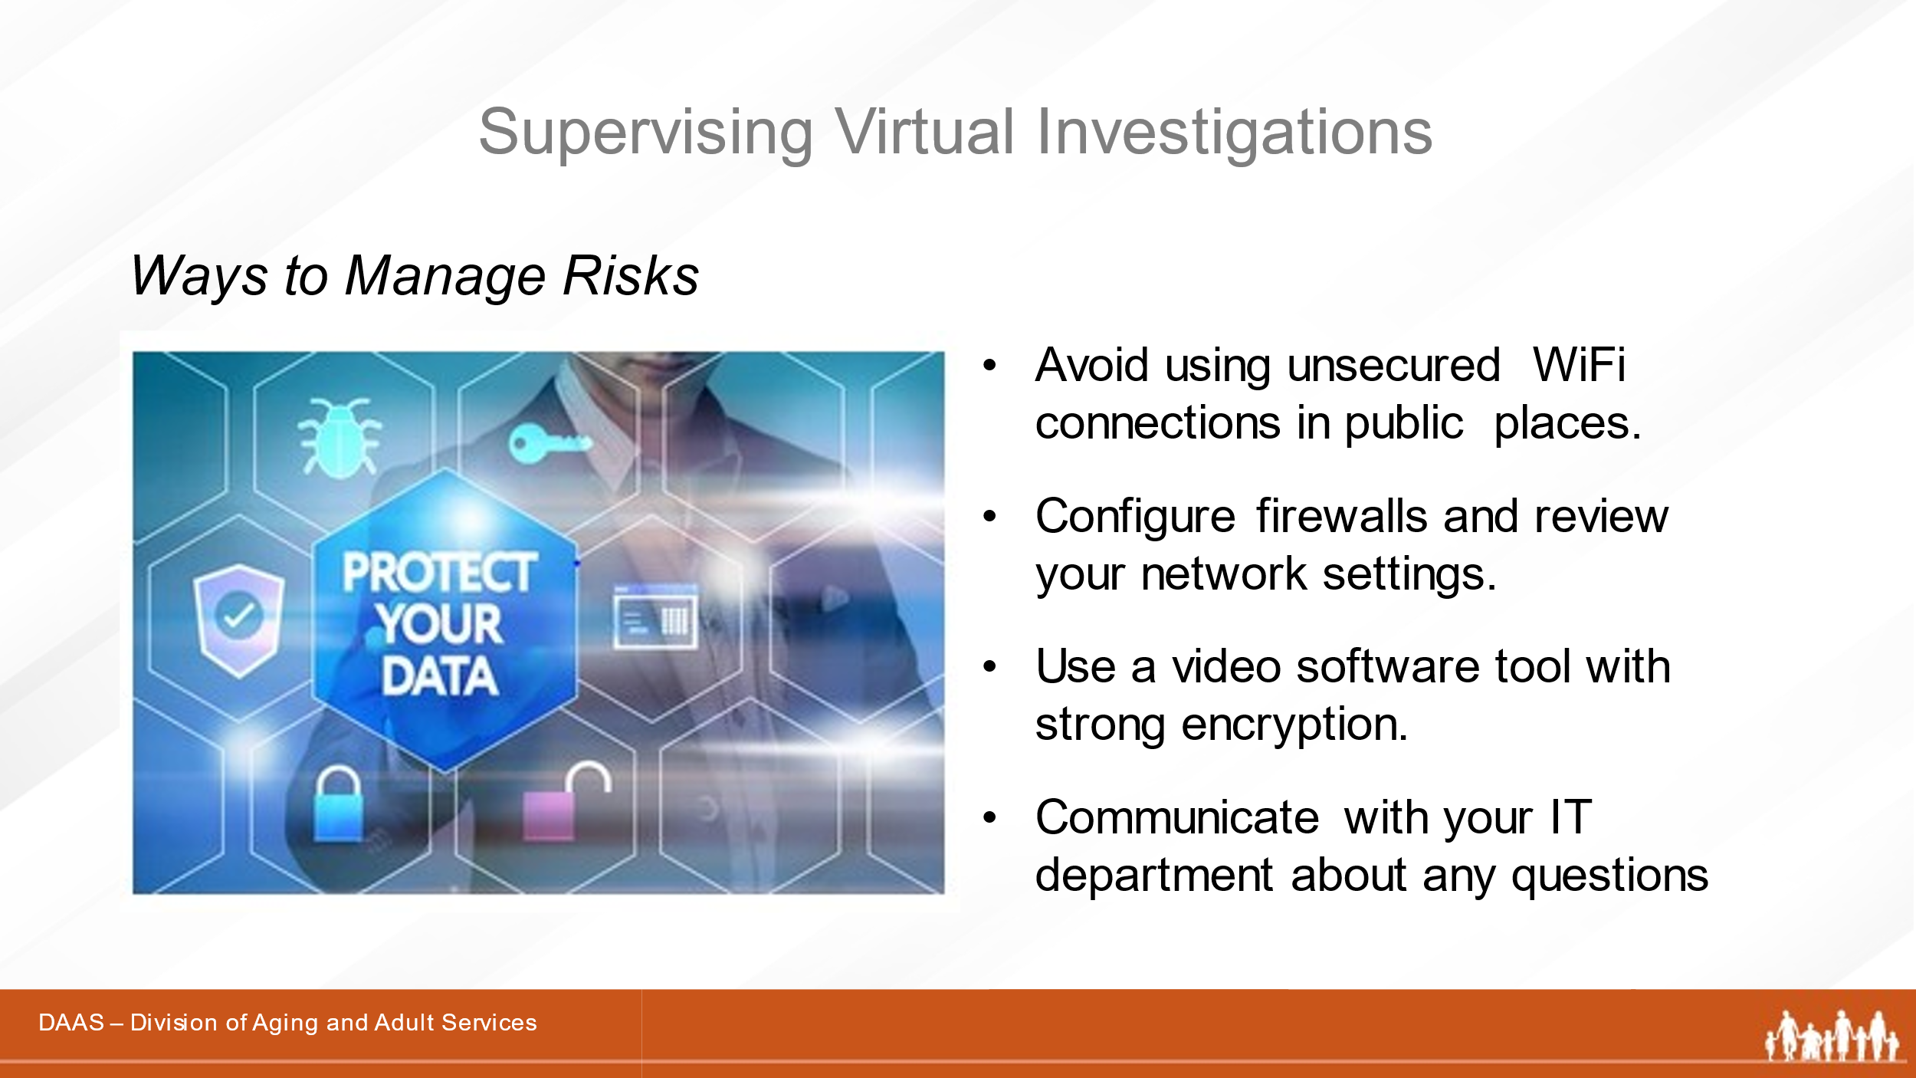
Facilitator:
It’s important to recognize that these risks can be managed and information protected – for APS staff and clients - by following some basic practices. You may be familiar with many of these and you will want your staff to know them as well.

- Avoid using unsecured Wi-Fi connections in public places that make it easy for hackers to gain access.
- Configure firewalls and review network settings.
- Use a video software tool with strong encryption. (The method by which information is converted into secret code that hides the information's true meaning.)

Slide 19 | 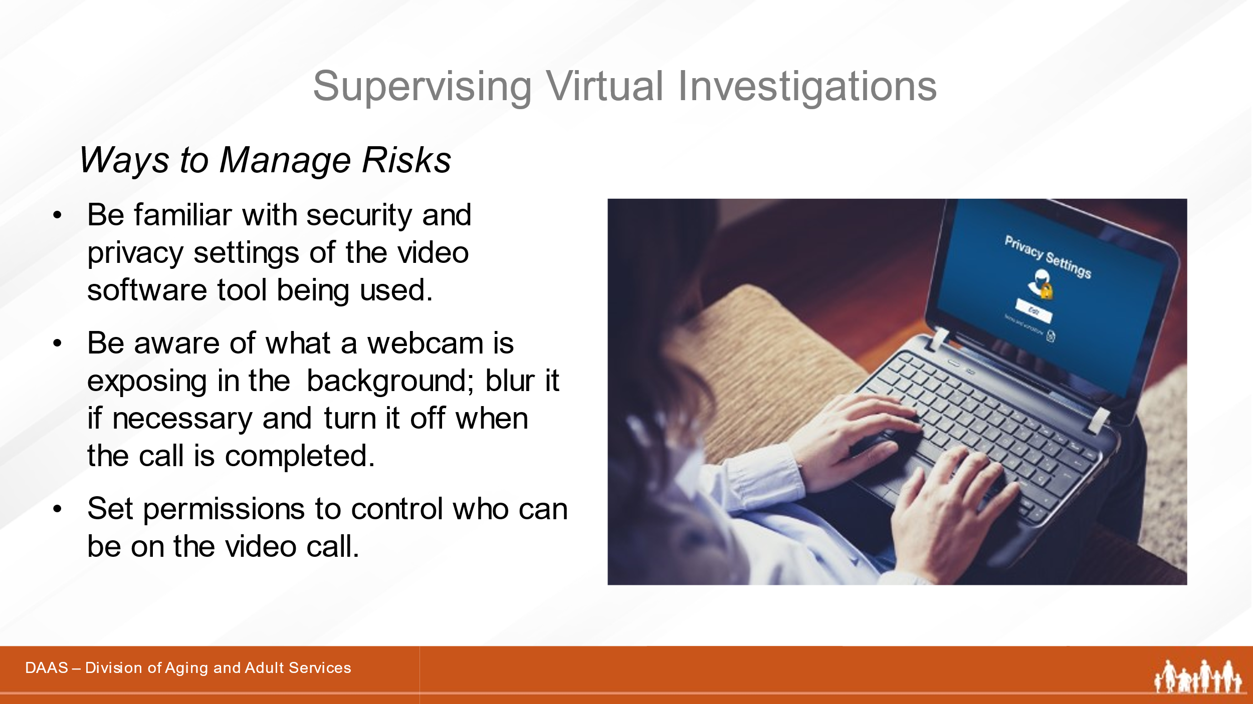
Facilitator:
In addition,
- Be familiar with the security and privacy settings of the video software tool being used.
- Be aware of what a webcam is exposing in the background, blur it if in the office, and turn it off when the call is completed.
- Set permissions to control who can be on the video call.

Slide 20 | 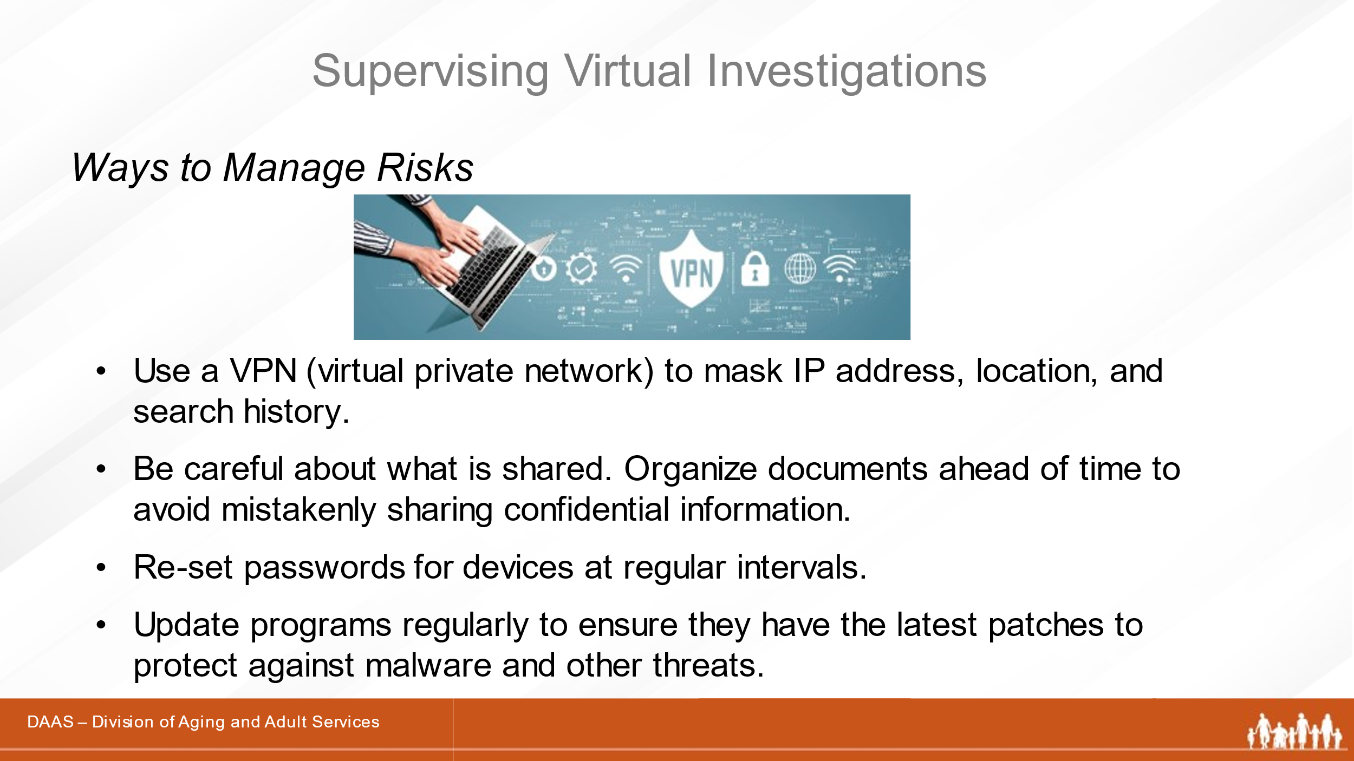
Facilitator:
- Use a VPN (virtual private network) to mask the IP address, location, and search history. (Prevents things like location tracking.)
- Be careful about what is shared. Organize any documents ahead of time to avoid mistakenly sharing confidential information.
- Update passwords regularly.
- Update programs regularly to ensure they have the latest protections against malware and other threats.

Slide 21 | 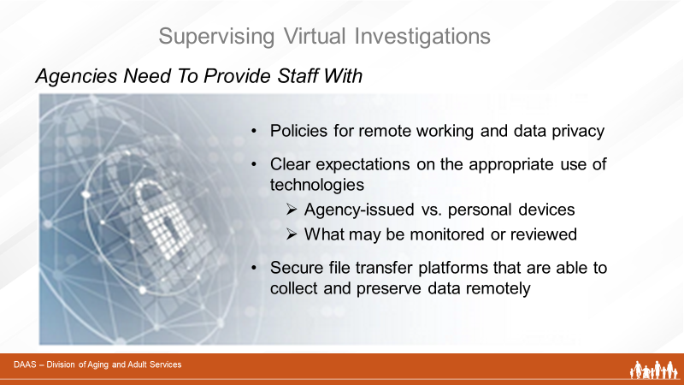
Facilitator:
When using technologies and working remotely, be sure your investigators know and follow your agency’s policies for:
- Remote working and data privacy
- The appropriate use of technologies
  - Agency-issued vs. personal devices
  - What may be monitored or reviewed
- Using secure file transfer platforms that are able to collect and preserve data remotely
You may want to have a member of your agency’s IT staff join you and your team to participate in discussions and help answer questions.

 | Section 3 – Role of the APS Supervisor
Slide 22 | 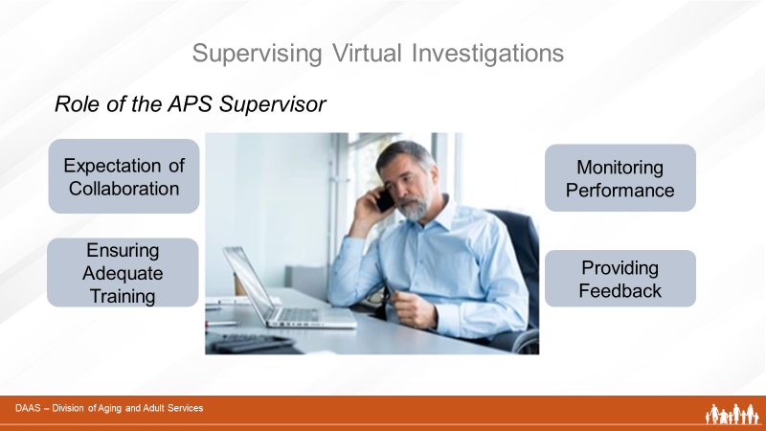
Facilitator:
Now we will discuss in more detail the role of the APS supervisor in supporting and developing their teams as they conduct virtual investigations.

Using a technology-driven approach may represent a new way of practice to your investigators and requires some additional knowledge to promote effective engagement, privacy, safety, and accurate documentation.

In this section, we will acknowledge each of the supervisory tasks shown on the screen. In the section to follow, we will review tools in your Participant Guide that supervisors can use with investigators in team trainings and during one-on-one supervisory sessions to ensure that they understand and follow safe and effective practices when using technology.

To begin, let’s do a group activity addressing each role of the APS supervisor in supporting and developing their teams as they conduct virtual investigations. There are four categories that see on the screen that include:
- Setting an Expectation and Collaboration
- Ensuring Adequate Training
- Monitoring Performance
- Providing Feedback

Slide 23 | 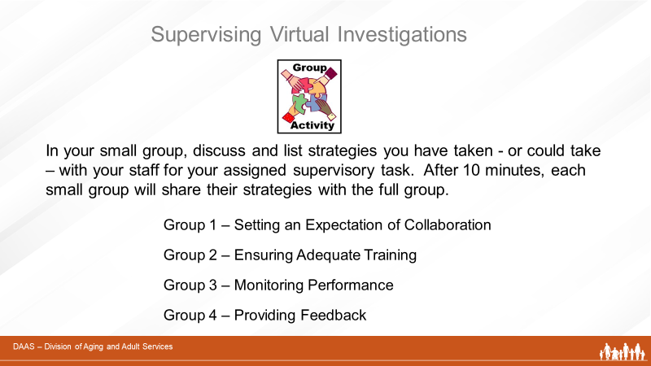
Facilitator:
First, we will break you into small groups with each group being assigned one of these four categories.

You will have 10 minutes to discuss what have been your strategies and methods with your assigned category.
Please select a team lead to report out for the group.

Producer: Announces participant names for each break-out room and the assigned topic for each group.
- Group 1:Setting an Expectation and Collaboration
- Group 2:Ensuring Adequate Training
- Group 3:Monitoring Performance
- Group 4:Providing Feedback
Allow 8 minutes and provide a 2-minute warning before closing the rooms and returning to the large group.
Facilitator:
Welcome back, everyone! Let’s have the spokespersons for each group take themselves off mute so they can share their strategies and ideas with us.
Slide 24 | 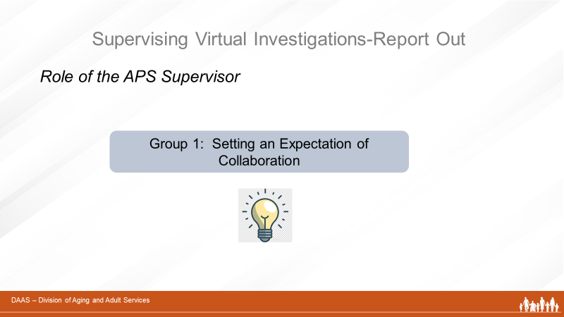
Facilitator:
Let’s start with Group 1’s ideas for promoting collaboration.
(Acknowledge responses and continue with next slide.)
Slide 25 | 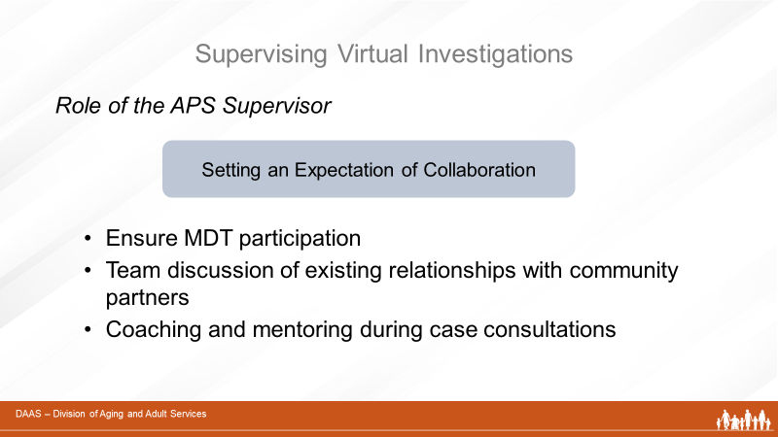
Facilitator:
As we noted earlier in this training, the study on the impact of Covid 19 on APS practices cited the value of increased collaboration with community partners when conducting virtual investigations. An example is the benefit of engaging with collaterals before an initial interview to gather and review existing information about the client.

So ensuring that your team makes and uses community connections will help them to carry out virtual investigations more efficiently. Supervisors can:
- Ensure team participation in MDT
- Have updates during team meetings on existing or new relationships with other community providers
- Use coaching and mentoring techniques to guide investigators in working with collaterals during pre-visit planning or post-visit case consultations.
Are there other ideas you would like to add?
Slide 26 | 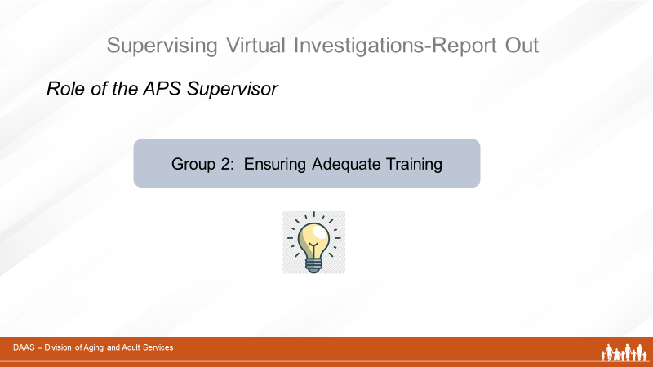
Facilitator:
Now let’s hear from Group 2 and their ideas about ensuring adequate training.
(Acknowledge responses then continue with next slide)

Slide 27
Thank you, Group 2!

Facilitator:
In their role as trainers, supervisors need to integrate technology-specific information and experiences in preparing staff to follow safe practices:
- Start by ensuring that investigators understand and follow their agency’s policies regarding decisions about the use of virtual investigations and policies that cover the appropriate use of technologies. Group trainings are useful for providing that overview.
- Consider having an IT representative from your agency do a group training with staff.
- As with all staff training, supervisors need to use techniques that match the experience level of the investigator. Newer investigators may benefit from one-on-one sessions, case reviews, structured observations with de-briefs, and shadowing with more experienced staff. Investigators with more experience will benefit from coaching techniques during case consultations especially when the case is complex.
- Team meetings are a good time to use case presentations highlighting effective strategies and challenges followed by a team discussion.
- Use “Investigator Checklists” to present new information, provide review as needed, and develop coaching questions to use during case consultations.

Slide 28 | 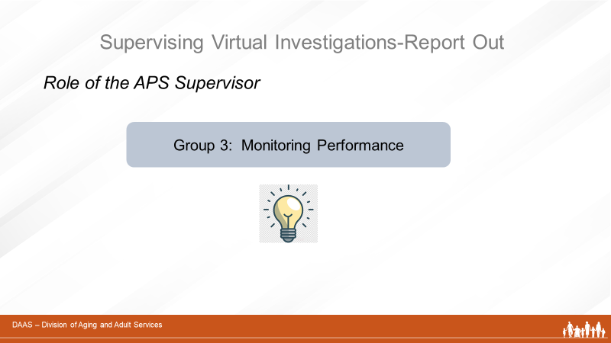
Facilitator:
Let’s hear ideas now from Group 3 on monitoring performance.

(Acknowledge responses and continue with next slide.)
Slide 29 | 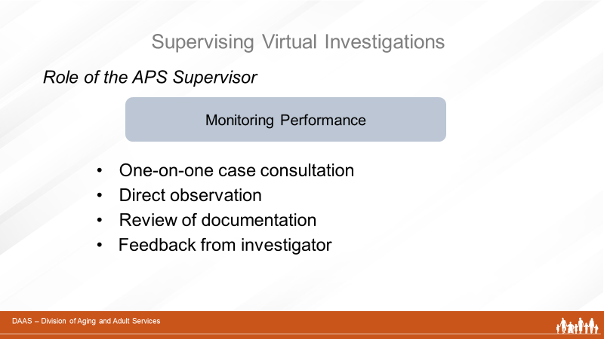
Facilitator:
Supervisors ask questions as they monitor the performance of their team members. Are they following agency policies? Are they demonstrating safe practices when using technology? Are they working with community partners? Are they documenting accurately and consistently?

Now let’s review these suggestions:
- Individual case consultation allows the supervisor to monitor progress, assess whether or not the investigator understands and follows safe practices, and provide appropriate guidance. Especially in cases that are complex, the supervisor may need to schedule planning consultations pre-visit to help the investigator prepare and post-visit to monitor case planning.
- Observing the investigator directly during interviews provides the supervisor with a view of strengths to build on and areas of challenge to address.
- Review of documentation can also help the supervisor monitor progress in a case.
- And feedback from the investigator is often useful to identify areas of strength and needs for assistance.
Slide 30 | 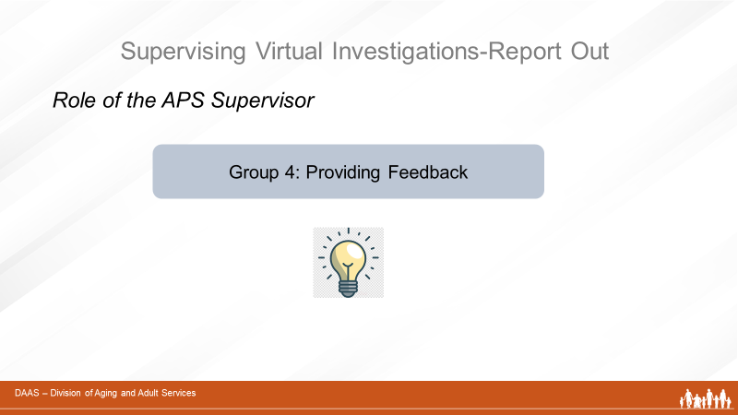
And now for Group 4. What strategies did you come up with to share?
(Acknowledge responses and continue.)
Slide 31 | 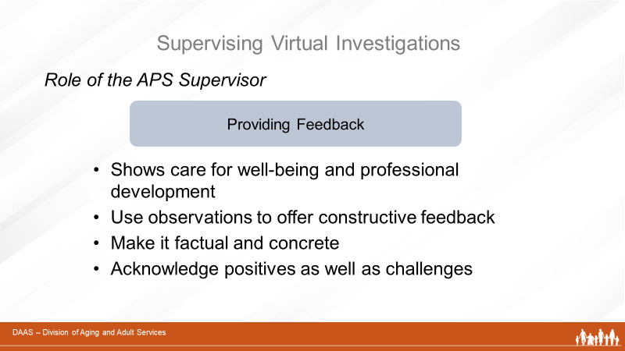
Thank you Group 4! Providing effective feedback is always a part of day-to-day supervision.
Facilitator:
Providing timely and constructive feedback shows the supervisor’s care and commitment to the well-being and professional development of the investigator. Using the practices that ensure effective engagement, privacy, safety and accurate documentation as a guide, supervisors can provide helpful feedback to investigators.
- Observations and debriefings during investigations provide good times to offer feedback.
- Keeping feedback factual and concrete is useful information for the investigator.
- Acknowledging what has gone well builds confidence
and motivates an investigator to focus on areas that need improvement.
Slide 32 | 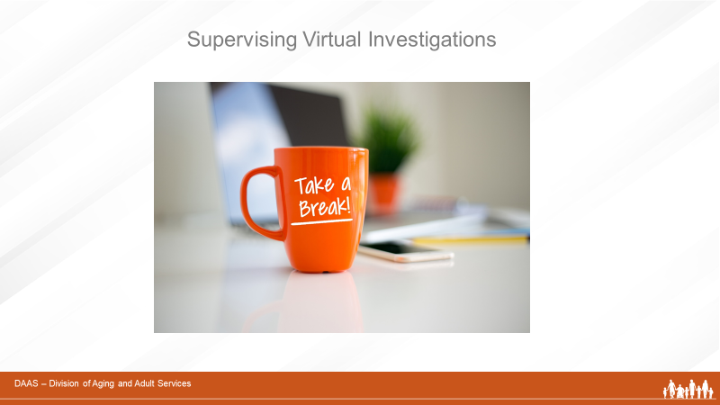  Facilitator:  Great job, everyone. Now, let’s take a 10 min. break.  When we return, we will review the “Investigator Checklists” in your Participant Guide that are tools supervisors can use with investigators – to train, coach, monitor and provide feedback during virtual investigations.

 | Section 4: Tools for Supervisors and Group Activity
Slide 33 | 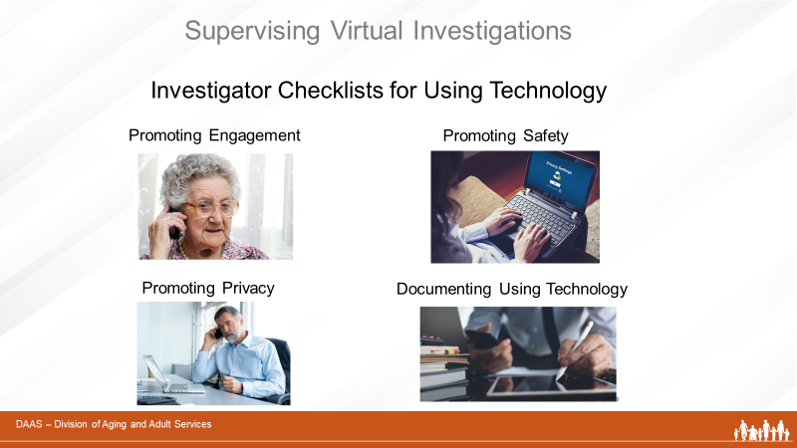
Facilitator:
Welcome back! In this section of today’s training, we will review the “Investigator Checklists” referenced earlier. These checklists can be used as a guide for investigators to promote safe and effective practices when using technology and a training resource for supervisors.

Slide 34 | 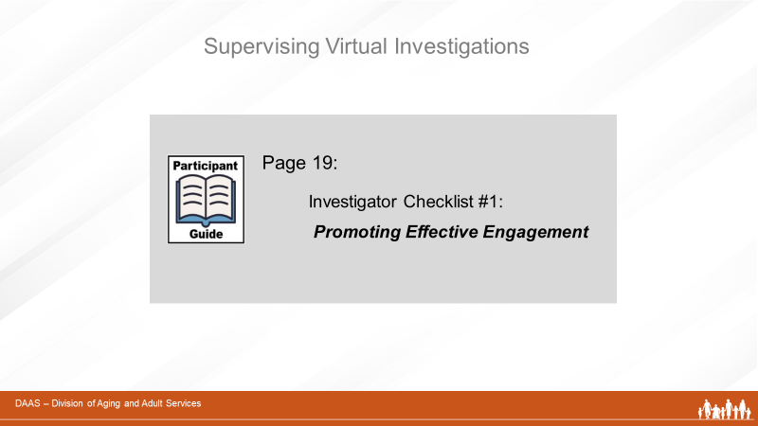
Facilitator:
To start, please refer to Page 19 in your Participant Guide as we review Checklist #1 – Promoting Engagement.
(Facilitator reviews the content. See next page.)

Investigator Checklist #1
Promoting Effective Engagement in Virtual Investigations
Engaging with clients virtually may require more time than face-to-face visits. Although most strategies for engagement are the same as face-to-face visits, investigators need to plan more time for building rapport. It may take several calls to develop enough rapport for the person to share information.
The following considerations can be used by investigators to plan virtual engagements with clients and collaterals and by supervisors as training and coaching aids.

Engaging with Clients – Initial Questions to Ask
- Does the client have access to a computer, tablet or a smartphone?
(Some individuals may not be able to communicate this way –
especially those with significant cognitive deficits.)
- Would the client like and feel safe having video chats or conferences?
- Does the client use e-mail and would they like and feel safe receiving
updates or corresponding through e-mail?
- Would written communication with the client (letters or emails) be
effective and safe?
- Use telephone contacts with a client’s family, friends, facility staff, or other professionals involved with the case to inquire about the client’s safety.
- If there is no alternative to a home visit, consider limiting contact by remaining outside the home at the CDC-suggested six-foot social distance.
Engaging with Clients – By Phone or Video Conferencing

- Send directions for using the app ahead of time to help ensure an
on-time, glitch-free start.
- Recognize that the call may be stressful. Using a trauma-informed
approach can affect the victim’s feelings of increased control and decreased vulnerability and make a significant difference in the efficiency and effectiveness of interactions between an alleged victim and APS staff.
- Try to accommodate to the interviewee’s schedule and needs
(best time of day, etc.)
- Provide reassurance of confidentiality and safety of information.
- Ease into interviews – build rapport by starting with conversational questions like “How are you doing?”
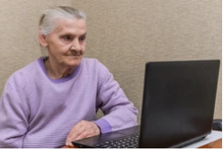
- Allow adequate time so the interviewee doesn’t feel rushed.
- When using video-conferencing, check to see that the interviewee can see and hear you.
- Maintain eye contact to show you are paying attention.
- Maintain an interested and neutral facial expression.
- Watch body language for signs of fatigue and need for a break.

Engaging with Collaterals
- If your agency is part of a multi-disciplinary team, have team
discussions about virtual investigations, when they may be needed,
and how partners can collaborate effectively.
- Have information-sharing agreements (MOUs) in place to
facilitate the transfer of information among partners.

Slide 35 | 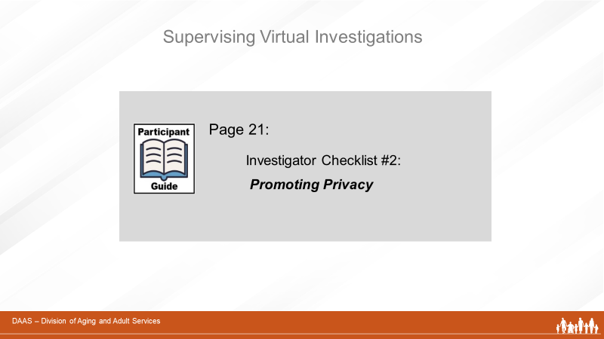
Facilitator:
Next, please refer to Page 21 for Checklist #2 - Promoting Privacy
(Facilitator highlights content. See next page.)

Investigator Checklist #2
Promoting Privacy During Virtual Investigations
The following considerations address privacy issues when planning calls with alleged victims. Supervisors may also find this information helpful as a training aid.

Privacy of the Investigator and the Client
- The investigator should be alone in a quiet room to ensure confidentiality.

- The investigator should ask the interviewee, “Is anyone in the room with
you?” or “Is anyone able to hear you?” If the client indicates they do not
have privacy, ask if you can reschedule the call.

Privacy of the Client’s Information

- Ensure all platforms and systems are secure and can be accessed only by the relevant parties.
- Parties involved in the investigation should have access only to the information specifically relevant to them.
- Organize files and their locations for online correspondence, e-mails, documents, and other evidence.
- Any evidence existing in hard-copy form must be securely stored.

Slide 36 | 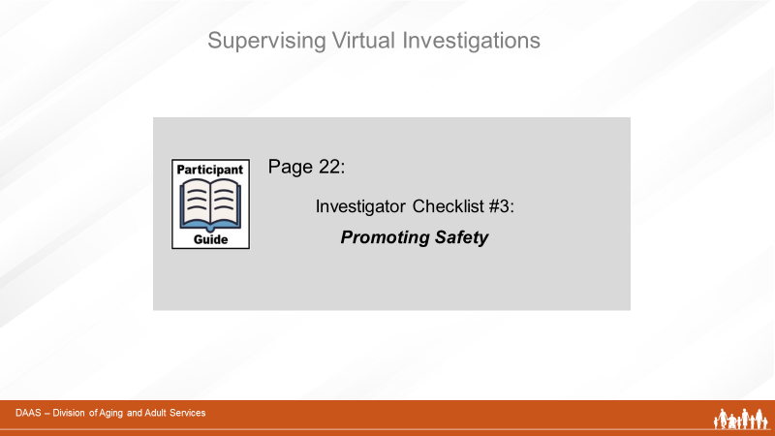
Facilitator:
Now we’ll turn to Page 22 to review Checklist #3 – Promoting Safety.
(Facilitator highlights content. See next page.)

Investigators can use the following safety considerations as a check-list when planning and conducting interviews virtually. Some may overlap with privacy considerations but are also safety issues.
Following these safety steps require pre-planning and preparation on the part of the investigator. Supervisors may find the check-list helpful as a training or coaching aid.
Investigator Checklist #3
Promoting Safety During Virtual Investigations

- Know how your video conferencing platform works.
- Before setting up an interview via video conferencing or phone, ask if there is a safe, private place the interviewee can use.
- When beginning the interview, determine whether the conversation is private:
  - Ask the interviewee, “Is anyone in the room with you?” or “Is anyone able to hear you?”
  - Listen for background noise and watch for movement behind the client.
  - Ask the client to show the room to the camera if using video software.
  - Ask the interviewee if they are able to use earphones or earbuds to reduce the chance of conversation being overheard from another room.
- Have a backup plan if the client indicates they are not alone.
- When the interview is finished, advise the interviewee to turn off the webcam.
- Technology may not always work as intended, so exchange telephone numbers ahead of time in case the interview needs to be conducted by phone.
- Advise the client/ witness upfront that you do not consent to allow the client/witness to record the interview.
- Before starting a video conference interview, advise the client/witness to clear any sensitive information and to close sensitive applications from their screens.
- Avoid conducting investigative interviews in public areas.
- Do not use a public Wi-Fi system to conduct interviews or otherwise perform other tasks related to the investigation such as sending emails.
- Investigator should always be the “host” so they are in control of the interview.
- Set a unique password to access the meeting and “lock” the meeting after the allowed participants have joined. If using Zoom, for example, review the security settings and be sure to use the most secure methods including password-protecting meetings; enabling the “private meeting” setting, and disabling screen-sharing and private chat for participants.
- For subsequent meetings or interviews, always use a different link, dial-in number, and password to prevent unauthorized others from accessing the meeting.
- Carefully organize any documents you plan to share to avoid any unintended sharing.

Slide 37 | 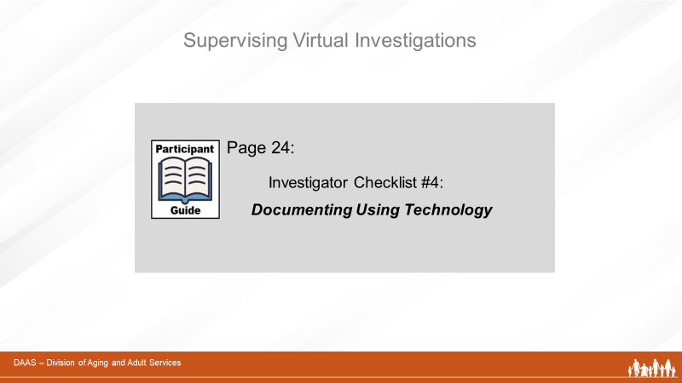
Facilitator:
And the final checklist, #4, can be found on Page 24 - Documenting Using Technology
(Facilitator highlights content. See next page.)

Investigator Checklist #4
Documenting Using Technology
While using technology to document may represent a shift in practice for those accustomed to “pen and paper” note taking, it does offer the benefits of speed and accuracy. Supervisors will want to review the benefits and practices below with their staff, monitor their documentation and assist as needed to ensure consistent practice.

- Follow agency policies and procedures regarding documentation.
- Using technology to document avoids duplication of handwriting and transcribing notes and improves the accuracy of recall.
- Ensure that you have remote connectivity to the agency’s case management system.
- Upload evidence into the case record as soon as it is collected.
- Entering evidence into data systems in real-time significantly improves the integrity and quality of the information obtained and enables supervisors to effectively monitor and support staff.

Slide 38 | 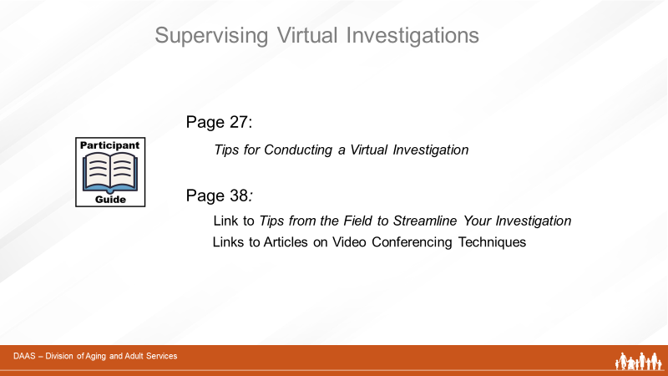
Facilitator:
There are several other tools that supervisors will find useful in supporting staff as they use technology-driven investigative techniques. They can be found in your Participant Guide as noted on the screen.

The first tool is a tip sheet called Tips for Conducting a Virtual Investigation. It incorporates practical suggestions shared by other APS professionals for doing virtual investigations when in-person visits cannot be carried out. It can be adapted to comply with your agency’s policies and procedures. And we’ll be using this tool in a group activity in just a few minutes.

The second tool to call your attention to is called
Tips from the Field to Streamline Your Investigation. It is a compilation of tips from other APS professionals and can be accessed on the Adult Protective Services Technical Assistance and Resource Center website. Although it is not specifically focused on virtual investigations, many of the tips can help streamline work by prioritizing, planning and using phone techniques effectively.

And, as you see on the slide, you’ll also find links to several articles on video conferencing techniques.
Slide 39

Facilitator:
So now let’s get familiar with the tool Tips for Conducting a Virtual Investigation which starts on Page 27 of your Participant Guide. You’ll break into small groups with an assigned spokesperson. Each small group will be given sections of the tip sheet to:
- Review briefly together.
- Decide how tips could translate into a supervisory action to support staff. (ex. develop a role-playing scenario.)
- Summarize and report their findings for the full group.
You will have 20 minutes in your small groups and 20 minutes for full group reports.

Slide 40 | 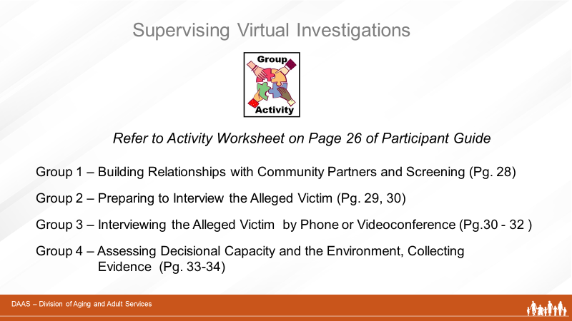
Facilitator:
As we break into groups, please refer to the worksheet on Page 26 in your Participant Guide to see these directions, small group assignments and a place for keeping notes. Any questions?
The producer assigns participants into small groups with a spokesperson, puts them into break-out rooms, monitors time and gives each small group a 5-minute warning before reconvening.

Facilitator:
Welcome back! I’ll ask each spokesperson now to give us a just a brief summary of the section they reviewed and their findings.
Let’s start with Group 1.
(Let each group report for 3-5 min. If time allows, let full group have follow-up discussion or questions on any points of particular interest.)
 | Thank you, everyone, for your contributions to this activity. As you have seen, the Tip Sheet offers a number of suggestions you can consider using or adapting to fit your training needs with your staff. Are there any comments or questions before we move on?
Slide 41 | 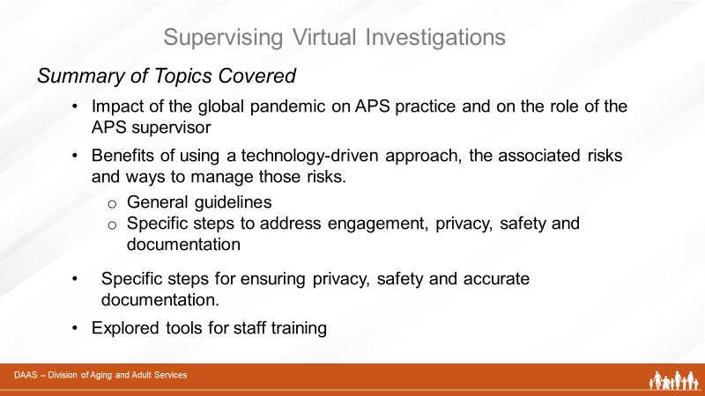
Facilitator:
As we wrap up this training, let’s do a quick summary of what we have covered:
- We have reviewed the impacts of the global pandemic on APS practice and on the role of APS supervisors.
- We have learned about the potential benefits of using a technology-driven approach, the risks involved and ways to manage those risks.
- We have looked at specific steps to ensure privacy, safety and accurate and efficient documentation
- And we have explored tools you can adapt for staff training
Slide 42 | 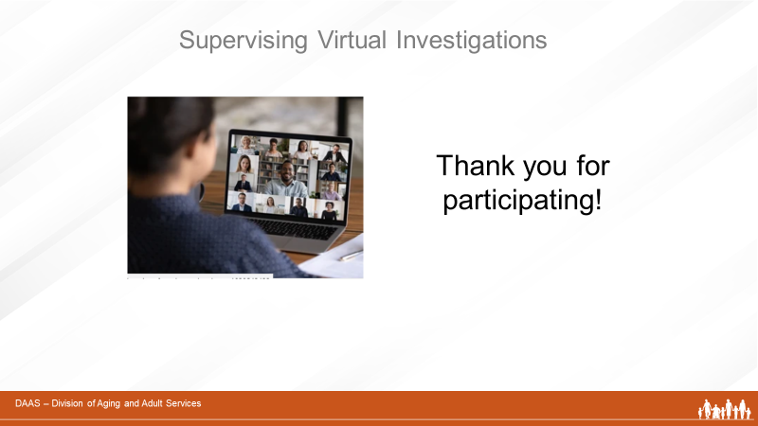
Facilitator:
Thank you all for participating today! We hope that the content and resources presented will be useful to you in preparing and supervising your staff to use technology safely and effectively as they conduct virtual investigations.

Resources
“Tips from the Field to Streamline Your Investigations” https://apstarc.acl.gov/getattachment/Education/Briefs/Streamlining-your-Investigation-FORMATTED.pdf.aspx?lang=en-US

“Adult Protective Services Study on the Impact of Covid-19”
https://apstarc.acl.gov/getattachment/Information-Research/COVID-19/LRC_COVID_19_Final_Report_508.pdf.aspx?lang=en-US

“8 Tips for Better Video Conference Calls”
https://www.pcmag.com/how-to/8-tips-for-better-video-conference-calls

“Stay Safe While Video Conferencing”
https://www.consumer.ftc.gov/blog/2020/04/stay-safe-while-video-conferencing

“Video Conferencing: 10 Privacy Tips”
https://www.ftc.gov/news-events/blogs/business-blog/2020/04/video-conferencing-10-privacy-tips-your-business

