Supervising a Remote Workforce
Division of Adult and Aging Services
Adult Protective Services

Participant’s Guide

Table of Contents
Course Objectives 1
What is a Remote Worker? 1
Benefits and Challenges 2
Keys to Effective Supervision 2
Best Practices for Onboarding 3
Communication is the Key 4
Methods of Communication – Pro’s and Con’s 5
Creating a Communication Plan – Example 8
Regularly Scheduled Meetings for the Team 12
Regularly Scheduled Meetings - Individual 13
What’s the Problem? 14
Lack of Information 14
Lack of Skills 14
Lack of Motivation 14
Personal Issues 14
Environmental Issues 15
Group Case Study 15
Coaching and Correction 16
Wrap Up and Action Planning 17
Next Steps 17
BOOSTER – Supervising a Remote Workforce 1

Course Objectives
Upon completion of this course, the Participants will:
- Explore the benefits and challenges of a remote workforce.
- Understand the importance of effective communication in a remote workforce.
- Develop a written communication plan for their unit.
- Learn best practices for onboarding staff in a remote environment.
- Identify the five factors that contribute to performance issues and apply that knowledge to a performance scenario.
- Apply one best practice of team building in a remote environment and report result back to other course Participants.

What is a Remote Worker?
There are many terms we use to define working in a remote environment. Whether we use the term teleworker, mobile worker or remote worker, what is required is a paradigm change. In the industrial age, work was somewhere you went. In the data age, work is something you do. In the case of Adult Protective Services, workers have always performed much of their work away from the office. However, COVID has required us to look for ways to become even more independent and work remotely.
“Work is something you do, not somewhere you go.”
Notes: ____________________________________________________________
___________________________________________________________________
___________________________________________________________________

Benefits and Challenges
When instructed by your facilitator, use the area below to identify the benefits and challenges of working in a remote workforce.
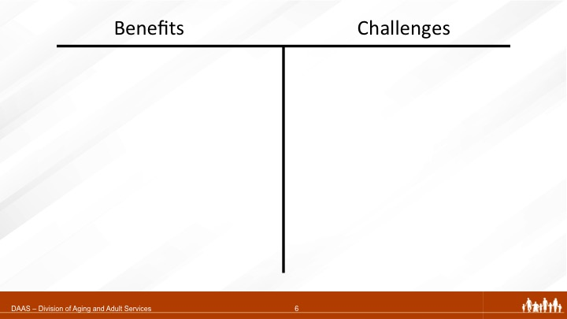

Keys to Effective Supervision
- Clearly Defined _____________
- ____________ Resources and Strengths
- Establishing _____________
- Monitoring and __________________
- __________________ Accomplishments
- _______________ Staff
Notes: ___________________________________________________________________
___________________________________________________________________

Best Practices for Onboarding
Your Instructor will break you into groups. Your group will have 15 minutes to compile a presentation and answer the following question:
Breakout
What are some of the best practices concerning onboarding new staff in a remote environment?
You can search the internet to get ideas and someone will need to report back to the larger group.

Notes: ____________________________________________
__________________________________________________
__________________________________________________
__________________________________________________
___________________________________________________________________
___________________________________________________________________
___________________________________________________________________
___________________________________________________________________
___________________________________________________________________
___________________________________________________________________
___________________________________________________________________
___________________________________________________________________
___________________________________________________________________

Communication is the Key

What a supervisor says is _________________ in a remote environment.

Make every communication ________________.

Choose Your Method of Communication __________________.
You will often need to communicate by email and phone. Since 80 percent of communication is nonverbal (conducted through body language, facial expressions, and so on), the more you know about your worker and the more clearly you communicate with your worker, the more effective your communication with that worker will be.

Notes: ____________________________________________________________
__________________________________________________________________
__________________________________________________________________
__________________________________________________________________
__________________________________________________________________
__________________________________________________________________

Methods of Communication – Pro’s and Con’s
Breakout
Your Instructor will break you into groups. Each group will have 7 minutes to compile a list of pro’s and con’s of your assigned method of communication.
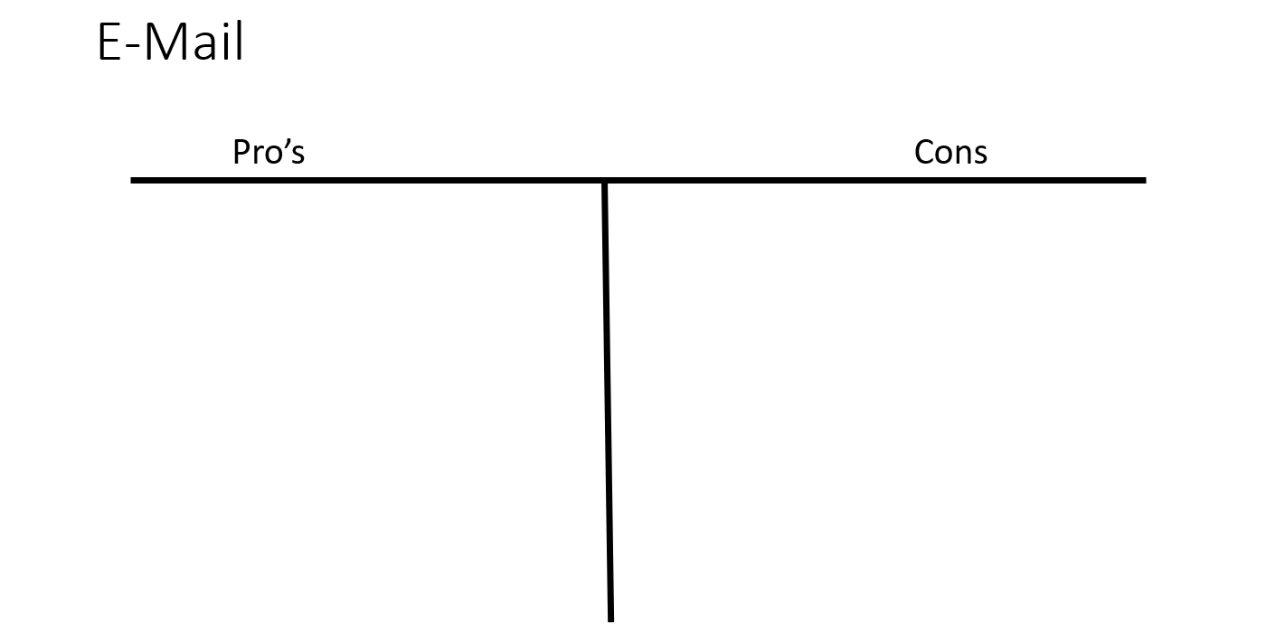
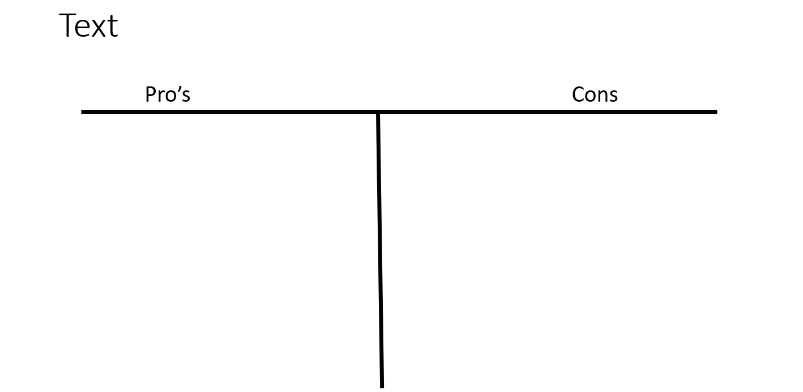
Remember, you can search the Internet to get ideas and someone will need to report back to the larger group.
Notes: ____________________________________________________________
___________________________________________________________________
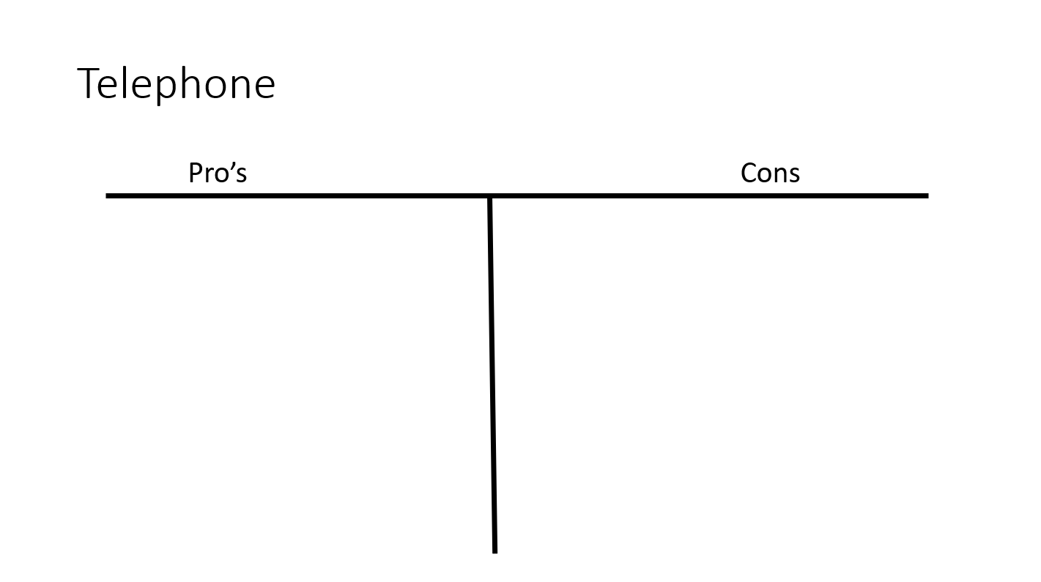
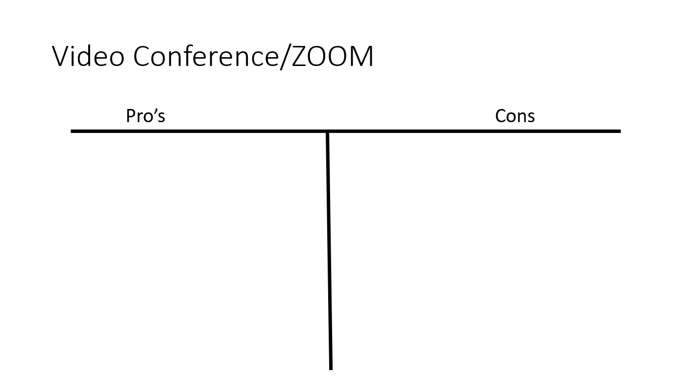

Notes: ____________________________________________________________
__________________________________________________________________
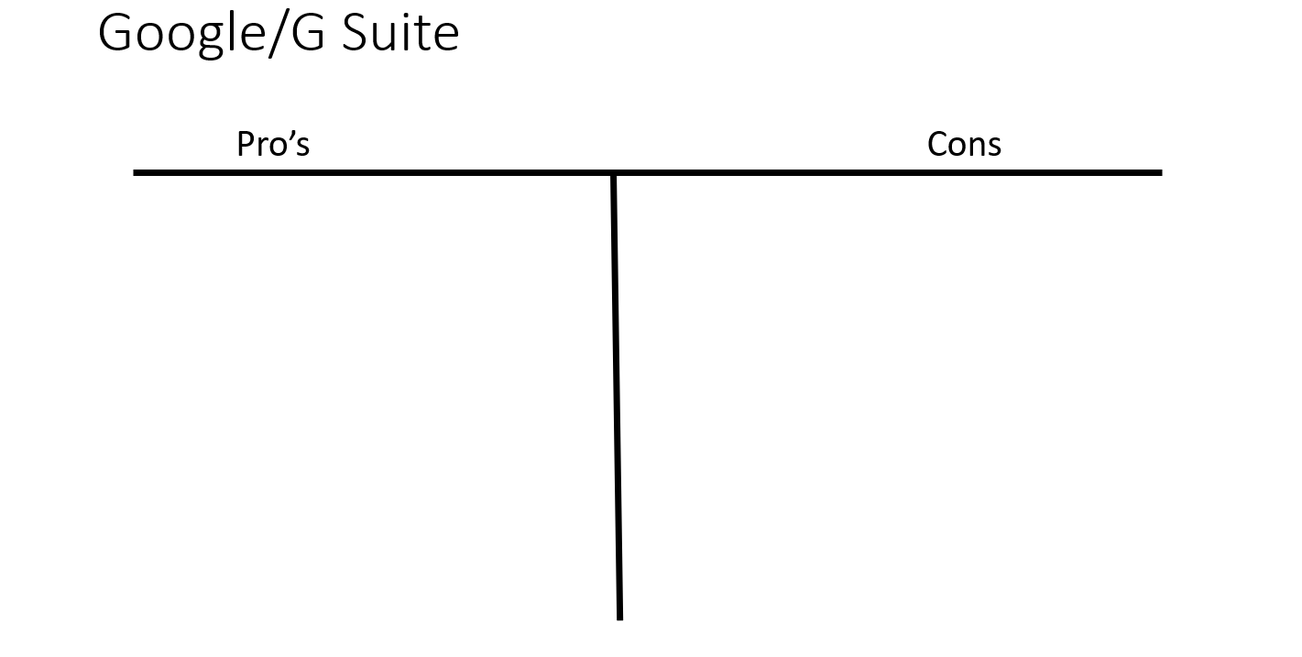

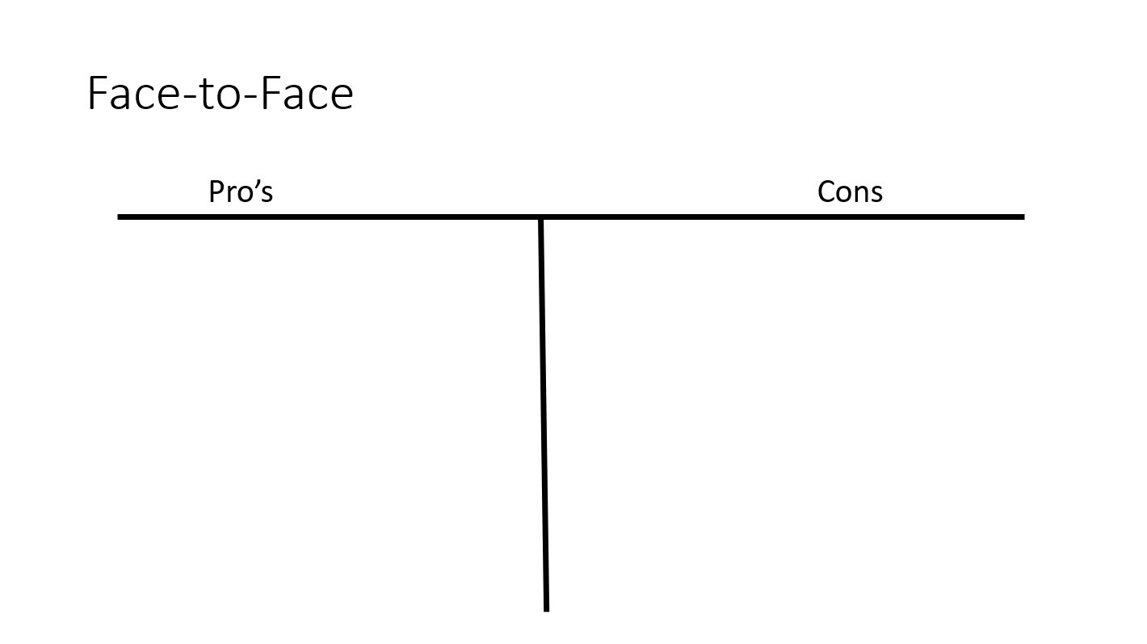

Notes: ____________________________________________________________
__________________________________________________________________

Creating a Communication Plan – Example
This document is an example of a document that can be used to develop a communications plan between the APS Supervisor and the Members of the Supervisor's unit. The plan is used to establish expectations to ensure good communication between unit Members who may not be in the same office and may seldom see each other during the workweek. However, a discussion around these topics with everyone in the unit can be beneficial.

How often should be checked throughout the day?

Expectation of the unit Member:

Expectation of the unit Supervisor:

Example: Email will be checked upon starting the workday, immediately after lunch, and a half hour before the end of the workday.

How long should emails be saved? What are the requirements for saving email?

Comments:

How often should voicemail be checked throughout the day?

Expectation of the unit Member:

Expectation of the unit Supervisor:

Example: Voicemail will be checked upon starting the workday, at least every two hours throughout the workday, and a half hour before the end of the workday. Calls will be returned within three hours.

What are appropriate uses of text messages?

Comments:

Example: Warning: Text messaging while driving is strictly prohibited and extremely dangerous. If you must respond to a text message while driving, pull over to the side of the road, away from traffic, before doing so.

How would the Supervisor like to be notified of sick days (e.g. Phone Call, Email, Text, etc.)?

Comments:

How often can we expect to meet face-to-face?

Comments:

Example: Will we meet weekly, every other week, monthly, and so on? Where is the best place to meet?

Is there a time during the day that you will generally be available by phone for case consultations or other business-related issues?

Identify the specific times of day that the Supervisor will generally be available:

Identify the specific times of day that the Member will generally be available:

Comments:

In many cases, sending text messages and email can result in miscommunication. At what point do we need to pick up the phone to ensure better communication when a problem arises?

Comment:

Example: In the event I feel something needs to be clarified, I will use the phone or make an effort to meet with you face-to-face. This includes when discussing performance or other issues that may cause emotions to "run high."

What other communication issues need to be explored?

Comments (use blank page, if needed):

Notes:______________________________
“The single biggest problem in communication is the illusion it has taken place”
George Bernard Shaw
___________________________________
___________________________________
___________________________________
___________________________________________________________________
___________________________________________________________________
___________________________________________________________________

Regularly Scheduled Meetings for the Team
Team Meetings/Huddle – What’s on the Agenda?

___________________________________________________________________
___________________________________________________________________
___________________________________________________________________
___________________________________________________________________
___________________________________________________________________
___________________________________________________________________
___________________________________________________________________
Team Huddle Agenda – You Practice
What will you do for an opener/mixer?

What special projects or assignments do you need to discuss?

Who will facilitate training? What topics will need to be covered?

Will there be a theme?

Regularly Scheduled Meetings - Individual
Individual (One-on-One) Meetings – What’s on the Agenda?
___________________________________________________________________
___________________________________________________________________
___________________________________________________________________
___________________________________________________________________
___________________________________________________________________

In the circles below, write some of the topics that you may want to discuss in a one-on-one meeting with your staff.

What’s the Problem?
Performance Issues in a Remote Environment
While it is important to identify performance issues in any work environment, the speedy diagnosis and correction of performance issues in a remote environment is crucial to the success of a remote team. Performance issues often go unnoticed for some time before being brought to the attention of a Supervisor. It is important to remember that the first time a Supervisor sees a performance issues is seldom the first time it has taken place. As such, taking swift action when a performance issue surfaces is critical. There are five causes of performance issues. These five issues, individually or in combination with one another, are usually at the root of any performance issues a person faces.

Lack of Information
___________________________________________________________________
___________________________________________________________________

Lack of Skills
___________________________________________________________________
___________________________________________________________________

Lack of Motivation
___________________________________________________________________
___________________________________________________________________

Personal Issues
___________________________________________________________________
___________________________________________________________________

Environmental Issues
___________________________________________________________________
___________________________________________________________________

Group Case Study

As we have explored the five reasons for performance issues, you may have had a performance issue you have faced come to mind. Use the space below to explore:
- What was the Issue?
- What do you think the root cause of the issue was?

Notes: ____________________________________________________________
__________________________________________________________________
__________________________________________________________________
__________________________________________________________________
__________________________________________________________________
__________________________________________________________________
__________________________________________________________________
__________________________________________________________________
__________________________________________________________________

Coaching and Correction
Coach _________________ and _________________.

Provide feedback _________________.
The first time you have seen a performance issue is likely not the first time the performance issue took place.
Reassess if coaching is not working.

Reach out to DASS HR.

Notes:_____________________________________________________________
__________________________________________________________________
__________________________________________________________________
__________________________________________________________________
__________________________________________________________________
__________________________________________________________________
__________________________________________________________________
__________________________________________________________________
__________________________________________________________________

Wrap Up and Action Planning
Take a few moments to think about what we have discussed during this workshop and answer the following questions:

What is one thing I can do in the next 30 days to improve communication in my unit?
___________________________________________________________________
___________________________________________________________________
___________________________________________________________________

What is one thing I can do in the next 30 days to improve on-boarding in my unit?
___________________________________________________________________
___________________________________________________________________
___________________________________________________________________

Next Steps

In addition to this workshop, you will be receiving an invitation to attend a one-hour workshop in the next 30-60 days. The invitation will include a short reading on ideas for establishing and strengthening your team.
- Read the assignment.
- Choose 1-2 ideas to experiment with.
- Be prepared to share how your experiment went.

BOOSTER – Supervising a Remote Workforce
Goals
The goals of this workshop include:
- Review Content from Managing a Remote Workforce
- Report on Activities that Have Been Successful
- Share Ideas on Team Building
- Create a 30 - 60 Day Plan to Try New Team Building Ideas

Experiments in Supervising a Remote Workforce
At the end of Supervising a Remote Workforce, you were asked to commit to taking action in the next 30 days to improve onboarding, communication and/or performance management. In your small group share what you tried, how did it go and what you learned. If you tried other ideas concerning these topics, you may choose to share those as well. Take notes below and be prepared to report to the larger group when you return from the breakout.
___________________________________________________________________
___________________________________________________________________
___________________________________________________________________
___________________________________________________________________
___________________________________________________________________
Why is Team Building Important?

Builds ________________ and improves ____________________________.

Maximizes Team __________________.

Helps with ________________ and emotional _____________________.

Helps manage ______________________ more effectively.

Bright Ideas in Team Building
In this breakout, you will be tasked with creating a 3–5-minute presentation on team building tips and techniques. You will have 15 minutes to compile your presentation and choose someone to present it back to the larger group. Your presentation must answer three questions:
- What have I tried and been successful with regarding team building?
- If not successful, what did I learn?
- What are some other ideas I can try? (Remember, Google is your friend.)
Use the area on the next page to take notes for your presentation.

Presentation Notes
______________________________________________________________________________________________________________________________________
____________________________________
____________________________________
____________________________________
____________________________________
____________________________________
____________________________________
____________________________________
____________________________________
____________________________________
___________________________________________________________________
Action Planning
Use the space below to write one or two ideas that you will try in the next 30-60 days regarding teambuilding.
__________________________________________________________________________________________________________________________________________________________________________________________________________________________________________________________________________________________________________________________________________________________________________________________________________________

