Supervisor as Trainer
Division of Aging and Adult Services
Adult Protective Services
Participant Guide

Table of Contents

Introduction 2
Section 1 – Learning & The Adult Brain 5
Links to Articles About Learning & Training 10
Examples of Multi-Sensory Training Activities ……………………………………………..11
Section 2 – Training Settings and Techniques 12
Characteristics and Benefits of Training Techniques 18
Links to National Training Resources 21
Participant Worksheet: Design a Training Group Activity 22
Section 3 – Phases of Learning 23
Learner Characteristics and Suggested Activities ……………....
Section 4 – Transfer of Learning and New Supervisor Tips……………………………………… 27
Sample Transfer of Learning Tool…………………………………………………………..29
Transfer of Learning Follow-Up Assignment ………………………………………….. 33

Introduction

Notes: _____________________________________________
____________________________________________________
____________________________________________________
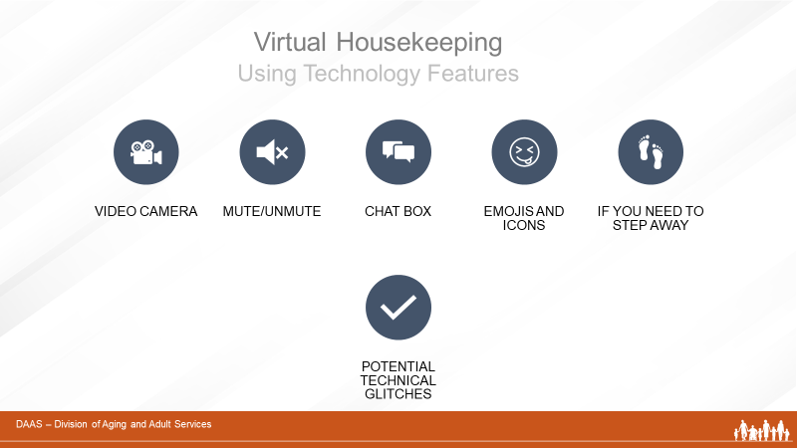
Notes: _____________________________________________
____________________________________________________
____________________________________________________
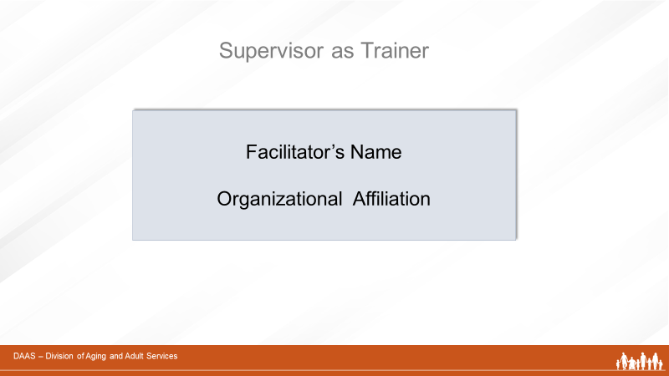
Notes: _____________________________________________
____________________________________________________
____________________________________________________
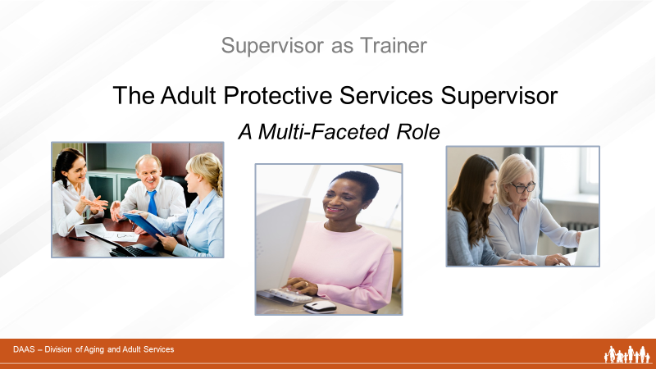
Notes: _____________________________________________
____________________________________________________
____________________________________________________
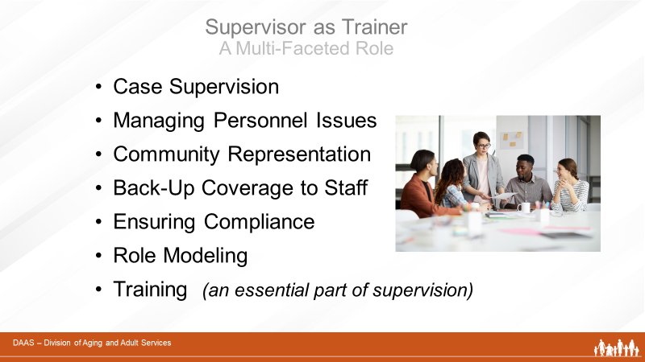
Notes: _____________________________________________
____________________________________________________
____________________________________________________

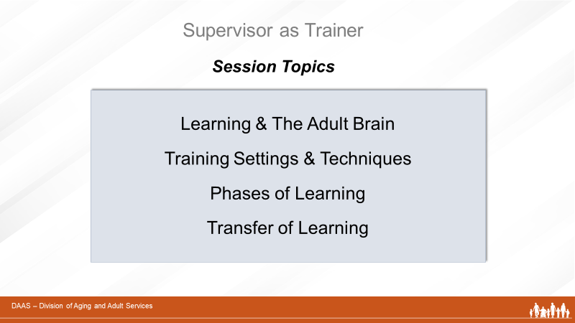
Notes: _____________________________________________
____________________________________________________
____________________________________________________

Section 1 – Learning & The Adult Brain

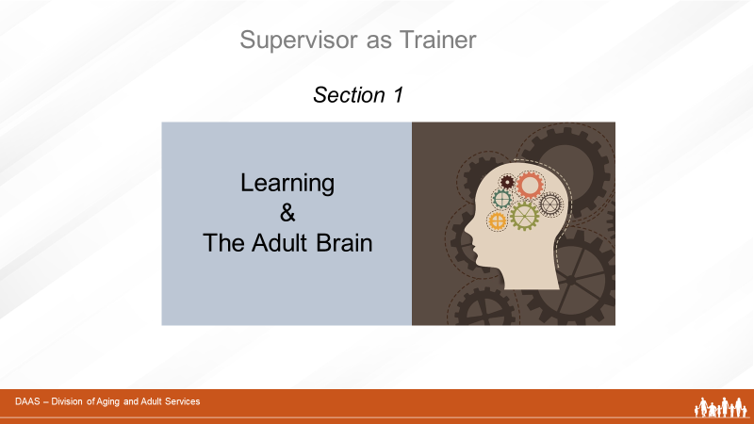

Notes: _____________________________________________
____________________________________________________
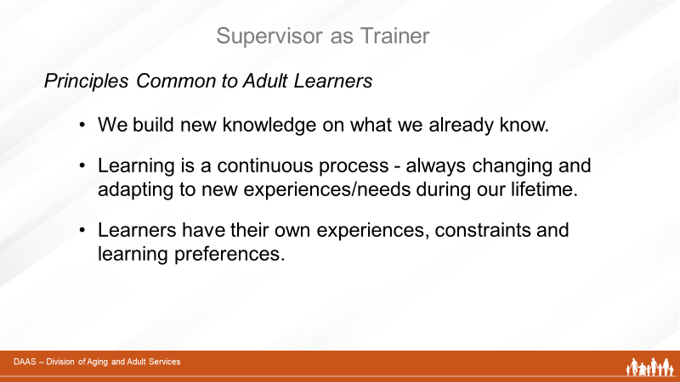
Notes: _____________________________________________
____________________________________________________
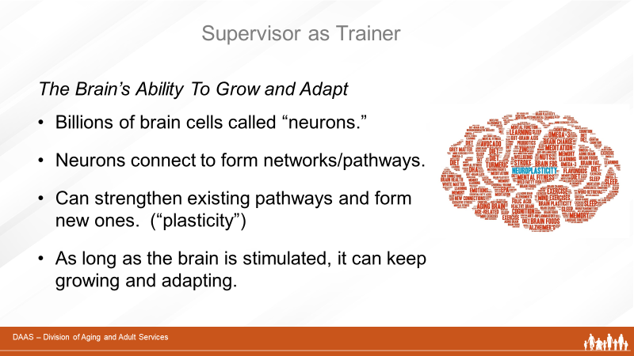
Notes: _____________________________________________
____________________________________________________
____________________________________________________

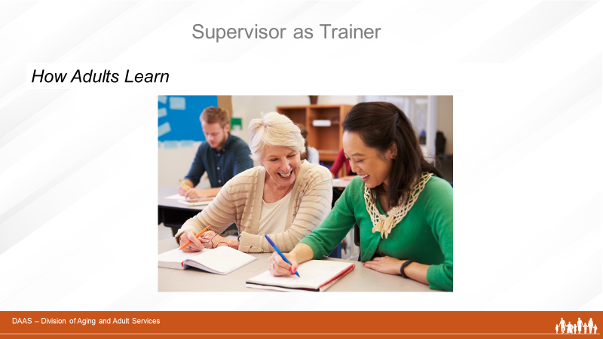
Notes: _____________________________________________
____________________________________________________
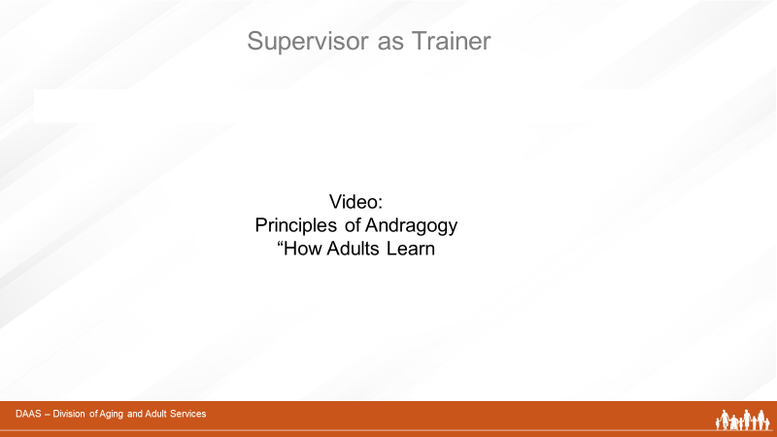
Notes: _____________________________________________
____________________________________________________
____________________________________________________
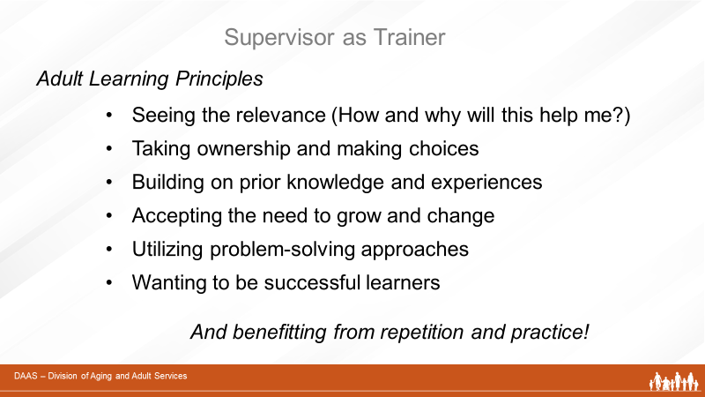
Notes: _____________________________________________
____________________________________________________
____________________________________________________

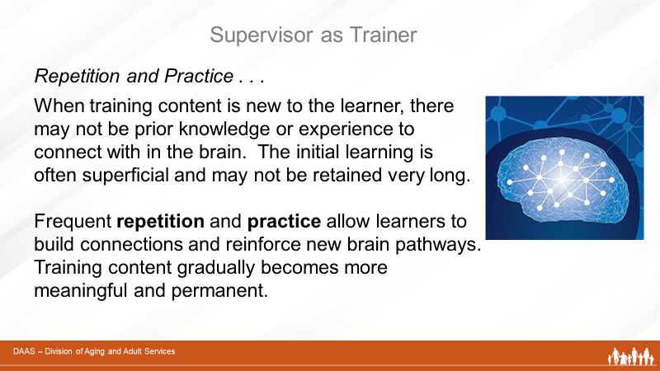
Notes: _____________________________________________
____________________________________________________
____________________________________________________
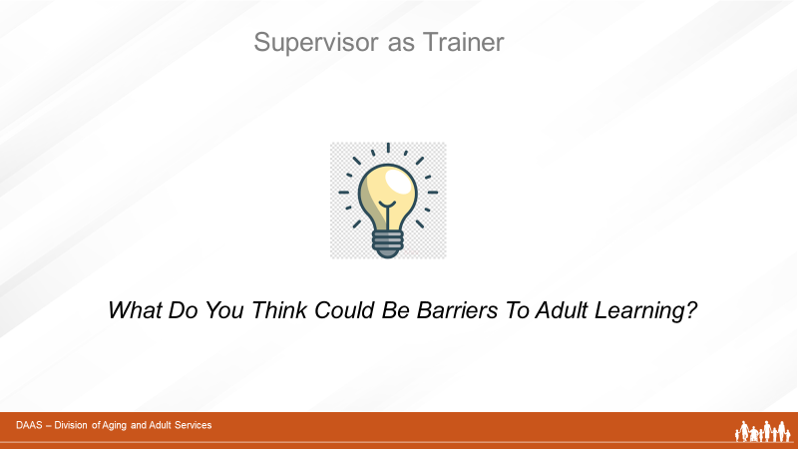

Notes: _____________________________________________
____________________________________________________
____________________________________________________

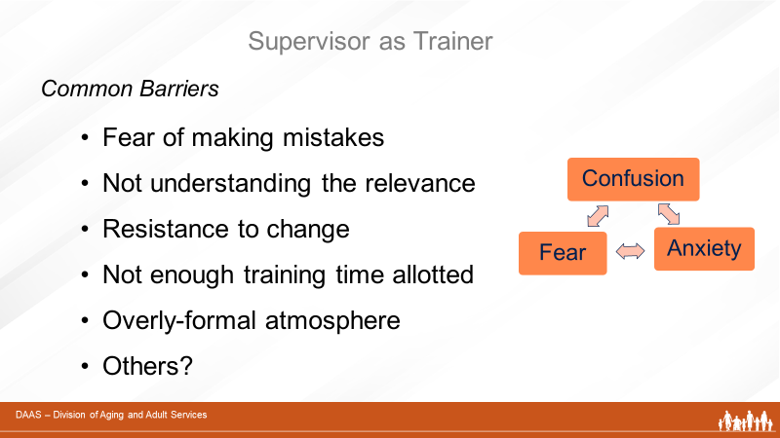

Notes: _____________________________________________
____________________________________________________

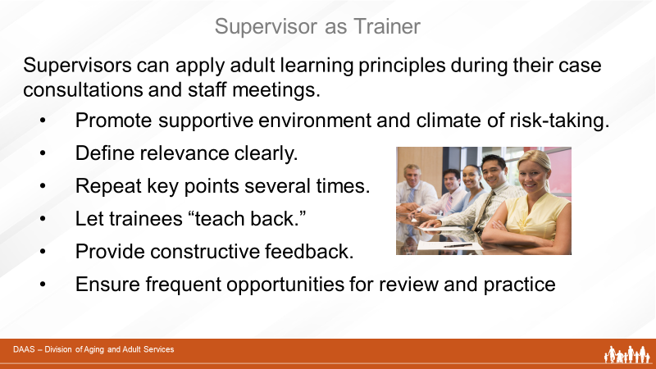
Notes: _____________________________________________
____________________________________________________

Links to Additional Articles about Learning and Training

Implementing The AGES Model for More Effective Training Delivery
https://elearningindustry.com/implementing-ages-model-for-effective-training-delivery

Brain-Based Learning

Multiple Intelligences Theory: Widely Used, Yet Misunderstood

https://www.edutopia.org/article/multiple-intelligences-theory-widely-used-yet-misunderstood

Howard Gardner’s Theory of Multiple Intelligences
https://www.wtc.ie/images/pdf/Multiple_Intelligence/mi10.pdf

Examples of Multi-Sensory Training Activities

Training Technique | Activities | Visual | Auditory | Kinesthetic
Using Case Studies | Reading case studies | Yes
 | Listening to and discussing case studies |  | Yes
 | Writing out care plan for a case study | Yes |  | Yes
 | Presenting a case plan developed from a case study | Yes | Yes | Yes
Using Videos | Listening to a training video |  | Yes
 | Watching a training video | Yes | Yes
 | Practicing the skill shown in a training video | Yes | Yes | Yes
Using Written Information | Reading information to yourself | Yes
 | Reading information and writing a summary | Yes |  | Yes
 | Reading information and presenting a summary to others | Yes | Yes | Yes
Brainstorming | Listening to a Brainstorming session |  | Yes
 | Brainstorming (as an active participant) |  | Yes | Yes
 | Brainstorming (as an active participant) AND keeping notes | Yes | Yes | Yes
Using Critical Incidents | Reading about a critical incident | Yes
 | Listening to a discussion of a critical incident |  | Yes
 | Read about AND discussing a critical incident | Yes | Yes | Yes
Using Games | Doing a word search for essentials of a case plan | Yes
 | Playing bingo for a case plan terms | Yes | Yes | Yes
 | Portraying a client in a written role play | Yes | Yes | Yes
Using Shadowing | Watching a worker perform an interview | Yes | Yes
 | Completing an assessment checklist based on observing an interview | Yes | Yes | Yes
 | Performing the interview and getting feedback from the lead worker  White = Addresses this learning preference //Black = Does not address this learning preference // Gray = Addresses ALL Learning preferences. Adapted from Training of Trainers Manual produced by AARP Foundation, August 1999 | Yes | Yes | Yes

Section 2 – Training Settings and Techniques
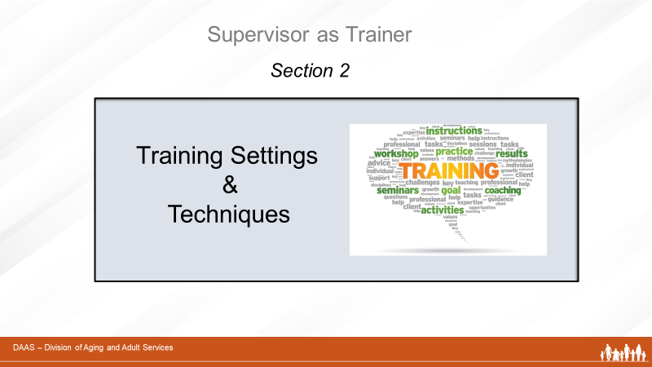
Notes: _____________________________________________
____________________________________________________
____________________________________________________
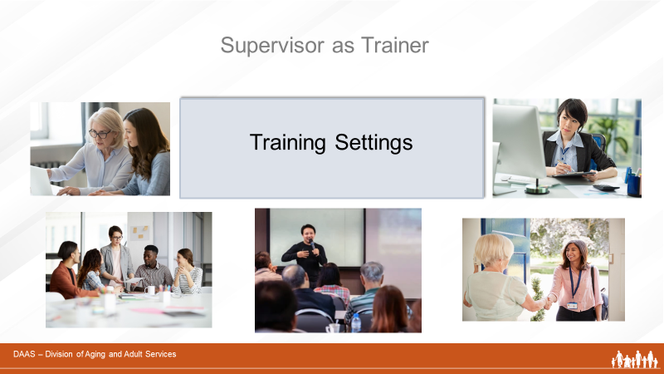
Notes: _____________________________________________
____________________________________________________
____________________________________________________
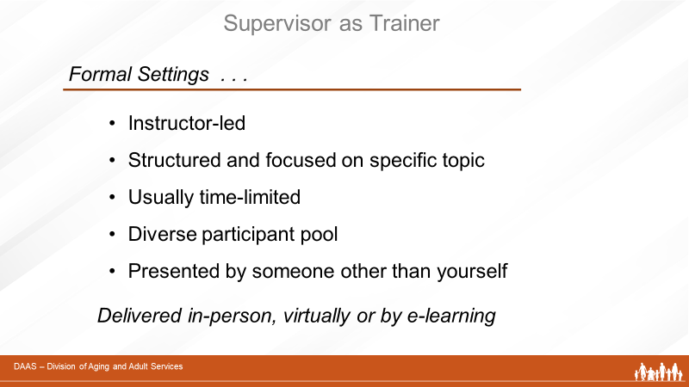
Notes: _____________________________________________
____________________________________________________
____________________________________________________

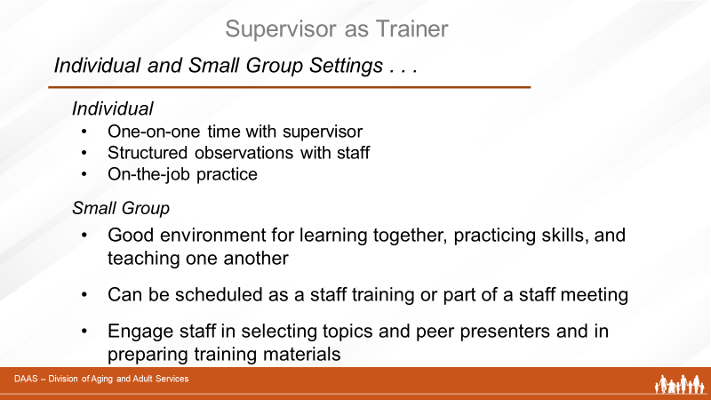
Notes: _____________________________________________
____________________________________________________
____________________________________________________
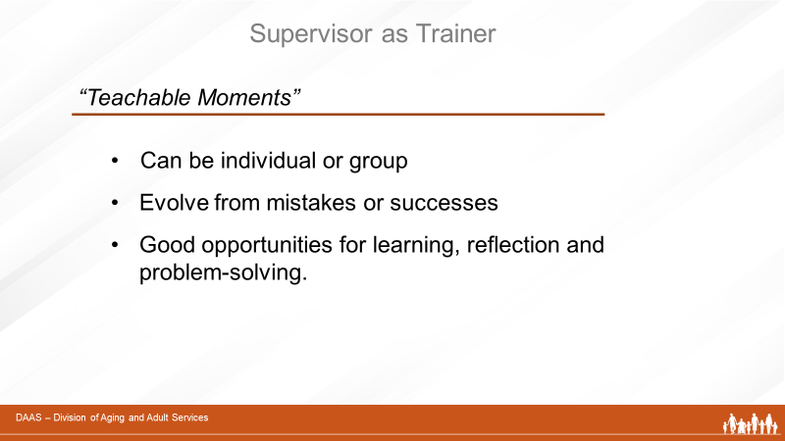
Notes: _____________________________________________
____________________________________________________
____________________________________________________

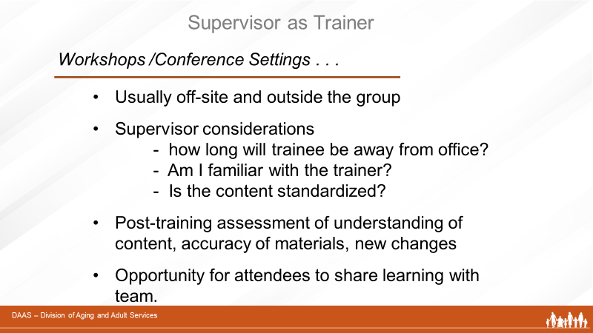
Notes: _____________________________________________
____________________________________________________
____________________________________________________
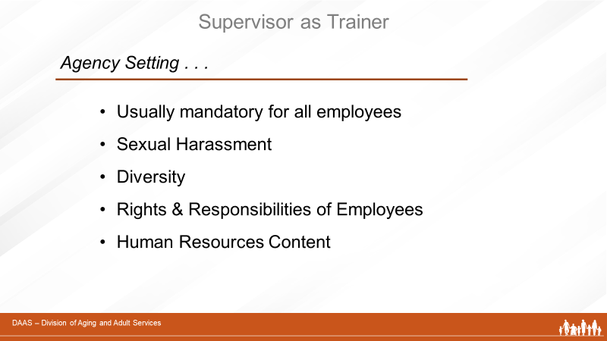
Notes: _____________________________________________
____________________________________________________
____________________________________________________

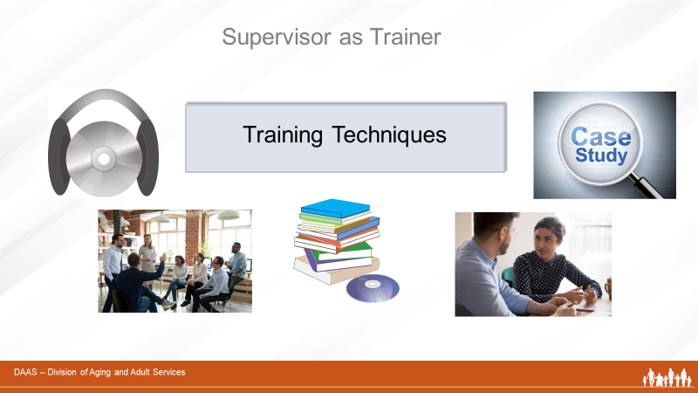
Notes: _____________________________________________
____________________________________________________
____________________________________________________
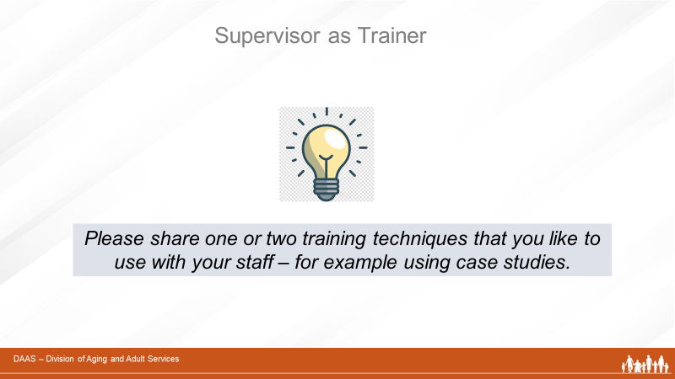

Notes: _____________________________________________
____________________________________________________
____________________________________________________

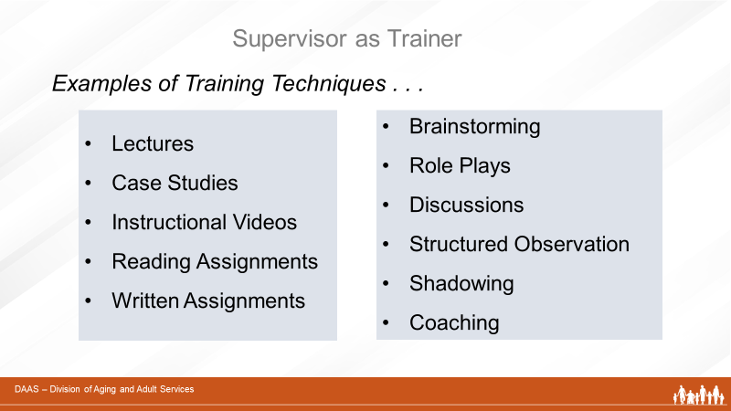

Notes: _____________________________________________
____________________________________________________
____________________________________________________

Characteristics and Benefits of Training Techniques
- Lectures

- Presenter conveys information to a group of learners by talking.
- Expert information can be shared in a time-efficient manner with a large number of people.
- Information is not altered or sidetracked by comments from attendees.
- Learning through lectures can be enhanced by visuals, Q&A opportunities, and follow-up discussions

- Case Studies

- Key points are very effective when using real-life situations
- Helps with developing analysis skills
- Multiple points of view help learners understand important concepts.
- May be relevant to the lives and/or experiences of the learners.
- Learners are active participants in the process.

- Instructional Videos

- Training videos are designed to improve job skills.
- They commonly cover interpersonal topics (compliance training) or job-specific topics.
- Use footage and stories of real people to help bolster the connection between the content and trainee and improves retention.
- Helpful as a “lead-in” for discussions and reinforcement of key training points.

- Reading & Writing Assignments

- Reading assignments
  - Manuals (to become familiar with state and agency statues, policies & protocols)
  - Standardized training materials
  - Case reports
- Writing assignments
  - Journaling
  - Practice in documentation and report writing
- Brainstorming

- A method of problem solving as a group.
- All team members can share ideas that are listened to.
- All ideas are accepted as valid and no one is ignored.
- Good technique to use when the learning objective is pulling together shared ideas of (ex. choosing a topic for a team training)

- Role Plays

- Learners act out roles presented in an open-ended situation
- Participants supply their own dialog within the context of the roles and the situations and develop their own outcome to the scenario presented.
- Good choice for a learning objective that involves person-to-person communication.
- Participants get to see, experience, and/or feel a new point of view.
- Participants are more inclined to express their true viewpoints if they are playing a role.

- Discussions

- A planned conversation (exchange of ideas or viewpoints) on a selected topic and guided by a trained discussion leader
- Can stimulate interest among learners when ideas and experiences of the group help them to discover the point they are learning.
- Needs an experienced discussion leader with knowledge to guide discussion and keep on track.
- It allows multiple points of view to be expressed and all learners (even new or shy ones) to express opinions and listen to the opinions of others on their team.
- Structured Observations

- Form of on-the-job training
- Supervisor assigns specific job functions for learner to observe during planned sessions with experienced staff.
- Learner accompanies staff, makes observations, and reports back/discusses observations with supervisor.
- Supervisor repeats as needed adding more functions to observe with different staff members.

- Shadowing

  - Learner follows and observes a trained and experienced staff member as they carry out their work.
  - Form of on-the-job training that allows a learner to see and understand the nuances of a particular job.
  - Effective when seeing is an important component of the learning.
  - New staff gets to know and interact with experienced staff.

- Coaching

  - Training technique used to improve a staff member’s performance
  - Focuses on the individual needs of the learner
  - As a coach, the supervisor
    - Answers questions
    - Suggests more effective strategies
    - Corrects errors
    - Guides toward goals
    - Gives constructive feedback and encouragement
Training Resources for APS Supervisors

APS Technical Assistance Resource Center
https://apstarc.acl.gov/Education/toolkits.aspx

This link connects to the APS Education and Training Toolkit available at the Training and Resource Center (TARC) on the Administration for Community Living’s website. It is a compendium of APS educational materials, videos, and other resources. The toolkit helps APS administrators and supervisors stay abreast of offerings, supplement trainings made available by their state programs, and promote continuous learning opportunities for APS staff.

APSWI Adult Protective Services Workforce Innovations
https://theacademy.sdsu.edu/programs/apswi/

The link is to Adult Protective Services Workforce Innovations (APSWI). This is a training program of the Academy for Professional Excellence, a project of the San Diego State University School of Social Work. APSWI provides innovative workforce development to APS professionals and their partners. In partnership with state and national organizations, APSWI has developed a nationally recognized Core Competency Training Curriculum for APS professionals.

Visit the site to access the many topic specific trainings and the Field Guide for APS. The Guide is intended to provide an agency or an individual APS supervisor with an organized system to ensure that the new APS worker gains the experiences and training needed to be an effective professional.

Design a Training Group Activity: Participant Worksheet
Small Group Training Tasks:
Group #1 - Identify several training strategies to increase a new staff member’s knowledge of the aging process.
Group #2 - Identify several training strategies for staff needing to increase knowledge and skills for serving adults living with disability.
Group #3 - Identify several training strategies for increasing staff knowledge and skills for investigating reports of alleged financial exploitation.
Group #4 - Identify several training strategies for increasing staff knowledge and skills to complete accurate risk assessments.
Group #5 - Identify several training strategies to increase staff knowledge and skills for investigating reports of alleged self-neglect.
Examples of Training Settings: Examples of Training Techniques
- Role Plays
- Discussions
- Structured Observation
- Shadowing
- Coaching

- Formal (instructor-led)
- Individual / Small Group
- Teachable Moments
- Conferences/Workshops
- Agency
- Lectures
- Case Studies
- Instructional Videos
- Reading Assignments
- Written Assignments

Links: https://apstarc.acl.gov/Education/toolkits.aspx
https://theacademy.sdsu.edu/programs/apswi/

nOTES:
Training Technique ideas | Training Setting Ideas | Support Materials Located

Section 3 – Phases of Learning

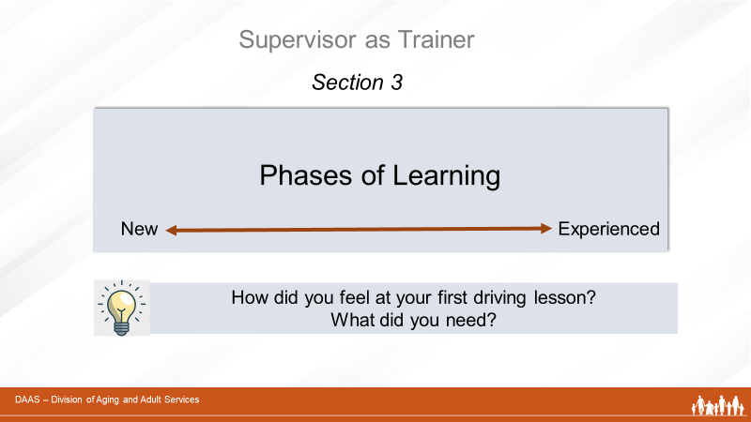

Notes: _____________________________________________
____________________________________________________
____________________________________________________

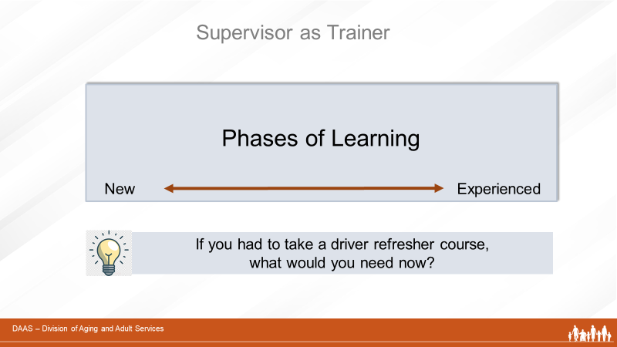
Notes: _____________________________________________
____________________________________________________
____________________________________________________
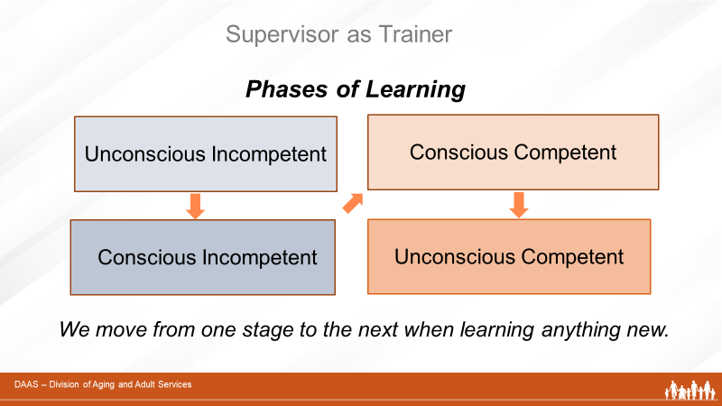
Notes: _____________________________________________
____________________________________________________
____________________________________________________

Phases of Learning
Learner Characteristics and Suggested Learning Activities
Learners move from one phase of learning to the next when learning something new. How long individual learners spends in each phase depends on their own learning style and pace. Some learners may not reach the final stage for a particular area of knowledge or skill, but still be able to perform it with competence.
Phase of Learning | Learner Characteristics / Suggested Activities
(Phase One)  “Unconscious Incompetent”  Learners for whom the content or skill to be learned is new. Most often applies to new staff early in the onboarding process. However, can also apply to any learner needing to learn new information or skills.  New learners in this phase will not readily retain complex information during training because they don’t have a conceptual framework on which to “hang” the new information. | Learners:  - Do not have context for or experience with the learning content. Need to build learning pathways in brain.  - Need frequent review and opportunities to practice.  APS supervisor can:  - Assess background and current skills (What do they already know? Can you give them an assignment that lets them make an immediate contribution to the team?  - Avoid overwhelming with too much information at one time.  - Begin with overview of program and how they fit.  - Talk about expectations and evaluations of performance  - Provide written information on APS (statutes, regulations, policies and procedures) and follow with a chance to address questions.  - Explain the APS process  - Review a case with the new staff member and let them ask questions.  - Plan structured observations with experienced staff:  - Identify a few steps in the process to  observe.  - Assign staff member to observe and  report back. Debrief on observations.  - Repeat adding other steps of the process  - Have new staff member shadow experienced staff in the field  - Have new staff member complete an investigation assisted by an experienced staff member  - Include both in debriefing sessions  - Look for teachable moments  - Repeat with different client populations and  types of allegations.

Phase of Learning | Learner Characteristics / Suggested Activities
(Phase Two)  “Conscious Incompetent”  Learners who have had some training, know what they don’t know, and are able to retain and apply new information. They understand the relevance of new information to improved job performance. | Learners:  - Are building brain pathways with new information  - Are more aware of what they don’t know  - Will ask more relevant questions.  - May question their ability to do the job.  APS Supervisors:  - May need to give frequent encouragement and plan for review of previous trainings.  - Offer different opportunities like team discussions, role plays, and review of more complex cases.
(Phase Three)  “Conscious Competent”  Learners who have had ongoing training and some field experience. | Learners:  - Are steady producers  - Know what they are doing and why  - May be good matches to assist new staff  - Are gaining experience and confidence  - Are encountering new experiences and challenges  APS Supervisors:  - Can gradually shift from frequent monitoring to coaching techniques (advising, consulting, helping with problem-solving and encouraging critical thinking)
(Phase Four)  “Unconscious Competent”  Experienced learners with the knowledge and skills to carry out complicated tasks with little thought because they have become so adept at performing their jobs. | Learners:  - Understand all aspects of job  - Do not have to think about the process any longer  - Usually assigned the most complex cases  - May re-visit earlier phases when faced with new content  APS Supervisors:  - Can involve in helping with team trainings  - Consider providing advanced trainings

Notes: _____________________________________________
____________________________________________________
____________________________________________________

Section 4 – Transfer of Learning and New Supervisor Tips

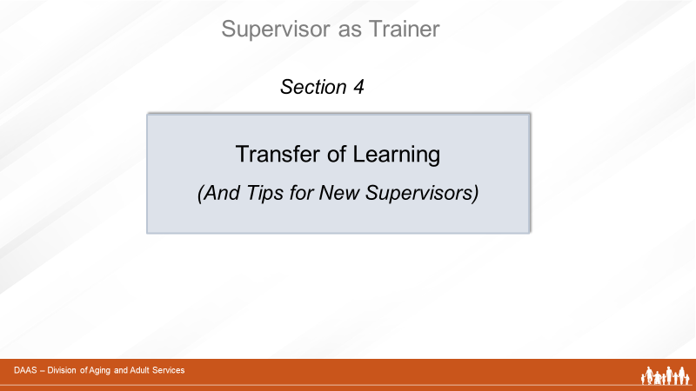
Notes: _____________________________________________
____________________________________________________
____________________________________________________
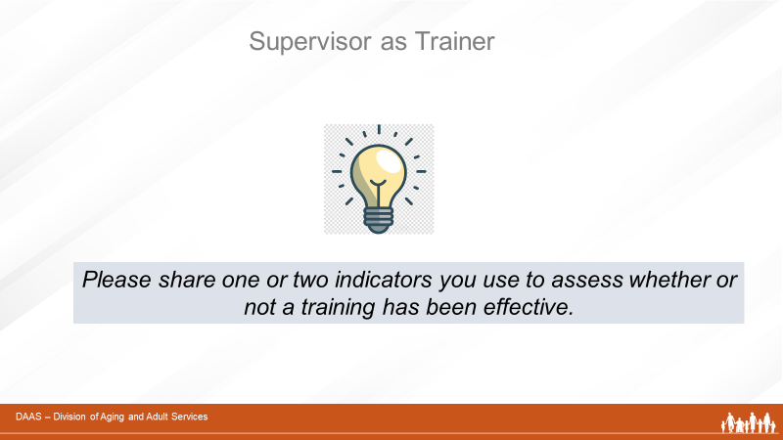
Notes: _____________________________________________
____________________________________________________
____________________________________________________
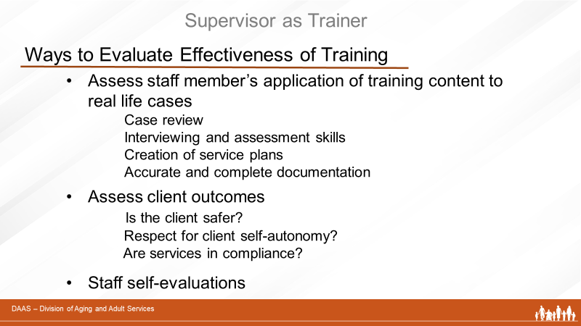
Notes: _____________________________________________
____________________________________________________
____________________________________________________
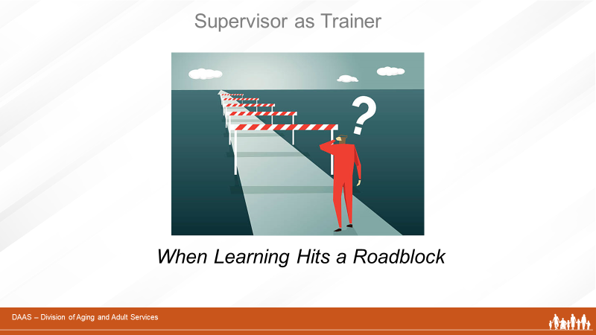
Notes: _____________________________________________
____________________________________________________
____________________________________________________

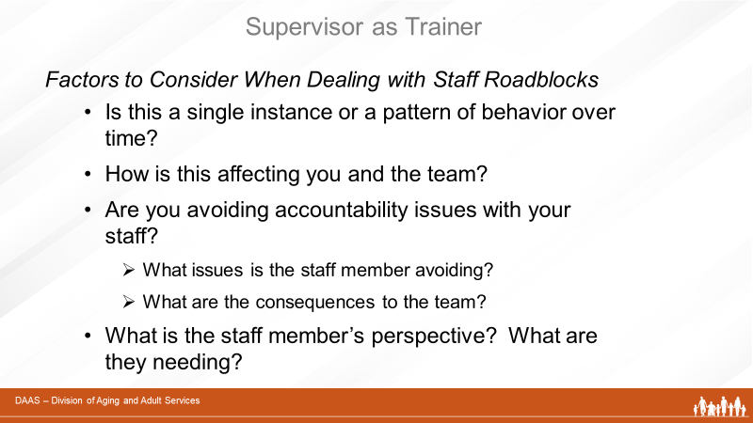
Notes: _____________________________________________
____________________________________________________
____________________________________________________

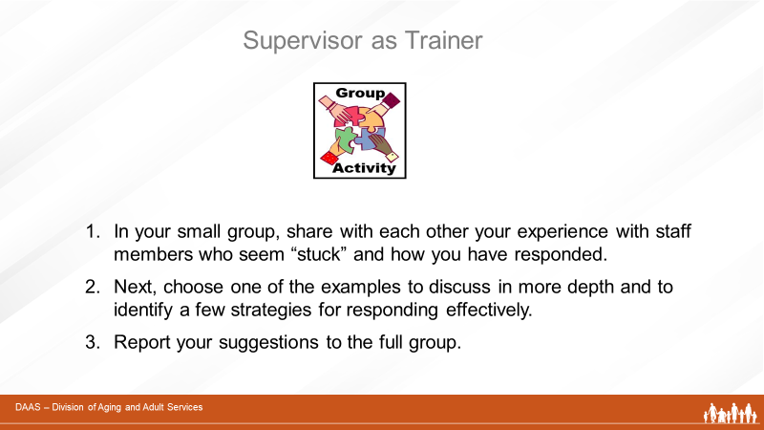
Notes: _____________________________________________
____________________________________________________
____________________________________________________

Sample Transfer of Learning Tool

This handout is a sample tool that can be utilized to evaluate a new staff’s integration of APS policies and regulations. It was developed specific to regulations in the state of California but could be adapted for use in other states. A supervisor would utilize this tool to review a recent case collaboratively with a new staff member.

Please review one of your recent cases with your supervisor using the following template.

How does your client meet the definition of an APS client? | Explain:
Was the reporting party a mandated reporter?
- Yes
- No
How did you handle confidentiality issues in this case? (Was there someone you had to talk to but had to watch what you said?) | Explain:
Did you discuss this case with a Multidisciplinary Team?

Did this case qualify for No initial-face-to-face investigation (NIFFI)? Why or why not? | Explain:
What was the response time for this case? Why? | Explain:
Did you get permission to enter the client’s residence?
- Yes
- No
Did you complete the assessment within the deadline?
- Yes
- No
Did your assessment documentation include:
- Reason for referral
- Summary of investigative findings
- Summary of concerns/ needs
- Summary of strengths, limitations & risk factors
- Client’s history with APS and other agencies
Did you complete the Service Plan within the deadline?
- Yes
- No
Did your Service Plan:
- Promote the goal of client’s safety in the least restrictive environment
- Reflect the goals of the client/ family
- Outline strategies to achieve goals
- Get approved by first level supervisor within 5 calendar days of completion
If your case was open more than 30 days beyond the initial face to face, did you monitor the case every 30 days?
- Yes
- No
Did you do a reassessment within 90 days?
- Yes
- No
Did you document:
- Appropriateness of service plan
- Need for continued APS involvement
If you have closed the case, did you document:
- Reason for case closure
- Services provided
- Resources now in place
- Achievement of Service Plan goals

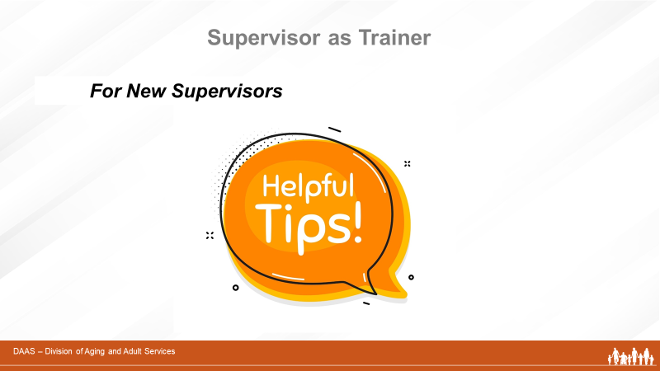

Notes: _____________________________________________
____________________________________________________
____________________________________________________

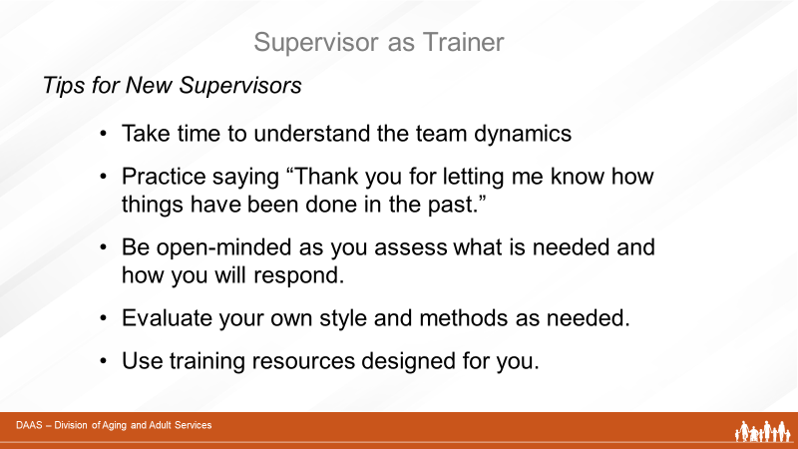
Notes: _____________________________________________
____________________________________________________
____________________________________________________

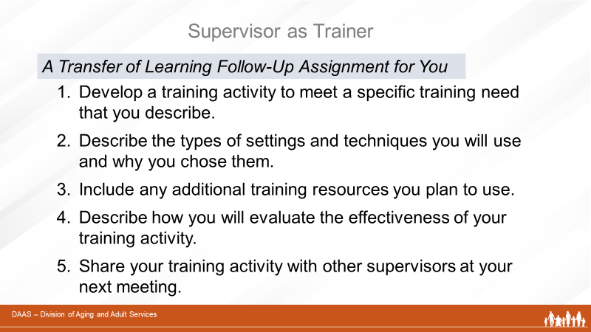

Notes: _____________________________________________
____________________________________________________
____________________________________________________
Supervisor as Trainer
Transfer of Learning Follow-Up Assignment
How will you evaluate the effectiveness of your activity?
List any existing training resources you plan to use in your activity and why.

Describe the activity you will develop.
What is the training need you plan to address?
- Please develop a training activity to meet a specific staff training need of your choice.
- Include the types of setting(s) and techniques you plan to use and why you chose them.
- List any existing training resources you plan to use in your activity.
- Describe how you will evaluate the transfer of learning of your activity.
- Share your activity with other supervisors at a future meeting or training.

