Building and Managing Effective APS Teams

Division of Aging and Adult Services
Adult Protective Services
Participant Guide

Table of Contents

Introduction………………………………………………………………………………… 2

Learning Objectives……………………………………………………………………… 4

Section 1 – What is Team Building ………………………………………………… 5

Building Team Strength and Resilience Journal Entry………………………………. 7

Team Meeting Facilitation Journal Entry………………………………………………. 8

Section 2 – Characteristics of Healthy & Unhealthy Teams…………………………8

Characteristics of Healthy & Healthy Teams Journal Entry………………… 10

Hand-Out: Tuckman’s Stages of Team Development……………………………… 12

Hand-Out: Team Assessment ………………………….……………………………. 14

My Action Plan …………………. ……………………………………………………… 15

Group Activity Notes …………………………………………………………………… 15

Teams Taught or Modeled? Journal Entry ……………… …………………………… 17

Section 3 – Team Roles and Members…………………………………………………. 16

Hand-Out: For Your Improvement: Motivating Others……………………………… .18

Hand-Out: Belbin’s Team Roles ………………………………………………………. 21

Challenging Team Members: Group Activity Notes……………………………………. 24

Trauma Informed Approaches……………………………………………………………. 26

Hand-Out: Trauma Informed Approaches …………………………………………… 26

Section 4 – Managing Virtual Teams……………………………………………………28

Link to Brain Breaks and Ice Breakers for Virtual Work………………………. 28

Handout: Transfer of Learning – Team Implementation Goals ………………. 30

Introduction

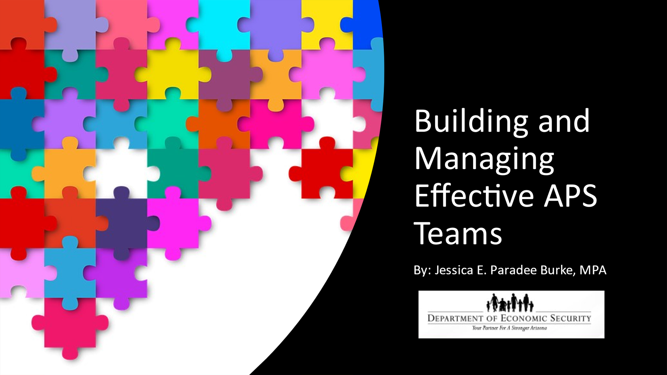
Notes: _____________________________________________
____________________________________________________
____________________________________________________

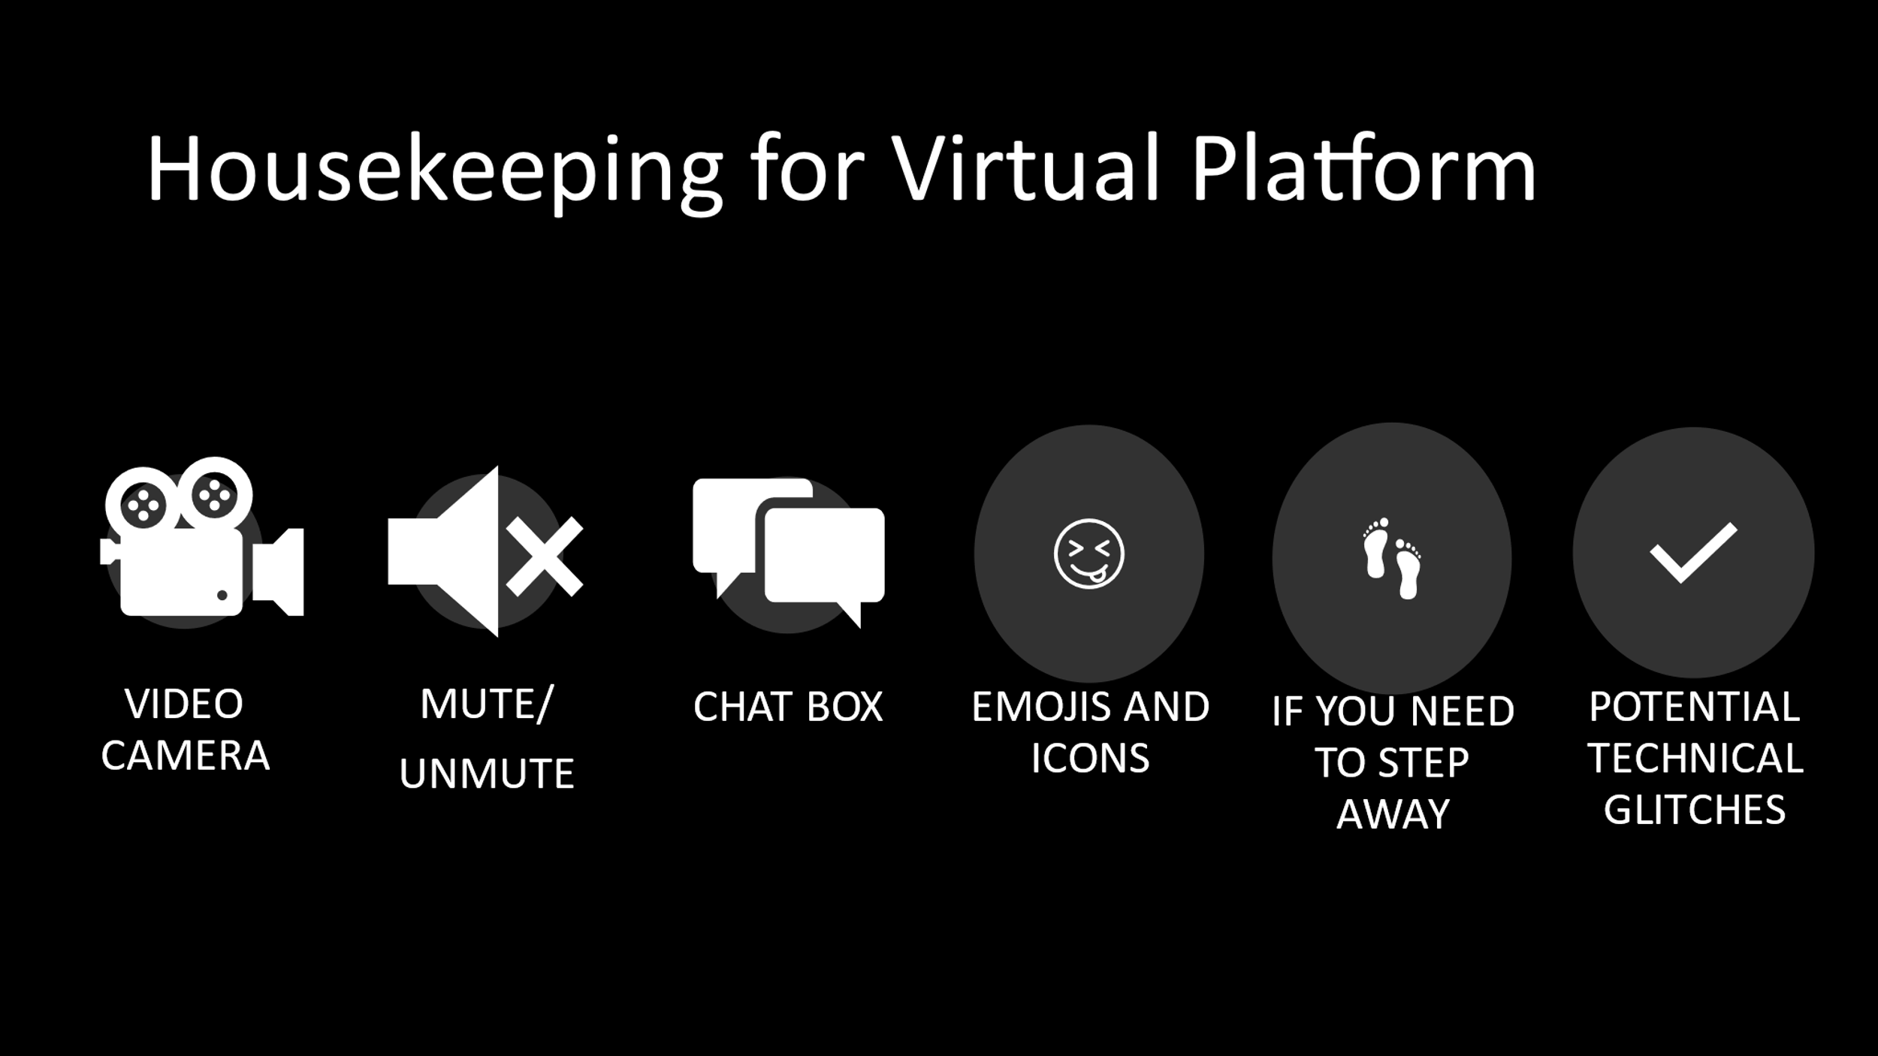
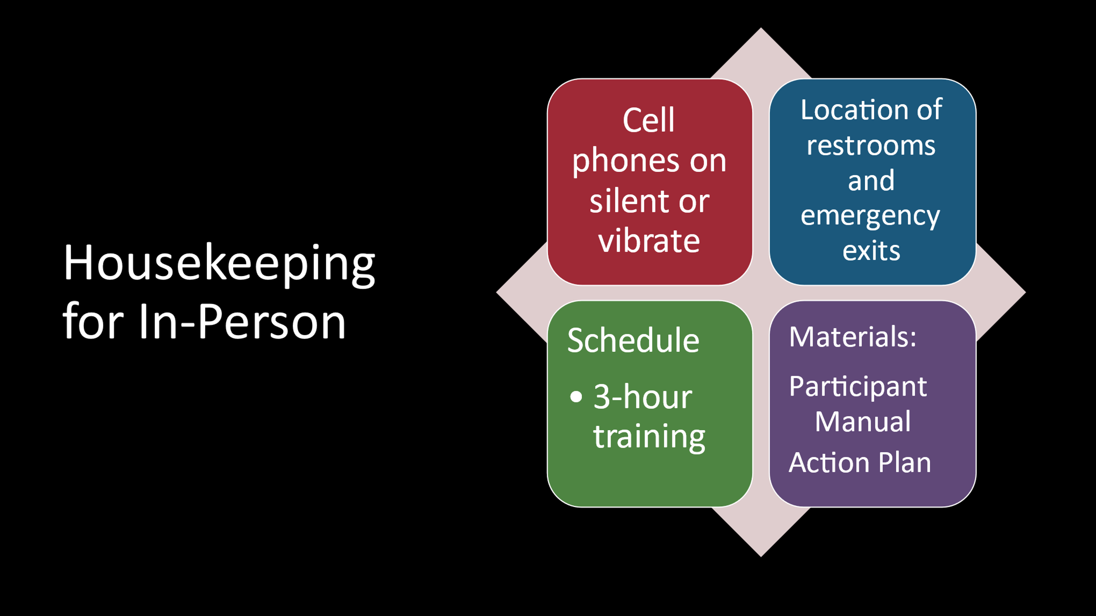

Learning Objectives

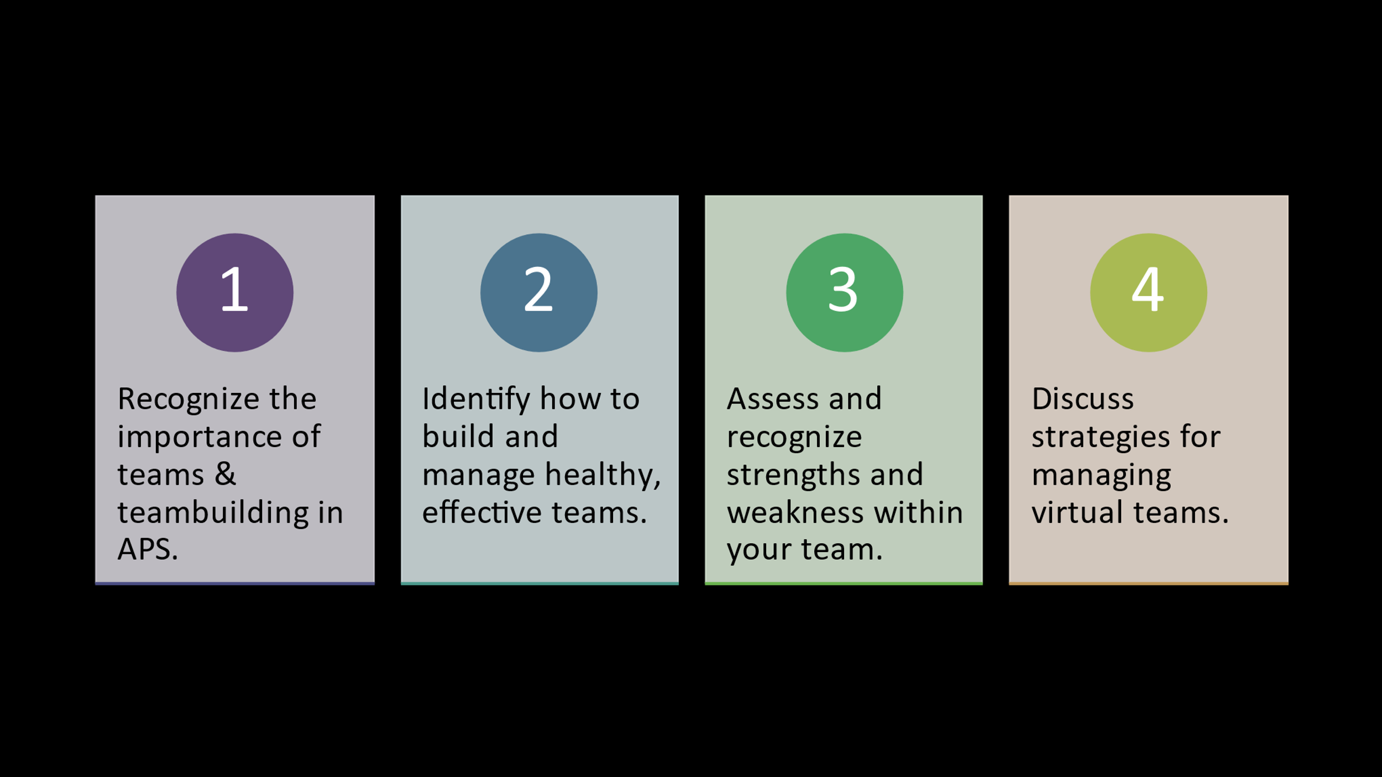
Notes: _____________________________________________
____________________________________________________
____________________________________________________
Notes: _____________________________________________
____________________________________________________
____________________________________________________
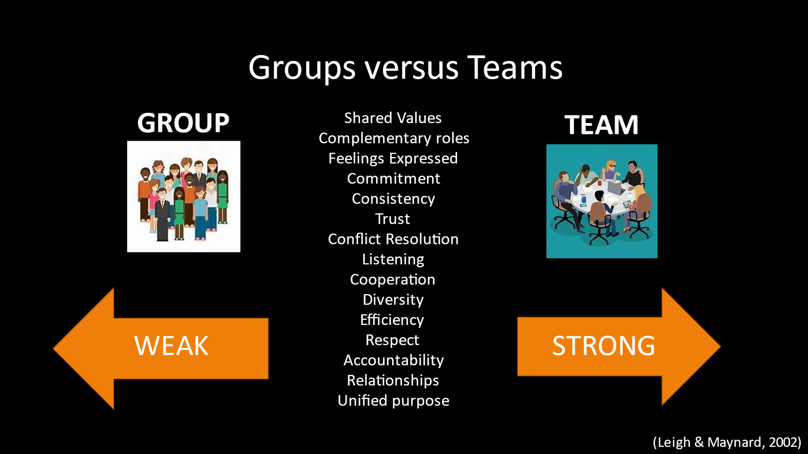
Notes: _____________________________________________
____________________________________________________
____________________________________________________

Section 1 – What is Team Building?

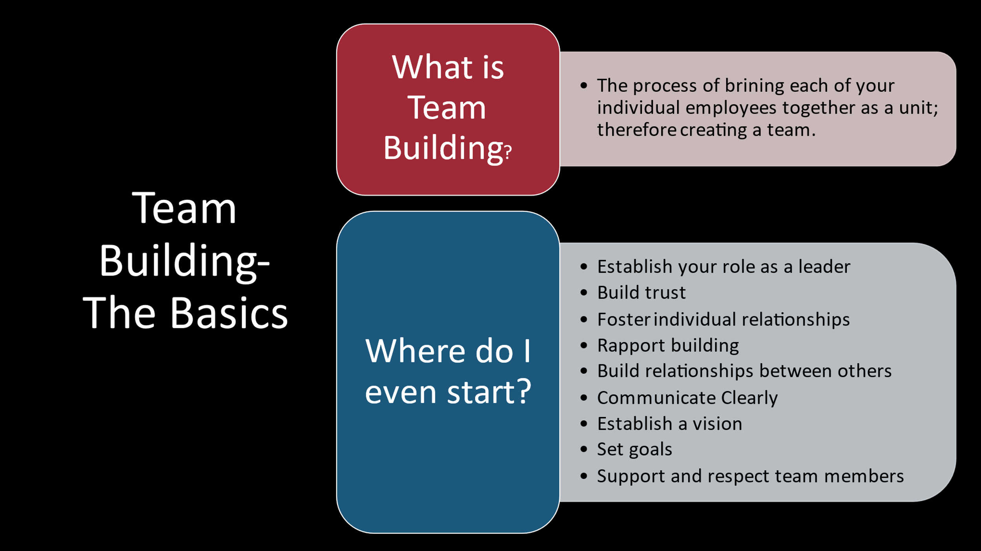
Notes: _____________________________________________
____________________________________________________
____________________________________________________
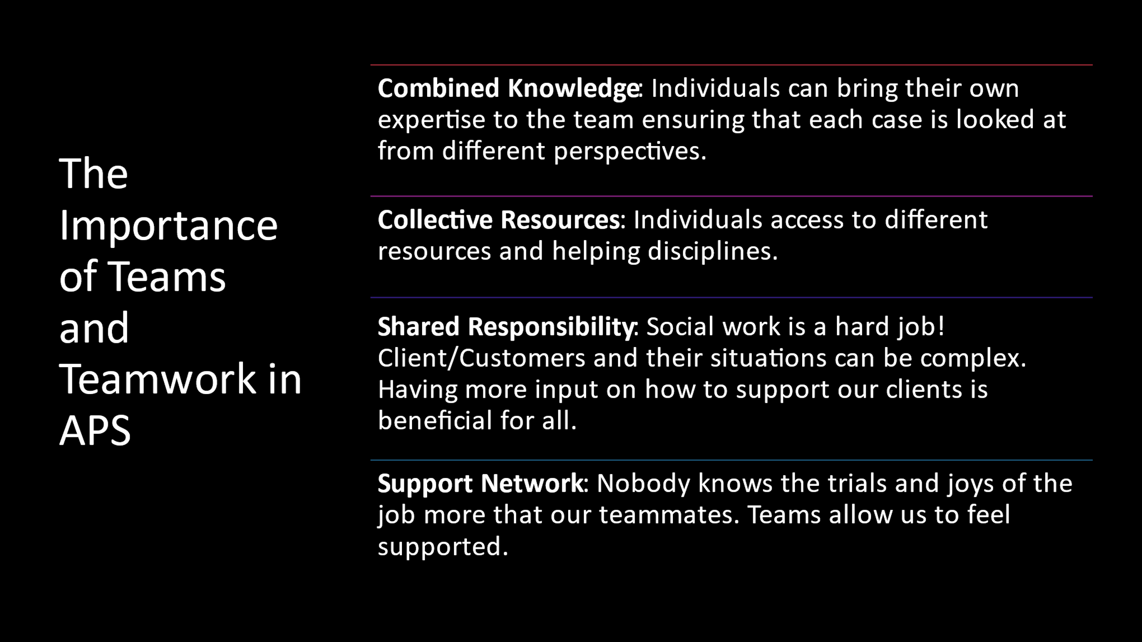
Notes: _____________________________________________
____________________________________________________
____________________________________________________
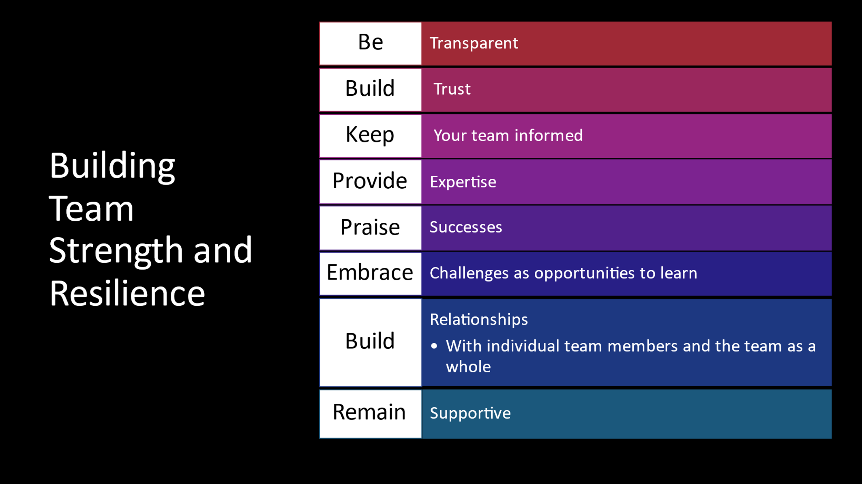
Notes: _____________________________________________
____________________________________________________

Building Team Strength and Resilience Journal Entry
Have I given the support to my team members that they have given to me?

Notes: _____________________________________________
____________________________________________________
____________________________________________________
____________________________________________________
____________________________________________________
____________________________________________________
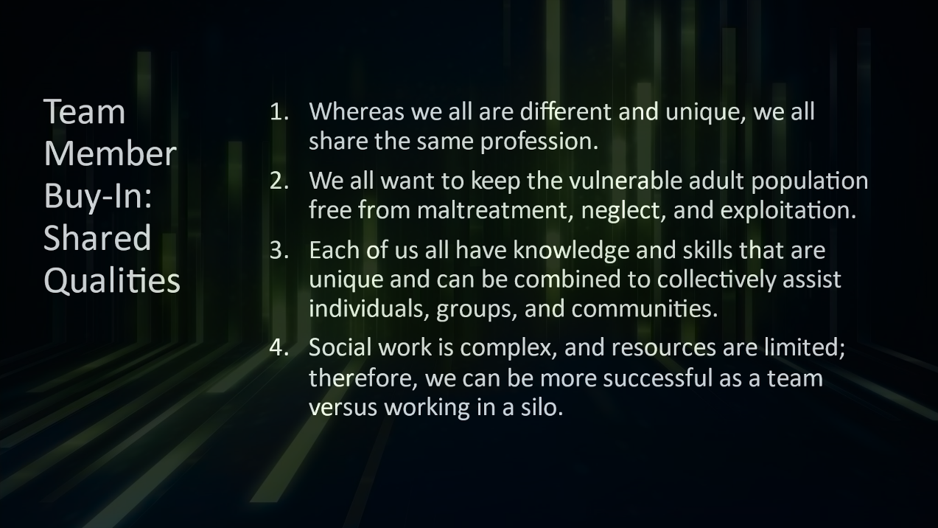

Notes: _____________________________________________
____________________________________________________
____________________________________________________
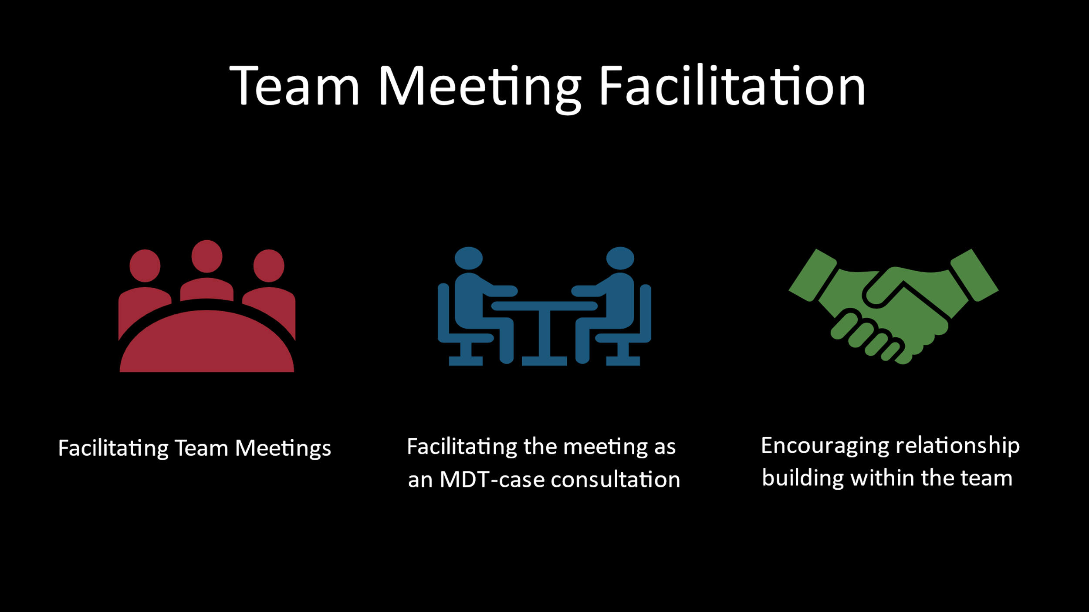
Notes: _____________________________________________
____________________________________________________
____________________________________________________

Team Meeting Facilitation Journal Entry
How can I make my team meetings productive and inspiring?
How can I give my team meetings energy?
Notes: _____________________________________________
____________________________________________________
____________________________________________________
____________________________________________________
____________________________________________________

Section 2 – Characteristics of Healthy and

Unhealthy Teams

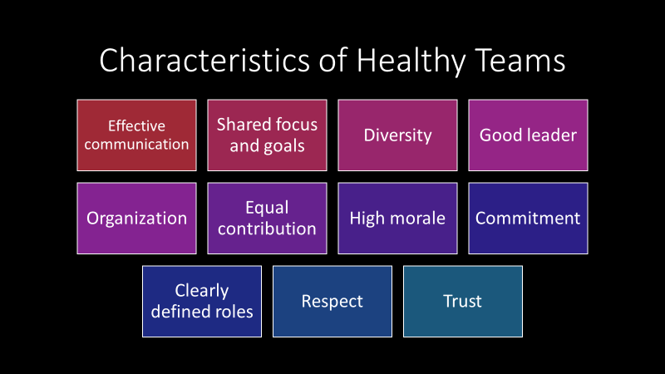

Notes: _____________________________________________
____________________________________________________

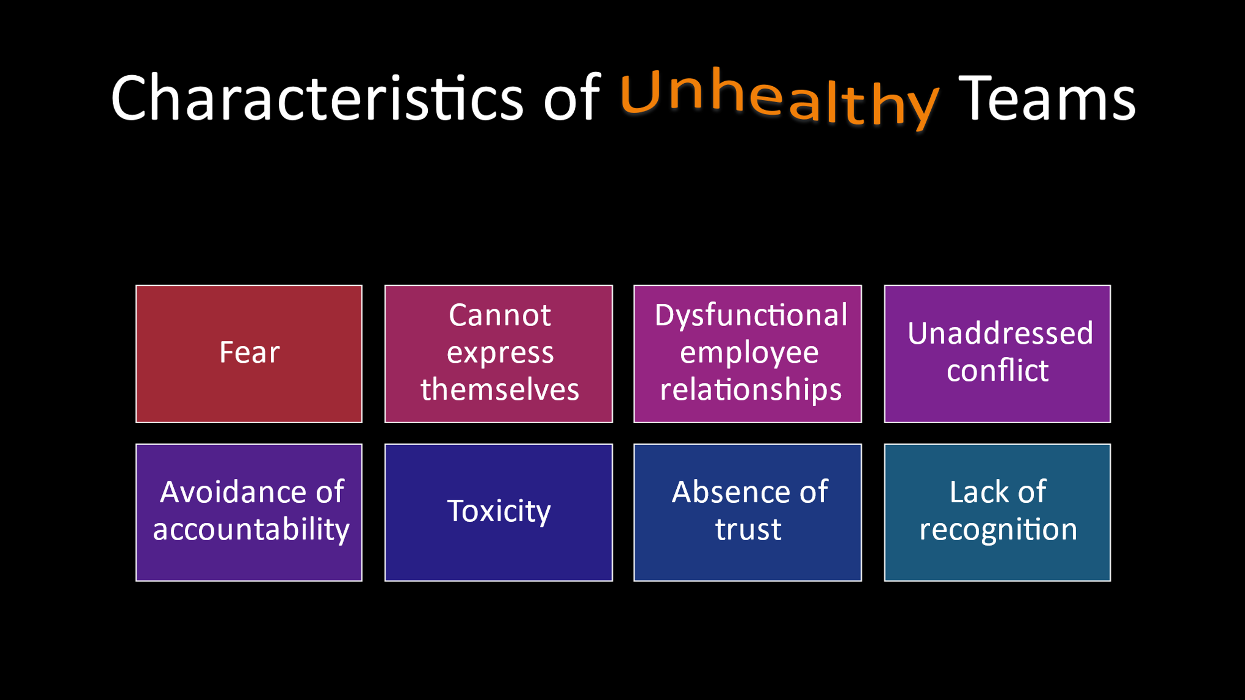
Notes: _____________________________________________
____________________________________________________

Characteristics of Healthy/Unhealthy Teams
Journal Entry
Think about your experience leading a team.
What elements create a positive team experience?
What elements create a negative team experience?
Notes: _____________________________________________
____________________________________________________
____________________________________________________
____________________________________________________
____________________________________________________
____________________________________________________

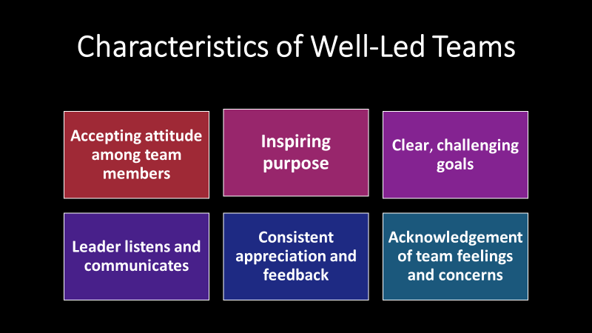

Notes: _____________________________________________
____________________________________________________
____________________________________________________

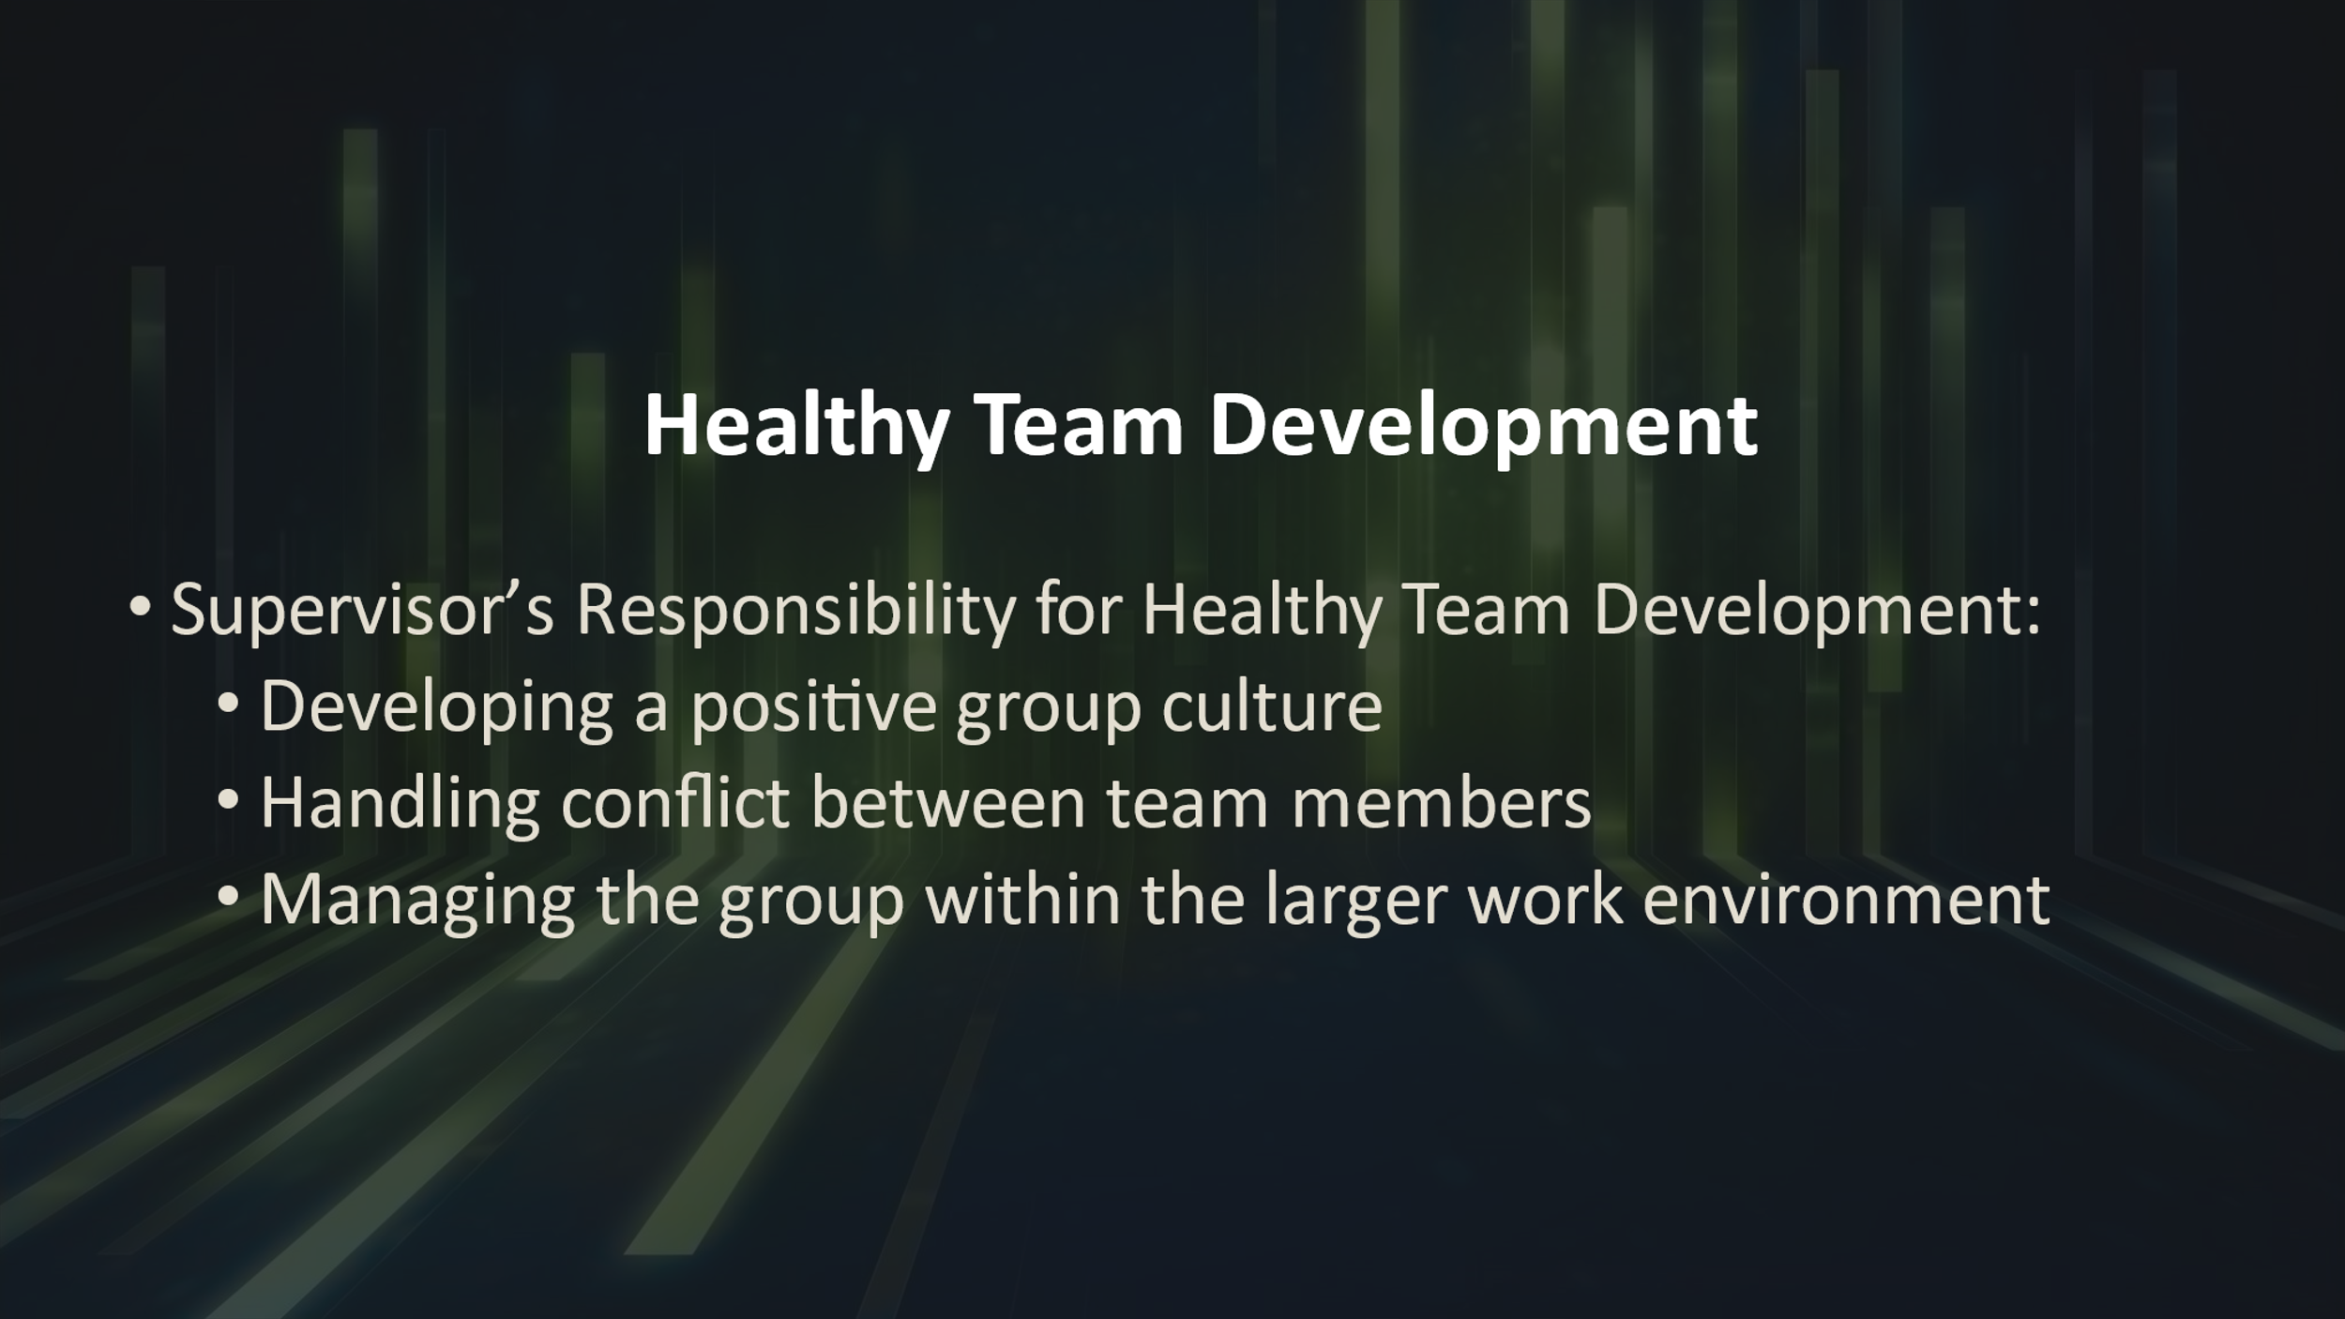
Notes: _____________________________________________
____________________________________________________
____________________________________________________

Tuckman’s Stages of Team Development
Stages of Team Development
Forming  Leader directs group activities.  Roles of individuals are unclear.  Low trust level between members.  Members may pretend to agree with the leader on  leader on all matters.  Storming  Leader coaches group members.  Members vie for influence.  Confusion about roles and boundaries.  Sub-groups form.  Unresolved conflicts arise.  Norming  Leader facilitates and enables.  Members become more comfortable  with one another.  Conflicts from prior stage resolve.  Members speak freely. | Performing  Leader delegates and oversees.  Norms become strong and binding.  Group is productive and able to resolve  disputes.  New member may upset the balance.  Performance may lag due to burnout.  Adjourning  Leader recognizes accomplishments.  Marks the end of the team.  May result in breakdown of group skills.  Conflict may arise.  Separating is difficult.  Evaluation of performance.  Source - The Academy for Professional Excellence. (2013). Teambuilding for APS
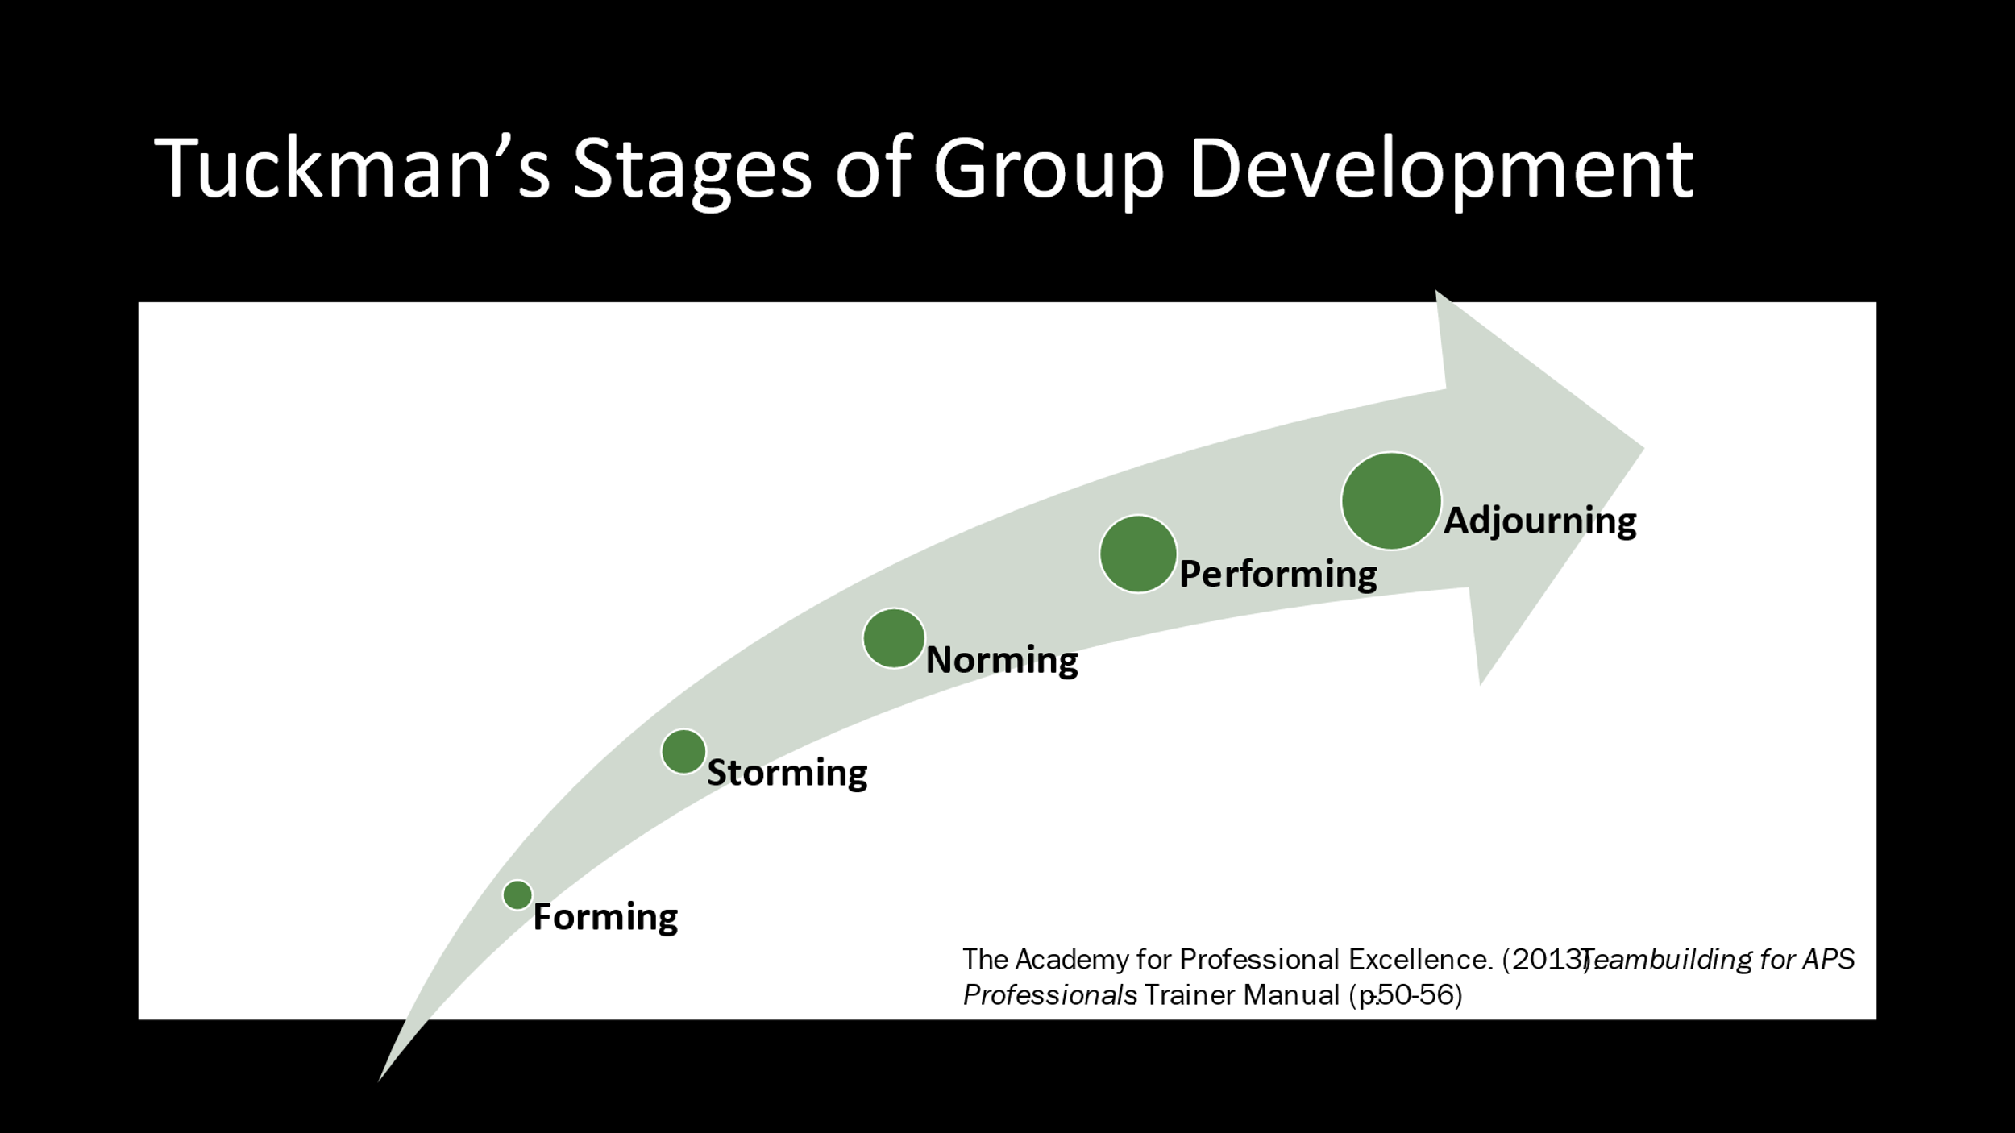
Notes: _____________________________________________
____________________________________________________
___________________________________________________
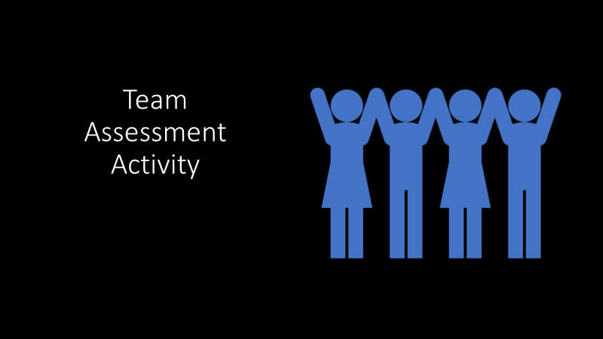

Notes: _____________________________________________
____________________________________________________
____________________________________________________
TEAM ASSESSMENT
How Good Are You and Your Team at Teamwork
and Team Building?
Instructions
For each statement, please rank yourself on a 5 point scale from 1-5 with 5 being “very often” to 1 being “not at all”. Please answer questions as you actually are (rather than how you think you should be).
Answers options range from “not at all” through “very often”.
1. My team is knowledgeable about the stages of development teams can be expected to go through.
2. Team members are provided with a great deal of feedback regarding their performance.
3. Team members are encouraged to work for the common good of the organization.
There are many complaints, and morale is low on my team.
5. Team members do not understand the decisions that are made, or don't agree with them.
6. People are encouraged to be good team members and build good relationships.
7. Team members are provided with development opportunities.
8. Meetings are inefficient and there is a lot of role overlap.
9. Team members are encouraged to commit to the team vision, and leaders help them understand how their role fits into the big picture.
10. Team members are often given a chance to work on interesting tasks and stretch their knowledge and capabilities.
11. The team understands what it needs to accomplish and has the resources needed to be successful.
12. Conflict and hostility between members is a pervasive issue that does not seem to get better.
13. People feel that good work is not rewarded, and they are not sure what is expected of them.
14. Team members balance their individual needs for autonomy with the benefits of mutual interdependence.
15. Working relationships across units or functions is poor, and there is a lack of coordination.
(Team Effectiveness Assessment, n.d.)

Team Assessment Self Reflection.
My Action Plan:
What I would like to strengthen?
How will I achieve this goal?
Notes: _____________________________________________
____________________________________________________
____________________________________________________
____________________________________________________
____________________________________________________
____________________________________________________
____________________________________________________
____________________________________________________
____________________________________________________
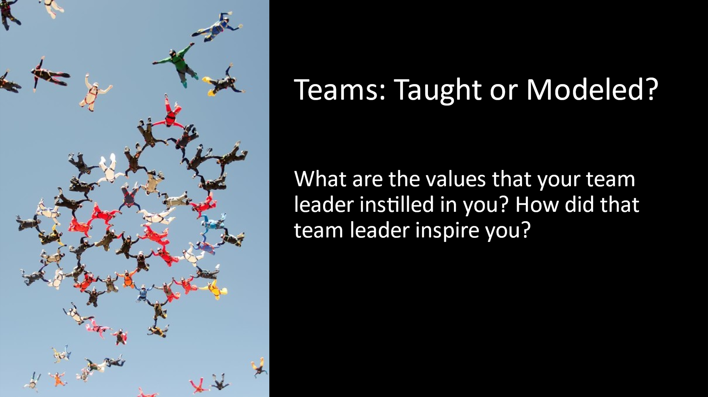
Notes: _____________________________________________
____________________________________________________
____________________________________________________

Small Group Activity
Small Group Training Tasks:
- In break-out groups you will think of a great inspiring team that you were once a part of that really stood out for you
- You will have 15 minutes to discuss the question in your group.
Notes: _____________________________________________
____________________________________________________
____________________________________________________
____________________________________________________
____________________________________________________
____________________________________________________
____________________________________________________

Teams Taught or Modeled? Journal Entry
I will model the value and importance of teams by:
I will inspire my team by:
Notes: _____________________________________________
____________________________________________________
____________________________________________________
____________________________________________________
____________________________________________________
____________________________________________________
____________________________________________________

Section 3 – Team Roles and Members

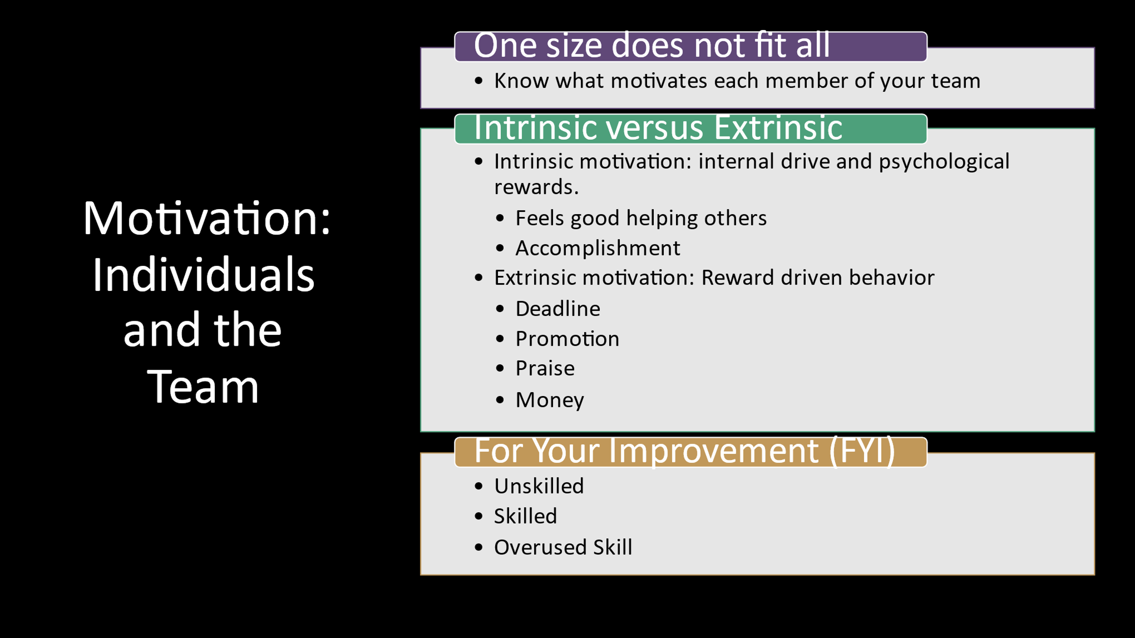
Notes: _____________________________________________
____________________________________________________

For your Improvement: Motivating Others
By: Michael M. Lombardo & Robert W. Eichinger
“Greater things can happen when people are motivated.”
Unskilled
- Doesn’t know what motivates others or how to do it.
- People under him/her don’t do their best.
- Not empowering and not a person many people want to work for, be around or with.
- May be a one-style-fits-all person, have simplistic models of motivation, or may not care as much as most others do; may be a driver just interested in getting the work out.
- May have trouble with people not liking him/her.
- May be a poor reader of others, may not pick up on their needs and cues. Intentionally or unintentionally demotivates others.
Skilled
- Creates a climate in which people want to do their best.
- Can motivate many kinds of direct reports and team or project members.
- Can assess each person’s hot button and use it to get the best out of him/her.
- Pushes tasks and decisions down.
- Empowers others.
- Invites input from each person and shares ownership and visibility.
- Makes each individual feel his/her work is important.
- Is someone people like working for and with.

Overused Skill
- May not be good at building team spirit because of an emphasis on individuals.
- May be seen as providing inequitable treatment by treating each person individually.
- May not take tough stands when the situation calls for it.
- May take too long getting input.
- May be reluctant to assign work with tough deadlines.

Motivation: Individuals and the Team Journal Entry
When it comes to motivating others:
What am I skilled at?
Where could I improve?

Notes: _____________________________________________
____________________________________________________
____________________________________________________
____________________________________________________
____________________________________________________
____________________________________________________
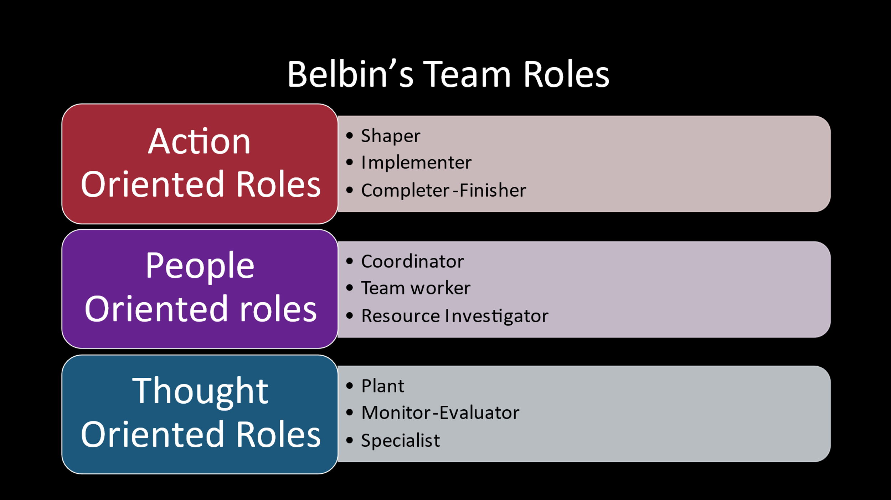
Notes: _____________________________________________
____________________________________________________
____________________________________________________
____________________________________________________
____________________________________________________
____________________________________________________

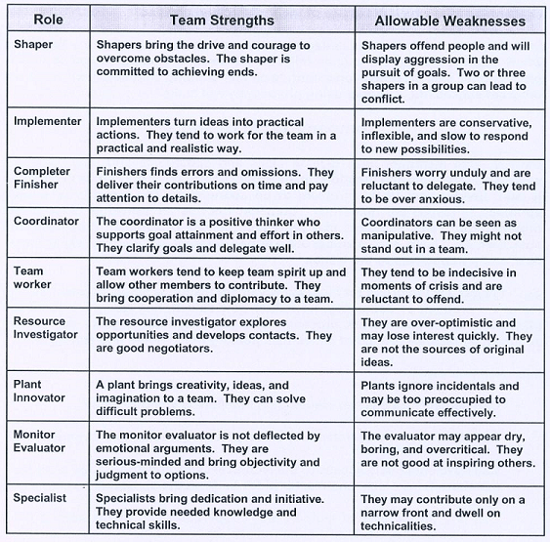
Belbin’s Team Roles

https://www.mindtools.com/pages/article/newLDR_83.htm

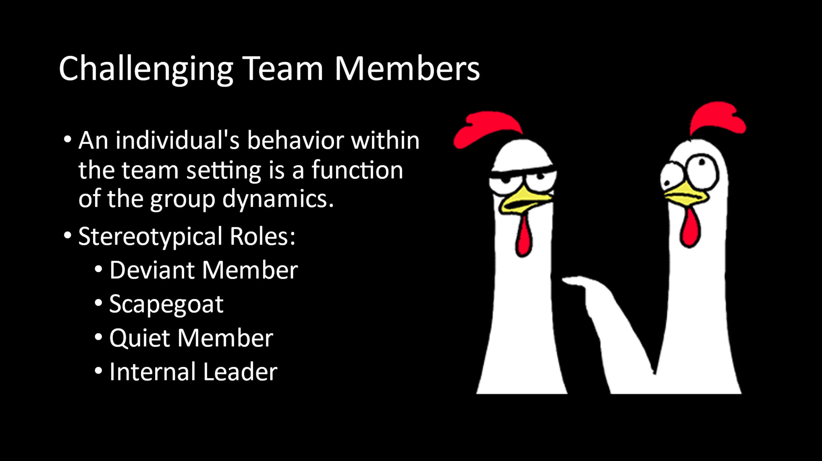
Notes: _____________________________________________
____________________________________________________
____________________________________________________
Kurt Lewin: Group Dynamics
Lewin is considered to be the Father of Group Dynamics and back in 1935 he explained that the behavior of an individual within a team or group was an expression of that individual's social role in relation to the activities of the group and the roles of the other team members. (Shulman - pg.236-7)
Shulman breaks out stereotypical behavior patterns of individuals within the group setting to try to address these roles that often may be problematic for supervisors.
A deviant member should not be considered in a pathological sense but rather an individual that frequently does not follow group norms regarding behaviors.
A deviant member might be someone that refuses to follow procedural roles established by the group, or an individual who may make "low jokes" or "potshots". This individual may often be someone that is not committed to the team.
The scapegoat is a term that you might be familiar with theory from family therapy. In a family with multiple children there is usually one that is considered the scapegoat, or the source of all the problems. This individual is not necessarily a rule breaker like a deviant member, but rather the group may collectively decide that this individual should carry all the blame. The result often is that the whole team will side against this individual and who is then an excluded team member. Supervisors must be aware of the role of the scapegoat because it is dangerous for a supervisor to side with the team against the scapegoat, or vice versa against the team and backing the scapegoat.
The quiet member may be often forgotten but easy to pick out when you start to reflect on the individual team members and the way that they interact during team meetings. The quiet member is the individual that rarely contributes or questions. It is not necessarily problematic to have one staff member that speaks less frequently than others during team meetings, but it is essential that the supervisor check in with this employee on a one-on-one basis about their feelings related to the group and to encourage some participation with the team. It can occur that other team members may become resentful of those that do not contribute or they may feel that they are being judged by someone who is not participating.
The Internal Leader is also easy to pick out during team meetings. This person or persons within the team can serve to be helpful and useful both to the group itself and the supervisor. This individual is the one that will help the group to tackle developmental tasks (the emotional function of the group) and handle business that needs attention (task completion function of the group). Supervisors should try to mentor this individual or individuals, but they must also make sure that they do not stifle other members of the team that may also be trying to take on a greater leadership role.
Challenging Team Members - Group Activity Notes:
Options To Share:

Group Challenges Listed:
Group list of challenges:

Circle the chosen challenge to discuss.

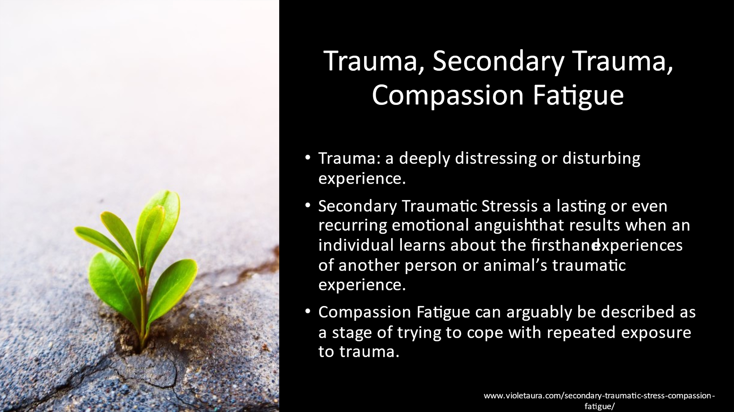
Notes: _____________________________________________
____________________________________________________
____________________________________________________

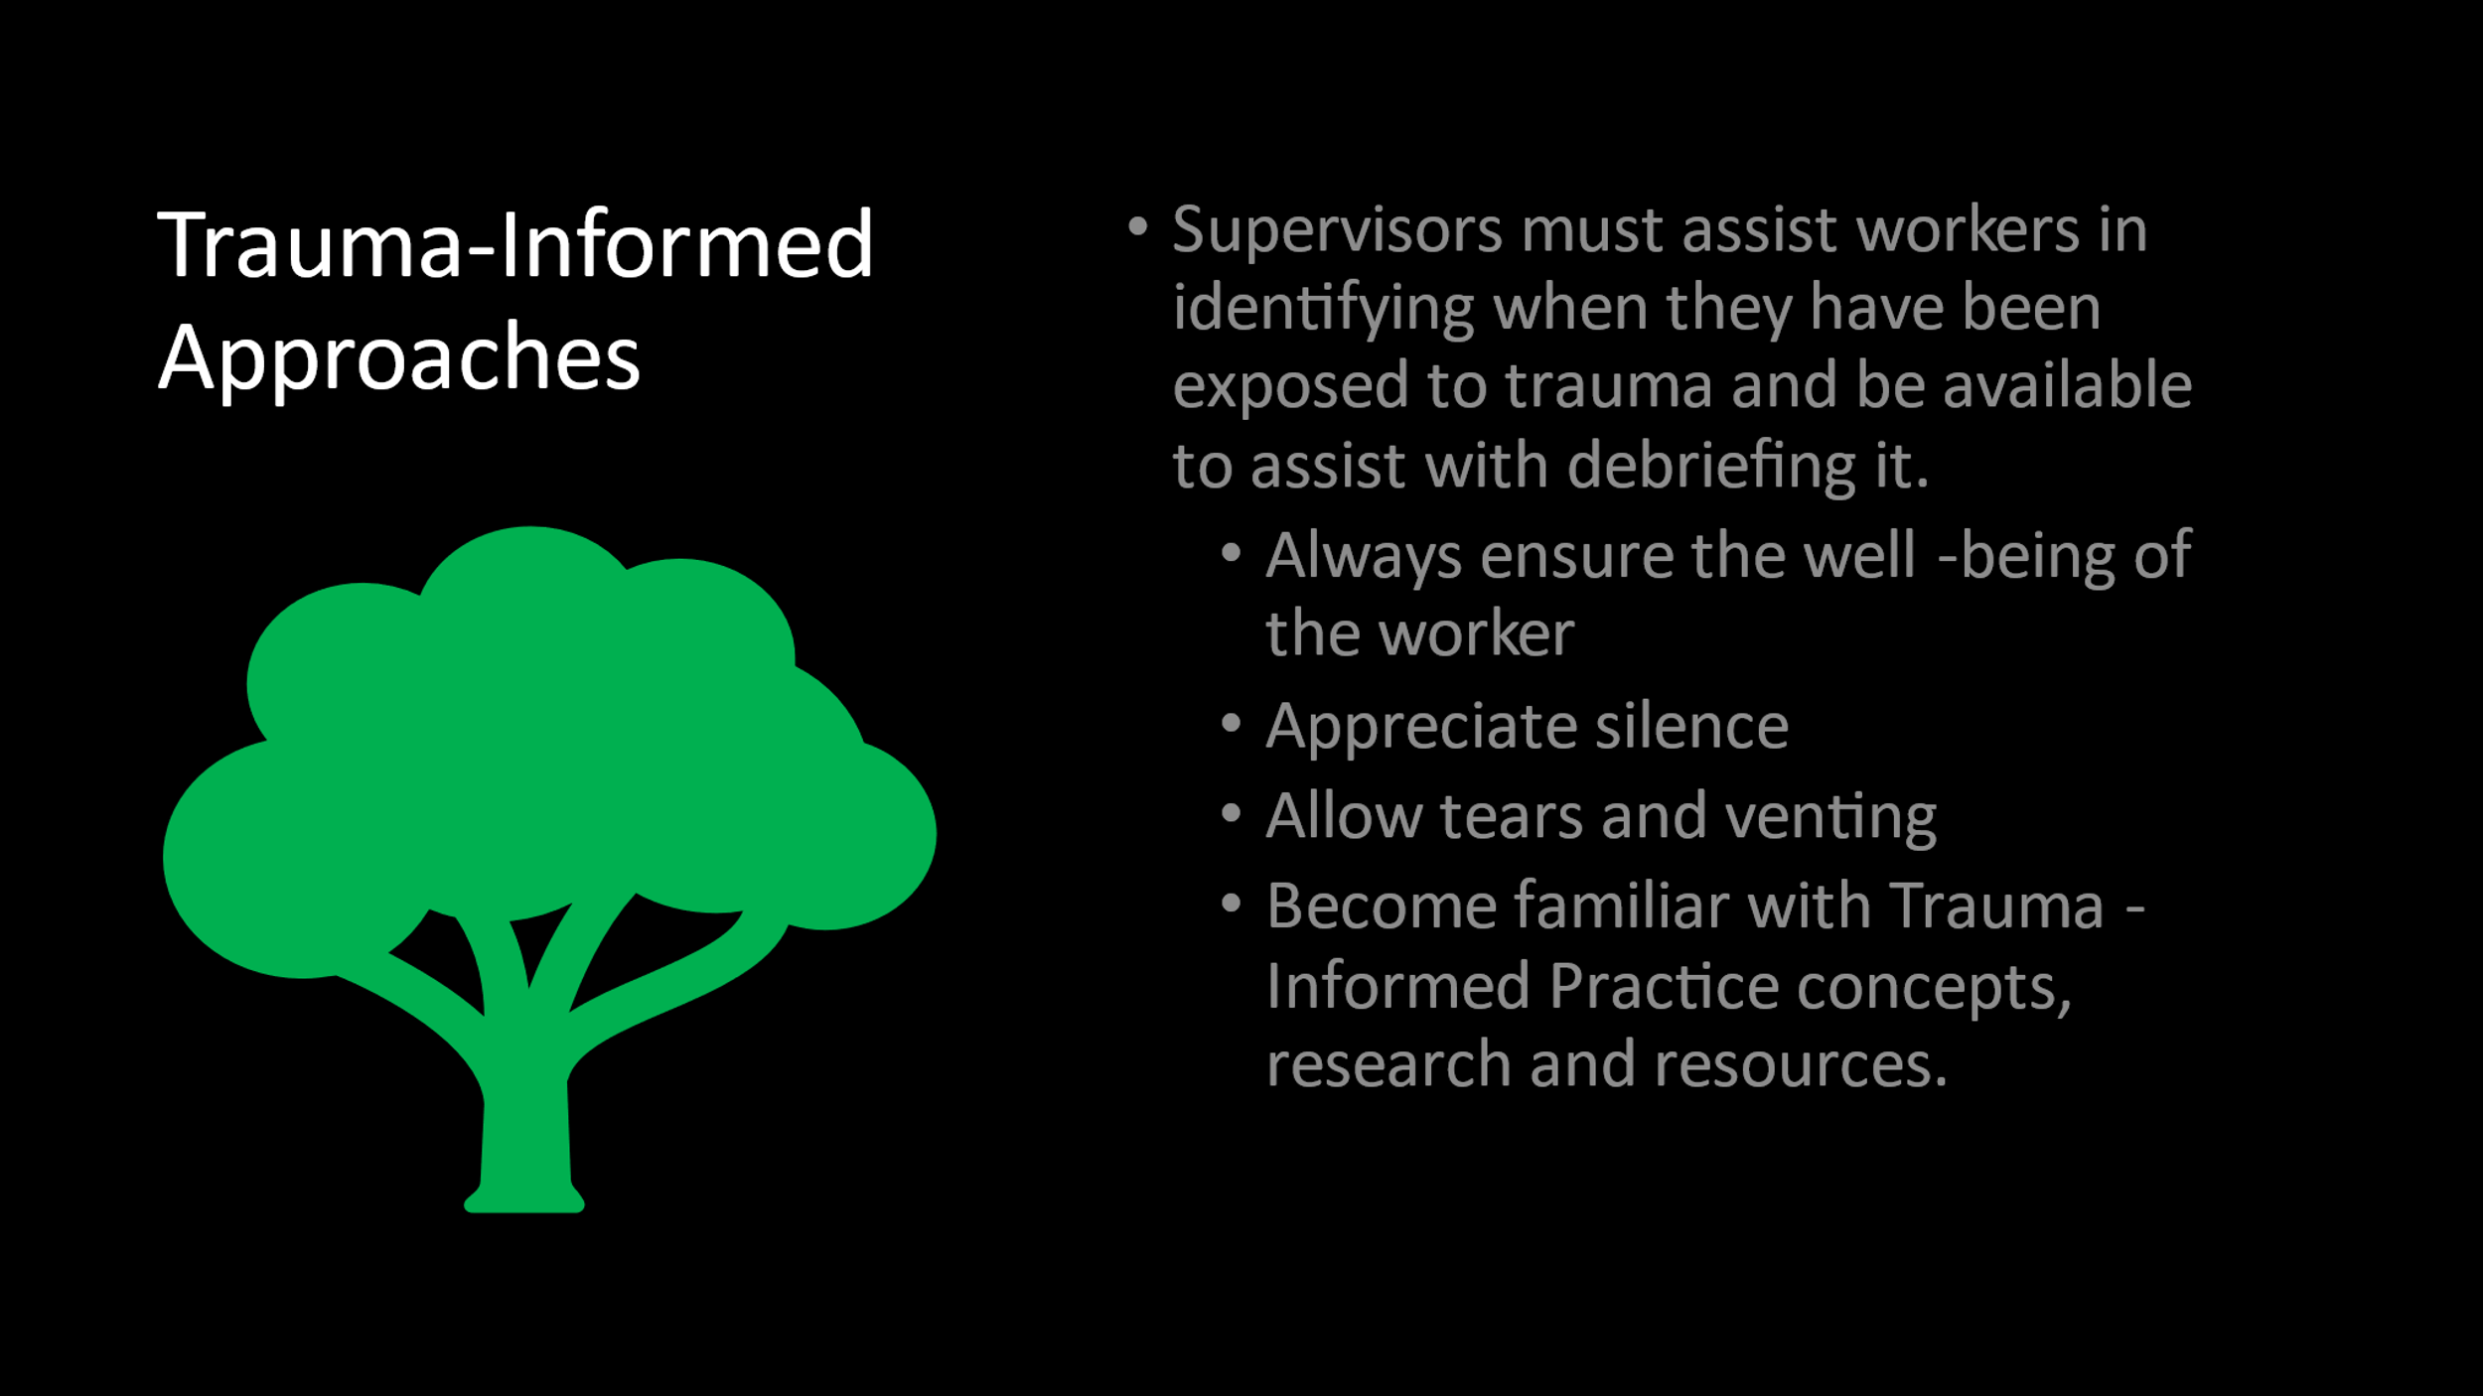
Notes: _____________________________________________
____________________________________________________
____________________________________________________
Trauma-Informed Approach
According to the concept of a trauma-informed approach, “A program, organization, or system that is trauma-informed:
1.Realizes the widespread impact of trauma and understands potential paths for recovery.
2.Recognizes the signs and symptoms of trauma in clients, families, staff, and others involved with the system.
3.Responds by fully integrating knowledge about trauma into policies, procedures, and practices; and
4.Seeks to actively resist re-traumatization."
A trauma-informed approach can be implemented in any type of service setting or organization and is distinct from trauma-specific interventions or treatments that are designed specifically to address the consequences of trauma and to facilitate healing.
Six Key Principles of a Trauma-Informed Approach
A trauma-informed approach reflects adherence to six key principles rather than a prescribed set of practices or procedures. These principles may be generalizable across multiple types of settings, although terminology, and application may be setting- or sector-specific:
1.Safety
2.Trustworthiness and Transparency
3.Peer support
4.Collaboration and mutuality
5.Empowerment, voice, and choice
6.Cultural, Historical, and Gender Issues
From this perspective, it is critical to promote the linkage to recovery and resilience for those individuals and families impacted by trauma. Consistent with this definition of recovery, services and supports that are trauma-informed build on the best evidence available and consumer and family engagement, empowerment, and collaboration.

Section 4 - Managing Virtual Teams

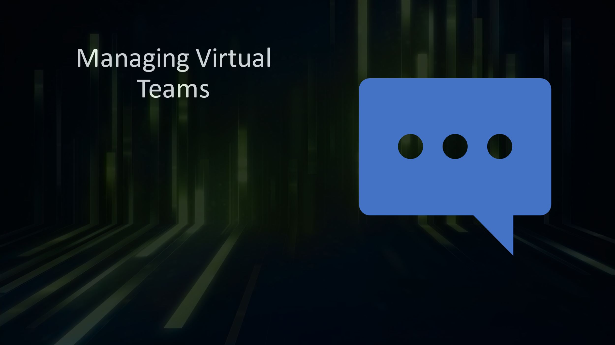
Notes: _____________________________________________
____________________________________________________
____________________________________________________

Brain Breaks & Ice Breakers for Virtual Meetings
The National Council for Behavioral Health created a 12-page resource guide entitled: Brain Breaks & Ice Breakers for Virtual Meetings. Access it through the link below.

Handout-Brain-Breaks-and-Ice-Breakers-for-Virtual-Work-Final.pdf (napsa-now.org)

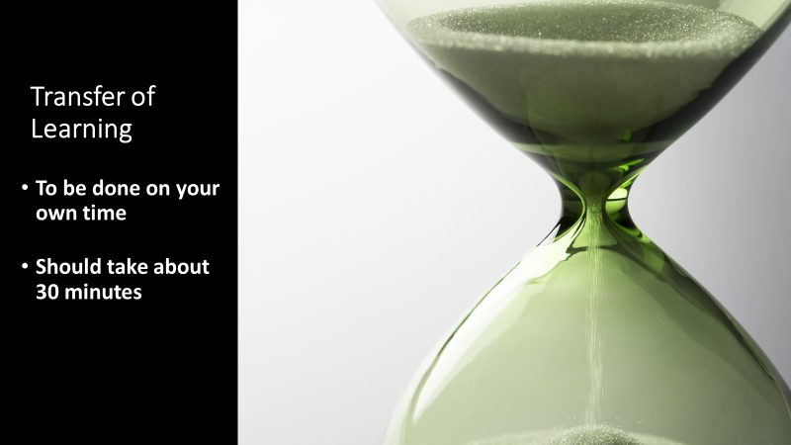
Notes: _____________________________________________
____________________________________________________
____________________________________________________
____________________________________________________
____________________________________________________

Transfer of Learning Activity
Team Implementation Goals
This is a Transfer of Learning (TOL) activity based upon the training that you attended entitled: Building and Managing Your APS Team.
Transfer of Learning (TOL) allows the learner to take education, ability or insight obtained from a prior setting and use it effectively in a new setting. The purpose of the TOL is to practice and apply information received in today’s training outside of the training environment.
This tool is meant to be used as a type of “roadmap” to assess your team, identify areas for improvement, and to create goals with an associated action plan.
This TOL activity can be done in conjunction with your team (at a team meeting) and can be done in-person, or within a virtual environment; or you can do this TOL activity on your own. It is recommended to complete this activity with your team to create a horizontal action plan; that is, what you will do to strengthen your team and what your team members will do to strengthen the team.

Please answer the following question: What 3 things will you do to strengthen your own team?
You might consider changes you could make to the structure and format of your unit meetings or new strategies that you could try to implement that will help to make the work environment more motivating.
What steps do you (and/or staff members) need to take to make that happen?
Be as specific as you can with your goals and action steps.

Goal 1 -

Action Item to support the goal:

Action Item to support the goal:

Action Item to support the goal:

Goal 2 –

Action Item to support the goal:

Action Item to support the goal:

Action Item to support the goal:

Goal 3 –

Action Item to support the goal:

Action Item to support the goal:

Action Item to support the goal:

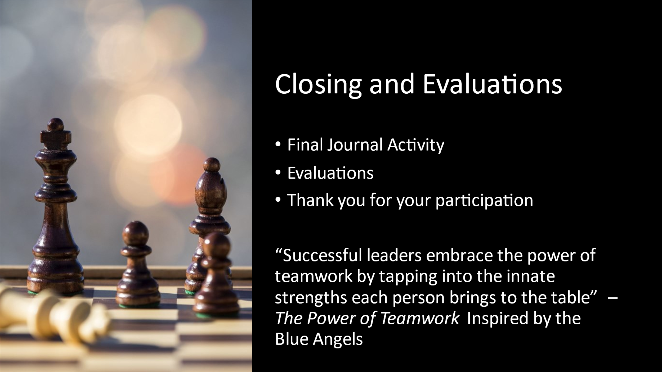
Notes: _____________________________________________
____________________________________________________
____________________________________________________

