Building and Managing Effective APS Teams
Division of Aging and Adult Services
Adult Protective Services
Facilitator Guide

Building and Developing Effective APS Teams
Supervisor Core Competency 3A

This training was developed by the National Adult Protective Services Association with support from the Arizona Department of Economic Security, Division of Aging and Adult Services-Adult Protective Services, and funded, in part, by a grant (No. 90EJSG0035-01-00) from the Administration for Community Living, U.S. Department of Health and Human Services (DHHS). Grantees carrying out projects under government sponsorship are encouraged to express their findings and conclusions. Therefore, points of view or opinions do not necessarily represent the official Administration for Community Living or DHHS policy.

Curriculum Developer:
Jessica E. Paradee-Burke, MPA

Acknowledgements:
This training is the result of a collaboration between Adult Protective Services administrators, supervisors, staff development officers, workers across the state and the nation, and professional educators. We would like to thank the following contributors:

Agencies:
Arizona Adult Protective Services, Division of Aging and Adult Services, Department of Economic Security
National Adult Protective Services Association
Adult Protective Services Workforce Innovations

Committees:
Supervisor Curriculum Advisory Committee (SCAC)
National Adult Protective Services Association Education Review Committee

Building and Managing Effective APS Teams
Supervisor Core Competency 3A

Use of Training Materials

This training was developed to provide APS programs across the nation with NAPSA-approved training content and materials that support specific learning objectives and promote APS supervisor core competency.

States and jurisdictions may customize these materials by adding information that meets their needs for state-specific content (regulations, policies, procedures, tools) in the following ways:
- State-specific PowerPoint slides
- State-specific hand-outs
- State-specific examples and experiences shared by the facilitator during trainings

User may also adjust the training time as needed by providing the content over multiple sessions or by using fewer activities and video examples.

Users agree to refrain from making any changes to the original, approved trainer narrative.

No commercial reproduction is allowed.

Table of Contents
Icons ………………………………………………………………………………………………………….2
Virtual Set-Up ……………………………………………………………………………………………….. 3
Instructor and Particiant Supplies ………………………………………………………………………….3
Course/ Lesson Goal ………………………………………………………………………………………..3
Learning Objectives …………………………………………………………………………………………3
Target Audience. …………………………………………………………………………………………….4
Course/ Lesson Length………………………………………………………………………………………4
For Facilitators……………………………………………………………………………………………… 4
Introduction…………………………………………………………………………………………………….5
What Is Teambuilding?……………………………………………………………………………………. 10
Characteristics of Healthy vs. Unhealthy Teams ……………………………………………………… 25
Team Roles & Members…………………………………………………………………………………… 46
Managing Virtual Teams …………………………………………………………………………………….62
Transfer of Learning Activity ………………………………………………………………………………..65

Note: Building and Managing Effective APS Teams is a training program that is
part of the National APS Supervisor Core Curriculum.
It is one of four training modules focused on supporting core competency
in Teambuilding and Individual Development. These modules include:
- Building and Managing Effective APS Teams (Module 3A)
- Supervisor as Trainer (Module 3B)
- Onboarding New Staff (Module 3C)
- Coaching and Mentoring (Module 3D)
While one is not a pre-requisite for another, it is recommended that the
modules be completed in the order listed.

National APS Supervisor Core Curriculum.

Icons
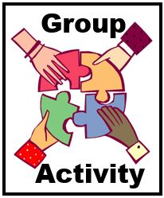 | 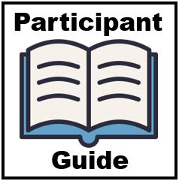
 | 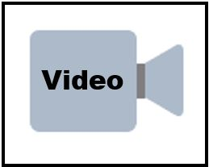
 | 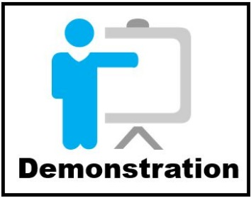

Virtual Setup
- Internet connection/Laptop computer with camera
- Connection to a virtual platform that allows breakout rooms
Note that this training has been formatted to be provided either virtually or in-person.

Instructor and participant Supplies
- Building and Managing Effective APS Teams Facilitator Guide
- Building and Managing Effective APS Teams PowerPoint Slides
- Building and Managing Effective APS Teams Participant Guide

Course/ Lesson Goal
In this interactive and dynamic introductory training, participants learn how to build and manage effective teams, maintain healthy teams, and assess their teams overall.

Learning Objectives
By the end of this course, participants should be able to:
- Explain the importance of Teams and Teambuilding in APS.
- Explain how to build and manage healthy, effective teams.
- Identify strengths and growth opportunities within your team.
- Explain the benefits of using a trauma-informed approach in managing teams.

Target Audience
The target audience for this training is APS supervisors.

Course/ Lesson Length
This is a 3.5-hour training.

For Facilitators
This Facilitator Guide provides the structured content, activities, and PowerPoint slides to present a 3.5-hour training either virtually or in-person. Facilitators are encouraged to review the guide and to add any state-specific information and/or examples from their professional experiences as appropriate. The accompanying Participant Guide contains the PowerPoint slides and hand-out materials that will be referenced during the training. Facilitators are encouraged to review these hand-out materials ahead of trainings, to be prepared to screen-share them as directed, and briefly describe content and use.

 | Introduction
Slide 1
Producer welcomes the class if in virtual format or Facilitator provides the welcome and self-introduction if in-person.
Producer or Facilitator Says:
Welcome, everyone, to today’s module on Building and Managing Effective APS Teams. (Introduces self and role in overseeing technology and managing questions and group activities.)
Slide 2 | 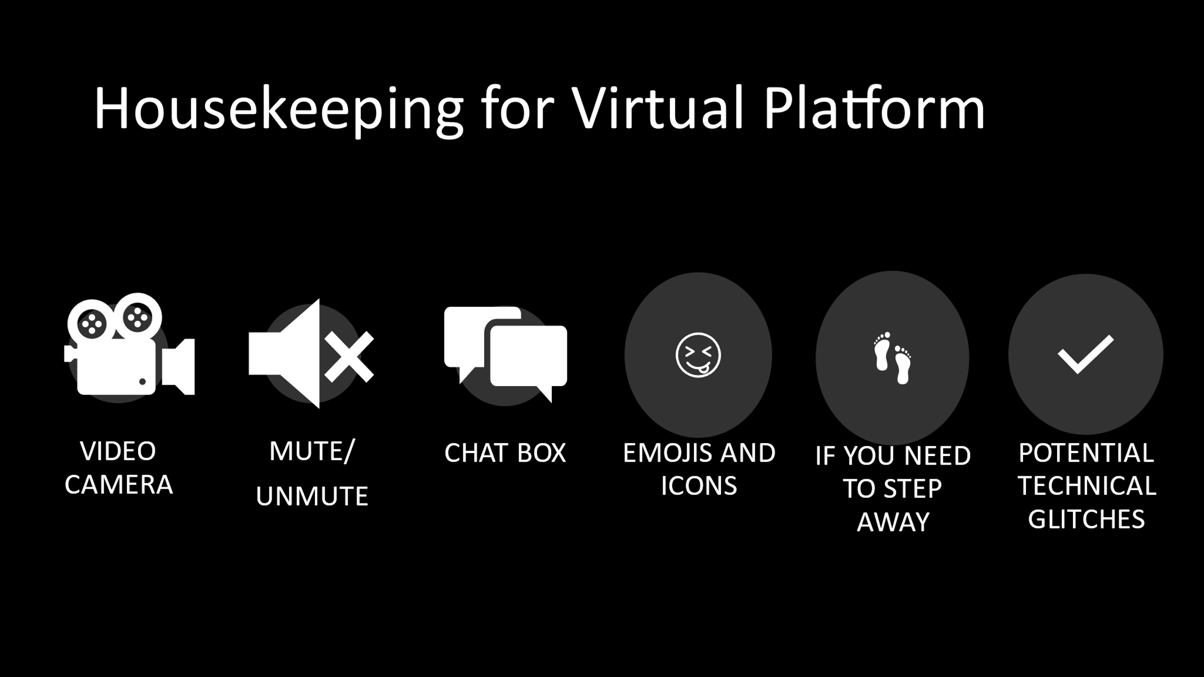
Hide this slide if the format is in-person. If virtual, use this slide with the narration below:
Producer says:
Before we get started, let’s review some virtual housekeeping details to be sure we’re familiar with the technology features we’ll be using to communicate with each other.
Some of you may be more familiar than others navigating through a virtual learning course. So we will briefly review the various functions of the virtual environment:
- Video Camera: Find the camera icon; when you do, please turn the camera off and on. During the session, please keep the video camera on since this is an interactive course.
- Mute/Unmute: Now, please locate the microphone. When you do, practice muting and unmuting yourself.
- Chat box: Find the chat icon. We will be using the chat function to communicate throughout the session.
- Emoji and Icons: These differ within the different virtual platforms
There will be a fifteen-minute break approximately halfway through the training. And while participants are expected to attend the entire training, if you need to step away please let the facilitator know by private chat.
And just a word about technical glitches. They are inevitable - on our end and your end! So please be patient and forgiving as we all navigate this virtual platform together.

And please have your copy of the Participant Guide handy to take notes. It contains all the slides and reference materials for this training. As we proceed, I will also note various locations in the Participant Guide for journal entries. Although we won’t take time to complete these during the training, we encourage you to review them and record your thoughts after the training.
Slide 3 | 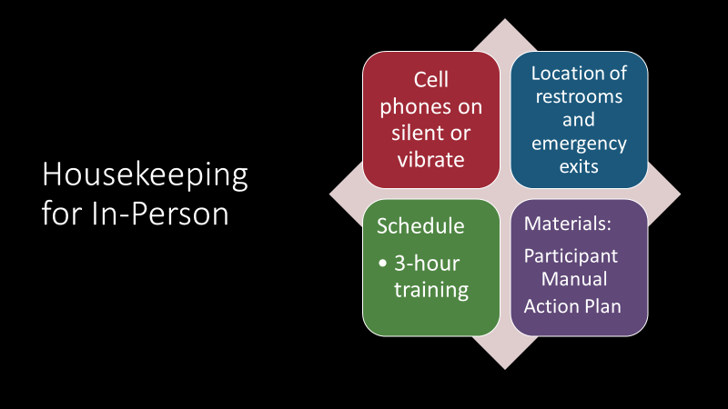
Hide this slide if the training is virtual. Show this slide if training is in-person using the narration below.

Facilitator says:
Before we get started, let’s review some housekeeping details. Please ensure that your phone is on silent or vibrate. If you must take a call please step outside and keep it brief. (Insert any agency policies regarding receiving credit if an attendee does not stay for the entire training). The restrooms are located ______________ and the emergency exits are located ______________.
This is a four-hour class with two 10-min. breaks during the class. Please have your copy of the Participant Guide handy to take notes and to create an action plan.

Slide 3 | 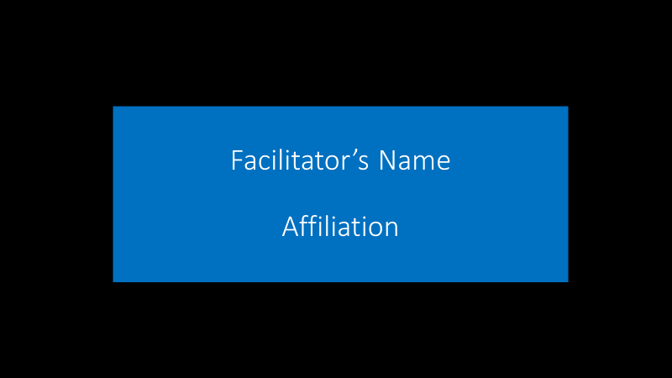  Producer says:  And now I’d like to introduce our facilitator for this training, _____________ .  Facilitator says:  Thank you! I’m pleased to be with you today to facilitate this training on Building and Managing Effective APS Teams. (Gives a short bio of professional background and experience.
Slide 4  Note: This slide is hidden unless presenting in-person. | 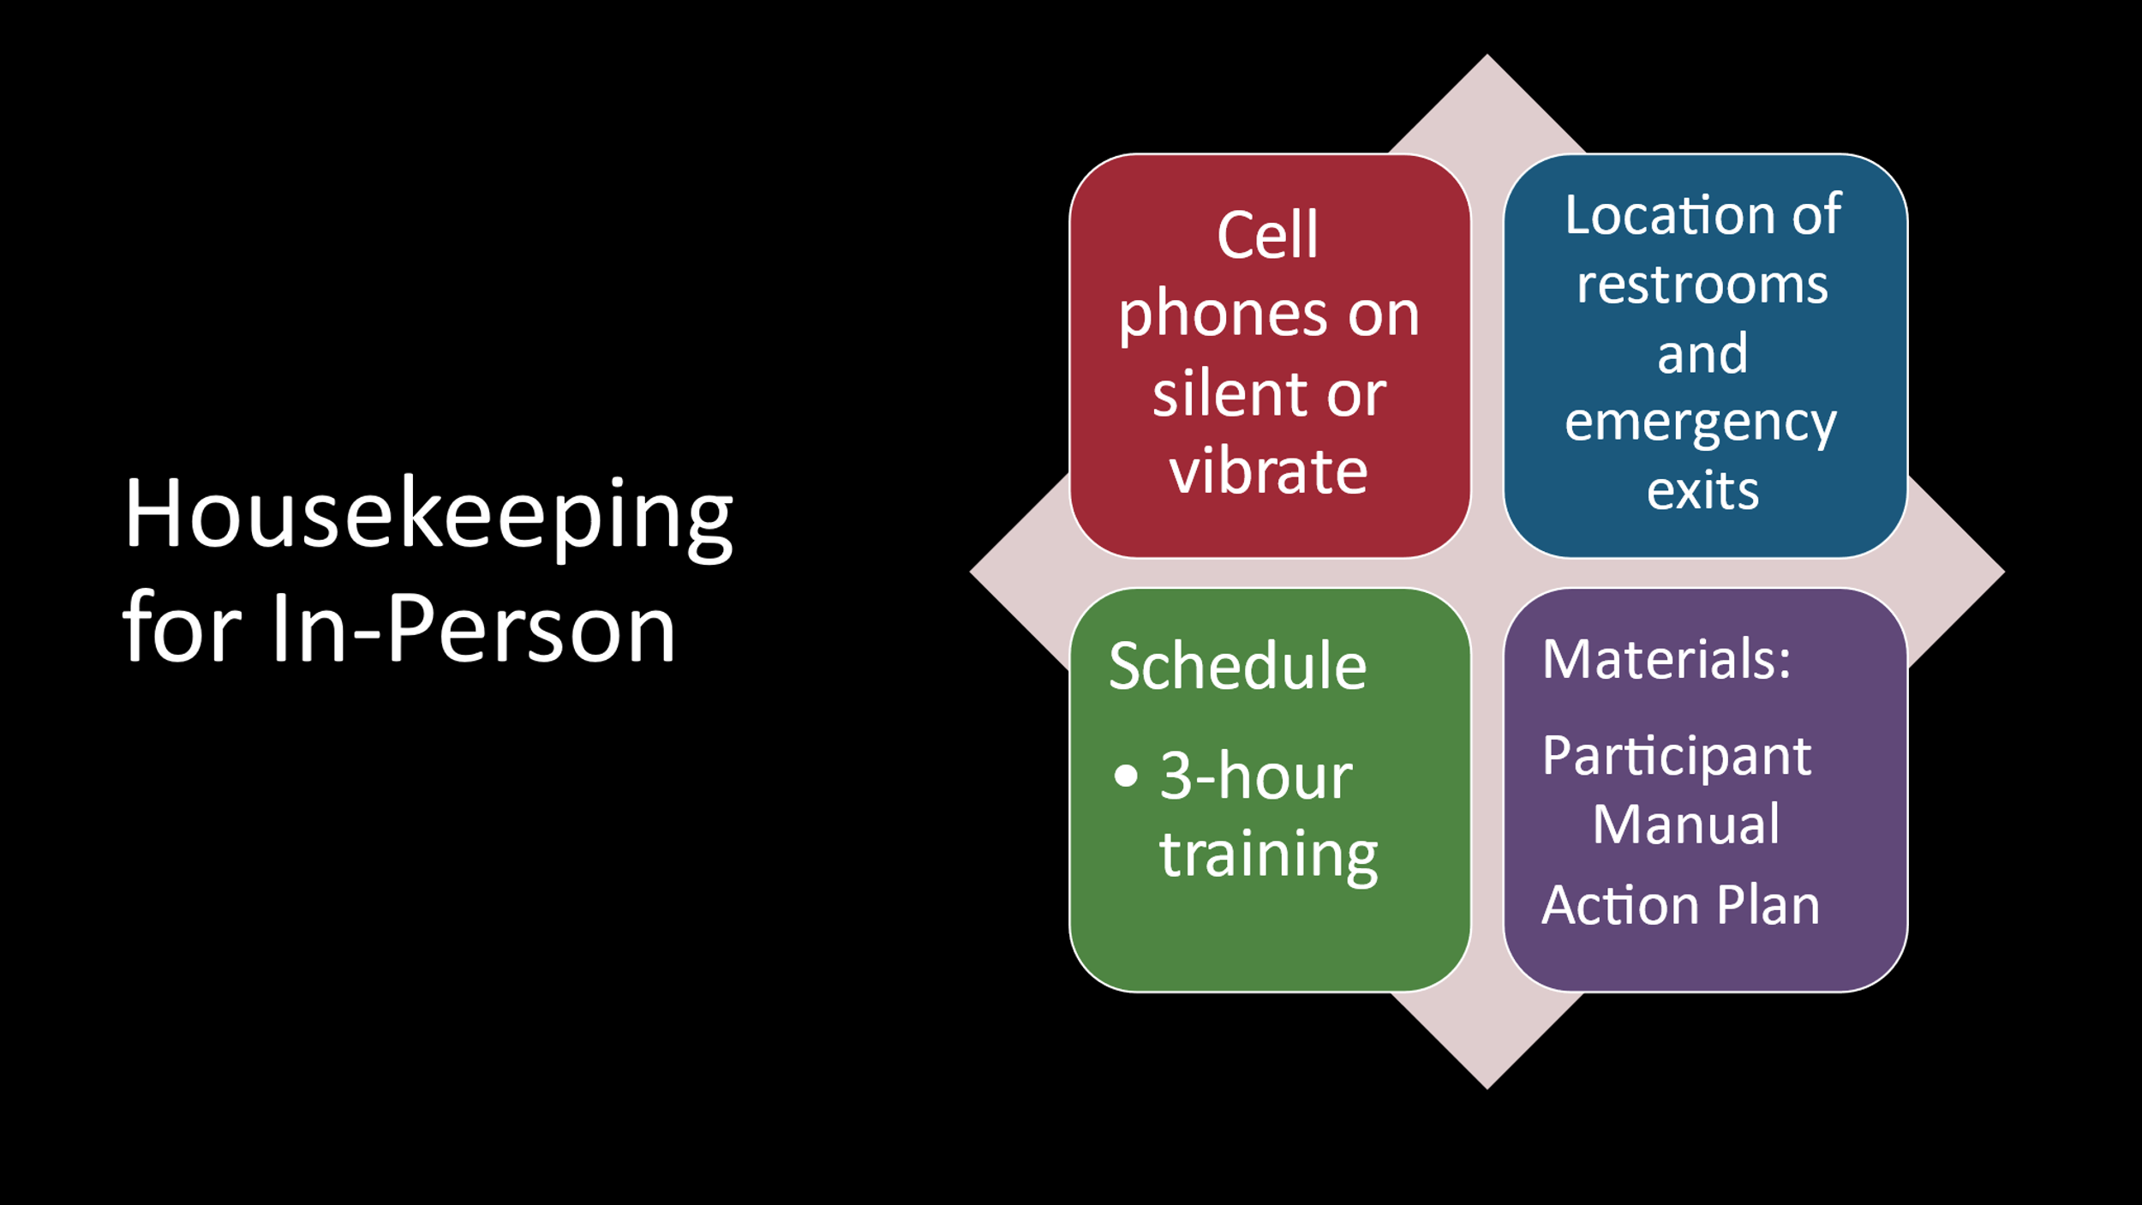
Facilitator says:
Before we get started, let’s review some housekeeping details. Please ensure that your phone is on silent or vibrate. If you must take a call, please step outside and keep it brief. (Insert any agency policies regarding receiving credit if an attendee does not stay for the entire training). The restrooms are located ______________ and the emergency exits are located ______________.
This is a three-hour class and there will be a 10-minute break approximately halfway through the class. Please have your copy of the Participant Guide handy to take notes to use to create an action plan.
Slide 5 | 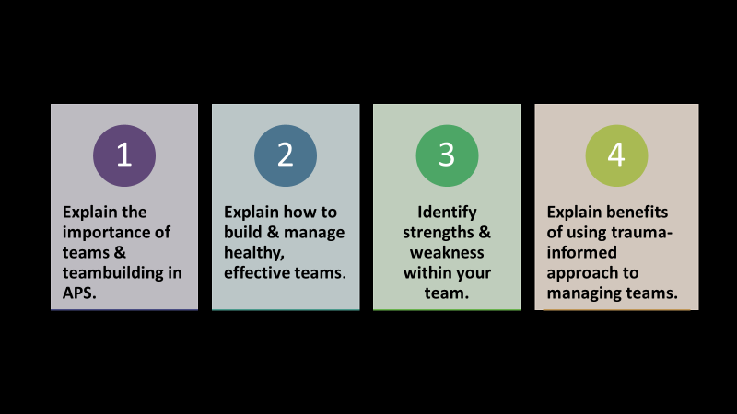
Facilitator says:

We all have different experiences working in or managing teams. This is an interactive training that will allow you to share team successes and challenges with each other. In today’s training, you will gain experience needed to be successful in building and managing effective teams.

(Facilitator paraphrases each of the learning objectives.)

Slide 6

Facilitator says:

In a moment, you will be divided into break-out groups.
You will be given 10 minutes to first introduce yourselves and then answer this question:
What do you find most challenging when it comes to managing teams in the workplace?
In-Person Guidance: Divide into small groups or 4-6 by tables.
Virtual:Producer Guidance: Assign the breakout rooms (4 to 6 people per breakout room) and set the timing for 10 minutes. Write the question “What do you find most challenging when it comes to managing teams in the workplace?” into the chat BEFORE sending the participants into the breakout rooms. Let participants know that, if they forget the instructions to any breakout activity, they can refer back to the chat.

Facilitator says:
Welcome back, everyone! Let’s have the spokesperson from Group One tell us what challenges they would like to report.
Facilitator note: As each group shares, acknowledge and discuss challenges as reported. Possible challenges might include: remote working situations, constantly changing teams (employee turn-over), low morale, challenging team members, getting team “buy-in” to changes.)
Slide 7 | 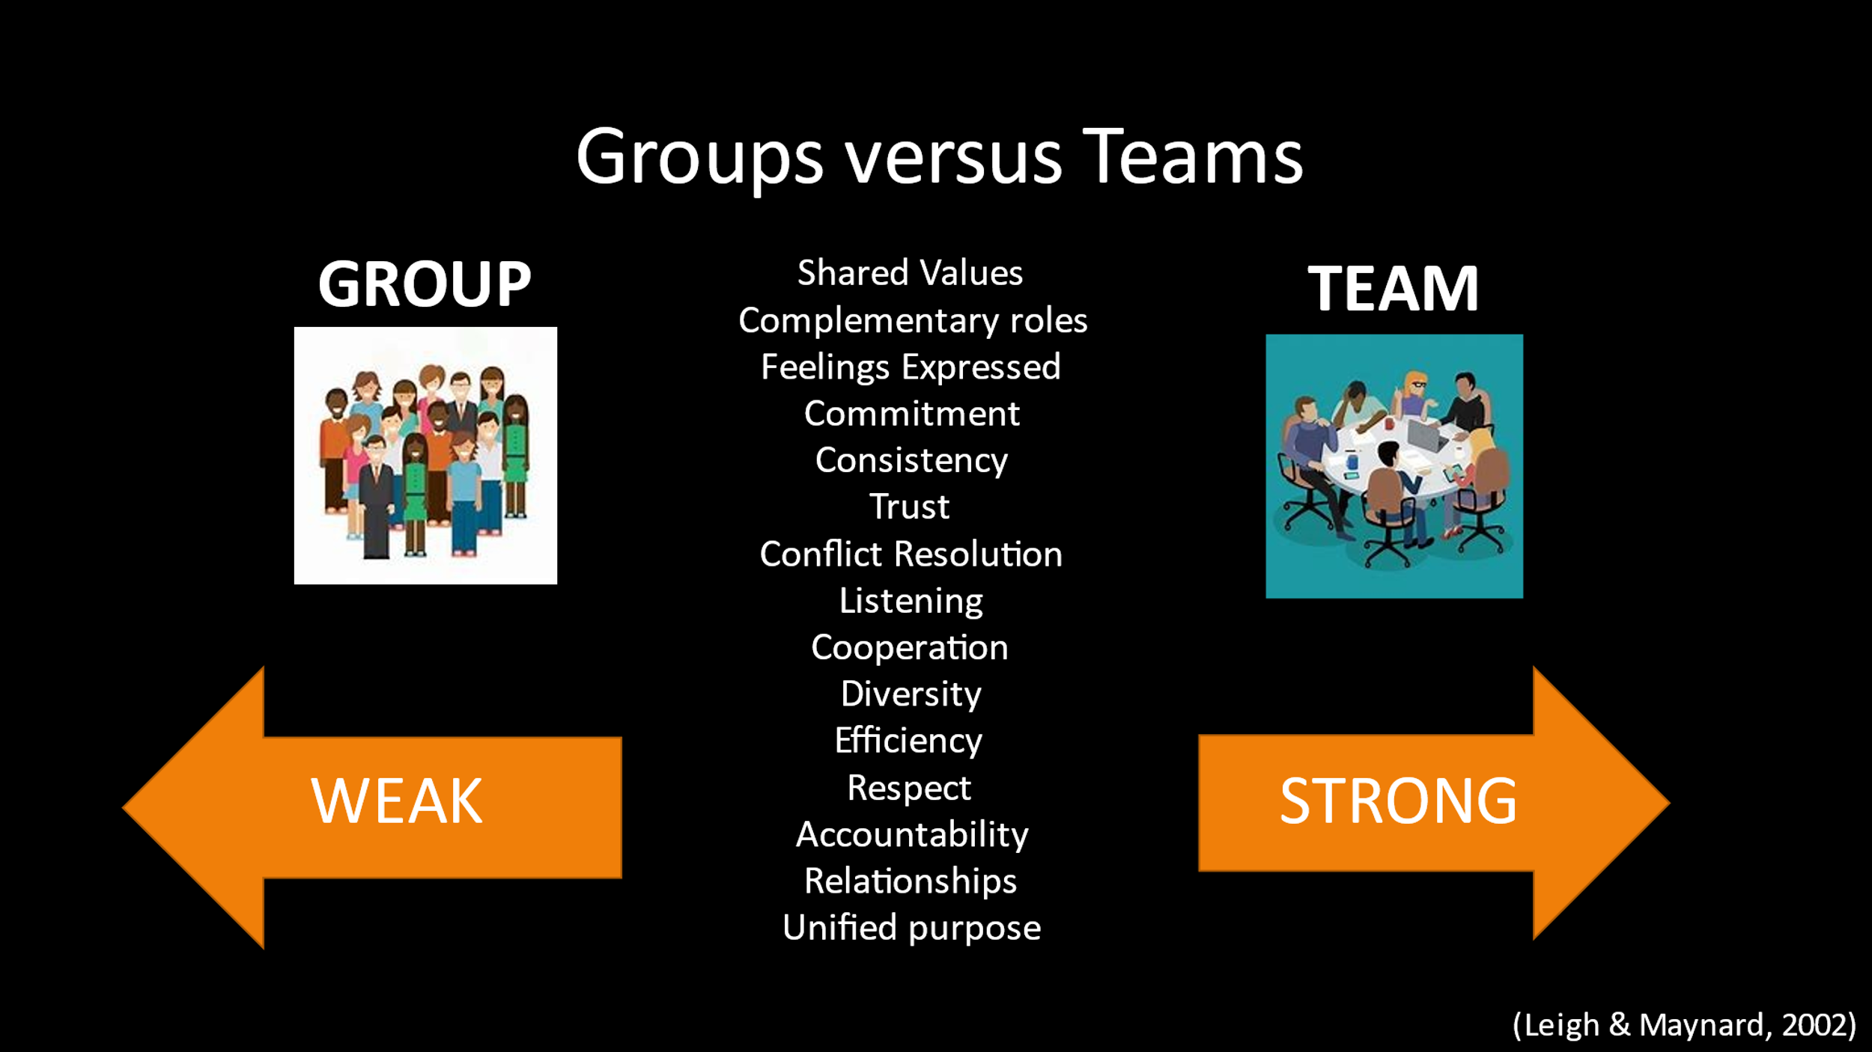
Facilitator says:

In order to clearly establish what a team is, we need to first determine the difference between a group and a team.

Facilitator asks:

Is there a difference between groups and teams?

Facilitator says:
According to (Leigh & Maynard, Leading your Team: How to Involve and Inspire Teams, 2002) The answer is yes: there are big differences.

“A group can be thought of as individuals who may share a common goal or who may combine efforts to reach a goal.”

“A team is more complex when broken down into specific characteristics. A team consists of individuals who share a common goal and/or value and employ their own behaviors and performance to fulfill that commitment.”

For example, a group of people going to see a movie together is quite different from a hospital multidisciplinary team.

The terms “Team” and “Teamwork” are commonly used in workplaces as many professions rely on a team “unit” to achieve great results. Teamwork is essential in APS as we are dealing with individuals’ health, safety, independence, and well-being.

Facilitator note: Step through the characteristics listed on the slide one by one. Each characteristic will appear with a mouse click. Review all characteristics.

Facilitator asks:
Which characteristic stands out to you and why? Please unmute yourself or type in the CHAT to respond.
Producer reports CHAT responses.

Slide 8 | 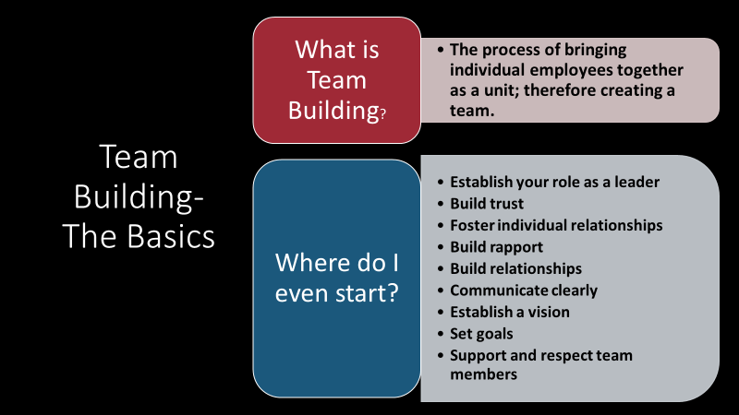
Facilitator says:
The definition of teambuilding can be thought of as the process of bringing each of your individual employees together as a unit; therefore, creating a team.

Teambuilding is just the beginning. It is vital for a good leader to also inspire and maintain healthy dynamics within the team.

Teambuilding can be a difficult process. A leader, experienced or not, may have a hard time engaging individual members of the team, or the team as a whole…and this takes practice and it takes time to create that perfect synergy.

Teambuilding does not necessarily roll out neatly. Even if you are a leader of a mature team, there are constant changes. Just like any relationship. Ultimately, teambuilding is a process that requires initial and ongoing attention and care.

Team building begins with YOU! The team leader! And the actions you see on the slide – from providing leadership, relationship-building, communicating and goal-setting
help create a good foundation for building a team.
Slide 9 | 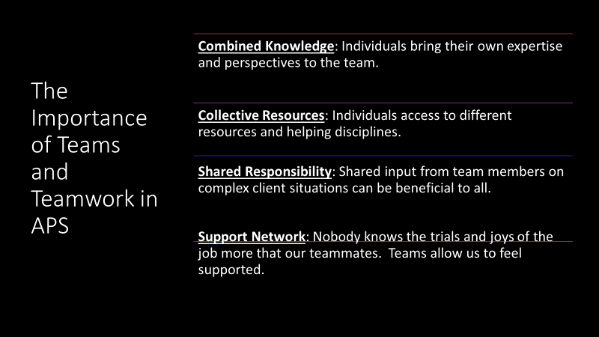
Facilitator says:
Teamwork is essential in APS and it would not be beneficial to the client nor your staff member to work in a silo due to the complexity of the job.

Teamwork allows each team member to contribute the following:
- Combined Knowledge: Each APS professional has a different background: educationally, professionally, socioeconomic status, past and present relationships, etc. This makes each staff member incredibly unique in their own views and allows each individual to be a subject matter expert in many different areas. Because of the complexity of our clients, and their own family dynamics/socioeconomic status/past trauma, etc. being able to tap into the different perspectives of the different team members allows for a 360-degree view of the APS case.
- Collective Resources: Whereas each staff member may be familiar with similar resources, some may have professional relationships with individuals within various organizations. Sharing this information and partnering with one another can ultimately cut down on time.
- Shared responsibility: Social work inherently is a hard job. APS clients’ situations are becoming more complicated; resources are limited, and the hours in the day to serve these clients are limited. A team committed to the profession, the clients, and each other, produces greater outcomes.
- Support Network: Social work can be emotionally, mentally, and at times, physically challenging. It is important to have a strong unit of support to rely on. Each of us have our friends and family members outside of our profession that are there to support us; however, do they really understand (see, hear, feel) the day to day work that APS professionals face like your fellow team member? Having that safe space of likeminded professionals that share core values and goals to fall back on after a difficult day is crucial to teamwork and fulfilling to team members.

APS workers, in many ways, are like first responders. They share a common, sometimes cynical sense of humor and often bond very closely with their coworkers as a result.

As the team leader, it is your responsibility to appreciate and leverage what each individual brings to the table and tap into the strengths of each individual to support the team as a whole.
Slide 10 | 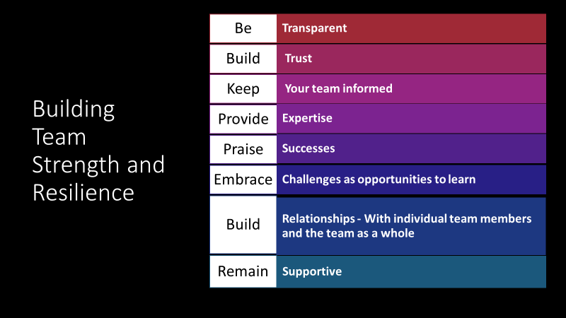
Facilitator says:
Building strength and resilience in your team can take time, but there are steps that you can take to be successful at both.
- Start by being transparent. You may be new in your supervisory role, and that is ok! Be transparent about learning your current role. What do team members expect or need from you? What do you need from them? Invite and encourage that transparency because you want to ensure that the team is healthy and successful. Encourage your team to provide constructive feedback about the work culture and about your performance; however, try not to take this personally or get defensive. Use this feedback as an opportunity to see what you can improve within yourself.
- Build trust. Let the team members know that while you are leading the team, you are still part of the team. That means being open to other points of view and providing honest feedback.
- Keep the team informed as to what is going on organizationally; the team will appreciate knowing information ahead of time versus being blindsided.
- Provide Expertise: While you are learning your new role, do not let that discourage you from giving your expertise to the team.
- Offer praise for successes: It is human nature to want praise, so do not miss an opportunity to give it!
- Approach challenges with opportunities to learn. There is nothing wrong with asking: What could we have done differently? How can we learn from it? How can this make the team stronger in the future?
- Build Relationships: Connect with your team! What do you have in common? Is it cooking? Have a cook off! You can find a common ground with each team member as a whole, and as a unit, without pushing professional boundaries.
- Remain Supportive: Recognize each employee’s efforts, be available to listen, and be ready to give advice. Support the individual and the team in the decision-making process.
Using these strategies, helps your team to build strength and be resilient in any situation. Because each member knows what to expect from you as you navigate your team.
Slide 11 | 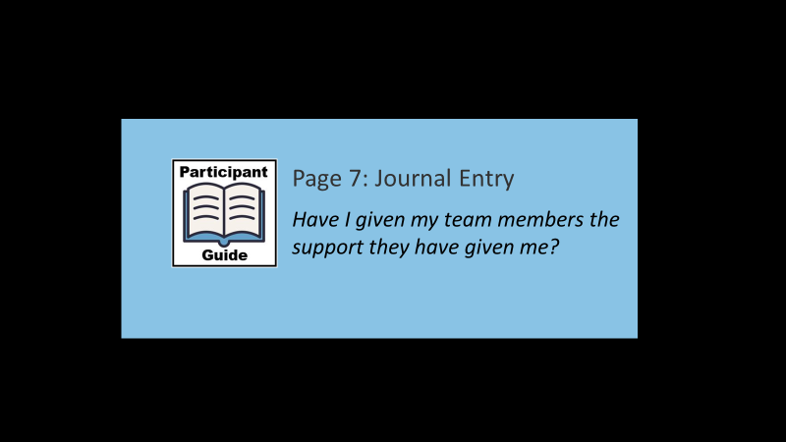
 | Please note the journal entry on Page 7 of your Participant Guide: “Have I given the support to my team members that they have given me?”
Slide 12 | 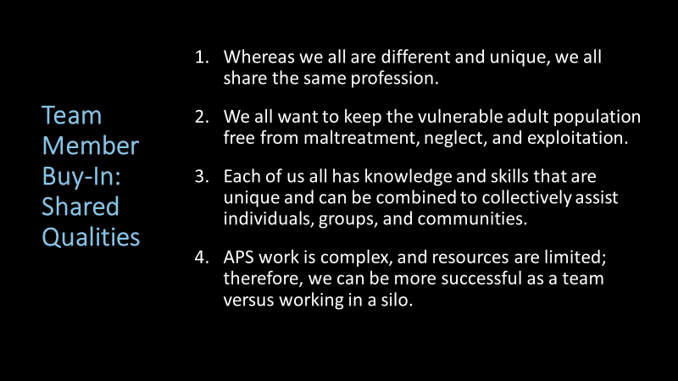
Facilitator says:
Don’t worry if you do not know where to start. You may be managing peers or a team that has history with another supervisor.

Getting individual buy-in may seem like a difficult process, and it is at times. Start with the basics that you see on the screen: what we all already have in common:
- Our shared profession.
- Our desire to keep vulnerable adults free from maltreatment, neglect, and exploitation.
- Knowledge and skills that can be used collectively
- Complex work and limited resources that can be more successful working as a team.

Slide 13 | 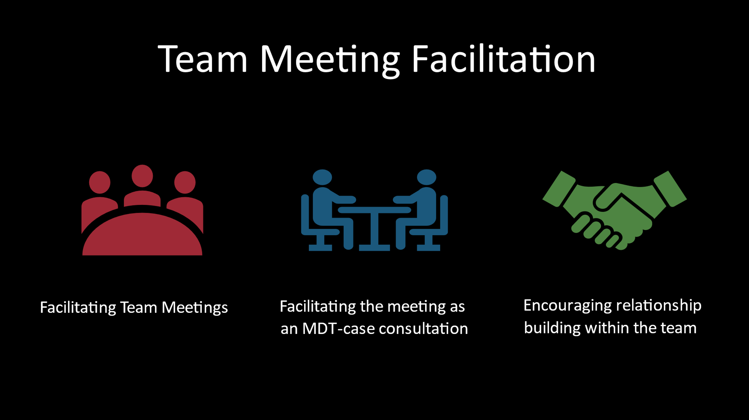
Facilitator says:
Team meetings and their functionality are essential to how a team performs. When you are having your team meetings is truly when you can see in real time your team functioning as a solid unit.

Effective team meetings start with structure, purpose, and goals.
- First, you want to design the meeting-
  - What is the purpose of the meeting? What do you hope to achieve?
  - Create an agenda and send it out to your staff members in advance.
- Next, you will conduct the meeting-
  - Before diving into agenda items, start with an ice breaker, or check-in.
  - Discuss the items on the agenda and assign action items as needed to team members and yourself.
- Finally, open the meeting to the members. This can be thought of as a round table. Go around the table and call each participant to see if they have any questions, concerns and comments. This personalizes the meeting and allows each staff member to have input.
Slide 14 | Facilitator says:  Team meetings are also an opportunity to have a team MDT. Encourage participants to bring difficult cases to discuss at the meeting. Have your staff member present  the case and what they are struggling with. This will create a positive problem-solving work environment.  During meetings, model professional behavior for your team.  Use team meetings to professionally develop the team and give praise.  And……food is always good! Nothing boosts morale like having breakfast together before diving into the difficult stuff! If you have a remote workforce, have coffee together as a team virtually.  Any other ideas that you’ve used to give your team meetings some energy? Use your CHAT box to share thoughts.  (Producer acknowledges comments.)  Thank you for those ideas!  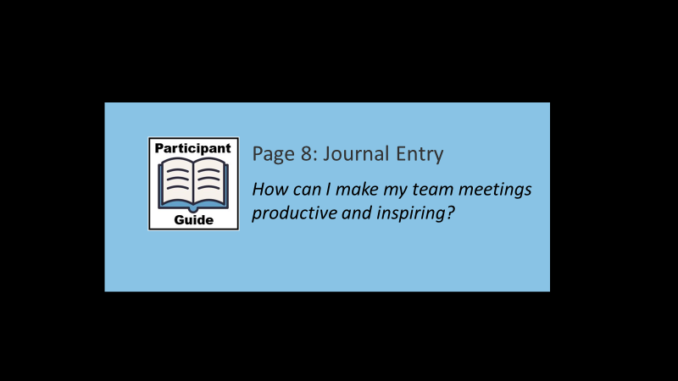  Facilitator says:  And please note the Journal Entry on Page 8 of your Participant Guide about using some of these ideas to make your team meetings productive and inspiring.
Slide 15 | 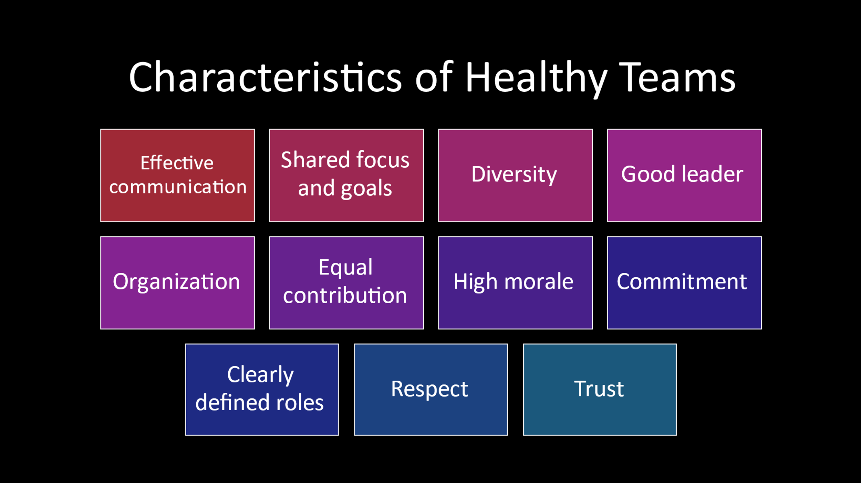
Facilitator says:
So let’s now talk about the characteristics of healthy teams. Take a few minutes to review this slide.
Please either unmute yourself or type in the CHAT which of these characteristics stand out to you?
(Producer acknowledges responses as they are offered. )
Facilitator says:
This list on the screen is not exhaustive; however, it is the leader’s responsibility and role to ensure that the team is functioning in a healthy manner. Healthy teams produce results; individuals want to be part of a healthy team versus an unhealthy team.

Unhealthy teams get stuck in their own dysfunctional role which in return can affect productivity and morale resulting in a poor work environment not only for the team, but for you as a leader.

Individuals communicate more honestly when they are not afraid to reveal themselves.
Slide 16 | 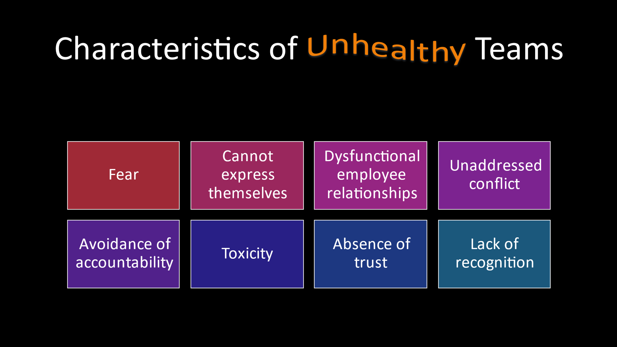
Facilitator says:
Now let’s contrast characteristics of healthy teams with those of unhealthy teams.
Take a look at this slide and then type in the CHAT which characteristics stand out to you as contributors to an unhealthy team.
(Producer: types question in chat box)
Facilitator says:
It is crucial for leaders to be aware of what is happening in their teams. These characteristics may not always be apparent; some of these characteristics may be team characteristics, while others may be individual.

Behaviors of unhealthy teams can include:
- Toxic team members that are not held accountable.
- Problems are not addressed and go underground causing additional problems.
- Skills are glorified over relationship-building.
- Indirect communication versus honest and open communication.
- Gossip, unhealthy competition, blame, and team members looking for fault in others.
- Favoritism by leadership.

So here are some key take-aways:
- Do not create a fear-based culture. This will decrease team and individual morale.
- If the team appears to be unhealthy, achieve change by taking personal responsibility.
- Acknowledge conflicts. Approach conflicts by addressing the behavior in a supportive way by focusing on issues, not personalities. If you focus on personalities, staff may feel that their character is being attacked.

Slide 17 | 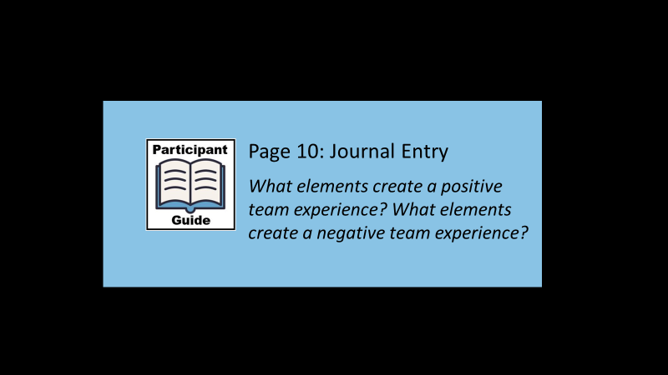
 | The Journal Entry on Page 10 of your Participant Guide asks you to think about elements that create both positive and negative team experiences.
Slide 18 | 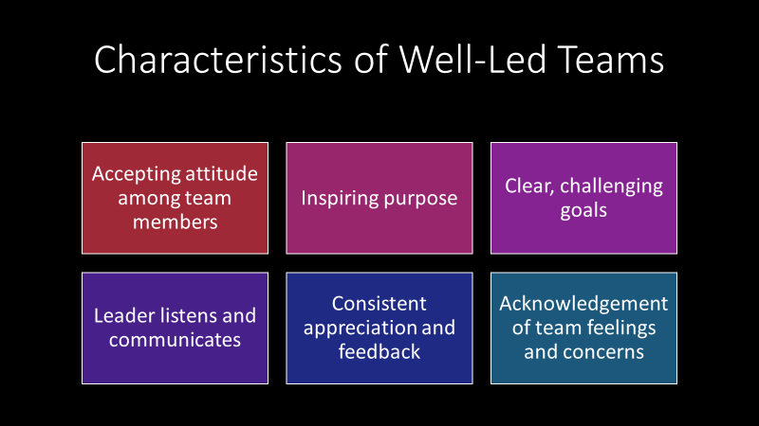
Facilitator says:
So now let’s look at some of the characteristics of well-led teams:
- Group morale is higher when the group is accepting of individual member’s faults and appreciative of his/her strengths- but we first must accept these in ourselves.
- Teams that have an inspiring purpose can be unstoppable.
- Good leaders will set inspiring yet challenging goals with clarity.
- Good leaders will listen and communicate to team members on how to achieve goals.
- Great leaders will give appreciation and feedback on a consistent basis.
- Great leaders will acknowledge individual and team feelings and concerns.

Slide 19 | 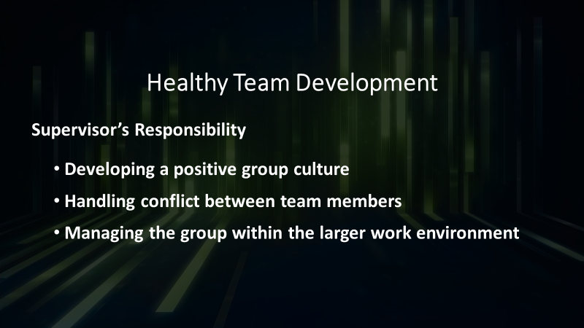
Facilitator says:
Even very seasoned supervisors can find themselves daunted by the task of leading groups. Team development is not a linear process and at times the process may be uncomfortable. There is an inherent difference between leading individuals and leading groups, and it is essential that supervisors are aware of these differences.

Lawrence Shulman studied the role of a supervisor in a social work setting and he found that teams had specific tasks that they needed to complete as a group. The supervisor's ability to lead the team through these fundamental tasks are an essential part of what makes the role of the supervisor so different when leading groups as opposed to individuals.
- Developing a positive group culture is a key part of any team's formation. By coming together, the team members create an entity that is greater than the sum of the parts. The level of cohesion of the group as well as the behavioral norms that dictate interactional patterns make up an important part of a team's culture. It is key that a supervisor helps a team to develop a positive identity.
- Handling conflict between members is another key responsibility that is delegated to the supervisor unless a group is highly developed. Ignoring conflict that arises between members can destroy the group's positive culture and negatively impact group interactions and productivity. It must be addressed.
- Managing the group within the larger work environment - refers to the supervisor's responsibility to serve as a buffer between the greater program and the team. APS units, for example, usually function as one part of the APS program, a small part of a larger department serving vulnerable adults, and this department is usually part of a larger agency, within a county system, sometimes, and/or that functions within the state or federal political and budget climates. This context significantly impacts the APS team although this impact may be more subtle than obvious at times. It is the responsibility of the supervisor to bring this context back to the team environment and to prepare the team for changes and upsets that may occur within the larger context.
Any questions or comments before we move on?
Slide 20 | 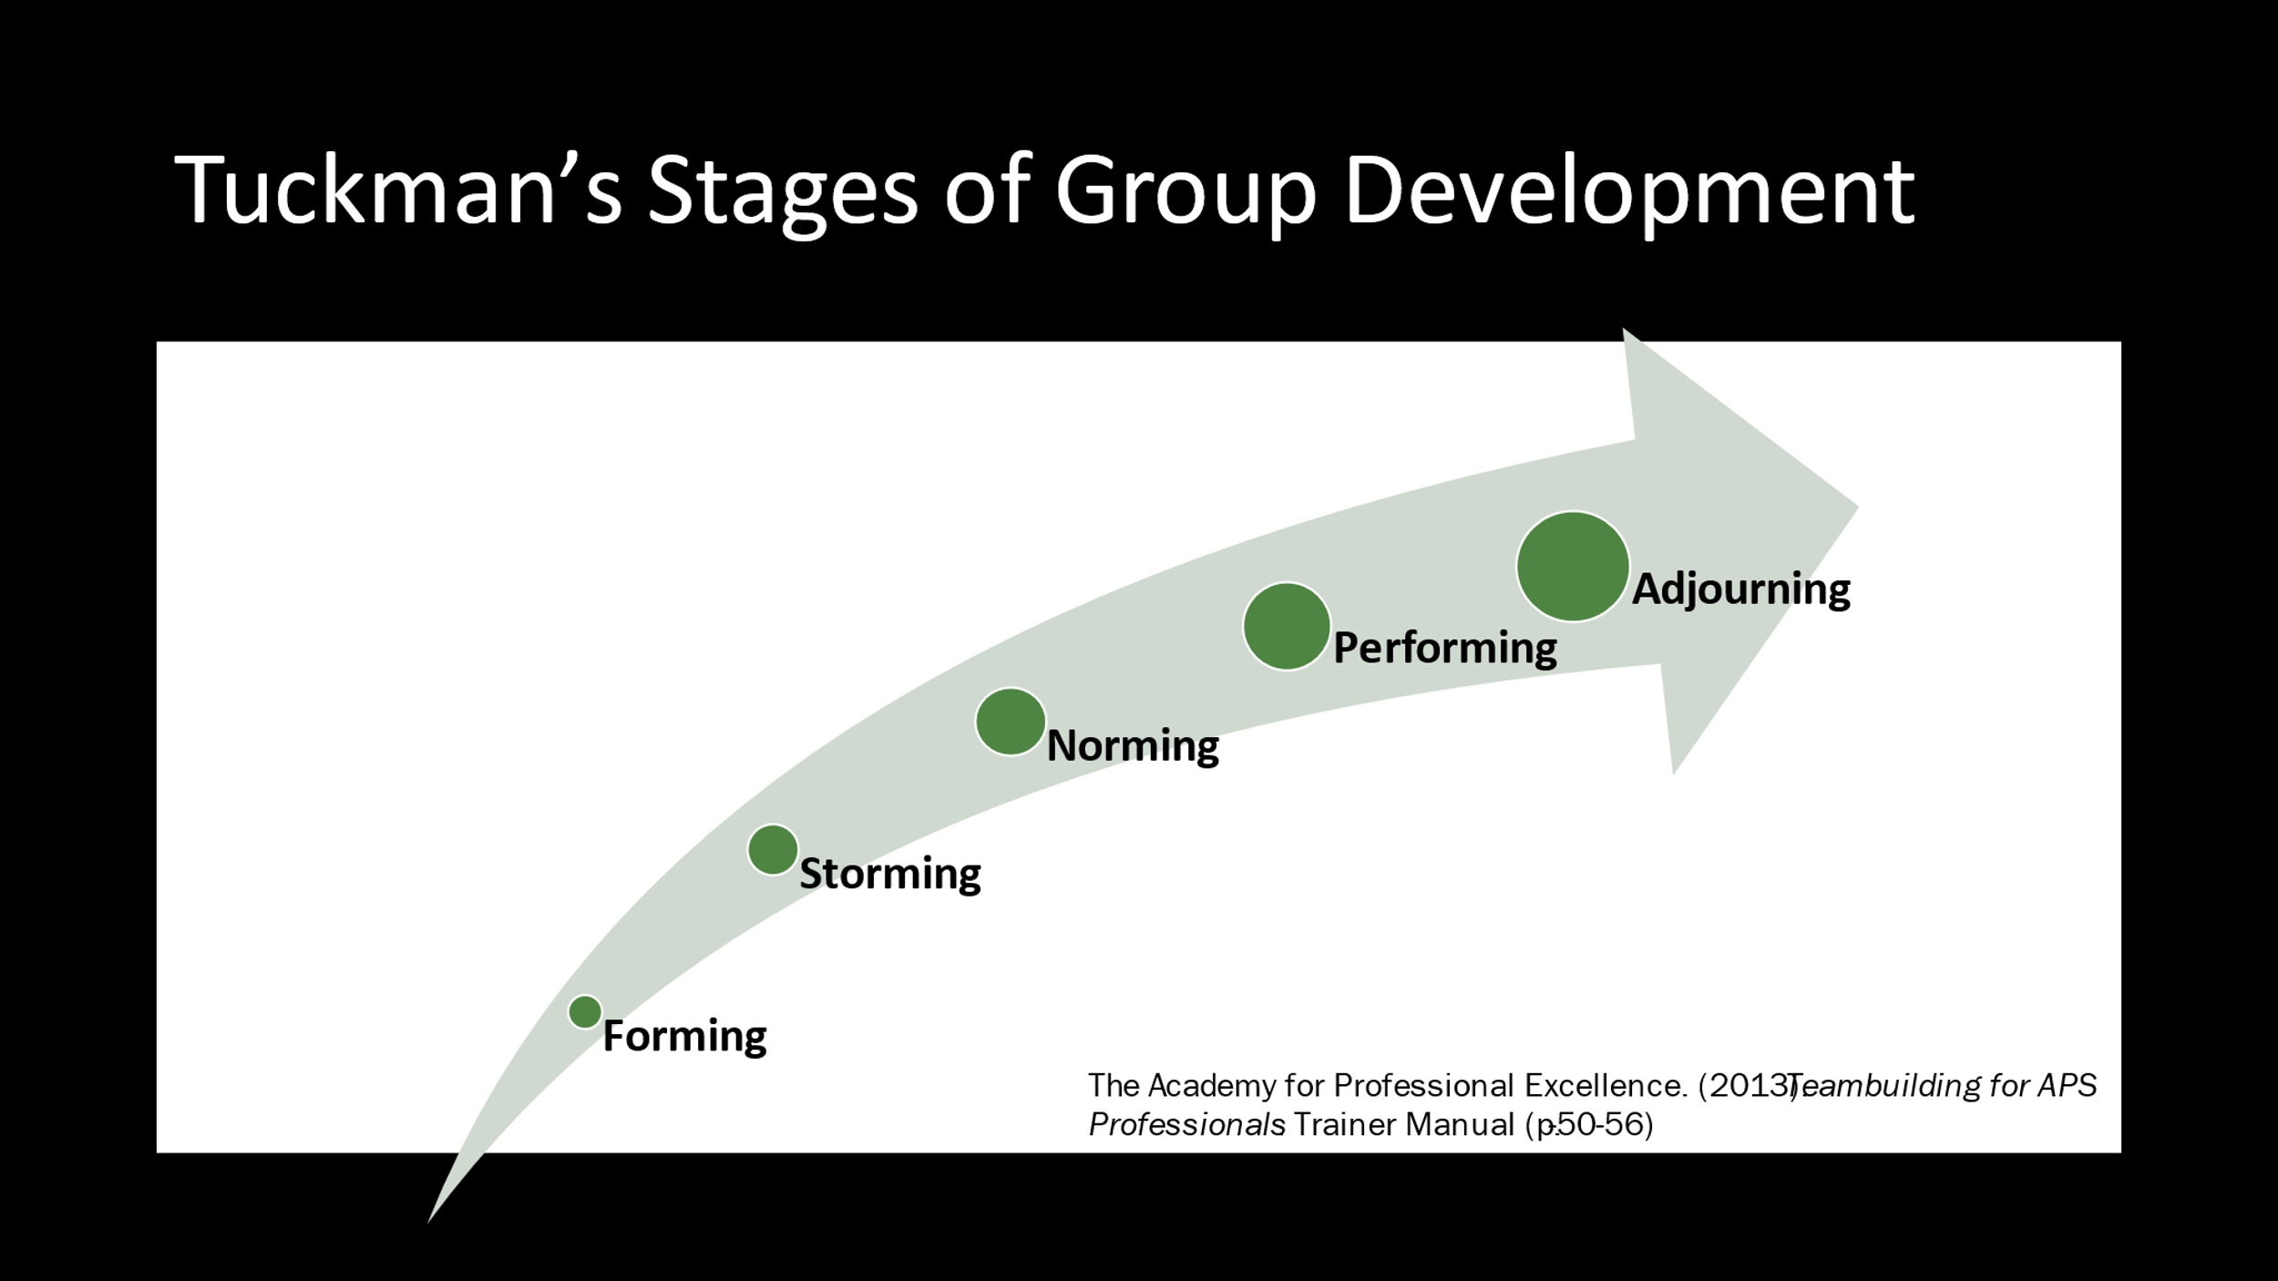
Facilitator says:
Now, we’ll look the different stages of group development as proposed by Dr. Bruce Tuckman in 1965.
As you see on this graphic, groups move through various stages as they develop - from “forming” to “adjourning.”
- The Forming stage, sometimes called the “tentative” stage is an initial one . The members of the group have not taken on roles yet and they look to the supervisor to direct them. This is the time that the team is beginning to define itself and develop trust.
- During the Storming stage – also known as the “Emerging” stage - members may be competing with each other for power or confused about their roles. The role of the supervisor here is to coach and guide the group members to collaborate effectively.
- The Norming stage - also known as the “Advanced” stage – is when the work that the team leader and the members have put into the group process is paying off. Members are more comfortable with each other. The supervisor can now enable others to accomplish their goals because norms have been established and group members are working together effectively.
- The Performing or “Mature” stage is when the team has developed a track record of successes and accomplishments. Norms are well-established. The supervisor can take a less directive role and enable the group to be more productive.
- And the Adjourning stage happens when the team has accomplished its purpose and is no longer needed. Even though doesn’t always apply to APS Units, it is worth mentioning since supervisors may often be involved as leaders of other groups. (Ex.
training group, multi-disciplinary team, pilot group, new policy group)
Facilitator asks:
Take a minute to think about these stages and then, using your CHAT, share with the group where you think your team is at this point in terms of its development.
(Facilitator invites responses from the group and acknowledges their experiences. May also ask participants how the addition or loss of team members affects stages of team development. )
Slide 21 | 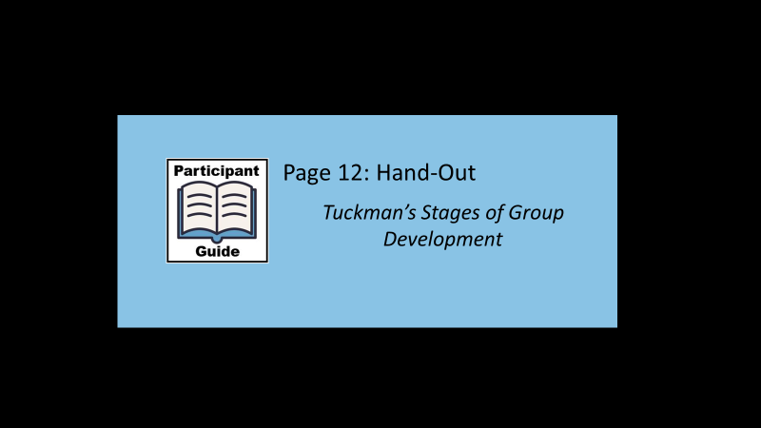  Facilitator says:  Your Participant Guide has a hand-out with more information about these stages of group development.
Tuckman’s Stages of Team Development

Stages of Team Development
 | Forming  Leader directs group activities.  Roles of individuals are unclear  Low trust level between members  Members may pretend to agree with leader on all matters  Storming  Leader coaches group members.  Members vie for influence.  Confusion about roles and boundaries.  Sub-groups form.  Unresolved conflicts arise  Norming  Leader facilitates and enables.  Members become more comfortable with one another.  Conflicts from prior stage resolve.  Members speak freely.  Group begins to feel united and cohesive. | Performing  Leader delegates and oversees.  Norms become strong and binding.  Group is productive and able to resolve disputes.  New member may upset the balance.  Performance may lag due to burnout.  Adjourning  Leader recognizes accomplishments.  Marks the end of the team.  May result in breakdown of group skills.  Conflict may arise.  Separating is difficult.  Evaluation of performance.
Slide 22 | 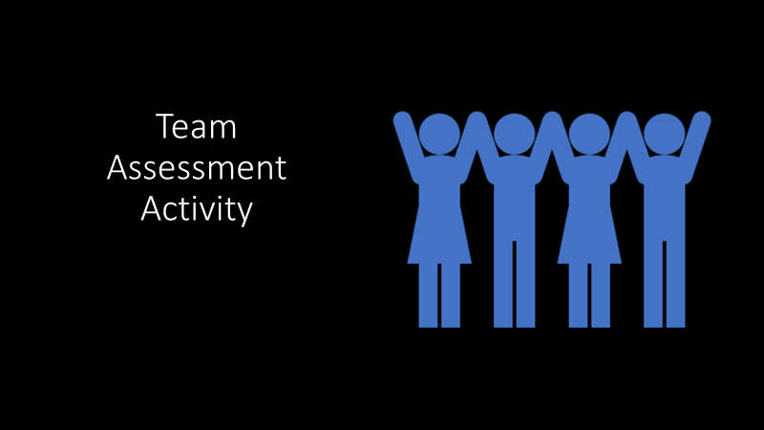
Facilitator says:
So now let’s shift our focus to your responses on the pre-training team assessment you were asked to complete: How Good Are You and Your Team at Teamwork and Team Building?

Slide 23 | 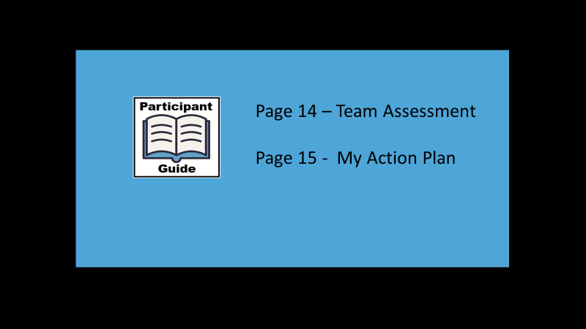
Facilitator says:
First, please turn to Page 14 in your Participant Guide and review your reponses to the Team Assessment that you completed prior to today’s training. Then, choose one or two of the ratings you gave yourself that you would like to improve or strengthen. Next, on Page 15, write down your thoughts about “My Action Plan” What would I like to strengthen? And how will I achieve this goal?

(Facilitator allows 10 minutes for this written activity then invites participants that are willing to share their ideas for strengthening their teams.)

Hand-Out: Team Assessment
How Good Are You and Your Team at Teamwork and Team Building?
Trainer Note: The questions listed below are what the participants are asked in the Participant Guide. This abbreviated version that does not contain the response options.
Instructions
For each statement, please rank yourself on a 5-point scale from 1-5 with 5 being “very often” to 1 being “not at all”. Please answer questions as you actually are (rather than how you think you should be).
Answers options range from “not at all” through “very often”.
1. My team is knowledgeable about the stages of development teams can be expected to go through.
2. Team members are provided with a great deal of feedback regarding their performance.
3. Team members are encouraged to work for the common good of the organization.
4. There are many complaints, and morale is low on my team.
5. Team members do not understand the decisions that are made, or don't agree with them.
6. People are encouraged to be good team members and build good relationships.
7. Team members are provided with development opportunities.
8. Meetings are inefficient and there is a lot of role overlap.
9. Team members are encouraged to commit to the team vision, and leaders help them understand how their role fits into the big picture.
10. Team members are often given a chance to work on interesting tasks and stretch their knowledge and capabilities.
11. The team understands what it needs to accomplish and has the resources needed to be successful.
12. Conflict and hostility between members is a pervasive issue that does not seem to get better.
13. People feel that good work is not rewarded, and they are not sure what is expected of them.
14. Team members balance their individual needs for autonomy with the benefits of mutual interdependence.
15. Working relationships across units or functions is poor, and there is a lack of coordination.
(Team Effectiveness Assessment, n.d.)
Slide 24 | 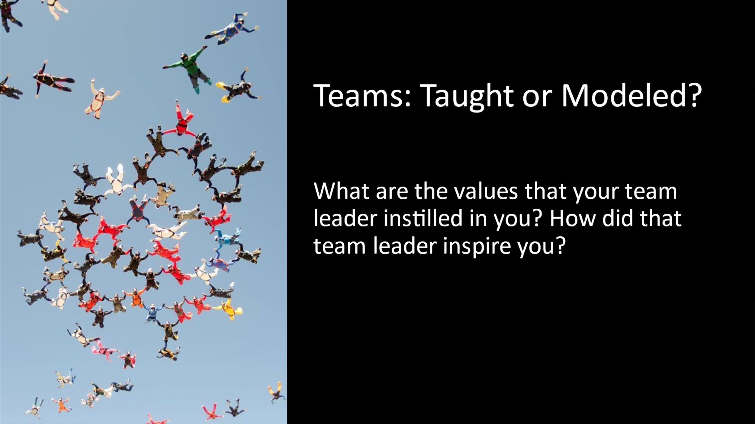
Facilitator says:
In a in a moment, you will be discussing in break-out groups a great/inspiring team that you were once part of and really stood out to you. (sports, church, workgroup, college project).

You’ll have 15 minutes to discuss the following questions in your group:

What are the values that your team leader instilled in you? How did that team leader inspire you?

The assigned spokesperson for each group will write down the qualities/values/inspirational techniques that each participant shares that was used to model the value and importance of teams. Then we’ll share each group’s list as a group.

In-Person: Break into table groups of 4-6 people.
Virtual: Producer notes:
Assign break out groups and spokespersons.
Monitor time and broadcast 2-minute warnings.

Facilitator says:
Welcome back everyone! Now let’s hear from the spokesperson from each group.

(Facilitator acknowledges and discusses some of the responses as they relate to various characteristics and styles of team leaders in sharing values and inspiration.)

There is not necessarily a “best way” of building and managing teams; just like in this activity. All of you had different qualities and characteristics of a team leader that stood out to you. These qualities helped shaped you into who you are today. Team wisdom is drawn from many sources and experiences. Teamwork is not taught. Yes, you are taking a class on teamwork; but really, this class is to enhance the skills that you already have.

Fire up the value of teams in your staff. Inspire them, empower them, praise them and develop them!

As supervisors and leaders of your teams, you have the ability to set the tone and create a work environment that will positively impact your staff and help them to be more productive and potentially more satisfied with their work. Additionally, if we create a positive work environment, like our workers, we will also like going to work more!

On Page 17 of your Participant Guide, you’ll find a Journal Entry asking you to reflect on how you will model the value and importance of teams – and how you will inspire your team. I encourage you to complete that after the today’s training.
Slide 25 | 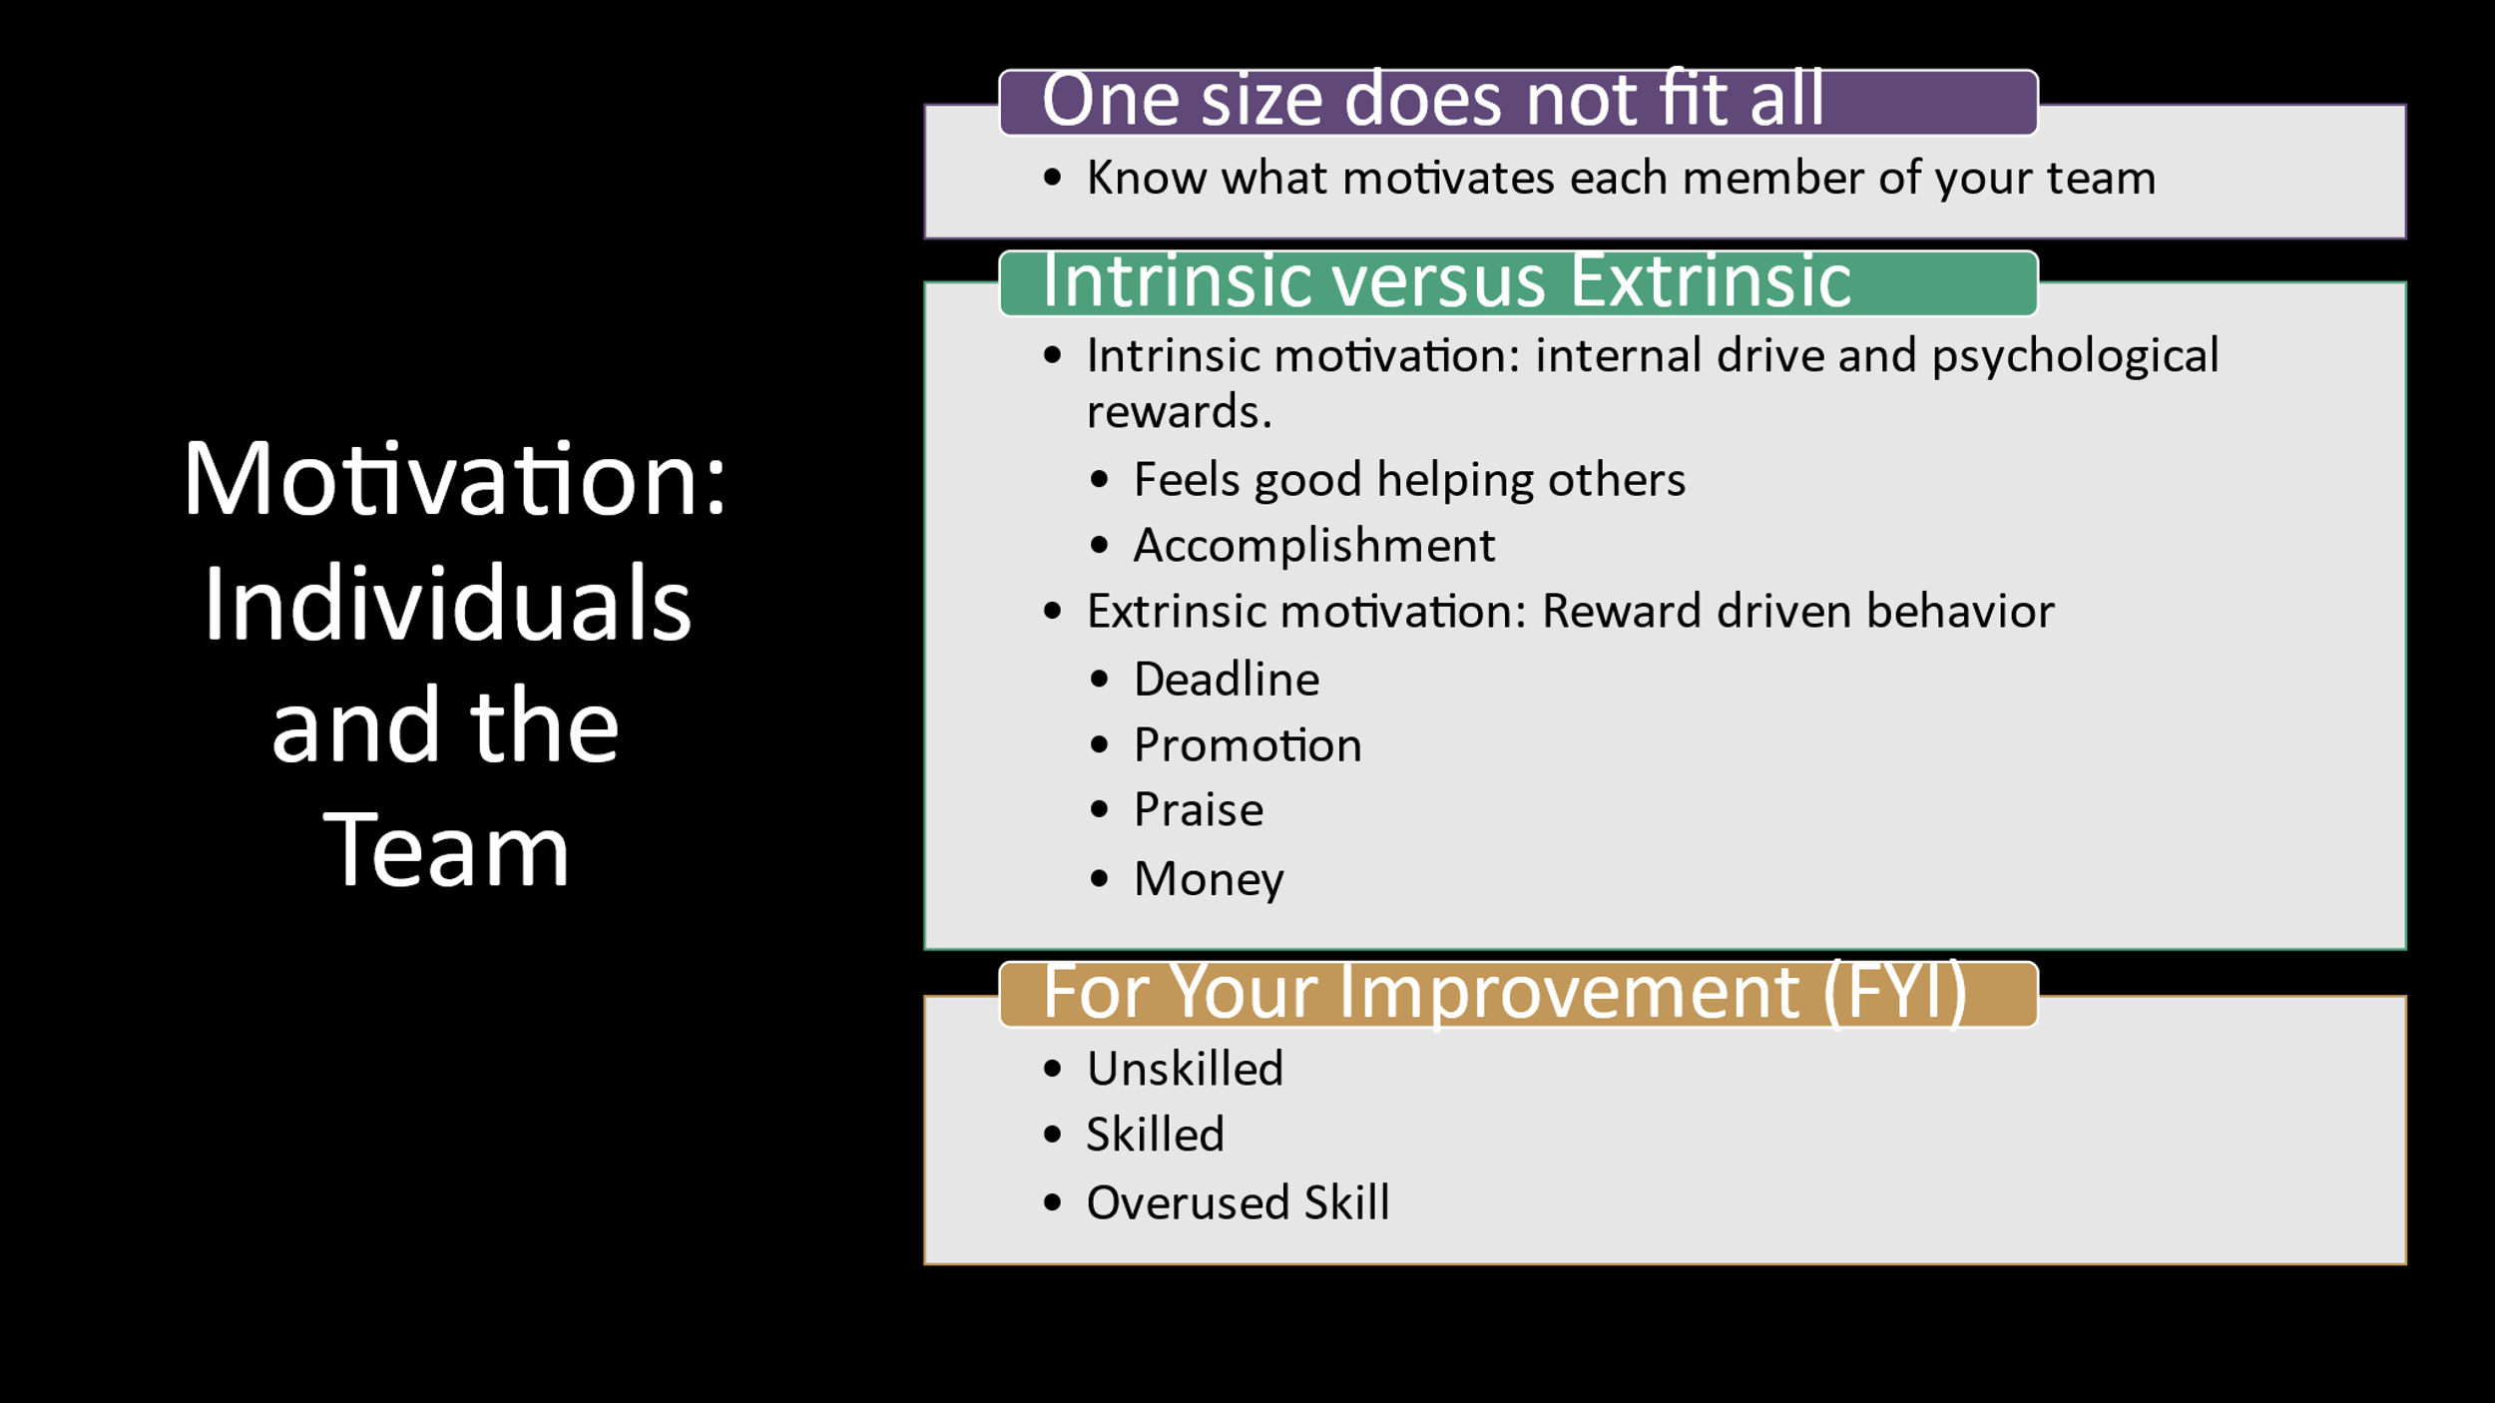
Facilitator says:
So now let’s talk about motivation. It is your job as a team leader to know each of your team members and what drives them. Both individually and collectively as a team.

Ask yourself, Is my staff member motivated internally, externally, or both?

- Intrinsic motivation can be thought of as the internal rewards or “feel good” rewards. Many of us got into the field of social work just for that, helping others and the sense of making a difference in people’s lives.

- Extrinsic motivation can be thought of as an external reward: recognition from peers or a supervisor, meeting a deadline, promotional opportunities, etc.

The supervisor can contribute to an employee's motivation, but it is actually creating a supportive, positive workplace that will continually motivate an employee.

To create a motivating work environment, it is essential that good work is rewarded. In the public sector we are not able to provide bonuses or raises, but we can provide praise. Supervisors should try to praise each of their workers on a consistent basis, even for very small achievements.

A motivating work environment must also have negative reinforcement mechanisms in place for substandard performance. Without systematic ways to reduce the likelihood of future negative performance, it will continue. Negative reinforcement for poor work performance coupled with rewards for good work is key.

The contrary type of environment is one in which an employee receives negative reinforcement for excellence. For example, if a star employee is always given more work than others because of their exemplary performance, the environment may ultimately demotivate the employee.

In union environments, it frequently occurs that co-workers may encourage high performing workers to "slow down" in order to not "raise the bar". This is the essence of a demotivating environment.

Additionally, if praise is not given out, if employees are not recognized, the environment will not be a motivating one.
For Your Improvement (FYI) is a book that is a supervisor’s guide for development and coaching. Written by Michael Lombardo and Robert Eichinger, this book dives into the competencies needed in leadership development. Each chapter has a competency and
defines how a skilled or unskilled leader manages that competency.

Let’s turn to that hand-out now on Page 20 of the Particiant Guide to see varying skill levels of motivating others.
Slide 26 | 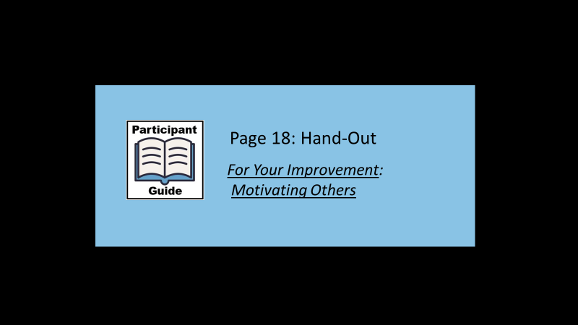
Facilitator says:
So let’s turn to that hand-out now on Page 18 of the Particiant Guide to see varying skill levels of motivating others.

Facilitator’s copy of hand-out:
For your Improvement: Motivating Others
By: Michael M. Lombardo & Robert W. Eichinger
“Greater things can happen when people are motivated.”
Unskilled
- Doesn’t know what motivates others or how to do it.
- People under him/her don’t do their best.
- Not empowering and not a person many people want to work for, be around or with.
- May be a one-style-fits-all person, have simplistic models of motivation, or may not care as much as most others do; may be a driver just interested in getting the work out.
- May have trouble with people not liking him/her.
- May be a poor reader of others, may not pick up on their needs and cues.
- Intentionally or unintentionally demotivates others.
Skilled
- Creates a climate in which people want to do their best.
- Can motivate many kinds of direct reports and team or project members.
- Can assess each person’s hot button and use it to get the best out of him/her.
- Pushes tasks and decisions down.
- Empowers others.
- Invites input from each person and shares ownership and visibility.
- Makes each individual feel his/her work is important.
- Is someone people like working for and with.

Overused Skill
- May not be good at building team spirit because of an emphasis on individuals.
- May be seen as providing inequitable treatment by treating each person individually.
- May not take tough stands when the situation calls for it.
- May take too long getting input.
- May be reluctant to assign work with tough deadlines
Slide 27 | 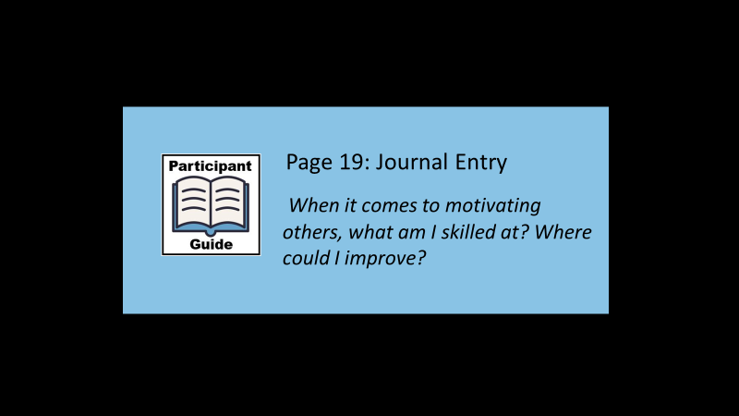
Facilitator says:
On Page 19 of your Participant Guide, there is a Journal Entry for you to complete after today’s training that asks you to think about your own skills in motivating others.
Slide 28 | 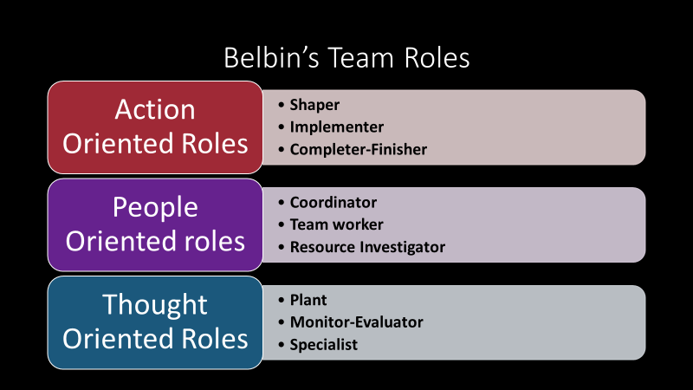
Facilitator says:
To fully understand how to leverage your team strengths, you must first become familiar with what each role that an individual may play.

Dr. Meredith Belbin studied teamwork and teamwork dynamics for years and came up with roles that team members may assume based upon their personalities and/or strengths. Some of the 9 roles may be easy to identify within your team, some may not be. That is why it is important to not only assess the individuals on your team at a macro level, but a micro level as well.

Remember, each team member brings to the table their strengths. That is why it is important to have diversity in your team. Belbin describes 9 team roles that make up great team dynamics.
Slide 29 | 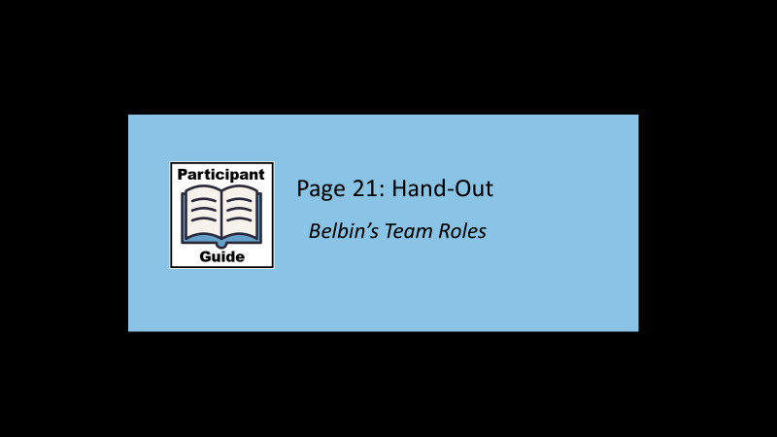
Facilitator says:
So let’s look now at a full version of Belbin’s Team Roles in your Participant Guide.
Facilitator briefly discusses the different roles that team members can assume, and the strengths and growth opportunities within each role.
Facilitator Copy:
Belbin’s Team Roles
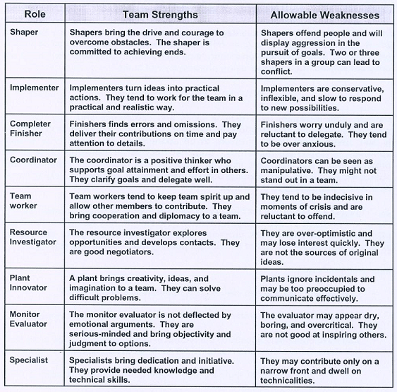
https://www.mindtools.com/pages/article/newLDR_83.htm

Facilitator says:
Becoming familiar with Belbin’s team role model will help you identify which individual will be most successful in each role; therefore, resulting in the best outcome for your team. Successful leaders are able to embrace the power of teamwork by becoming familiar with each individual’s innate strengths and applying those strengths to achieve success.
Slide 30 |  | 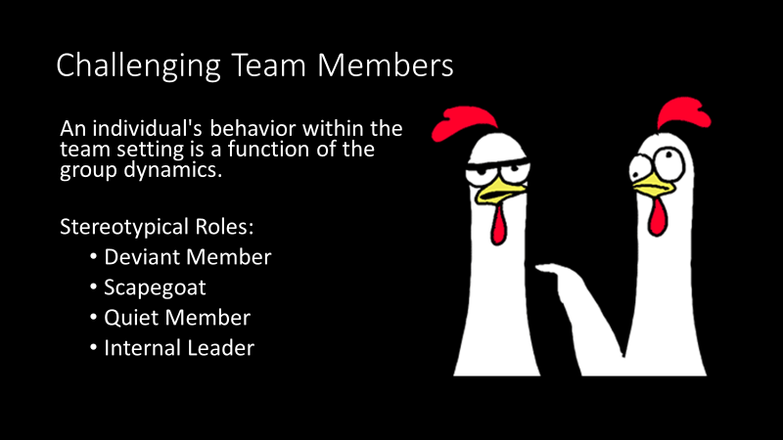
Facilitator says:
Now we’re going to talk about challenging team members. Groups are dynamic systems and as such, individuals can exhibit behaviors that may even be out of character with their more ingrained personality traits.

Lewin is considered to be the “Father of Group Dynamics” and back in 1935, he explained that the behavior of an individual within a team or group was an expression of that individual's social role in relation to the activities of the group and the roles of the other team members. (Shulman - pg.236-7)

Shulman breaks out stereotypical behavior patterns of individuals within the group setting to try to address these roles that often may be problematic for supervisors.
- A deviant member should not be considered in a pathological sense but rather an individual that frequently does not follow group norms regarding behaviors. A deviant member might be someone that refuses to follow procedural roles established by the group, or an individual who may make "low jokes" or "potshots". This individual may often be someone that is not committed to the team.
- The scapegoat is a term that you might be familiar with theory from family therapy. In a family with multiple children, there is usually one that is considered the scapegoat or the source of all the problems. This individual is not necessarily a rule breaker like a deviant member, but rather the group may collectively decide that this individual should carry all the blame. The result often is that the whole team will side against this individual and who is then an excluded team member. Supervisors must be aware of the role of the scapegoat because it is dangerous for a supervisor to side with the team against the scapegoat, or vice versa against the team and backing the scapegoat.
- The quiet member may be often forgotten but easy to pick out when you start to reflect on the individual team members and the way that they interact during team meetings. The quiet member is the individual that rarely contributes or questions. It is not necessarily problematic to have one staff member that speaks less frequently than others during team meetings, but it is essential that the supervisor check in with this employee on a one-on-one basis about their feelings related to the group and to encourage some participation with the team. It can occur that other team members may become resentful of those that do not contribute or they may feel that they are being judged by someone who is not participating.
- The Internal Leader is also easy to pick out during team meetings. This person or persons within the team can serve to be helpful and useful both to the group itself and the supervisor. This individual is the one that will help the group to tackle developmental tasks (the emotional function of the group) and handle business that needs attention (task completion function of the group). Supervisors should try to mentor this individual or individuals, but they must also make sure that they do not stifle other members of the team that may also be trying to take on a greater leadership role.
There is no best way to handle challenging team members. It is best to learn more about the individual and have a transparent, yet structured, conversation.
Slide 31 |  | 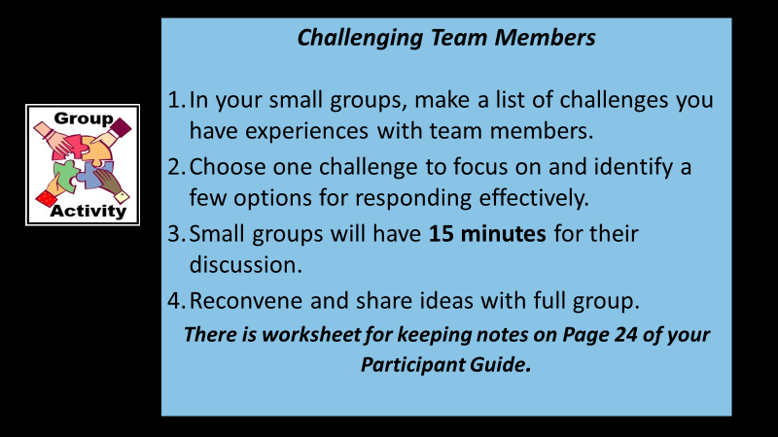
Facilitator says:
So to follow-up on this discussion of challenging team members, you will be meeting in break-out groups of 4-5 people with an assigned spokesperson.
In each group, participants will first create a list of challenging situations that they have experienced with their team members. For example, a team member whose negativity affects the whole team. Next, they will choose one challenge to focus on and identify some options for responding effectively.

You’ll be given 15 minutes for your small group discussion and then we will reconvene so the spokesperson for each group can report on their initial list of challenges; their choice of challenge to focus on, and their suggestions.
In-Person: Break groups by tables.
Virtual” Producer sets up break-out rooms and announces participants and an assigned spokesperson. Broadcasts a 5-minute warning after 10 minutes. Closes rooms after 15 minutes.

Facilitator says:
Welcome back! Let’s hear from each group’s spokesperson what you’ve come up with.

Facilitator acknowledges and validates each small group’s feedback and asks for additional comments, thoughts or ideas from the full group as each is reported.

Thank you for work and your responses about some of the challenges to team building! Sharing perspectives, experiences and suggestions about these issues can be useful for all of us!
Slide 32 |  | 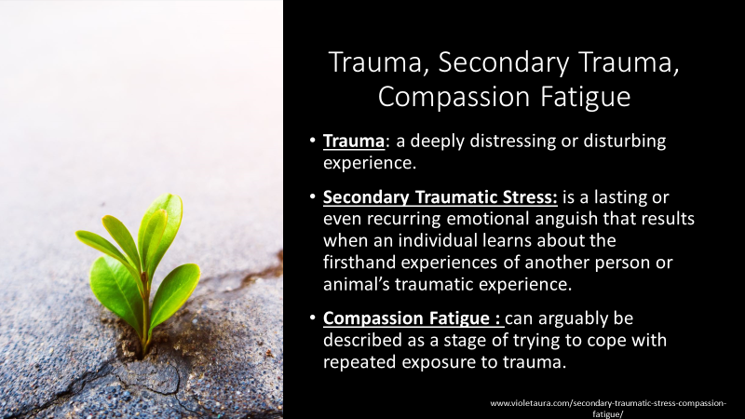
Facilitator says:
Although there are other training modules that focus on trauma and its effects on supervision, it is important to acknowledge how it relates to managing teams in APS.
What we have covered in this module is knowing your team and the individuals who are part of your team. It is also important to know if a member of your team is experiencing trauma, secondary traumatic stress, or compassion fatigue.

Trauma is defined as a deeply distressing or disturbing experience. Secondary Traumatic Stress is a lasting or even recurring emotional anguish that results when an individual learns about the firsthand experiences of another person or animal’s traumatic experience.
Compassion Fatigue can arguably be described as a stage of trying to cope with repeated exposure to trauma.

Trauma is associated with physical/psychological threats. Exposure to trauma is an occupational hazard for APS workers. APS Workers are often exposed to trauma since they are investigating situations of maltreatment of adults that may involve very distressing and upsetting human circumstances.

Become aware of signs that your workers may be experiencing negative impacts of trauma.

These signs include:
• Being afraid to take time away from daily activities.
• Thinking the worst in every situation
• Reacting disproportionately.
• Never taking a vacation.
• Forgetting why they do their job.
• Decreased performance at work.
• Constantly not getting enough sleep.
• Increased arguments with your family.
• Decreased social life.
• Isolation from colleagues, friends, and family.
As supervisors, you are probably all familiar with signs of trauma in your staff. Let’s take a few minutes to your CHAT and share a challenge you face in recognizing trauma when supervising remotely.

(Producer reports the CHAT responses and facilitator validates responses and thanks participants.)

Facilitator asks:
Any additional thoughts about what supervisors can do to recognize and support staff experiencing trauma? Please unmute yourself to share your ideas.
(Facilitator acknowledges and validates participant responses.)
Slide 33 |  | 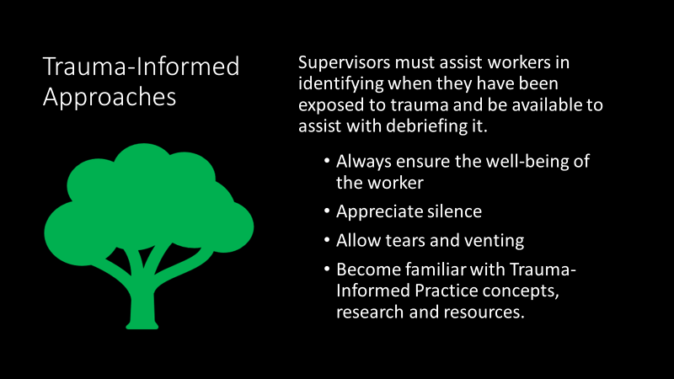
Facilitator says:
Supervisors must assist workers in identifying when they have been exposed to trauma and be available to assist with debriefing it. Here are a few guidelines:
- Always ensure the well-being of the worker.
- Appreciate silence.
- Allow tears and venting.
- Become familiar with Trauma-Informed Practice concepts, research and resources.
Now let’s look at few additional tips to navigate your team around trauma:
- When it comes to trauma and your team, individuals are more willing to disclose symptoms of trauma when they accept themselves and feel accepted by the group.
- The group bonding can help insulate individuals from trauma and will protect and support each other if they feel a shared purpose. Give workers permission to discuss difficult cases and feelings. Make sure workers know that you will support them seeking help when needed.
- The emotional support and encouragement that team members provide is one way that workers are able to take care of themselves.
- Encourage your workers to collaborate as a team around issues of casework.
- Encourage and model self-care – As you are reminded every time you fly, “Please fasten your oxygen mask securely before tending to others” – this is helpful in reminding you that, as a supervisor, you have the obligation to yourself and your workers to address your own self-care needs.

In other words, practice what you preach!
There is a good deal of information on trauma at MentalHealth.org including trauma-informed concepts, research and resources on the subject.
Slide 34 |  | 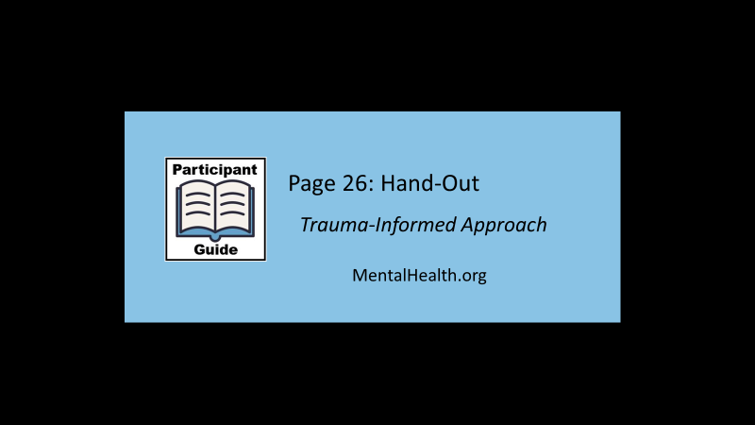
Facilitator says:
Now, let’s look at one example of their research in your Participant Guide on Page 26. This hand-out only touches on some of the information provided on that web page and there are many other resources you can access on trauma-informed care.

Facilitator Copy:
Trauma-Informed Approach
According to the concept of a trauma-informed approach, “A program, organization, or system that is trauma-informed:
1.Realizes the widespread impact of trauma and understands potential paths for recovery.
2.Recognizes the signs and symptoms of trauma in clients, families, staff, and others involved with the system.
3.Responds by fully integrating knowledge about trauma into policies, procedures, and practices; and
4.Seeks to actively resist re-traumatization."

A trauma-informed approach can be implemented in any type of service setting or organization and is distinct from trauma-specific interventions or treatments that are designed specifically to address the consequences of trauma and to facilitate healing.

Six Key Principles of a Trauma-Informed Approach

A trauma-informed approach reflects adherence to six key principles rather than a prescribed set of practices or procedures. These principles may be generalizable across multiple types of settings, although terminology, and application may be setting- or sector-specific:
1.Safety
2.Trustworthiness and Transparency
3.Peer support
4.Collaboration and mutuality
5.Empowerment, voice, and choice
6.Cultural, Historical, and Gender Issues

From this perspective, it is critical to promote the linkage to recovery and resilience for those individuals and families impacted by trauma. Consistent with this definition of recovery, services and supports that are trauma-informed build on the best evidence available and consumer and family engagement, empowerment, and collaboration.
Slide 35
Facilitator says:
As you may recall we learned about supervising staff virtually in a previous training, Supervising a Remote Workforce, and some techniques that can be used to further connect with employees.

Teams may be working remotely; however, that does not mean that you cannot have employee engagement and meaningful conferences. The National Council for Behavioral Health created a 12-page resource guide entitled: Brain Breaks & Ice Breakers for Virtual Meetings.

Slide 36 | 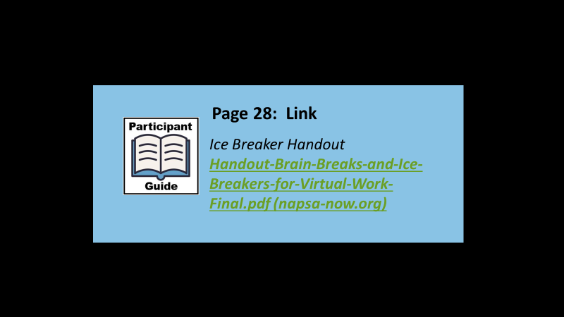
Facilitator says:

Your Participant Guide has a link to this resource on Page 28. Please take a look at these resources and consider using the techniques with your staff

Slide 37 | 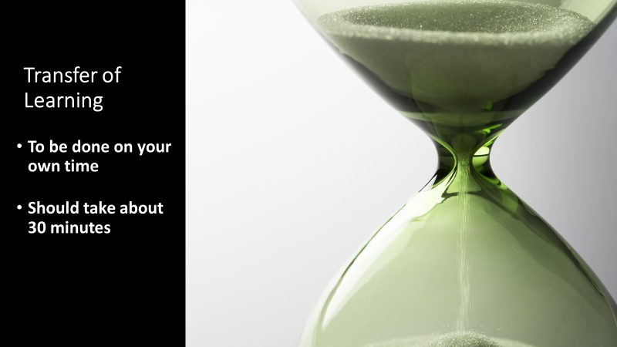
Facilitator says:
There was a great deal of information in today’s training and we want to follow it up with a transfer of learning activity for this module. It should be done on your own time and should only take about 30 minutes.
Slide 38 | 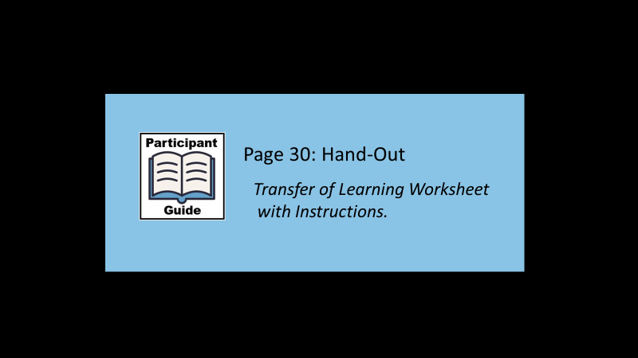
Facilitator says:
Instructions for completing the TOL are in the handout on Page 30 of your Participant Guide. So let’s look at together in case you have any questions about it.
Note to facilitator:
It is recommended that you review the TOL to see if participants have any questions or need additional clarification.

Facilitator Copy:

Transfer of Learning Activity
Team Implementation Goals
This is a Transfer of Learning (TOL) activity based upon the training that you attended entitled: Building and Managing Your APS Team.
Transfer of Learning (TOL) allows the learner to take education, ability or insight obtained from a prior setting and use it effectively in a new setting. The purpose of the TOL is to practice and apply information received in today’s training outside of the training environment.
This tool is meant to be used as a type of “roadmap” to assess your team, identify areas for improvement, and to create goals with an associated action plan.
This TOL activity can be done in conjunction with your team (at a team meeting) and can be done in-person, or within a virtual environment; or you can do this TOL activity on your own. It is recommended to complete this activity with your team to create a horizontal action plan; that is, what you will do to strengthen your team and what your team members will do to strengthen the team.
Please answer the following question:
What 3 things will you do to strengthen your own team?
You might consider changes you could make to the structure and format of your unit meetings or new strategies that you could try to implement that will help to make the work environment more motivating.
What steps do you (and/or staff members) need to take to make that happen?
Be as specific as you can with your goals and action steps.

Goal 1 -

Action Item to support the goal

____________________________________________Action Item to support the goal

____________________________________________

Action Item to support the goal

____________________________________________

Goal 2 -

Action Item to support the goal

____________________________________________

Action Item to support the goal

____________________________________________

Action Item to support the goal

____________________________________________

Goal 3 -

Action Item to support the goal

____________________________________________

Action Item to support the goal

____________________________________________

Action Item to support the goal

____________________________________________
Slide 39 | 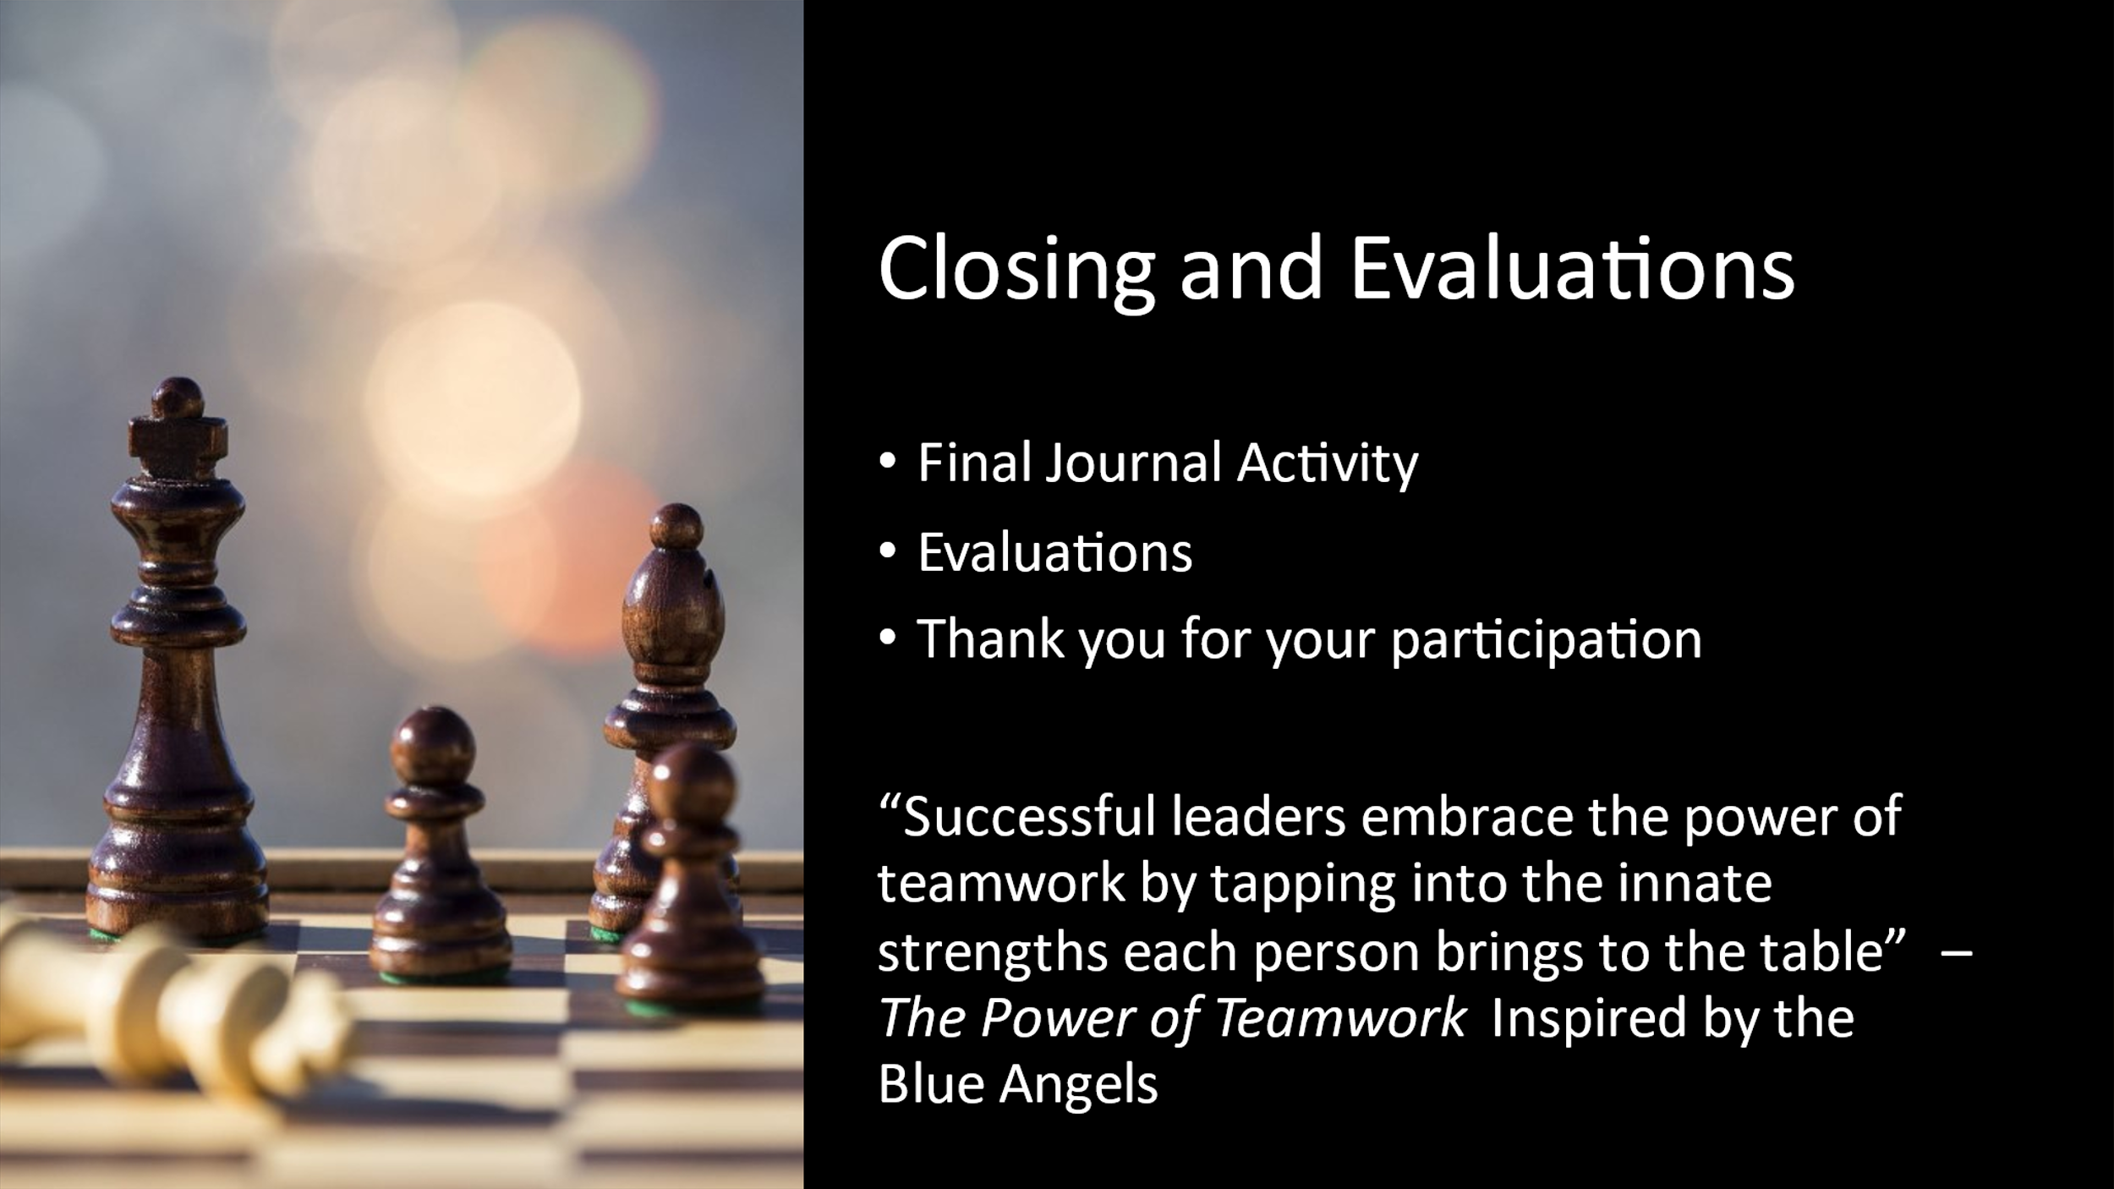
Facilitator says:
So as we wrap up this session, it’s important to understand that team building requires ongoing attention, care, and evaluations.

Are there any questions regarding today’s session or the Transfer of Learning assignment?

I want to thank you all for making the time for your own professional development by attending this training - and for what you do every day for your staff and the vulnerable adults in the community.

