Onboarding New Staff
Division of Aging and Adult Services
Adult Protective Services
Facilitator Guide

Onboarding New Staff
Supervisor Core Competency 3C

This training was developed by the National Adult Protective Services Association with support from the Arizona Department of Economic Security, Division of Aging and Adult Services-Adult Protective Services, and funded, in part, by a grant (No. 90EJSG0035-01-00) from the Administration for Community Living, U.S. Department of Health and Human Services (DHHS). Grantees carrying out projects under government sponsorship are encouraged to express their findings and conclusions. Therefore, points of view or opinions do not necessarily represent the official Administration for Community Living or DHHS policy.

Curriculum Developer
Susan Staples, NAPSA Consultant

ACKNOWLEDGEMENTS
This training is the result of a collaboration between Adult Protective Services administrators, supervisors, staff development officers, workers across states and the nation, and professional educators. We would like to thank the following contributors:

Agencies:
Arizona Adult Protective Services, Division of Aging and Adult Services, Department of Economic Security
National Adult Protective Services Association
Adult Protective Services Workforce Innovations

Committees:
Supervisor Curriculum Advisory Committee (SCAC)
National Adult Protective Services Association Education Review Committee

Onboarding New Staff
Supervisor Core Competency 3C

Use of Training Materials

This training was developed to provide APS programs across the nation with NAPSA-approved training content and materials that support specific learning objectives and promote APS supervisor core competency.

States and jurisdictions may customize these materials by adding content to meet their needs for state-specific information (regulations, policies, procedures, tools) in the following ways:
- State-specific PowerPoint slides
- State-specific hand-outs
- State-specific examples and experiences shared by the facilitator during trainings

Users agree to refrain from making any changes to the basic approved content.

No commercial reproduction is allowed.

Table of Contents
Icons 2
Classroom Setup 3
Classroom Supplies List 3
Course/ Lesson Goal 3
Learning Objectives 4
Target Audience 4
Course/ Lesson Length 5
For Facilitators 5
Introduction 6
Section 1- The Onboarding Process and the Supervisor’s Role 12
Section 2 – Implementing an Onboarding Plan 21
Section 3 – Using Training Resources 29
Section 4 – Developing Critical Thinking Skills 37
Section 5 – Evaluating and Documenting Progress 48
Section 6 – Summary and Transfer of Learning 61
Transfer of Learning Assignment ………………………………………………………………………….. 66
Group Activity – Case Scenarios and Sample Answers 67

Note: Onboarding New Staff is a training program that is part of the National
APS Supervisor Core Curriculum.
It is one of four training modules focused on supporting core competency
in Teambuilding and Individual Development. These modules include:
- Building and Managing Effective APS Teams (Module 3A)
- Supervisor as Trainer (Module 3B)
- Onboarding New Staff (Module 3C)
- Coaching and Mentoring for APS Supervisors (Module 3D)
While one is not a pre-requisite for another, it is recommended that the
modules be completed in the order listed.

Icons
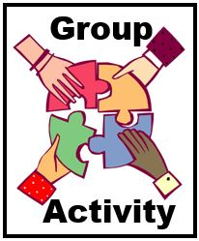

Classroom Setup
- Internet connection/Laptop computer
- Connection to virtual platform

Classroom Supplies List
- Onboarding New Staff Facilitator Guide
- Onboarding New Staff Participant Guide
Reference materials and links:
- Ideas for Your Onboarding Checklist
- Considerations for Implementing an Onboarding Plan
- Sample Communications Tool
- Link to National Training Resources
- Phases of Learning and Suggested Training Activities
- Tips for Training in a Virtual Environment
- AZ Interview Observation Checklist
- Group Activity: Case Scenarios
- Delivering a Successful Critique
- Transfer of Learning Assignment Worksheet
- Onboarding New Staff PowerPoint Slides

Course/ Lesson Goal
The goal of this course is to provide APS supervisors with an understanding of the onboarding process for new staff and their role during the process.

Learning Objectives
By the end of this course, participants should be able to:
- Define the onboarding process and its importance.
- Describe the supervisor’s role during onboarding and 3 components of an onboarding plan.
- Evaluate and document new staff’s progress in meeting milestones.

Target Audience
The target audience for this training is APS supervisors. It is recommended that all supervisors take the training at initial roll-out. Subsequent training will be made available to new APS supervisors.

Course/ Lesson Length
This training has a total training time of 4 hours. It can also be divided into two, 2-hr. sessions if desired.(Part 1-Section 1,2,3 and Part 2-Section 4,5,6)

For Facilitators
This Facilitator Guide provides the structured content, activities, and PowerPoint slides to present the training. Facilitators are encouraged to review the Guide and to add any state-specific information and/or examples from their professional experiences as appropriate. The accompanying Participant Guide contains the PowerPoint slides, links to other resources and reference materials. Facilitators are encouraged to review these materials ahead of trainings, be prepared to screen-share them as directed, and briefly describe content and use.

 | Introduction
Slide 1 | 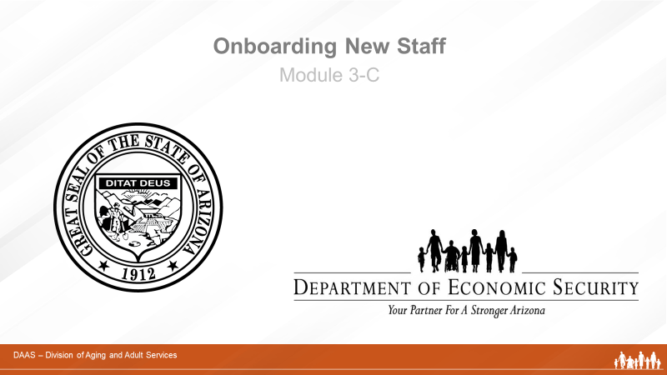
Producer Says:
Welcome, everyone, to today’s training session on Onboarding New Staff. We appreciate your taking the time to participate! (Introduces self and role in overseeing technology and managing questions and group activities.)

Slide 2 | 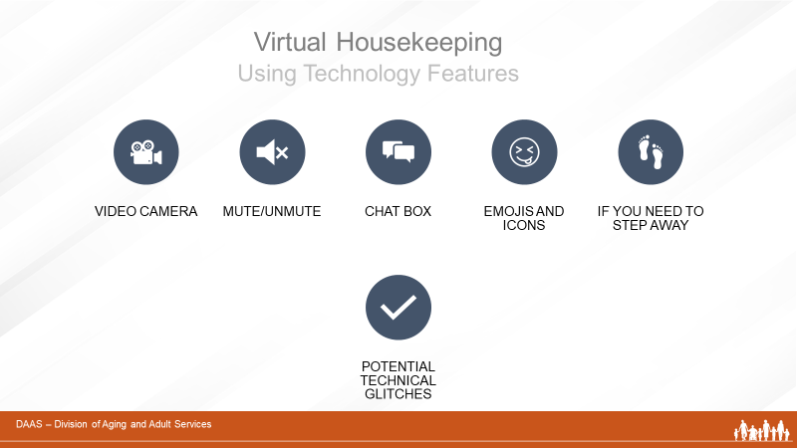
Producer Says:
Before we get started, let’s review some virtual housekeeping details with the technology features we’ll be using to communicate with each other.
Some of you may be more familiar than others navigating through a virtual learning course. So we will briefly review the various functions of the virtual environment:
- Video Camera: Find the camera icon; when you do, please turn it off and on. During the session, please keep the video camera on since this is an interactive course.
- Mute/Unmute: Now, please locate the microphone icon. When you do, practice muting and unmuting yourself.
- Chat box: Find the chat icon. We will be using the chat function to communicate throughout the session.
- Emojis and Icons: These differ within the different virtual platforms
This training is approximately 4 hours in length and there will be a short breaks at intervals. While participants are expected to attend the entire training, if you need to step away, please private chat the facilitator.

And just a word about technical glitches. They are inevitable - on our end and your end! So please be patient and forgiving as we all navigate this virtual platform together.

Producer Says:
Now, let me introduce our facilitator for today’s session. (Introduces with short bio.)
Slide 3 | 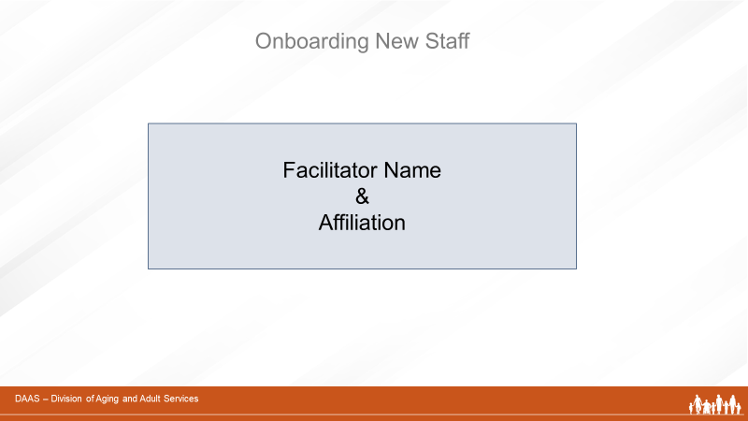
Facilitator Says:
Thank you! I’m very pleased to join you all to facilitate this module on Onboarding New Staff. (May want to add a little more about professional background.)
Slide 4 | 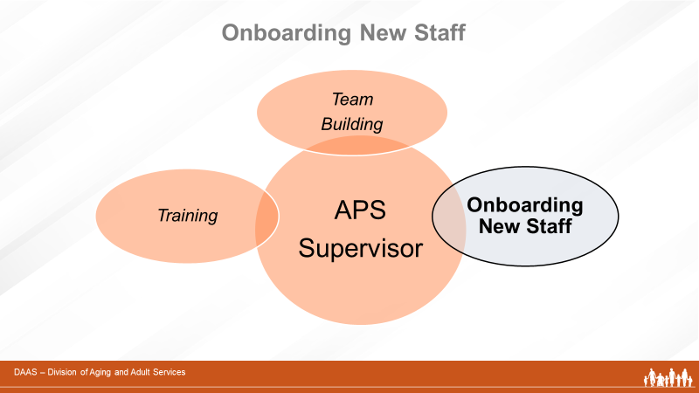
Facilitator Says:
In previous training modules, we have acknowledged that the role of the APS supervisor is a multi-faceted one - with many supervisory tasks - including building a cohesive team and ensuring that all team members receive the training support needed to carry out their professional roles.
This module will focus on the supervisor’s role during “onboarding” - or the process of introducing newly-hired staff into an organization.
Slide 5 | 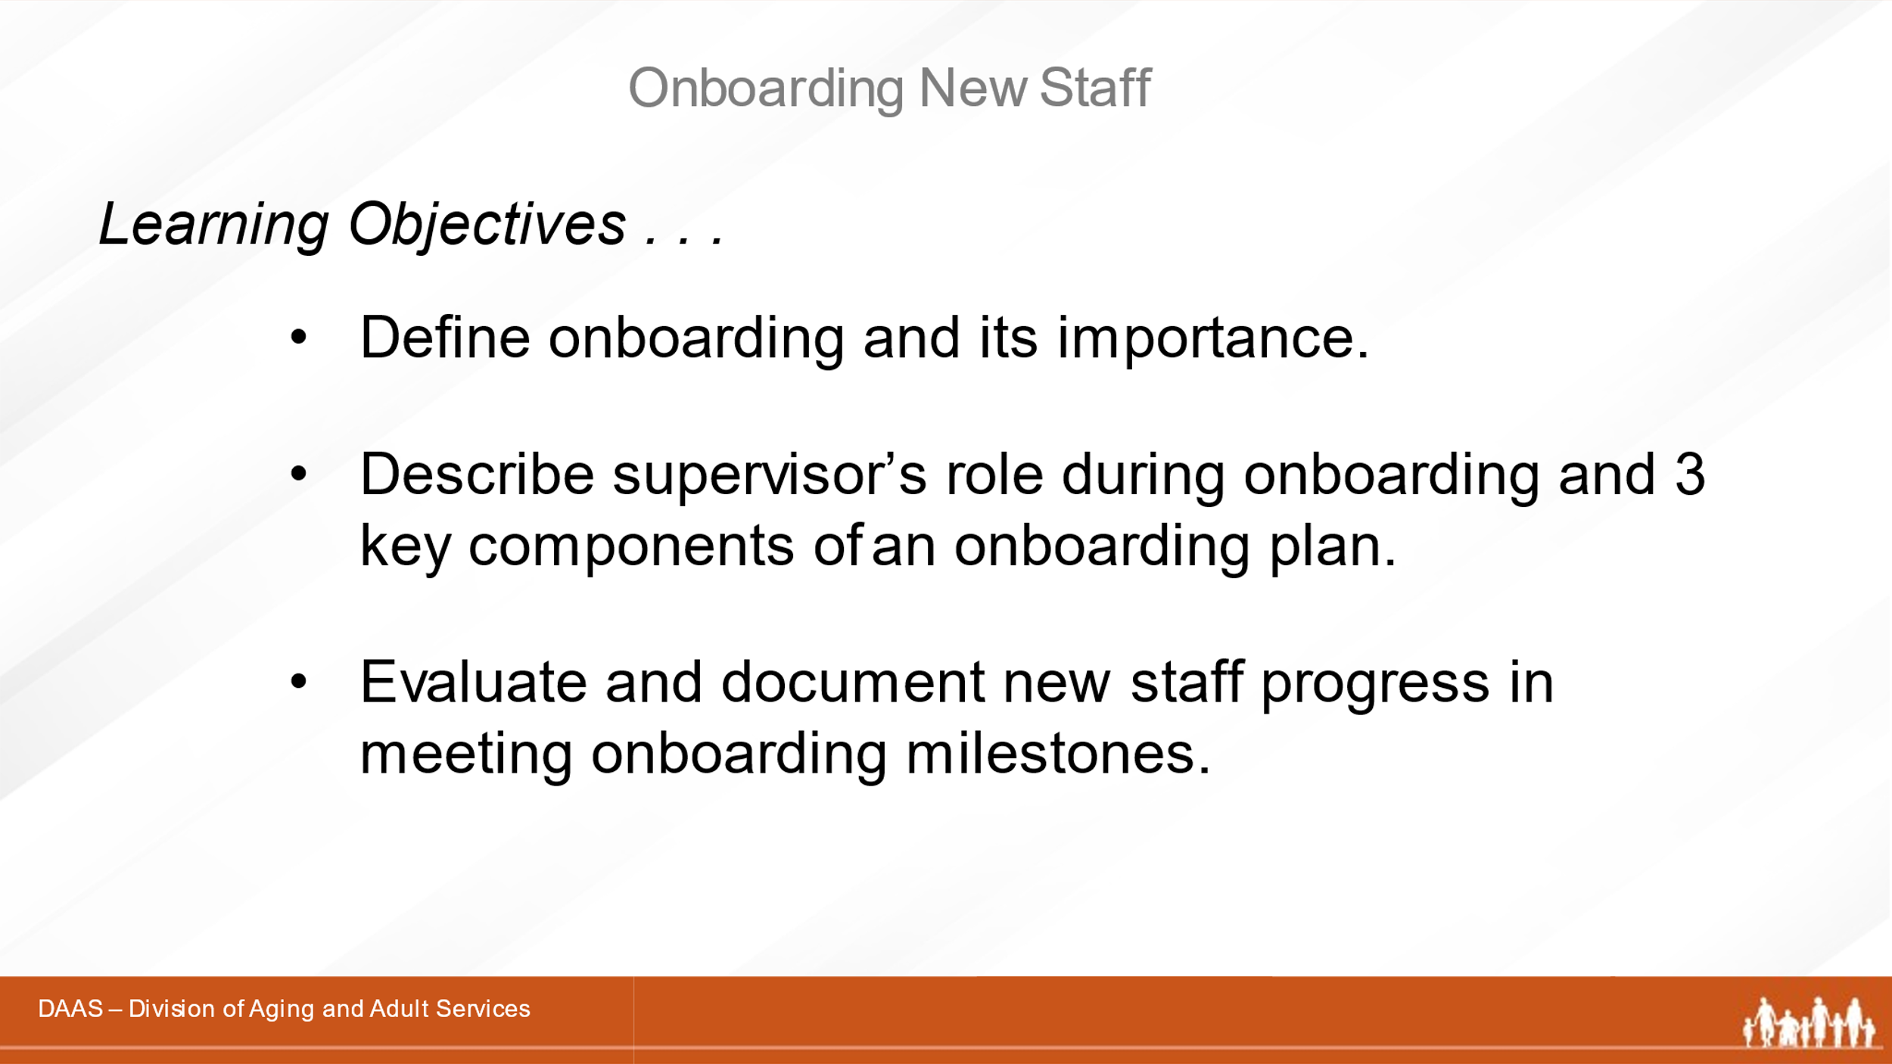
Facilitator Says:
After completing this module, you will be able to:
- Define the onboarding process and its importance.
- Describe the supervisor’s role during onboarding and three components of an onboarding plan.
- Evaluate and document new staff’s progress in meeting onboarding milestones.

 | Section One – The Onboarding Process and the Supervisor’s Role
Slide 6
Facilitator Says:
So let’s start by describing the onboarding process and the supervisor’s role throughout.
Slide 7 | 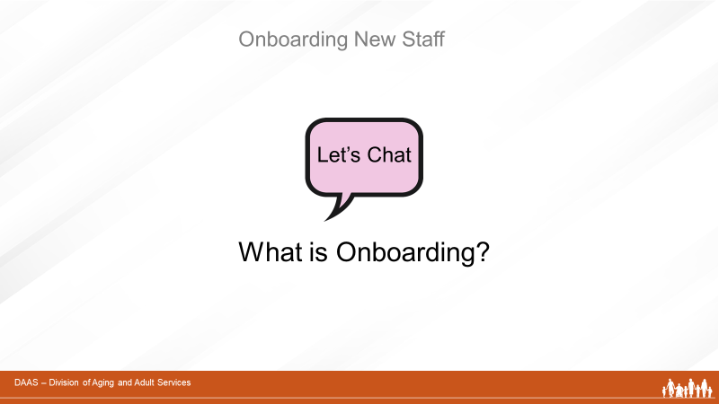

Facilitator Says:
And we’ll begin our discussion of onboarding with a question for all of you. “How do you describe onboarding?” Please take a few minutes to use your CHAT button and share your thoughts.
(Producer reports responses to group.)
Great! Thanks, everyone, for your responses.
Let’s take a look at the screen now and highlight any additional points.
`Slide 8 | 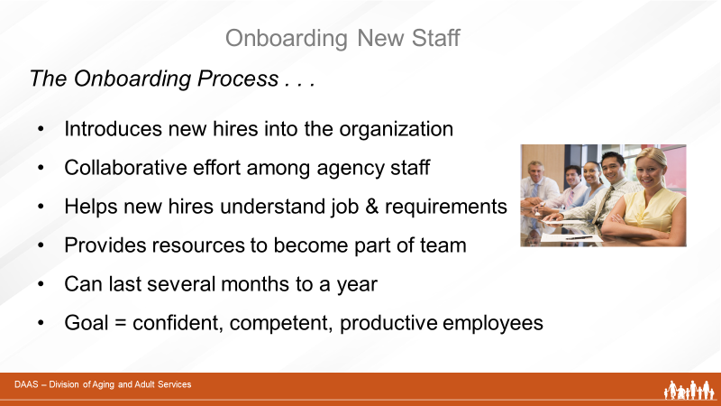
Facilitator Says:
So onboarding is:
- The process of introducing newly-hired employees into an organization
- A collaborative effort between the supervisor, new employees, training team and human resource professionals
- An important part of helping new employees understand their new position and job requirements
- A time to provide new staff with the resources to become fully engaged and culturally aware members of a productive team
- A journey lasting anywhere from several months to a year
- Focused on the goal of having confident, competent and productive employees when the onboarding process is complete
Now that we’ve answered the question “What is Onboarding?” let’s look at why the onboarding process is so important to any organization.
Slide 9 | 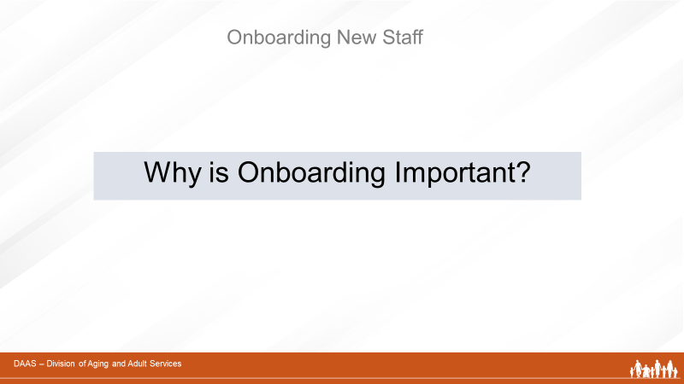

Facilitator Says:
Think back to your own experiences in a new job. Those early weeks and months can be stressful as you try to become part of a professional team of co-workers, learn about your organization and what is expected, and gain the specific kinds of knowledge and skills you need to do your job.
Slide 10 | 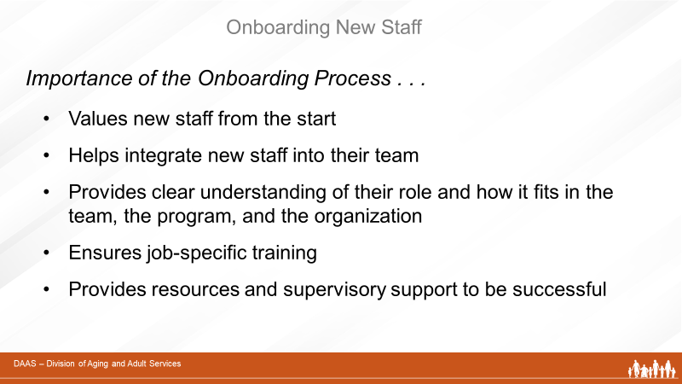
Facilitator Says:
A well-planned onboarding process for new staff alleviates some of that early stress by:
- Showing that the organization values new employees from the start
- Helping new employees feel like they’re part of the team – builds positive working relationships
- Helping new employees understand clearly what is expected of them and how their role fits into the team, the program and the organization
- Providing new employees with the training to do their jobs
- Ensuring continuous supervisory support and feedback
Slide 11 | 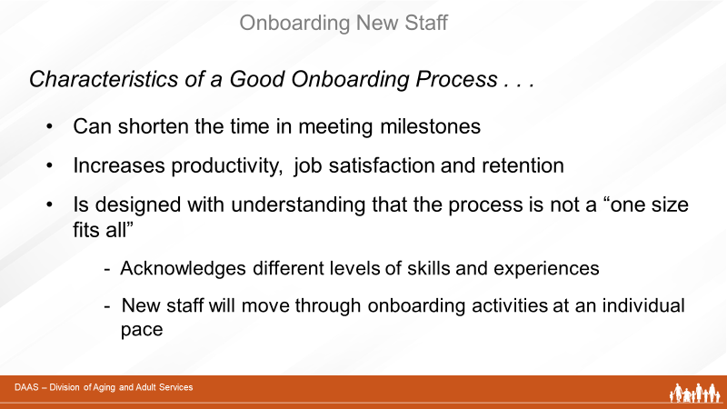
Facilitator Says:
Studies conducted by the Society for Human Resource Management show that a good onboarding process can shorten the time for new employees to reach their first milestones. And the sooner a new staff member feels welcomed and prepared for their new job, the faster that staff member will be able to contribute to the success of the team and the organization. Effective onboarding increases productivity, job satisfaction and retention.

Onboarding programs will vary from organization to organization, but those that are designed and managed well acknowledge the individual differences among new employees and that onboarding is not a “one-size-fits-all” process.

New staff members come to their onboarding journey with different levels of experience and skills. Based on educational background and prior work experiences, some new staff may be able to transfer existing knowledge and skills to aspects of their new job quickly and confidently. Others will be new to the workforce and to APS work and will need more time to complete their onboarding process successfully. So each new staff member will move through his or her onboarding process at a pace that reflects their individual knowledge and skill levels.
Slide 12
Facilitator Says:
Now let’s focus on the central role the APS supervisor plays in guiding new staff members through their onboarding journey.
Slide 13 | 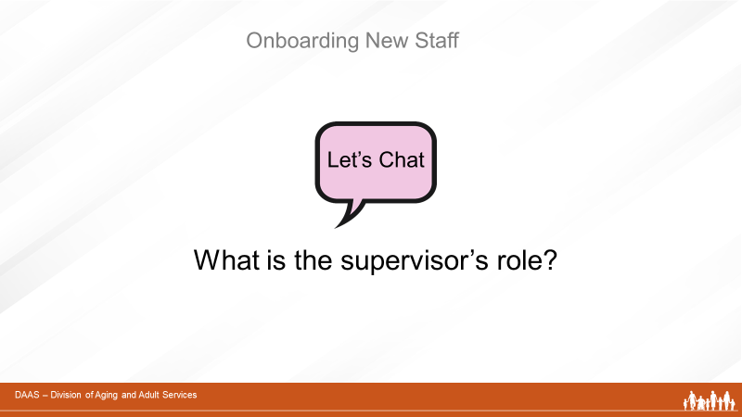

Facilitator Says:
Let’s start by taking a moment to share ideas. Please use your CHAT box to share one or two responsibilities of the supervisor during onboarding process. (Producer acknowledges responses and facilitator continues with next slide highlighting any points not already mentioned.)
Slide 14 | 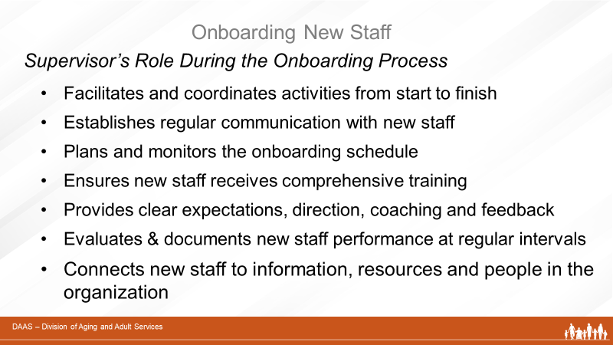
Facilitator Says:
Thank you for your ideas! We’ve mentioned that many of the activities listed on the screen are important aspects of a good onboarding process. They also help define a supervisor’s role during the process. The APS supervisor:
- Facilitates the successful integration of new employees into the organization - from start date to the completion of onboarding. Working with human resources, agency trainers, team members and new staff, the supervisor coordinates onboarding activities.
- Establishes regular communication with new employees.
- Plans and monitors an onboarding schedule that allows enough time for new staff to attend trainings and fully participate.
- Ensures that new staff receive comprehensive training and opportunities to develop the knowledge and skills to do their jobs.
- Provides clear expectations, direction, coaching and feedback to new staff.
- Evaluates and documents new staff performance at regular intervals.
- Connects new staff to information, resources, and people within the organization.
By getting to know new staff members and their knowledge and skill levels; having regular and frequent communication with them; and coordinating their learning activities; the supervisor becomes the “go-to” person that new staff will turn to for guidance and help during their onboarding process.

 | Section 2- Implementing an Onboarding Plan
Slide 15
Facilitator Says:
So let’s look now at implementing an onboarding plan. Onboarding begins prior to new staff members arriving for their first day and ends when they are successfully integrated into the team and can demonstrate their ability to do their jobs independently. The steps in-between are guided by a thoughtfully designed and implemented onboarding plan.
Note: Add state-specific onboarding information here.
(Ex. The state of Arizona has developed a New
Investigator Training and Onboarding Program.)

Slide 16 | 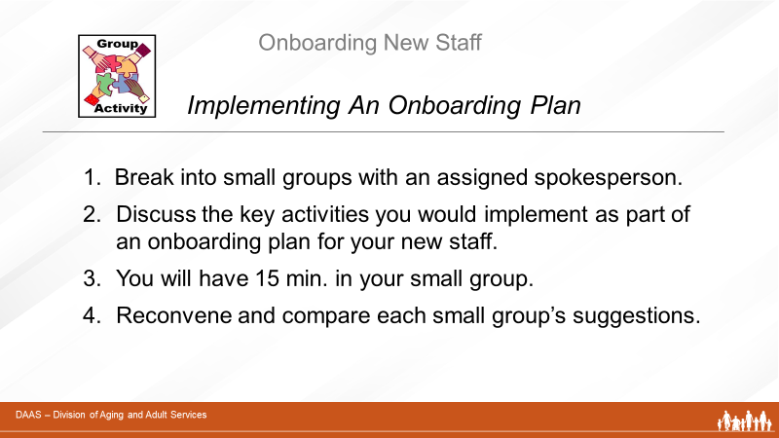
Facilitator Says:
Building on our discussion of the onboarding process, its importance to the agency, and the central role of the supervisor, let’s explore the key components of an onboarding plan to be implemented. And we’ll start with a group activity that includes your own perpectives and experiences with onboarding new staff.
- First, we will break you into small groups and assign a spokesperson for each one.
- Next, each group will discuss the types of activities they think should be implemented as part of an onboarding plan and create a list to share with the full group. (You will have 15 minutes to create your list.)
- Then, the full group will come back together to compare each small group’s suggestions.
 | Have producer report non-duplicated responses. Facilitator acknowledges group contributions and continues with discussion of the key onboarding components.
Slide 17 | 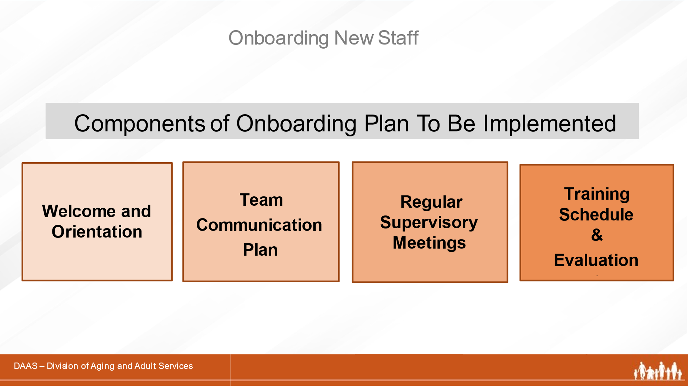
Facilitator Says:
Good job! We can see that many of the activities you mentioned fall into the components you see on the screen. Your organization may have some onboarding guidelines to assist you - particularly in the first few weeks of onboarding new staff.
Generally, these onboarding components include:
- An initial welcome/orientation to the team, agency & organization
- A communication plan used by the team
- A plan for regular supervisory meetings with new staff
- A plan for delivering and monitoring training

Let’s take a quick look at each of these components.
Slide 18 | 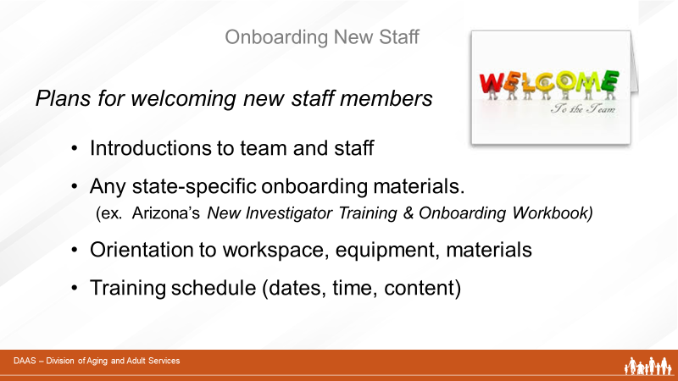
Facilitator Says:
New staff members need to “get their bearings” and feel welcomed by a new group of co-workers and a new work environment. So start with activities that include:
- Personal introductions to key staff and other team members
- Any onboarding materials that your agency may have.(ex. Arizona has developed a New Investigator Onboarding Workbook.) and additional information (agency organizational chart, APS team member contact information, technical assistance contacts, HR contacts, procedures and forms, etc.)
- Orientation to workspace, equipment and materials

Note: If you are providing a welcome and orientation remotely, review and apply concepts from Supervising a Remote Workforce that include:
- Holding a virtual “welcome” event for the APS team
- Planning for how the new staff members will receive computer equipment, protective equipment, and other materials at their remote location
- Planning for regular virtual supervisory check-ins and training activities
Slide 19 | 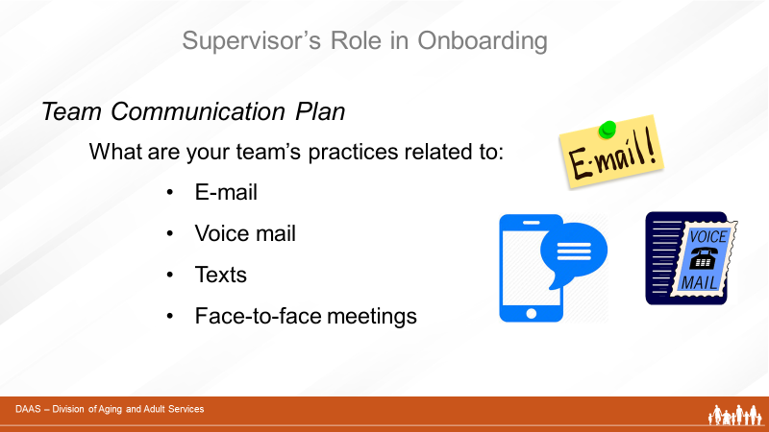
Facilitator Says:
It is also important to share your team’s communication plan with new staff so they will understand the team’s practices related to:
- E-mail - - - - How often is e-mail checked / How
long are e-mails kept?
- Voice mail – How often is it checked?
- Texts - - - - What are appropriate uses?
- Face-to-face meetings - How often?
Slide 20 | 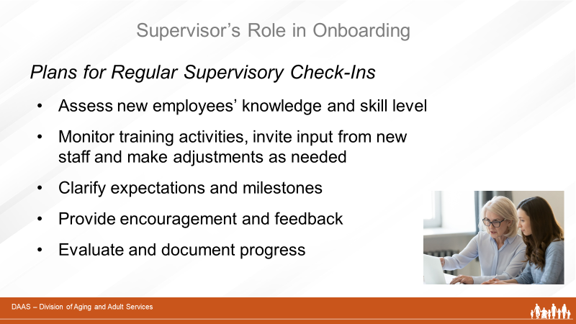
Facilitator Says:
Plan time for frequent and regular check-ins with new staff. Especially in the early months, these one-on-one sessions allow the supervisor to:
- Assess new employees’ knowledge and skill level - what training settings and techniques are most appropriate?
- Monitor progress of training activities, invlte input from new staff and make adjustments as needed
- Clarify expectations and milestones
- Provide encouragement and feedback
- Evaluate and document progress
Slide 21
Facilitator Says:
We will focus in more detail on onboarding training in the next section, but as you think about implementing this component of your onboarding plan, use the tools that your organization may have already developed: procedures, checklists, or other resources to guide your onboarding planning. And consider engaging your experienced team members who demonstrate “best practices” and who can assist during the process:
- In structured observations
- In reviewing and discussing case reports
- In introducing new staff to community partners and Multi-Disciplinary Teams

 | Your Participant Guide also contains some additional resources as well.
Slide 22 | 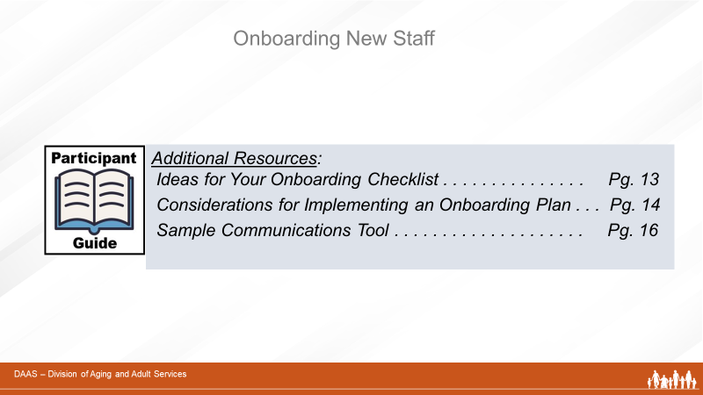

 | Section 3 - Using Training Resources
Slide 23 | 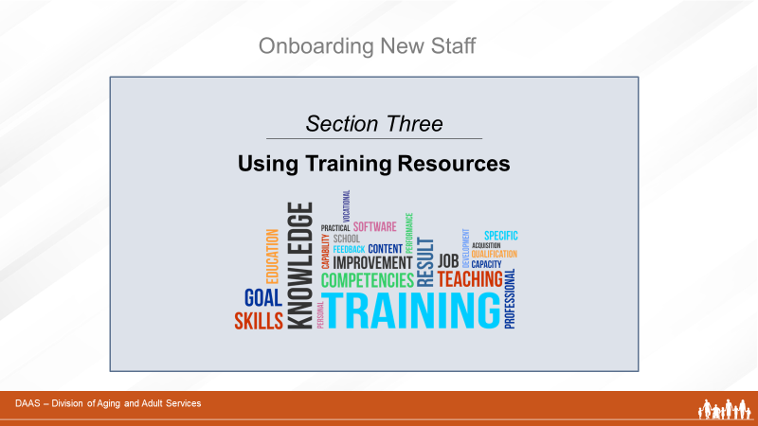
Facilitator Says:
In the previous sections of today’s session, we focused on an overview of the onboarding process, its importance, the role of the supervisor, and the types of activities to be implemented as part of the onboarding plan.

In this section, we will look at the supervisor’s role in utilizing training resources. We’ll start by reviewing training resources available for onboarding. And we’ll also review a few of the training concepts that were covered in Supervisor as Trainer as they apply to training during onboarding.
Slide 24 | 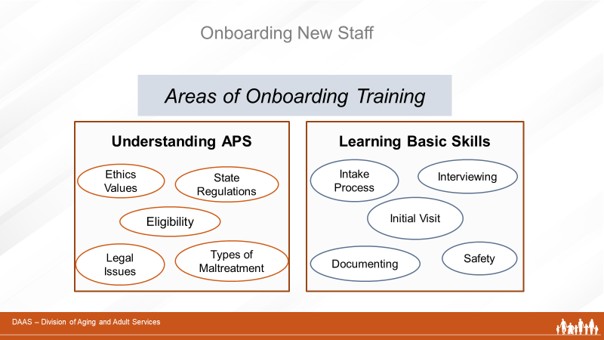
Facilitator Says:
Onboarding training covers many areas of knowledge and skill development specific to APS work. In addition to state-specific materials your agency may already have, we want you to be aware of two national sites that are rich in training resources for APS supervisors.
Slide 25 | 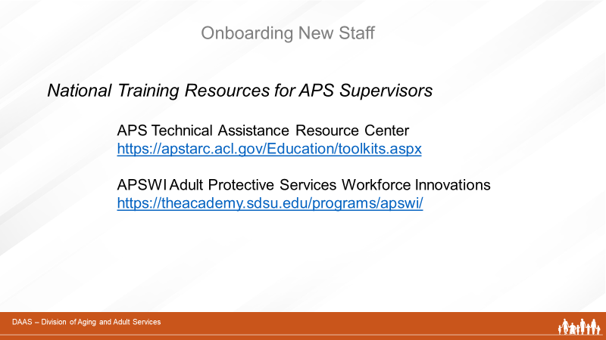
Facilitator Says:
You may recall these two national training resources introduced in Supervisor as Trainer. When planning for the onboarding training needs of your staff, these two sites offer additional training resources – topic-specific content, tools, videos and suggested activities.
- The first link connects to the APS Education and Training Toolkit available at the Training and Resource Center (TARC) on the Administration for Community Living’s website. It is a collection of APS educational materials, videos, and other resources. The toolkit helps APS administrators and supervisors stay abreast of offerings, supplement trainings made available by their state programs, and promote continuous learning opportunities for APS staff.
- The second link is to Adult Protective Services Workforce Innovations (APSWI). This is a training program of the Academy for Professional Excellence, a project of the San Diego State University School of Social Work. APSWI provides innovative workforce development to APS professionals and their partners. In partnership with state and national organizations, APSWI has developed a nationally recognized Core Competency Training Curriculum for APS professionals.

Visit the site to access the many topic specific trainings and the Field Guide for APS. The Guide is intended to provide an agency or an individual APS supervisor with an organized system to ensure that the new APS worker gains the experiences and training needed to be an effective professional.
Slide 26 | 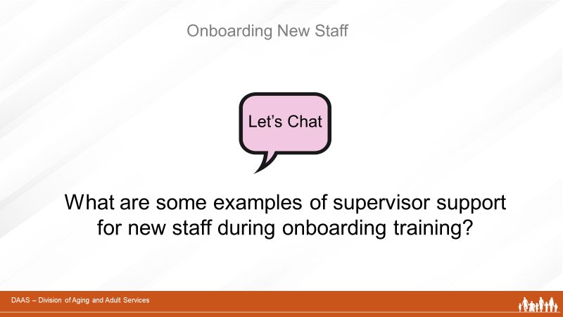
Facilitator Says:
So I’d like you to now use your CHAT box and share a couple ways you think a supervisor can support new staff during their onboarding training. (Producer acknowledges responses and facilitator continues with next slide.)
Slide 27 | 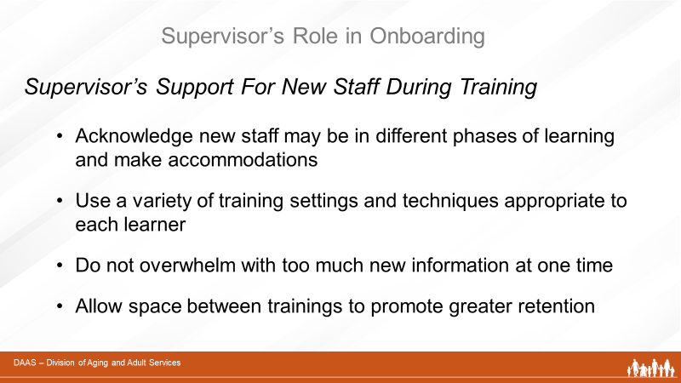
Facilitator Says:
Thank you, everyone! In addition to ensuring that new staff receive the training content needed during onboarding, supervisors should also consider ways to effectively support individual learning during the process. Apply some of adult learning principles from Supervisor as Trainer as you work on your onboarding training plans.
- Acknowledge that new staff come with different levels of experience and knowledge. They will progress through phases of learning during onboarding at different paces.
- Use a variety of training settings and techniques depending on the content to be learned and the skill level of the individual learner.
- Do not overwhelm with too much new information at one time. And allow some space between trainings to promote greater retention.

Slide 28 | 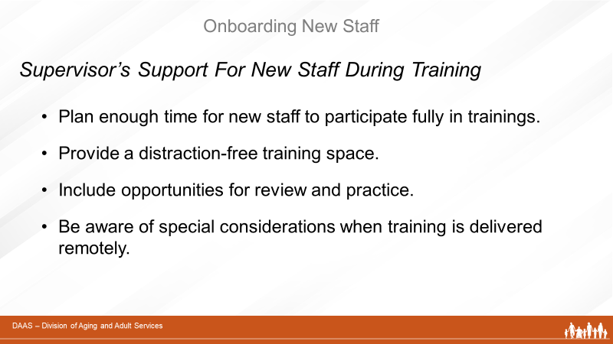
Facilitator Says:
- Make sure new staff have enough time to participate fully and a distraction-free training space to maximize their attention.
- Build in opportunities for review and practice to strengthen brain pathways and make new learning meaningful and permanent.
- Be aware of special considerations when training is delivered remotely.
There are additional resources in your Participant Guide to help you support new staff during onboarding training.
Slide 29 | 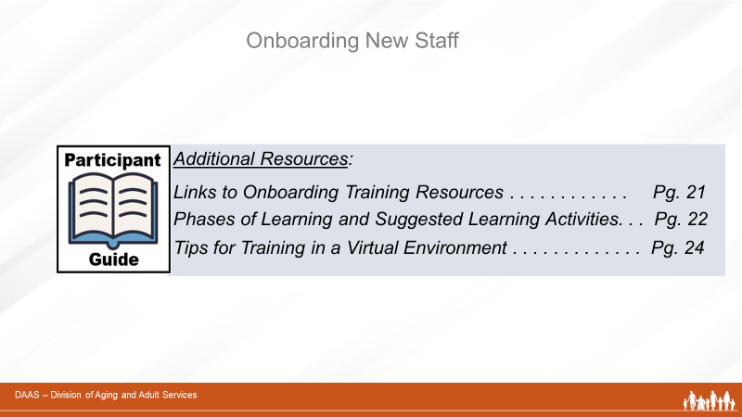
Facilitator Says:
Be sure to take a look at these additional resources. Are there any comments or questions about onboarding training before we move on?
Slide 30
 | Let’s take a 10-minute break!
Slide 31 | 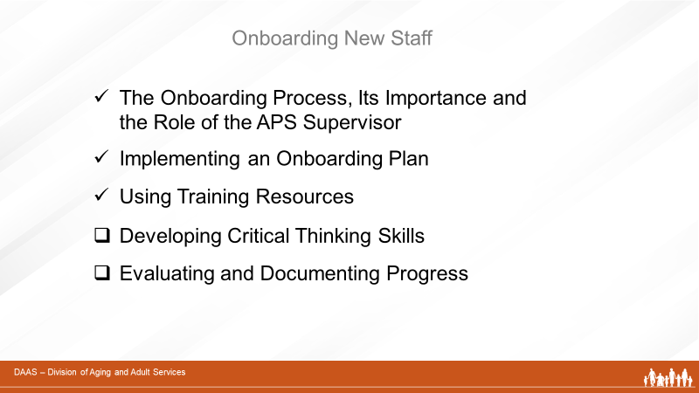
Welcome back! In the previous sections of this training, we talked about the onboarding process, the supervisor’s role, implementation ideas and the use of training resources. Now we’ll change our focus to two important other aspects of onboarding new staff:
- Developing Critical Thinking Skills
- Evaluating and Documenting Progress

Section 4 – Developing Critical
Thinking Skills
Slide 32

Facilitator Says:
Welcome back! In this section, we’ll focus on ways that supervisors can help new staff members develop skills to think critically. This means developing the ability to think things through; separate fact from opinion; and question information before accepting it. And the onboarding process is a good time to introduce and encourage these skills in new staff.
Slide 33 | 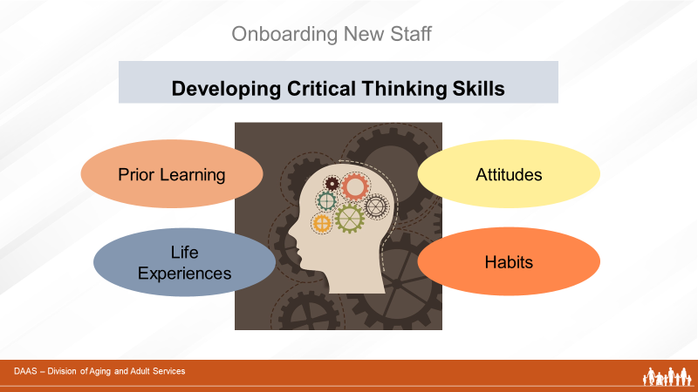
Facilitator says:
It’s important to remember that each new investigator comes to their onboarding journey with his/her own knowledge base, experiences, attitudes and habits. You may recall from the training module, Supervisor as Trainer, that when we need to learn new information or develop new skills, we build on neural connections and pathways that exist in our brains. So, what we have already learned; what our life experiences have been; and what attitudes and habits we have formed, all affect the way we approach new learning. And each individual is different. Supervisors who understand this can provide the individual supports and practice opportunities that help staff develop new skills for assessing information they receive in the course of doing their casework.
Slide 34 | 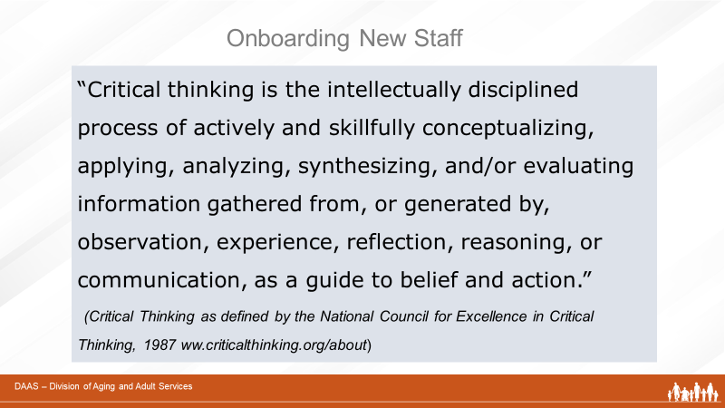
Facilitator says:
So let’s look more closely at the skills of critical thinking and start with a definition provided by the National Council for Excellence in Critical Thinking.

Could I please get a volunteer to read this aloud for us?

(Volunteer reads the definition for the group. Facilitator thanks volunteer and continues with next slide.)
Slide 35 | 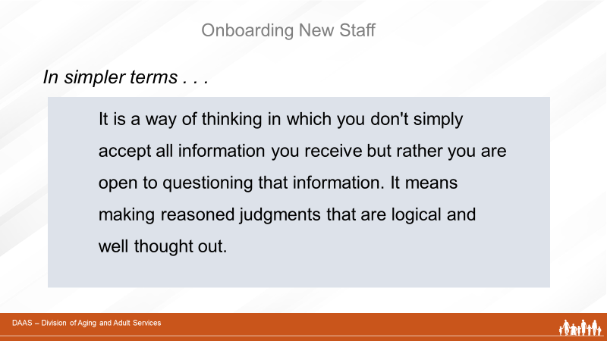
Facilitator Says:
Now let’s look at it in simpler terms. Critical thinking is a way of thinking in which you don't simply accept all information as you receive it, but rather you are open to questioning that information. It means making reasoned judgments that are logical and well-thought out.
Slide 36 | 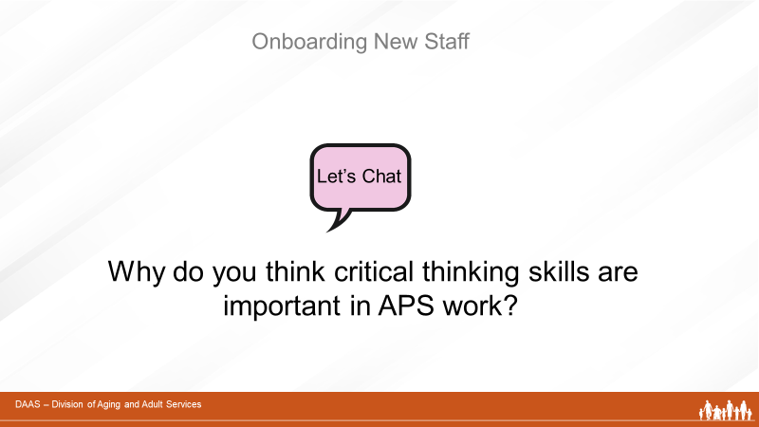
So using your CHAT button, please take a few moments to share one or two thoughts you have about why critical thinking skills are important to APS work.

(Producer tracks and reports responses. Facilitator acknowledges feedback and continues by highlighting any points the group has not yet mentioned).
Slide 37 | 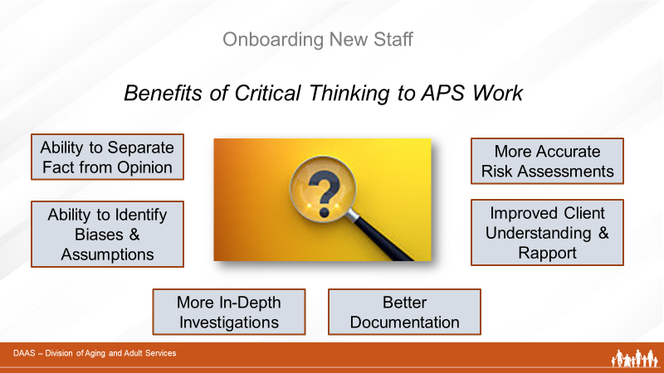
Facilitator Says:
Good responses! Now let’s compare them to these points on the screen.
Critical thinking enhances the ability of APS staff to:
- Separate fact from opinion in reviewing case information
- Identify biases and assumptions about the case
- Conduct more in-depth investigations
- Perform accurate risk assessments
- Provide better documentation
- Develop rapport with clients
- Promote connection with and understanding of clients

Any additional thoughts about the benefits of critical thinking?
Thinking things through, analyzing, and being open to questioning information as it is provided, are all skills that supervisors want to encourage early in onboarding new staff. So let’s look at an approach a supervisor can use to accomplish this.
Slide 38 | 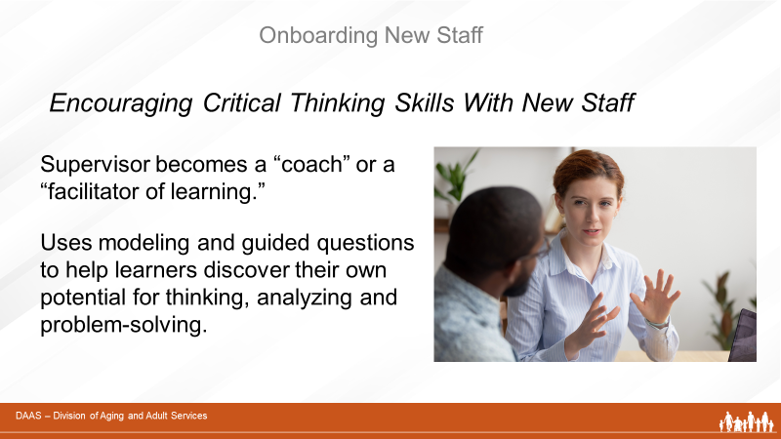
Facilitator Says:
To encourage critical thinking, the supervisor takes on the role of a coach. Using basic coaching techniques the supervisor acts as a “facilitator of learning” rather than a teacher.
By modeling critical thinking behaviors and using guiding questions, the supervisor helps new staff discover their own potential for ways to think, analyze and problem-solve when working on a case.

In fact, as your new staff becomes more experienced and independent, your supervisory role will very gradually shift to that of a coach. The next training module, Coaching and Mentoring, will focus on strategies for coaching your staff in greater detail.

For the purposes of helping staff develop critical thinking skills, let’s look at some techniques supervisors can use in one-on-one supervisory time with new staff.

And let’s start by using your CHAT box to share one or two of your ideas.
Slide 39 | 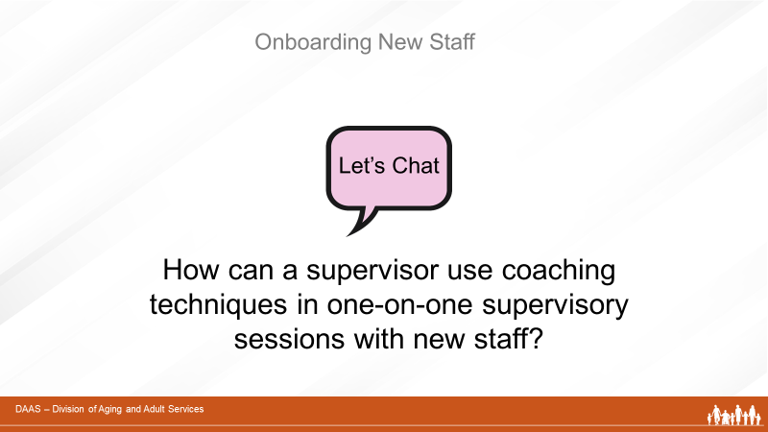
 | (Producer reports responses and facilitator continues.) Thanks for those good responses! Now let’s compare them to the strategies listed on the screen.
Slide 40 | 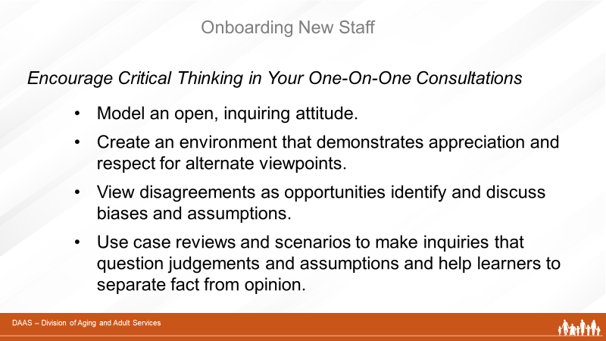
To encourage critical thinking, supervisors can:
- Model an open, inquiring attitude about cases.
- Create an environment that demonstrates appreciation and respect for alternate viewpoints.
- View disagreements as opportunities identify and discuss biases and assumptions.
- Use case reviews and scenarios to make inquires that question judgements and assumptions and help learners to separate fact from opinion.
Slide 41 | 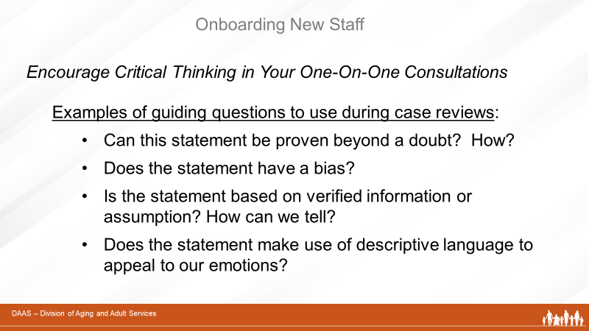
Facilitator Says:
Supervisors can also use guiding questions during case reviews to challenge learners and stimulate critical thinking. Questions like:
- Can this statement be proven beyond a doubt? How?
- Does the statement have a bias?
- Is the statement based on verified information or assumption? How can we tell?
- Does the statement make use of descriptive language to appeal to our emotions?
Can you think of some additional examples of guiding questions? Please use your CHAT box to share one or two.

Slide 42 | 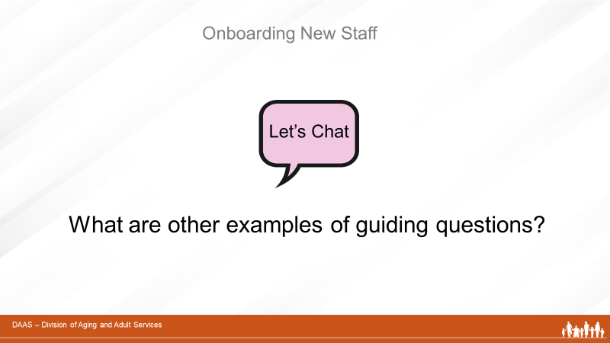
(Producer acknowledges the responses and facilitator continues.)
Facilitator Says:
Thank you, everyone! Let’s review these additional examples of guiding questions on the screen.
Slide 43 | 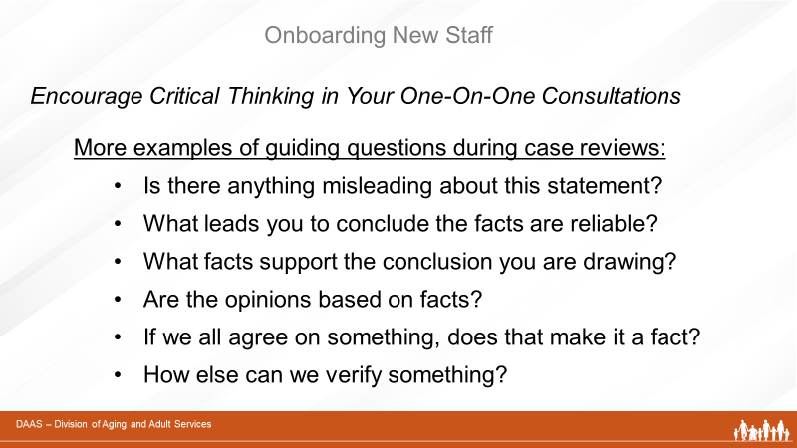

Facilitator Says:
- Is there anything misleading about this statement?
- What leads you to conclude the facts reliable?
- What facts support the conclusion you are drawing?
- Are the opinions based on facts?
- If we all agree on something, does that make it a fact?
- How else can we verify something?
Slide 44 | 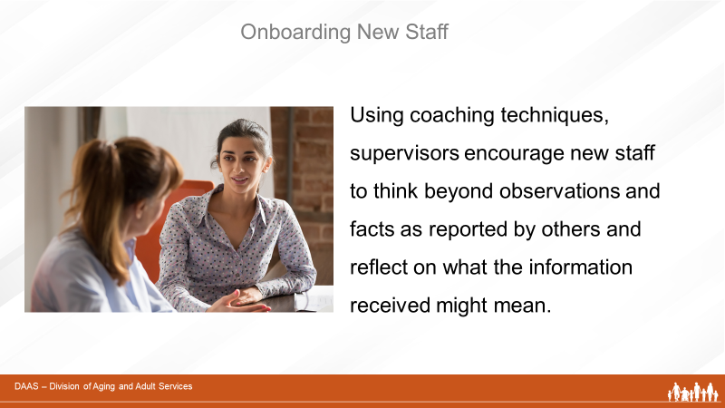
Facilitator Says:
Using these techniques during supervisory sessions with new staff, supervisors help learners to develop new skills and to think beyond surface observations and facts as they are reported by others and reflect on what the information received may mean.
Any other thoughts or questions before moving on?

Section 5 – Evaluating & Documenting
Progress
Slide 45 | 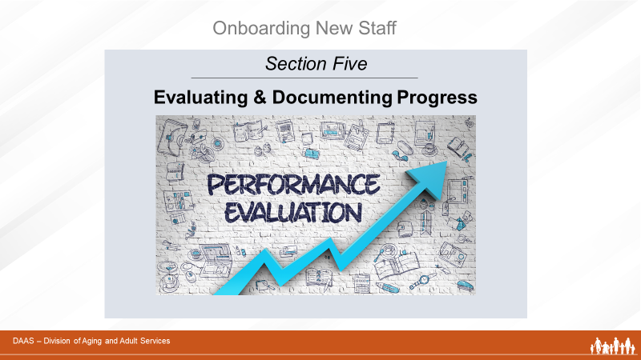
Facilitator Says:
In this section, we will focus on the supervisory responsibility of evaluating and documenting the progress of each new staff member at regular intervals – including ways to provide effective feedback.
Slide 46 | 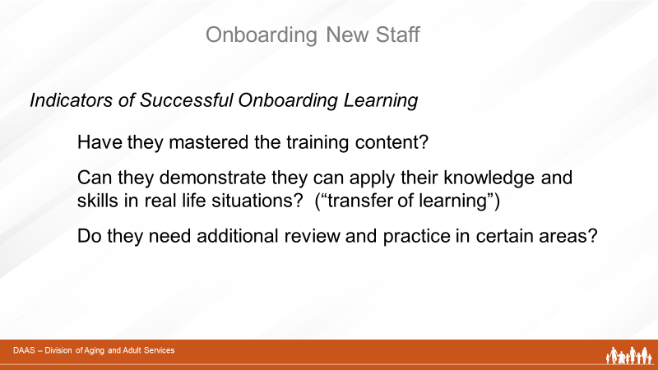
Facilitator Says:
Supervisors will want to monitor and evaluate progress in terms of the onboarding training plan. Some indicators of progress can include
- Have they mastered the training content?
- Can they demonstrate they can apply their knowledge and skills in real life situations? (“transfer of learning”)
- Do they need additional review and practice in certain areas?
Slide 47 | 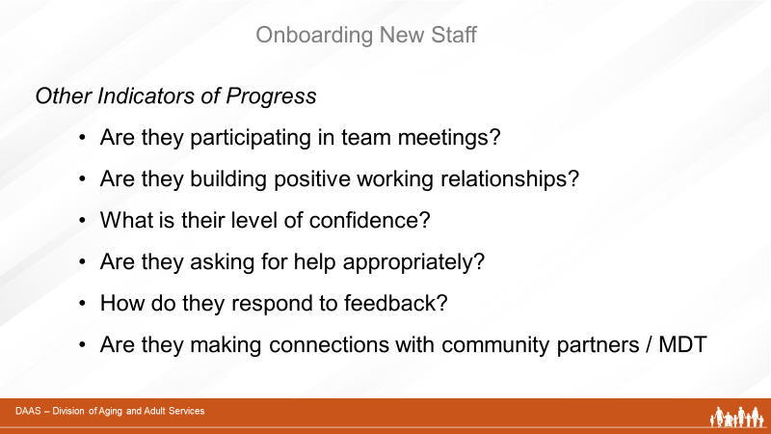
Facilitator Says:
Other indicators of progress that supervisors may want to look at include:
- How well are they integrating into the team and unit? Are they participating in team meetings?
- Are they establishing good working relationships?
- What is their level of confidence? Are they asking for help appropriately?
- How are they responding to feedback?
- And as they progress through their onboarding journey, are they connecting with community partners and participating in MDT meetings?

Evaluation allows supervisors to monitor the progress of their new staff members – and the onboarding plan. What are areas that need to be addressed or adjusted? For example, additional training activities or a change in scheduling may be needed. Or more opportunities to interact as a team need to be planned. Review the concepts presented in Module 3-A (Teambuilding) to review strategies for helping new staff become part of the team.
Slide 48 | 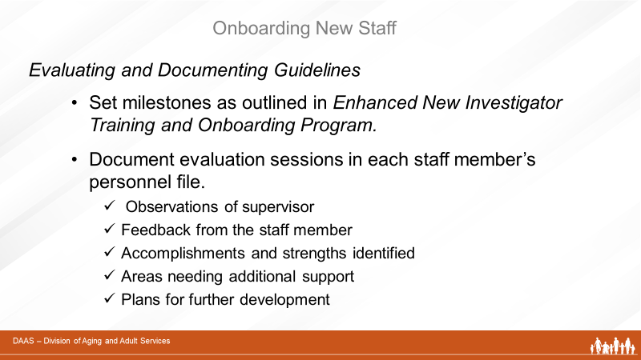
Facilitator Says:
- Use onboarding milestones set by your agency. (Ex. Enhanced New Investigator Training and Onboarding Program developed in AZ) .
- Document evaluation sessions in each staff member’s personnel file noting what was discussed (observations of supervisor, feedback shared by staff member, accomplishments and strengths identified, areas needing additional support, response to feedback, plans for further development.)
Side 49 | 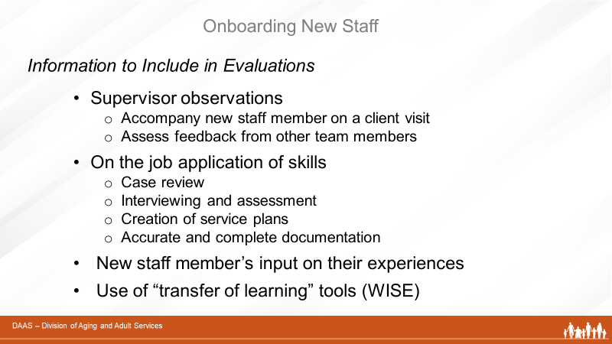
Facilitator Says:
And here are some suggested areas to include in your evaluations:
- Supervisor observations
  - Accompany new staff member on a client visit and follow with a debrief
  - Assess feedback from other team members
- On the job application of skills
  - Case review
  - Interviewing and assessment
  - Creation of service plans
  - Accurate and complete documentation
- New staff member’s input on their experiences
- Use of coaching tools
The APS Interview Observation Checklist is a coaching tool used to assess the interviewing skills of Adult Protective Services Investigators. The direct observation of an interview, in conjunction with case reading and case consultation, gives supervisors, trainers and other management staff information about investigators’ interviewing and social work skills. In addition to gathering information for assessment purposes, it also can be used to identify individual investigator’s training needs.
You will find a copy of this tool with instructions for use in your Participant Guide.

Slide 50 | 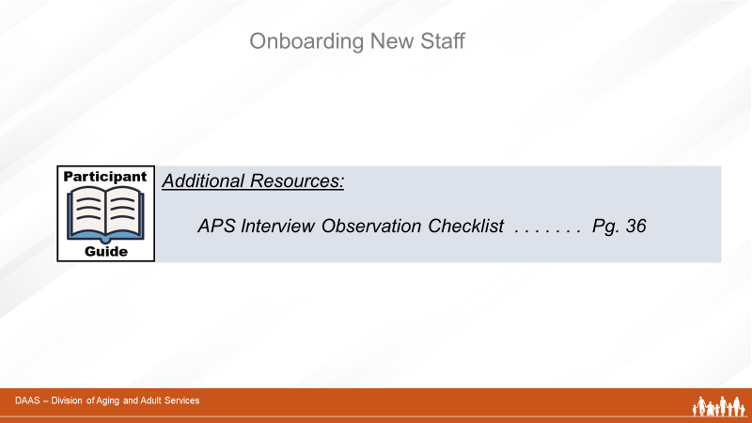
Slide 51 | 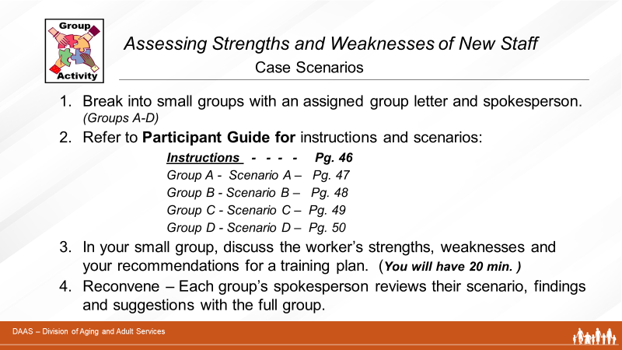
Facilitator Says:
Supervisors use the information gathered from their regular evaluations with new staff to identify strengths and weaknesses and areas that need additional attention and support.
In this next group activity, you will have a chance to use these skills as you review some new staff scenarios in small groups and use the areas of strengths and weaknesses you identify to develop an appropriate training response.
Facilitator Instructions:
- Break participants into small groups (Group A -Group D) and assign each group a spokesperson.
- Assign each group a different scenario corresponding to their group letter. Refer them to their Participant Guides to find their group’s scenario according to info on the screen.
- Give small groups 20 minutes to read their scenario, discuss the new staff person’s strengths, weaknesses and a training plan to address the person’s learning needs.
- At the end of the 20 minutes, reconvene and ask the reporter from each group to review their vignette and share their findings and plan.
- Following group reports, thank participants for their work and point out that there are sample answers for each scenario in the Participant Guide beginning on Page 51 to add to their own responses.
Facilitator Note: Scenarios with Sample Answers begin on Page 67 of
this guide.
Facilitator Says:
Good job, everyone! We’ve talked about ways to assess new staff learning during the onboarding process; identifying their areas of strengths and weaknesses; and making training plans to address learning needs.

Are there any comments or questions before we move on to talk about providing effective feedback ?
Slide 52
Facilitator Says:
An important aspect of the evaluation process is the opportunity it provides for supervisors to give effective and supportive feedback to new staff. Either by direct observation or the use of evaluation tools, supervisors gather information about performance that prepares them to offer constructive feedback to their new staff.
In addition to feedback as part of scheduled evaluations, it is important to recognize that providing effective feedback is also a key element of day-to-day supervision. It is often referred to as “debriefing.” Following an on-the-job activity or experience is a good time for the supervisor to debrief with a new staff member.
Slide 53 | 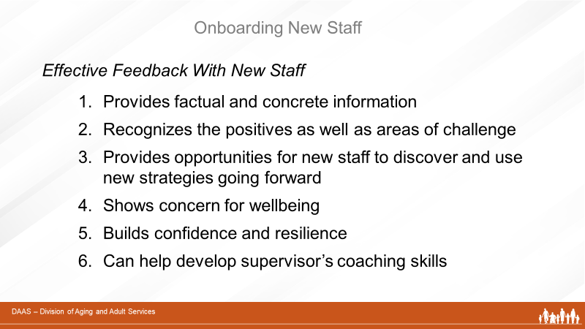
Facilitator Says:
Let’s look at significance of effective feedback - to new staff and to the supervisor. It provides factual and concrete information. Effective feedback acknowledges what new staff have done well and what areas may need additional attention. It helps new staff to discover and use more effective strategies as they move forward. Effective feedback shows concern for wellbeing and helps build confidence and resilience in new staff. And it can also be an opportunity to enhance your own learning and coaching skills.
Slide 54 | 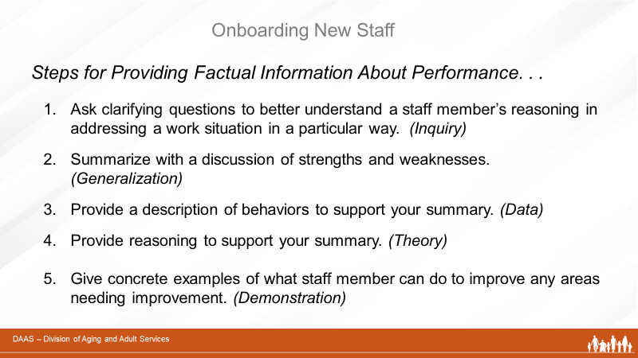
Facilitator Says:
There are five elements to providing factual and concrete information – or a critique - about performance:
- Ask clarifying questions of the staff member to understand their reasoning for addressing work in their particular fashion. (Referred to as “Inquiry”)
- Summarize with a discussion of strengths and weaknesses. (Called “Generalization”)
- Provide a description of behaviors to support this summary. (Referred to as “Data”)
- Provide reasoning to support the summary. (Called “Theory”)
- Give concrete examples of how they could improve upon their performance. (Referred to as “Demonstration”)
Your Participant Guide has a resource describing these steps along with examples of effective and ineffective responses. (Facilitator can screen share if time permits and briefly review document with participants.)
Slide 55 | 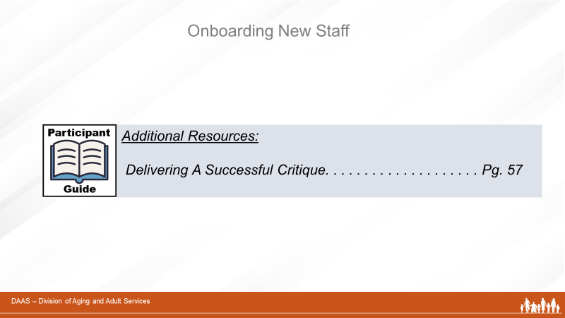
Slide 56 | 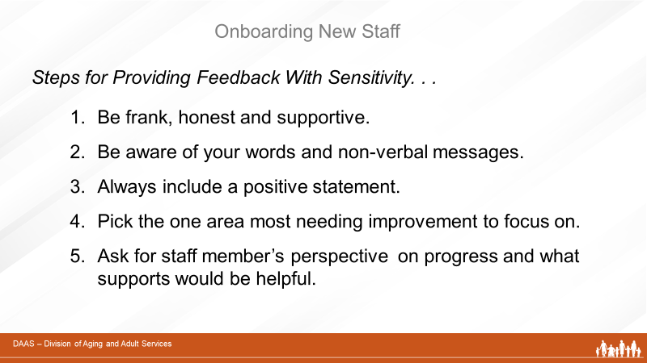

Facilitator Says:
In addition to providing feedback that is factual and concrete, the supervisor needs to do so in a manner that is supportive. Always provide your staff with positive feedback when things go well. Be clear and honest in your critique of areas that need improvement but deliver it with sensitivity. Think about the words you use and the nonverbal messages you send. Always include a positive statement about performance. (Remember, no effort is so bad that you can’t find something good to comment on.)
Pick the single most important area needing improvement to comment on. For example, a pattern of ineffective behavior is a better area to focus on than numerous one- time blunders. Always invite the staff member’s perspective on their progress and what supports they think might be helpful to them.
Any comments or thoughts before we move on?

 | Section 6 – Summary & Transfer of Learning
Slide 57 | 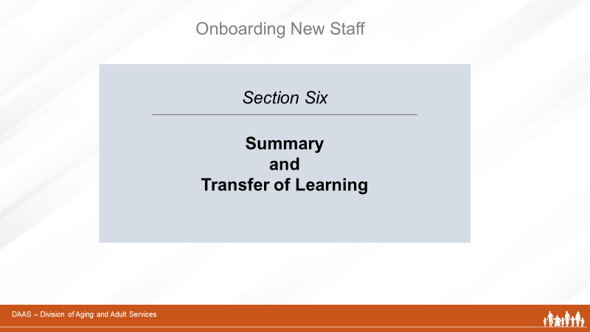
Facilitator Says:
So as we wrap up, let’s review the key points of this training session.
Slide 58 | 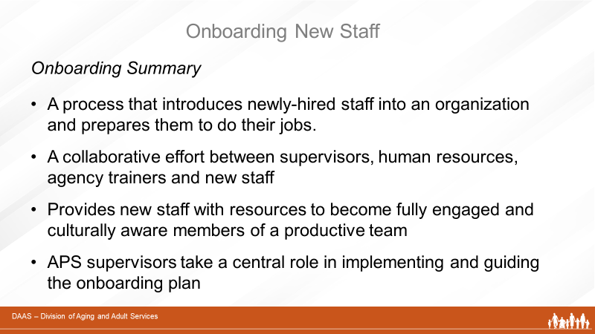

Facilitator Says:
Onboarding is an important process that introduces new staff to an organization and prepares them to do their jobs. As we have seen, it is a collaborative effort involving the APS supervisor, the new employee, human resource professionals and the agency’s training team.
The onboarding process also provides new employees with the resources to become capable, engaged and culturally-aware members of a productive team.
And, as we’ve discussed, APS supervisors take a central role in implementing the onboarding plan.
Slide 59
Facilitator Says:
Throughout the onboarding process, the supervisor
- facilitates and coordinates activities that support the onboarding plan
- uses training resources and monitors the training schedule
- meets regularly and often with new staff
- encourages critical thinking skills
- provides effective feedback and support
- and evaluates and documents each new staff member’s progress.
Onboarding new staff takes a good deal of supervisor time and effort. However, the long-term benefits of adding confident, capable, engaged members to your professional team are invaluable.

Once new staff members have successfully completed the onboarding process and have demonstrated their ability to begin handling cases independently, your role as a supervisor will gradually shift from one requiring close supervision and frequent feedback to one that is more focused on coaching techniques to guide their continued learning and development.
Are there any final questions or thoughts as we wrap up this session?

Slide 60 | 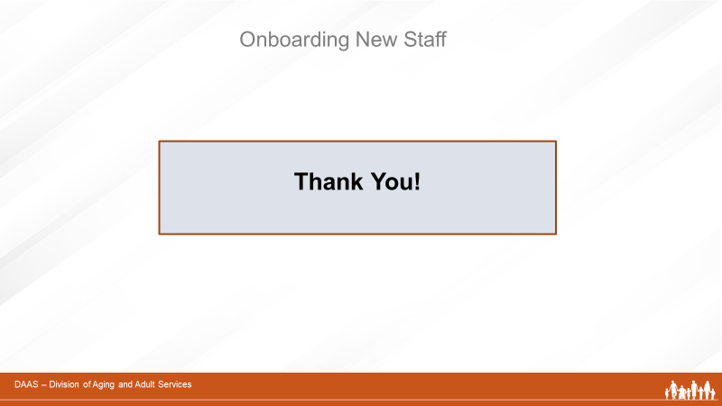
Facilitator Says:
Thank you, everyone, for participating today. And special thanks to our producer for keeping us on track! You have been a wonderful group and we appreciate your taking the time to complete this module.
Slide 61 | 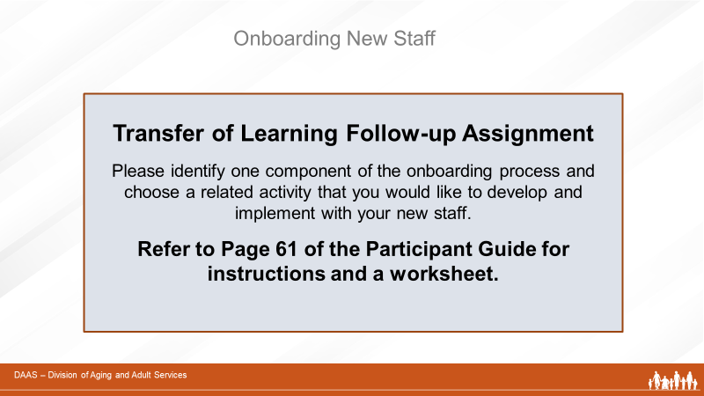
Facilitator Says:
In closing, we would like to evaluate whether this training has been effective. To do this, we are leaving you with a follow-up assignment on Page 61 of your Participant Guide.

Please identify one component of the onboarding process and choose a related activity that you would like to develop and implement with your new staff (ex. planning welcome and orientation activities, using additional training resources, encouraging critical thinking skills, evaluating and documenting progress).

Describe the activity you plan to develop, the steps you will take to implement it, the resources you plan to use, and how you will evaluate it. Then submit your ideas as directed on the worksheet. Thank you!

Tansfer of Learning Follow-Up Assignment Worksheet
Thank you for participating in the training session Onboarding New Staff. As a follow-up activity, we are asking participants to complete this transfer of learning assignment to help us evaluate the effectiveness of the session.
Please identify one component of the onboarding process and choose a related activity that you would like to develop and implement with your new staff. (ex. new welcome and orientation activities, using additional training resources, encouraging critical thinking skills, evaluating and documenting progress, ways to provide effective feedback.) And be prepared to share your onboarding activity with another supervisor who attended this training or at a future meeting!

- Describe the onboarding activity you plan to develop.

- What steps will you take to implement this activity?

- What resources can you use to assist you?

- How will you evaluate the effectiveness of this activity?

To complete your participation in this training, please finish this worksheet within two weeks of your training and submit to your supervisor. Thank you!

Group Activity - New Staff Scenarios
(Followed by sample Answers)

Please read over the scenario and then, as a group answer the following questions.

Scenario A

Jane started as an APS professional five months ago. Prior to starting with APS, she had worked with older adults as a Services Coordinator in a senior independent living building. She approached her APS work with tremendous zeal and she expressed a passion for serving older and vulnerable adults. However, Jane’s supervisor noticed during their regular supervision meetings that Jane demonstrated difficulties closing cases. For example, Jane was working with one older female client with limited family support who was at risk of experiencing self-neglect. In three months’ time, Jane had transported this client to the doctors four times, she had purchased groceries for this client on six different occasions, and she even helped the client to reorganize her closets. When questioned about Jane’s plan to link the client with community support services, she responded that, “I just don’t think that anyone can help her like I can, but I am starting to feel overwhelmed.” Jane’s supervisor reviewed her caseload and found that she had over 10 cases that had been open for 90 days or longer and she was starting to fall behind on her compliance with state mandated documentation guidelines.

- What are the APS professional’s strengths?

- What are the APS professional’s areas of weakness?

- With your group, set up a training plan that will address this staff’s training related needs.

Please read over the scenario and then, as a group answer the following questions.

Scenario B.

Edward has been a new APS professional for approximately four months. He started taking cases about two months ago after participating in a number of training related activities including shadowing experienced staff and reading through materials from his manual. Edward’s supervisor is concerned because Edward has consistently reported to his supervisor during case consultation that his clients are “fine” and that they have indicated to him that they do not want any services from APS. He reports that he enjoys conducting home visits and that he feels that this job is “not as hard as everyone said it was going to be”. Edward’s documentation shows that he is only interviewing the client on one occasion, he is not trying to locate collateral parties, and he has not been following up on significant risk factors with his clients such as cluttered and unsafe home environments.

- What are the APS professional’s strengths?

- What are the APS professional’s areas of weakness?

- With your group, set up a training plan that will address this staff’s training related needs.

Please read over the scenario and then, as a group answer the following questions.

Scenario C.

Maria is a new APS professional who had transferred to APS from Child Welfare Services during a recent wave of lay-offs at her county. She has been reluctant to participate in the training activities that have been offered to her and has told her supervisor that she “already knows how to do field work.” It has been noted that Maria has been effective with clients who are victims of physical abuse and she is prompt about following up with the police and assisting her clients to obtain Restraining Orders. However, Maria’s documentation suggests that she does not understand how to conduct a basic screening of a client’s cognitive status, and she does not appear to be assessing a client’s ability to perform basic ADLs/ADIs. One experienced staff who shadowed Maria on a recent home visit informed Maria’s supervisor that she appeared anxious around her older client and did not dedicate any time at the start of the visit to small talk or rapport building.

- What are the APS professional’s strengths?

- What are the APS professional’s areas of weakness?

- With your group, set up a training plan that will address this staff’s training related needs.

Scenario D.

Please read over the scenario and then, as a group answer the following questions.

Donald is about to complete his probationary period with APS and his supervisor is in the process of completing his evaluation. He has participated actively and enthusiastically in the training related activities. Donald’s supervisor has been impressed by his ability to develop rapport with challenging clients as well as the initiative that he takes to follow up on unmet care needs that he identifies during home visits. However, when Donald’s supervisor conducts a review of his documentation he realizes that his assessments are highly detailed and descriptive, but they do not address issues pertinent to the initial report or the investigation. Donald’s supervisor also finds several cases when Donald failed to cross report to the police and in one case where he should have cross reported to CWS. During a case consultation meeting it becomes apparent that Donald does not accurately understand probate conservatorships.

- What are the APS professional’s strengths?

- What are the APS professional’s areas of weakness?

- With your group, set up a training plan that will address this staff’s training related needs.

Sample Answers to Scenario A:

- Identifying the APS professional’s strengths:

  - Jane is passionate about working with older and vulnerable adults.
  - She seems to be well-versed in biopsychosocial issues pertaining to geriatric populations.
  - She appears to be a hard worker.

- Identifying the APS professional’s areas of weakness:

  - Jane is a “mother hen” who has poor professional boundaries.
  - Jane is creating dependency with her clients instead of trying to build self-efficacy or to enhance her client’s support system by linking them to outside resources.
  - Jane does not appear to understand the role of an APS social worker and she appears to be demonstrating difficulties with the quick turnover of cases that is directly in contradiction to the long standing relationships that she had with her clients at the senior independent living center where she previously worked.

- Plan of Action:

  - Provide constructive feedback that first focuses on her strengths.
  - Review with Jane fundamental mandates of APS work as set up by state guidelines.
  - Discuss with Jane dependency relationship that she is fostering and promote insight about potential negative impact that she could have on a relationship.
  - Review community referrals that serve to promote independence of APS clients.
  - Select case notes from self-neglect cases highlighting model APS work and promotion of self-efficacy.
  - Have Jane shadow a specific veteran staff who is adept at linking clients to appropriate referrals and has strict boundaries.
  - Closely monitor Jane’s compliance with documentation deadlines.
  - Regular check-ins with supervisor to assess progress.

Sample Answers to Scenario B:

- Identifying the APS professional’s strengths:

  - Edward reports that he likes conducting home visits.
  - He does not feel overwhelmed by job or demands.

- Identifying the APS professional’s areas of weakness:

  - Edward lacks skills to carry out a full assessment.
  - He is not fully investigating case.
  - He is not demonstrating initiative with his cases.
  - He does not appear to be making an effort to interview collateral sources.
  - He is not effectively linking clients to services.
  - He appears to lack the ability to develop rapport with his clients.
  - He is not developing service plans for clients outside of their refusals.

- Plan of action:

  - Provide constructive feedback that first focuses on her strengths.
  - Edward has shadowed veteran staff on cases but may not be aware of the extra steps that they are taking to fully investigate a case once they are back in the office. Have him read full cases (including closure) for those that he has shadowed.
  - During case consultation collaboratively set up service plans for clients, even if they have refused services.
  - Shadow Edward on home visits to point out and discuss issues that he is not identifying as needs.
  - Provide close supervision of cases to ensure that he is following up on investigative and case management tasks.
  - Have Edward attend group case consultation meetings or collaborative consultation meetings such as FAST/MDT so that he develops understanding for regular protocol surrounding APS cases.
  - Regular check-ins with supervisor to assess progress.

Sample Answers to Scenario C:

- Identifying the APS professional’s strengths:

  - Maria is an experienced CPS worker who is highly trained to deal with emergency cases and those that involve the police.
  - Maria responds promptly.
  - Maria likely has strong investigative skills.

- Identifying the APS professional’s areas of weakness:

  - Maria lacks knowledge pertaining to geriatric populations.
  - Maria does not know how to carry out a functional or a cognitive assessment.
  - Maria appears to feel uncomfortable with older adults and does not appear to know how to carry out an effective assessment or interview.
  - Likely that Maria will not know how to connect her older clients to appropriate referrals.

- Plan of Action:

  - Provide constructive feedback that first focuses on her strengths.
  - Set up a plan to help Maria gain knowledge specific to working with older and vulnerable adults.
  - Site visits to ADHC programs, senior centers, SNFs, Assisted Living, RCEB day program.
  - Review literature regarding normal age related changes.
  - Literature about dementia.
  - Have Maria observe a neuropsychological evaluation during a home visit.
  - Have Maria attend trainings in community related that may be related to aging and disability, although not necessarily abuse.
  - Have Maria participate in medication activity provided by training.
  - Discuss Maria’s impressions from shadowing.
  - Assignments to focus on self-neglect cases that will allow her to focus on rapport building.
  - Regular check-ins with supervisor to assess progress.

Sample Answers to Scenario D:

- Identifying the APS professional’s strengths:

  - Donald is enthusiastic and energetic.
  - Donald demonstrates initiative.
  - He appears to be a hard worker.
  - He is passionate about filed work.

- Identifying the APS professional’s areas of weakness:

  - Donald appears to get wrapped up in the details and narrative of the cases that he is working.
  - Donald is losing sight of the investigation that needs to happen when he goes out and likely because he becomes very involved in discussions with the clients and families.
  - Donald is having difficulties prioritizing issues.
  - Donald’s documentation is reflective of the fact that he is getting wrapped up in the details and not prioritizing issues.
  - Donald does not have an accurate understanding of APS mandates or cross reporting mandates.
  - Donald does not appear to have fully absorbed the training related material presented to him as evidence by his lack of knowledge regarding conservatorships.

- Plan of Action:

  - Provide constructive feedback that first focuses on Donald’s strengths.
  - Review APS mandates orally as well as cross reporting guidelines.
  - Provide literature regarding mandates and cross reporting.
  - During case consultation discuss role and responsibilities of APS stressing importance of adhering to mandates.
  - Donald to review documentation from other staff per supervisor suggestion.
  - Supervisor to provide feedback on sample assessments.
  - Donald to attend training on conservatorships.
  - Supervisor to review his integration of mandates, APS concepts, at a follow up point.
  - Regular check-ins with supervisor to assess progress.

